Results from the GAMMA experiment on Mt. Aragats - improved data
ROMEN MARTIROSOV
Yerevan Physics Institute, 2 Alikhanyan Br. Str., 0036 Yerevan, Armenia
ALEKSANDER GARYAKA
Yerevan Physics Institute, 2 Alikhanyan Br. Str., 0036 Yerevan, Armenia
SAMVEL TER-ANTONYAN
Department of Physics, Southern University, Baton Rouge, USA
ANATOLY ERLYKIN
P.N.Lebedev Physical Institute of the RAS, Leninsky prospect, 53, Moscow, Russia
NATALYA NIKOLSKAYA
P.N.Lebedev Physical Institute of the RAS, Leninsky prospect, 53, Moscow, Russia
YVES GALLANT
LPTA, Universit´e Montpellier II, CNRS/IN2P3, Montpellier, France
LAWRENCE JONES
Department of Physics, University of Michigan, USA
JACQUES PROCUREUR
Centre d’Etudes Nucl´eaires de Bordeaux-Gradignan, Gradignan, France
HOVHANNES BABAYAN
State Engineering University of Armenia, 105 Teryan Str., 0105 Yerevan, Armenia

The ground-based GAMMA experiment (Mt. Aragats, Armenia) is designed to study Extensive Air Showers (EAS) at 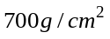 of atmospheric depth in the primary energy range 1-1000 PeV. The present status of the GAMMA facility consisting of an enlarged surface EAS array (116 of 1sq.m. scintillation detectors) and underground muon carpet (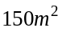detectors) is described. The recent results on mass composition and energy spectrum at energy region above the knee obtained on the basis of the GAMMA experimental data are presented. The irregularities of the energy spectrum at about 70-80 PeV are discussed in comparison with other experiments.

Introduction
Study of energy spectrum and mass composition of the primary cosmic radiation was and still is a fundamental problem of the cosmic ray physics. Particular attention is paid to 1 – 1000 PeV energy range. Several decades ago the break of the energy spectrum has been discovered in this region at 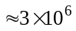 GeV, presently known as the “knee” [Kulikov&Khristiansen, 1958]. The primary goal of many ground-based experiments in cosmic rays is to study the energy spectrum and mass composition of cosmic rays in this energy range. Until recently change of the slope of the all-particle energy spectrum from -2.7 below the knee to -3.1 beyond the knee was commonly accepted. Presently there is 30% to 40 % difference in the all-particle energy spectrum obtained from various experiments. Considerably large discrepancy is also observed in experimental data in this energy range on the mass composition of primary cosmic rays. Correct measurement of mass composition can shed light upon the origin of the knee in the energy spectrum. It is necessary to notice, that experiments in this energy range are carried out by the ground installations located at various elevations. Therefore, one of the reasons of those discrepancies in experimental data could be due to the large fluctuation of the extensive air showers (EAS) deep in the atmosphere. The other reason might be the difference of the interaction models of the cascade development in the atmosphere.
Special attention should be paid to the energy range 10 - 100 PeV which still lacks in experimental data. At the same time noticeable irregularities of the energy spectrum are observed at these energies. Our group was the first to report this phenomenon in 2002 [Garyaka et al., 2002]. More detailed analysis of this energy range has been presented by us in a more recent publication [Garyaka et al., 2008]. In this work we present experimental results on the energy spectrum and mass composition at 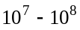 GeV derived from the GAMMA experiment on Mt. Aragats in Armenia.

GAMMA experiment
The GAMMA installation was realized in an attempt to study the energy spectrum and mass composition of the primary cosmic radiation in the energy range 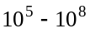GeV as well as for investigation of primary very high energy gamma-quanta. The GAMMA (Figure 1) is located on the southern hills of the Mt. Aragats in Armenia with the following geographical coordinates Latitude = 40.47 N, Longitude = 44.18 E and consists of two main parts:
- surface scintillation detectors for registration of the EAS electromagnetic component;
- underground scintillation detectors for registration of the EAS muon component;
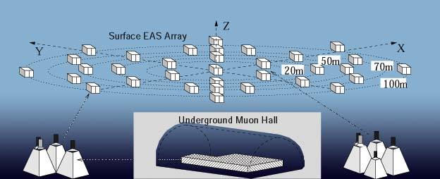
Figure 1. Diagrammatic layout of the GAMMA facility

The surface scintillation array
At present the surface scintillation array consists of 33 groups of three plastic scintillation detectors, arranged in concentric circles with radii of 20, 28, 50, 70 and 100 m. Each detector has an effective area of 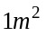and a thickness of 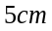. The total area of the surface part is about 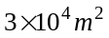. Each of the central nine stations contains also (4th) small scintillator with dimensions 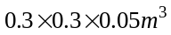 for high particle density measurements. Recently 8 additional scintillation detectors were installed at radii 14 and 30 m. It has allowed to reduce the energy threshold up to 10⁵ GeV.

Underground muon detector
Muon carpet composed of 150 scintillation detectors are compactly arranged in the underground hall under 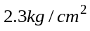 of concrete and rock. The scintillator dimensions, casings and photomultipliers are the same as in the EAS surface detectors. The arrangement of the muon detectors gives the possibility of determining the muon lateral distribution up to 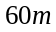 at 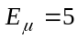 GeV.
The EAS angular characteristics (zenith and azimuth angles) are estimated on the basis of the shower front arrival times measured by the 33 fast-timing surface detectors, applying a maximum likelihood method and the flat-front approach.

Results

Rigidity-dependent cosmic ray energy spectra [Garyaka et al., 2007]
On the basis of the extensive air shower (EAS) data obtained by the GAMMA experiment, the energy spectra and elemental composition of the primary cosmic rays are derived in the 1-1000 PeV energy range. The reconstruction of the primary energy spectra is carried out using an EAS inverse approach in the framework of the SIBYLL2.1 and QGSJET01 interaction models and the hypothesis of power-law primary energy spectra with rigidity-dependent knees. It is necessary to underline that all the results are derived taking into account the detector response, the reconstruction uncertainties of the EAS parameters, and fluctuations in the EAS development.
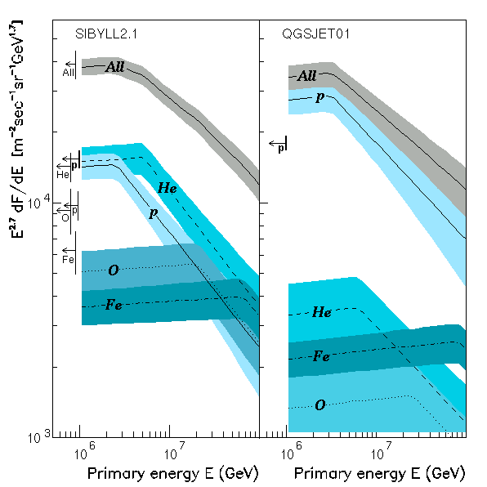
Figure 2. Energy spectra and abundances of the primary nuclei groups (lines and shaded areas) for the SIBYLL (left panel) and QGSJET (right panel) interaction models. All-particle spectra from GAMMA [Ter-Antonyan et al, 2005] and KASCADE [Antony et al., 2005] are shown as symbols. Vertical bars show the extrapolations of balloon and satellite data [Wiebel-Sooth, Biermann&Meyer, 1998].

Energy spectra and abundances of the primary nuclei groups for the SIBYLL and QGSJET interaction models are shown on the Figure 2. As can be seen from this figure, the derived primary energy spectra depend significantly on the interaction model, and slightly on the approach applied to solve the EAS inverse problem. The derived abundances of primary nuclei at an energy PeV in the framework of the SIBYLL model agree (in the range of 1–2 standard errors) with the corresponding extrapolations of the balloon and satellite data [Wiebel-Sooth, Biermann&Meyer, 1998], whereas the results derived with the QGSJET model point toward a dominantly proton primary composition in the 1– 100 PeV energy range.
The corresponding spectral power-law indices are 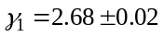 and 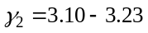 below and above the knee respectively.

All-particle primary energy spectrum in the 3–200 PeV energy range [Garyaka et al., 2008]
Applying a new event-by-event 7 parametric energy evaluation the all-particle energy spectrum in the knee region is obtained on the basis of the data set obtained using the GAMMA EAS array [Garyaka et al., 2007] and a simulated EAS database obtained using the SIBYLL interaction model (Figure 3).
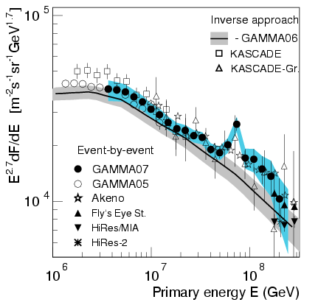
Figure 3. All-particle energy spectrum in comparison with the results of EAS inverse approach [Bruggemann, M. et al, 2006, Garyaka et al., 2007] and our preliminary data [Ter-Antonyan et al, 2005]. The AKENO, Tibet-III, Fly’s Eye Stereo, Hires/MIA and Hires-2 data were taken from [Nagano, N. et al., 1984; Amenomori, M. et al., 2008; Bird, D.J. et al., 1995; Abu-Zayyad, T. et al., 2001; Abbassi, R. U. et al., 2002] respectively.

The event-by-event reconstruction of the primary all-particle energy spectrum using the GAMMA facility is mainly based on high correlation of primary energy 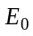 and shower size (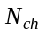). The high accuracy of energy evaluations and small statistical errors point out at the existence of an irregularity (‘bump’) in the 60–80 PeV primary energy region. According to [Garyaka et al., 2008] the bump can be described by a two-component model of primary cosmic ray origin, where additional (pulsar) Fe components are included with very flat powerlaw energy spectrum (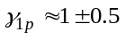) before the cut-off energy 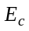,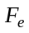.
Though we cannot reject the stochastic nature of the bump completely, our examination of the systematic uncertainties of the applied method lets us believe that they cannot be responsible for the observed feature.
The indications from other experiments (Figure 4) mentioned in [Erlykin&Wolfendale, 2010] provide the argument for the further study of this interesting energy region.
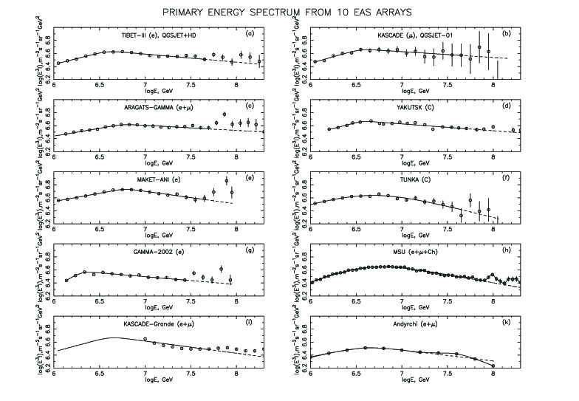
Figure 4. Energy spectra of primary CR, measured by Tibet-III (a), KASCADE (b), GAMMA (c), Yakutsk (d), Maket-Ani (e), Tunka (f), GAMMA-2002 (g), MSU (h), KASCADE-Grande (i) and Andyrchi (k) arrays.
References
[1] Abu-Zayyad, T. et al.: 2001, Astrophys. J., 557, 557.

[2] Abbassi R U et al.: 2002, Preprint astro-ph/0208301.

[3] Amenomori, M. et al.: 2008, Preprint arXiv:0801.1803.

[4] Antoni, et al. : 2005, Astroparticle Physics, 24, 1.

[5] Bird, D.J. et al.: 1995, Astrophys. J., 441, 144.

[6] Bruggemann, M. et al.: 2006 Proc. 20th ECRS (Lisbon, 2006) available at http://www.lip.pt/events/2006/ecrs/proc/ercs06-s3–77.pdf

[7] Erlykin, A.D., Wolfendale, A.: 2010, Proc. of the 22nd ECRS, Turku

[8] Garyaka, A.P., Martirosov R.M., Procureur, J., Mamidjanian, E.A. and Eganov, V.S.: 2002, J. Phys. G: Nucl. Part. Phys. 28, 2317.

[9] Garyaka, A.P., Martirosov R.M., Ter-Antonyan, S.V., Nikolskaya, N.M., Gallant, Y.A., Jones, L.W. and Procureur, J.: 2007, Astroparticle Physics 28, 169.

[10] Garyaka, A.P. Martirosov R.M., Ter-Antonyan, S.V., Erlykin A.D., Nikolskaya, N.M., Gallant, Y.A., Jones, L.W. and Procureur, J.: 2008, J. Phys. G: Nucl. Part. Phys. 35, 115201.

[11] Khristiansen, G.B., Kulikov, G.V.: 1958, Nuovo Cimento, 8, Suppl. N2.

[12] Nagano, N. et al.: 1984, J. Phys. G: Nucl. Phys., 10, 1295.

[13] Ter-Antonyan, S.V., Gallant, Y.A., Garyaka, A.P., Jones, L.W. Martirosov R.M., Nikolskaya, N.M., and Procureur, J.: 2005, Proc. of the 29th ICRC, Pune, 6, 105.

[14] Wiebel-Sooth, B., Biermann, P.L., Meyer, H. : 1998, Astron.&Astrophys. 330, 389.

