MARS TRACKING SIMULATIONS FOR THE MU2E SLOW EXTRACTED PROTON BEAM.*
V.Nagaslaev#, I.Rakhno, Fermilab, USA

Abstract

Particle tracking taking into account interactions with fields and materials is necessary for proper evaluation of the resonant extraction losses and geometry optimization for the extraction beam line. This paper describes the tracking simulations for the Mu2e Resonant Extraction and discusses the geometry choices made based on these simulations.

introduction
Mu2e experiment [1] uses the third integer resonant extraction from the Fermilab Delivery Ring to deliver the 8kW proton beam to the production target. Beam losses at the extraction location are a very serious concern of the design. Heavy in-tunnel shielding will be needed even for localized beam losses as low as 1% in order to keep prompt radiation dose levels on the surface within acceptable range and to reduce the residual doses in the tunnel to facilitate the machine maintenance. Another consequence of high beam losses is activation of hardware, which makes its servicing more difficult. Extraction channel geometry needs to be optimized for best extraction efficiency. We define the extraction channel here as the section of the beam line including two Electrostatic Septa (ESS) straddling a focusing quad Q203, defocusing quad Q204 and two magnetic septa straddling the large aperture quad Q205. The layout of this section is shown in Figure 1. Extracted beam is separated from the circulating beam and deflected horizontally in the ESS and vertically in the Lambertson and the C-magnet. Quads Q204 and Q205 provide additional horizontal and vertical kicks outwards due to their defocusing and focusing functions correspondingly.
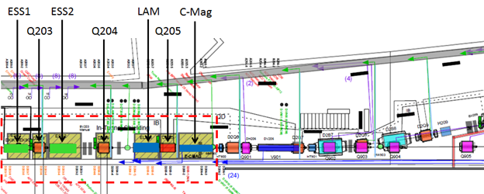

* Work supported by DOE under contract DE-AC02-07CH11359
#vnagasl@fnal.gov
Figure 1. Extraction beam line, plan view. Extraction channel is marked by the red dashed line. Hatched yellow blocks are the in-tunnel shielding around the most activated elements.
The process of beam passage through the extraction channel and generation of losses in the ESS has been studied using tracking simulations with MARS program [2]. MARS provides a very detailed description of particle interaction with materials as well as tracking in the fields.

mars model
Most of the beam line elements were described in the model using MARS “extended” and “nonstandard” types of geometry. Mixing these two types has to be done with care and should be avoided in volumes with thin objects. It is important that tracking in the ESS handles correctly transitions in and out the tiny foil strips, therefore only
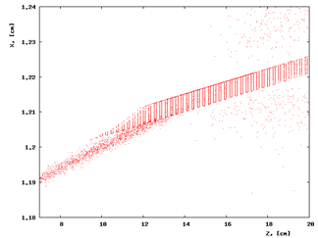
Figure 2. Beam tracking through the foil plane. Red dots show stopping points between two consecutive steps of a particle. They “light up” the foil strips boundaries.
“extended” objects are used there. The volume recognition is verified in Figure 2 that shows the proton beam crossing through the foil plane. Red dots on the plot indicate locations of the ends of steps along the particle path. The points are random outside the foil plane but in the plane they concentrate on the foil boundaries; this demonstrates that the volume transitions are properly recognized. The ESS planes are formed by the W/Re 50µ thick foils, of 1mm width, spaced at 2.6mm centre-centre. The foil shapes in Figure 2 are exaggerated by the strong compression in z-direction along the beam path.
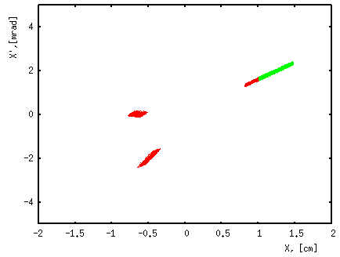
Figure 3. Phase space of the sample beam with the region of smaller amplitudes removed. Units are cm and mrad.

Particle samples for the MARS tracking have been provided from the resonant extraction simulation in the Delivery Ring made with the Synergia program [3,4]. The phase space of two such samples is shown in Figure 3. The green sample (Sample 1) represents particles at the entrance of the ESS1 that arrive beyond the nominal position of the septum foil plane in X - these are the extracted particles. The red sample (Sample 2) represents the outmost parts of the beam that still circulate in the ring but will be extracted after the next 1, 2 and 3 turns.

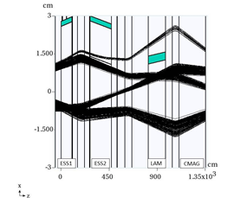
Figure 4. Tracking the multiband sample in the extraction channel –horizontal plane view. The upper band shows part of the extracted beam closest to the septa planes. The other three bands show the boundary of the circulating beam envelope.
The central part of the circulating beam is by far more populated but it is not needed in these simulations and therefore excluded in order to save on CPU time. Extracted sample is the main one used in this study. It’s been collected in the middle of the spill and correction was applied for the average X’ drift during collection time. The natural X’ spread at the septum plane horizontal position X_{S} is very narrow at zero chromaticity (rms=10µrad). The angle spread in the sample is 60µrad rms that corresponds to chromaticity C_{X}=1. In order to account for beam scattering and beam splitting in the foils the foil plane was properly shifted into the samples in X plane.
Upon every change in the geometry new alignment of the beam line elements have been performed. Alignment is demonstrated in Figure 4 and has to be made using the multiband sample 2. The upper band is split in two parts by the ESS1. The ESS1 septum plane needs to be aligned to be very close to parallel to the beam in order to minimize scattering. In ESS2 the separation between beams is substantial and the septum plane is aligned in the middle between them. The septum in the Lambertson magnet is aligned the same way but in this case other bands of the sample also need to be taken into account.

Beam losses
Beam scattering and losses are analysed in the detector placed behind the C-magnet. There is a deficit of protons in the detector due to the direct local losses in the extraction channel. There will be also distributed losses downstream in the ring and the extraction beam line because not all the remaining protons are contained within the machine acceptance. Figure 5 shows the phase space of the beam in extracted (green) and circulating (blue) regions. Scattered protons form the halo shown in red. Cyan ellipses are the 20 π-mm-mrad boundaries for the ring and extraction beam line acceptance.
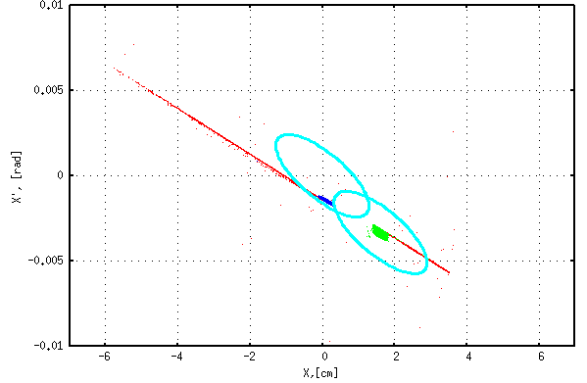
Figure 5. Phase space of the beam at the C-magnet exit after scattering in the ESS foils.
We chose to use the fraction of scattered particles outside the cyan ellipses in Figure 5 as a measure of total distributed losses downstream. The sum of local and distributed losses gives the total inefficiency of the extraction. It needs to be noted that similar scattering tails are observed in vertical plane as well. Besides, scattered particles also have deficit in energy. The numbers quoted below are obtained by counting outside particles in all three dimensions. However, this is not much different from counting horizontal plane only because the tails in Y-, ΔE- and X-distributions are correlated. For the case shown in Figure 5 the local losses are 0.7% and distributed losses are 0.55% therefore total inefficiency is 1.25%.

Choice of foils
Since relatively recently, the electrostatic septa made with foil ribbons instead of wires have become a preferred choice for slow extraction in the high energy machines due to better mechanical stability of the foils. Here we compare the performance of the foils and wires in their typical configurations. Performance is evaluated by modelling total and local losses dependent on the beam misalignment with septum plane (angle scans). Figure 6 presents such an angle scan for ESS1 with the septum plane made of 100µ diameter W/Re wires spaced with 2mm and that of 50µ thick W/Re foils of 1mm width spaced with 2.6mm centre-to-centre.
As expected, local losses for the wire plane are smaller. Not so obviously, total losses for the wire plane are larger than that of the foil plane. That is because the total losses are close to the geometrical losses, which are proportional to the full septum plane thickness. We conclude that wires do not have an apparent advantage over the foils. This is also a conservative comparison because options of using the 25µ thick W/Re foils or Molybdenum foils are also available.
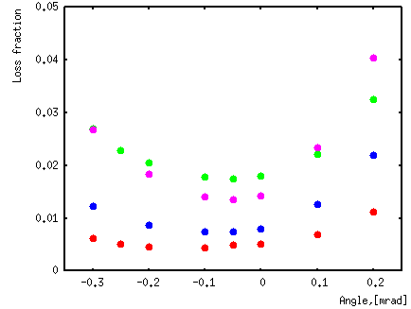
Figure 6. Fraction of the local and total beam loss versus the incident angle of the beam with respect to the septum plane. 50µ W foil strips plane: purple points – total losses and blue points- local losses; 100 µ diameter W wire plane: green points- total losses and red points- local losses.

septum lengths
Extracted beam starts to separate from the circulating beam in the ESS1 due to deflection in the electrostatic field. This separation becomes substantial in ESS2, so scattering in the ESS2 does not practically contribute to losses. The circulating beam in ESS1 remains close to the foil plane, continuing to contribute to losses due to its angular spread. This component of the losses can be minimized by reducing the length of ESS1 and increasing the ESS2 length so that the total kick remains unchanged. Figure 7 shows the total losses angle scan for different ESS1/ESS2 length combinations.
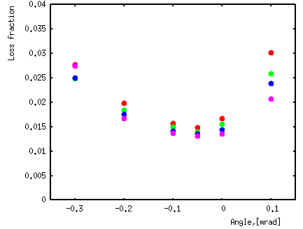
Figure 7. Total loss fraction versus beam incident angle misalignment for various ESS1/ESS2 lengths: red points: L1/L2= 1.5m/1.5m; green – L1/L2= 1.0m/2.0m; blue- L1/L2 = 0.7m/2.3m; purple- L1/L2=0.5m/2.5m.
There is some improvement for shorter ESS1 lengths, however there are practical limitations for going below L1=1m such as fabrication, alignment and spacing for the longer ESS2 module. One possible solution is to step back further and use the length ratio of 1.2m/1.8m – this choice would allow us to use the same length of the two foil supporting C-frames and make design common for the two septa vacuum vessels, accommodating a diffuser in front of the ESS1.

diffuser
Particles that experience most scattering in the foils resulting in their loss predominantly travel substantial distance through the foil plane until multiple scattering deflects them away from this plane. A clever way to reduce scattering for these particles was proposed at CERN [5]. This is done with a plane of low density material of the same thickness as the foils placed in front and aligned with the ESS1 foil plane. This diffuser selectively pre-scatters particles most affected otherwise by foil plane scattering and helps them avoid this stronger scattering in the septum plane. An angle scan with a pre-scattering diffuser is shown in Figure 8.
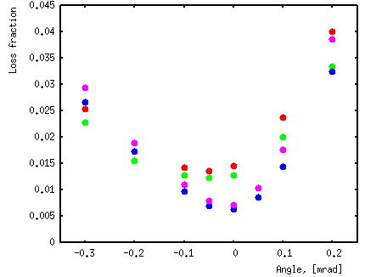
Figure 8. Fraction of total beam losses in the foil strip septum with a 30cm long carbon foil strip diffuser in front of the septum plane (blue - Mo foils, purple - W foils) and without pre-scattering (green – Mo foils, red - W foils).
Reduction of beam losses is substantial with good alignment and full angle spread within 0.1mrad. Low density foils are best to use for the diffuser. However very close performance may also be achieved even with Mo foils of 1 mm width spaced at 2cm or more within 30-50 cm in front of the ESS1.

CONCLUSION
A possibility to achieve a low level of beam losses for slow extraction from the Delivery Ring has been demonstrated in the MARS tracking simulations. With a careful orbit control they could be at the level of 1.5% and about half of that are the local losses. The use of a low density diffuser can reduce losses by about half. Further improvement may be made by reducing the foil thickness down to 25µ and/or reconfiguring the machine optics.

References
[1] Mu2e Experiment TDR, arXiv:1501.05241
[2] N. Mokhov, “MARS15 overview,” Fermilab-CONF-10/518-APC, 2010.
[3] J. Amundson et al., Synergia: “An Accelerator Modeling Tool with 3-D Space Charge,” J. Comp. Phys. 211 (2006), pp. 229-248.
[4] C.S.Park, “Tracking Simulation of Third-Integer Resonant Extraction for the Fermilab Mu2e Experiment”, Mu2-docdb-3634, to be published.
[5] A letter of Alain Durand to CERN, April 1974

