Vibrating Wire Monitor for Beam Profiling
B. Smith*, University of Illinois at Urbana-Champaign, Champaign, IL 61820, United States
V. Scarpine, Fermi National Accelerator Laboratory, Batavia, IL 60510 United States
SIST Program, Fermi National Accelerator, August 4th, 2015

Characterization of a Large Aperture Vibrating Wire Monitor (LA-VWM) used for measuring halos of beams and beam profiling. This new system utilizes two wires (target and vibrating) and has a larger aperture (60 millimeters). Initial beam measurements have been performed at the Fermilab High Intensity Neutrino Source facility by Dr. Moses Chung. Further bench tests were performed to characterize LA-VWM for potential use at Fermilab’s PXIE, PIP-II, Main Injector, and other beam lines.
INTRODUCTION
The measurement and monitoring of the beam halos are important to Fermilab’s future high-intensity beams at PXIE and PIP-II. Halos are important to measure and monitor in high-intensity beams because the particles that form the halo are particles separated from the core of the beam which decrease the beam energy and power. Halos form as a result of the particles acquiring transverse energy from the repulsive space-charge forces. These halo particles can be lost on the walls of the beamline and in other devices along the beam. This will increase the amount of radioactivity within the beamline, which requires more time and money to clean up the radioactive material and requires specialized workers to be able to work on the beamline [1]. For PXIE, Fermilab seeks to increase the intensity of the proton accelerator that will deliver an adjustable beam to several experiments in the future. High-intensity beams are necessary for particle physics because it delivers more particles to an experiment. The more particles hitting targets or detectors, provides experimenters more data to analyze for new discoveries in particle physics.
In order to monitor and measure beam halos, it is necessary to measure the core of the beam in addition to the halo [2]. There have been several advances to increase the range of halo measurements. A new imaging technique using a digital optical mask has been developed. This imaging technique uses a Charge Injection Device or a Charge Couple Device to image synchrotron or optical transition radiation emitted by the beam particles. These cameras have a high dynamic range due to their unique pixel design. This allows greater accuracy, compared with a low dynamic range camera, which results in saturation at the core region of the beam due to the pixels becoming overcharged. However, Charge Injection Devices and Charge Couple Devices are generally used in electron accelerators. In addition, the cameras perform poorly in radiation areas because the radiation causes damage to the device [3].
Despite this, wire scanners are still used for nondestructive halo beam measurements. The vibrating wire monitor (VWM) was developed to improve the dynamic range of traditional wire scanners [4].
VIBRATING WIRE MONITOR FUNCTIONALLITY
The VWM halo measurements are based on the change in frequency of a vibrating wire. The wire vibrates at a natural oscillation frequency generated by placing the vibrating wire in a permanent magnetic field and driving an alternating current through the wire. The vibrating wire is connected to a positive feedback circuit. This circuit consists of operational amplifiers and amplifies oscillation at a certain natural frequency. The voltage of the alternating current that drives the wire is controlled by a voltage-controlled resistor in a negative feedback loop. The sine wave output from the operational amplifier is then amplified and converted to a square waveform. The square waveform is then transferred using an Ethernet cable; this allows the ability to transfer data over longer distances. This signal is used for frequency counting, is then digitized, and displayed on the computer in terms of frequency [5].
The original VWM design consists of one vibrating wire that also acts as the target wire (Seen in FIG. 1). Approximately 2/3 of the wire is placed in the magnetic field and the other 1/3 is available as a target for the beam (Fig. 1). Four SmCo (samarium-cobalt) magnets are used to place the vibrating wire in a magnetic field. The magnetic field has the strength of about 0.5-0.7 T. However, this VWM has a target wire length of 12mm, so many of the particles that make up the halo are deposited on the structural components of the device. The target wire also acts as the vibrating wire in this system. To resolve this issue, the length of the target wire must be increased. In the case of this system, the entire device size would have to increase and this would decrease the response time of the device [5].
In this paper we characterize a newer version of the VWM. This large aperture vibrating wire monitor (LA-VWM) consists of two wires (target and vibrating). The vibrating wire remains in the similar setup, placed in a magnetic field and driven by an alternating current. The vibrating wire now measures the strain of the other wire (target wire). The target wire is then exposed to the beam for measurements. To measure beam halos, the LA-VWM changes the frequency the vibrating wire is osculating at when the beam is applied to the target wire. The particles from the beam deposit energy in the target wire and cause a change in the temperature of the wire. Since the target wire is no longer in a magnetic field, it allows for the target wire to be larger than the previous design. This also means that the target wire is not connected to the positive feedback circuit. This enables usage of nonconductive materials and materials with different thermal conductive properties. The target wire has the length of 60mm allowing a larger area for particles to hit for large aperture halo measurements.
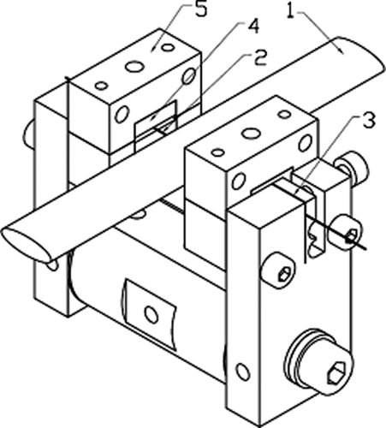
FIG. 1. The main view of the original design of the VWM. 1: beam; 2: vibrating wire; 3: clips; 4: magnet; 5: magnet holder. Here, the vibrating wire serves as a target for the beam at the same time. The wire length is 36 mm, but only ∼1/3 of the wire is available as a target for the beam measurements [5].
In this new design of the LA-VWM the target and the vibrating wires are coupled by a balanced arm with a bearing axis (FIG. 2). The original design of the VWM increased the dimensions making installation more difficult. This balanced arm design solves many of the problems above and keeps the LA-VWM more compact, compared to enlarging the older model. Both the target wire and vibrating wire are under tension, so when beam is applied to the target wire, the wire will expand changing the tension in both wires, thus changing the frequency of the vibrating wire. In addition, having two different wires for the target and vibrating wire allows for different combinations of wire types depending on the desired usage of LA-VWM. Material types can vary the response time or sensitivity of the LA-VWM.
The LA-VWM is an improvement from the VWM and traditional wire scanners because of its resolution and dynamic range. The LA-VWM has a resolution of 0.01 Hertz and a dynamic range of 2x10⁵. This allows for more precise measurements of beam halos.
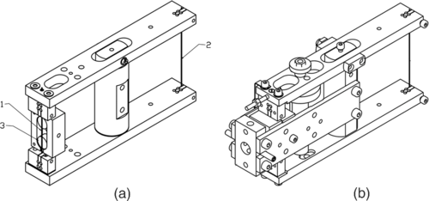
FIG. 2. (a) Main parts of the LA-VWM: 1: vibrating wire; 2: target wire; 3: round magnets providing the magnetic field for wire oscillation generation. (b) Assembled view of the LA-VWM. The space to the right of the balancing arm support is free for beam measurement (in comparison with the previous model of the VWM in Fig. 1) [5].
STABILITY CHARACTERISTICS
The first test to characterize the LA-VWM was to find how stable the device is in a given environment. The tests performed looked to find what frequency the LA-VWM operated at when placed in air, in a standard office space. The variables such as, wire material, sampling rate, exposure to mechanical vibrations, and exposure to magnets, were changed throughout testing. Tests were also performed to see if there was a difference between the two identical LA-VWM. The LA-VWM was setup on an optical board and data was collected for a minimum of 30 minutes without applying heat to the target wire.
Results and Discussion
Wire Material
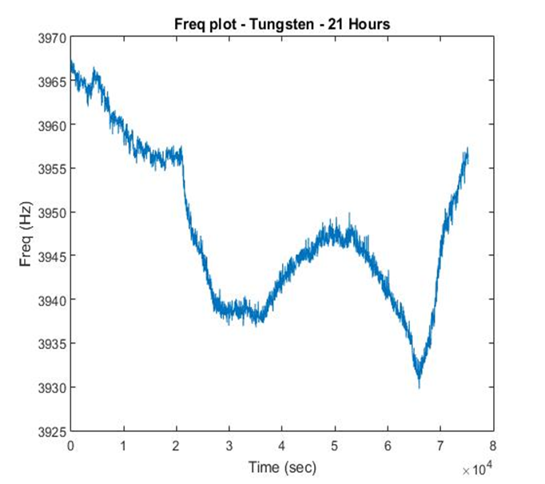
FIG. 3 displays the frequency versus time plot of the stabilization test of tungsten wire as both the target and vibrating wire. The test was performed for 21 hours.
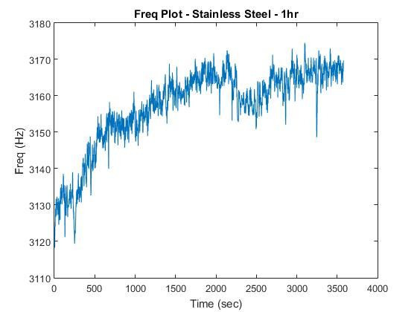
FIG. 4 displays the frequency versus time plot of the stabilization test of stainless steel wire. The test was performed for 1 hour.
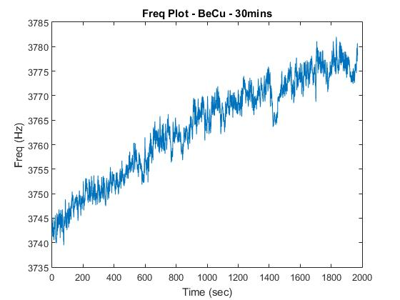
FIG. 5 displays the frequency versus time plot of the stabilization test of beryllium copper (BeCu) wire. The test was performed for 30 minutes.
Figures 3-5 display the stability of the LA-VWM across the various material types. The tests show that regardless of the material they all respond to the surrounding changes in environment. The materials sense the changes in the room temperature which explains the slow changes over the long testing periods. Concerning the high frequency changes seen in the data, tungsten proves to have the smoothest curve. The use of two different materials as the vibrating wire and target wire do not remove these effects.
Future tests should be performed in a temperature controlled environment to test if the resolution of the device will improve. The environment should also be isolated from mechanical vibrations. The tests above were performed on the second floor of a building; the LA-VWM was exposed to the natural frequencies of the floor moving as people walked either in or past the office where tests were performed. Tests should also be performed in a vacuum chamber to test if that aids in eliminating some of the noise seen in these tests.

Sampling Rate (Gate)
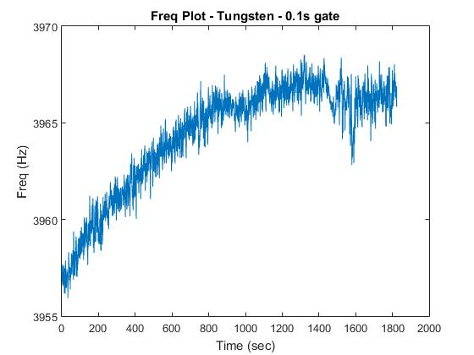
FIG. 6 displays the frequency versus time plot of tungsten wire. This test uses a .1 second sampling rate (gate) for 30 minutes.
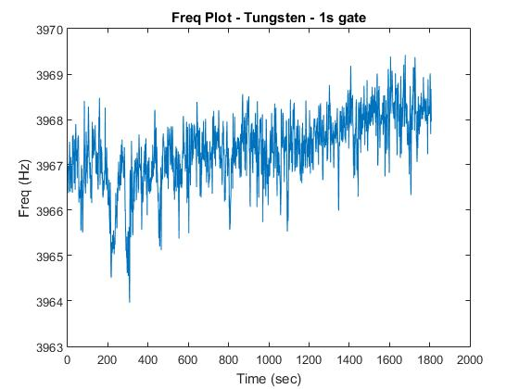
FIG. 7 displays the frequency versus time plot of tungsten wire. This test uses a 1 second sampling rate (gate) for 30 minutes.

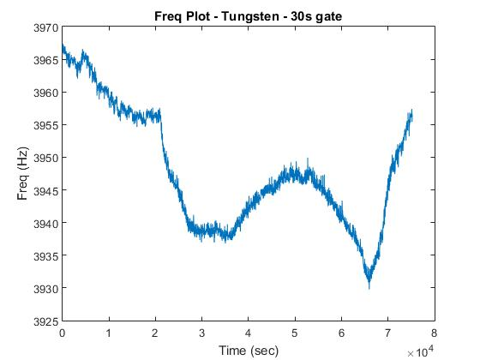
FIG. 8 displays the frequency versus time plot of tungsten wire. This test uses a 30 second sampling rate (gate) for 21 hours.

The tests in Figures 6-8 test if changing the sampling rate of the LA-VWM would eliminate the noise seen in the previous tests and improve the resolution of the LA-VWM. Changing the gate does eliminate some of the high frequency noise seen by the LA-VWM. However, it does not eliminate the slow changes in the data due to the changes in ambient temperature.
LA-VWM Device
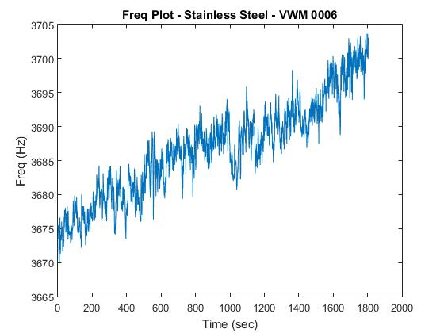
FIG. 9 displays the frequency versus time plot of stainless steel wire. Test performed on LA-VWM device 0006.
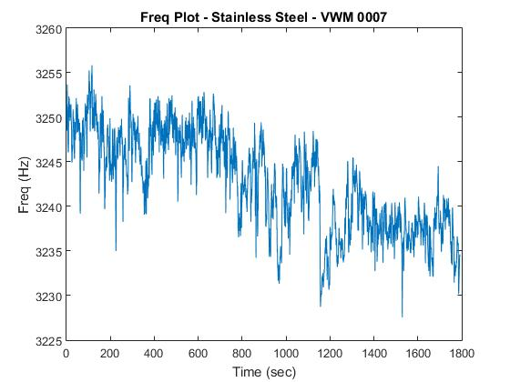
FIG. 10 displays the frequency versus time plot of stainless steel wire. Test performed on LA-VWM device 0007.
In Figures 9 and 10, tests were performed to see if there were any significant differences in the two LA-VWM’s. Despite the small difference in initial frequencies, which are due to the slight differences in how the wires were strung, both LA-VWM’s are the same and perform the same way.
Magnetic Fields
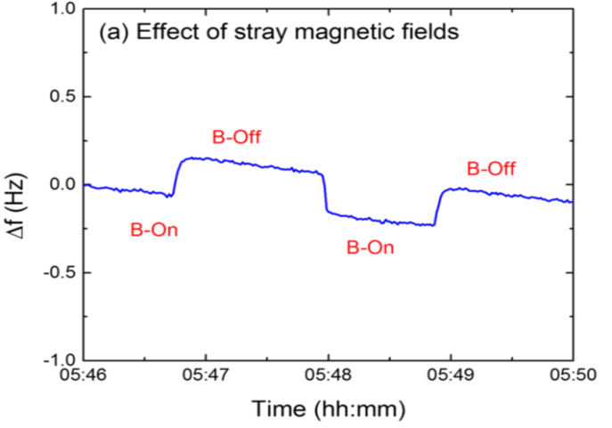
FIG. 11 displays the change in frequency versus time plot of stainless steel wire. The test was performed at Fermilab’s HINS experiment by Dr. Moses Chung. Test was to understand how LA-VWM responds to magnetic fields [5].
Figure 11 tests how the LA-VWM responds to stray magnetic fields. This is important because within the beamline there are magnetic fields that could potentially interfere with the LA-VWM. This test was performed by Dr. Moses Chung, and his results clearly show that stray magnetic fields greatly affect how the LA-VWM performs.
In addition to the above tests the LA-VWM also responds to mechanical vibrations. These vibrations were observed through just working with the LA-VWM, if anything drops near and around the LA-VWM the device will pick it up.
In the end, the LA-VWM is a very sensitive device. This is crucial in the fact that it will be an excellent candidate at monitoring beam halos precisely. However, the problem with the LA-VWM is the fact that other factors that are not beam halo could be read by the LA-VWM. The LA-VWM responds poorly to ambient temperature, magnetic fields, and mechanical vibrations. When placed in a beamline, the LA-VWM would be exposed to all of the above as the beam line has several magnets and other moving factors. Future work must be down to find ways to eliminate some of these factors.
THERMAL RESPONSE CHARACTERISTICS
The second test was to see how the LA-VWM responds to heat changes. Three different tests were performed to place heat on the target wire to observe how the LA-VWM system responds. The target wire was exposed to heat provided by a heat gun, a heated wire, and a two milliwatt helium neon laser. During the heat gun test the target wire was exposed to a heat gun in 5 minute intervals. The heat gun was placed about a foot away from the target wire. The wire material was changed during these tests to test if one material was more sensitive to heat change compared to the other materials. The heated wire was also used to heat the target wire. The heated wire was heated by an alternating current and the current was turned on and off in 5 minute intervals. The heated wire was placed within a centimeter of the target wire to avoid heat loss to the air. The last experiment was to observe how the LA-VWM responds to heat applied by a 2 mW HeNe laser. The target wire was aligned with the center of the laser.
Results and Discussion

Wire Material- Heat Gun
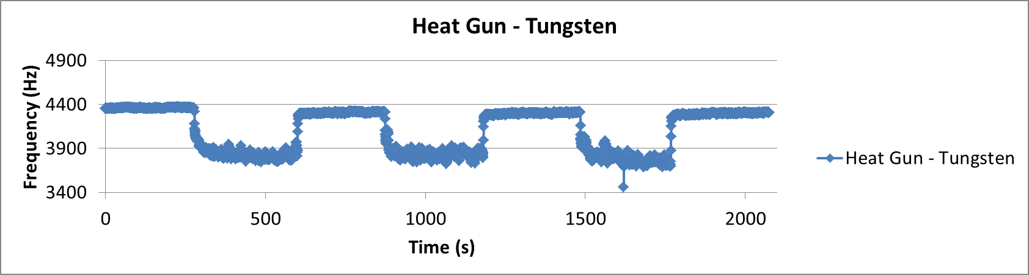
FIG. 12 displays the frequency versus time plot of tungsten wire. The test was to see how the LA-VWM responded to heat. Heat gun was turned on and off in 5 minute increments.
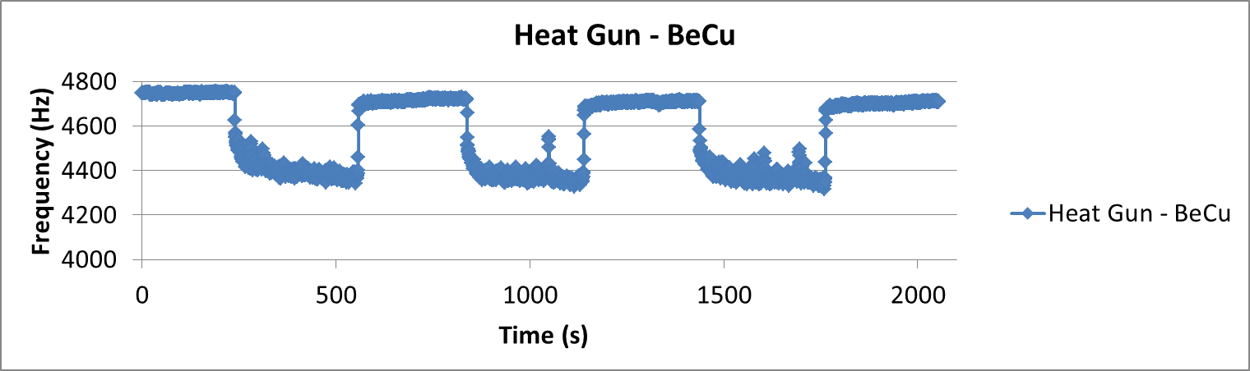
FIG. 13 displays the frequency versus time plot of BeCu wire. Test was to see how BeCu wire responded to heat changes. Heat gun was turned on and off in 5 minute increments.
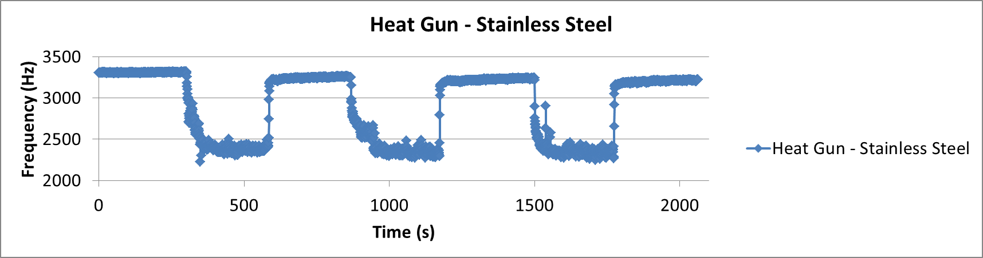
FIG. 14 displays the frequency versus time plot of stainless steel wire. Test was to see how stainless steel wire responded to heat changes. Heat gun was turned off and on in 5 minute increments.

Figures 12-14 display how different materials respond to heat changes provided by a heat gun. A thermocouple was placed near the target wire to get an estimate of the change in temperature of the target wire when the heat gun turned on and off. The thermocouple read about a 70 degree change in Fahrenheit which is about a 40 degree change in Celsius.
This test was done to gauge how the different materials respond to heat changes. Stainless Steel was the most sensitive, changing about 1000 Hertz, when heat was applied. This is important to beam halo monitoring because more sensitivity allows a larger dynamic range. This gives the LA-VWM the ability to sense a larger range of particles.
However, the heat gun also produces a wind current which could potentially affect the heat response results. Future tests must be done with different methods to heat the target wire. The goal would be to get a precise measurement of the change in frequency per change in temperature. This would allow the ability to calculate how many particles are passing through the target wire. One way to achieve a more precise measurement would be using a high powered laser.

Heated Wire
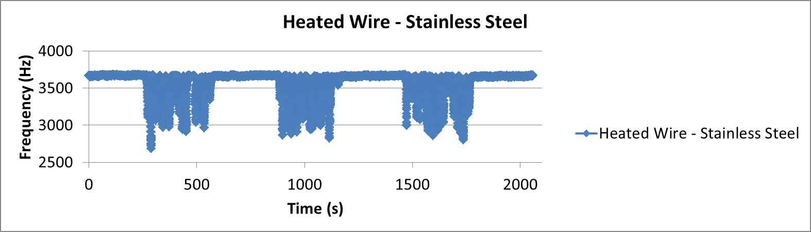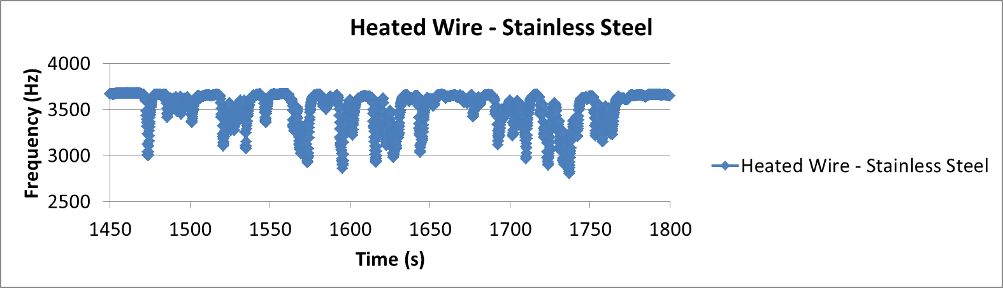
FIG. 15a displays the frequency versus time plot of stainless steel wire. Test was see how the LA-VWM responds to heat provided by a tungsten wire heated by running an alternating current through the wire. The heated wire was turned off and on in 5 minute increments. FIG. 15b displays a portion of FIG. 15a to show the oscillation effects of the heated wire.
a)
b)

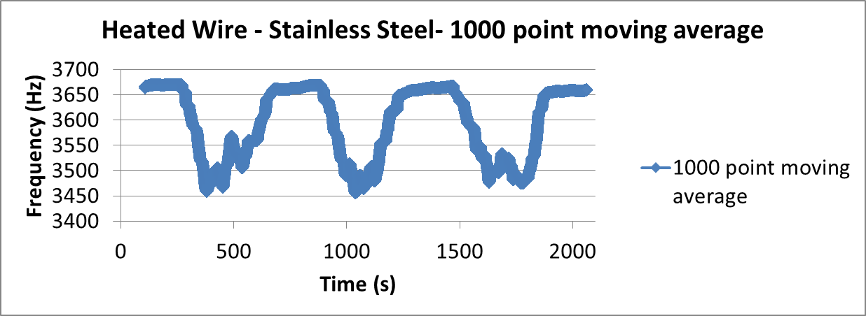
FIG. 16 is a 1000 point moving average of FIG. 15. This is to eliminate the noise seen in FIG. 15.
As mentioned above, in the previous test the heat gun was not an ideal method for heating the target wire because the heat gun provided a wind current to the target wire. To resolve this issue, a test was preformed using a heated wire. The results of this test are seen in Figures 15 and 16.
The heated wire was heated by running an alternating current through the wire. This would cause the wire to achieve temperatures above 200 degrees Fahrenheit. As seen in Figure 15 the use of the heated wire caused noise concerns. The current flowing through the heated wire caused coupling with the LA-VWM. This resulted in the alternating current causing a small capacitance which interfered with the LA-VWM phase-lock loop circuit, which is used for counting the frequency. This caused the large downward spikes in the data.
To eliminate these issues, the LA-VWM was isolated from the laser board table by placing plastic spacers between the laser board and the LA-VWM. This failed at eliminating the coupling effect. The alternating current used to heat the wire was then exchanged for a direct current. This still caused the downward spikes in the data.
Figure 16 displays what was expected to see by the LA-VWM when it was heated by the heated wire. The figure is a moving average of the data from Figure 15; this removes the noise and smooths the data to allow further analysis of the data.

2mW HeNe Laser

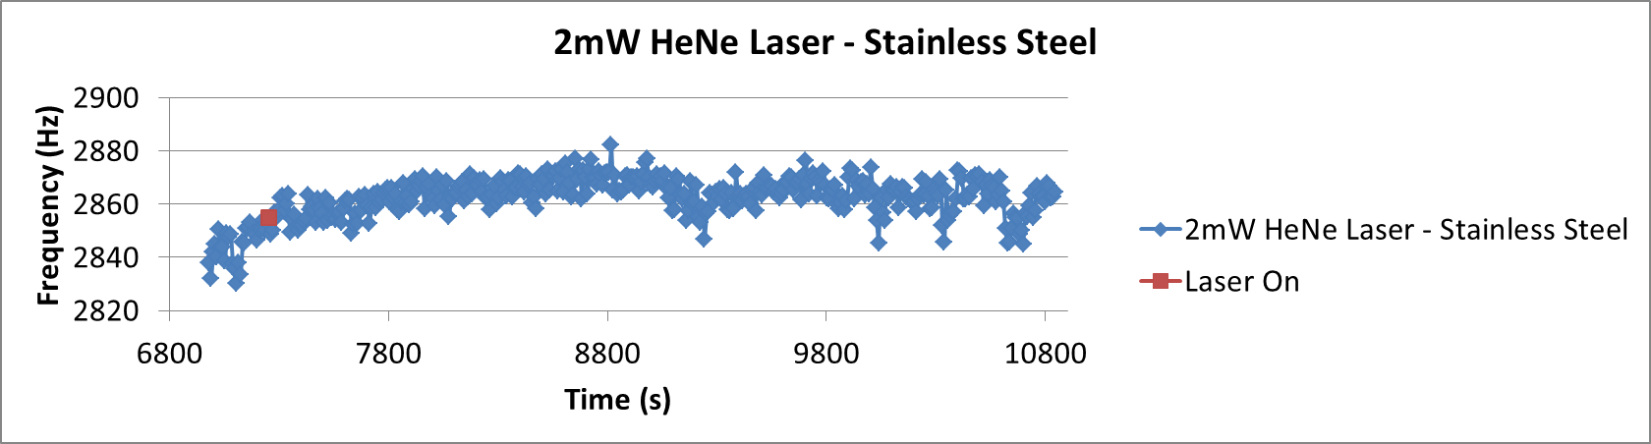
FIG. 17 displays the frequency versus time plot of stainless steel wire. Test to discover how the LA-VWM responds to a 2mW HeNe laser. The red dot is 5 minutes into the test when the LA-VWM was place in the center of the laser. The LA-VWM ran for 1 hour after the laser was tuned on.
The test performed in Figure 17 was to investigate how the LA-VWM responded to a laser. A 2mW HeNe laser was placed in the center of the target wire to see how the device responds to heat provided by another source other than the heat gun and heated wire. The problem with the laser was either the laser did not have enough power to cause a change in frequency or it was not strong enough to overcome the change in the ambient temperature. Future tests must be done with a higher powered laser to get a better characterization of the LA-VWM’s response to heat changes and to find a way to calibrate the LA-VWM system.

Thermal Equations

Change in frequency per change in temperature equation is essential because the data provided by the LA-VWM is only in terms of frequency. In order to get a change in temperature, which could then be used to estimate the particles hitting the target wire, this relates to the change in frequency of the vibrating wire. The vibrating wire frequency change on the target wire temperature change as:
(1)
TABLE I. Response time for different target wire materials.
Material | τ[sec] | ρ[g/cm3] | c[J/(g∗K)] | Λ[W=cm∗K]
Gold | 3.67 | 19.3 | 0.129 | 3.18
Silver | 2.72 | 10.5 | 0.237 | 4.29
Platinum | 18.65 | 21.45 | 0.133 | 0.716
Tungsten | 6.95 | 19.3 | 0.133 | 1.73
Invar | 145.50 | 8 | 0.505 | 0.13
Stainless  Steel | 114.77 | 7.96 | 0.502 | 0.163
Graphen | 0.38 | 2.23 | 0.72 | 20
where is the initial frequency of the vibrating wire and ΔF = F − F₀. In the equation the variables ρ₁ and E₁ are the density and elasticity modulus of the vibrating wire material. The variable is the tensile strain, and is the length of the strained (unstrained) vibrating wire. Finally, α₂ is the thermal expansion coefficient of the target wire [5].
Another important equation for the LA-VWM is how fast the device responds to temperature changes. This is important because changes need to be done to the beam size a faster response time is desirable. The response time equation:
(2)
where ρ is the density and c is the specific heat coefficient of the target wire. l is the target wire’s length and λ is the wire material’s thermal conductivity coefficient. In Table I, the values of τ for different materials are presented (the wire length l is set to 61.2 mm for all materials.

CONCLUSION

The new model of the VWM, the LA-VWM has the potential to be used in Fermilab’s PIXE and PIP-II experiments. The large aperture of this new model allows greater ability to measure beam halos because it allows more particles to interact with the target wire. This allows for more precise measurements.
Despite the problems that occurred during testing, the LA-VWM still has the ability to measure beam halos. If an experimenter can find a way to eliminate the noise signals picked up from wind currents, magnetic fields, mechanical vibrations, and ambient temperature change, then the sensitivity of the LA-VWM will be ideal for measuring beam halos.
For the future, more tests must be done in different environments. For bench tests in air, an environment where there is a constant temperature, no wind currents, and is isolated from mechanical vibrations is needed for accurate results. Tests also must be performed in a vacuum chamber, this will help eliminate many of these noise issues and give a more precise reading from the LA-VWM.
The data presented here, were basic bench tests performed in a standard office space. This work also includes tests performed by Dr. Moses Chung and his results from tests performed at the HINS facility. These tests show that the LA-VWM could be used to measure halos in future accelerators.
ACKNOWLEDGEMENTS
I would like to acknowledge and thank all the people who help me with the project. I would like to thank Dr. Victor Scarpine, my supervisor, for helping and guiding me through the project and for teaching me more about electrical engineering and particle accelerators. Thank you to Brian Fellenz for helping me with this project. I also would like to thank Julien Bergoz of Bergoz Instruments for letting me test their device and providing me with more information about the LA-VWM. I also acknowledge Dr. Moses Chung, who previously worked with the LA-VWM and was a huge help in understanding its functionality. Lastly, I would like to thank the SIST committee for allowing me the opportunity to be a part of this internship.

REFRENCES
[1] Wangler, T. P., and K. R. Crandall. "Beam Halo in Proton Linac Beams." <i>XX International Linac Conference</i> (n.d.): 341-45. Web.
[2] K. Wittenburg, Proceedings of the 39th ICFA Advanced Beam Dynamics Workshop, High Intensity High Brightness Hadron Beams, HB’2006, Tsukuba, Japan, 2006 (KEK, Tsukuba, Japan, 2006), p. 54.
[3] J. Egberts and C. P. Welsch, JINST 5, P04010 (2010).
[4] Arutunian, S. G., N. M. Dobrovolski, M. R. Mailian, and I. E. Vasiniuk. "Vibrating Wire Scanner: First Experimental Results on the Injector Beam of the Yerevan Synchrotoron." <i>Physical Review Special Topics - Accelerators and Beams</i> 6.042801 (2003): n. pag. Web.
[5] Arutunian, S. G., A. E. Avetisyan, M. M. Davtyan, G. S. Harutyunyan, I. E. Vasiniuk, M. Chung, and V. Scarpine. "Large Aperture Vibrating Wire Monitor with Two Mechanically Coupled Wires for Beam Halo Measurements." <i>Physical Review Special Topics - Accelerators and Beams</i> 17.032802 (2014): n. pag. Web.

