Synchronization of the Pixel and Strip Telescopes at the Fermilab Test Beam Facility
David Gonzalez-Dysinger
Harvard University
FNAL SIST Intern

Abstract: A tracker telescope consisting of silicon pixel and strip detectors is in place at the Fermilab Test Beam Facility in order to test new detectors for the High Luminosity and Phase II upgrades of the CMS experiment at CERN. The pixel telescope is to be removed, leaving only the strip telescope, which has a larger coverage area and better resolution. The goal of my project was to improve the merger code to allow the two telescopes to reconstruct the same particle tracks. Analyzing four test beam runs conducted using both the pixel and strip telescopes, I noticed that some trigger numbers were out of order with respect to the Beam Crossing Number (BCO), which is used to correlate in time hits from different detectors. I managed to improve the efficiency computed using only strip telescope by adapting an algorithm used by collaborator Matthew Jones to calculate the Event BCO. However, the efficiencies computed using just the strip telescope are still lower than those computed using just the pixel telescope. A detailed analysis of the inefficient events points to synchronization problems between the different Data Acquisition (DAQ) firmware for strip and pixel detectors as the cause of the remaining inefficiency. Future study of the inefficient events is needed to develop improvements to the existing firmware.

Introduction:
The High Luminosity LHC (HL-LHC) will greatly increase the luminosity in order to potentially observe rare events that may point to new physics.⁵ In order to handle the increase in luminosity, new detectors must be designed and tested. Essential to testing detector prototypes is understanding their behavior when exposed to high levels of radiation. In particular, long-term exposure to radiation can decrease the efficiency of silicon detectors. The T-992 collaboration’s mission is to test silicon pixel detector prototypes for the endcaps of the pixel tracker layer of the CMS experiment for the Phase II upgrade.
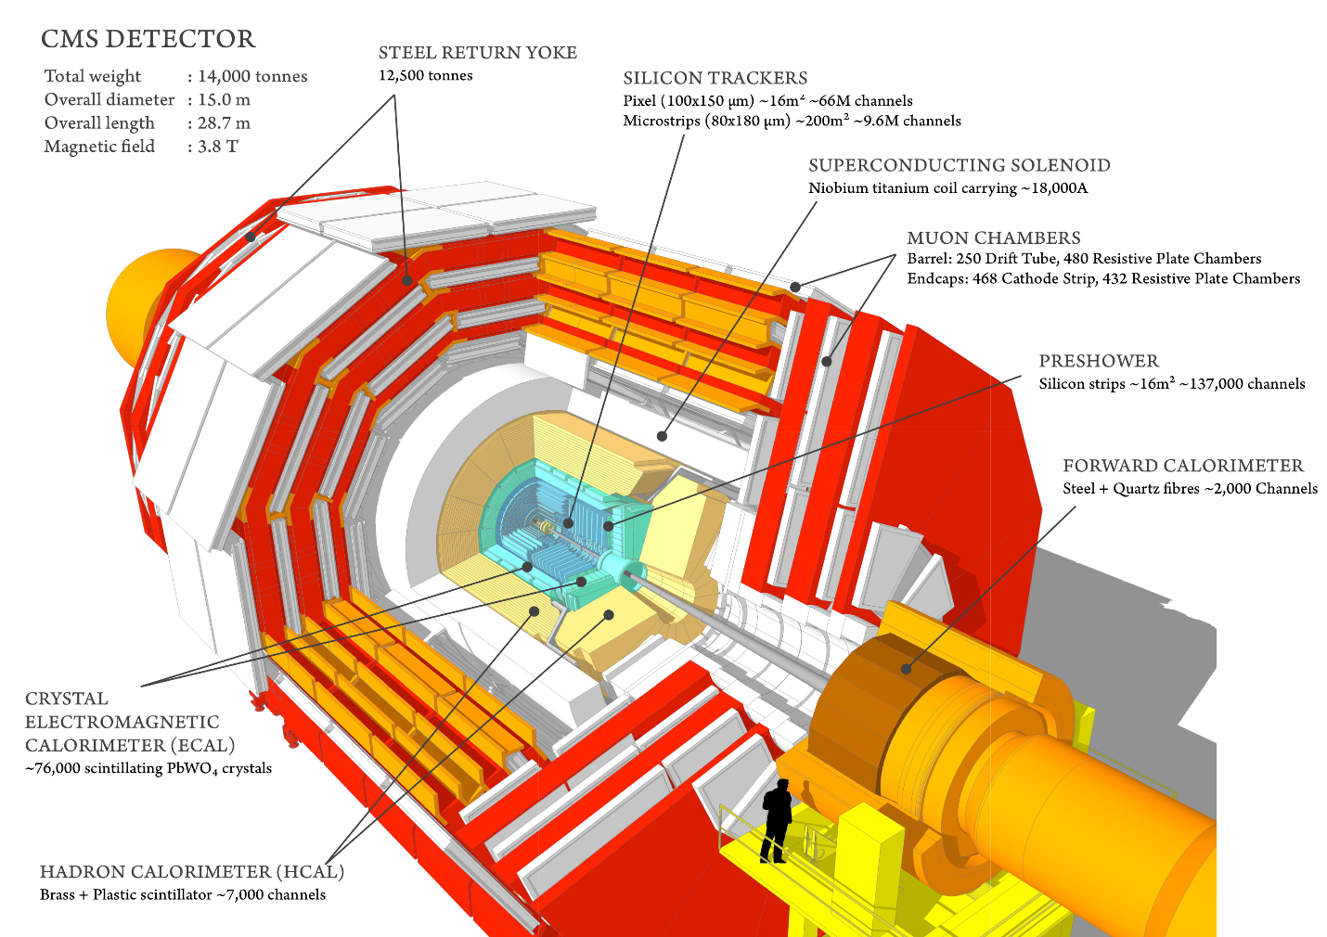
Figure 1. The CMS experiment at CERN.
The Compact Muon Solenoid (CMS) is an experiment at CERN that analyzes the particles and phenomena produced by collisions in the LHC.³ In 2012, CMS (along with fellow CERN experiment ATLAS) announced the discovery of the Higgs Boson.⁶ CMS consists of several cylindrical layers of detectors around a large solenoid magnet. The innermost layer is the silicon tracker, which is used to reconstruct the tracks of charged particles produced by collisions.³
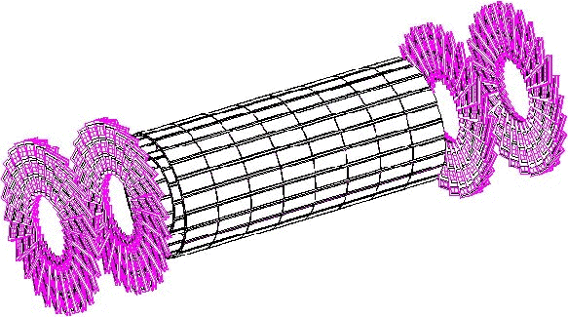
Figure 2. The CMS pixel detector.
The silicon tracker is divided into two sub-layers: an outer one made up of strip detectors and an inner one made up of pixel detectors. Each sub-layer consists of a barrel and several endcaps.
The Fermilab Test Beam Facility (FTBF) is a high energy beam facility used for detector tests. The T-992 collaboration uses the MTest beamline, which sends 120 GeV protons at a frequency between 1 and 300 kHz. The accelerator clock is set to 54 MHz, and protons arrive in four second spills every minute. Two to four times a year, the T-992 collaboration gets beam time to test detector prototypes brought in by users. These tests are conducted using the silicon pixel and strip telescopes show in Figure 3.
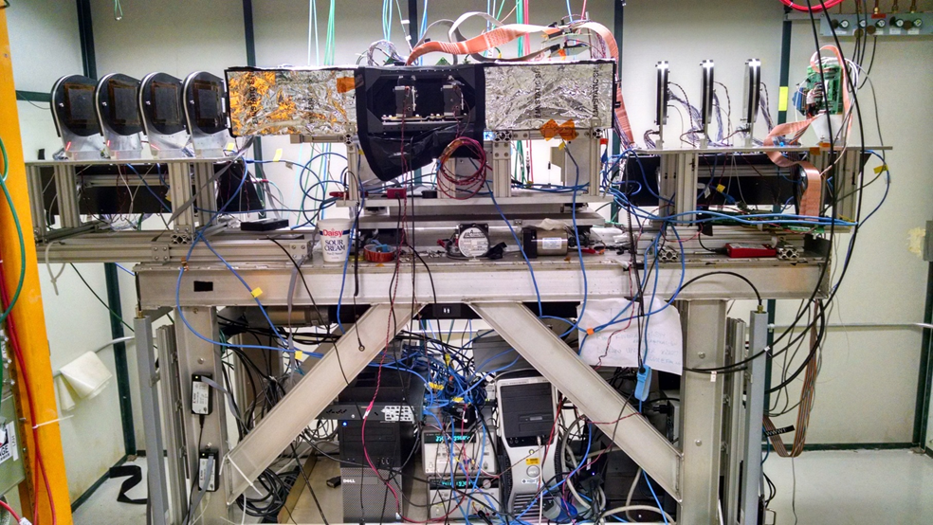
Figure 3. Pixel and Strip silicon telescopes at the FTBF.
A tracker telescope is a collection of detector planes that measures the trajectory of charged particles. The DUTs (devices under testing) are placed in the center of the telescope. Particle tracks are reconstructed using hits on the telescope planes. The T-992 collaboration uses two silicon tracking telescopes: one made of pixel detectors and one made of strip detectors. The pixel telescope is divided into 2 stations (one upstream and one downstream) of four planes each, and the strip telescope is divided into 3 stations (two upstream made up of four planes and one downstream made up of six planes).
The pixel telescope consists of silicon pixel detectors made with PSI46 read out chips (ROCs).² Each ROC is made up of 80 x 52 pixel cells with dimensions of 100 x 150 μm² each. Four of the pixel planes have a 2 x 3 grid of ROCs while the other four have a 2 x 4 grid of ROCs; there are two planes of each size in each station. Due to the way the planes are oriented, the pixel telescope has a coverage area of ~2x2 cm².
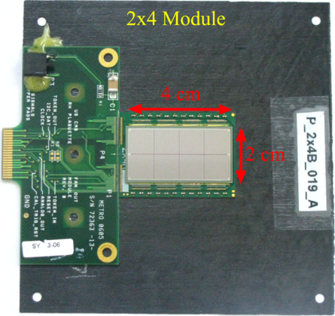
Figure 4. A silicon pixel detector.
A pixel detector is a grid of pixel cells which readout a hit and an ADC value when the charge released inside exceeds a certain threshold. A hit in a single pixel is readout as being located in the center of the cell. However, if a particle passes through multiple pixel cells, it may release sufficient charge to register a hit in each cell. Then the ADC value in each cell can be used to accurately measure the coordinates of the hit. In order to maximize the number of hits in multiple cells, the pixel planes are tilted at 25°. The 3D arrangement is shown below.
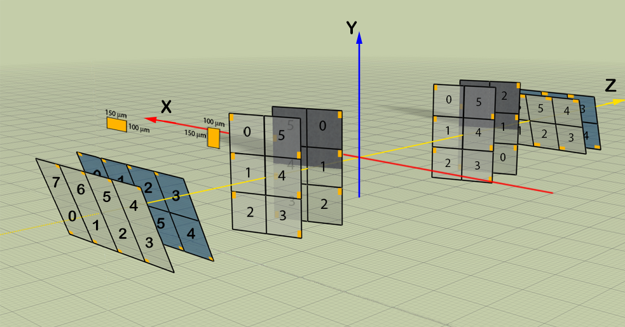
Figure 5. The orientation of the pixel planes.
The strip telescope consists of silicon microstrip detectors made with FSSR2 ROCs.² Each detector has 639 strips that are 60 μm wide and 9 cm long. Strips only measure with precision the position of a hit along one coordinate axis, so pairs of strips are placed orthogonal to each other to measure both coordinates. This offers a coverage area of ~4x4 cm². The planes of the strip telescope are also tilted (15° along the y-axis) to ensure more multi-cell hits and thus better position measurement.
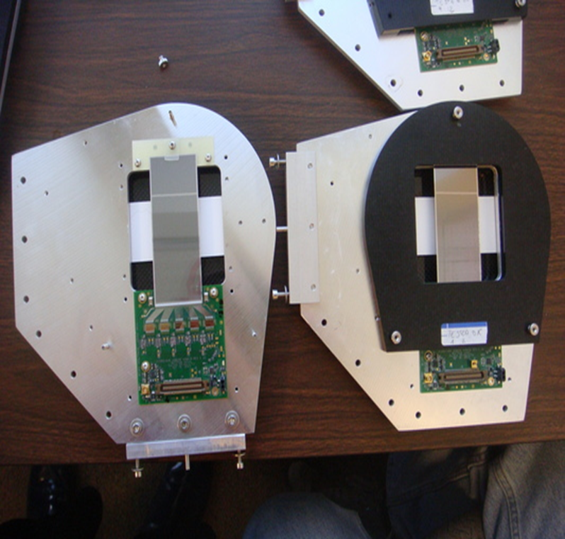
Figure 6. A silicon strip detector.
Each station in the telescope is attached to an octagonal DAQ board, called CAPTAN, with a programmable integrated circuit, an FPGA, placed in the middle. The FPGA runs firmware that handles various processes related to data acquisition.
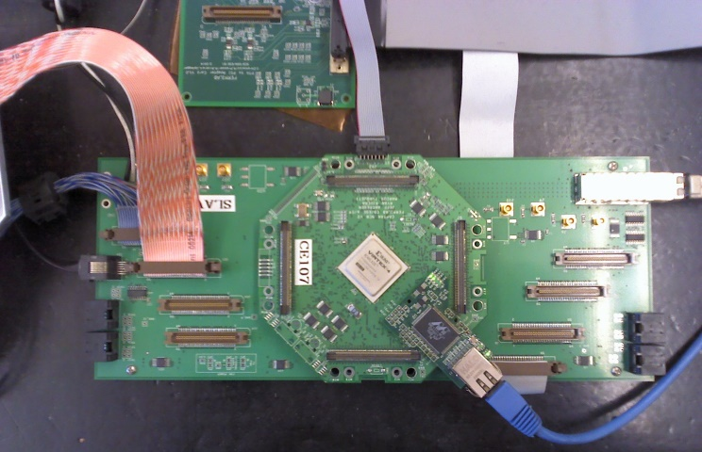
Figure 7. A CAPTAN DAQ board.
Data is read-out from the telescopes using the following procedure. When beam passes through a pixel plane, it sends hit data to its station's CAPTAN, which waits until it receives a trigger signal to label the data with a trigger number. When beam passes through a strip plane, the FSSR timestamps hit data with an 8-bit counter called the Beam Crossing Number (BCO) running at ¼ of the accelerator frequency. After passing through the telescope, the beam goes through the scintillator, generating a trigger signal, which goes to the master CAPTAN, where the trigger number is incremented. The signal is then redistributed to the strip CAPTANs, where it is time stamped with a BCO and counted, and to the pixel CAPTANs where it is simply counted. Data is then sent from the CAPTANs to the testbeam computers over Ethernet cables.
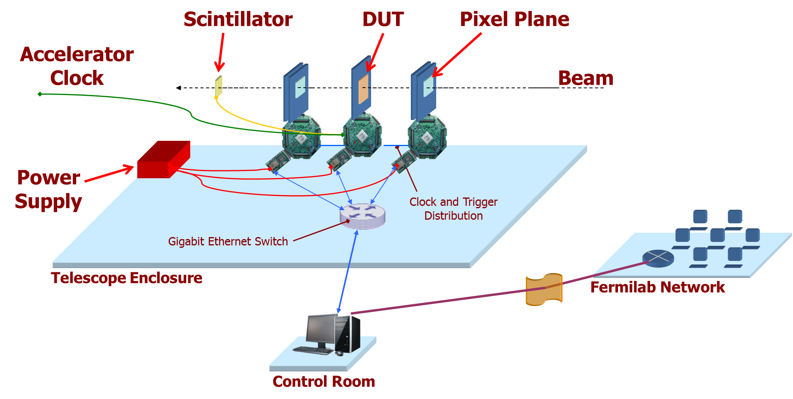
Figure 8. The layout of the DAQ system.
Data from pixel and strip planes are formatted differently, so we use the Merger program to combine them and reconstruct full events. The FSSR 8-bit hit BCO is combined with a 48-bit BCO (the Long BCO) sent out by the CAPTAN to generate what we call the Event BCO. An event is a set of plane hits associated with a particular trigger number.
The trigger is also timestamped in the strip CAPTANs with 8 bits of the BCO and then associated in the Merger to the appropriate Event BCO. Pixel and strip events are then connected to each other by their trigger numbers.
We then reconstruct the tracks of charged particles using a software called Monicelli. Monicelli is a software package written in C++ and developed by the INFN group at the University of Milano-Bicocca in Italy.³ It allows users to precisely align the telescope and save alignments as geometry files, as well as reconstructing tracks by looking at the hits on the telescope planes and then fitting a track between the points.
Further analysis is conducted in Chewie, a software package designed by the T-992 collaboration. Taking the output file from Monicelli, Chewie then calculates the efficiency of the DUTs and creates histograms of various measurements, including efficiency, charge distribution and resolution. DUT efficiencies are calculated as follows:
ε = recorded hits on plane efficiency normalization
Chewie projects a track onto the DUT, and if it passes certain cuts, we add one to the efficiency normalization. If there is an actual hit on the DUT at that point, we add one to the recorded hits on plane.

Objectives
The goal of my project was to improve the merger code so that the efficiencies computed using just the strip telescope would match those computed using just the pixel telescope. This is important to achieve because the collaboration is aiming to remove the pixel telescope, leaving just the strip telescope with its larger coverage area and better resolution. The pixel telescope is made of the same ROCs as the DUTs, which are both triggered systems. The strip telescope is not triggered. Given the different nature of the FSSR ROCs, we are having trouble reconstructing events with the strip telescope and associate them with the correct pixel event. Although we reached efficiencies above 99%, we still needed to investigate why we had a different efficiencies of approximately 0.4% between pixel and strip telescopes.

Methods
I focused my analysis on four runs (with run numbers from 1068 to 1071) our collaboration took at FTBF using both the pixel and strip telescopes. The DUTs being tested during those runs included an FMM and an SP (slim pitch) detector, both of which have read-out mechanisms that still need to be better understood. Thus I focused on events inefficient for DUT 0 whose read-out type is well understood.
In order to figure out how to improve the computed DUT efficiencies, I first had to analyze the inefficient events. I ran the Merger program so that only hit data from the strip planes and DUTs would be used. Then I reconstructed tracks in Monicelli and exported the file to Chewie. I changed the Chewie code to print out the trigger number and plane ID number of events inefficient for DUT 0, and wrote those events to a txt file. I then wrote code to parse the txt file and print the inefficient events and all the hits associated with them (including BCOs, rows and columns, and trigger numbers), as well as all the events that were +/- 5 BCO from the inefficient events.

Results
Analyzing four test beam runs using both pixel and strip telescopes, I noticed that some trigger numbers were out of order with respect to the BCO. This pointed to issues with the 8-bit BCO wrapping around, in fact the BCO that hit data is time-stamped with is only 8-bits long and resets every 256 clock cycles. If not treated correctly in the code, this can result in hit data being associated with the wrong trigger number. As a result, some events will be missing hits on the DUTs and thus will be considered inefficient.
The old merger code handled this by adding 256 to the Event BCO if the hit BCO was greater than low 8 bits of the Long BCO, and doing the same for the trigger BCO. I managed to improve the DUT efficiency computed using only the strip telescope by adapting an algorithm used by collaborator Matthew Jones to calculate the Event BCO.
Jones's algorithm creates three candidate BCOs: one equal to the Event BCO, one equal to the Event BCO + 256, and one equal to the Event BCO – 256. The differences between the candidate BCOs and the current Long BCO is then calculated, and whichever candidate has the smallest difference becomes the new event BCO. This is done with the Event BCOs of both the hit and the trigger.
Implementing this algorithm increased the computed DUT efficiencies. This because it catches events that need 256 added to their Event BCO.

Run Number | DUT Efficiency for pixel telescope | DUT Efficiency for strip telescope with old merger code | DUT Efficiency for strip telescope with revised merger code
1068 | 99.8% | 96.8% | 99.4%
1069 | 99.7% | 97.4% | 99.5%
1070 | 99.7% | 97.3% | 99.4%
1071 | 99.7% | 96.6% | 99.5%
Table 1. The efficiencies computed with the merger code before and after it was improved.
However, the efficiencies computed using just the strip telescope are still lower than those computed using just the pixel telescope. Using Run 1068 as a test case, I analyzed patterns in the remaining inefficient events and I classified them as belonging to one of five most common inefficient event types. All these events have hits on all the strip planes because the list of inefficient events was produced when running Chewie on only strip events with a minimum hit cut of 14 (all strip telescope planes). There are 381 total events inefficient for DUT 0.
Events with hits on all telescope planes: These events will be inefficient for both the strip and pixel telescopes, so it is unlikely that these inefficiencies can be prevented. There are 98 of these events.
Events with hits on only the strip planes: These events are likely caused by out-of-time particles. Particles in the beam typically come at the beginning of the beam clock cycle, but occasionally a particle arrives out-of-time with the beam clock. Since the clock for the strip telescope has half the frequency of the clock for the pixel telescope, there may be occurrences of an out-of-time particle that is missed by the pixels (including the DUT) but seen by the strips.

Figure 9. Out-of-time particle clocks.
In order to investigate this phenomenon, I have been looking at a fast clock encoded in the trigger primitives (data words that show where particles arrive during a clock cycle) to see when the particles arrive with respect to the BCO. However, the histograms below (which show when during each clock cycle particles pass through the first upstream strip station) do not show what we would expect, which is bins on either the even or odd numbers (particles arriving when the pixel clock is down). More analysis is required to understand how to interpret the trigger primitive histograms. There are 20 of these events.

Events with hits on only one pixel station: These events have hits on a full pixel station, but no hits on the other pixel station. This likely results from a slight difference in the synchronization of the clocks in the CAPTANs of the two stations. There are 5 of these events.
Events with badly decoded hits: These events have hits on the DUTs, but the positions of those hits are off the detector: the row and/or column are too large. This inefficiency results from problems with the CAPTAN firmware that decodes hit data. There are 119 of these events.
Events with hits on various planes: These are the events that don’t fall in any of the other categories. More analysis of these events must be conducted, as it is uncertain what causes them. There are 139 of these events.

Conclusion
A detailed analysis of the inefficient events point to synchronization problems between the different firmware for strip and pixel detectors. More study of the inefficient events should be conducted to figure out exactly how the firmware needs to be updated. In particular, the fast clock in the trigger primitive needs to be studied further so it can be used to identify whether out-of-time particles are a significant contribution to the inefficiency or not.
Acknowledgements
Thanks to my supervisor Lorenzo Uplegger for all his help and mentorship. I would also like to thank the rest of the research team, including Ryan Rivera, Ivette Bermudez Macias, Daniel Parilla, Ethan Lewis, and Jalen Crump, as well as our collaborators across the globe, in particular Matthew Jones, Steve Wagner, and Fabio Ravera. Finally, many thanks to the SIST program and its administrators for giving me the opportunity to do research at Fermilab.

References
1: S. Kwan, C. Lei, D. Menasce, L. Moroni, J. Ngadiuba, A. Prosser, R. Rivera, S. Terzo, M. Turqueti, and L. Uplegger, “The CMS pixel tracking telescope at the Fermilab Test Beam Facility,” (2013).
2: K. Stifter, “Updated track fitting and alignment method for the silicon tracking telescope at the Fermilab Test Beam Facility,” (2014).
3: L. Vigani, “New Pixel Detectors for Next Generation Colliders,” (2013).
M. Jones, L. Uplegger, “Tracking at the Fermilab Test Beam Facility,” (2015).
4: R. Rivera, M. Turqueti, L. Uplegger, A. Prosser, S. Kwan, “Results from a Telescope of CMS PSI46 Pixels and the CAPTAN Data Acquisition System,”
5: K. Kahle and L. Rossi, “Designs on higher luminosity,” CERN Courier (2012).
6: S. Chatrchyan et al., “Observation of a new boson at a mass of 125 GeV with the CMS experiment at the LHC,” Physics Letters B (2012).

