Channeling Radiation Experiment: Calibration of X-ray Detector and Measurement of Emittance of Electron Beam
K. G. Capobianco-Hogan
Introduction
Current x-ray production methods utilize large synchrotron sources, which are costly to maintain and operate and require substantial amounts of space. An electron beam from a LINAC as short as five meters in length can potentially be used to produce x-ray beams with spectral brilliance that would be useful for several applications, thus decreasing cost and size of the systems making them more readily available.
The purpose of this experiment is to demonstrate the x-ray production capabilities of channeling radiation in a diamond crystal lattice in ranges used in x-ray spectroscopy and other applications. There are several matters that must be attended to in preparation for the channeling radiation experiment at FAST Facility. Among them are the calibration of the x-ray detector that will be used in the channeling experiment and the measurement of the emittance of the electron beam.
The electron beam is emitted by a photocathode as a result of incident photons produced by a laser. The beam then passed through two superconducting accelerating cavities, which increase the beam energy to 50 MeV. After the accelerating cavities, a three quadrupole FODO is used to focus the beam. This is followed by a chicane to reduce bunch length and after the chicane another three quadrupole FODO array is again used to focus the beam to minimize its transverse cross section when it reaches the goniometer. The goniometer holds the diamond crystal to allow for alignment of the crystal lattice with respect to the electron beam. (See Figure 1)
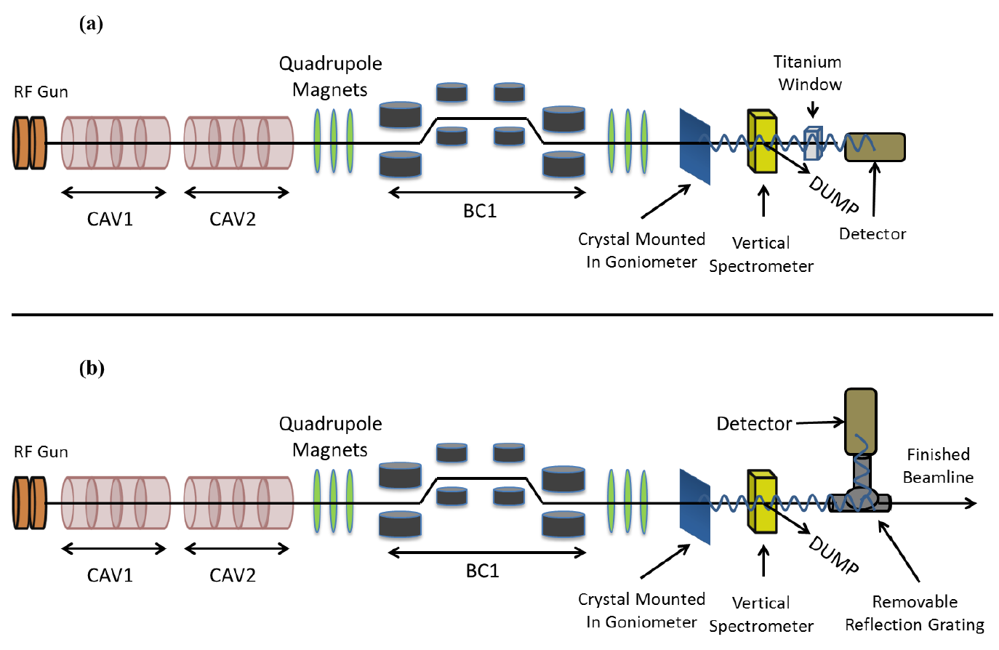
Figure 1: FAST beamline (1).
The x-ray detector is an Amptek X-123 CdTe x-ray spectrometer. The responses of the X-123 must be characterized for calibration and to determine its optimal configuration for the channeling experiment. The emittance measurement utilizes a quadrupole scan (quadscan) method, which requires that the standard deviation of the beam spot on a YAG screen be determined for various quadrupole magnet currents. The calculation of the standard deviation has proven more problematic than expected because of the presence of significant dark current background and required special analysis techniques. Following calculation of the standard deviations, the emittance will be computed using Elegant.
Amptek X-123 X-Ray Detector
The radioactive isotopes cobalt-57 and americium-241 have been used for calibration measurements to test various settings of the spectrometer so that operation can be optimized for the channeling experiment. Readings were taken with the X-123 in various configurations for optimization of peaking time, slow threshold, and fast threshold.
The X-123 uses an Amptek DP5 digital pulse processor to measure the energy of x-rays absorbed by a CdTe diode. The absorption of an x-ray by the CdTe diode results in the production of electron-hole pairs in the diode, where the number of electron-hole pairs is proportional to the energy of the incident x-ray. The electron-hole pairs create a pulse of current that is shaped by preamplifiers and shaping amplifiers before reaching the DP5. The DP5 then analyzes the pulse using its fast and slow channels. The slow channel is used to measure the height of the pulse while the fast channel is used to identify when multiple x-rays are incident in a shorter timeframe than the slow channel can resolve, which is called pile-up. The peaking time is the period the slow channel takes to perform a measurement of an x-ray’s energy.
Both the fast and slow channel thresholds are used to reject events of low magnitude, i.e. noise. If they are set too high, then valid signal may be rejected. If they are set too low, then noise signals will contaminate the spectrum. The fast channel threshold is also used in pile-up rejection to identify when multiple x-rays are incident within the temporal resolution of the slow channel and in determining the actual count rate (as opposed to the skewed count rate that would be obtained from the histogram produced using the low channel, which is lower than the actual count rate because of x-rays missed during the system’s deadtime).
Optimization of peaking time (TPEA), slow threshold (THSL), and fast threshold (THFA) was based on several factors. Firstly, the full width at half maximum (FWHM) of peaks in the spectrum is related to the resolution of the spectrometer. The smaller the FWHM, the more precisely the x-rays’ energies were measured by the slow channel. The precision of these measurements is positively correlated with the peaking time (see Figures 2 and 3)
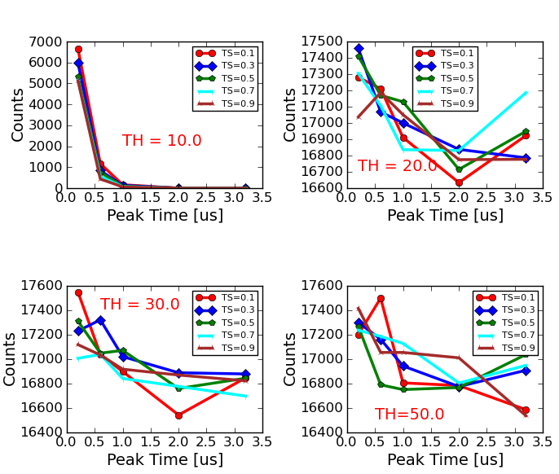
Figure 2: Counts recorder for one-hour measurement at different settings of X-123 (plot created by Daniel Mihalce) (Note: in this figure, slow threshold is denoted TS and fast threshold is denoted TH).
Figure 3: FWHM of 122 keV peak for different settings of X-123.
Secondly, the number of counts recorded by the detector must be maintained sufficiently high to allow for reliable measurements. The number of counts detected decreases with peaking time, but how rapidly it decreases is dependent on the other parameters, primarily the fast threshold.
The lowest five settings for peaking time (0.2 µs, 0.6 µs, 1.0 µs, 2.0 µs, and 3.0 µs), slow threshold (0.1, 0.3, 0.5, 0.7, 0.9), and fast threshold (10.0, 20.0, 30.0, 40.0, and 50.0) were investigated with a gain of 8.0 for one-hour long measurements of a Co-57 sample. It was found that the lowest setting of the fast threshold resulted in almost all counts being rejected, and so it is no longer under consideration. Readings taken so far do not show any significant correlation between slow threshold and count rate or FWHM, so further analysis will be needed for this parameter. Similarly, the fast threshold does not show much in the way of significant correlations with count rate or FWHM when its lowest setting is excluded from the analysis.
When analyzing the spectra produced by Co-57 measured with the X-123, it was found that the 14.4 keV peak was fairly Gaussian in nature while the 122 keV peak was asymmetric, possessing a tail on the lower energy side. The FWHM was used to characterize the resolution of the X-123 at the energies of the spectral peaks. Determining the FWHM was simple enough for the 14.4 keV peak, simply fit with a Gaussian and multiply the Gaussian’s standard deviation by $2\sqrt{2\ln{2}}$. Determining the FWHM for the 122 keV peak was more challenging given the asymmetry.
Initial attempts at fitting the 122 keV peak focused on a “double” Gaussian fit function in which different $σ$’s were used on either side of the peak, i.e.
$$f\left(x\right)=\left\{\begin{aligned}h\exp\left[-\frac{1}{2}{\left(\frac{x-μ}{σ_{1}}\right)}^{2}\right], &x<μ, \\ h\exp\left[-\frac{1}{2}{\left(\frac{x-μ}{σ_{2}}\right)}^{2}\right], &x≥μ,\end{aligned}\right.$$ | (Eqn. 1)
where $μ$ is the peak energy and $h$ is the height of the double Gaussian. Similar attempts were made with a double Lorentzian fit function. Based on a description of the 122 keV peak Co-57 found in Amptek’s documentation for the X-123, which described the peak as the combination of a Gaussian peak, an exponential tail, and a step function, fitting was attempted using such the following equation
$$f\left(x\right)=\left\{\begin{aligned}h_{G}\exp\left[-\frac{1}{2}{\left(\frac{x-μ}{σ_{G}}\right)}^{2}\right]+h_{S}+h_{T}\exp\left[-\frac{x-μ}{σ_{T}}\right], &x<μ, \\ \left(h_{G}+h_{S}+h_{T}\right)\exp\left[-\frac{1}{2}{\left(\frac{x-μ}{σ_{1}}\right)}^{2}\right], &x≥μ.\end{aligned}\right.$$ | (Eqn. 2)
where $h_{i}$ and $σ_{i}$ are restricted to positive values. It was found that this function better fit the data fairly well over sufficiently long ranges as to be viable for analysis. It should be noted, however, that while coefficients of variation were in excess of 0.9 for almost all spectra analyzed, the reduced chi square values for most fits were between 2 and 8. (See Figures 4 and 5)
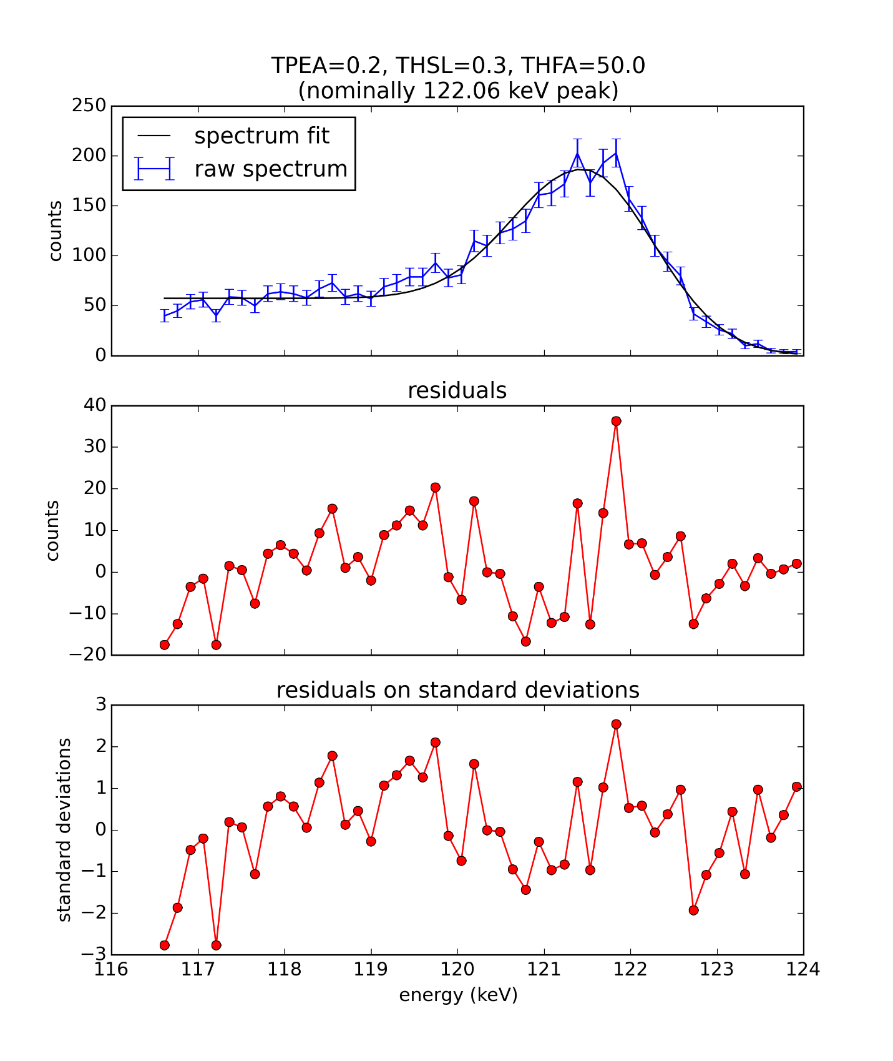
Figure 4: Fit curve (Eq. 2) for 122 keV peak.
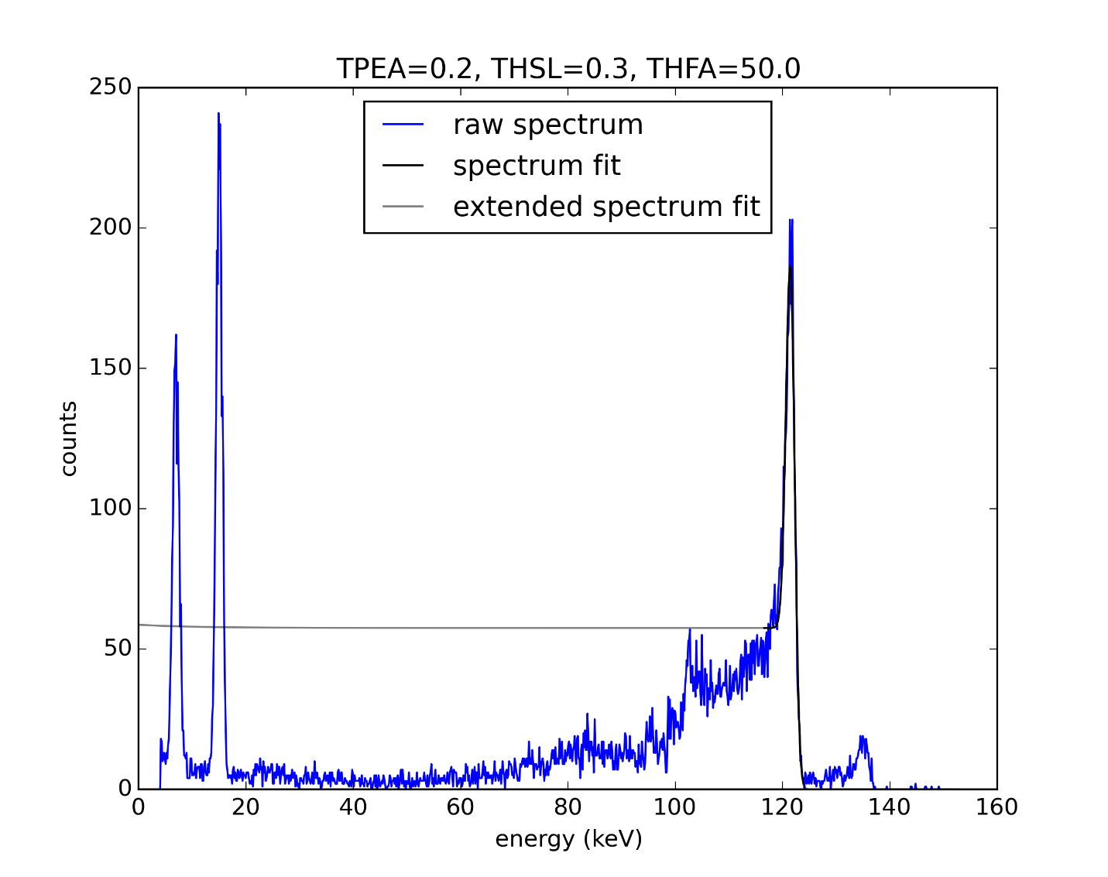
Figure 5: Co-57 spectrum as measured with X-123, with fit curve for 122 keV peak shown in black over fitted region and in gray outside fitted region.
After subsequent research in relevant literature, it appears that the function Amptek was referring to was one in which the Gaussian function is convolved with an exponential tail and a step function as described in (2),
$$f\left(x\right)=G\left(x\right)+S\left(x\right)+T\left(x\right)$$ | (Eqn. 3)
$$G\left(x\right)=h_{G}\exp\left[-{\left(\frac{x-μ}{σ_{G}}\right)}^{2}\right]$$ | (Eqn. 4)
$$S\left(x\right)=\frac{h_{S}}{2}\operatorname{erfc}\left[\frac{x-μ}{σ_{G}\sqrt{2}}\right]$$ | (Eqn. 5)
$$T\left(x\right)=\frac{h_{T}}{2}\exp\left[\frac{x-μ}{σ_{T}}\right]\operatorname{erfc}\left[\frac{x-μ}{σ_{G}\sqrt{2}}+\frac{σ_{G}}{σ_{T}\sqrt{2}}\right]$$ | (Eqn. 6)
$$\operatorname{erfc}\left(x\right)=1-\operatorname{erf}\left(x\right)=1-\frac{2}{\sqrt{π}}\int_{0}^{x}{\exp\left(-t^{2}\right)dt}$$ | (Eqn. 7)
It appears to be commonly referred to as a modified Gaussian or as the “Hypermet” function (as in (2)).
Further analysis will investigate the use of tail and shelf functions convolved with a Gaussian or Voigt function in order to more accurately describe the shape of the 122 keV peak. Preliminary results of such fits have yielded reduced chi square values on the order of 20.
Poor reduced chi square values for fits using both the Eqns. 2 and 3 may be indicative of uncertainties well in excess of the statistical uncertainty intrinsic to counting (which is the square root of the count). Repeating the measurements with the addition of collimators may improve the quality of the data (3) and is recommended for future measurements to ascertain if this does in fact improve data quality.
For x-rays with some energy $E_{i}$, some fraction of those incident on the detector’s CdTe diode will be absorbed and the remainder will be transmitted and go undetected. The fraction absorbed is given by $\left(1-e^{-μ_{i}t}\right)$ where $μ_{i}$ is the absorption coefficient for energy $E_{i}$ in CdTe and $t$ is the thickness of the diode.
A radioactive cobalt-57 sample was used for part of the detector calibration. Two of its x-ray emissions, energies $E_{1}=14.4 keV$ and $E_{2}=122.1 keV$, were analyzed to determine the thickness of the detector using the equation
$$\frac{N_{1}}{N_{2}}=\frac{P_{1}\left(1-e^{-μ_{1}t}\right)}{P_{2}\left(1-e^{-μ_{2}t}\right)}$$ | (Eqn. 8)
where $N_{i}$ is number of counts detected with energy $E_{i}$ and $P_{i}$ is the probability that an x-ray with energy $E_{i}$ is emitted by the sample. Cobalt 57 was used because it possesses both a low energy peak at 14.4 keV (which is almost completely absorbed by the detector) and a high energy peak of 122 keV(which is only partially absorbed by the detector.) The difference in absorption probabilities allow for accurate calculation of the relative peak intensity and therefore of the diode thickness.
The X-123 detector’s manufacturer, AmpTek, gives the equation
$$t=\frac{\ln\left(N_{1}P_{2}-N_{2}P_{1}\right)-\left[\ln\left(N_{1}P_{2}\right)-\ln\left(N_{2}P_{1}\right)\right]}{μ_{2}-μ_{1}}$$ | (Eqn. 9)
as a solution to Eqn. 8. As a check, an analysis of Eqn. 9 was performed, in which $n=\frac{N_{1}}{N_{2}}$ was calculated using Eqn. 8 for values of $t$ around the nominal expected thickness of 1 mm and $n$ was then used to calculate approximate values of $t$ using Eqn. 9. The analysis was also performed on the approximate solution found by using a first order Taylor expansion
$$t≅\frac{2}{μ_{2}-μ_{1}}\ln\left(\frac{N_{1}P_{2}μ_{2}}{N_{2}P_{1}μ_{1}}\right).$$ | (Eqn. 10)
But the analysis found that neither Eqn. 9 nor Eqn. 10 were suitable approximations the solution to Eqn. 8 for $t\sim 1 mm$ (see Figure 6). When the same analysis was performed for ten-iteration Newton’s method approximations, it was found that the Newton’s method solutions were accurate to within ${10}^{-7}\%$ across the range of the analysis (see Figure 7).
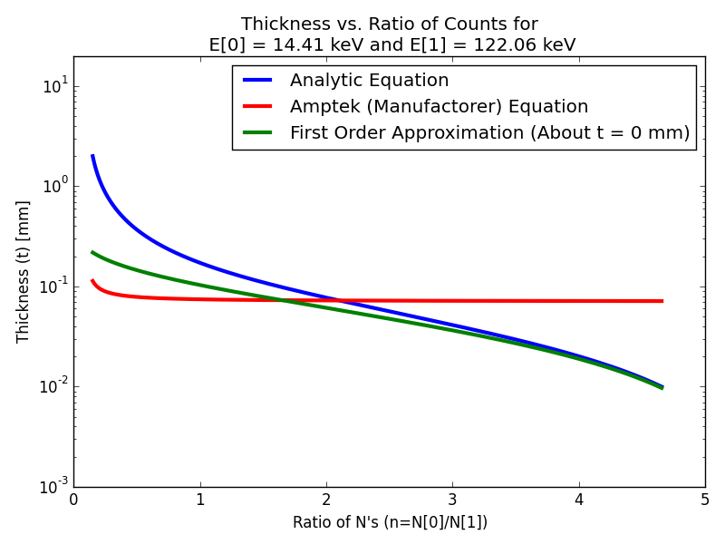
Figure 6: Relationship between thickness of CdTe diode and relative count rate for 14.41 and 122.06 keV peaks from Co-57 spectra according to analytic equation (Eqn. 8), Amptek equation (Eqn. 9), and Taylor expansion (Eqn. 10).
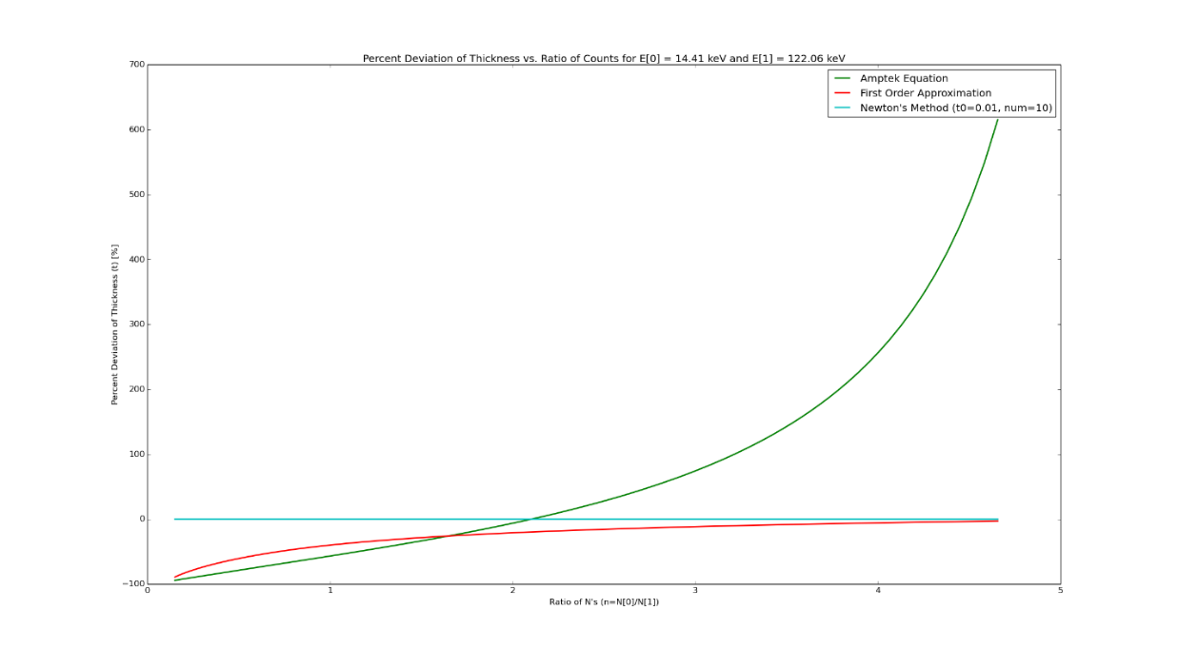
Figure 7: Percent deviation from analytic equation (Eqn. 7) for Amptek equation (green, Eqn. 9), Taylor expansion (red, Eqn. 10), and Newton's method solution (cyan).
One-hundred of the one-hundred-twenty-five spectra created to analyze the effect of different spectrometer settings on measurements were used estimate the relative count rates for the 14.41 and 122.06 keV peaks of Co-57 (spectra measured with THFA = 10.0 were excluded). The estimated relative count rates were highly variable and resulted in highly variable results for the thickness of the CdTe diode (see Figure 8).
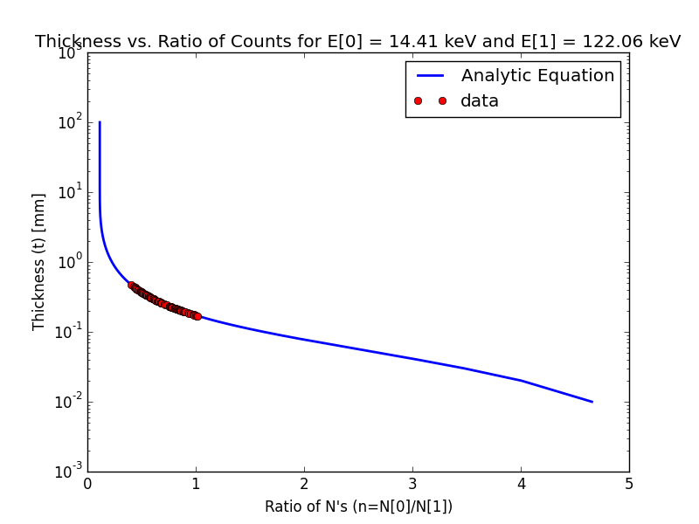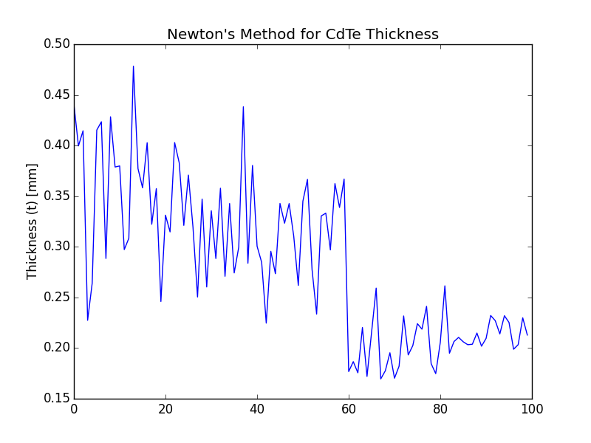
Figure 8: Newton's method results for thickness calculations for relative count rates from 100 spectra verses relative count rate (left) verses measurement number, 0 through 99, (right).
Statistical Analysis of Noise Corrupted Data
Quadscan readings were taken during the month of June, prior to the recent shutdown for the installation of the goniometer to be used during the channeling experiment and of CAV 1, the second of the two accelerating cavities to be installed at FAST, CAV 2 already having been installed. The standard deviation of the beam spot had to be determined from the profiles taken at X-121 using a CCD for different quadrupole currents so that emittance calculations that can be performed using Elegant.
The analysis of data with significant noise or background where the signal is not well described by analytical functions requires special methods. Because FAST is a linear accelerator, its beam does not tend toward a highly Gaussian transverse profile as it would in a circular accelerator. In some cases, the transverse beam profiles appear as though they might be better modeled by a piecewise linear function of four to six segments or so than by a Gaussian with some vertical offset to account for background.
A Gaussian with a vertical offset was considered a good first order estimation of the profiles statistical properties. Next, direct calculations of the mean and standard deviation from the dataset were attempted using the formulas
$$μ=\frac{\sum_{i}{x_{i}w_{i}}}{\sum_{i}{w_{i}}} and σ=\sqrt{\frac{\sum_{i}{{\left(x_{i}-μ\right)}^{2}w_{i}}}{\sum_{i}{w_{i}}}}$$ | (Eqn. 11)
respectively, but the results were clearly inconsistent with the actual structure of the profile, due to the skewing effect of background. The background is relatively constant in particular when compared to the peak (i.e. the variations in background values are much smaller than the nominal background value and even smaller compared to the height of the peak), as a result the background skews the mean of the dataset towards the center of its range.
In an attempt to account for this, the mean background level was set to zero and the direct statistical calculations were attempted again. This time they tended to return negative values for the variance. It is currently believed that this was the result of tails below the mean background at the ends of the profiles, since they are farthest positions from the mean; they have the largest contributions to the variance and are therefore able to skew the variance into the negatives.
To compensate, the minimum value of the profile was zeroed, which produced substantial improvements to the statistical calculations, but still returned values that differed significantly from initial estimates.
The method that proved most useful however was simply truncating the dataset so as to exclude regions where the background dominated. The standard deviation of the level of the profile over overlapping windows (20 data point overlap, 80 data point offset, 100 data points overall length) was taken and to a threshold value, the second consecutive window to each side of the peak to fall below the threshold value was deemed to be part of the background region, as well as any data beyond the window. The mean level of the background region was calculated and subtracted from the dataset (i.e. zeroed as before). Then by using the same direct calculations of the statistical parameters of the truncated signal region, a substantially lower standard deviation was calculated, specifically on the order of the Gaussian values.
Low pass Fourier filtering was used in an attempt to reduce the variation of background and restrict its range of values, thereby bringing the minimum background closer to the mean background, which should allow for more accurate calculation of the statistical parameters. It was found, however, that Fourier filtering requires careful analysis of the filtered profile to find an appropriate value of the filtering coefficient. The filtering resulted in highly variable results, depending on the coefficient (which was essentially the -3 dB frequency of the filter) filtering could be quite minimal or considerable, but with low fidelity (i.e. considerable flattening of the signal, which of course means an upward skewing of the variance). Because of the volatility of Fourier filtering, every one of the hundreds of profiles would have to be individually optimized were it to be implemented. Fortunately, Savitzky-Golay smoothing was found to be far more forgiving, and since its parameters are a small set of integers rather than the set of real numbers, optimization was far simpler. Savitzky-Golay smoothing also has the advantage that it can preserve up to a user specified statistical moment (the second moment was chosen to maximize smoothing while still preserving the properties under analysis, namely the first raw moment (the mean) and the second central moment (the variance)).
A simulated dataset consisting of a Gaussian signal with white noise, a gain mismatch, and a vertical offset (set to approximate values of the equivalent parameters of the actual data) was run through the program, which returned a standard deviation in agreement with the actual standard deviation of the simulated Gaussian signal to within 1.53 pixels (7.64%).
Values Calculated  After | Calculated Values |  | Deviations from  Actual Value
 | Mean  (pixels) | Standard  Deviation  (pixels) | Mean  (pixels) | Standard  Deviation  (pixels)
Actual Values | 1320.0 | 20.0 | - | -
No Modifications | 1256.1 | 685.8 | -63.9 | 665.8
Truncation | 1318.5 | 77.8 | -1.5 | 57.8
Background  Subtraction | 1319.7 | 18.2 | -0.3 | -1.8
Savitzky-Golay  Smoothing | 1319.6 | 18.5 | -0.4 | -1.5
One of the profiles is shown below at each stage of the correction process in Figures 9 and 10.
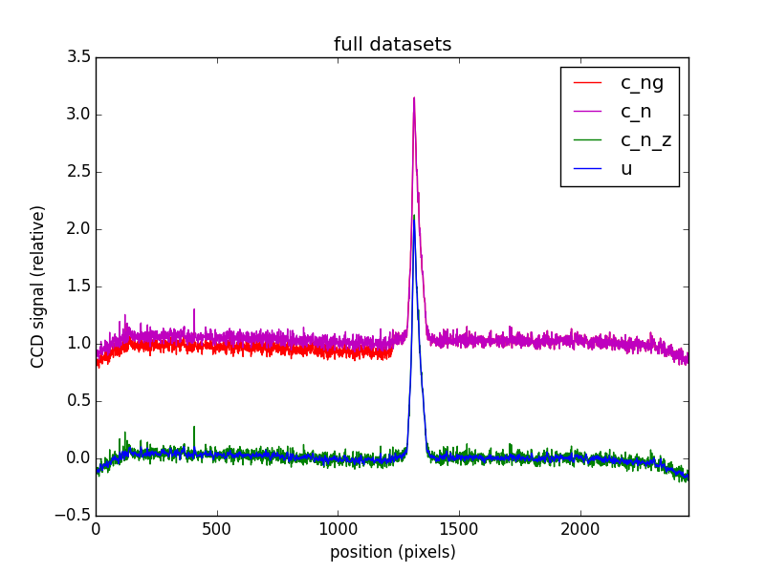
Figure 9: c_ng (red) is the raw signal (with noise and gain mismatch), c_n (cyan) is the gain mismatch corrected profile, c_n_z (green) is c_n after background has been zeroed, and u (blue) is c_n_z after Savitzky-Golay smoothing.

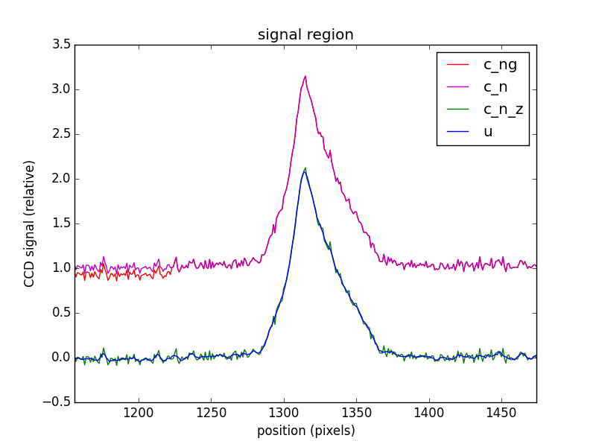
Figure 10: The same profile as in Figure 9, but truncated to the signal region.
Summary
The experiment is currently scheduled to begin in October 2015 and will continue for approximately one year. In preparation for this experiment, methods of analyzing the x-ray energy spectra produced during the channeling radiation experiment have been developed although further refinement may be necessary if the addition of collimators prove infeasible or ineffective at improving spectrum quality. Methods of converting relative peak intensities from the x-ray spectra to thickness of the CdTe diode of the x-ray detector have been refined to produce accurate results in the range of the expected thickness. Additionally, methods of calculating the mean and rms beam spot size from profiles with low signal to background ratios were developed.
It is recommended that x-ray spectrum measurements be re-taken with the addition of collimators if feasible as this may reduce partial absorption of x-rays by the detector resulting in underestimation of energies and downward skewing of peaks in the energy histogram. Once improved values for the relative peak sizes at 14 and 122 KeV have been calculated, they will be used to calculate CdTe diode thickness. Beam rms measurements from the quadscan will be used to calculate beam emittance using ELEGANT.

Acknowledgments
Special thanks to my mentor, Dr. Tanahi Sen, who guided me through the research I performed during the Lee Teng Internship Program. Thanks also to Dr. Daniel Mihalce, Professor Philippe Piot, and Wade Rush, collaborators in the channeling experiment. A program of this magnitude and complexity could not occur without the energy and planning of Tanja Waltrip.

References
1. Channeling Radiation with Low-Energy Electron Beams: Experimental Plans & Status at Fermilab. Blomberg, B., et al. New York : FEL2013, 2003. MOPSO07.
2. Van Grieken, Rene E. and Markowicz, Andrzej A., [ed.]. Handbook of X-Ray Spectrometry. New York : Marcel Dekker, Inc., 1993. 0-8247-8483-9.
3. Debertin, Klaus and Helmer, Richard G. Gamma- and X-Ray Spectrometry with Semiconductor Detectors. Amsterdam : Elsevier Science Publishers B.V., 1988. ISBN: 0-444-871071.

