

**FERMILAB**

**Technical Division**

**Test and Instrumentation Department**

**Handling Procedure for LQS Magnets**

**Transfer to IB1 and VMTF Installation/Removal**

|  |  |  |
| --- | --- | --- |
| **Prepared by:**  *[signed copy in T&I Dept. Files]* Date: 10/19/10  William Mumper, Technical Specialist | **Organization**  TD/T&I | **Extension**  4148 |
| **Reviewed by:**  *[signed copy in T&I Dept. Files]* Date: 10/19/10  Giorgio Ambrosio, Scientist – LARP Long Quadrupole | **Organization**  TD/MSD | **Extension**  2297 |
| **Reviewed by:**  *[signed copy in T&I Dept. Files]* Date: 10/19/10  Cosmore Sylvester, Deputy T&I Department Head | **Organization**  TD/T&I | **Extension**  4765 |
| **Approved by:**  *[signed copy in T&I Dept. Files]* Date: 10/19/10 | **Organization**  TD/T&I | **Extension**  3195 |
| Ruben Carcagno, T&I Department Head |

**Revision History**

|  |  |  |  |
| --- | --- | --- | --- |
| **Revision** | **Date** | **Section No.** | **Revision Description** |
| 1.0 | 06-07-2010 | All | Initial Release |
| 1.1 | 10-19-2010 | 2.2 | Added section 2.2 to cover magnet removal from VMTF and preparations for transport back to IB2 |
|  |  |  |  |
|  |  |  |  |
|  |  |  |  |
|  |  |  |  |
|  |  |  |  |
|  |  |  |  |
|  |  |  |  |
|  |  |  |  |
|  |  |  |  |
|  |  |  |  |

**TABLE OF CONTENTS**

1. Activities Performed in IB3 4

2. Activities performed in IB1 5

3. Appendix 8

1. Activities Performed in IB3
   1. Complete the inter-coil splicing.
   2. Wire FVT and perform preliminary electrical checkout including hipot.
   3. Insert Circuit Board Probe.
   4. Attach VMTF aluminum base plate to the return end (RE) of the magnet assembly and secure the RE cables in the groves machined in the aluminum base plate.
   5. Reset the accelerometers
   6. Start the accelerometers
   7. All of the fasteners used to connect the lifting structure to the LQS magnet assembly are grade 8 and are either ½-13 UNC or ¾-10 UNC socket head cap screws. Check the bolt torque on the Lifting Beam-to-Cradle, Support Foot, and Lifting Beam-to-Collar bolts before lifting and/or tilting the assembly. The ½-13 UNC bolts must be torqued to 40 ft-pounds and the ¾-10 UNC bolts must be torqued to 130 ft-pounds.
      1. The four Lifting Collar assemblies each have two ¾-10 UNC bolts for a total of 8 bolts which must be torqued.
      2. The four (4) Support Foot assemblies each have eight (8) ½-13 UNC bolts for a total of 32 bolts which must be torqued.
      3. The four (4) Support Foot assembly-to-Lift Beam plate connections each have three (3) ¾-10 UNC bolts for a total of 12 bolts which must be torqued.
      4. The four (4) Support Foot assembly-to-Stand-off plate connections each have four (4) ½-13 UNC bolts for a total of 16 bolts which must be torqued.
      5. Collect and bundle together the coil instrumentation wires from the return end. The bundle and associated plugs must be confined within the perimeter given by the coil rods, and in the longitudinal direction must not extend further than the coil rods during transport, lifting and tilting.
      6. Protect the magnet from moisture by wrapping in plastic and or use of desiccant bags during transport from IB3 to IB1.
   8. Using the building crane and appropriate slings as specified in the Hazard Analysis associated with the handling of this device, to move the magnet (LQS) on to the flat bed and secure it.
   9. Deliver the magnet to IB1.

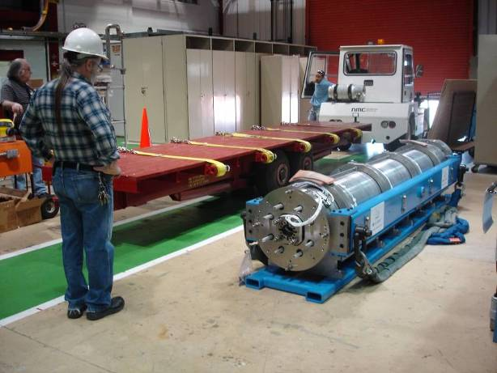

Cradle

Lifting Beams

Return End

Figure 1- LQS Magnet as delivered to IB1

1. Activities performed in IB1
   1. Connection to the top plate and test preparation
      1. Position the pedestal in the VMTF pit area (NE corner).
      2. Move the Transport Trailer and Magnet assembly to the VMTF bay. Connect instrumentation cables and read the output of the strain gages using the LBNL portable DAQ system.
      3. Re-locate the two 15-ton capacity swivel lifting eyes from the Return end of the lifting beams to the center pivot location and torque to 470 ft-pounds as specified on the swivel eye.
      4. Use a ratchet strap to secure the lead end of the magnet to the Lifting beams.
      5. Rig slings, Spreader Bar and shackles for a 2-point center-pivot lift. Attach tag-lines to both ends of the lifting beam.
      6. Remove the Lifting Beam-to-Cradle bolts. Check the bolt torque on Support Feet, and Beam-to-Collar bolts before lifting and/or tilting.

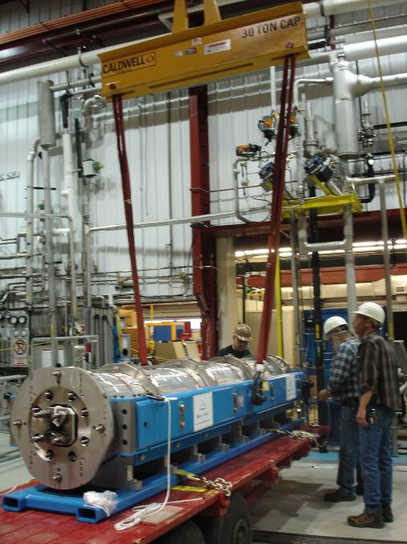

Slings -10 ft long 13000 lbs capacity each

30-ton Capacity Spreader Bar

S/N # 29690

Figure 2 – Magnet with Lifting Beams attached rigged for Lifting

* + 1. Lift LQS from the Cradle assembly.
    2. Lift LQS and pivot into a vertical position with the aid of the tag-lines as shown in Figure 3 and Figure 4.

|  |  |
| --- | --- |
| DSC01477  Figure 3 – Initial Magnet Lift | DSC01487  Figure 4 – Up-righting of the Magnet assembly |

* + 1. Lower the LQS on to the pedestal and secure the magnet to the forklift using straps and a ratcheting strap. The aluminum plate at the return of the magnet which is used to center the magnet in VMTF is manufactured with grooves to accommodate some of the return end instrumentation wire bundles. Check that all wire bundles are clear of the pinch area between the pedestal and the aluminum plate.

|  |  |
| --- | --- |
| DSC01494  Pedestal  Figure 5 – Magnet being lowered onto Pedestal | DSC01501  Ratcheting Straps  Figure 6 – Magnet Assembly secured to the Forklift |

* + 1. Disconnect the Spreader bar and slings from the lifting beams and store these items.
    2. Connect the 15 kA Top plate to the VMTF crane and position the 15 kA Top plate assembly over the magnet assembly. Connect the Top plate assembly to the magnet end plate. Keep the crane connected to the Top plate/magnet assembly.
    3. Connect the instrumentation cables for the strain gages and read the output of the strain gages using the LBNL portable DAQ system.
    4. With the Top plate assembly connected to the magnet assembly remove the forklift
    5. Remove the lifting beams after detaching them from the magnet collars and from the end plates. Refer to Figure 8 in the Appendix working on one lifting beam at a time.
       - 1. Working from a man-lift, disassemble the top support feet assembly while the lifting beam is tied-off to the top of the magnet structure. Note that the heaviest component weighs ~ 35 pounds.
         2. Remove the eight (8) lifting beam-to-collar bolts on the Lifting Beam being removed.
         3. Tighten the suspension rod split-clamp bolts, then loosen the Collar assembly bolts (3/4-10 UNC), down one side and install the shims provided by LBNL in the gap. Re-torque these bolts to 130 ft-pounds.
         4. Attach the ½-13 UNC hoist rings to the lifting beam so that the lifting beam can be suspended from a lifting hook mounted on the forklift, once the man-lift is removed from the area.
         5. Use the forklift to support the lifting beam suspended by slings as shown in Figure 7.

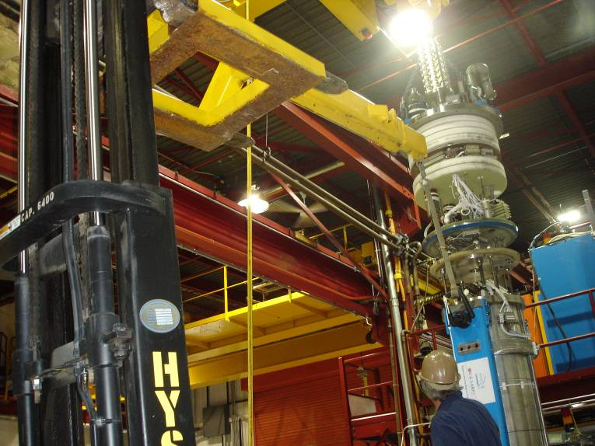

Figure 7 – Lifting beam support via Forklift

* + - * 1. Re-position the man-lift and untie the top of the lifting beam from the top of the magnet assembly.
        2. Unbolt and disassemble the bottom support feet to disengage the lifting beam from the bottom stand-off plate. Use the forklift to remove the lifting beam from the area.
        3. Repeat steps 2.14.1 through 2.14.7 for the other lifting beam.
        4. With both lifting beams off and the magnet connected to the top plate, the assembly could now be stored in the VMTF cryostat overnight as required.
        5. Remove accelerometers
    1. Connect instrumentation cables and read the output of the strain gages using the LBNL portable DAQ system.
    2. Install RTDs and pigtails and fix/mount all connectors to the magnet shell.
    3. Perform instrumentation and electrical checkout outside the cryostat.
    4. Install assembly in VMTF.
    5. Perform final in-dewar electrical checkout.
    6. Use the standard VMTF lifting hoist to raise and lower the magnet assembly as required during final assembly and checkout.
  1. Removal from VMTF and transport back to IB2
     1. Lift magnet out of dewar and remove LL sensors and thermometers as the magnet is lifted.
     2. When magnet is at a good working height, unsolder the lead splices taking precautions to prevent debris from falling into the dewar.
     3. Place the magnet on the pedestal.
     4. Attach upper and lower support feet.
     5. Loosen collar bolts and remove shims.
     6. Using a forklift and boom, lift and position side beam to align with upper and lower support feet.
     7. Install and torque ¾ x 10 side beam bolts to the specified value in 1.7.
     8. Attach remaining tie plates both top and bottom with ½ x 13 bolts and torque to the specified value in 1.7.
     9. Lift magnet and rotate 180 degrees and repeat process and re-torque collar bolts to 130 ft-pounds.
     10. Use forklift to stabilize magnet as shown in Figure 6.
     11. Use man-lift to access the area where the header assembly is connected to the magnet and disconnect the header assembly from magnet and store the header assembly.
     12. Attach the spreader bar and slings to center swivel lifting eye on each side beam.
     13. Remove strap and fork-lift from the magnet.
     14. Using the 10-ton crane, lift the magnet, and remove from pit area.
     15. Install tag lines to facilitate the tipping of the magnet from the vertical to the horizontal position.
     16. Rotate the magnet into the horizontal position, position the magnet in shipping cradle and insert ½ x 13 bolts (used to attach magnet to cradle).
     17. Install strain relief for leads and cable bundles.
     18. Cover magnet with plastic sheet and ship to IB3.

1. Appendix

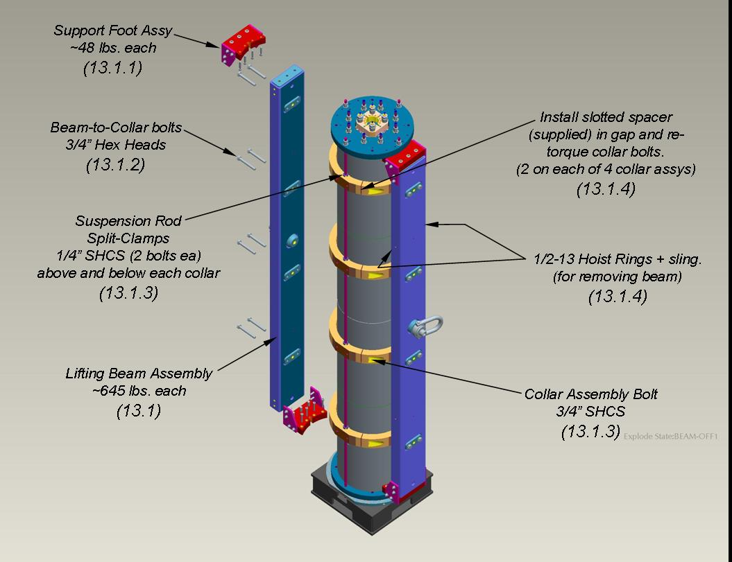

Figure 8 – Lifting Beam Disassembly