October 16, 2015

**Analysis of MICE Spectrometer Solenoid magnet M1 coil failure**

A. Bross, S. Feher, P. Hanlet, M. Palmer, M. Popovic

On September 13th, a training run for the downstream MICE spectrometer solenoid magnet (SSD) was initiated. Due to the fact that additional quench protection for coil M2 of this magnet had not yet been implemented, we decided to ramp to quench with only M1 and ECE coils. [Note: the QP for coil M2 was compromised when one of the voltage tap leads across a low-temperature SC lead was lost.]

The ramp to quench proceeded normally and a quench occurred at ~ 260 A in coil ECE. The quench data was saved and the magnet team entered the hall to refill and secure SSD. Upon entering the hall, a strong odor associated with burning electronics was noted. This was strongest near the 40 psig He relief valve.

Detailed investigation of the quench data and measurements on the coils of SSD then followed. We determined very quickly that coil current could no longer be put into coil M1 and that coil ECE looked normal.

A detailed investigation utilizing 4-wire resistance measurements and AC measurements with the voltage tap leads then followed.

There were many days of investigations and a full suite of measurements was completed. A detailed understanding of the event is now in hand. Not powering coil M2 caused a significant delay in the onset of the quench in coil M1. The quench initiated in ECE, was detected by the QP system and a quench signal triggered opening of all of the contactors in the power supply system for the magnet. ECE quenched immediately, but a quench in M1 had not occurred at 20 seconds into the event. An overall plot of the voltage tap data is given in Figure 1. Figures 2a and 2b present an expanded view (in V) of these data.

From an analysis of the QP data and all measurements on the voltage taps, an understanding of the resultant condition of the M1 coil circuit has been developed. It is shown in Figure 3.

For comparison, data from the QP system for a ramp in which all the coils were powered are shown in Figure 4. In this event, a quench was detected in ECE and the QP system fired. Quench propagation was normal ECE, then M2 and finally M1.

Finally, after the event of September 13th, we looked at voltage signals induced on the M1 coil and lead when the ECE coil was ramped (see Figure 5). The M1 coil was disconnected from its power. The voltage signals across the M1 voltage taps and across the M1 LTS-B lead voltage taps were recorded. The recorded data are consistent with the circuit diagram presented in Figure 3.



Figure 1. Coil and LTS lead voltages. M2 coil was not powered. EC coil had a spontaneous quench. M1 coil did not quench and the cable that connects the 8 mOhms resistor with the diode gradually overheated and opened around 20 sec after the contactor was opened. Than arc developed between LTSA and LTSB lead at the flange region. LTSB was welded to LTSA and it opened. Arc moved to ground at two locations developing a double ground fault. Finally the current decayed to zero.





Fig 2a and Fig 2b. Coil and LTS lead voltage traces enlarged.

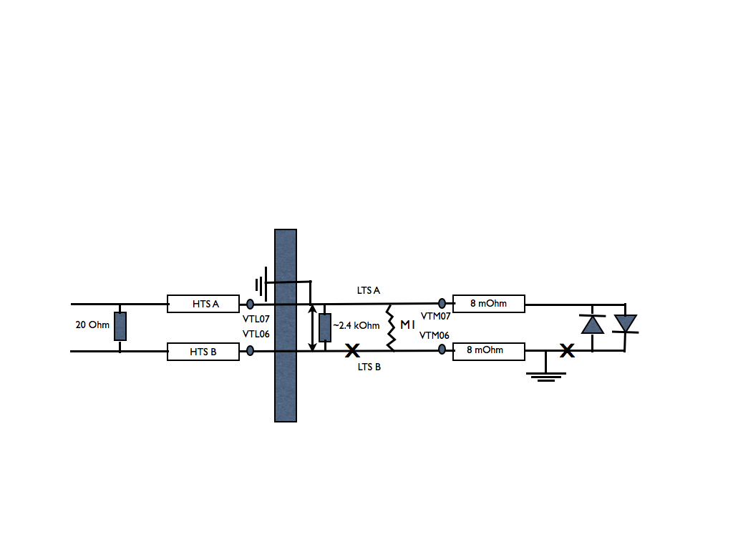

Figure 3. Diagram of the M1 circuit after the quench of September 13th. Resistance (four wire and two wire) measurements revealed: i) Lead A has hard short to ground, ii) LTSB is shorted to LTSA through 2.4 kOhms and LTSB is not connected to the M1 coil on the Lead B side.



Fig 4.Normal quench event. Quench initiated in ECE. First EC quenched then about 6 sec later M2 and finally around 10 sec later, M1.



Fig. 5. Test of induced voltages on M1. M1 is disconnected from its power supply and the ECE coils were ramped to 5A. As can be seen, voltage (as seen on the voltage taps) is seen on M1 due to mutual inductance. The LTS-B voltage taps clearly measure the inductive voltage with opposite polarity, which is expected, based on the explanation given in caption of Fig 1.