Maintenance/work items in the Pelletron (and tentative schedule)

August 5th, noon: Interlocks are dropped
August 6th, 7am: Gas transfer starts
August 7th, 10am: Pelletron is open and ready for access

Maintenance work can start, including (not necessary in the following order but close…):
- Visual inspection (Ron, Fernando/Jerry, Kermit, Sasha)
- Record running times (chain, shaft) (Kermit)
- Measure the distance between the GVM and the dome (Ron, Fernando/Jerry)
- Remove a few rings – eye level when platform is at the bottom (Ron, Fernando/Jerry)
- Measure chain elongation and find a way to record it with respect to a fixed part in the Pelletron (Ron, Fernando/Jerry, Terry)
- Remove ½ brick from counter weight (Ron, Fernando/Jerry)
- Measure chain elongation (Ron, Fernando/Jerry, Terry)
- Inspection of the electronics, charging circuitry (charging resistances in particular),… (Greg, Kermit, Sasha, Lionel)
- Replace needles (Kermit)
- Install equipment needed for OTR measurements except camera (Arden)
- Prep MI-31 for tour (cooling solenoid, posters,…) (Lionel, Sasha, Kermit)
- Repair/replace parts that were found broken/damaged during inspections (Ron, Fernando/Jerry, Kermit, Greg)

August 10th, 1pm: Students tour (Sasha, Lionel)
August 13th, 8am: Measure GVM frequency response (Kermit)

No later than:
August 15th, 7am: Final cleaning and closing
Measure the distance between the GVM and the dome before closing
August 16th, 7am: Gas transfer starts
August 17th, 4pm: Pelletron is ready for operation
MI-31 is searched and secured over the weekend

August 20th, 9am: Install camera for OTR measurements – Controlled access (Arden, Mary)
August 20th, 1pm: OTR measurements can start… but need new/amended running permit

MI-31 run permit ‘issue’

Run permits will be withdrawn and cancelled after the beginning of the shutdown
- Perhaps as soon as the first or second week of the shutdown
⇒ Would prevent from running in U-Bend mode

A new run permit is normally issued only after the shutdown work for the particular machine has been completed and signed off by the department heads (Cryo, Ops, EE,…), Mike Gerardi and Roger.
- Usually at the end of the shutdown period
- Relatively long and painful process

John Anderson needs to know of our plans before the run permit is rescinded should we plan to run in U-bend mode during the "shutdown"
- Kermit responded to him (by voicemail) and expressed our desire to be able to run in U-bend mode starting about the 15th of August
⇒ Need to agree on a draft plan that we (Kermit) can communicate to him so that we can preserve the U-bend operating permit for the period starting once the Pelletron inspection and cleaning work is completed on or about the 15th of August.

I DON’T KNOW WHAT THAT MEANS EXACTLY
No cancellation of our permit?
New permit without all the signatures?
Facilitate approval/process of new permit?

… BUT whatever it is, we need to deal with it as soon as possible.

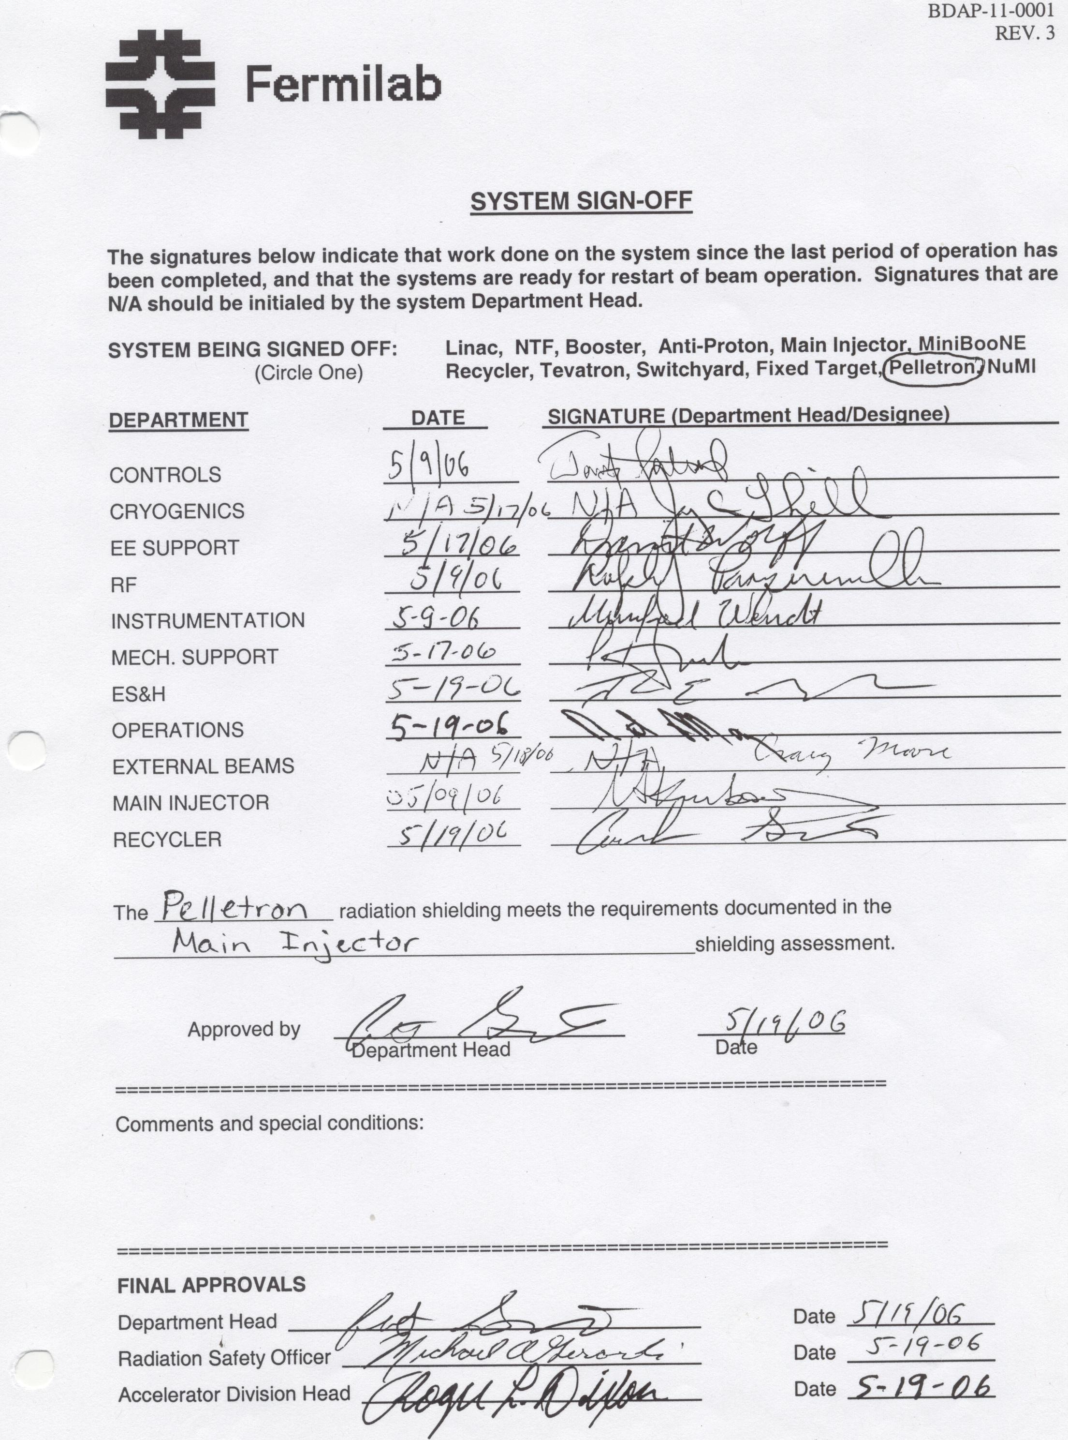
10 days
LAST SHUTDOWN

