Modification of LBNE Beam, Concept
Milorad Popovic
Fermi National Accelerator Laboratory

November, 2015

Abstract
This note describes modified proton, pion beam lines for LBNE that will provide usage of a multi megawatt proton beam, reduce the cost of the present design and will preserve advertised experimental goals.

Introduction
At present LBNF[1] is designed to operate with beams up to 2.4 MW. The concept is as on Figure 1.
Figure1.
The assumption is that the multi megawatt proton beam will hit targets under 5.7 degrees, pions will be collected with one or more Horns and will enter ~200 m long decay. The neutrinos from pion decays will travel ~1300 km and hit the detector located in Sanford Underground Research Laboratory in South Dakota. From MARS simulations[2] for energy deposition, it is expected that ~40% of the beam power is deposited in the Target Hall
Complex, 30% to the Decay Pipe region and 30% to the Absorber Hall complex at the end of decay Pipe.
To contain radiation produced by the decay of the megawatt of beam, the Decay Pipe is design to be 4 m inside diameter, Helium filled and with a wall made out of 5.6 m of concrete shield, Figure 2.
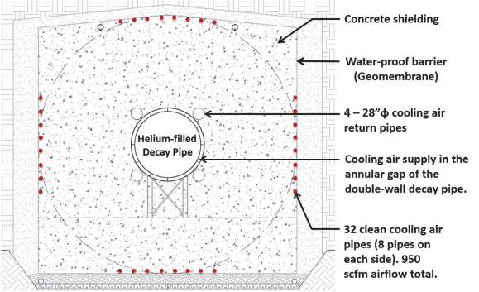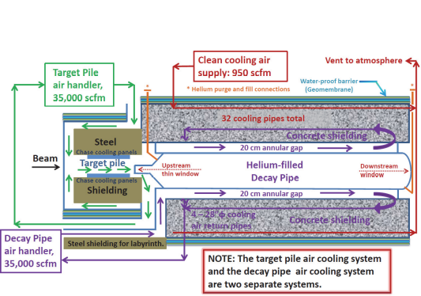
Figure 2. Decay Pipe, Target complex
The Target Complex is show in Figure 3 and the distance from target to the entrance to the Decay Pipe is ~25 m.

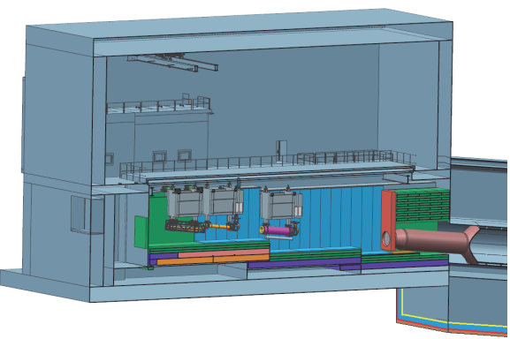
25 m
Figure 3.
The next section will outline possible modifications of the described concept.

Modified LBNF Beam Line

Most of the beam power that is deposited in the Decay Pipe and the Absorber at the end of the Decay Pipe comes from 120 GeV protons and neutrals that entering the Decay Pipe. A Simple G4Beamline model (Figure 4) of the Target, Horn and Target complex (modeled as 1 m diameter, 25 m long pipe) shows that out of 100k 120 GeV protons that are hitting target there will be 27k protons with energy higher than 118 GeV at the end of target complex.

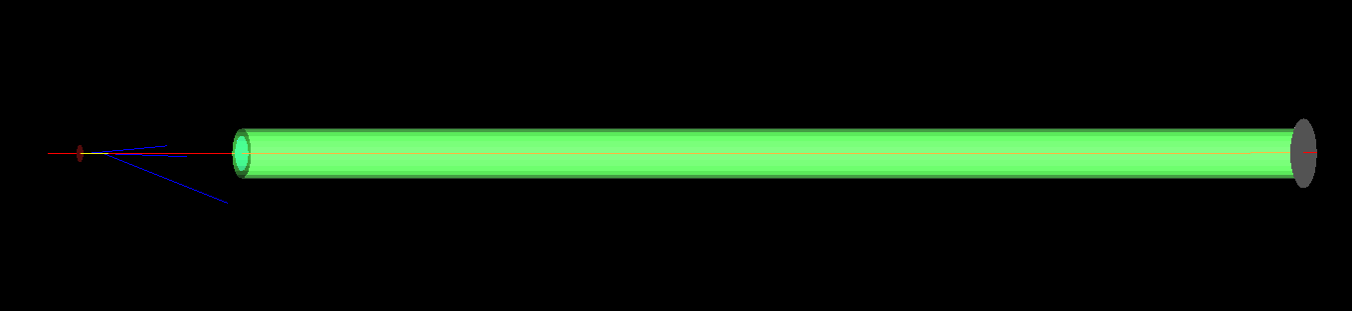
Target & Horn
Decay Pipe
25 m
Figure 4. Target Complex is simulated as target, Horn and 1 m diameter pipe.

From the same simulations at the entrance to the Decay Pipe, there will be a total of 55k positive pions and most of them have energy less than 20 GeV, Figure 5.
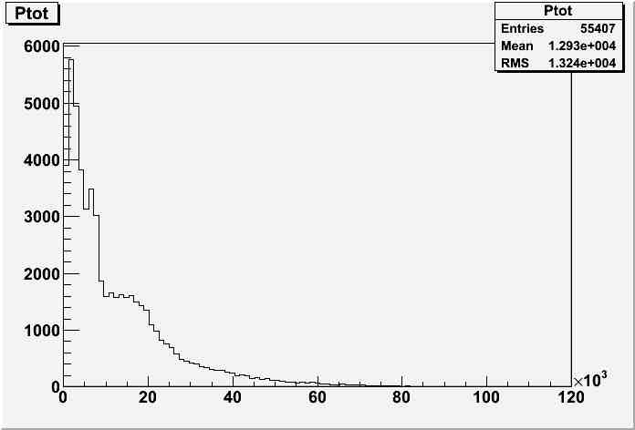
Figure 5. Pions produced by 100k protons hitting C target and entering Decay Region

This is a large number of pions, but not all of them contribute to the production of neutrinos visible by detectors. The fact that the Decay Pipe is ~ 200 m long reduces very much the number of useful pions with higher energy. Less than 20% of pions with an energy higher than 15 GeV decay in the Decay Pipe, see Figure 6.
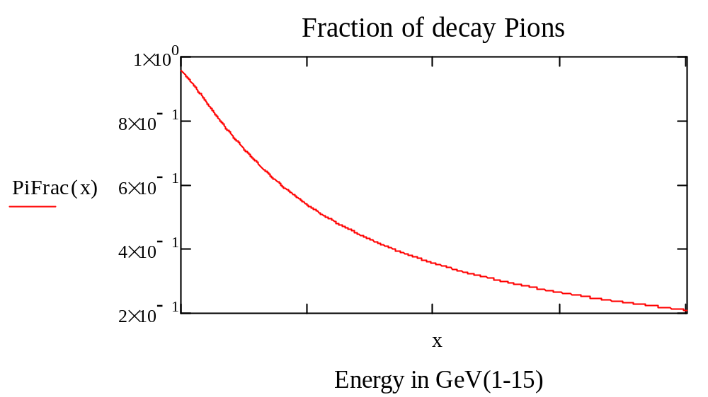
Figure 6. Fraction of decayed pions in 200 m long Decay Pipe.
Looking at muon neutrino spectrum[3], Figure 7, we may try to estimate importance of pions as the function of the pion energy to produce desired neutrino flux.
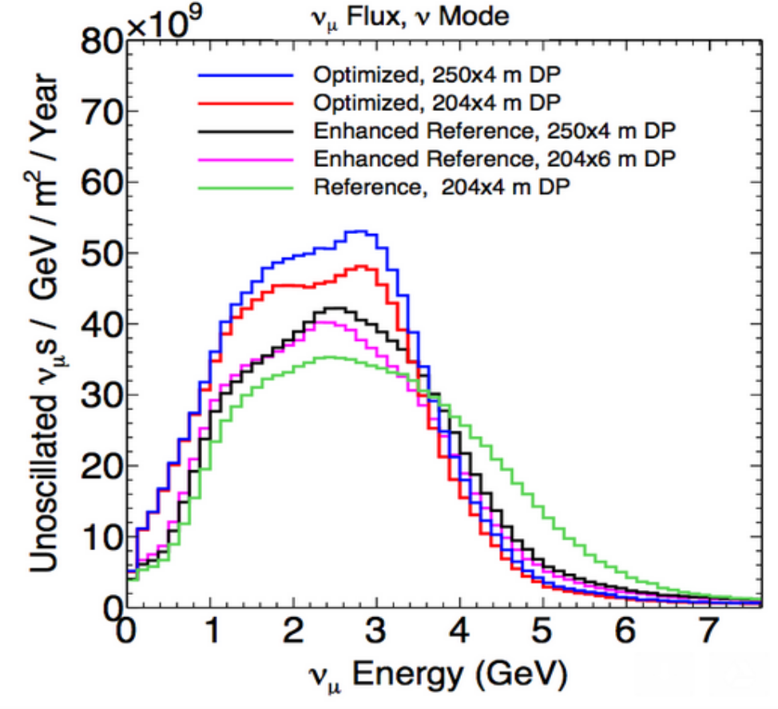
Figure 7.
Looking at the low energy end, neutrinos with energy less than 0.5 GeV do not play significant role, and based on this observation we can consider pions with energy less than 1 GeV not important, and this is, see Figure 8, ~3k out of the total number of pions (55k) that enter the Decay Pipe. Looking on the high energy end of neutrino spectra from Figure 7 we see that number of neutrinos with energy more than 5 GeV is small, so is a significant amount of pions with energy more than 12 GeV that produce neutrinos with energies higher than 5 GeV.
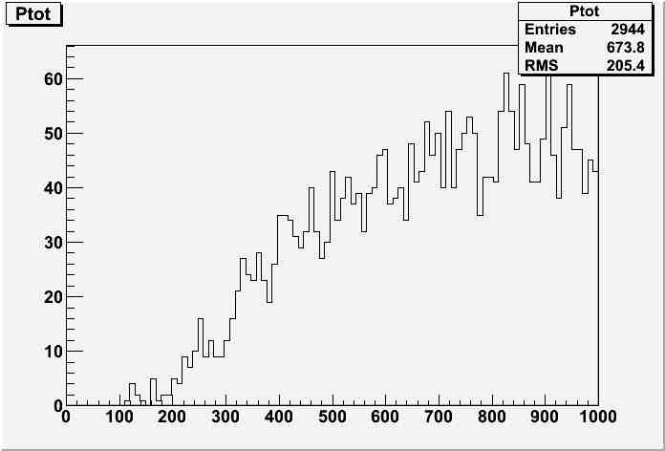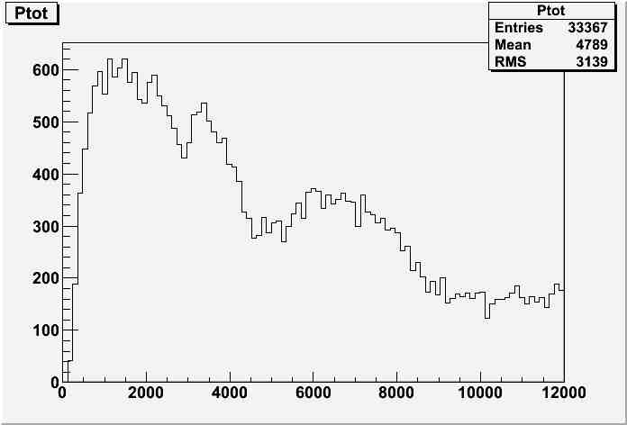
Figure 8.

Following these assertions, we should try to separate as many as possible “useful pions”,
pions with energy from 1 to 12 GeV, from the rest of particles that are coming after LBNF Horn. To do this we can bend charged pion beam using high momentum acceptance bending system. Similar approach [4] was used in attempt to marge nuSTORM and LBNE but at that time aim was to collect relatively narrow of pion momentum bite
In the rest of the note we will study the case where LBNE Hill is removed, protons hit the target and the pion beam is bended right after the Horn and directed under angle of 5.7 degree toward DUNE Facilities.

LBNF Modified

The bend is made using a Double Bend Achromat [5], it is simple and is used to demonstrate pion beam separation. Figure 9 shows G4beamline output. The whole system is 25 m long starting from the target. The assumption is that all the beam elements are located inside the Target Complex for easy maintenance and handling.

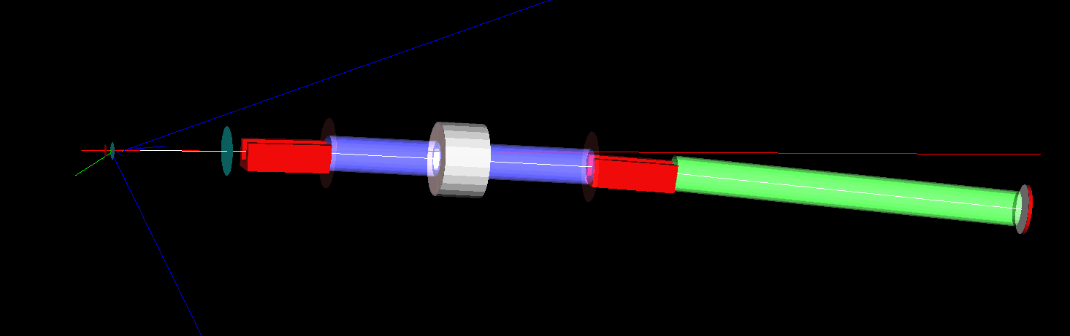
Figure 9.
The beam line selects 4 GeV kinetic energy positive pions and is made out of two C-dipoles, 2.4 m long with a 2.98 kG field and single F quad 1.3 m long with a 0.6 m diameter and a 1 T field at pole tip. The first dipole is located 0.5 m after the Horn. The DBA is 12.4 m long and is followed by 1 m diameter, 10 m long pipe to the entrance of LBNF Decay Pipe.
The G4beamline [6] simulation shows (red detector at the end of green pipe in Figure 9) that only ~3% of beam power enters the Decay Pipe. Table 1 summarizes beam power loss in elements with 10k, 120 GeV protons on target,

Element | Beam Power Loss (%)
Target Complex | 45
Target | 35
Magnet1 | 8
Pipes | 7
Magnet2 | 2
Entrance to Decay Pipe | 3
Table 1.

Target Complex, Pion Collection - LBNF Modified

As it was stated in the introduction new LBNF beam line has several goals
- Remove Proton Targeting Hill
- Minimized beam power deposition in Decay Pipe
- Collect as many ‘useful pions’ to make number of neutrinos in detectors (almost) the same as present LBNF concept
- Provide charge separation
- Make pion separation complex short (< 25 m)to fit inside of existing Target Complex for easy maintenance and handling
- Reduce cost of Decay Pipe and Proton Delivery Line

As an added benefit, we can think about having second target just before main beam Absorber.
Pion separation system is modeled using G4Beamline and is shown in Figure 10.

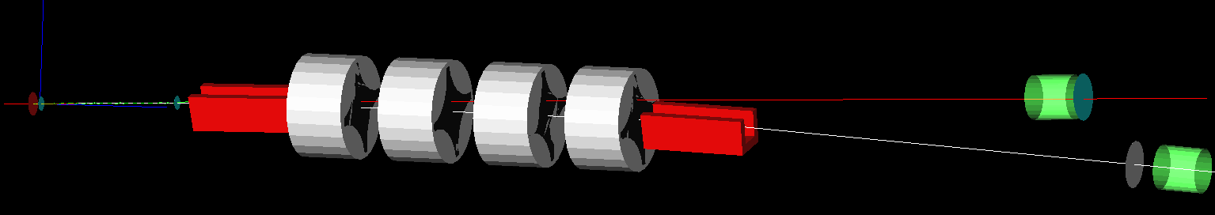
Target & Horn
C-Dipoles, 2.88 degree
F-D-D-F Quads
Absorber
Decay Pipe
Figure 10.
Initial design is done using Trace3D[7] (envelope code). The input beam (4 GeV Kinetic Energy positive pions) in Trace3D is defined assuming that the beam coming from the Horn has a radius ~12 cm, is an upright ellipse and makes it out to the Decay Pipe after 25 m long drift in the pipe of 1 m diameter (see Figure 11 on the left). The channel is tuned so that the output beam makes it to the end of 200 m long decay pipe with a radius of 4 meters and very minimal dispersion, Figure 11, on the right.

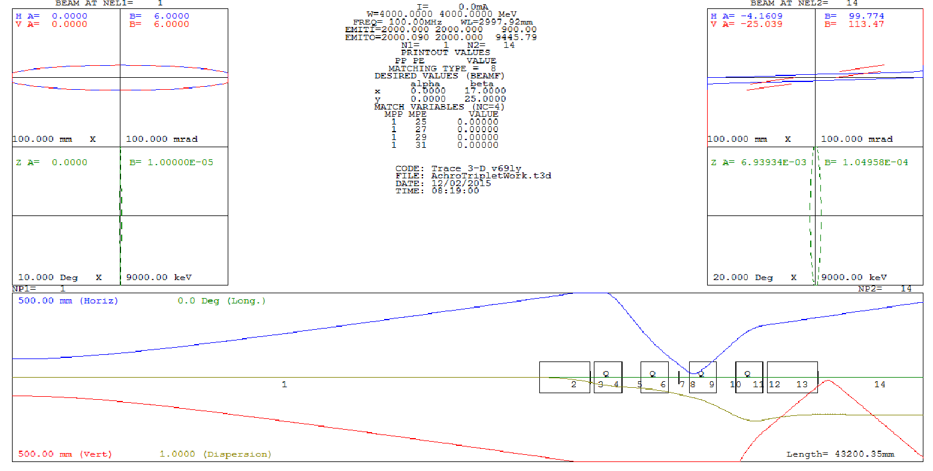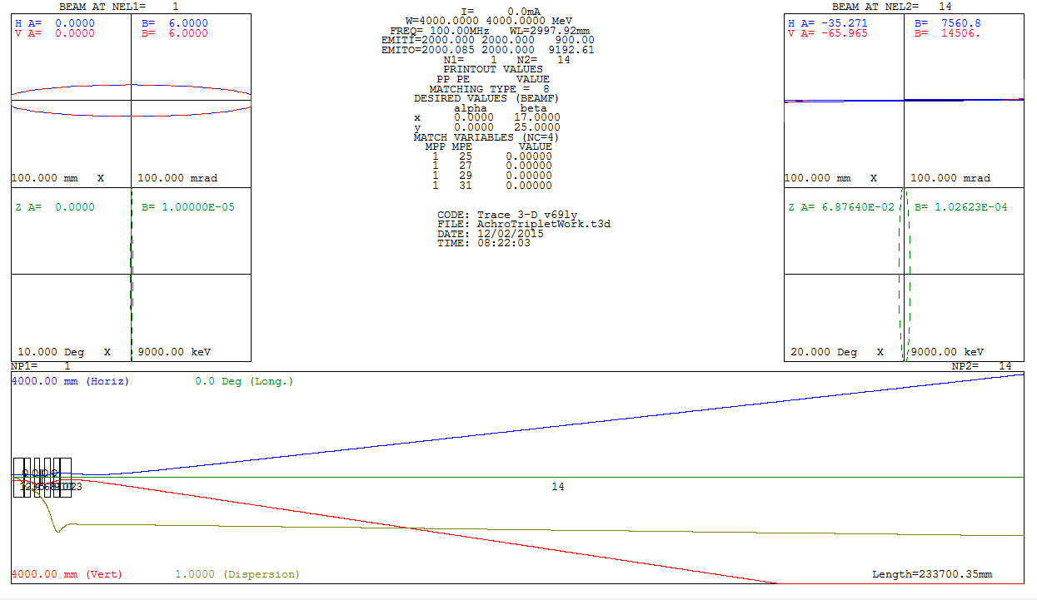
Figure 11. Trace3D, input and output beam for the pion channel.

Figure 12 shows the beam envelope in the pion channel, starting from the end to the Horn and ending at the entrance to the Decay pipe. The red trace is a horizontal beam envelop, blue is a vertical envelop and the dispersion is kept smaller than 0.5 meter and kept constant in the Decay Pipe.

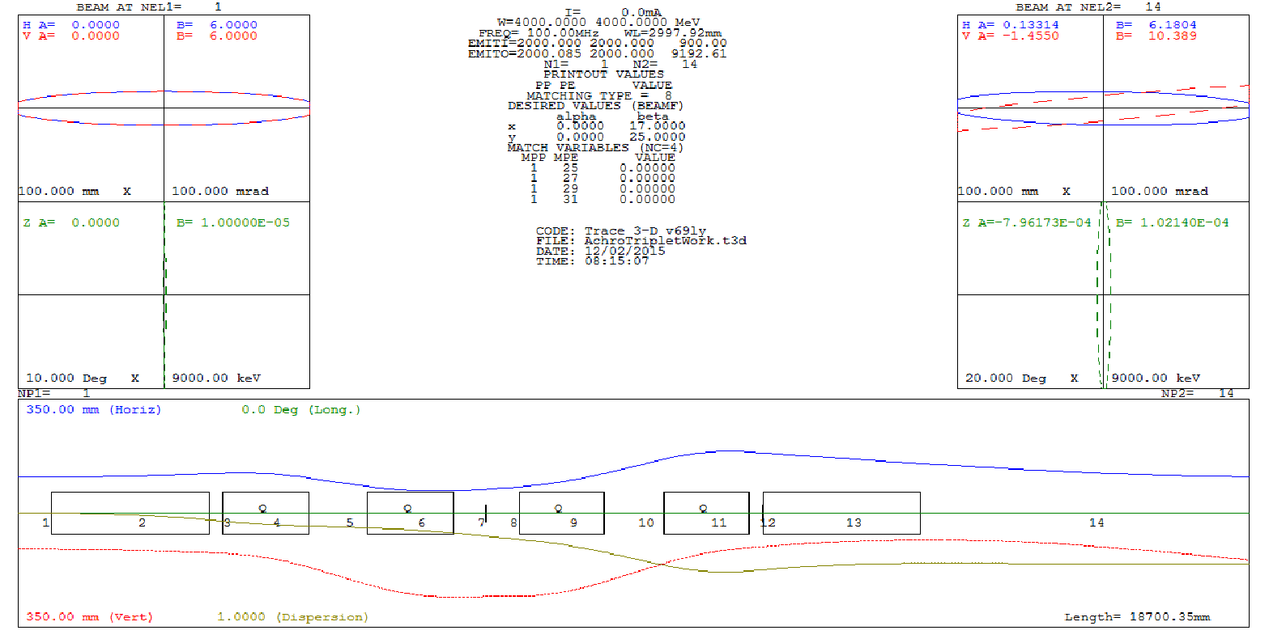
Figure 12

The assumption is that whole line is shorter than 20 m and built with conventional beam elements.
Element Number | Element Type | Parameters | Comment
Beam-Proton | 120 GeV |  | G4BL
-2 | Target | C, l=65 cm r=7mm | Not in Trace3D
-1 | Horn | L=3.3 m, 6T, r=2cm | Not in Trace3D
Beam | See Figure 36
1 | Drift | 500 mm | After the Horn
2 | C-Dipole | 2.88 deg, R=47.75m | B=0.289 T, l=2.4m
3 | Drift | 200 mm
4 | Quad-F | L=1.3m, g=3.7T/m, r=35cm | Bmax=1.3 T
5 | Drift | L=0.9 m
6 | Quad-D | L=1.3m, g=2.7T/m, r=35cm | Bmax=1.3 T
7,8 | Drift | L=0.5 m | Total 1 m drift
9 | Quad-D | L=1.3m, g=2.7T/m, r=35cm | Bmax=1.3 T
10 | Drift | L=0.9 m
11 | Quad-F | L=1.3m, g=3.7T/m, r=35cm | Bmax=1.3 T
12 | Drift | L=0.2 m
13 | C-Dipole | Gap=0.5m, w=0.6m | B=0.289 T, l=2.4m
14 | Drift | L=5 m
Table 2 summarize parameter of beam elements

The G4beamline simulations show that with 100k protons on the target, there are 32k positive pions at the entrance to the Decay Pipe, Figure 13.
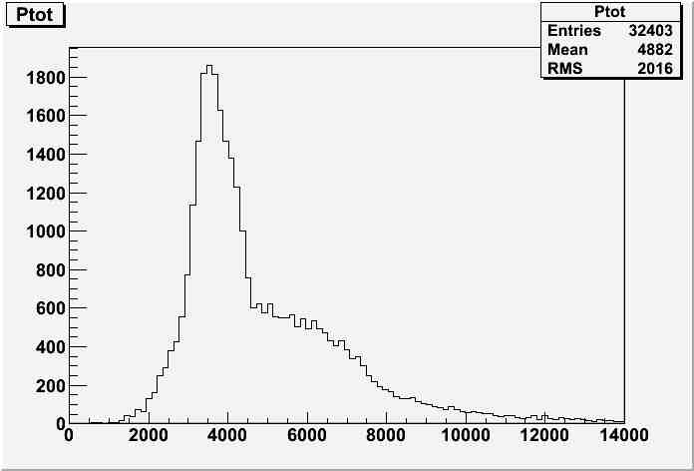
Figure 13. This is for 4 GeV pion kinetic energy
This number similar to the number of ‘useful pions’ in the model simulating current LBNF design, see Figure 8.

Second Target

Now that main absorber is moved on same elevation as Main Injector, just after Target Complex we can insert second target before Absorber, see Figure 14.

Second Target
Figure 14.
G4beamline simulations show that out of 100k protons there will be 26k with energy of 120 GeV and ~20k with spot size smaller then r= 2 cm, Figure 15. This means that second target will get at least 20% of beam power delivered on primary target. In LBNF era one can envision running experiment like NuSTORM with 200kW target completely parasitic to LBNF. If needed yield on second target can be increase using proton Lithium Lens

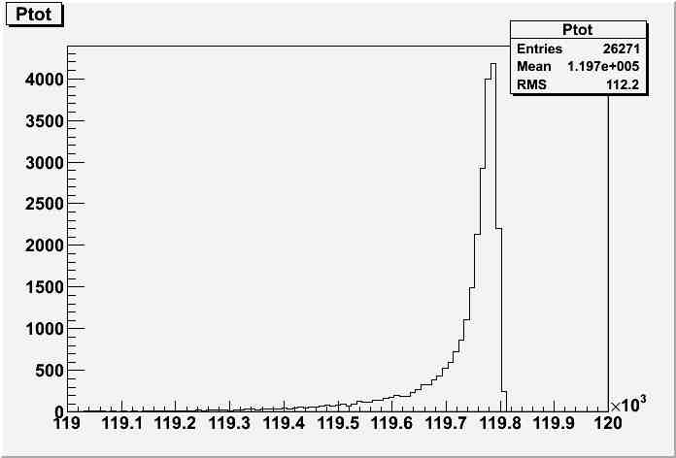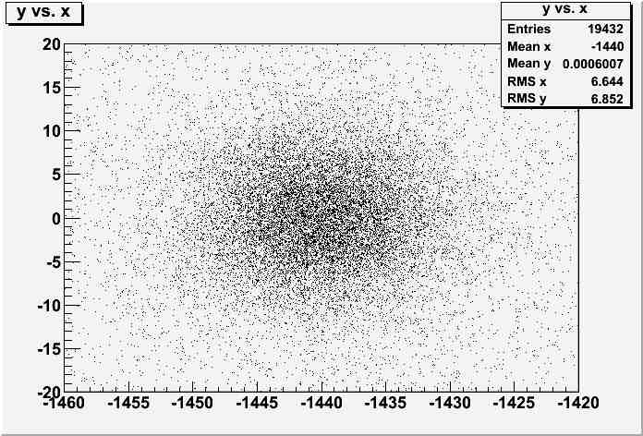
Figure 15.

Conclusions

It appears that simple redesign of LBNF proton and pion beam line can significantly reduce need for complex proton delivery on target and the complex pion Decay Pipe with a very similar number of neutrinos in detectors. This conclusion can be only verified by full Monte Carlo simulations. Figure 16 shows Target Complex on same elevation as Main Injector. The simulation show that less of 1% of beam power is sent down the Decay Pipe and this will significantly reduce need for the thick shielding wall of the Decay Pipe.

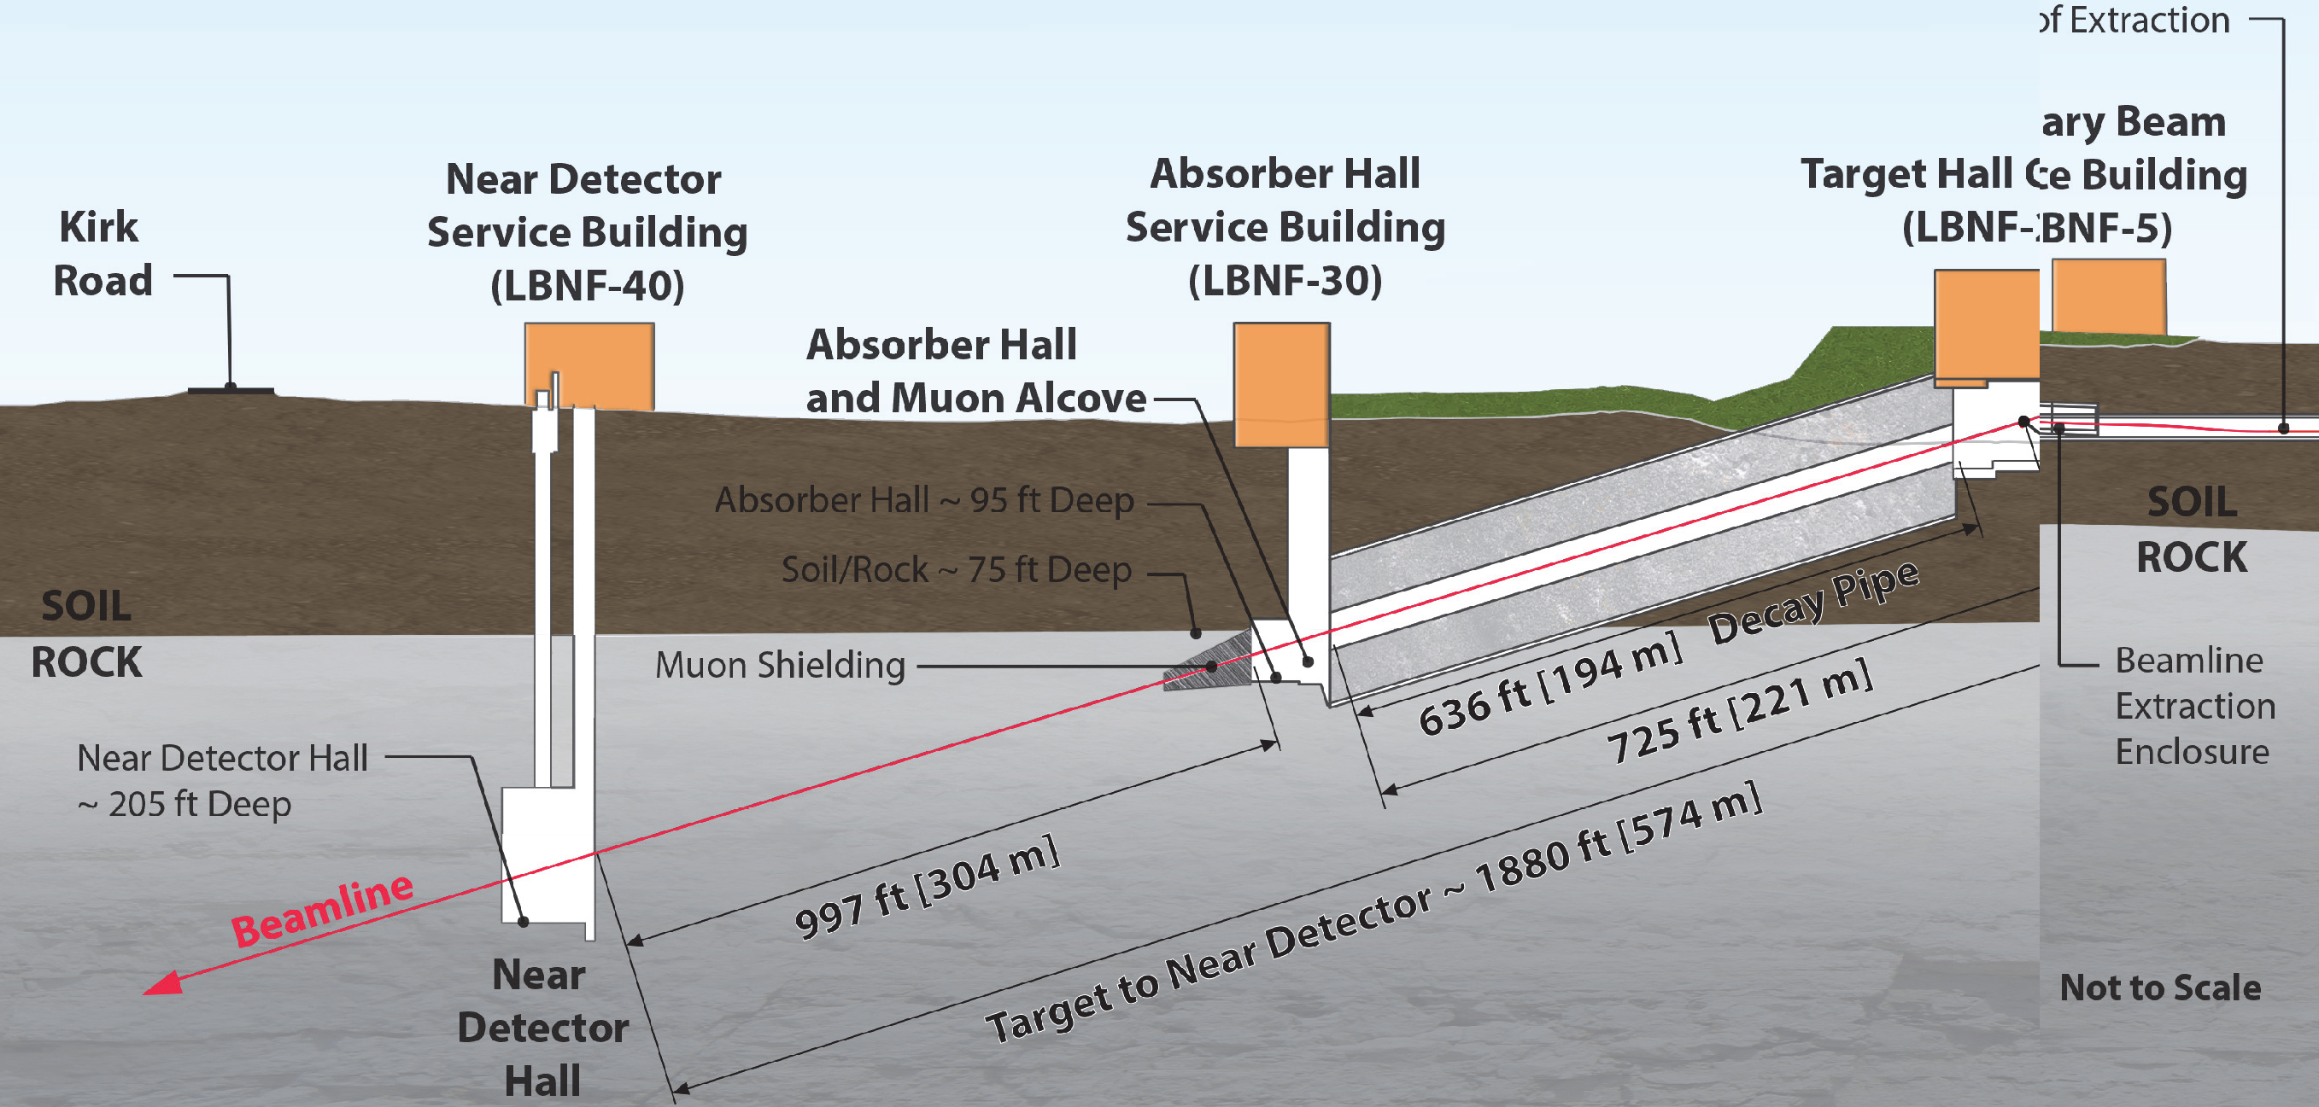
Figure 16. LBNF as described in this note.

Pion separation system is design using conventional beam line elements, housed in Target Complex and with technically conservative requirements and will require two dipoles and four quadrupoles, Figure 17. The same system can be used to take pions from second target.
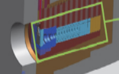
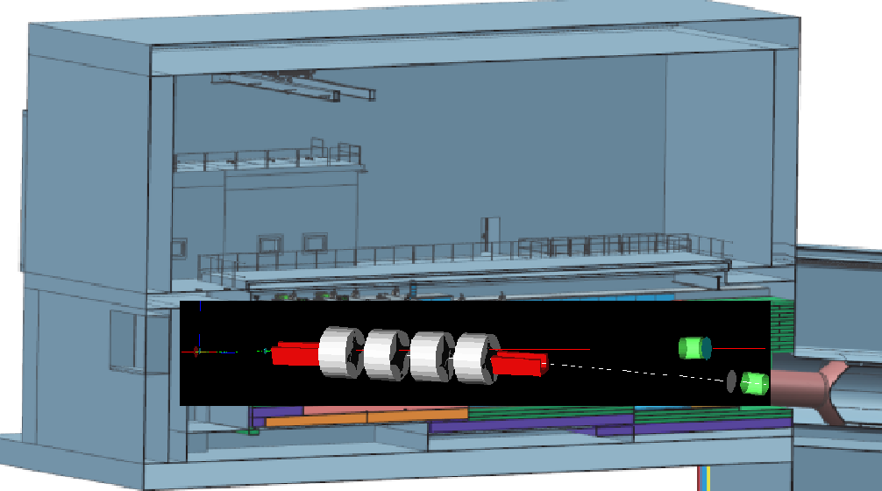
Figure 17.Target Complex with pion beam line and main absorber (red box).

References
- LBNF Design Report, http://lbnf.fnal.gov/
- Jim Strait, Nufact 2015, https://indico.fnal.gov/getFile.py/access?contribId=126&sessionId=16&resId=0&materialId=slides&confId=8903
- DUNE/LBNF CDR Volume 2, http://docs.dunescience.org/cgi-bin/ShowDocument?docid=181
- MAP2012 Winter Meeting https://indico.fnal.gov/materialDisplay.py?contribId=92&sessionId=12&materialId=slides&confId=5097, Virginia NuFACT 2012, https://www.jlab.org/indico/abstractDisplay.py?abstractId=78&confId=0Jean-
- Baptiste Lagrange, Nufact 2015, https://indico.fnal.gov/getFile.py/access?contribId=124&sessionId=16&resId=0&materialId=slides&confId=8903
- G4Beamline, Muons Inc. http://www.muonsinternal.com/muons3/G4beamline
- Trace3D, Los Alamos

============================================

