Documents for RFP

PW March 25, 2016

*Interface specification (Steve Plate, Mike Anerella)- ready by end of April*

Physical dimensions, as built

Electric, mechanical, cryogenic, vacuum interfaces

*Functional specification – most ready April 1; “change summary” later*

* + LBNL RFP
  + Wang paper to ASC
  + Wang Final Engineering Design document (if LBNL owns it)
  + LBNL CAD model (Roy Preece, Steve Plate, Paul Kovach)
  + Luvata specification for spare conductor
  + Summary of changes to Wang’s design to **cold mass** (6-10 pages), including LBNL mods not shown in the model (if known) and what isn’t known about the magnet as built (e.g., cold mass supports)
  + Quench protection system (note from Feher)

*Lessons learned / advice for rebuild  - ready April 1*

E2 force analysis by Witte, Marone.

Peak field reduction by Gupta

QD/QP instrumentation – redundant taps at coil midpoint, heaters, Feher’s design

How much, if any, of the report of the December review committee?

BNLlogostat

**MICE Spectrometer Solenoid Replacement Cold Mass**

**Functional Specification**

**Summary of Changes to Wang Design**

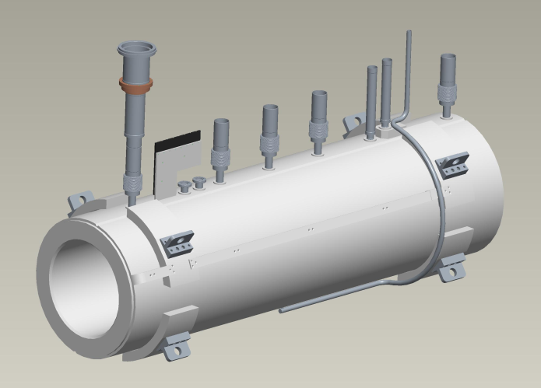

M. Anerella / P. Kovach / S. Plate

Rev. A

March 25, 2016

CHAPTER I – Introduction

CHAPTER II – MICE Detector Spectrometer Solenoid Coil Assembly Design

II-1. Coil design – no change at this level of description; for new optimization see R. Gupta specification.

II-2. Conductor design – see Luvata specification.

II-3. Insulation design turn to turn, layer to layer and coil to ground:

1. Conductor insulation – no change (Formvar)
2. Turn to turn insulation – conductor insulation + 0.001” nominal spacing during winding, filled after layer is wound with Stycast 2850 FT.
3. Layer to layer insulation – 0.006” total thickness (0.003” fiberglass) epoxy impregnated fiberglass
4. Coil to ground insulation – Coil I.D. at mandrel and O.D. at aluminum banding, 3 layers of 0.002” Kapton + 0.006” epoxy impregnated fiberglass; end flanges, 0.250” of G-10 minimum thickness including exiting leads.

II-4. Coil winding pack design and design of coil former:

1. Control winding density – 0.001” spacing between turns based on nominal conductor dimension.
2. Coil layer and potting epoxy – Stycast 2850 FT coated over each completed layer, then overwrapped with 0.006” total thickness epoxy impregnated fiberglass before winding subsequent layer. Voids at layers ends and ramps to subsequent layers to be filled with epoxy putty.
3. Aluminum coil banding to support coil force - 0.032" x 0.250" rectangular aluminum strip to be wound around completed coil with 20-25 lb. tension, total thickness TBD (≥ 0.250”), welded after wrapping to prevent unraveling, or other suitable restraint system TBD.
4. Conductor joints and voltage tap – exiting coil leads all to have a second identical superconductor spliced to them as a stabilizer immediately as they exit the body of the coil (note that this requires the stabilizer of the start lead to be soldered prior to winding). All soldered lead/stabilizer assemblies are to be independently insulated with 2 layers of 0.001” Kapton. Splices to exiting leads shall be made with a minimum of 6” overlap. Redundant voltage taps shall be installed on both sides of splices. Splices shall be mechanically restrained in G-10 clamps or equivalent.
5. Coil center taps –
   1. Voltage taps shall be installed at the approximate midpoint of each coil winding.
   2. Redundant voltage taps shall be installed at each location.
6. No change
7. No change
8. Layer to layer thickness, winding build – conductor thickness + 0.006” epoxy impregnated fiberglass = x.xx”. Inner radius of all coils = 258 mm (10.158”). winding build of each coil is shown in table below:

|  |  |  |
| --- | --- | --- |
| **coil** | **# of windings per layer** | **# of layers** |
| E1 | 132 | 38 |
| Center | 652 | 20 |
| E2 | 132 | 38 |
| M1 | 115 | 42 |
| M2 | 114 | 28 |

1. Coil Former inner radius = 245 mm (9.645”). Coil former Outer Radius (inner radius of outer helium vessel) = 698.5 mm (27.50”). Overall length of Coil Former = 2544 mm (100.157”).

II-5, II-6. Stress and deflection analyses of coil and coil former – see separate report by A. Marone.

II-7. Coil Former Fabrication and Quality Control – no change at this time. Possible future change to stainless steel TBD.

II-8. Coil Former Insulation Installation and Ground Plane Hipot Testing - Coil I.D. at mandrel and O.D. at aluminum banding, 3 layers of 0.002” Kapton + 0.006” epoxy impregnated fiberglass; end flanges, 0.250” of G-10 minimum thickness including exiting leads. Coil to ground voltage potential tested to 5KV with 50 µA leakage current.