Fermilab Office of the CRO

CRO Technical Scope of Work FOR R&D

Version 1.5
HV Test at PC4
July 2016
[Expiration Date filled in by Division Management]

TABLE OF CONTENTS
Note this is a public document, provisions to protect the document can be made with the host division.
Table of Contents
I. Personnel and Institutions: 4
II. R&D Area and Other Considerations: 5
2.1 Location 5
2.2 R&D Effort Conditions 5
2.2.1 Area Infrastructure 5
2.2.2 Electronics and Computing Needs 5
III. Responsibilities by Institution – Non Fermilab 6
3.1 Name of Institution: 6
IV. Responsibilities by Institution – Fermilab 7
4.1 Fermilab Particle Physics Division and/or Neutrino Division: 7
4.2 Fermilab Scientific Computing Division Error! Bookmark not defined.
4.3 Fermilab ESH&Q Section 7
4.4 Fermilab Collaborators 7
4.4.1 Summary of Costs 7
V. General Considerations 8
VI. Signatures: 9
VII. Appendix I: Equipment Needs Error! Bookmark not defined.
VIII. Appendix II: - Hazard Identification Checklist Error! Bookmark not defined.
Introduction
This is a technical scope of work (TSW) between the Fermi National Accelerator Laboratory (Fermilab) Particle Physics Division (PPD) and/or Neutrino Division (ND) and the responsible parties noted in this document.
The TSW is intended primarily for the purpose of recording expectations for budget estimates and work allocations for Fermilab. It reflects an arrangement that currently is satisfactory to the parties; however, it is recognized and anticipated that changing circumstances of the evolving research program will necessitate revisions. The parties agree to modify this scope of work to reflect such required adjustments.

Description/scope of research effort:
[This should be a 1-2 page summary (plus diagrams or photos) of the R&D effort, the physics goals and techniques. See examples.
Describe the detector and/or technology you are testing. Inclusion of pictures and/or diagrams is highly recommended. Describe the tests – why do they need to be performed? What is the goal?]
[A TSW is a document between two parties. So, unless both parties are relevant, words like "we" and "our" are inappropriate, typically being replaced by "the researchers" the "the R&D effort’s".]

The goal of this test is to evaluate the HV performance of the design of the proposed ProtoDUNE field cage. Given the history of high voltage performance in noble liquids and recent understanding that the dielectric strength of liquid argon is in many cases much less than ~1 MV/cm, it is desired to perform a test of the components exposed to some of the highest fields before ProtoDUNE is built. This test will evaluate the performance of the individual pieces with the planned ProtoDUNE fields on them and the integration of the components between the cathode down the field cage. The device under test is a section of the proposed ProtoDUNE field cage design. The cathode and 10 rings of the field cage will be tested along with the ground planes above and below the tested section of the time projection chamber (TPC). A drawing of the device is shown in Figure 1.

This will be a full electric field test. It is planned that the cathode will be brought to -180 kV by a commercial supply outside of the cryostat. A feedthrough will deliver the high voltage to the cathode within the cryostat. From there, each field cage profile will drop the voltage 3 kV making the anode at -147 kV (11 stages between 10 field cage steps). A resistor network will take the relative anode from -147 kV to ground. This setup will create the same fields on the cathode and first field cage tubes that ProtoDUNE will experience.

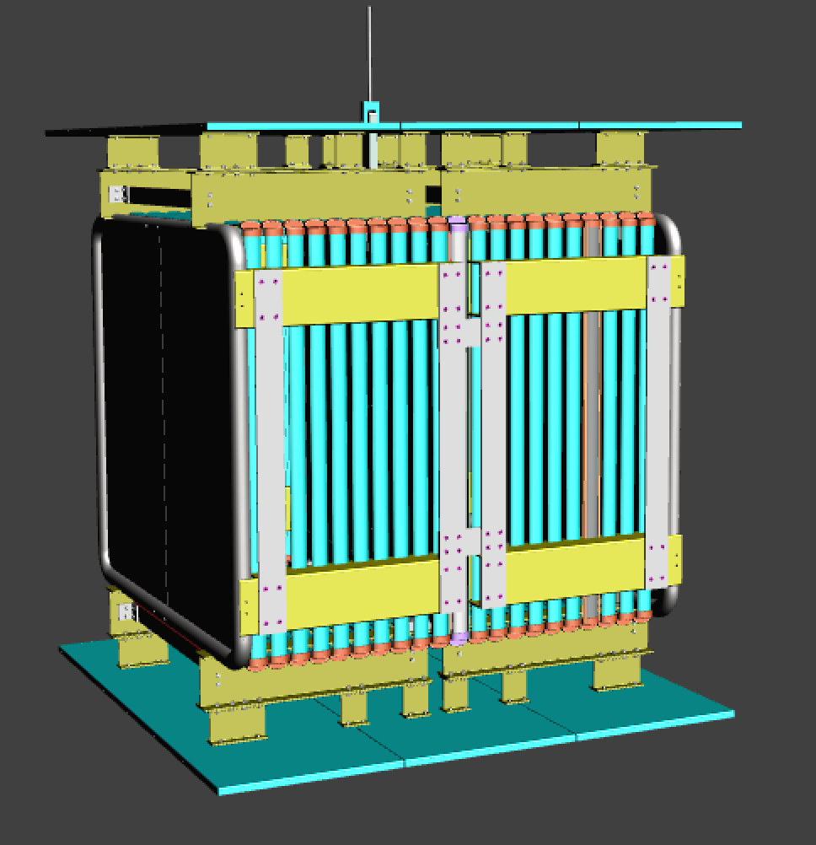
Figure 1: The field cage assembly to be tested. The cathode (darker blue) is planned to be at -180 kV. The relative anode (green) will be at -147 kV. A resistor network will grade the voltage to ground from the anode. Ground planes (gray) will be above, below, and behind the field cage.

Personnel and Institutions:
Lead Researcher for the R&D effort: [The lead researcher is the official contact and is responsible for forwarding all pertinent information to the rest of the group, arranging for their training and getting the necessary approvals for the R&D effort to begin testing and/or operations. See Sections V for more responsibilities.]
Sarah Lockwitz
Detector R&D Group Portfolio Manager/Contact: [Detector R&D Group Portfolio Manager/Contact who can assist with support and review of the project]
Brian Rebel
Fermilab Point of Contact (POC): Sarah E. Lockwitz
Other researchers working on the project are: (Please use full names, include institution or affiliation)
Institution | Country | Collaborator | ID# (if available) | Designation (student, prof., tech, etc.)
William & Mary | USA | Jeff Nelson | 07730V | Professor
 |  | Mike Kordosky | 09365V | Professor
Fermilab | USA | Alan Hahn | 08423N | Scientist
 |  | Sarah Lockwitz | 15893N
 |  | Mike Zuckerbrot | 15184N | Engineer
 |  | Frederick Schwartz II | 32365N | Engineer
Kansas State U. | USA | Glenn Horton-Smith | 11946V | Professor
BNL | USA | Bo Yu | 14352V | Scientist
 |  | James Stewart | 06639V | Scientist
 |  | Rahul Sharma | - | Engineer
LSU | USA | Thomas Kutter | 08040V | Professor
Stonybrook | USA | Michael Wilking | 10375V | Professor
U. of Chicago | USA | Victor Guarino | 12522V | Engineer
CERN | Switzerland | Francesco Pietropaolo | - | Scientist
ANL | USA | Zelimir Djurcic | 11901V
LBNL | USA | Cheng-Ju Lin | - | Scientist
 |  | Tim Loew | 33076V | Engineer
 |  | Will Waldron | - | Engineer
UCLA | USA | Hanguo Wang | - | Professor
U. of Houston | USA | Andrew Renshaw | 17918V | Professor

R&D Area and Other Considerations:

Location
    - The R&D effort will take place in PC4 using the 35 T cryostat. A desk space to the lab south of the cryostat will be maintained for computers and a high voltage power supply. The area to the lab north of the cryostat will be used for staging.
    - [List additional space needed and for what purpose. (ie. Work space, office space, storage space, meeting area, cosmic test area, static sensitive work room, etc.)]

R&D Effort Resource Needs

Area Infrastructure
[Describe the R&D effort setup, include weights and dimensions.
Include any facility infrastructure the R&D effort needs, like special power or cooling needs, crane coverage, ventilation, etc. Does the R&D effort use any gases? ]
The test TPC will be 1.5 m x 1.5 m x 1.5 m in size and is made from this stainless steel profiles held by an FR4 support structure. The researchers need access to TPC-quality liquid argon (τ ~ 3 ms), and liquid nitrogen for a condenser. Purity monitors and gas analyzers will be needed to monitor the quality of the argon. A 3 phase 208 V outlet is required if the use of a larger power supply is desired. A crane-like lift is needed to raise pieces to the top of the cryostat for installation.
After closing the cryostat, dry air is needed to flow through the cryostat and remove moisture. Cool gaseous argon will then be needed to flush the cryo-system. After the experiment, warm nitrogen may be used to help with the boil off process of the argon. Dry air will again be sent into after the boil off to get breathable air into the cryostat.

Engineering and Technical Resources
[Describe any technical resources you may need such as engineering for systems, drafting, trained operators of forklifts, cranes, rigging needs, etc. here]
The collaborators will need use of a crane or lift for installation of the device into the cryostat including moving the top flange. They may require a crane or lift to move the power supply. A technician will be on watch during the installation to meet the confined space rules.

Electronics and Computing Needs
[Particularly describe any non-commercial electronics, in depth. Please note: electrical diagrams that include power, wire gauge, fusing and grounding paths of any non-commercial electronics will need to be submitted two weeks prior to the Operational Readiness Clearance (ORC) review.]
[Include the line: See Appendix I for summary of PREP equipment pool needs. Or indicate that No PREP electronics are requested.]
The purity monitors use power supplies and NIM bins from PREP. These items are part of an existing request as the purity monitors have been used for other run and experiments.
[Does the R&D effort expect to bring any computers or other devices (besides personal laptops) that need to be connected to the Fermilab network? See https://fermi.service-now.com/kb_view.do?sysparm_article=KB0010655 for details.]
We will use existing Fermilab computers.

R&D Effort Planning Milestones
[R&D Effort milestones in sequence, including tentative dates for beginning the installation and for beginning data-taking. If the R&D effort requires construction of major pieces of equipment, the TSW should specify dates for one or more stages of the design, procurement and construction process.]
July 2016: Complete the design of the field cage components and order long lead-time items. Begin fabricating parts.
August 2016: Remove the 35 T TPC from the cryostat.
September 2016: Clean and preassemble parts at William and Mary.
October 2016: Ship the parts and begin installing in the cryostat.
November 2016: Finish installation. Purge, cool down, and fill the cryostat.
December 2016: Perform test.
January 2017: Warm up the cryostat.

Responsibilities by Institution – Non Fermilab

Name of Institution:
- [List or describe contributions to the R&D effort by this institution.]
- William & Mary: Responsible for delivery of the time projection chamber apparatus into the cryostat including cleaning of the parts. Specifically, collaborators from William and Mary will procure material and fabricate the field cage including the high voltage receptacle cup and assembly of the CERN-delivered ground planes. The researchers are responsible for cleaning all pieces, shipping to FNAL, and assembly in the cryostat. William and Mary will also ensure delivery of cameras including installation and readout to assist in diagnosis of high voltage instabilities.
- University of Chicago: Will provide engineering effort to design of the apparatus and make mechanical drawings.
- Kansas State U: Responsible for high voltage delivery. The collaborators are also responsible for the resistor network to ground including instrumentation and monitoring of the pick-off point, and a field shaping board (first from cathode plane). If the -250 kV Glassman is used, KSU is responsible for the controls.
- Brookhaven National Lab: Procure profiles that make up the time projection chamber stages and their endcaps.
- Louisiana State University: Responsible for the time projection chamber resistor network.
- UCLA: Will make a backup feedthrough. If supplying the feedthrough, a power supply and cable will be provided.
- Houston: Responsible for providing a resistive filter for the voltage out of the power supply and a corona monitor.
- LBNL: Will contribute to the assembly and disassembly of the TPC in the cryostat.
- CERN: Fabricate and ship resistive panel for the cathode. Procure ground planes and ship to William and Mary.
- Argonne National Lab: Will procure material and fabricate the CPA, APA, and a side ground wall including supports. Theese will be shipped to W&M for a test assembly. Mechanical drawings will also be provided.

Responsibilities by Institution – Fermilab

Fermilab Particle Physics Division and/or Neutrino Division:
[Detail any support by each division listed. If no support is required, please delete the section for that division. Please include any requested engineer or technician assistance for assembly, installation and maintenance.]
Neutrino Division will provide cryogenics support including filling and emptying the cryostat. Gas analyzers and purity monitors including personnel and computing support will also be provided. Technician from the division will assist with any crane needs during installation.
[Be sure to include Infrastructure needs specified in section 2.2.1]
[Be sure to include Crane/Forklift needs specified in section 2.2.2]
Conduct a NEPA review of the R&D effort.
Provide day-to-day ESH&Q support/oversight/review of work and documents as necessary.
Provide safety training as necessary, with assistance from the ESH&Q Section.
Update/create ITNA’s for users on the R&D effort. Responsibility of the spokesperson or Fermilab Point of Contact.
Initiate the ESH&Q Operational Readiness Clearance Review and any other required safety reviews.

Fermilab ESH&Q Section
Assistance with safety reviews.
Provide safety training, with assistance from PPD, as necessary for researchers. [0.2 FTE]

Fermilab Collaborators
If the R&D effort has a Fermilab component to the collaboration, this would be the place to include the responsibilities of the collaboration members and the items to be contributed, as well as manpower. These numbers should be included in table 4.4.1 Summary of Costs.
Alan Hahn will be managing the cryogenic side of the project, and Sarah Lockwitz will be coordinating the HV test effort. Frederick Schwartz and Michael Zuckerbrot will be contributing engineering effort for cryogenics.

Summary of Costs
Source of Funds [$K] | Materials & Services | Labor  (person-weeks)
Host Division(s) | 0.0 | 2.2
Scientific Computing Division | 0 | 0
ESH&Q Section | 0 | 0.2
Liquid argon | $60K
Alan Hahn |  | 20
Sarah Lockwitz |  | 20
Michael Zuckerbrot |  | 4
Frederick Schwartz |  | 4
Totals Fermilab | $0.0K | 1.7
Totals Non-Fermilab | [specify from Section III] | [specify]

- General Considerations
- The responsibilities of the participants in the R&D effort and the procedures to be followed by researchers are found in the Fermilab publication "Procedures for Researchers": (http://www.fnal.gov/directorate/PFX/PFX.pdf). The participants in the R&D effort agree to those responsibilities and to ensure that the researchers all follow the described procedures.
- To carry out the R&D effort a number of Environmental, Safety and Health (ESH&Q) reviews are necessary. This includes creating an Operational Readiness Clearance document in conjunction with the standing Particle Physics/Neutrino Division committee.
- All regulations concerning radioactive sources will be followed. No radioactive sources will be carried onto the site or moved without the approval of the Fermilab ESH&Q section.
- All items in the Fermilab Policy on Computing will be followed by the researchers. (http://computing.fnal.gov/cd/policy/cpolicy.pdf).
- The participants in the R&D effort will undertake to ensure that no PREP or computing equipment be transferred from the R&D effort to another use except with the approval of and through the mechanism provided by the Scientific Computing Division management. The Spokesperson also undertakes to ensure no modifications of PREP equipment take place without the knowledge and written consent of the Computing Sector management.
- The participants in the R&D effort will be responsible for maintaining both the electronics and the computing hardware supplied by them for the R&D effort. Fermilab will be responsible for repair and maintenance of the Fermilab-supplied electronics Any items for which the R&D effort requests that Fermilab performs maintenance and repair should appear explicitly in this agreement.
At the completion of the R&D effort:
- If applicable: The participants in the R&D effort are responsible for the return of all PREP equipment, computing equipment and non-PREP data acquisition electronics. If the return is not completed after a period of one year after the end of running the participants in the R&D effort will be required to furnish, in writing, an explanation for any non-return.
- The researchers agree to remove their R&D equipment as requested by the Laboratory. They agree to remove it expeditiously and in compliance with all ESH&Q requirements, including those related to transportation. All the expenses and personnel for the removal will be borne by the researchers unless removal requires facilities and personnel not able to be supplied by them, such as rigging, crane operation, etc.

Signatures:
The Lead Researcher on the R&D effort is the official contact and is responsible for forwarding all pertinent information to the rest of the group, arranging for their training, and requesting ORC or any other necessary approvals for the R&D effort to run. The Lead Researcher is responsible for marking equipment with emergency contact information. The Lead Researcher is responsible for removal of the equipment according to Fermilab Environmental Safety and Health Manual (FESHM) and Fermilab Radiation Control Manual (FRCM) rules. To ensure the safe removal of equipment, work planning exercises with ES&H, engineering and/or technical groups are required.

________________________________________________ / / 2016
[Name], R&D effort Lead Researcher

Items for which there is anticipated need should be checked.
See ORC Guidelines for detailed descriptions of categories.
There is no need to list existing facility infrastructure.

Flammables  (Gases or Liquids) |  |  | Gases |  |  |  | Hazardous Chemicals |  | Other Hazardous /Toxic Materials
Type: |  |  | Type: |  | Dry air, nitrogen, argon |  |  | Cyanide plating materials | List hazardous/toxic materials planned for use:
Flow rate: |  |  | Flow rate: |  | ~10 scfm |  |  | Hydrofluoric Acid
Capacity: |  |  | Capacity: |  |  |  |  | Methane
Radioactive Sources |  |  | Metals of Concern |  |  |  |  | photographic developers
 | Permanent Installation |  |  | Beryllium (Be) |  |  |  | PolyChlorinated Biphenyls (PCBs)
 | Temporary Use |  |  | Lithium (Li) |  |  |  | Scintillation Oil
Type: |  |  |  | Mercury (Hg) |  |  |  | TEA
Strength: |  |  |  | Lead (Pb) |  |  |  | TMAE
Nuclear Materials* |  |  |  | Tungsten (W) |  |  |  | Other: (Activated Water?)
Name: |  |  |  | Uranium (U)
Weight: |  |  |  | Other: |  |  | Lasers
Mechanical Structures |  |  | Electrical Equipment |  |  |  |  | Permanent installation
 | Lifting Devices |  |  | Cryo/Electrical devices |  |  |  | Temporary installation
 | Motion Controllers |  |  | Capacitor Banks |  |  |  | Alignment
 | Scaffolding/  Elevated Platforms |  | x | High Voltage/High Amperage |  |  |  | Calibration
 | Other: |  |  | Exposed Equipment over 50 V |  |  | Type:
 |  |  |  | Non-commercial/Non-PREP |  |  | Wattage:
 |  |  |  | Modified Commercial/PREP |  |  | MFR Class:
Vacuum Vessels |  |  | Pressure Vessels |  |  |  | Cryogenics
Inside Diameter: |  |  | Inside Diameter: |  |  |  | x | Inert cryogenic liquids
Operating Pressure: |  |  | Operating Pressure: |  |  |  |  | Hydrogen cryo liquids
Window Material: |  |  | Window Material: |  |  |  |  | Other cryo liquids
Window Thickness: |  |  | Window Thickness:

*NUCLEAR MATERIALS
Reportable Elements and Isotopes / Weight Units / Rounding

Name of Material | MT  Code | Reporting Weight Unit Report to Nearest Whole Unit | Element Weight | Isotope Weight | Isotope Weight %
Depleted Uranium | 10 | Whole Kg | Total U | U-235 | U-235
Enriched Uranium | 20 | Whole Gm | Total U | U-235 | U-235
Plutonium-2421 | 40 | Whole Gm | Total Pu | Pu-242 | Pu-242
Americium-2412 | 44 | Whole Gm | Total Am | Am-241 | –
Americium-2432 | 45 | Whole Gm | Total Am | Am-243 | –
Curium | 46 | Whole Gm | Total Cm | Cm-246 | –
Californium | 48 | Whole Microgram | – | Cf-252 | –
Plutonium | 50 | Whole Gm | Total Pu | Pu-239+Pu-241 | Pu-240
Enriched Lithium | 60 | Whole Kg | Total Li | Li-6 | Li-6
Uranium-233 | 70 | Whole Gm | Total U | U-233 | U-232 (ppm)
Normal Uranium | 81 | Whole Kg | Total U | – | –
Neptunium-237 | 82 | Whole Gm | Total Np | – | –
Plutonium-2383 | 83 | Gm to tenth | Total Pu | Pu-238 | Pu-238
Deuterium4 | 86 | Kg to tenth | D2O | D2
Tritium5 | 87 | Gm to hundredth | Total H-3 | – | –
Thorium | 88 | Whole Kg | Total Th | – | –
Uranium in Cascades6 | 89 | Whole Gm | Total U | U-235 | U-235

1 Report as Pu-242 if the contained Pu-242 is 20 percent or greater of total plutonium by weight; otherwise, report as Pu 239-241.
2 Americium and Neptunium-237 contained in plutonium as part of the natural in-growth process are not required to be accounted for or reported until separated from the plutonium.
3 Report as Pu-238 if the contained Pu-238 is 10 percent or greater of total plutonium by weight; otherwise, report as plutonium Pu 239-241.
4 For deuterium in the form of heavy water, both the element and isotope weight fields should be used; otherwise, report isotope weight only.
5 Tritium contained in water (H2O or D2O) used as a moderator in a nuclear reactor is not an accountable material.
6 Uranium in cascades is treated as enriched uranium and should be reported as material type 89.

- OTHER GAS EMISSION
Greenhouse Gasses (Need to be tracked and reported to DOE)
- Carbon Dioxide, including CO2 mixes such as Ar/CO2
- Methane
- Nitrous Oxide
- Sulfur Hexafluoride
- Florinaded Gases (eg; Hydrofluorocarbons, perfluorocarbons)
- Nitrogen Trifluoride

The following people have read this TSW:

________________________________________________ / / 2016
Detector R&D Group Leader (determines appropriate sign-offs below)
________________________________________________ / / 2016
Host Division DSO
________________________________________________ / / 2016
Area Coordinator
________________________________________________ / / 2016
Detector Development & Operations Department Head
_________________________________________________ / / 2016
Mechanical Engineering Department Head
_________________________________________________ / / 2016
Electrical Engineering Department Head
_______________________________________________ / / 2016
Host Division, Division Head

