Measurement of the Beam Longitudinal Emittance in the Booster at Injection and Extraction

Demetrius Andrews, Virginia Tech

August 17, 2016



**Overview**

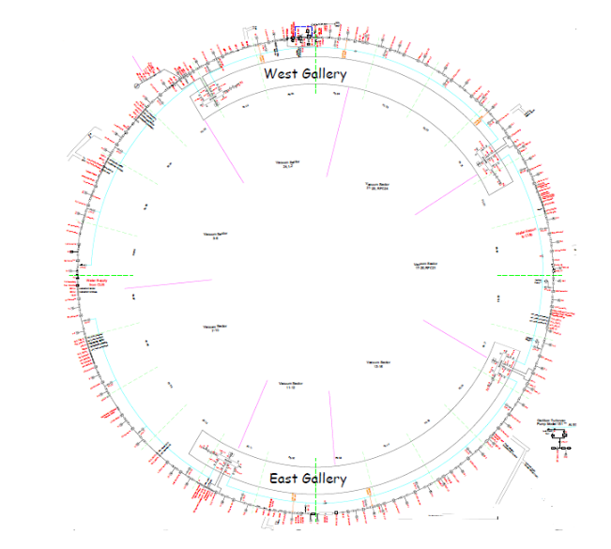The Booster is a synchrotron that is a part of the Fermilab accelerator complex. A synchrotron is a type of cyclic particle accelerator that uses focusing, defocusing and bending magnetic devices (magnets) to guide charged particle in a high vacuum beam pipe. A set of radiofrequency (RF) cavities are used to bunch the beam and to accelerate them to a higher energy (or decelerate the beam) in synchrotrons. An important feature of synchrotrons is that it uses phase focusing which allows a particle to gain the desired energy during acceleration. The Booster is a proton synchrotron, which accelerates protons with an injection kinetic energy at 400 MeV to an energy of 8 GeV at extraction. The Booster is the second step in the current proton acceleration process. It lies between the LINAC (Linear Accelerator) and the Recycler synchrotron. The Booster consists 96 dipoles magnets and large number of horizontal and vertical dipole correctors, quadrupoles and higher ordered correctors to beam keep beam particles in the machine during the course of injection, acceleration and extraction.

*Figure 1: Layout of the Booster Ring*

Since the acceleration of protons in the Booster occurs so early in the process it is important that it runs efficiently. In this regard, it is highly desirable to measure and understand beam properties in the Booster at various stages of the acceleration process. This is why a program was developed to help track and measure the emittance of the beam.

*Injection Process*

The LINAC delivers 400 MeV H- ions to the Booster with a bunch structure of 200 MHz. The length of the LINAC beam can vary, but has a max length of 40 microseconds. A dipole is then used to bend the beam upwards into the Booster from the LINAC. The LINAC is at a higher elevation as compared with the plane of the Booster synchrotron. As a result of this beam is bent vertically downwards before injection in to the Booster. The vertical bend of the beam causes some dispersion as it travels 70 meters through a transport line. To reduce beam energy spread at injection an 800 MHz debuncher RF system is used. This debuncher RF cavity is situated nearly at the mid-point between Booster Ring and the last magnetic element in the LINAC. An injected proton typically travels around the Booster ring once in about 2.2 microseconds. The Booster is capable of creating 18 Booster turns, which takes up around 39.6 microseconds of the 40 microsecond LINAC pulse. Interference (beams colliding into each other) doesn’t occur because injected beam is H- and circulating beam is H+ (proton) – thus the incoming beam can merge with the circulating beam. The beam then travels inward after filling of the beam is complete.

*Booster Overview*

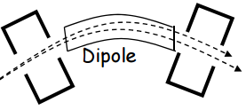 A combination of dipole magnets bend the injected beam around the ring of the Booster. These are combined function magnets, i.e., the North pole and South pole faces of these magnets are not parallel. They are at an angle. As a result of this, there are some quadrupole, sextuple and higher ordered magnetic poles contribute to the beam particle motion along with the dipole component. Additional corrector dipole magnets, quadrupole magnets and other multipole magnets are used for fine tuning of the beam.

*Figure 2: Shows how dipole magnets are used to bend the path of the beam*

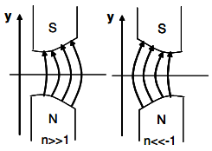The beam is able to remain in a constant closed orbit around the ring due to the simultaneous focusing and defocusing of particles as they pass through the magnets. The magnets either focus the particles vertically and defocus horizontally or focus horizontally and defocus vertically. The beam accelerates as it passes through the RF cavities. The RF frequency of the cavities is increased in synchronized with the revolution period of the beam in the Booster. For example, the revolution period decreases from 2.2 μsec to 1.59 μsec from injection to extraction.

*Figure 3: Shows the combined function magnets working together on the beam*

The phases of the acceleration cycle are injection, acceleration, and extraction. During the injection process the beam from the LINAC enters the Booster and there is a de-bunching and capture process. In the acceleration stage, the beam’s energy increases. The final stage of extraction takes the beam and shoots it into the Recycler Ring. The frequency of the RF cavities and magnet strength must increase to stay in tune with the accelerating particle.

The final frequency is 52.81 MHz from a starting frequency of 37.86 MHz The ratio of the RF frequency to that of the revolution frequency of the beam (harmonic number, h) is 84. Which creates 84 bunches of particles also called buckets that can capture and accelerate the beam particles.

*The Physics of Emittance*

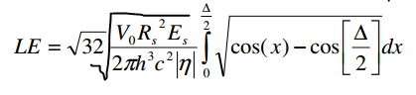Emittance is the phase space area that encapsulates all the particles in the beam. A beam has a horizontal, a vertical and longitudinal emittances. These quantities are generally independent and can be measured separately. My project is focused on measuring only the longitudinal emittance of the beam in the Booster. The computer program that I have written during this summer calculates the longitudinal emittance of the beam by taking in different parameters of the beam and multiply it by a function integrated from 0 to half the bunch length (delta), measured in radians. The longitudinal equation [1] is as follows:

V0 is the corresponding peak voltage on the RF cavity. Rs is the beam radius, Es is the synchronous energy, and is the slip factor. The unit of longitudinal emittance is eV-secs. If emittance is represented as a cloud in a plot, then the area of the cloud is the emittance. A lower emittance is desired to have a higher brightness for the beam.

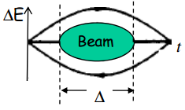

*Figure 4: Example of emittance of a beam*

*Program*

Computer program was written in Python programming language and it takes raw beam data from three of the channels of a scope used in the Booster. There are also two traces at injection and extraction for each graph amounting to a total of six graphs. The goal of the program is to take this raw data and analyze the three channels in order to find the longitudinal emittance of the beam. Data is also used to find beam height and bucket height. The program operates as follows:

1. The program takes the raw data from the wall current monitor (WCM), RF voltage, and radial positioning at injection and extraction.
2. Then, the program checks for the location in which the radial position clearly begins to decline and stops oscillating. This corresponds to beam acceleration point.
3. The program then locates the distance from one notch to the next notch in a set of data that corresponds to the location found in step 2.
4. A fast Fourier transform (FFT) is also performed to find the frequency and revolution period of the beam over that length.
5. A Gaussian filtering is then used over that length to find the bunch length of the beam.
6. When the bunch length is found, the program then uses data to calculate the longitudinal emittance.
7. The data is then plotted for visual reference.

Finding the emittance of the beam is another way to also check for the brightness of the beam. The results of these measurements are highly valuable to determine the quality of the beam and guide us to improve Booster performance for future experiments.

*Data Analysis*

The raw data received from the scope had two traces for each channel. The WCM data appears as shown in Figures 5 and 6.

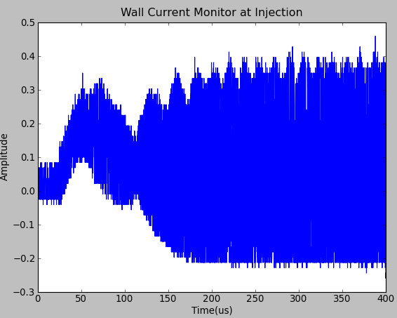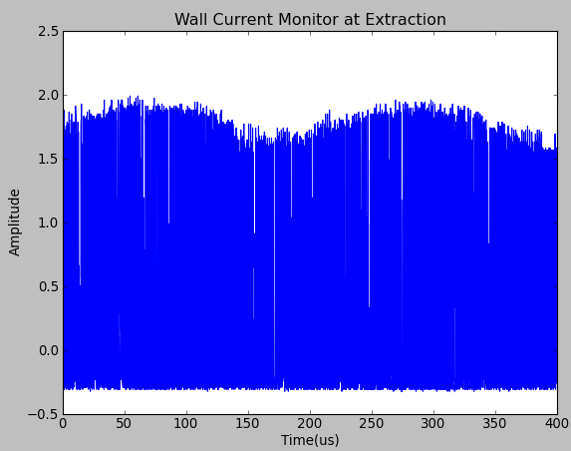

*Figure 5 & 6: The figure on the left is the first trace of the WCM at injection and beam capture. The figure on the right shows the WCM data at extraction. Both span about 400 microseconds.*

The WCM is an AC coupled system, which helps us to measure bunch profile, i.e., longitudinal distribution of the beam particle around the ring.

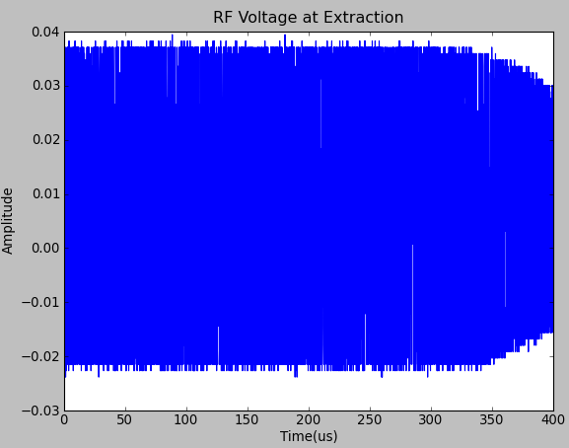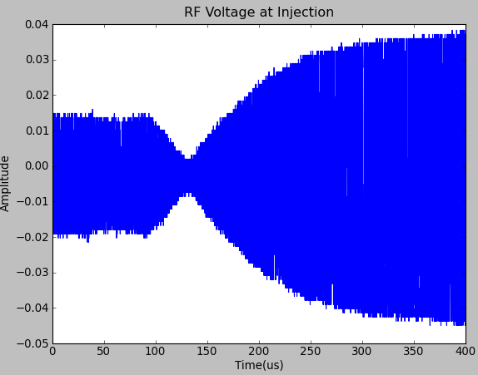The RF voltage appears as:

*Figure 7 & 8: RF voltage at injection on left and RF voltage at extraction on the right*

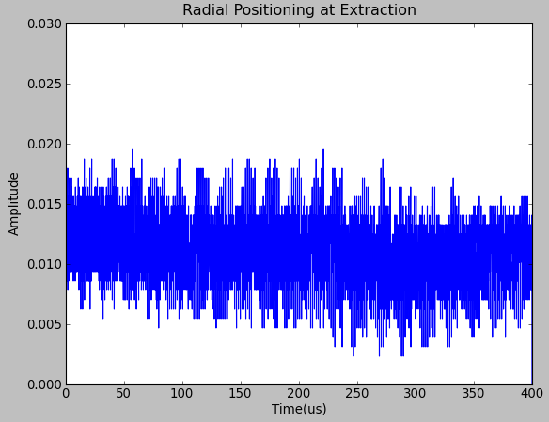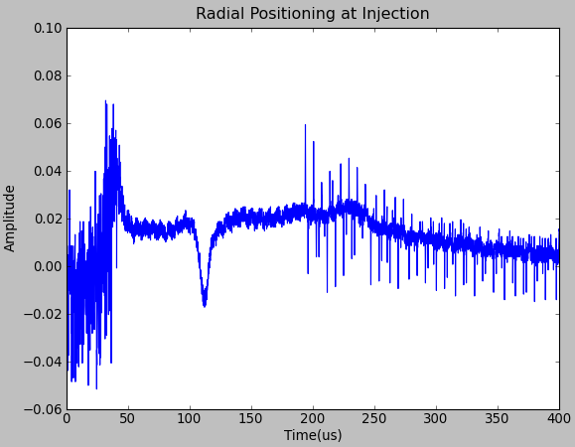 The RF voltage is also measured over a period of 400 microseconds. One can tell that the intensity of the RF voltage at injection increases significantly after 150 microseconds.

*Figure 9 & 10: Raw data for Radial Position at injection and extraction*

The graph of the radial position can be used to infer the location of the start of the beam acceleration. For example, a kink around 240 micro second in the Figure 11 shows end of the beam capture and start of the beam acceleration. In this picture we are interested in data just before start of the

*Location of Max value in Radial Positioning*

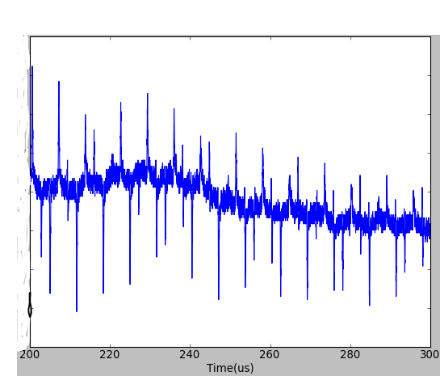 The first step was cutting off the first 199 microseconds of the graph shown in Figure 9 and only plotting from 200 microseconds and beyond. There was a cutoff after 300 microseconds because that part of the data clearly occurs after the maximum and remains more constant. So, the time period between 200-300 microseconds was used.

*Figure 11: Magnified view of desired section of radial positioning*

The data has outliers in it that skews the data. This prevents the program from taking an absolute maximum over this period. The data had to be smoothed and then averaged in order to find an absolute maximum value. The location of the time where the maximum occurs is the starting point for the plot of the WCM data. The period and revolution are then able to be extracted.

*Extraction and Injection Location and Fast Fourier Transform*

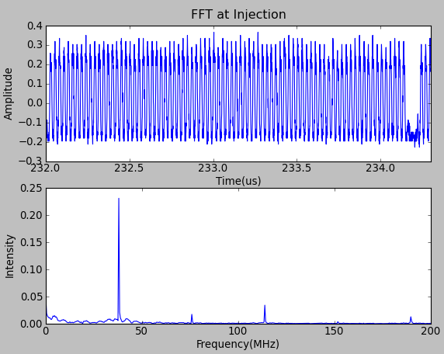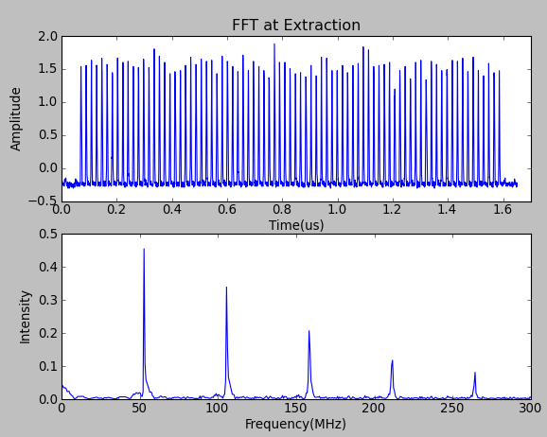The region around 232 µs and 234 µs found to be end of beam capture and used for further analysis. A fast Fourier transform (FFT) on the data in this region of the WCM data gives the RF frequency of 37.9 MHz at the end of the beam capture. Revolution period To= h/RF frequency. This gives revolution period of 2.21 µs. At extraction the RF frequency is 52.7 MHz, with a corresponding period of 1.59 µs. The diagrams below give a better idea of how the bunch looked and its FFT.

*Figure 12 and 13: Bunch data at inj. and ext. with bunches (above) and FFT (below)*

With this data I was able to find the bunch length necessary to find the longitudinal emittance.

*Finding the Bunch Length*

 The bunch length was found by using the following equation [2]:

λ =3, corresponds to the third harmonic of the fundamental frequency, and V (λω0) is the magnitude at each harmonic. Then 4σ bunch length is determined. And then used in equation [1] to find the longitudinal emittance. The bucket height and beam height was also calculated using the equation [3] and equation [4] respectively,

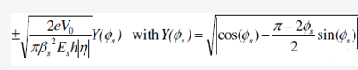

[3]



[4]

**Results**

Once the longitudinal emittance, beam height, and bucket height were calculated at the sample data of 13 Booster turns, two sets of data were taken at 8, 10,12,14,16, and 18 Booster turns. The chart below shows the longitudinal emittance (eV-s) and beam height (MeV) at both injection and extraction

|  |  |  |  |  |
| --- | --- | --- | --- | --- |
| **Booster Turns** | **Emittance(eV-s)** | | **Beam Height(MeV)** | |
|  | Injection | Extraction | Injection | Extraction |
| **8_1** | 0.027 | 0.101 | 1.535 | 16.633 |
| **8_2** | 0.0274 | 0.1042 | 1.54 | 16.882 |
| **10_1** | 0.02603 | 0.1037 | 1.503 | 16.856 |
| **10_2** | 0.02686 | 0.1051 | 1.525 | 16.953 |
| **12_1** | 0.02552 | 0.1163 | 1.489 | 17.838 |
| **12_2** | 0.02525 | 0.1104 | 1.481 | 17.367 |
| **13** | 0.02 | 0.1347 | 1.327 | 19.162 |
| **14_1** | 0.02531 | 0.1311 | 1.483 | 18.918 |
| **14_2** | 0.02607 | 0.1208 | 1.504 | 18.151 |
| **16_1** | 0.02664 | 0.1248 | 1.519 | 18.459 |
| **16_2** | 0.02686 | 0.1271 | 1.525 | 18.629 |
| **18_1** | 0.02685 | 0.1387 | 1.525 | 19.436 |
| **18_2** | 0.027 | 0.132 | 1.529 | 18.983 |

**Data Chart**

*Figure 14: Shows the beam height and emittance for the two sets of data at different Booster turns*

The chart shows that the beam height at extraction increases significantly from the injection beam height. The emittance also increases from injection to extraction. The next chart shows the beam intensity at each Booster turn, the average, and half deviation.

The data shows that as the number of Booster turns increases the beam intensity also increases. The beam intensity is measured in protons per cycle (ppc).

|  |  |  |  |  |
| --- | --- | --- | --- | --- |
| **Intensity** | **Emittance(eV-s)** | | **Beam Height(MeV)** | |
|  | Injection | Extraction | Injection | Extraction |
| **2.64E12ppc** | 0.027 | 0.103 | 1.5 | 16.8 |
| **Half Deviation** | 0.0002 | 0.0016 | 0.0025 | 0.1245 |
| **3.38E12ppc** | 0.026 | 0.104 | 1.5 | 16.9 |
| **Half Deviation** | 0.000415 | 0.0007 | 0.011 | 0.0485 |
| **4.02E12ppc** | 0.025 | 0.113 | 1.5 | 17.6 |
| **Half Deviation** | 0.000135 | 0.00295 | 0.004 | 0.2355 |
| **4.78E12ppc** | 0.026 | 0.123 | 1.5 | 18.5 |
| **Half Deviation** | 0.00038 | 0.00515 | 0.0105 | 0.3835 |
| **5.26E12ppc** | 0.027 | 0.126 | 1.5 | 18.5 |
| **Half Deviatio** | 0.00011 | 0.00115 | 0.003 | 0.085 |
| **5.58E12ppc** | 0.027 | 0.135 | 1.5 | 19.2 |
| **Half Deviation** | 7.5E-05 | 0.00335 | 0.002 | 0.2265 |

*Figure 15: Shows average of each Booster Turn (descending from 8-18) and associated Intensity*

**Final Remarks and Acknowledgments**

Gaining a better understanding of beam emittance is very important for the Booster as future experiments are set to begin in the next few years. Attaining a lower emittance for the Booster is desired, so that the beam brightness and intensity can improve. I want acknowledge my supervisors Dr. Chandra Bhat and Brian S. Hendricks for providing me with my assignment and teaching me about the accelerators and control system at the Fermilab Accelerator Complex this summer.

**References**

**[1] Bhat, Chandra, Dr. "Aspects of Longitudinal Beam."**

**[2] Drennan, Craig. "Booster Bunch Length Monitor." N.p., 23 Oct. 2009. Web.**

**[3] Bhat, Chandra, Dr. "Practical Accelerator Physics." N.p., 7 Jan. 2008. Web.**