ProtoDUNE-SP System Testing and Exploitation

# Introduction

The principle idea behind the DAQ testing plan for ProtoDUNE-SP is to facilitate the timely installation of the detector to allow for data taking in 2018. To this end, the DAQ will follow the APA installation timeline, and overall commissioning timeline of the detector. Where possible, parallel development and testing paths have been adopted to allow work to happen at the same time, and reduce competition for resources and coupling of independent systems.

Throughout this document, dates are organised relative to the ProtoDUNE APA and commissioning schedule. A detailed spreadsheet of tests with expected completion dates can be found here:

<https://docs.google.com/spreadsheets/d/10qfOsnc2UKal0J8Bkml8FM-dLaWvlgMO5IDiAU41JA8/edit?usp=sharing>

The installation schedule is shown in the following figure:

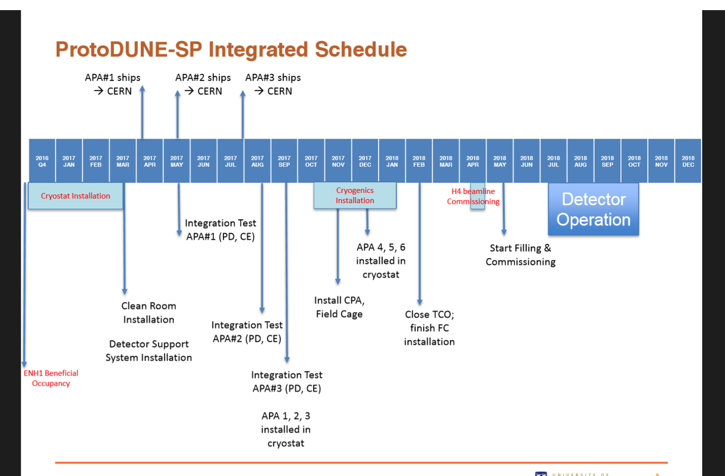

# Late 2016 testing centres

Several test centres have been set up focussing on different areas of DAQ testing. For the most part, the test centres have been organised geographically so that teams can work efficiently without suffering delays due to travel and timezone differences. Here outlines each of the test centres, their focus, current and future work.

## UK

The UK testing is focused on setup of the readout boards and associated infrastructure (servers, networking, etc) and the artDAQ BoardReaders responsible for accepting the data, and sending configurations messages to the readout boards. A replica slice of the 35t prototype was used as a starting point to learn how to deploy such a system. This knowledge will be invaluable at CERN for the initial RCE and SSP installation. So far, the RCE and SSP data readout has been validated using this strategy with data being read from both boards to the artDAQ framework and stored to disk.

In the lead up to the end of 2016, the UK test stand will be updated (software and firmware) to that which will be installed in ProtoDUNE. An emulator of the new Warm Interface Board (WIB) will also be added to the chain and used to test new data formats, BoardReaders and firmwares.

The ProtoDUNE timing system prototypes will be initially tested in the UK test-stand. This is a crucial component for the entire DAQ and essential that it is produced and tested as soon as possible. Tests will include basic operation (clock recovery, etc.) with the RCEs and SSPs.

## US

The US testing is focused on the testing of dataflow through artDAQ and performance improvements thereof. Much in a similar vein to the UK testing strategy – a clone of the 35t artDAQ software was used as a basis for the testing. This has since had many performance enhancements. The current slew of testing uses the artDAQ demo project which allows the user to use generated data rather than real hardware for testing. Performance and throughput have been tested of late on the BoardReader, EventBuilders and Aggregators in attempt to find bottlenecks in the software.

Unlike the other testing sites, which will mostly migrate to CERN for integration, the artDAQ testing stand will remain in operation as a means to validate new versions before rollout to CERN and as a cross-check of possible problems that arise at CERN.

Other developments include merging of artDAQ with the CERN Joint Controls Project [JCOP] software which will become the Run Control for ProtoDUNE.

## FELIX testing at PNNL and NIKHEF

Although geographically separated, PNNL and NIKHEF share the goal of testing the FELIX readout board and its integration into ProtoDUNE. Testing includes new firmware testing – particularly of the “Full GBT” mode which will be used for ProtoDUNE, loopback testing for throughput, and development of the FELIX BoardReader in artDAQ.

By mid-2017, different compression schemes will have been evaluated, and tests will be peformed with the new WIB in FELIX mode.

## CERN

As CERN will become the final installation site, most of the testing from 2017 onward will be performed here. The experience gained at the other testing sites will be used to set up for the initial vertical slice test at CERN. Apart from the overall integration, much of the Run Control will be developed and tested at CERN.

# APA integration and testing

From January 2017, most effort will be driven to installing and preparing the DAQ for Cold Box tests and APA installation and integration. The EHN1 area is expected to be ready (in terms of power and cooling) for DAQ installation in March 2017. The DAQ will need the computing infrastructure (computers, operating systems, software installation) to be ready for users as soon as possible. The DAQ components will be assembled into racks. Software and components from the UK and US test-stands will be integrated.

Once all of the initial infrastructure is in place, it will be necessary to set up the DAQ for reception testing. Initial reception tests will be of the DAQ and electronic components themselves (RCE, WIB, SSP, FEMB). Apart from the APA itself, at least one of each of the components necessary to make a minimal detector slice (from FrontEnd to Storage) will be available in January at CERN. Initialisation and synchronisation tests will follow shortly afterwards.

Reception testing will be in coordination between CERN and the “source institute” such that repeat testing can be performed at source and destination to identify any problems in transit. Strict quality control procedures need to be in place, and all qualification tests documented and logged for historical record. The reception testing will be supported by a material tracking database, servers for electronic logbook and documentation.

## First APA arrival at CERN

In April 2017, the DAQ is expected to be ready to be used with the “Cold Box” setup to be able to the the initial APA upon its arrival at CERN. At this point, it is planned to split the DAQ into two partitions. This is most likely to be a physical splitting (rather than virtual, where software takes care of the separation). The first partition will be designated for use with APA and electronics testing. The DAQ operation of this partition should be considered stable and not subject to new hardware or software rollout.

## First to third APA arrival at CERN

The second partition will be dedicated to DAQ development. It will be used to develop the Run Control, test new DAQ firmwares, and develop the online monitoring. A mock data challenge will be performed to qualify the DAQ computing cluster and its connection to storage. Beam instrumentation prototypes are expected to appear at this point and will be tested with a prototype of the trigger board.

## Fourth to Final APA arrival at CERN

This period is expected to cover the last quarter of 2017. At this point the reception testing should be a streamlined operation, as all of the final parts of the experiment arrive at CERN. At the same time the final versions of the timing and trigger systems will be in place. Run Control and monitoring will be at a full operational level, and artDAQ latest developments will have been installed. The last of the computing cluster will be installed and a full data challenge will be performed to check out the completed system.

# Commissioning

At the beginning of 2018, the integration of the APAs and reception tests should have completed. The partition responsible for the reception testing will be absorbed back into the development partition and inherit all the developments that occurred since the split. This complete DAQ system will be brought to a stable condition, and updates will be rolled out periodically and tested extensively. A new virtual parititioning scheme will be put in place such that commissioning work can be performed in parallel. Testing will focus on robustness of the system, and integration of the beam instrumentation and preparation for cosmic and eventually beam data taking. Nearline data taking modes with the CRT and Beam Instrumentation will be performed in coordination with the offline computing groups.

A review of the integration and partitioning of the DAQ is shown in the figure below.

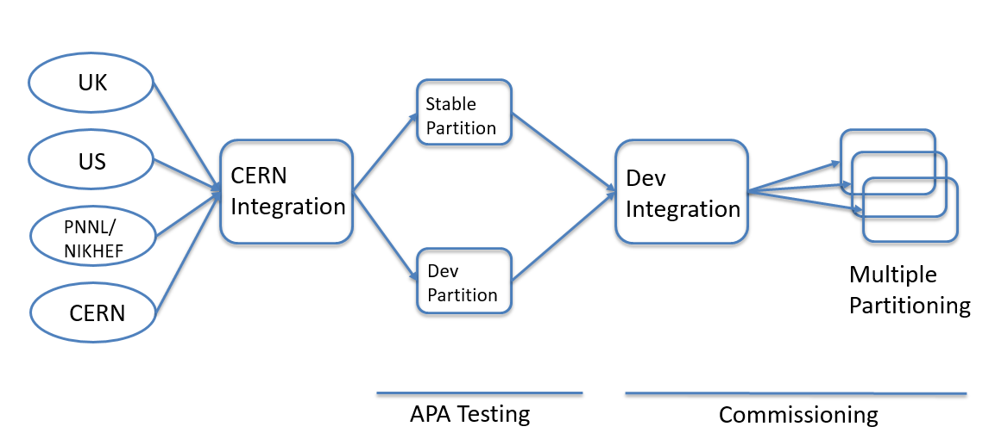

# Critical tests

Here are described some tests with the greatest impact on the progress of the ProtoDUNE DAQ.

## APA response calibration

Qualifying and installing the APA and front-end electronics is essential to ensure the healthy operation of the detector and achieve its peak performance. This task goes beyond just the DAQ and requires close collaboration with colleagues in the APA, Cold Electronics and Photon groups. The following is a small example of the types of tests expected:

* TPC noise characterisation
* APA Wire testing/Cable-Channel Mapping
* SSP threshold scans – for signal optimisation
* TPC drift time calibration – may take 5ms of drift time, but prefer more post-trigger info than pre-trigger.
* HV scans

To facilitate these tests the DAQ must provide the necessary data taking infrastructure. For the TPC, this would be readout of noise or pulse data. For the photon detector this would mean reading out the PDS waveform data. This differs from standard readout and the SSP BoardReader must be able to process this data. Other special data taking may require similar changes to BoardReader configuration. The DAQ will provide the online monitoring framework for producing plots required for specific tests. The plot content and algorithms however, are the responsibility of the detector/device experts (assistance will be provided whenever possible).

## Synchronisation tests

In order to have data useful for physics, the detector readout must be fully synchronised. This means that signals must sampled in coincidence on the front-end and the same samples must arrive in the same event on disk.

The first simplest test will be to check the timing with pulse injection on the FEMB. The data must pass from the FEMB, through the WIB, to the RCE, and then to artDAQ. A single pulse and appropriately timed (delayed) trigger to the RCE will ensure the correct data sample is captured. This first test demonstrates the method of delay determination. This can then be expanded to multiple front-ends. Some slight timing variation is to be expected as a function of cable length, but this is not expected to be a significant factor in ProtoDUNE, as the overall drift length of 5 ms dominates.

A similar set of tests can be performed with the PDS and an LED pulse injection. Following that, the process is repeated with both RCEs and PDS simultaneously. This process of delay determine will be automated in time. The process will be repeated several times during commissioning to time to the beam using triggers from the Beam Instrumentation.

## Data Challenge

Two or more data challenges will be performed during 2017. The first of which will be early to qualify the performance of artDAQ and the computing cluster. In this case, the data generators will be employed to feed data into the BoardReaders at a rates comparable to beam data taking (and higher to stress test the system). These data generators may be “in FPGA” generators on the WIB or RCE or from the front-end by lowering thresholds to generate many noise hits.

Each element of the artDAQ chain will be measured individually (BoardReaders, EventBuilders, Aggregators), and also performance the storage systems. The last challenge will be a checkout of the complete system towards the end of 2017. As commissioning progresses towards shifter operation in 2018, the system will be continually tested for long periods.

# Calibration and Run Modes

In 2018, the data taking period with cosmics preceding the beam data taking will be crucial for calibration of the ProtoDUNE detector. The cosmic data rate will dominate the beam rate significantly and will therefore provide a detector occupancy close to beam conditions. It will allow for early testing of the compression schemes used for both the RCEs and the FELIX. Periodic or random fake trigger signals can be used to simulate the 25 Hz trigger rate and the beam spill structure. Naturally, higher rates will be tested to find the extreme limits of the system.

Aside from physics data taking modes, the Photon calibration modes, TPC triggerless modes, and tests with the beam instrumentation are expected.

Once beam arrives, most of the time running will be dedicated to physics data taking. There will also be special runs for:

* Photon detector only – waveforms for calibration
* Threshold scans for beam trigger calibration (expected for different beam modes)

# Risks

* Delays to EHN1  
  Any delays to the readiness of EHN1 for DAQ installation and integration could seriously affect the schedule for APA testing. Other areas at CERN are available which can be used for DAQ installation and testing, however installation followed by movement and installation is considered undesirable and has an associate risk itself.
* High noise affecting RCE compression  
  Effective compression relies on a reasonable signal-to-noise ratio. If this is too low the compression may become ineffectual. Several compression schemes are being tested for both low and high noise scenarios. The overall data size could be compensated by reducing the inter-spill data taking, and reducing the drift margin (currently taking 2x drift time).
* Backpressure  
  Extensive testing will be put in place to avoid backpressure where possible and monitor it should it happen. To restrict the effects of backpressure, buffers can be reset at the end of the spill cycle – ensuring that the system is always in same state at start of spill. A software trigger throttle will also be put in place to lower the trigger rate to compensate.
* Monitoring  
  A lack of manpower actively working on this area exists. The basic 35t monitoring software exists as a backup solution. Incorporating frameworks from other LAr experiments is also a possibility
* New critical components   
  If the WIB is late it hampers our ability to test the front-end and prepare for APA testing.

A mitigation is to use WIB-emulator where possible.

* Channel mapping  
  This must be established early to avoid mistakes in the data interpretation. It can lead to incomprehensible data, and is very difficult to fix on the spot. Appropriate use of labelling, database tracking, verification of channel mapping with pulse injection is essential.

# References

* 35t lessons learned
  + http://docs.dunescience.org:8080/cgi-bin/ShowDocument?docid=1315
* Risk register
  + <https://docs.google.com/document/d/1-sa5M29dshODIRxJVc7A5Zde4Pv_u9h8JeV3t2mNLvY/edit?usp=sharing>
* Detailed Testing plan
  + <https://docs.google.com/spreadsheets/d/10qfOsnc2UKal0J8Bkml8FM-dLaWvlgMO5IDiAU41JA8/edit?usp=sharing>