2017-01-12 LCLSII pCM workshop

Is a beamline purge system necessary during assembly? (Tug Arkan, Ari Palczewski) 8am-8.30am

**•               What beamline purge system is being used and how does this compare to XFEL?**

Status at TTC topical clean room assembly 2014: <https://indico.in2p3.fr/event/10347/timetable/#20141113.detailed>

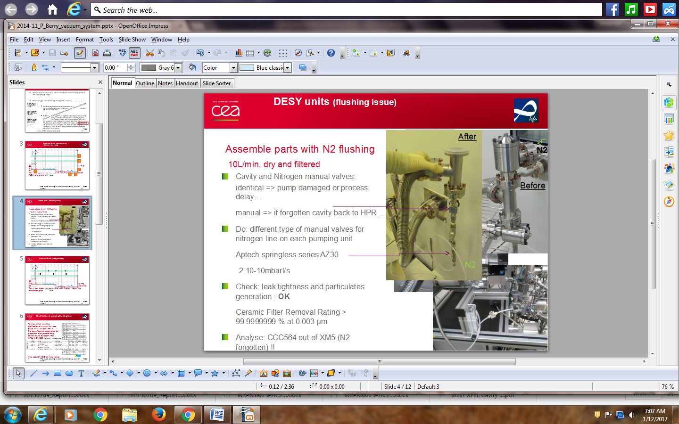

What has been change since 2014:

* change the Aptec valves for all metal valve VAT DN16CF

### the solution 3 has been put in place : for detail see [Clean Room Integration of the European XFEL Cavity Strings](http://accelconf.web.cern.ch/AccelConf/IPAC2014/papers/wepri001.pdf#search=%20domain%3Daccelconf%2Eweb%2Ecern%2Ech%20%20%2Bauthor%3A%22berry%22%20%20url%3Aaccelconf%2FIPAC10%20url%3Aaccelconf%2FIPAC2011%20url%3Aaccelconf%2FIPAC2012%20url%3Aaccelconf%2FIPAC2013%20url%3Aaccelconf%2FIPAC2014%20url%3Aaccelconf%2FIPAC2015%20url%3Aaccelconf%2Fipac2016%20FileExtension%3Dpdf%20%2Durl%3Aabstract%20%2Durl%3Aaccelconf%2Fjacow) accelconf.web.cern.ch/AccelConf/IPAC2014/papers/wepri001.pdf

* The component in the rectangle are used as a tool (means stays on the cavity until the cavity is connected to the string)
* Allow to reduce by about 2 the number of cavity valve close-open cycle and number of connection to cavity

The result on cavity performance after integration is XFEL module performance:

NO PERFORMANCE DEGRADATION in module compare to vertical test

**•               Should a study of the beamline purge use be carried out to understand the correct flow to be used and particle migration?**

The **maximum** **venting flow** is based on data (Zapfe SRF2007): 50mbarl/s (3L/min for N2)

The **purging flow** is based on DESY experience: 10L/min (depending on cavity port aperture)

PARTICLE FREE PUMP DOWN AND VENTING OF UHV VACUUM SYSTEMS

K. Zapfe and J. Wojtkiewicz

Proceedings of SRF2007, Peking Univ., Beijing, China WEP74

Results: Turbulences move particles over meters

Caution: Avoid p =1 mbar

In pressure range P>1 mbar flow

Venting of the vessel starts by setting mass flow controller 1 to a throughput of 50 mbar l/s (3L/min for N2)

Same for pumping

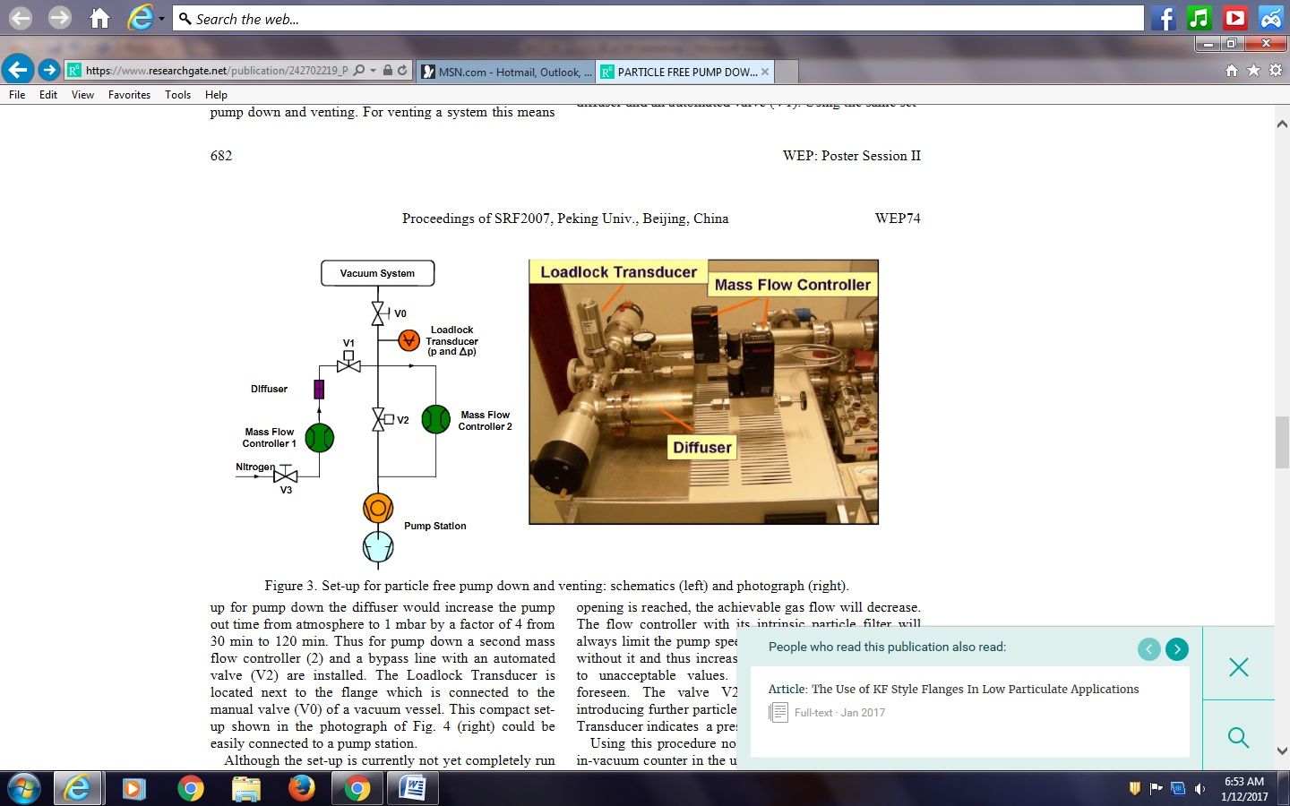

Differences in assembly techniques for string assembly at FNAL and JLab and possible correlations to CM performance (Tug Arkan, Danny Forehand) 8.30am – 9.30am

Issues identified during pCM assembly that need to be improved –path forward, lessons learned (Tug Arkan, Kirk Davis, Danny Forehand) 9.30am – 10.30am

Copper plated components – bare spots, oxidation and cleaning (Katherine Wilson) 10.30am – 10.30am

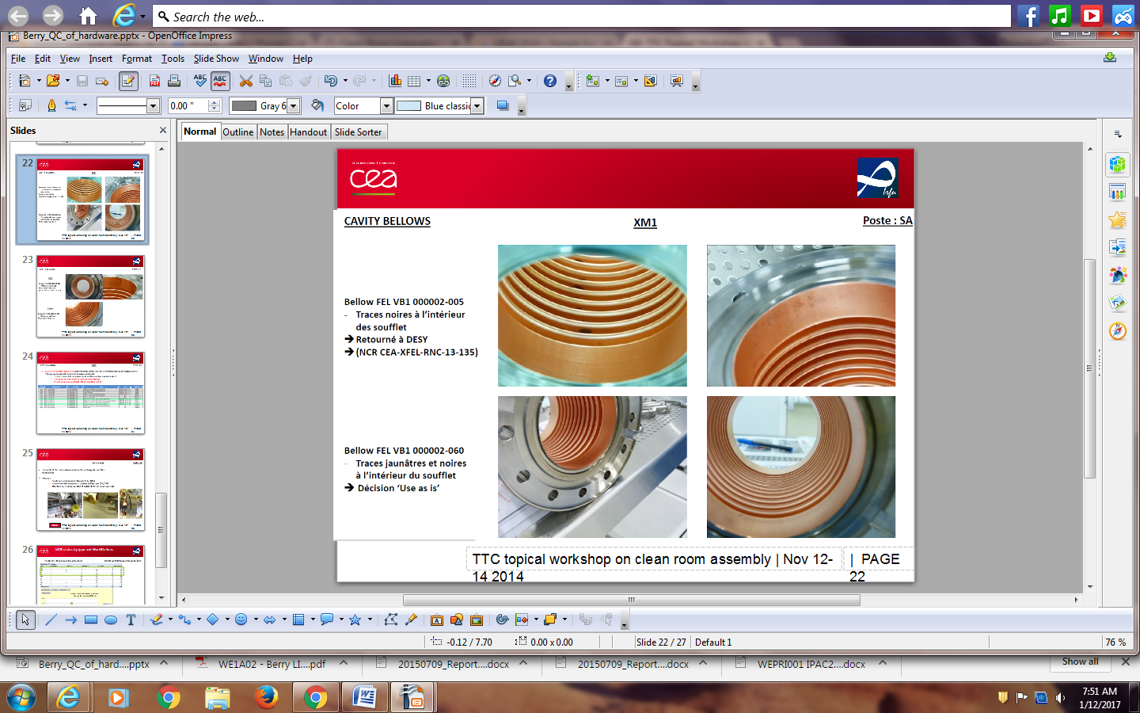

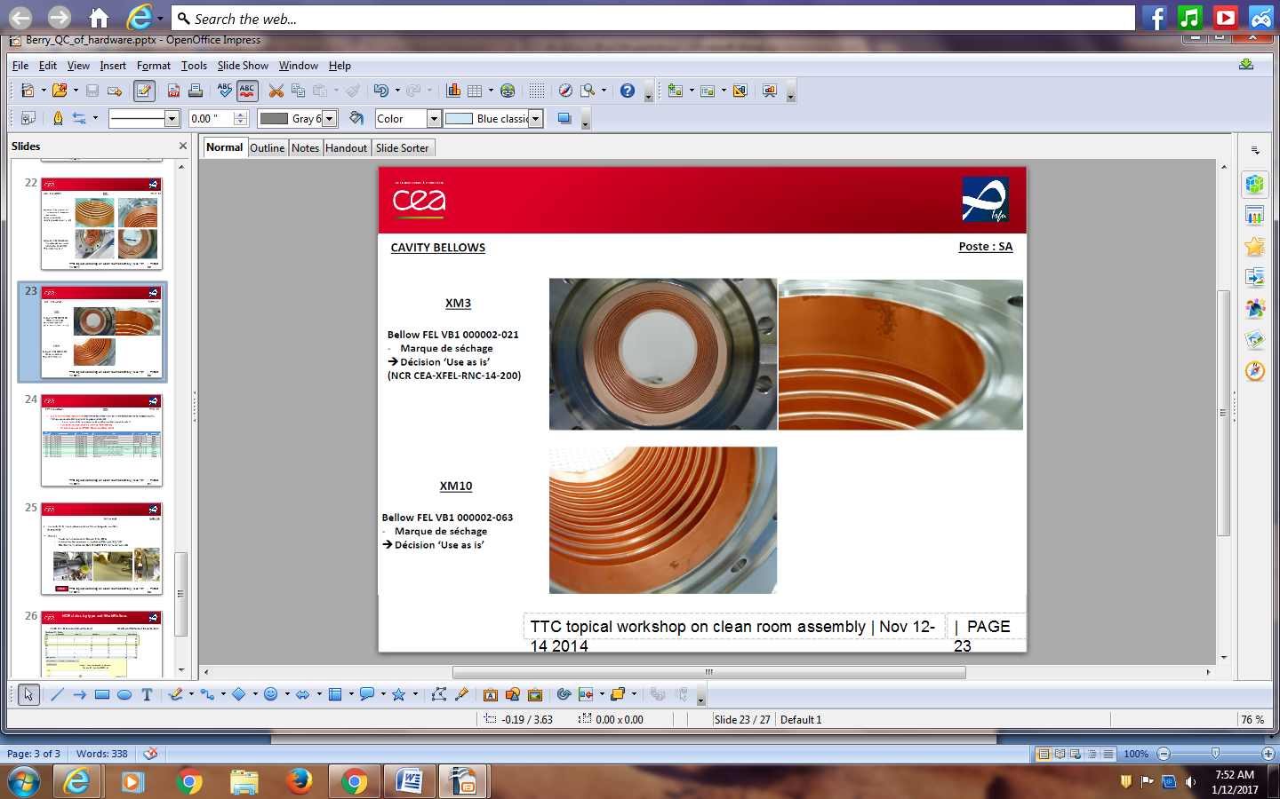

Hardware cleaning techniques at each lab (Tug Arkan, Jim Folkie, Danny Forehand) 10.30am -11am

Summary and key points write-up 11am – 12pm