The NEWSdm experiment

A. Di Crescenzo on behalf of the NEWSdm Collaboration

NEWSdm (Nuclear Emulsions for WIMP Search with directional measurement) [1] is meant to be the first experiment with a solid target for directional dark matter searches: the use of a nuclear emulsion based detector, acting both as target and tracking device, would allow to extend dark matter searches beyond the neutrino floor and provide an unambiguous signature of the detection of Galactic dark matter.
The novel emulsion technology, based on the use of nuclear emulsion films with nanometric AgBr crystals (NIT) [2, 3], makes it possible to record the sub-micrometric tracks produced by the WIMP scattering off a target nucleus. The presence, in the emulsion components, of light and heavy nuclei results in an enhanced sensitivity to both light and heavy WIMP masses. The detector is conceived as a bulk of NIT films surrounded by a shield to reduce the external background. The detector is then placed on an equatorial telescope in order to absorb the Earth rotation, thus keeping fixed the detector orientation with respect to the incoming apparent WIMP flux. The angular distribution of the WIMP-scattered nuclei is therefore expected to be anisotropic with a peak centred in the forward direction.
The signal confirmation is obtained with powerful optical microscope equipped with a light polarizer: exploiting the different response of non spherical grain clusters to different polarization angles, the unprecedented spatial resolution of 10 nm is obtained. This resolution allows to measure track lengths shorter than one hundred nanometers, thus providing a very high signal to noise ratio.
In March 2017 the NEWSdm Collaboration has installed an experimental setup for the exposure of a ~10g detector at the Gran Sasso INFN Underground Laboratories. This test aims at measuring the detectable background from environmental and intrinsic sources and to validate estimates from measurements [4] and simulations. The confirmation of a negligible background will pave the way for the construction of a pilot experiment with an exposure on the ~ 10 kg year scale. This pilot experiment will act as a demonstrator to further extend the sensitivity towards the neutrino floor. A Technical Design Report for the pilot experiment is expected at the end of 2017.
The expected cost for the pilot experiment amounts to about 1.5 M$.
The Collaboration is made of 70 physicists from 14 Institutes in five Countries.
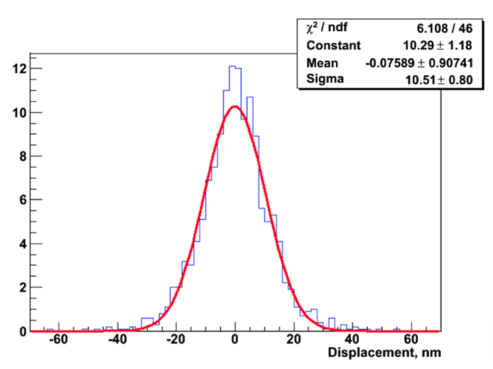
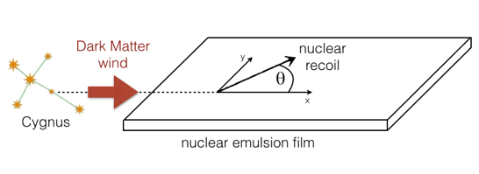
Figure 1: Left - The track reconstruction is performed in the xy-plane. The x-axis is directed opposite to the Cygnus constellation and θ is the angle between the x-axis and the projection of the nuclear recoil in the xy-plane. Right -Position accuracy of about 10 nm with the resonant light scattering.
______________________________________________________________________________________________
[1] A. Alexandrov et al. (NEWSdm Collaboration), arXiv:1604.04199, LNGS-LOI 48/ 15
[2] M. Natsume et al., Nucl. Instr. Meth. A575 (2007) 439
[3] T. Naka et al., Nucl. Instrum. Meth. A718 (2013) 519
[4] A. Alexandrov et al., Astroparticle Physics 80 (2016) 16.

