The SHiP experiment

A. Di Crescenzo on behalf of the SHiP Collaboration
SHiP (Search for Hidden Particles) is an experiment aimed at exploring the domain of hidden particles at the intensity frontier and studying the properties of tau neutrinos. The 400 GeV/c proton beam extracted from the SPS will be dumped on a heavy target with the aim of integrating 2×10²⁰ protons on target (pot) in five years. The SHiP Technical Proposal has been submitted to the CERN SPS Committee in April 2015. The SHiP Collaboration is committed to provide a Comprehensive Design Report in 2018, which will provide input into the next update of the European Strategy for Particle Physics.
An Emulsion Detector located downstream of the target, based on the Emulsion Cloud Chamber (ECC) technique, will allow to search for Light Dark Matter (LDM) scattering. The dark matter particles produced by the decay of a dark photon may be detected through their scattering off electrons in the ECC target. The ECC combines the excellent position resolution of nuclear emulsions with the high density of lead and it is a high-sampling calorimeter, well suited for electron identification and energy measurement, as demonstrated by the OPERA experiment [1,2] and shown e.g. in the left plot of Fig. 1.
With the existing detector design, the dominant backgrounds are expected to come from elastic, quasi-elastic, deep-inelastic and resonant neutrino scattering processes, when only the electron is visible at the primary neutrino interaction vertex, giving a total background of ~280 events in 2×10²⁰ pot. The main variables to separate signal from background are the electron energy, the angle with respect to the incoming particle direction, and the number of detectable particles at the neutrino interaction vertex. These topological and kinematic variables can be accurately measured in an ECC detector.
The parameter space explored by the SHiP experiment in the search for light dark matter is shown in the right plot of Fig. 1, assuming a number of 50 observed signal events of light dark matter scattering. The SHiP sensitivity goes beyond the expectations from the relic density at low masses. This study is preliminary and an optimization of the detector performances is the subject of an on-going study.
The estimated cost of the SHiP experiment, including the facility at CERN, a decay vessel and a detector for hidden particle decays amounts to 193.5 M$.
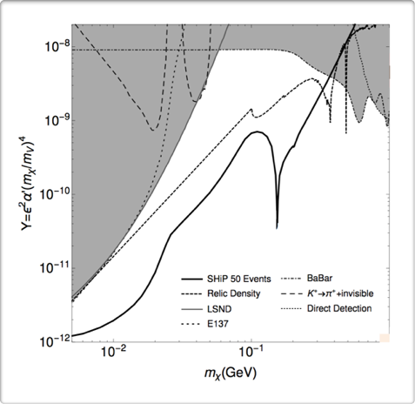
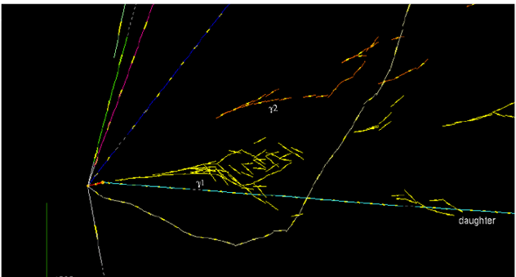
The Collaboration is made of 250 physicists from 49 Institutes in 17 Countries.

Figure 1: Left – A neutrino interaction detected in the ECC of the OPERA experiment. The electromagnetic showers originated by two photons are visible. Right - SHiP sensitivity to light dark matter, as a function of light dark matter mass m_{χ} and the parameter Y, assuming 50 signal events (courtesy of P. deNiverville).

[1] N. Agafonova et al., JINST 4 (2009) P04018.
[2] N. Agafonova et al., PRL 115 (2015) 121802.

