Jefferson Laboratory Facilities, Arne Freyberger, Jefferson Lab.
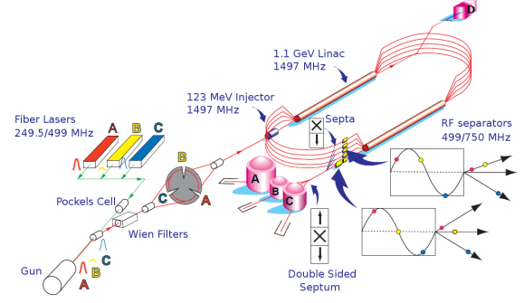
Jefferson Lab (JLab) operates two electron accelerator facilities, the Continuous Electron Accelerator Facility (CEBAF) and the Low Energy Recirculator Facility (LERF). The primary mission of JLab is to support the Office of Science, Office of Nuclear Physics research program, specifically the exploration of confined states of matter, quarks and gluons, via energic electromagnetic probes. There are 1530 active JLab users from 236 institutions and 31 countries.
CEBAF has been successfully upgraded to achieve maximum electron energy of 12 GeV. The accelerator upgrade and transition to operations is complete. CEBAF has four experimental end-stations (A,B,C &D), one hall (D) is a new addition and two halls (B&C) have upgraded standard equipment detectors to take advantage of the higher electron beam energy. The remaining hall (A) serves has multi-purpose hall, staging and executing a diverse experimental program. The beam parameters can be found in the table below. The CEBAF end-stations A,B&C can receive beam at energies of 1,2,3,4,5 times the one-pass energy (nominally 2.1-2.2 GeV/pass), beam to Hall-D must recirculate 5.5 times through the linac and has energy of 11.6-12 GeV). The electron beam polarization is near 90% (always greater than 85%) and Hall-D beamline includes the production of linearly polarized photon beam (40% polarization, peak energy near 9 GeV) via coherent bremsstrahlung production off of a diamond radiator.
LERF is a one-pass energy recovery linac with maximum electron beam energy of 170 MeV (see Table below for beam parameters). LERF was constructed and operated as a tunable free electron laser and can support up to 10 mA of beam current when in energy recovery mode. The LERF has recently been reconfigured to support the DarkLight experiment by installing a large solenoid and gas target on the beamline.
 | LERF | CEBAF
Max. Energy | 170 MeV | 11 GeV (ABC)
 |  | 12 GeV (D)
Duty Factor | CW | CW
Max. Beam Power | >1 MW | 1 MW
Bunch Charge (Min-Max) | 60-135 pC | 0.004 fC – 1.3 pC
Repetition Rate on Target | 4.68-74.85 MHz | 31.2 – 499 MHz
Nominal Hall Repetition Rate | 74.85 MHz | 249.5 MHz
Number of Exp. Halls | 1 | 4
Max. Number of Passes | 1 | 5.5
Emittance (geometric) at full energy | 50 nm-rad(X)/30 nm-rad(Y) @ 135 pC | 3 nm-rad(X)/1 nm-rad(Y)
Energy Spread at full energy | 0.02% | 0.018%
Polarization | None | >85%
Beyond the Standard Model Experimental program at JLab includes dark matter searches and precision parity violation experiments (measurements of sin²θ_{W}). Direct searches for dark matter experiments include the APEX and HPS experiments on CEBAF, and DarkLight at the LERF. All of these experiments have received beam. A beam dump experiment, BDX, has been recently approved (presentations at this workshop include HPS, DarkLight and BDX). The MOLLER experiment, which recently received DOE project approval, will perform a precise measurement of sin²θ_{W}, which has sensitivity to the mass and coupling limits on dark matter. The program advisory committee meets once a year to review new proposals.

This material is based upon work supported by the U.S. Department of Energy, Office of Science, Office of Nuclear Physics, under contract DE-AC05-06OR23177

