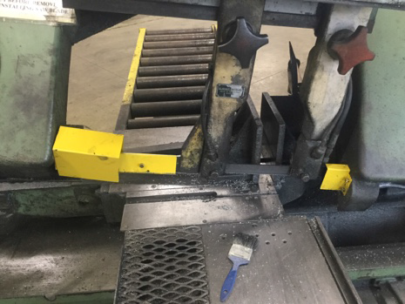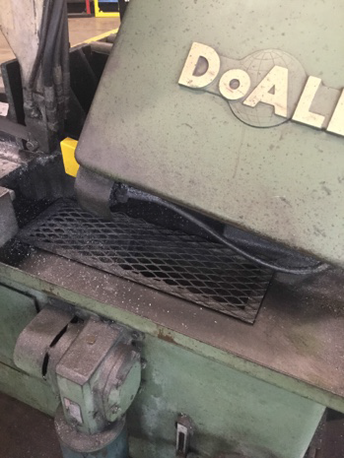
A
B
All guards (A – front, B – lower) must be in place before machine can be operated. If guards are not in place, do not use, tag out of service and contact your supervisor. When conducting pre-use and scheduled inspection, inspect with guards in all configurations.
DO NOT OPERATE THE MACHINE IF GUARDS ARE MISSING OR DAMAGED

