Summary Report of the
High Power Targetry R&D Roadmap Workshop
P. Hurh, R. Zwaska, K. Ammigan (FNAL)
D. Senor (PNNL)
M. Calviani (CERN)
M. Bishai (BNL)
June 23, 2017
- Background and Workshop Charge
On May 31 – June 2, 2017, Fermilab hosted a scientific workshop to gather input and information to help formulate a provisional roadmap to plot the course of High Power Targetry (HPT) R&D activities in support of the High Energy Physics (HEP) program. This roadmap is envisioned to be helpful to the Department of Energy (DOE) HEP office when planning and prioritizing future R&D activities as well as leveraging synergies across the DOE Office of Science. In addition, the resulting roadmap will be extremely beneficial to the broader (external to DOE HEP) HPT community by communicating the high-level strategy and objectives for HPT R&D and enabling opportunities for collaboration. The workshop charge is:
Identify the required and most beneficial High Power Targetry (HPT) R&D routes and associated key milestones, considering the needs, objectives, and timeline of the HEP experimental program as recommended in the 2014 P5 report. The resulting HPT R&D for HEP “roadmap” should plot the course that is suitable for HPT R&D GARD (General Accelerator Research and Development) activities for the next ten years while supporting the objectives of HEP projects in the 10 – 30 year time frame. Synergies with other branches of the DOE Office of Science should be identified and evaluated for potential benefits.
The workshop was organized into 3 sessions. The first session, Future HPT Facilities Requirements, included presentations and discussions concerning current HPT operational experiences, near and far future HPT challenges, and associated HPT facility requirements. The second session, HPT R&D Methods and Routes, included presentations and discussions concerning the HPT R&D activities currently employed, identifying additional promising routes of R&D, and how the HPT R&D activities can be best structured to support future HPT facilities. The third session, HPT R&D for HEP Roadmap Development, included discussions on both HPT facilities’ requirements and HPT R&D methods in the context of a 30-year roadmap.
28 registered participants from 13 institutions actively engaged in the presentations and discussions. The majority of these were representing HEP facilities. However several expert representatives from facilities external to HEP, namely Rare Isotope Beams and Spallation Sources, also participated in order for the roadmap to be relevant to the broader HPT community.
The presentations were very interesting and the discussions were lively. A framework for the draft roadmap was introduced and a path forward to develop the roadmap was agreed upon. This document summarizes the most significant themes and recommendations from the workshop. All presentations are available on the workshop web-site:
http://indico.fnal.gov/event/HPT_Roadmap_Workshop_2017
- Session 1: HPT Future Facilities Requirements
Session 1 was convened by Robert Zwaska (FNAL), Mark Messier (IU) and Mary Bishai (BNL). Nine presentations describing current and future target facilities were given, including:
- NuMI-NOvA (FNAL)
- T2K 750 kW & possible future upgrades (J-PARC)
- LHC, LIU & HiLumi-LHC Beam-Intercepting Devices (CERN)
- Mu2e-II (FNAL)
- LBNF-DUNE 1.2 & 2.4+ MW (FNAL)
- Beam Dump Facility – SHiP (CERN)
- Antiproton Decelerator Facility (CERN)
- Muon and MLF Facility (J-PARC)
- COMET and Hadron Experimental Facility (J-PARC)
- Transmutation Experimental Facility (J-PARC)
- SNS First and Second Target Stations (ORNL)
- Future Circular Collider (CERN)
- FRIB (MSU)
- ILC Positron Target and Main Beam Dump (KEK)
Focus at the Workshop was on targetry requirements and challenges for the future DOE HEP science program, thereby aligning with the 2014 P5 report. However, as can be seen by the list of target facilities discussed above, there are significant synergies with the global High Power Targetry community (including nuclear physics, spallation neutron sources, etc.) which can be leveraged for mutual benefit.
Beam and operating environment parameters were collected for the various facilities (when available) for the purposes of determining requirements of the facilities and developing objectives/milestones for the HPT R&D roadmap. The conveners began work on creating a comprehensive table of requirements which sparked discussion on the best way to characterize and organize facility requirements. Collating not only by facility, but also by targetry component type/function was recommended. As well, it was agreed that required lifetimes of components would best be expressed in total fluence (integrated number of particles per unit area) rather than displacements per atom (DPA) since calculation methods vary for DPA, and since DPA depends greatly upon the target material while not accounting for other factors such as irradiation temperature and dose rate.
Some highlights included:
- the extremely high-energy deposition on the planned FRIB graphite target (up to 60 MW/cm³) which will be rotated at 5,000 rpm to spread that extremely high energy deposition;
- the high stored energy in the HiLumi LHC beam (~300 MJ or the equivalent of 80 kg of TNT) that must be dealt with in the dump and collimator systems;
- the factor of 40 times higher in instantaneous beam pulse intensity for an ideal Mu2e-II target at 800 MeV and 100 kW over the current generation Mu2e target (8 GeV and 8 kW);
- the extremely high beam power (17 MW) required to be absorbed in the ILC main beam dump;
- the almost 4 times higher beam pulse intensity on the currently being designed SNS second target station solid tungsten target (due to smaller beam spot area) compared to the SNS first target station liquid mercury target;
- and the high energy deposition (1,000 W/cm³) anticipated on the FCC beam dump compared to the LHC requirement (10 W/cm³).
The conveners will work with participants after the workshop to complete the table of requirements and reduce the detailed information into sets of objectives that can be used for the HPT R&D Roadmap development process.
- Session 2: HPT R&D Methods and Routes
Session 2 was convened by Kavin Ammigan (FNAL) and Marco Calviani (CERN). Ten presentations describing current HPT R&D activities were given, including:
- Experimental investigation of proton irradiation effects in the NuMI beryllium primary beam window and comparison to He ion irradiation of beryllium
- High-energy proton irradiation experience at BLIP
- The use of low-energy ion irradiation to mimic high-energy proton irradiation
- Conducting thermal shock experiments at CERN’s HiRadMat beam-line facility
- Development of electrospun nanofiber materials for HPT applications
- Development of oxidation resistant coatings for graphite in high temperature applications
- Development of radiation resistant “ductile” tungsten for target applications
- Radiation protection experience at the T2K beamline
- Remote handling challenges at the SNS target facility
The conveners led discussions focused upon the advantages and disadvantages of various HPT materials R&D routes and methods. Guided by the workshop organizers, the focus was primarily on materials R&D, namely radiation damage effects and thermal shock effects in beam-intercepting materials. Although targetry technology R&D needs were presented and discussed at some level, the materials R&D topics were treated with higher priority due to the general lack of a knowledge base for these applications, the relatively long time frame for R&D iteration cycles, and because individual projects cannot support such long-term, fundamental research studies. Whereas, targetry technology studies (radiation protection, remote handling, advanced manufacturing methods, etc.) already has a knowledge base currently being advanced in industry, typically has shorter R&D iteration cycles, and individual projects must support these highly facility-specific development efforts to deliver a credible Conceptual Design Report to their sponsors.
Discussion of materials R&D routes and methods led to general consensus on the following points:
- Qualification of materials for use in HPT facilities will require high-energy proton irradiations and thermal shock testing in concert to reproduce single pulse material response.
- High-cycle fatigue response of materials in an irradiated condition is almost unique to the HPT accelerator facility application.
- The current routes for high-energy proton irradiations are expensive, long in duration, and lack control of testing conditions and schedule. Alternative solutions/facilities should be explored.
- Autopsy and PIE of failed target components is a significant component of the radiation damage R&D thrust. New facilities should seriously consider including autopsy and irradiated material recovery capability during the design phase.
- Likewise, proton beam thermal shock studies are relatively expensive, long in duration, and dependent upon the host accelerator facility operations schedule. Alternative solutions such as electron beam or laser beam facilities should be explored.
- Low-energy ion irradiations are attractive because they allow study of the evolution of the micro-structure during irradiation without activating the specimens, are relatively low cost, and can achieve high dose in very short durations. However, they are limited in reach because damage effects are confined to a narrow layer of penetration (microns) and do not include gas production effects (although the latter can be mimicked using hydrogen and helium ion implantation). Accumulation of irradiation damage is also non-prototypically high and the effects of high damage rate must be considered. Low-energy ion irradiations are therefore very helpful to help guide R&D studies and interpret results of high-energy proton irradiation damage studies by enabling fundamental exploration of a variety of materials and formulations/conditions of materials and down-selecting relatively quickly to the most promising formulations for more intense study.
- Micro-mechanics and meso-scale testing are potential enabling technologies to overcome some of the limitations of low-energy irradiations as well as to drastically reduce specimen size requirements (which also reduces activity of specimens). However correlating micro- and meso-properties with bulk, macro-properties is still very challenging and must be validated for each material under consideration.
- Atomic- and meso-scale modeling/simulations of radiation damage mechanisms is advancing in the field of nuclear materials. The primary utility of such efforts is providing insight into interpreting experimental results and helping guide irradiation experiment planning. However, the technologies are presently not mature enough for accurately predicting complex material response (polycrystalline, non-pure materials). Incremental funding from the targetry community is extremely unlikely to accelerate progress in this field beyond its current pace, but the community should monitor developments and take advantage of state-of-the-art capabilities as appropriate to complement experimental efforts.
Based on the material presented and the ensuing discussions, material R&D activities were grouped into 3 categories: Materials Testing Cycles, Enabling R&D Activities, and Material R&D activities.
Materials Testing Cycles includes those activities primarily focused upon exposing specimens of candidate materials to a variety of loading environments and subsequent examinations in a cyclic nature. This included high-energy and low-energy irradiations as well as thermal shock testing. Each cycle has a predictable program of sub-activities and durations that can be shown on the HPT R&D Roadmap. Durations for each cyclic activity identified were proposed, but need to be further vetted.
Enabling R&D Activities includes those activities primarily focused on developing technologies or validating existing technologies that enable the use of certain materials testing cyclic activities (e.g. development of an electron-beam based thermal shock testing technique enables the use of the technique for faster, lower-cost thermal shock testing cycles). These activities included:
- Modeling Development and Validation (MC codes and Thermo-structural)
- Micro/Meso-scale property evaluation and validation
- Low-energy to high-energy irradiation correlation and validation
- Non-proton beam thermal shock testing alternatives
- High-energy proton beam irradiation facility alternatives
Material R&D activities includes the actual R&D activities needed to evaluate and explore candidate HPT materials to reach the Roadmap objectives. These activities include the identification and production of new materials, the testing and evaluation regimen to down-select on the most promising materials, and the prototypic testing to qualify the material for use. The testing and evaluation stages are envisioned to consist of the Materials Testing Cycles described above.
The conveners will work with participants after the workshop to further explore the HPT R&D routes and methods to identify other potential Enabling R&D Activities and confirm the durations of the Materials Testing Cycles.
- Session 3: HPT R&D for HEP Roadmap Development
Session 3 was convened by Patrick Hurh (FNAL) and David Senor (PNNL). The conveners moderated discussion on development of the HPT R&D Roadmap using a generic template for the Roadmap that was created prior to the Workshop. Discussion primarily focused upon how best to capture the targetry requirements of future facilities and transform these into Roadmap objectives/milestones, what Enabling R&D Activities are ripe for exploration, and how to incorporate targetry technologies (remote handling, radiation protection, advanced manufacturing techniques, advanced methods of quality assurance, high heat-flux cooling, etc.) into the Roadmap.
The Materials Testing Cycles timelines are shown in Figure 1. Please note that these timelines still need to be confirmed by participants. They are shown (in “rolled-up” form) integrated into the generic roadmap template in Figure 2. Also in Figure 2 are shown the identified Enabling R&D Activities and how they might tie into the Testing Cycles (arrows). At the bottom of Figure 2 are the Materials R&D Activities. It is expected that Objectives/Milestones will be added to that timeline that tie into the future projects timeline.

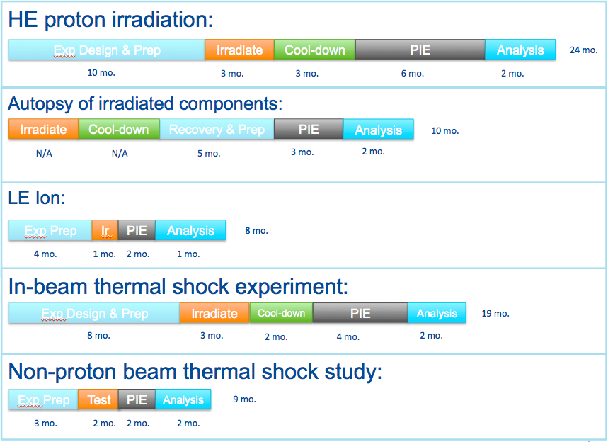
Figure 1: Materials Testing Cycles
It is expected that the resulting HPT R&D Roadmap report will include sections expanding upon each thrust of the Roadmap and give examples of how the Roadmap will be followed for a given material. One such example is shown in Figure 3. At the bottom is shown a timeline for a new materials R&D cycle. The arrows indicate how the Materials Testing Cycles would be used to conduct evaluations of the candidate material. The first round of testing of a new material type would likely include less costly and shorter duration evaluations using low-energy ion irradiations and alternative thermal shock studies to down-select on the best formulations of the material. If potential is seen in particular new material formulations, then the material formulation would be adjusted (if necessary) and a second round of testing would occur. The second round would likely include a higher investment of resources by using a high-energy proton irradiation and proton beam thermal shock study, in addition to continuing with the lower cost and faster turn-around studies. At the end of the second round evaluation, it may be that enough is known about the new material’s behavior to qualify it for some application. Or it may require a third round of testing. So, given that the individual activity timelines are reasonable, it could take 9-15 years to qualify a material for a specific application. This can be compared to the similar, but more rigorous, process of qualifying materials for nuclear reactor use (~15 – 20 years).

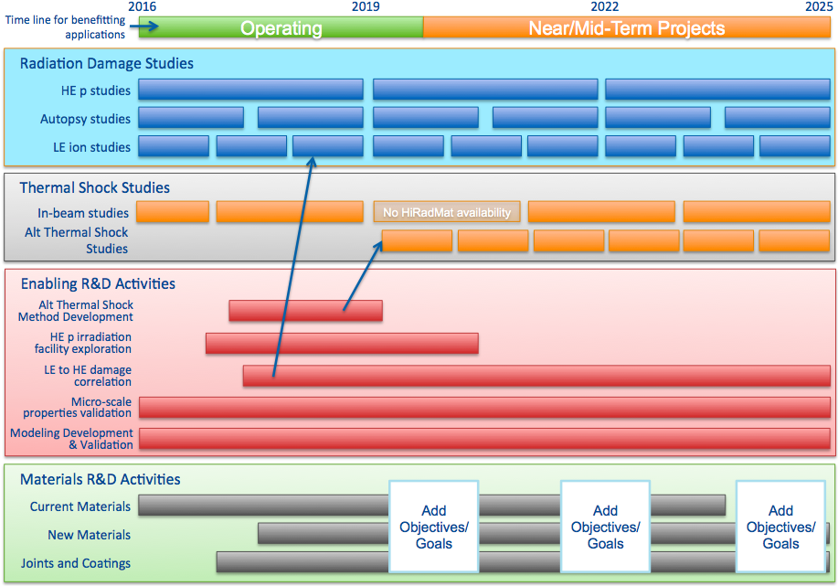
Figure 2: Generic HPT R&D Roadmap draft showing 4 thrusts.
The targetry technologies R&D activities were considered a lower priority for this workshop (as described in the previous section). However, they are still critical for the success of future accelerator target facilities. Conveners will discuss, after the workshop, how best to incorporate them into the Roadmap report (separate roadmap or set of guidelines?). In general, these activities involve keeping abreast of advances in industry, collecting lessons learned from operating facilities, and then looking for opportunities for application within HPT.

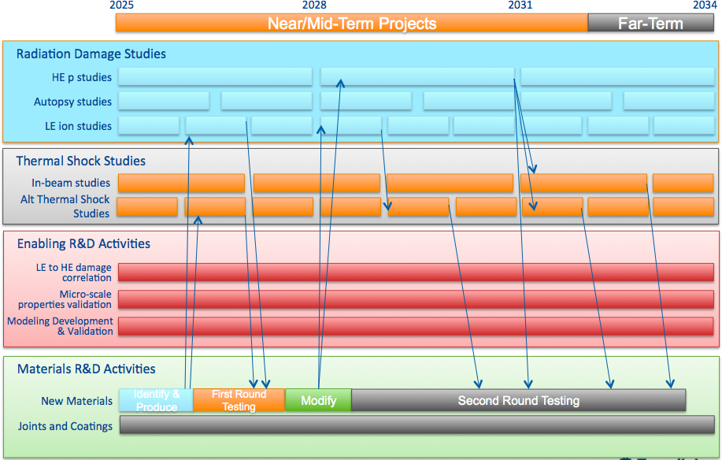
Figure 3: Generic HPT R&D Roadmap draft showing example of new material R&D path.

- Conclusion and the Path Forward
The presentations and discussions at the HPT R&D Roadmap Workshop were very successful in gathering input and formulating the general structure of the Roadmap. Still there is work to be done to distill, collate, and confirm that input into a final cohesive and representative Roadmap. The conveners and participants have committed to produce the HPT R&D Roadmap Report on the following rough timeline:
- June, 2017
  - Complete HPT future facilities requirements table
  - Confirm HPT R&D routes’ timelines
  - Develop objectives/milestones based upon the above
  - Explore early ideas for Enabling R&D Activities to confirm timelines
- July, 2017
  - Develop Roadmap
  - Generate examples of paths through the Roadmap for various use cases
  - Complete draft of the HPT R&D Roadmap Report
- August, 2017
  - Distribute Roadmap Report draft for review and comment
  - Finalize Roadmap Report and share with the HPT community and DOE
- Acknowledgements & Participants
We would like to thank all the registrants for their participation in the workshop, especially the session conveners. In addition, we are grateful to the workshop Organizing Committee who helped plan and execute the successful workshop. And we are grateful to Dr. L.K. Len (DOE) for his participation which helped put our workshop discussions in context with the DOE HEP General Accelerator R&D program.
- Session Conveners
  - Robert Zwaska (FNAL)
  - Mary Bishai (BNL)
  - Mark Messier (IU)
  - Kavin Ammigan (FNAL)
  - Marco Calviani (CERN)
  - Patrick Hurh (FNAL)
  - David Senor (PNNL)
- Organizing Committee
  - Patrick Hurh
  - Robert Zwaska
  - Kavin Ammigan
  - Katsuya Yonehara
  - Sujit Bidhar
  - Marilyn Franck
  - Cara Kachel

- Participants:

Dr. AMMIGAN, Kavin | ammikav@fnal.gov | Fermi National Accelerator Laboratory
Dr. BIDHAR, Sujit | sbidhar@fnal.gov | FNAL
Dr. CALVIANI, Marco | marco.calviani@cern.ch | CERN
Mr. CROWLEY, Cory | crowley@fnal.gov | Fermi National Accelerator Lab
Dr. DENSHAM, Chris | chris.densham@stfc.ac.uk | STFC Rutherford Appleton Laboratory
Dr. GLENZINSKI, Douglas | douglasg@fnal.gov | Fermilab
Mr. HURH, Patrick | hurh@fnal.gov | FNAL
HYLEN, Jim | hylen@fnal.gov | Fermi National Accelerator Laboratory
Dr. ISHIDA, Taku | taku.ishida@kek.jp | J-PARC/KEK
Dr. JIANG, Weilin | weilin.jiang@pnnl.gov | Pacific Northwest National Laboratory
KALRA, Daisy | daisykalra89@gmail.com | Panjab University, Chandigarh
Dr. KUKSENKO, Viacheslav | viacheslav.kuksenko@materials.ox.ac.uk | University of Oxford
Dr. LEN, LK | lk.len@science.doe.gov | DOE
Dr. LYNCH, Kevin | klynch@york.cuny.edu | York College/CUNY
MAKIMURA, Shunsuke | shunsuke.makimura@kek.jp | J-PARC/KEK
Prof. MESSIER, Mark | messier@indiana.edu | Indiana University
Dr. MOKHOV, Nikolai | mokhov@fnal.gov | Fermilab
Mr. MORIKAWA, Yu | yu.morikawa@kek.jp | KEK
Dr. PELLEMOINE, Frederique | pellemoi@frib.msu.edu | Michigan State University - Facility for Rare Isotope Beams
Prof. POPP, James | jpopp@york.cuny.edu | York College of The City Univeristy of New York
Dr. RAKHNO, Igor | rakhno@fnal.gov | Fermilab
Mr. RIEMER, Bernie | riemerbw@ornl.gov | Oak Ridge National Laboratory
Dr. SENOR, David | david.senor@pnnl.gov | Pacific Northwest National Laboratory
Prof. SNOPOK, Pavel | snopok@gmail.com | Illinois Institute of Technology
Dr. TERUNUMA, Nobuhiro | nobuhiro.terunuma@kek.jp | KEK
Dr. TSCHIRHART, Robert | tsch@fnal.gov | Fermilab
YONEHARA, Katsuya | yonehara@fnal.gov | Fermilab
Dr. ZWASKA, Bob | zwaska@fnal.gov | Fermilab

