 | DUNE International Project |  | Work Package: | Calibration
 | Single-Phase Far Detector |  | Doc. Category:
 |  |  | Doc. Type: | Note
DUNE DocDB# | Institute Document No. | Created: |  | Pages:
 |  | Modified: |  | Rev. No.:

Calibration Concept Study

Authors:
Draft For Discussion

Prepared by:  J Stewart | Submitted/Checked by: | Approved by:

Distribution List

DocDB | Version Number | Author | Version Date | Description of Changes

History of Changes

Table of Contents

History of Changes 2
Table of Contents 2
Calibration Goals 3
Energy Scale 3
Electron Lifetime 4
Mechanical Alignment/detector Geometry 4
Electric Field 4
Recombination (Charge and Light Yield) 4

Calibration Goals

This document will describe the needs for detector calibration using dedicated far detector systems or cosmic rays. It will form the basis of the agreement between DUNE and LBNF for the cryostat requirements related to detector calibration.

The DUNE single-phase far detector will be a unique instrument. Not only because of its size---the largest LAr-TPC ever constructed---but also because of its depth. It differs both from existing long-baseline neutrino detectors, and existing LAr-TPCs.

Like the Super-Kamiokande detector, DUNE is monolithic---essentially a box filled with liquid. But unlike Super-K, DUNE has by design a response that varies within the volume of the liquid, providing it with an effective segmentation that allows fine-grained tracking at a very low cost. Charge created at a particular position is intended to go to a small subset of wires, rather than photons that might travel to any of the many PMTs in Super-K. In segmentation, DUNE is therefore like MINOS or NOvA, but also with important differences. Truly segmented detectors like MINOS and NOvA provide position information without any need for calibration---they are explicitly `voxelized' detectors. A final important difference is that DUNE does not as yet have a near detector design and, unlike MINOS and NOvA, the near detector is unlikely to be very like the far detector.
Thus DUNE has as its great advantage precision tracking without the cost of fine-grained segementation, and an ultra-clean target medium whose fiducialization could provide unprecedented rejection of low-energy external backgrounds.
But it also will have challenges in understanding its detector response. Ultimately, a determination of backgrounds in DUNE will come from in situ sideband analyses, extrapolated into various regions-of-interest using Monte Carlo simulation. Similarly, a determination of the energy and reconstruction response for events of interest will be based on a simulation model, informed by parameters governing the response. A convincing measurement of CP violation, or a resolution of the neutrino mass ordering, will require a demonstration that the overall detector response is well understood, and can be extrapolated across the entire physics regions of interest.
Generally speaking, calibrations provide four distinct things:
Corrections: These are usually applied to data, such as corrections for channel-dependent gain.
Parameter Measurements: These are determinations of the parameters that are in the detector response model, such as electron lifetime. Some parameters may be universal and can be measured ex situ.
Efficiencies: In some cases, the efficiency or acceptance of a cut or set of cuts is not expected to be well-modeled by a simulation, and a better estimate can be obtained by applying the cuts to a sample of data. For example, the efficiency of a cut that removes noise hits might be more accurately and easily determined with a sample of data, than a complex detector response model.
Tests: Like any model, the detector response model should be tested and the most convincing tests are done on data samples that are as close as possible to physics events of interest. Such calibration samples are often not available---obviously there is no local, triggered beam of ν_{e}s to use, for example. If large, differences between the predictions of the model and the results of test indicate either poorly or incorrectly measured parameter models, that the model itself is somehow not complete, or that corrections applied to the data are not as precise as hoped. If small, differences between the test and the model can be used as estimates of systematic uncertainties on higher-level response parameters, such as energy scale uncertainties or biases. One of the great benefits of a precise and controlled test it that it verifies assumptions in the detector response model: for example, if a parameter has been measured ex situ and is believed to be universal, good agreement between the model prediction and the test data can support or falsify the assumption.
Below we list some of the critical parameters that enter into DUNE's TPC response model:
- Argon ionization energy
- Electron drift velocity v_{d}(x,y,z,t)
- t₀ offsets
- Electron lifetime τ(x,y,z,t)
- Recombination parameters
- Electric field E(x,y,z,t)
- Longitudinal and transverse electron diffusion
- Wire positions/geometry
- Wire field response
- Channel gain
- Overall electronics analog transfer function (e.g., ``shaping'')
- Electronics noise, including correlated noise
- ADC linearity (differential and integral).
These parameters fall into several categories, and in some cases multiple categories. Some parameters are universal---for example, we would expect the ionization energy of argon to be the same whether it is an argon atom in DUNE or an argon atom in the same electric field somewhere else.
Some parameters also may well be measurable accurately on the bench-top if they are known to stay fixed between the benchtop and the DUNE far detector. For example, it is possible that the linearity of an ADC will stay fixed regardless of where or when it is being used (although this is certainly not true of all ADCs and would have to be demonstrated for DUNE's ADCs).
Some parameters may be calculable, if the parameters upon which they depend on are measured. For example, v_{d} depends on E, and temperature. So v_{d}(x,y,z,t) could be calculated from the electric field map and a temperature map, if these were done precisely enough.
And some parameters need to be measured, and may need to be measured as a function of both position and time. Exactly how finely-gridded such things need to be in space, and binned in time, remains to be determined. Clearly a hard, lower limit on the grid would be something on the scale of the wire spacing, but likely a far coarser grid could be good enough. Whatever the answer, however, it will depend on what reasonable variations there might be in both time and space, probably based on measurements that will occur in DUNE itself, and of course also on how well we need to know such variations in the first place.
There are also correlations between these parameters, that mean that either an iterative procedure needs to be made to measure them, or explicit calibration sources must be developed to break the correlation. For example, uncertainty in the transfer function or noise of the electronics could lead to an incorrect measurement of diffusion. Similarly, incorrect knowledge of the wire positions in the cold could affect measurements of drift velocity or the wire field response.
What is missing in this discussion is an idea of how well we need to determine any of these parameters. Far easier is the task of knowing how well we need to constrain the output of the entire model. How well we need to know, for example, the energy or reconstruction bias, the partice ID efficiency and purity, or the energy resolution. Clearly, uncertainties on many of the parameters can lead to the same systematic uncertainty on these high-level quantities, thus each must be independently smaller than the overall error budget.
In addition to the detector response model parameters listed above, there are many uncertainties for which calibration data can either check or define. Among these are:
- Position reconstruction biases and uncertainties compared to the MC model
- Direction reconstruction biases and uncertainties
- Energy scale biases uncertainties
- Energy resolution biases and uncertiainties

There are also likely to be cut efficiencies for background removal for which calibration data may be relevant for measuring or checking:
- Particle ID efficiencies
- Noise removal efficiencies
- Other instrumental effect removal efficiencies

ex situ Calibrations
Two kinds of truly ex situ calibrations are possible for DUNE: those that measure instrumental characteristics that are known never to change, and those that measure universal physical or phenomenological parameters. An example of the former might be the differential and integral non-linearity of cold ADCs. In principle, one would expect this would not change, although in practice the protoDUNE cold ADCs do change their response. Similarly, the transfer function of the analog front-end might be something that would stay fixed, although the long-term behavior is not yet known. Another option that has been discussed is the wire field response---in principle, this depends only on the configuration of the wires, and a calculation of exactly how signals are induced on non-adjacent induction plane wires. A measurement on the benchtop that verifies the calculation could then be used to predict the wire field response for DUNE in its as-built/as-run configuration. Of course, it is critical to understand the precision needed for these benchtop measurements, and how they extrapolate to DUNE, to be sure they are satisfactory for a DUNE precision measurement program intended to definitively resolve the mass hierarchy and discover leptonic CP violation. Nevertheless, even with precision ex situ measurements, a test that shows that the overall model (including the parameters measured ex situ) correctly reproduce real detector data is critical to demonstrate convincing physics measurements.
A “functionally equivalent” near detector---something that looks like DUNE or can be spoiled or adjusted to approximate the DUNE response (say by throwing out extra wires or pixels not present in the far detector)---is a type of ex situ calibration. If the collaboration can show that it can correctly model the response of the near detector once the parameters in that model are measured, then the same model can apply to the far detector once its parameters are measured. As the near detector becomes more different from the far detector, the extrapolation from one to the other will necessarily become more uncertain.
ad situm Calibrations
For a detector like DUNE, in which the target material is not forever resident inside the detector, measurements of properties can be made that are neither in situ nor ex situ but rather ``near the site’’ or ad situm. Other experiments have done such a thing: Super-Kamiokande makes attenuation measurements on water that is circulating into the detector, and SNO made measurements of water purity during circulation. In these cases, however, the ad situm measurements were either used as monitors of variations or were confirmed or strengthened by truly in situ measurements. In DUNE’s case, LAr purity can be measured just outside the cryostat, as can temperature. Even electric field can be constrained via measurements at external HV pickoff points. While these measurements will all be valuable, they are not likely to lead to precision constraints on the detector model.
in situ Calibrations

In situ calibrations include many options and in principle can provide the entire suite of deliverables, from corrections to parameter measurements, efficiencies, and tests. We focus here on some of the options and what each can and cannot provide.

Cosmic Rays

We pause for a moment to define some terminology. The detector is the entire collection of objects in the cavern. A module is contained within a single cryostat, the detector consists of 4 modules. A TPC is monolithic piece of liquid argon, also called a drift volume, which is surrounded by a field cage. In the first 10-kTon module, there are 4 TPCs. Each TPC is divided into 50 sub-volumes, in an array of 2 high by 25 long (along the beam direction). An anode plane assembly (APA) has a steel frame that supports two sets of wire planes. A cathode plane assembly (CPA)

If no new systems are added to DUNE, all TPC (ie, non-electronics) calibration corrections, parameters, efficiencies, and uncertainties will be determined ex situ, ad situm, or in situ with cosmic-ray events. Both MINOS and NOvA have successfully used cosmic-ray events as a source of calibrations---the former with relatively long integration times. MicroBooNE has also used cosmic-ray events to provide preliminary tests of reconstruction efficiencies and energy scale measurements.

Cosmic-ray events fall into four useable classes:
- Events that cross one or more APA or CPA planes
- Through-going muons that pass through any section of the TPC volume in any direction
- Stopping muons
- Michel electrons from stopping muons

“Crossing Muons”
The multiple TPC volumes within DUNE provide a real, physical segmentation that can be exploited to constrain muon trajectories and hence make measurements of various parameters in the detector response model. Figure 1 below shows a Monte Carlo event plotted by Leigh Whiteheard that shows what a few muons crossing multiple APA/CPA volumes would look like in the event display. The circles indicate places where his algorithm correctly “stitches” tracks together across the planes.
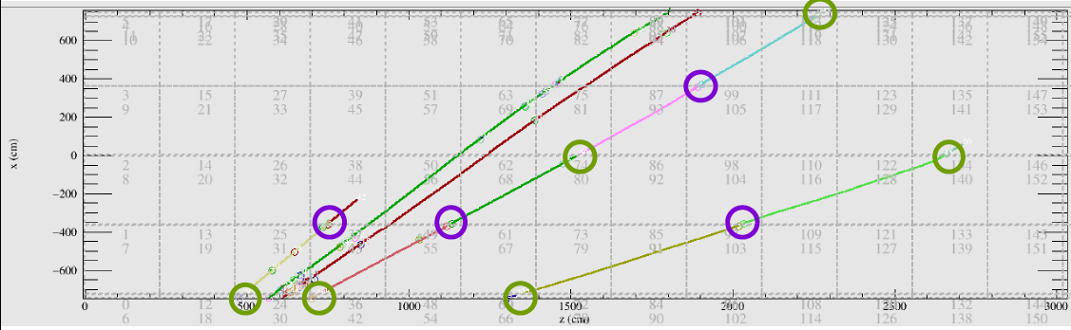
Figure 1: Multiple simulated muons crossing APA/CPA plane combinations, with circles indicating tracks that have been “stitched” together by Whitehead’s algorithm.
With the very low occupancy expected for DUNE with its 4850 ft overburden, we anticipate that track stitching will be a completely unambiguous process, and will likely be done with very high efficiency (not necessarily true for a surface detector like ProtoDUNE-SP).
Among the first, most critical calibrations for a TPC are the corrections that convert measured time into position. Obviously, with knowledge of v_{d}(x,y,z,t) and t₀, we can get the x distance from any hit wire,
Δx = v_{d}(t-t0)
and with knowledge of the wire position, the position of the deposited charge x=Δx-x₀. Notice that this means that for any charge deposit, there are three parameters needed: v_{d}, t₀, and x₀.
The crossing events are special, because they can eliminate some of these parameters, and allow determination of the others. Tracks that cross APAs have charge in two adjacent TPCs and therefore we know Δx=0 on either side. Looking at the distance between the earliest track segments on either side of the APA thus allows us to determine t₀ between the PDS (which in the absence of a CRT will be used for the t₀ for these events) and the TPC. An early t₀ will appear as Δx>0, a late t₀ will appear as two segments offset in z, because the earliest part of the track segments will be in a distinct drift window. An approach like this was used to uncover a 32 μs offset in the 35 tonne t₀. This data set can also be used to identify any DAQ timing offsets among the detector subsystems.
The required precision on this t₀ will depend on physics for out-of-beam events. The t₀ associated with the beam will likely be determined via GPS, although this can be compared to the t₀ from the PDS for beam events. A simple guideline would be the desired precision on the fiducial volume. It is possible that this t₀ will depend weakly on position in the detector, if for some reason different parts of the PDS have slightly different offsets. Given the fast propagation of signals from the lightguides to the SiPMs and through cables, it is not likely that these variations are big enough to require a lot of measurements of t₀ throughout the volume, although at least one per TPC would seem prudent.
CPA-crossing events provide a different constraint. With knowledge of t₀ from the APA crossers, the latest charge to hit a wire can provide us with a measurement of the average drift velocity over the entire drift distance, <v_{d}(y,z,t)>_{x}, although now there will be some dependence on our knowledge of the positions of the wires relative to the CPA---we know x at the CPA, but not Δx to the wires. If for the moment we put aside the issue of how we determine in situ the relative positions of the wires and the CPA, the average <v_{d}(y,z,t)>_{x} at least provides a check on the uniformity of the drift velocity integrated over the drift direction, and the differences (if any) between one TPC and an adjacent TPC. Nevertheless, if there do seem to be variations, this method does not by itself tells us the source or allow us to include those variations in a model or as a correction in any robust way.
Full TPC (or multiple TPC) crossers can be used to provide more information on v_{d}(x,y,z,t)---not just an average. A muon that passes through at least one APA and a CPA has known endpoints in three dimensions for the track. With a known t₀ from APA crossers, and which wires are hit when the muon passes through the APA plane, we know x,y, and z for that track. When the muon passes through the CPA, the presence of charge in both TPCs tells us that the endpoint of the track has x at the CPA---y and z depend on which wires are hit after the drift and in cases where the field is noticeably distorted (such as is true when there is significant space charge) this may not represent the true track length. Nevertheless, if we assume that for the majority of the bulk the field is not significantly distorted and thus charge drifts in a straight line along x, we can use the entire track to map out v_{d} along it by comparing the straight-line track inferred from the APA/CPA crossing to the reconstructed track. The conundrum here is that our assumption of a uniform field implies there is no need for such a map in the first place---if E is uniform, very likely so is v_{d}, unless there are significant temperature variations along the track.
Clearly, all of these measurements may run into statistical limitations. At the 4850 ft level, DUNE will see about 4 cosmics/day/m². This is a large number over the area of the detector, but not all of these will cross an APA or CPA, and fewer will cross an entire TPC volume. Figure 2, from the Cosmogenics WG, shows the expected angular distribution of cosmic-ray muons at DUNE, and a side view of the TPC structure. The minimum zenith angle for a muon to pass across an entire TPC is about 17º, or cos(θ_{z})=0.95. For a single sub-volume, it is 31º.

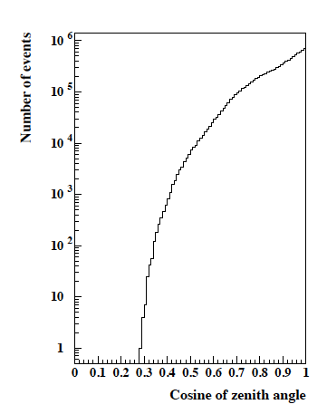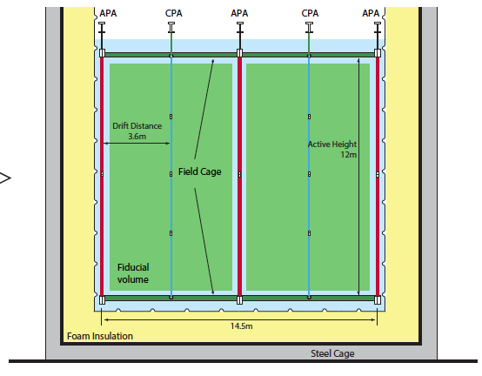
Figure 2. (Left) Zenith angular distribution of cosmic-ray muons at DUNE. (Right) DUNE TPC volumes and dimensions.
As the figure shows, about 25% of all muons have a shallower cos(θ_{z}) than 17º, and thus throughout the whole detector there are plenty of these each day (about 1000). Those that cross through just a single APA or CPA plane will be even more plentiful. For measurement of t₀, which should have at best a weak position dependence, the statistics are more than adequate. For <v_{d}(y,z,t)>_{x}, the needed statistics will depend on the expected variations, and the necessary precision on those, and that is all assuming we know the wire and CPA positions perfectly. We do not yet have an idea of either of these. Lastly, for determining v_{d}(x,y,z,t) using TPC-crossing tracks (assuming the bulk field is reasonably uniform), we are likely very limited unless we use spatial bins that are sizeable fractions of the TPC volume or accept low precision.

Downward Throughgoing Muons
Even at the large depth of DUNE, there will still be a significant rate of downward, through-going muons, which we define here as those that have a zenith angle from 5 º to 17 º and which do not stop within the detector. Smaller zenith angle tracks will saturate the ADCs. With a rate of about 2000/day, these are the highest-statistics, high-energy events we will have in DUNE. Without a CRT, and by our definition of “downward”, these events will not have individual trajectories that are known independently from the TPC information. What is known, however, is the time of these events (the t₀ from the photon system having been calibrated via the APA-crossers), and, given the narrow angular acceptance (5º <θ<17º) the distribution of their tracks through the detector should be known with reasonably high precision (although an independent measurement would be helpful here). We also have some idea of the energy deposit of such events, based on simulations of the muon flux and their propagation down to the DUNE site. Figure 3, again provided by Vitaly Kudryavtsev and the Cosmogenics WG, shows a simulation using MUSUN of the energy deposit for events passing through DUNE, with no angular cut applied. The long tail toward high energies is in part caused by showering muons, and the tail down to low energies by muons that do not pass through the entire volume, but clip the detector. The minimum ionizing peak can be seen clearly.
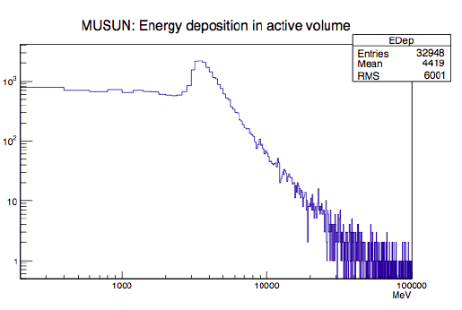
Figure 3. Energy deposit of cosmic rays in DUNE as provided by MUSUN simulation, with no cuts applied.
To use these events as a calibration source, cuts on both the length of the track inside the volume and on the number of secondaries must be developed, but these are far simpler tasks than, say, shower reconstruction. With such cuts, we would be left with a MIP-enriched sample. While this sample will not be exclusively MIPs, we would expect that the fluctuations in their energy depositions from event-to-event would be small, and therefore plotting the observed charge versus Δt=t-t₀ for many cosmics provides a measure of the electron lifetime in the detector. The range of zenith angles usable for this purpose should be investigated further, the range presented here is a guess. A more relevant quantity in track selection than zenith angle is the number of collection plane wires crossed by the track.
The precision on this measurement will depend in part on how many discrete volumes in the detector we care to sample. At the very least we would want distinct samples in every TPC volume, so our 4000/day becomes 1000/day in each TPC. We expect that the lifetime may vary near the edges of the detector, or might (as was true for the 35 tonne prototype) vary as a function of height in the detector, so it is possible this sample will be divided up further. The precision will also depend (hopefully weakly) on the precision of t₀, and also on our knowledge of the energy deposit of these through-going muons. The peak shown in Fig. 3 is not so narrow, and thus we will need to average over many muons to be able to compare average charge deposit versus Δt, and hence a lifetime. The issue will be made worse by the intrinsic resolution of the detector itself. Fortunately, since we know the functional form of the lifetime effects on the measured charge, we do not need many points along the drift direction, thus we do not need to bin these very finely (4 bins would already overconstrain the exponential to 2nd order). It is also true that, as the lifetime gets long, our precision on it becomes poor, but clearly precision on the lifetime is not the critical parameter; rather precision on the relative charge between tracks near the cathode and tracks near the anode is what will matter. A very long lifetime, if constant and uniform, will make this calibration far less important.
The other piece of calibration information that can be provided by downward-going muons is information about the drift velocity, or the uniformity of E. Because we should know the expected distribution of the muon tracks throughout the TPC volumes, we can compare the TPC-reconstructed track distribution to this known distribution. A scaling of v_{d} would show up as a distribution of tracks that are narrower or broader than expected. What these muons don’t provide is the source of such a scaling---it could be E, it could be temperature, it could be something completely unknown. Such a test will be limited in precision again by statistics, although we would hope that E, at least, will be reasonably static. It remains to be determined how small an effect can be seen.

Stopping Muons
Muons that stop within the detector volume have the great advantage that the dE/dx as a function of residual range allows us to identify a region that we know should be minimum ionizing, typically about a meter or so before the muon endpoint. Thus, with a calibrated or assumed map for v_{d}, an assumed map for E, and book-value expectations for diffusion, these events can be used to test our determination of dE/dx using our conversion from dQ/dx to dE/dx. Statistically, the test will suffer in precision unless we average over a large fraction of the volume. The rate of stopping muons in DUNE is about 30/day/module before any cuts, and assuming 100% efficiency for their identification. If we assume that 1 m of each track is considered “pure MIP”, then in 1 day we test calorimetry in 30 1 m³ bins, albeit with a single muon. If we assume that the response is in fact uniform across the entire detector (or that we only care about the average), and that any stopping muon provides an estimator of the average detector response, then for a precision of 1% and an energy resolution of 10% we need just 3 days to provide such a measurement. Binning this further by the four TPCs this grows to roughly two weeks. We note that the average over the stopping muons may not be representative of where beam events interact: the stopping muons may preferentially be near the top of the detector.

We also note that while we anticipate effects such as recombination, diffusion, lifetime, electronics noise and response to apply to these muons as well as to any other event, it is not a certainty that the impact upon showering or hadronic events will be the same as on straight tracks. This type of effect was seen in MicroBooNE with their Michel electron analysis: the details of gamma conversions and the impact on these was an important part of energy reconstruction. In other words, a 1% precision on stopping muon energy reconstruction does not apply directly to other event types.
Along the same lines, most stopping muons will be downward-going, and thus sample the response differently from our longitudinally-oriented beam events. Simulation should allow us to extrapolate from these events to beam events, but that will require a precise model of all the effects assumed above: recombination, diffusion, electronics response, as well as precision determinations of v_{d} and the electric field map.
Lastly, if our test of the energy response fails---in other words, the difference between the measurement using the stopped muons and our calibrated Monte Carlo prediction is larger than our desired systematic uncertainty on energy scale---it is not clear what path to take. If, for example, it is a problem in our electric field map, or a temperature gradient, or some other response, these events are not guaranteed to tell us. Some other sample needs to be used to resolve the question.
A CRT that helps tag the stopping muons, and help to identify their path, could help to eliminate dependence on knowledge of v_{d}, as well as provide a “trigger” on stopping muons if needed.

Michel Electrons
For about 2/3 of the stopping muons, we will get a Michel electron. Michel electrons provide a nice sample of non-muon events whose reconstruction can also serve as a test of energy scale. The Michels suffer, however, in that they have an intrinsically broad distribution, thus their precision is worse than that for stopping muons. The MicroBooNE Michel spectrum has a width around 10 MeV and a mean around 25 MeV (before corrections for gamma-ray losses). For a 1% precision on the energy scale this means we need about 1600 Michels. MicroBooNE claims a 2% efficiency for defining their Michel sample, and if in DUNE we had the same efficiency, it would take 4000 days just to achieve a 1% precision over the entire detector volume (that is, without any additional binning). With an 80% efficiency for selecting Michels, this would take just 100 days, before any detector binning. If we want this precision in each TPC, we would need more than a year of data to get to 1%.

“Dirt” Muons
Neutrino interactions in the rock from beam events will create muons that can enter the detector, and unlike the cosmic-ray muons, these will have the same direction as ν_{μ} CC events that occur inside the detector. They will also have a reasonably well-known energy spectrum, given that the primary ν_{μ} spectrum will be measured by the near detector, and the neighboring rock should be well-modeled. In addition, they have an advantage that t₀ is known independently from the photon system. The number of these expected per year is not known although it is likely something like the total number of ν_{μ} CC event in the detector---probably 500-1000/year for each 10 kt module. Applying the cosmic-ray electron lifetime corrections to these events, and comparing the dE/dx to that for a MIP, allows a check of the lifetime corrections. Statistics for this are not as limited as one might expect from the rate, because these muons will hit many wires and the test will be done per wire for each event. ICARUS has done a similar test using internal ν_{μ} CC events, and finds a systematic offset of about 2.5%, with a spread of about 1% for data taken during a period of stable lifetime.
If there is a systematic bias such as that observed by ICARUS may be hard to determine whether this is due to a poor lifetime measurement, or reconstruction of the track position. A CRT with counters at least at the front of the detector could help to break this covariance. A CRT would also provide a measurement of other reconstruction biases, caused by uncertainties in v_{d}, or even just the entire processing chain from front-end charge to final reconstruction algorithm.

Tagged Beam Events (π⁰s, K⁰s, etc.)
Even should comic-ray muons provide precise calibrations of electron lifetime and diffusion, and tests of our reconstruction of dE/dx (thereby verifying---or not---other response parameters such as electronics response and noise), extrapolating to other event types requires at least a test of our model of the detector response. Such tests will be done by LArIAT, MicroBooNE, ProtoDUNE, and the SBN program, but it is unknown at this time what the precision of these tests will be, and how they, in turn, extrapolate to DUNE. Differences between these detectors and DUNE may be due to differences in the noise environment and model, differences in size (e.g., LArIAT), and differences in the energy spectra of the events being looked at.
The only in situ measurements at DUNE of non-muon events, other than Michels, will be events associated with neutrino interactions that are easily identified by topology, or by associated production of leptons in charged-current events. A CC event with an easily identified muon, for example, cannot have any other primary lepton, and thus particle ID purity may be tested by looking to see if (say) a second electron or muon, not associated with a hadronic decay, appears to be present. The advantage of such tagging schemes is that the particle ID efficiency and purity for the non-leptons in the event is reasonably independent from the topology used to tag them. A very pure sample of events with a muon can be identified using strict cuts, for example, without worry that these have the “best-looking” associated π⁰s or π⁺s to which are applying our particle ID algorithms.
Similarly, reconstruction of particle masses, such as π⁰s or K⁰s, serve as a test of the calorimetric reconstruction of non-muon events. There is a small bit of caution needed here, though: selecting a “pure’’ set of π⁰s may skew the test---they may be the ones with the most precise (or worst) energy reconstruction. A simulation study can help here, to show whether any such selection results in such biases, under reasonably variations of knowledge of the detector response parameters.
In addition, these tests can be compared to the calorimetry of the charged-current muons themselves. As described above, ICARUS has shown that, when the purity was known to be stable, correcting the dE/dx values by the measured electron lifetimes using cosmic rays produced an rms spread of about 1%, although with a systematic underestimate of about 2.5%. If DUNE does better than this, we can show that any differences in the pion or kaon masses that we see is associated with something specific to their interactions and topology, not something more universal such as electron lifetime.
Where this approach runs into some trouble is in the overall statistics. In a single 10 kt module, we expect about 600 ν_{μ} CC events per year. For testing dE/dx corrections as ICARUS did, this is a sufficient number because many portions of a single track can be used for comparison. For use as tags for particle ID, the number may not be sufficient, given that it is likely additional cuts that will be needed as part of the tag (e.g., cannot be quasielastic, events should be far from the edges, etc.). If we bin by TPC volume the 600/year drops to 150/year, but if other parameters of the detector model have been measured precisely across TPCs this division may not be necessary. For particle ID, however, the required precision for the test is not yet known, and therefore it is unknown whether 600/year is sufficient or not.

Laser System
The purpose of a laser calibration system is to provide a measurement of the electric field in the detector with high statistics. Although we do not expect space charge distortion in the Far Detector, given its depth, distortions in the E-Field can be generated by several detector imperfections. The far detector will be constructed using 264 Field cage modules each with resistor divider chains used to set the potential. DUNE will have a resistive cathode which could in theory produce voltage variations across the surface if there were manufacturing issues that go undetected. The flatness of the APA and CPA are expected to be planar within 2 cm which will produce measurable alterations in the field. ICARUS found that for muon momentum measurements using multiple scattering it was necessary to correct field distortions caused by mechanical distortions on the 1-2 cm scale. ICARUS did successfully use cosmic rays to correct for the field distortions in one dimension caused by the mechanical distortions at the few percent level. However, it is unclear if the procedure used at ICARUS is sufficient for DUNE as the precision needed for DUNE is at the percent level. In addition, given the size of DUNE, distortions in other dimensions (for example, a small tilt to a CPA) are possible that may not be measureable with cosmic rays. An unambiguous field map requires crossing tracks in every relevant “voxel” of the detector---something that is just not achievable with cosmic rays alone.

In addition, a map of the field using a laser system has no covariances with uncertainties with recombination, given the spatial extent of the laser beam. Thus a laser would enable studies like how recombination depends on the particle type and angle to the beam where the effects are expected to be on the percent level and could be disguised by field effects. It will also independently verify that the field fluctuations are at the level expected from component tolerances.

Advantages of the laser are:
- It is the only means for DUNE to generate high statistics tracks in known locations.
- The charge generation is different from tracks as the 3-photon process is distributed over a large volume thus eliminating recombination effects and particle-dependent effects.
- Crossing tracks can be generated which is necessary to unambiguously construct the field map.
- The track location placement precision is limited solely by the optics design.
- The laser is the only means to verify that the field is stable over short timescales.

MicroBooNE has been instrumented with a laser system, but precision results from this system are not publically available as the analysis is ongoing. The experience in MicroBooNE with their laser system has shown that tracks will propagate over the full 10m length of the detector which is to be expected as the Rayleigh scattering length of 266 nm light is about 40m. However various effects like self focusing (Kerr effect) are observed which could limit the maximum practical range. At this point in time a maximum usable track length is unknown. Given this a reasonable assumption is that track lengths of at least 16 m are possible but it is not excluded that the full 60m far detector length could be achieved after optimization. Assuming a 16 m length is feasible then the minimum volume mapped by such a laser would be a 10m x 12m x 3.6m volume which is a 10 m length of the detector. A minimum laser system configuration is then shown in the figure below. Four lasers are used per TPC drift volume. By placing a laser at the ends of the detector and then a second laser 10 m into the detector in z you are ensured that at minimum the 10 meters at each end of the TPC drift volumes can be mapped with crossing tracks. If the effects of Rayleigh scattering and self-focusing do not limit the laser track length then potentially the two end lasers could illuminate the full volume with crossing track data.

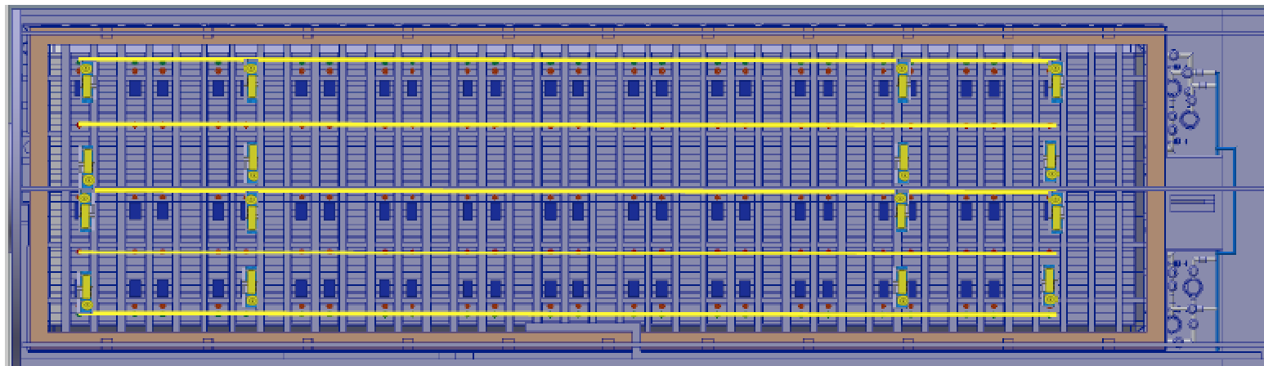

In the above figure the lasers are shown in yellow. They are placed near the anode planes similarly to what is planned for SBND. By placing the lasers near the anode the risk due to discharge is minimized as the field seen by the mechanical components of the laser is small. Historically the decision has been made not to shoot the UV laser at the UV sensitive photon detectors even though bench tests did not see significant damage for exposures exceeding the expected detector lifetimes. A model of the SBND laser steering head is shown below to demonstrate how such a system could interface with the field cage modules.

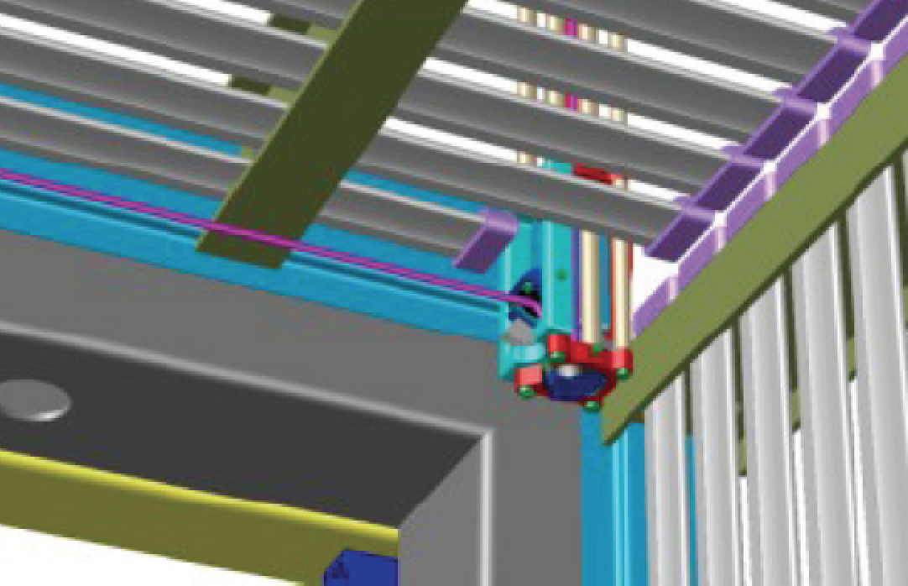
If the laser system in this document is to be implemented then 16 feedthrus are needed to cover the 4 TPC drift volumes. A crossing tube diameter of 200 mm is recommended which is slightly larger than the SBND size.

Radioactive Sources
Another big advantage of having the DUNE far detector underground is that the physics potential will be vastly increased beyond studies with beam neutrinos. For example, a large liquid argon detector, located deep underground, is an ideal observatory for astrophysical neutrinos originating from supernova bursts (SNB), when such occur nearby in our galaxy. SNB could even help to resolve the neutrino mass hierarchy by measuring the electron-neutrinos from the neutronization burst in a LAr target, as opposed to water or hydrocarbon.
These electron-neutrinos have a mean energy of about 10 MeV. Moreover, all electron-neutrinos CC transitions on 40Ar have to go into the excited state of 40K (as the direct transition to the ground state is forbidden), thus additionally resulting in gammas and/or neutrons, important to be collected for good calorimetry.
Michel electrons from stopped cosmic muons are useful to calibrate the continuous detector response to intermediate energies up to 53 MeV. But Michel electrons are not as useful as well-defined deployable radioactive sources when calibrating energies around 10 MeV and below.
If the established radiopurity requirements were met in the far detector construction, the detection threshold is then defined by the intrinsic 39Ar contamination of 1 Bq/kg of natural LAr and 10^-4 Bq/kg of 42Ar. 39Ar has a half-life of 269 years and a beta endpoint energy of 565 keV causing a 10 MHz signal in each 10 kt module. 42Ar has a half-life of 32.9 years and a beta endpoint energy of 599 keV, causing a 1 kHz signal in each 10 kt module. However, 42K subsequently decays with a half-life of 12 hours to 42Ca with a beta endpoint energy of up to 3.5 MeV and correlated gamma cascade of up to 3.4 MeV total gamma energy.

Background estimates already indicate that a $^{60}$Co
calibration source with a larger optimized activity and suitably
placed in the DUNE TPC would give a detectable photon signal in
addition to the previously described wire hits in the APA.
Radioactive sources with larger energy deposits, such as for
example a nickel source with $9\,$MeV $\gamma$'s from
$^{58}Ni(n,\gamma)^{59}Ni$ (using e.g. $^{252}$Cf as neutron
provider) would be very promising and will be studied by UA. It is
proposed to simulate and study the impact and design of different
types of calibration sources for DUNE to infer a coherent
scintillation light yield model: In particular $\beta$-sources
with relatively high end point energies, such as for example
$^{144}$Ce (halflife of $284\,d$, daughter $^{144}$Pr with
$\beta-<2.99\,$MeV) or $^{106}$Ru (halflife of $368\,d$, daughter
$^{106}$Rh with $\beta-<3.54\,$MeV). The scintillation light yield
of $\beta$-sources would be particularly of interest with respect
to probing the detector capabilities regarding ES tagging of
supernova neutrinos and potentially their directional
reconstruction.

Even in the case that radioactive sources could only be detected
in the direct vicinity of APA and photon detectors, it would still
be invaluable to compare timing response, measured charge and
light yields with the expectation from simulation. Thus, light
yield models could be validated as well as the critical electron
lifetime for charge drift. A set of well-defined calibration
sources of different types of particles at different energies will
help both the time calibration and the refinement of the
simulation response for detecting supernova neutrino signals in
the $10\,$MeV energy regime throughout the entire active volume.

UV Light-based Photon detector Monitoring System

A UV-light based calibration system can be used to monitor and calibrate the Photon detector system. The Photon detector in DUNE has the primary function to determine the ‘t0’ of the event, which would be an input to the LArTPC reconstruction. A calibration system for the photon detectors would verify the dynamic range, SiPM gains and time resolutions. The system would also evaluate the relative efficiencies of the detectors and monitor the stability and the response of the entire photon detection system as a function of time – for the duration of the experiment.
The UV calibration system would also be crucial during the commissioning of the detector system—before the detector is filled with LAr –- to test the photon detectors.

The system consists of a set of LEDs which emit light at a wavelength of 280 nm. The LEDs are a part of a rack-mounted Light Calibration Module (LCM)that includes the LED driver circuitry, which utilize the Argonne SiPM Signal Processor (SSP) motherboard for control and communication with the trigger and timing systems. Each UV-LED in the LCM is coupled to a quartz fiber-optic cable, which transmits light via an optical feedthrough into the cryostat and the detector volume. Each of the fibers terminate in to one of the diffusers, which are mounted at particular locations on the Cathode Plane Assembly (CPA), as illustrated in Fig. to achieve uniform illumination of the APA. The diffuser consists of a UV reflector and quartz glass diffusers. The TPB coated photon detector will shift the wavelength of 280 nm light to mimic the photon detector response to LAr scintillation light. The LCM allows for varying of pulse width, pulse amplitude and selective flashing of particular diffusers to test response of the entire photon detector system.

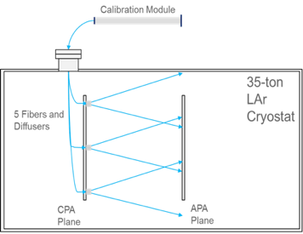
Fig: Schematic of the UV-light calibration system as realised in the 35t prototype experiment.

An identical UV-led calibration system was used in the 35t DUNE prototype experiment, and is in the works for ProtoDUNE experiment. For ProtoDUNE, which is a single module of the DUNE experiment we implement 5 optical diffusers on a single side of the CPA plane. Preliminary simulation studies have shown that 5 diffusers are sufficient to illuminate the entire photon detector system in ProtoDUNE.
In case of DUNE there are multiple options for implementing this scheme. The DUNE 10k ton module will have two CPA planes each 58 m long 12 m high. We consider two options: One fiber/diffuser per 4m x 4m area, which translates to 9 fibers per 12m x 12 m area. Second option is five fibers per 12m x 12 m area. The two options can be implemented by having either 5 or 9 feedthroughs above each CPA plane. Preliminary studies indicate that light attenuation in the fiber is not a major factor (2-3% loss over 25 m).

