Summer Internship in Science and Technology (S.I.S.T.)
2017

NUISANCE-GENIE VALIDATION AND SAMPLE ADDITIONS

Adrian I. Orea
Department of Physics
North Central College
Naperville IL, 60540

Supervisor: Dr. Minerba Betancourt
Neutrino Division
Fermi National Accelerator Laboratory (FNAL)
Batavia IL, 60510

Contents:
Introduction 2
NUISANCE 3
GENIE 3
Cross Sections 4
Neutrino Interactions 5
Variables 6
MINERvA Project 6
Validations 7
-2016 Publication
-2017 Publication
Sample Additions 10
Double Differential Cross Section
Muon Neutrino
Anti-Muon Neutrino
Models 13
Future Work 14
Conclusion 14
Acknowledgments 14
References 15

Abstract:
Precision is important to calculate values in many areas of particle physics. In neutrino physics however, precision is crucial due to the rarity of neutrino interactions. This precision is implemented in two ways, with the design of the detector as well as with modifying the physics that is used in simulation models. Due to the modifications made to the simulation models, their validity and functionality must be tested. After the detector construction has been completed, the task of maintaining precision is mainly dependent on simulation models and signal definitions. Validation occurs in two steps, validation of NUISANCE to ensure that the signal is correctly computed and validation of new simulation models. Upon completing these validations, the model is able to be used for further analyses.
Another part of precision keeping comes in adding samples to the NUISANCE framework to allow for validation as well as future analyses with the variables defined in the samples. In this project, two publications were used for validation and the double differential cross section for transversal and z-direction momentum was added to the comparison framework.
Introduction:
Cross sections are crucial measurements that shed light on many fundamental properties and quantities in many fields such as particle physics. Many of the detectors at Fermilab, as others in the world, produce data that is used for cross section analysis. The MINERvA detector at Fermilab uses data from neutrino interactions to expand our knowledge on neutrinos. Some of the tools for these measurements are Monte Carlo (MC) simulation models that are used to compare to actual data. From these comparisons, the physics that is used in the simulation is modified to better fit the real-world events. As a result of these tunings, our understanding of the underlying physics is modified and expanded. However, the validity of these simulation models and comparison framework is crucial to reach fine precision. Therefore, it is crucial to test the models and signal definitions in NUISANCE to validate against publications. In short, the purpose of the project was to validate the signal definitions for various measurements and to add new measurements.

NUISANCE:
The program that was used to compare MC data to data from the detector was NUISANCE. This program allows the user to read in a sample and a MC simulation file to directly compare the two via nuiscomp. NUISANCE generates several histograms that are used for different functions such as examining the direct superposition, a one-dimensional representation of a two-dimensional histogram, or a ratio examination. Within the NUISANCE framework is the constructor file for a specific experiment sample which loops over the MC data to select specific events and perform calculations on them according to the variables that the sample specifies. NUISANCE was essential in providing a central area to generate histograms to makes comparisons as well as providing a uniform guide to signal and variable definitions.
In addition to the functions that were used for this project, NUISANCE also offers many other important features. One is the ability to use simulation data from different generators such as GENIE, NuWro, NEUT, and GIBUU. Also, it includes various reweighting table generators as well as allowing for parameter reweighing and performing model tuning. The last feature was the one that was used the most during this project.
GENIE:
GENIE was the MC simulation program that was used to generate the files that we used for comparisons. Within this program, there were many options that allowed for flexibility that was needed for the different analyses that were needed for this project. Some of the user options were changing the target, the initial particle, and the nuclear model. These options were very valuable since various targets were used in the analysis and the nuclear model needed was specified as default. For the majority of the files, 2.5 million events were generated on hydrocardbon (CH), although other targets such as Iron and Lead were also used. This number of events allowed for enough statistics to give data that was very similar to the data from the detector.
Another feature of GENIE, which is also common among other generator programs, is using PDG codes for the different particles in order to specify the target and initial and final state particles. Although GENIE also offers its own comparison feature, this was not used since NUISANCE was readily available for use on out analyses. In addition to event generation, GENIE was also used to generate splines that were needed for event generation. However, the majority of the project focused solely of event generation.
GENIE is important for use not only in the MINERvA detector for use in many other existing and future detectors such as DUNE. It was developed with around 120,000 lines of C++ code and is based in ROOT. Due to the variety of neutrino flavors, targets, and energy ranges GENIE is very useful due to its flexibility. Another crucial element of GENIE is its ability to be modified to fit the needs of future analyses.
Cross Sections:
Effectively, cross sections are the “area” that a particle needs to be to another particle in order to interact with it. The term refers to the model that particles are hard pool balls that collide. However, a cross section is not its geometric size. As an example, the physics cross section of the particle is bigger than the geometric cross section for forces at a distance. For use in particle physics, the cross section is used to determine the probability of an interaction taking place since the cross section is proportional to the probability of that interaction. The equation for it is below, where $N$ is the number of events, $Φ$ is the flux, and $T$ is the number of targets.
$$σ=\frac{N}{Φ*T}$$
When a cross section is measured as a function of a variable, examples of which will be discussed in the variables section, the cross section is measured as a differential cross section. For example, if measured as a function of the solid angle, it is labelled as $\frac{dσ}{dΩ}$. The validations that were done in this project involved recreating histograms that had a differential cross section as the dependent variable. Similarly, the cross section can also be measured a function of more than one variable as is the case with the added sample of $\frac{d^{2}σ}{dp_{t}{dp}_{||}}$.

Neutrino Interactions:
Although a neutrino event is rare, there are various types of interactions that can occur by impacting a nucleon. These interactions fall under one of two categories, charged current (CC) and neutral current (NC). What distinguishes these two categories is the characteristic particle that results from the interaction and allows the observer to determine the flavor of the neutrino. In a neutral current event, there is no “flavor” particle and what results is the neutrino scatters off the nucleon and is undetected. For our analyses, only muon neutrinos were used. Subsequently, the flavor particle that was produced after the interaction was a muon ($μ^{-}$).
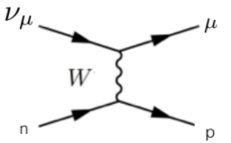
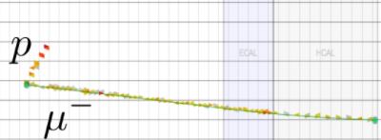
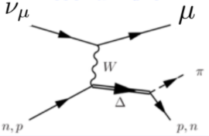
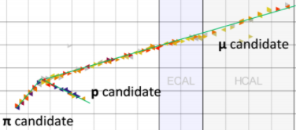
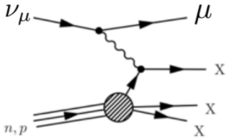
Within the charged current category, there are three subgroups that have different particles, and quantities, in the final state. They are labelled as quasi-elastic (QE), resonant elastic (RES), and deep inelastic (DIS). Within the NUISANCE framework, the different types of events are labelled first by the type of event and then the subcategory that it fall under. For a quasi-elastic event from the MINERvA detector, it is labelled as MINERvA_CCQE. For the majority of our analyses only QE data was used. However, one complication with QE and RES is the possibility of the pion being absorbed by a nucleus and not appearing in the final state. This is accounted for in the measurements, but that methodology was not part of this analysis.
CCQE:
CCRES:
CCDIS:
Figure 1: Feynman diagrams and events for each type of event. Diagrams provided by Minerba Betancourt

Variables:
For the differential cross sections, there were a variety of variables that were analyzed. Each variable was defined within its respective sample in NUISANCE. Some of the variables were directly from the measurements that were done at the detector but others were calculated. Although it is common to find the differential cross section as a function of the solid angle, many of the variables used for our analysis were in relation to quantities of the particles. Some of these variables include muon momentum and angle, pion kinetic energy, neutrino energy, and four momentum transfer. For the signal definitions in NUISANCE that were validated, only muon momentum, muon angle, neutrino energy, and four momentum transfer were analyzed. However, for the double cross section these variables were the transversal and z-direction momentum of the muon.
Within the NUISANCE framework, all of the samples were labeled according to the type of event, as seen in the previous section, but the variable was also added. This was done to keep an organized and uniform method to keep track of samples to avoid confusions. Additionally, the dimension is also included for the same purpose. For the muon angle the sample name was MINERvA_CC0pi_XSec_1Dthmu_nu, where the final part is used to distinguish from antineutrino samples (antinu).
MINERvA Project:
One of the detectors for neutrino research at Fermilab is the MINERvA near detector. This detector is unique for two main reasons, it’s hexagonal shape and its incorporation of five different nuclei into one detector. It is the only detector on the planet with this number of different targets, which are Lead, Iron, Carbon, Helium, and water. Using the NuMI line at Fermilab, the MINERvA detector will provide data that is used for several months or years of analysis. One of the main purposes of this project is to analyze the interactions in order to test simulation models and improve our knowledge on neutrinos.
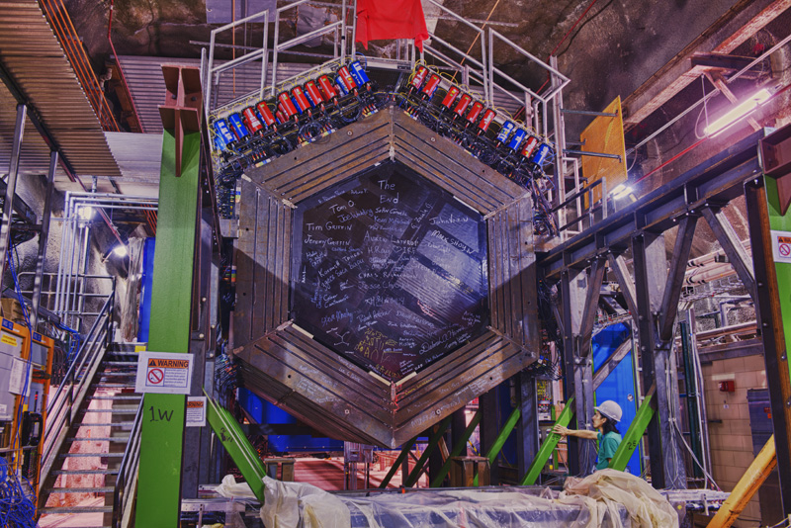
Figure 2: MINERvA Detector at Fermilab. Photo Credit: Fermilab Photo Gallery (Reidar Hahn)
Validations:
As mentioned in the introduction, this project’s main goal was to validate the signal definitions in NUISANCE against publications from 2016 and 2017. The publication from 2016 was a paper while the one from 2017 was a presentation. For these validations, the figures in the publications needed to be recreated with the same model that was used in order to verify that NUISANCE is making the correct calculations and cuts to match that of the official GENIE extractor. In the first stage of validation, the histograms were one dimensional and were compared between two different GENIE versions as well. During the second stage, the histograms were two dimensional and therefore the figures were made with slices in order to check the shape and values. These two-dimensional histograms came from the presentation and were also the same sample that was added to the NUISANCE framework, therefore those plots will be shown in the next section.

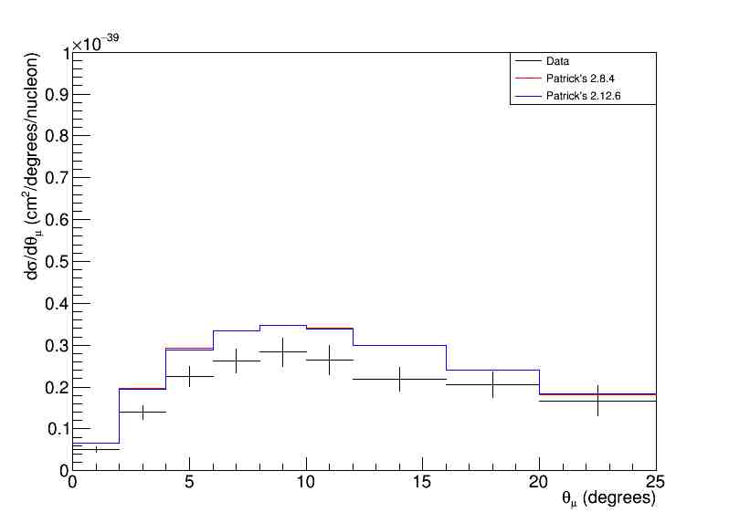
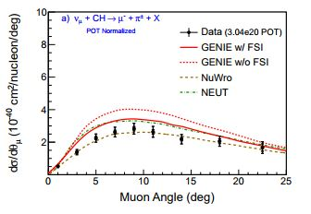
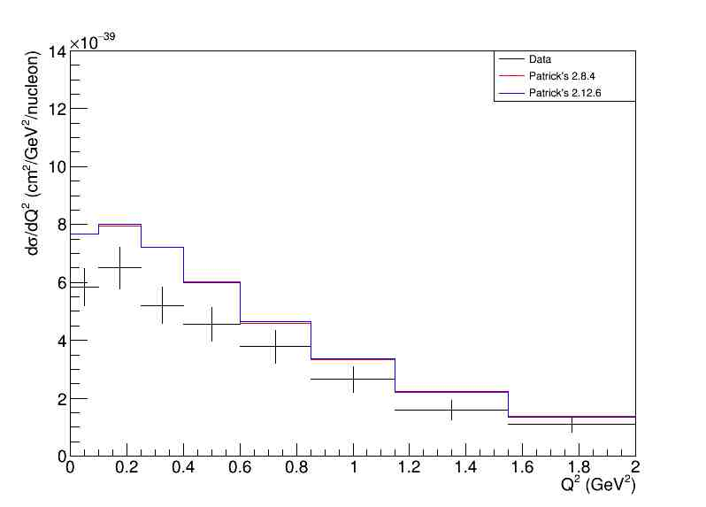
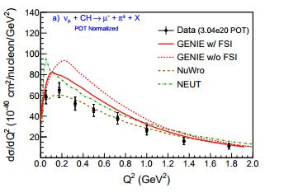
Figure 3: Side by side plots of MINERvA figures for four momentum transfer. Recreated plots with GENIE 2.12.6 and 2.8.4 (Left) Plots published in 2016 with different generators. Comparison was done to the red line
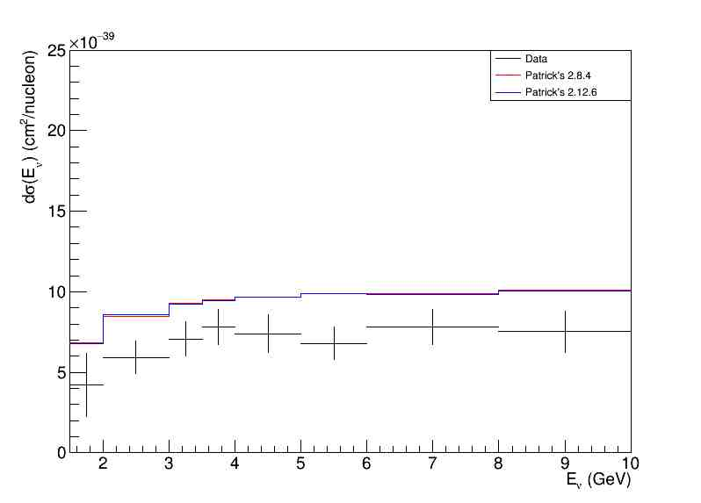
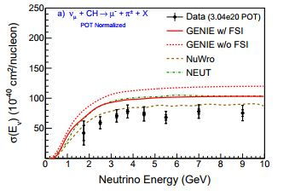
Figure 4: Side by side plots of MINERvA figures for muon angle. Recreated plots with GENIE 2.12.6 and 2.8.4 (Left) Plots published in 2016 with different generators. Comparison was done to the red line
Figure 5: Side by side plots of MINERvA figures for the neutrino energy. Recreated plots with GENIE 2.12.6 and 2.8.4 (Left) Plots published in 2016 with different generators. Comparison was done to the red line

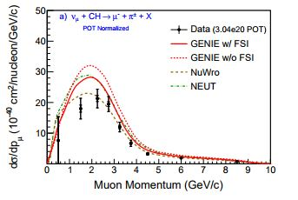
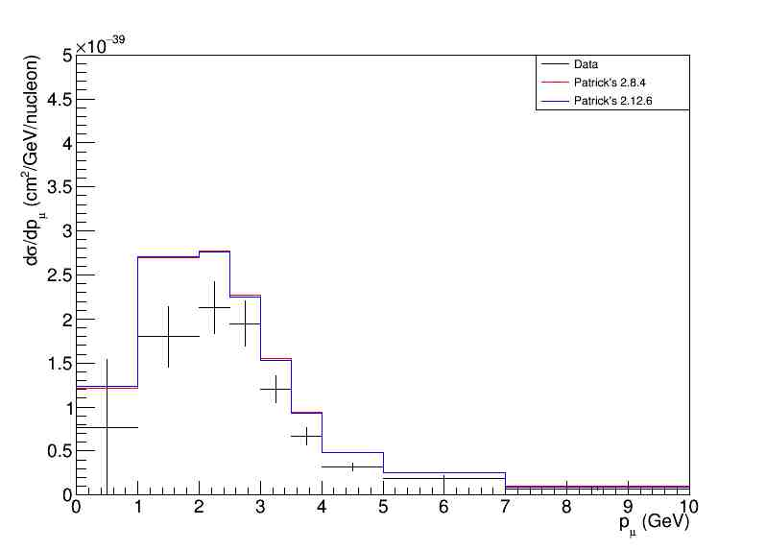
Figure 6: Side by side plots of MINERvA figures for muon momentum. Recreated plots with GENIE 2.12.6 and 2.8.4 (Left) Plots published in 2016 with different generators. Comparison was done to the red line
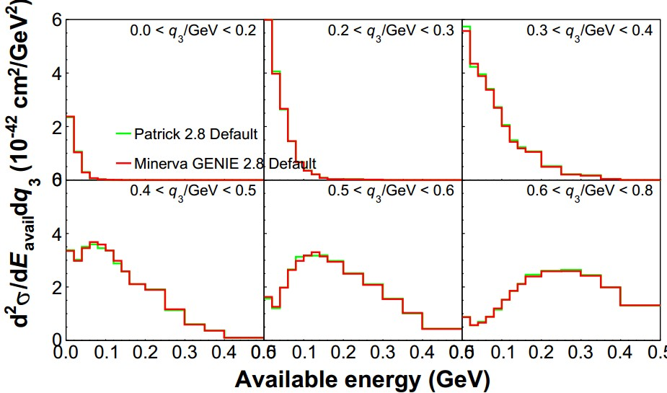
From inspecting these plots, the red line on the plots on the right fits the lines on the plots on the left very nicely. Therefore, the models were validated both between versions and the definitions in NUISANCE are correct. The plots that follow have also been verified. However, these were not from a publication but rather just a comparison to data from the production team. From figure 7 and the figures in figure 8, it is easily seen that the data from the production team and the data generated as a part of the project line up nicely as seen in the previous plots.
Figure 7: Slice plot for double differential validation for low recoil data
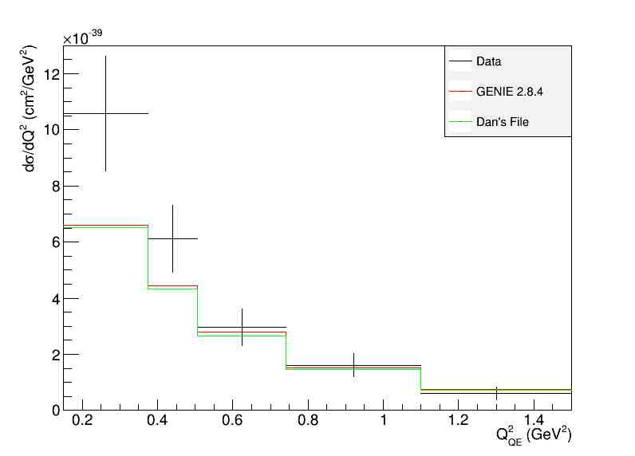
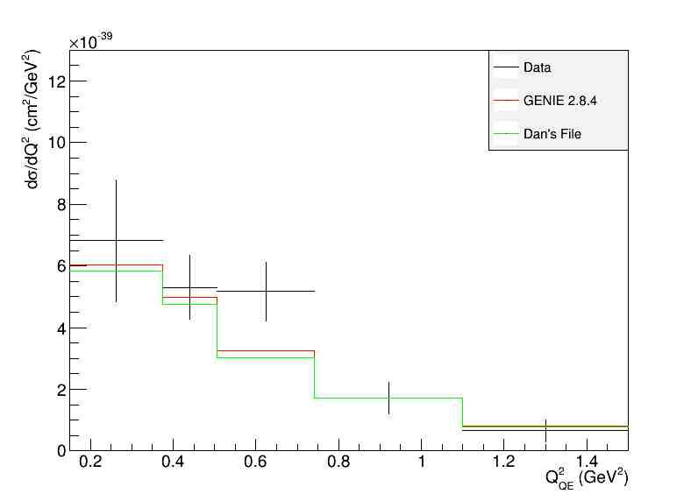
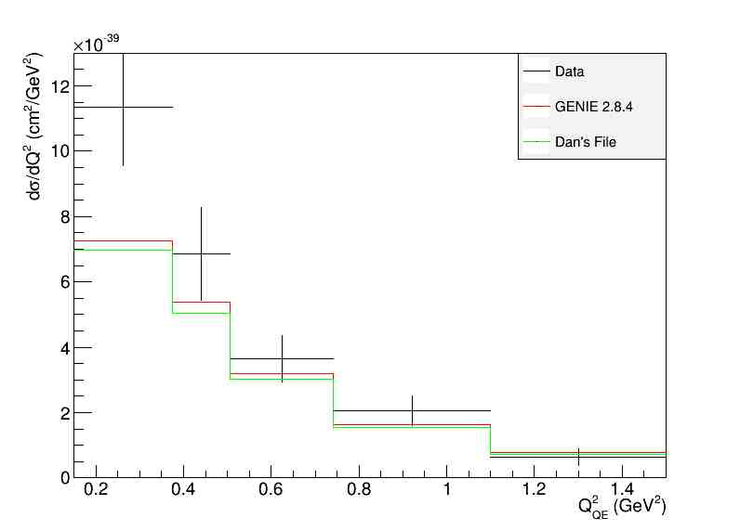
Figure 8: Superposition of four momentum transfer for different targets. Includes data, my MC data, MC data from the production team (CCW Iron, Carbon, Lead)
Sample Additions:
As mentioned in the NUISANCE section, there are several samples with data from the detector and scripts to perform the correct calculations and variable definitions. As part of the project, more samples were added into the framework so that future analysis could be done. With this sample however, a two-dimensional histogram needed to be produced since the transverse and z-direction momentum needed to be calculated. This addition was of both neutrinos and antineutrinos. The publication that this was compared to was a presentation at the NuInt meeting. This task involved making the correct cuts for angle and final state particles in order to only analyze the events that were of interest.
From looking at these comparisons, it is clear that the new sample addition is functioning correctly and that it has been validated to the plots from the presentation. These slices in my slides include my MC data, MC data from the production team, and data.
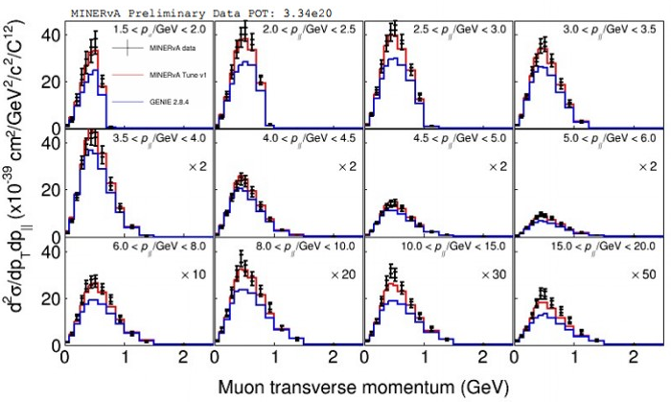

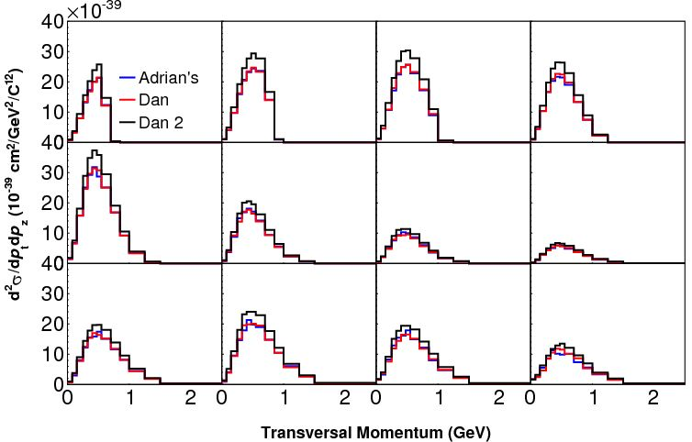
Official GENIE Extractor
Figure 9: Validation and final result of the added double differential cross section sample for neutrinos. NUISANCE plot (Top) NuInt plot (Bottom) Scaling on the NUISANCE plots are the same as the NuInt slides
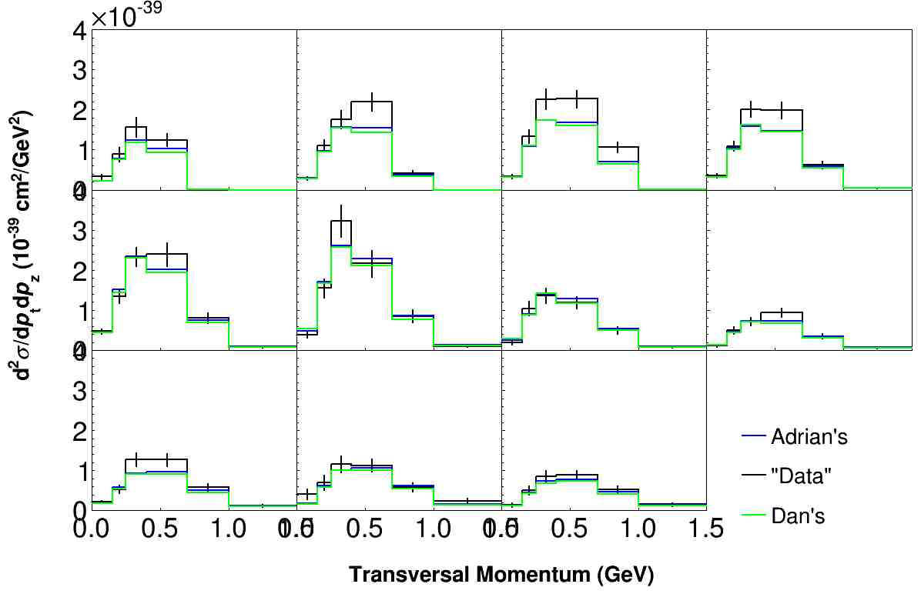
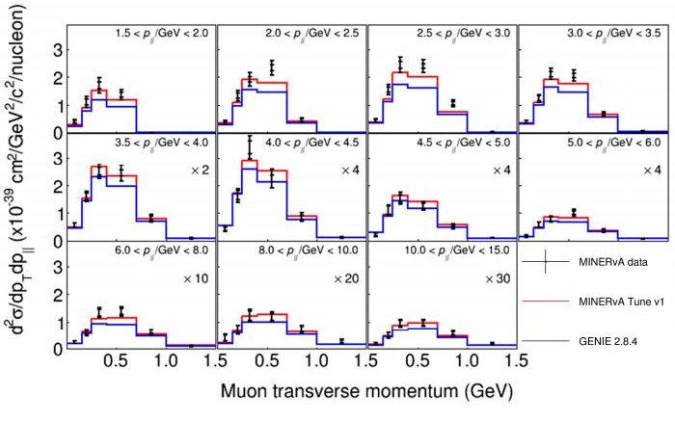
Figure 10: Validation and final result of the added double differential cross section sample for antineutrinos. NUISANCE plot (Top) NuInt plot (Bottom) Scaling on the NUISANCE plots are the same as the NuInt slides
Official GENIE
Extractor
Data

Models:
The final section of the project was to redo the validation plots from the publication as well as the sample addition plots with different models. The purpose for this was to check the functionality of the different models that are currently in GENIE. Each model operates differently due to the different parameters. The ones that were covered were Default, DefaultPlusMECWithNC, DefaultPlusValenciaMEC, EffSFTEM, and ValenciaQEBergerSehgalCOHRES. Although knowledge of the actual workings behind them were not crucial, it is worth noting their differences.
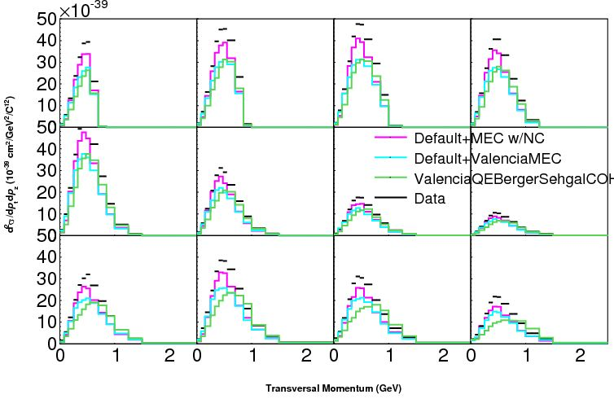
In the Default model, GENIE uses the Smith-Moniz QE model with relativistic Fermi gas. The pion production is described by the Rein-Sehgal model. With DefautlPlusMECWithNC, most is identical to Default expect the QE interactions are handled with an empirical model with data form the MiniBooNE detector. Similarly, DefaultPlusValenciaMEC is very similar to Default but uses a theoretical 2p2h model instead of an empirical model. EffSFTEM removes the QE model from the Default models and uses an effective spectral function model and replaces the 2p2h model with a transverse enhacement model (TEM). Finally, ValenciaQEBergerSehgalCOHRES uses the 2p2h model but also uses a QE model like Default but with a local Fermi gas model. For pion production, it uses a model that improves on the Rein-Sehgal model from Default. As mentioned previously, the details of each model did not affect the project since this project was to compare and validate data rather than directly change parameters.
Figure 11: Model Comparison for sample addition
Future Work:
From looking at these validations, the models used for the simulations are functioning as expected and the plots from the publications are reproducible with the definitions in NUISANCE. However, more plots from different publications can also be used to validate with a similar process to further confirm the results of this project. Also, with regards to sample additions there are other samples from published data that could be added in to the NUISANCE framework to provide a central frame for making more comparisons and validations.
Conclusion:
As a result of this project, the samples in the NUISANCE framework have been validated against the plots published by the MINERvA group.. Also, the different models of GENIE have also been confirmed to be functional and reliable. The addition of the new sample has also validated the slides from the NuInt meeting and have also provided more resources for neutrino analysis in the future. As a result of these validations, GENIE can now be fine-tuned even further to modify the physics that takes place in the simulation to reveal more aspects about neutrinos in the real world.
Acknowledgments:
I would like to express my enormous gratitude to my supervisor Minerba Betancourt for her patience and willingness to answer all my questions. Similarly, I would like to thank Kevin Ewart, Patrick Stowell, Gabriel Perdue, Aaron Bercellie, and Sarah Henry for giving me tips and clearing up any confusions that I had. Without these people, I would not have been able to accomplish any work during this project. The Fermilab staff, especially the SIST coordinators, have been very helpful and kind to the interns. They have created an environment at Fermilab where we are provided with enough support to be comfortable yet also enough to allow us to explore on our own and be challenged. Finally, I would like to thank North Central College and the Physics department for providing me with the academic background, work ethic, and opportunity to work at Fermilab. Although the work was challenging, I felt prepared to handle new challenges due to being exposed to similar challenges in lectures.
References:
McGivern, C.L., et al. “Cross Sections for Νµ and ν¯µ Induced Pion Production on Hydrocarbon in the Few-GeV Region Using MINERvA.” 19 Aug. 2016, pp. 1–17., arxiv.org/pdf/1606.07127.pdf.
Ruterbories, Daniel. “MINERvA CC0pi Results.” NuInt . NuInt, 29 June 2016, Guanajuato, MX.
Betancourt, Minerba. “Neutrino Experiments at Fermilab.” TARGET. 6 July 2017, Batavia.
C.Andreopoulos, C.Barry, S.Dytman, H.Gallagher, T.Golan, R.Hatcher, G.Perdue and J.Yarba
The GENIE Neutrino Monte Carlo Generator: Physics and User Manual
e-Print: arXiv:1510.05494[hep-ph]
C.Andreopoulos, A.Bell, D.Bhattacharya, F.Cavanna, J.Dobson, S.Dytman, H.Gallagher, P.Guzowski, R.Hatcher, P.Kehayias, A.Meregaglia, D.Naples, G.Pearce, A.Rubbia, M.Whalley and T.Yang The GENIE Neutrino Monte Carlo Generator
Published in Nucl.Instrum.Meth.A614 (2010) 87-104
NUISANCE: a neutrino cross-section generator tuning and comparison framework.
P. Stowell, C. Wret, C. Wilkinson, L. Pickering, et. al., 2017 JINST 12 P01016, arXiv:1612.07393

