For Title Use Style Heading 1: allcaps, 12-point Times New Roman centered Font, continuous line without line breaks
Author1 Name¹, Author2 Name^{1,2}, Author3 Name³, Author4 Name^{1,3}, Author5 Name⁴
¹ Department/Unit in Affiliation 1, University or other Institution, City, State (in any), Country (do not exceed one line)
² Department/Unit in Affiliation 2, University or other Institution, City, State (in any), Country (do not exceed one line)
³ Department/Unit in Affiliation 3, University or other Institution, City, State (in any), Country (do not exceed one line)
⁴ Department/Unit in Affiliation 4, University or other Institution, City, State (in any), Country (do not exceed one line)
Keywords: e.g. Voice; Modelling; High-Speed Videoendoscopy; (up to 4 that apply)

Introduction
This proceedings paper is limited to 2 pages, but does not need to fill full 2 pages, or it could be a single-page abstract. Start with a very short introduction of the problem, the purpose, significance and/or innovation to the field of voice research. Mention any important background information from literature and preliminary data. Use square brackets for references placed at the end of the sentence [1-5]. Clearly state the purpose of the study followed by the research questions or hypotheses!
This template has been designed for output on the US-letter paper size, and it is saved as “Word” document file for the PC. The abstract has to be submitted as Word file. All formatting styles and specifications needed for preparing electronic versions of the abstract are already included. All standard paper components have been specified for three reasons: (1) ease of use when formatting individual papers; (2) automatic compliance to electronic requirements that facilitate the concurrent or later production of electronic products; and (3) conformity of style throughout the conference Abstracts. Margins, column widths, line spacing, and type styles are built. It is not recommended to change them. Some components, such as multi-leveled equations, graphics, and tables are not prescribed, although the various table text styles are provided. The formatter will need to create these components, incorporating the applicable criteria that follow.

Methods

Human Data
Describe your human data sample here (if applies), the inclusion and exclusion criteria.
The formatting styles used in this template are intended as follows: the title uses “Heading 1” style; section titles use “Heading 2”; section subtitles use style “Heading 3”; section text uses “Normal” style; author names use “Names” style; author affiliations use “Affiliation” style; figure and table captions use “Caption” style. Please DO NOT change or edit otherwise any formatting styles. Avoid using the “Footer”, “Header” and “Page Number” styles, which are reserved for publishing purposes only. No changes in the Header or Footer areas are allowed. Do not insert page numbers. All margins, column widths, line spaces, and text fonts are prescribed; please do not alter them. Define abbreviations and acronyms the first time they are used in the text, even after they have been defined in the abstract. Before you begin to format your paper first save the contents as a format-free text file; then copy and paste in order to preserve the template format.

Instrumentation and Measurement
Describe instrumentation with the essential specs (if applies). Describe measurement techniques and methods.

Analysis
Provide description of the analysis methods, usually statistical analysis, modelling paradigm, or in some case more complex analytic techniques (if any).
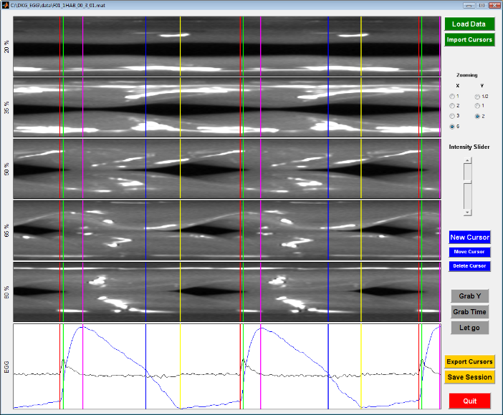Fig. 1: Place figure (if any) captions below the figure. Avoid very long captions. ICVPB Abstracts will be a color PDF file, thus color figures are acceptable.
The equations are an exception to the prescribed specifications of this template. You will need to determine whether or not your equation should be typed using either the Times New Roman or the Symbol font (please no other font). To create multileveled equations, it may be necessary to treat the equation as a graphic and insert it into the text after your paper is styled.
Number equations consecutively. Equation numbers, within parentheses, are to position flush right, as in (1), using a right tab stop. To make your equations more compact, you may use the solidus ( / ), the exp function, or appropriate exponents. Italicize Roman symbols for quantities and variables, but not Greek symbols. Use a long dash rather than a hyphen for a minus sign. Punctuate equations with commas or periods when they are part of a sentence, as in
a  b    
Note that the equation is centered using a center tab stop. Be sure that the symbols in your equation have been defined before, as shown above. Use “(1)”, not “Eq. (1)” or “equation (1)”, except at the beginning of a sentence: “Equation (1) is.

Results
When using a separate “Results” section present only the resulting data without discussing them. Alternatively, you can combine a “Results and Discussion” section. Refer to tables as Table 1; and figures as Fig.1. Figure captions should be below the figures; table heads should appear above the tables. Insert figures and tables after they are cited in the text. Large figures and tables may span across both columns.
Some Common Mistakes:
- The word “data” is plural, not singular.
- Do not use the word “essentially” to mean “approximately” or “effectively”.
- Be aware of the different meanings of the homophones “affect” and “effect”, “complement” and “compliment”, “discreet” and “discrete”, “principal” and “principle”.
- Do not confuse “imply” and “infer”.
- There is no period after the “et” in the abbreviation “et al.”
- The abbreviation “i.e.” means “that is”, and the abbreviation “e.g.” means “for example”.
- Refer to the tables from the text as Table 1, Table 2, etc. If the table is too big to fit in a two-column section, use section break switching to a single column then switching back again to a two-column section.
Table 1: Place table (if any) captions above the table.
Register | Range | Male Range | Female Range
Modal | 90.02 Hz – 269.05 Hz | 90.02 Hz – 164.45 Hz | 152.29 Hz – 269.05 Hz
Falsetto | 300.5 Hz – 1041.71 | 300.05 – 496.04 Hz | 411.59 Hz – 1041.71 Hz

Discussion
Use this section to discuss the results. This section may be combined with either “Results” or “Conclusion” sections. That is, there could be separate “Results”, “Discussion” and “Conclusion” sections; or “Results and Discussion” and “Conclusion”; or “Results” and “Discussion and Conclusions” section.

Conclusion
Clearly state the conclusion(s) from this work. That may also include suggestions for future studies.

Acknowledgments
The preferred spelling of the word “acknowledgment” in America is without an “e” after the “g”. Avoid the stilted expression “one of us (R. B. G.) thanks ...”. Use neutral form, such as: Research funded by research grant #xxxx “Title of Grant, if any”. Special thanks to Dr./Mr./Ms…

References
Number references (if any) consecutively, in order of appearance, within brackets [1]. The sentence punctuation follows the bracket [2]. Refer simply to the reference number, as in [3]—do not use “Ref. [3]” or “reference [3]” except at the beginning of a sentence: “Reference [3] was the first ...”
The following reference style is preferred due to compactness, but it is not mandatory:
[1] Baken RJ, Orlikoff RF. Clinical Measurement of Speech and Voice. 2nd ed. San Diego, CA: Singular Publishing Group; 2000.
[2] Hollien H. On vocal registers. J Phonetics 1974; 2:125-143.
[3] Hollien H, Girard GT, Coleman RF. Vocal fold vibratory patterns of pulse register phonation. Folia Phoniatr 1977;29(3):200-205.
[4] Titze IR. Interpretation of the electroglottographic signal. J Voice 1990;4(1):1-9.
[5] Whitehead RL, Metz DE, Whitehead BH. Vibratory patterns of the vocal folds during pulse register phonation. J Accoust Soc Am 1984;75(4):1293-1297.
[6] Young M. The Technical Writer’s Handbook. Mill Valley, CA: University Science, 1989.

Proceedings Paper Submission Instructions:
Please email your paper as a “.doc” or “docx” file to icvpb2018@gmail.com. Name your document to follow the standard file name given (“[first author surname] ICVPB2018 Proceedings Template.docx”); an example if the first author surname was Smith and co-authors: “Smith et al ICVPB2018 Proceedings.docx”. For logistical reasons, when you email your document please include the filename in the subject line of the email similar to Subject Line: Smith et al ICVPB2018 Proceedings submission.
The submission deadline is June 15th, 2018. The proceedings papers will not be further edited for content. The authors are solely responsible for the content. Only minor syntax or formatting editing may be performed by the publishing team. Upon acceptance, both oral and poster presentations are expected to submit a proceedings paper, which will be included in the official in the official ICVPB Proceedings in the form provided by the authors.

