MQXFAP1-2 Magnetic Measurement Plan
Version 0, 9/27/17

Contents
1 Magnetic measurement goals for MQXFAP1-2 1
2 Facility and rotating probe 1
3 Reference parameters and conditions 2
4 Measurements before and during cool-down, check-ups and training 3
5 Field quality characterization 3
5.1 Z scan at intermediate current with circuit #2 (220 mm probe) 3
5.1 Accelerator cycle to nominal gradient 4
5.2 Z scan at nominal gradient with circuit #2 (220 mm probe) 5
6 Z scan during warmup and at room temperature 5
7 References 6

Magnetic measurement goals for MQXFAP1-2

MQXFAP1 is the first long prototype of the MQXF design for the HL-LHC Q1 and Q3 final focus quadrupoles. The MQXFAP1 assembly has several non-conformities: in particular, one coil is built according to the first generation cross-section, and the others are built according to the second-generation cross-section. In addition, different wire architectures are used in different coils. For these reasons, it is not considered a field quality magnet. The second thermal cycle, MQXFAP1-2, will provide the first opportunity to commission the new magnetic measurements system which was developed specifically for this magnet, and to get a first set of measurements to compare with those of previously tested short models.

Facility and rotating probe

The PCB magnetic measurement probe was designed and fabricated at Fermilab incorporating the lessons learned from previous tests of MQXFS short models. In particular, number of layers has been optimized to provide the optimal signal strength and the length has been adjusted to better match the cable twist pitch. Two identical copies were made, one to be used at Fermilab for short models and the second to be used at BNL for long prototypes. Both probes were commissioned and cross-checked at Fermilab during the MQXFS1c test.
Two circuits are included in each probe, one with a nominal 110 mm length, and the second with a nominal 220 mm length. Taking into account the detailed design of the PCB, the actual magnetic length is 108.74 mm for the 110 mm circuit, and 217.88 mm for the 220 mm circuit. Therefore, assuming the probe is moved by half of the relevant magnetic length at each step of the z-scan, the required step is 54.37 mm for the circuit #1 (110 mm) scan; and 108.94 mm for the circuit #2 (220 mm) scan.

Reference parameters and conditions

- Nominal ramp rate is 14 A/s.

- Currents and corresponding gradients for injection, nominal and ultimate level are specified in Table 1. Injection level was calculated as follows. G.inj = 132.6/7*0.45 = 8.5 T/m. Low current transfer function is 8.86 T/m/kA (Ref: MQXF design report v7, July 2015), therefore 0.96 kA for 8.5 T/m

Table 1 Reference current levels for magnetic measurements of MQXFS.
Current [kA] | Symbol | Gradient [T/m] | Remarks
0.1 | I.res | 0.9 | Reset level for pre-cycle
0.96 | I.inj | 8.5 | Injection level
6.0 | I.lim | 48.8 | Current limit (pre-training)
16.48 | I.nom | 132.6 | Nominal level
17.76 | I.ult | 143.2 | Ultimate level
21.6 | I.ssl | 171.8 | 1.9K Short Sample Limit

- An optimized profile for acceleration/deceleration at the beginning and end of each ramp needs to be defined (for each ramp rate) to minimize the impact on the multipole decay and to avoid current overshoot and the resulted ramp irregularity

- Pre-cycle parameters for measurements up to I.nom (or higher). A pre-cycle is applied to put the magnet into a reproducible state prior to the following measurements: accelerator cycle, stair-step measurements and ramp-rate dependence measurements.

  - The pre-cycle is defined as follows:

    - From 0 to I.nom at 14 A/s,
    - Hold for 300 s at I.nom,
    - Ramp down to I.res at 14 A/s
    - Hold for 0s at I.res
    - Ramp to I.inj at 14 A/s
    - [Hold at I.inj is treated as part of the measurement cycle]

  - The pre-cycle needs to be adapted for measurements limited to lower current (e.g. before training, if any). The modified pre-cycle is described in the corresponding sections.
  - For measurements requiring a pre-cycle, the pre-cycle needs to be repeated in the case of a spontaneous quench, prior to completing the measurement.

- The central location will be determined by matching the transfer function dependence on z to design calculations.

The following sections describe the individual magnetic measurements to be performed.

Measurements before and during cool-down, check-ups and training

- No measurements are foreseen prior to, or during training quenches. The system is only expected to be operational in the second part of the test.

Field quality characterization

Z scan at intermediate current with circuit #2 (220 mm probe)

- Goals:
  - Perform a first measurement of the field quality variations along the magnet length
  - Verify the system operation and date quality in a relevant conditions, but at a relatively low current level
  - Confirm the position of the magnetic center for future measurements, and to compare with design calculations

- Notes:
  - It is assumed that a first determination of the magnet center is made based on geometrical data of the magnet and installation
  - Confirm that sufficient margin is available between the lowest probe positions and the length of the warm finger in order to avoid any risk of contact
  - It is suggested that 5.1 is performed before the protection studies, then go to protection studies while analyzing the data and implementing any required modifications to the magnetic measurement system, and then perform the remainder of the magnetic measurements.

- Conditions:

  - Longitudinal locations refer to center of circuit #2 (circuit #1 data recorded in parallel)
  - Longitudinal locations: from z=-2396.68 to z=+2396.68, every 217.88 mm

- Measurement cycle :

- Perform standard pre-cycle
- Hold 1000 s at I.inj
- Ramp to I.lim at 14 A/s
- Hold 300 s at I.lim
- Z-scan at I.lim
- Ramp down to zero

Accelerator cycle to nominal gradient

- Goals:
  - Measure central field quality in conditions that approximate the machine cycle to nominal gradient
  - Assess stability at I.inj and changes in harmonics at the start of ramp
  - Assess stability of operation at I.nom
  - Assess reproducibility from cycle to cycle

- Conditions:
  - Use circuit #2 at central location (circuit #1 data recorded in parallel)

- Measurement cycle (Fig. 3):

  - Perform standard pre-cycle
  - Hold 1000 s at I.inj
  - Ramp to I.nom at 14 A/s
  - Hold I.nom for 600 s
  - Ramp down to I.res at 14 A/s
  - Hold for 0s at I.res
  - Ramp to I.inj at 14 A/s
  - Repeat point 2 to 5 for two more times
  - Ramp down to zero

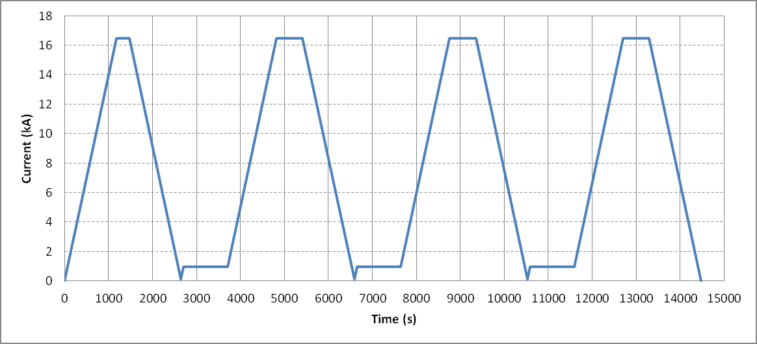
Figure 3: current profile for one accelerator cycle to nominal gradient.

Z scan at nominal gradient with circuit #2 (220 mm probe)

- Goals:
  - Measure field quality variations along the magnet length

- Conditions:

  - Longitudinal locations refer to center of circuit #2 (circuit #1 data recorded in parallel)
  - Longitudinal locations: from z=-2396.68 to z=+2396.68, every 217.88 mm

- Measurement cycle :

- Perform standard pre-cycle
- Hold 1000 s at I.inj
- Ramp to I.nom at 14 A/s
- Hold 300 s at I.nom
- Z-scan at I.nom
- Ramp down to zero

Z scan during warmup and at room temperature

- Goals:
  - Measure geometric harmonics at low current as a function of temperature

- Conditions:

  - Default current 10 A. Maximum current as defined in Table 2.
  - Longitudinal locations refer to center of circuit #1 (circuit #2 data recorded in parallel)
  - Longitudinal locations: from z=-2396.68 to z=+2396.68, every 108.94 mm

Table 2 Maximum current for different temperature intervals
Temp. (K) | Current (A)
200 – 295 | ± 15
100 – 200 | ± 20
< 100 | ± 30

- Additional notes:

- Perform one scan soon after the magnet enters the normal state (~ 30 K) to obtain the geometric effect with maximum effect of preload from cooldown.
- External heating to expedite the warmup process should be off before and during the measurements to help reducing temperature gradient along the magnet.

References

- MQXFS Test plans in HiLumi DocDB:
http://us-hilumi-docdb.fnal.gov/cgi-bin/DocumentDatabase/
Search keyword: TESTPLAN

