MQXFAP2 Conductor and Coils
Readiness Review Report
D. Cheng, G. Chlachidze (Chair), J. Muratore
December 7, 2017

This page intentionally left blank

Table of Contents
Introduction 3
1.0 Findings 4
2.0 Comments 6
3.0 Recommendations 7
4.0 Response to Review Charge Questions 8
5.0 Appendix: Review Goal and Charge 9

Introduction
The review committee would like to thank the presenters for putting together presentations with a comprehensive information on conductor and coils for MQXFAP2.

The reviewers also thank members of the Strand & Cable Lab at Fermilab for providing additional information and for a prompt testing of witness sample from coil 106.

The review charge can be found in the Appendix.

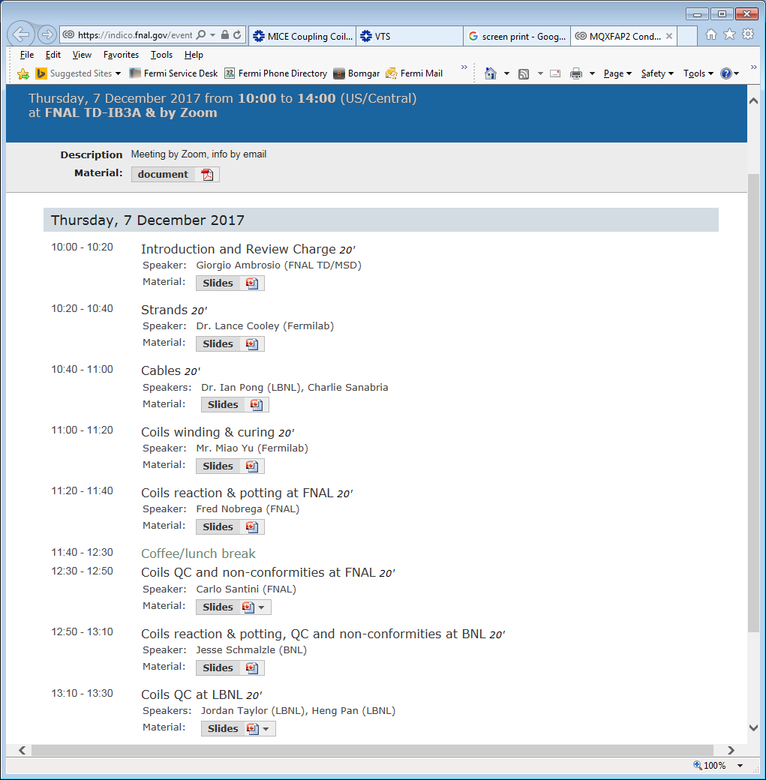
- Findings
- All Nb₃Sn RRP 108/127 strands used in the candidate coils satisfy the HiLumi specifications.
- New reaction fixture that was developed by CERN was used for witness samples reaction in coils 105 and 106 at BNL and FNAL. The usual separate reaction retort was used for samples in coils 101, 102 and 104.
- RRR measured in extracted samples of coils 104 (126-135) and 106 (139-157) are the lowest among all coils. RRR measurement results for extracted samples in coil 105 (211-238) were provided only after the review.
- Ic for all 3 extracted witness samples of coil 106 were obtained by extrapolation of the voltage rise signal. Another witness sample from this coil was available for testing. It is required to test at least two extracted and one virgin strands for each coil.
- Coil 106 strands demonstrated higher cable degradation (10.2%) among all coils, although Ic in all witness samples in this coil exceeds the strand specification.
- Comprehensive cabling information was provided at the review meeting. Mid-thickness of the cable is above the upper specification along first few tens of meters of several cables. In all cases the manufactured good cable length exceeds the required minimum of the total cable length per coil (441 m).
- Minor irregularity in the major edge facet size over 4 strands was found in cable P43OL1082 (coil 105). A broken strand was found at the startup length in cable P43OL1072 (coil 101).
- No major issues were reported on cable insulation. The insulation thickness in some samples were found out of specification, although still less than the available tolerance from the cable.
  - Noticeably different braid tightness was found in cable P43OL1073 (coil 102), and a dark spot was found and cleaned with Alcohol on cable P43OL1081 (coil 104). Both cases were investigated together with the vendor and the cause is understood. Few popped strands were observed and fixed in coils 102, 104 and 106.
  - Worn insulation areas were found in coil 105. The insulation in these areas were replaced with 3-mil E-glass tape. Heat cleaned S2 glass tape was not available when this repair was done.
- 50% of all coil parts (pole pieces) and 25% of all end parts in the sample are inspected using the CMM measurements.
- Number of wedges was increased from 4 in coils 102-103 to 6 in coils 104-106, changing the wedge gap distribution in coils.
- In one case cable length was measured ~10 m shorter at New England than at FNAL. The reason of this difference was not reported, whether it was investigated and understood.
- There are indications of pole gaps pinching the glass insulation around the pole in coils
- As suggested at MQXFAP1 Conductor and Coils Readiness review, heat cleaned glass tape is used around the pole starting from coil 107.
- There are still differences in the coil reaction recipe at BNL and FNAL. Actual plateau (dwell) time during reaction are estimated differently. All dwell times reported at FNAL are shorter then prescribed. The temperature sensor mounted on the retort with witness samples was used for estimation of the dwell time for coil reaction at FNAL.
- Comprehensive information on coil impregnation was provided by FNAL.
- Ceramic coating on edge of OL saddle tip was found chipped in coil 105. Loose chips were removed and double layer of 2-mil Kapton was added to cover the insulation damage area. Similar damage was observed in coil 101 at FNAL, but no additional Kapton insulation was added.
- Coil-to-OL end-shoe hipot failed in coil 101 at FNAL. Later on the same issue was confirmed at LBNL. Moreover, the OL-to-IL end-shoe breakdown was observed at 700-800 V.
- Outer coil pole pins were found protruding into the alignment key slot of coil 101 after impregnation. Starting from coil 106 shorter pole pins and silicone rubber fillers are used.
- Piece of mid-plane G10 was detached from the edge of coil 104 during the after-impregnation cleaning. Repair procedure was developed and successfully tested at FNAL using S2 glass and CTD101 epoxy putty.
- There is a small dry spot on the heater trace in coil 104. As a corrective action for following coils, it was decided to set the impregnation tooling horizontally during the post-impregnation curing and cool down.
- Nb₃Sn-NbTi leads were spliced with a small angle in coil 106. Attempts to re-position the leads failed. Small window cut in the glass blanket should provide sufficient clearance between the OL and IL splice blocks.
- Axon (CERN recommended vendor) wires utilized for protection heaters and voltage taps in coils 104, 105 and 106.
- Electrical QA parameters have been standardized. All voltage taps and heaters are operating properly. Electrical checkout data were presented for all coils, except for the hipot and impulse test results in coil 106.
- All labs are using different equipment for CMM measurements.

- Comments
- New reaction fixture was used for witness samples in coils 105 and 106. Procedure of samples preparation and handling with the new reaction fixture may require further development and coordination between labs.
- Coil reaction procedure has to be standardized. FNAL should adjust dwell times to match the correct recipe timeline. Clear guidelines are necessary for any temperature scenario, as well as for estimation of dwell time during the reaction process. The conductor group within the HL-LHC AUP could help with recommendations.
- Some problems keeping to nominal temperatures are observed at FNAL, which could be explained with broken heaters in the reaction furnace. It may be useful to perform periodic checks of heating elements for damage, and whether lessons can be learned to prevent similar issues with the BNL oven.
- Lower RRR in coils 104 and 106 could be related with longer dwell time during the reaction at 665ºC
- Hipot failure in coil 101 could be related with a broken plasma coating in the saddle. The issue with this specific end-piece was known well before coil winding and no corrective steps have been taken prior to impregnation. Due to high cost of coil fabrication process, it seems reasonable to perform a thorough visual inspection of all coil pieces before installation and final impregnation. Any non-conformity should be well documented and possible corrective actions should be discussed.
- Coil to end-shoe hipot failure in coil 101 was detected and rated as a medium risk failure at FNAL. Later on the same issue, as well as the OL-to-IL end-shoe breakdown was reported at LBNL. Any additional short between the coil and the IL end-shoe, as well as between the OL end-shoe and the structure, may cause a major damage to the magnet during the high current test. Therefore, even a single point insulation breakdown in coils should be treated as a high risk failure.

- Additional insulation between the coil 101 end-shoes and the magnet structure could reduce the risk of ground insulation breakdown. Impulse tests could be used to verify that there are no additional shorts between the coil blocks. Voltage taps attached to the end-shoes at the return end of coil 101 could be also used for monitoring.
- Critical current measurements in witness samples of coil 106 demonstrated clear voltage rise. In all cases the maximum achieved voltage was very close to, but did not reach, the voltage criterion, therefore Ic was determined by extrapolating the V-I curve. The last extracted witness sample from this coil was tested at FNAL after the review and demonstrated the similar behavior. The SSL estimate and degradation of conductor in coil 106 did not change after this test.
- Due to the largest cable degradation and lowest temperature and current margins coil 106 can be considered as a spare coil.
- Coil 106 passed hipot and impulse tests after the review. RRR measured in witness samples of coil 105 also was provided after the review.
- Different equipment makes difficult to make consistent and uniform CMM measurements among the three labs.

- Different coil nomenclatures (naming) were used in the review presentation materials. Correct naming conventions should be used to avoid any source for uncertainty.

- Recommendations
- We recommend to use baseline coils 101, 102, 104 and 105 in MQXFAP2 magnet.
- Coil 106 with the largest cable degradation among all candidate coils is recommended as spare coil.
- We recommend to use coil 101 with compromised coil to end-shoe insulation in the middle of the magnet circuit, close to the grounding point, to minimize the expected coil to ground voltage.
- Impulse checks of coil 101 can be used to determine if any additional short is developed between the coil blocks and the end parts during the magnet assembly or cool down. We also recommend to apply additional ground insulation and attach voltage taps to the inner layer and outer layer end-shoes at the return end of coil 101.
- We recommend the conductor group within the HL-LHC AUP to develop detailed guidelines for coil reaction, with clear instructions regarding acceptable temperature ranges for different reaction stages. These guidelines also should describe situations when coil temperature is out of the acceptable range.
- We recommend to use the same CMM equipment for production coils in all participating labs.
- We recommend to treat any coil hipot failure as a high risk failure.

- Response to Review Charge Questions
Question: Is the baseline plan (to use coils #101/2/4/5) for MQXFAP2 assembly and test fine?
Answer: Yes, we suggest to proceed with assembly of MQXFAP2 using baseline coils 101, 102, 104 and 105

Question: Are conductor and coils fabrication and QC data adequate for a thorough evaluation?
Answer: After receiving RRR measurement results for coil 105 and witness sample test results for coil 106, we think that conductor and coils fabrication and QC data are adequate for a thorough evaluation.

Question: Are there major non-conformities? If answer is yes, have they been adequately documented and processed?
Answer: Yes, hipot failure of RE end-shoes in coil 101. See recommendations section for managing this issue during the assembly.

Question: Do you have any other comment or recommendation regarding coil selection to assure successful MQXFAP2 assembly and test?
Answer: We recommended to use coil 101 in the middle of the magnet circuit, close to the grounding point, to minimize the expected coil to ground voltage.

- Appendix: Review Goal and Charge
  - Review Goal
MQXFAP2 is the second prototype of the MQXFA magnets to be used in Q1 and Q3 for the High Luminosity LHC.
MQXFAP2 is the first prototype using coils with 4.2 m magnetic length (QXFA coils).
GOAL: meet all MQXFA requirements
Five QXFA coils (#101/2/4/5/6) were completed for MQXFAP2. The baseline plan is to use coils #101/2/4/5 and to keep #106 as spare coil.
This is an internal review where L3s in charge of conductor and coil fabrication are going to present the data for coil acceptance.

  - Charge
The committee is requested to answer the following questions:
- Is the baseline plan (to use coils #101/2/4/5) for MQXFAP2 assembly and test fine?
- Are conductor and coils fabrication and QC data adequate for a thorough evaluation?
- Are there major non-conformities? If answer is yes, have they been adequately documented and processed?
- Do you have any other comment or recommendation regarding coil selection to assure successful MQXFAP2 assembly and test?

Link to talks
https://indico.fnal.gov/event/15843/

