The Silvaco package uses finite element code packages to simulate semiconductor devices. Athena performs structure initialization and manipulation, and provides basic deposition and etch facilities. Atlas performs the physical simulation based on finite element based-analysis of the semiconductor equations. Deckbuild is the framework to run the simulation scripts (.in files). Tonyplot is used to plot the associated structures (.str files) and characteristics (.log files).

The intent in EDIT is not to provide an in-depth tutorial, but to provide some examples of how TCAD can be used. The programs are described in more detail in the SIMDET2016 workshop website: https://indico.in2p3.fr/event/12967/timetable/?view=standard and in the very detailed manuals that can be accessed from deckbuild help. Students are free to extend the examples based on your curiosity.

- Computer
You will need a computer capable of running X-windows. This can be a mac with X-11 installed, a linux box or a Windows PC with Cygwin installed. Two windows machines are available in the test area with Cygwin.
  - To run with Cygwin click the Cygwin desktop icon and type “startxwin &”

- Logon
>kinit USER@FNAL.GOV
>ssh -Y -o "GSSAPIAuthentication yes" trainingNN@fasic-beast1.fnal.gov
where NN is a number from 1 to 20. The -o "GSSAPIAuthentication yes"
May not be needed.
- Setup (first time on account)
Make a working area:
>mkdir yourdirname
>cd yourdirname
> cp /fasic_home/lipton/silvaco/EDIT/EDIT_str.in .
> cp /fasic_home/lipton/silvaco/EDIT/EDIT_tr.in .
> cp /fasic_home/lipton/silvaco/EDIT/params_edit.txt .
> cp /fasic_home/lipton/.bash_profile .
> source .bash_profile

- nedit params_edit.txt to reflect your choice of simulation options. Default values are:
  - set thick=200
#device thickness (microns)
  - set bdose=3e12
#bulk doping density
  - set bulk="boron"
# bulk material (p-type=boron)
  - set dx=10
# half-width of sensor (microns)
  - set Vmax=200
#maximum simulation voltage
  - set SEUSTR = 0
#impact depth of track
  - set com = “NAME”
#TEXT at the end of your output files – your name?
Filenames are built from the params_edit.txt file and the EDIT_tr analysis expects to read the files written by the EDIT_str generation program. This only works if the filenames are not modified.
- Run deckbuild for initial structure generation and analysis
> deckbuild EDIT_str.in & or
> deckbuild -as -run EDIT_tr.in -outfile olutput_logfile.txt –ascii (for batch running)
This opens a window that runs the program to build the simple diode structure results in:
EDIT_DXXXX_TYYY__NAMEDV.str – structure only
EDIT_D3e+16_T200__NAMEVF.str – structure after bias
EDIT_D3e+16_T200__NAMEVF.log – VI, CV and other data
- Now run deckbuild for the transient analysis
> deckbuild EDIT_tr.in & or
> deckbuild -as -run EDIT_str.in -outfile olutput_logfile.txt –ascii (for batch running)
This opens a window that runs the program to perform a transient analysis on the structure just built. The current version assumes a fast (delta function) impact of the track on the sensor:
EDIT_D3e+16_T200__NAME-200.str – State of the device at 1.1 ns (with the strike at 1 ns)
EDIT_D3e+16_T200__NAME-200.log – File with transient pulse shape
- Use Tonyplot to examine the structure and log files.
- tonyplot EDIT_D3e+16_T200__NAMEVF.log &
(initial VI and CV data)
- tonyplot EDIT_D3e+16_T200__NAME-200.str &
(structure file)
- tonyplot EDIT_D3e+16_T200__NAME-200.log &
(transient analysis)
Play with the parameters to see how they effect the pulse and structure. You can also add radiation exposure by modifying the fluence parameter.

EXTRA
There is also a simulation for a n-on-p strip detector available. With this you can explore charge sharing and more complex pulse shapes. The files are:
/fasic_home/lipton/silvaco/EDIT/params_strip.txt
/fasic_home/lipton/silvaco/EDIT/EDIT_strip.in (builds the structure)
/fasic_home/lipton/silvaco/EDIT/EDIT_tr_strip.in (transient simulation)
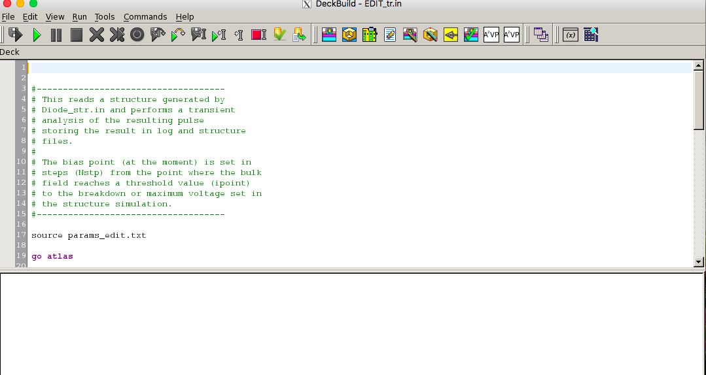
Deckbuild interactive window – Just push the green arrow to execute

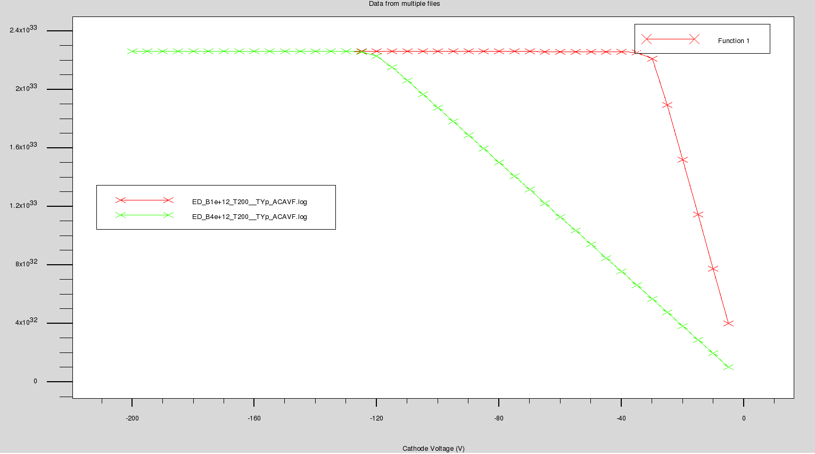
Tonyplot of 1/c^2 vs Cathode Voltage function for two different substrate resistivities. (It is more straightforward to plot Cathode Voltage vs C Anode>Cathode, 1/c^2 requires a function definition). This uses the overlay option in the File menu.
- Plot
- X Quantity – Cathode Voltage
- Y Quantity – Function 1 == 1./(C Anode>Cathode)^2 or C Anode>Cathode
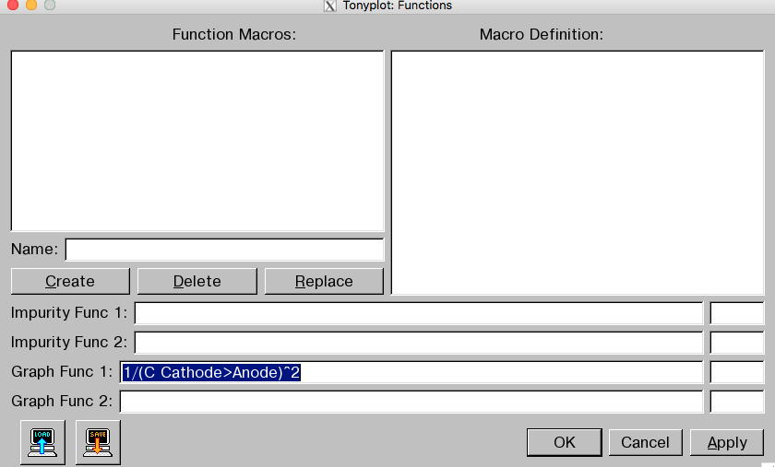

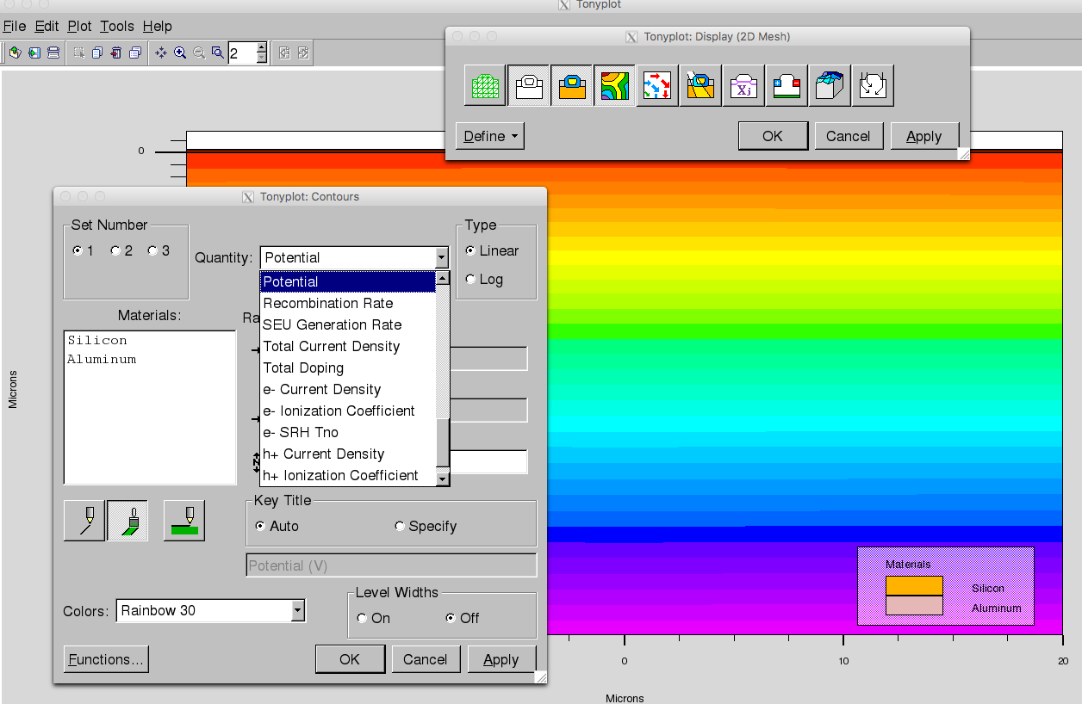
Tonyplot window
- plot
- click yellow/orange/green pattern
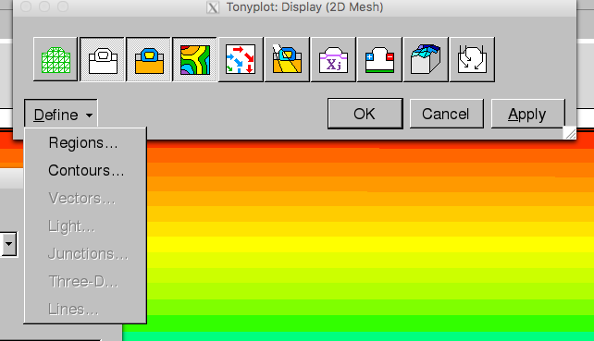
- Define/contours/potential
Or any other parameter (current …)

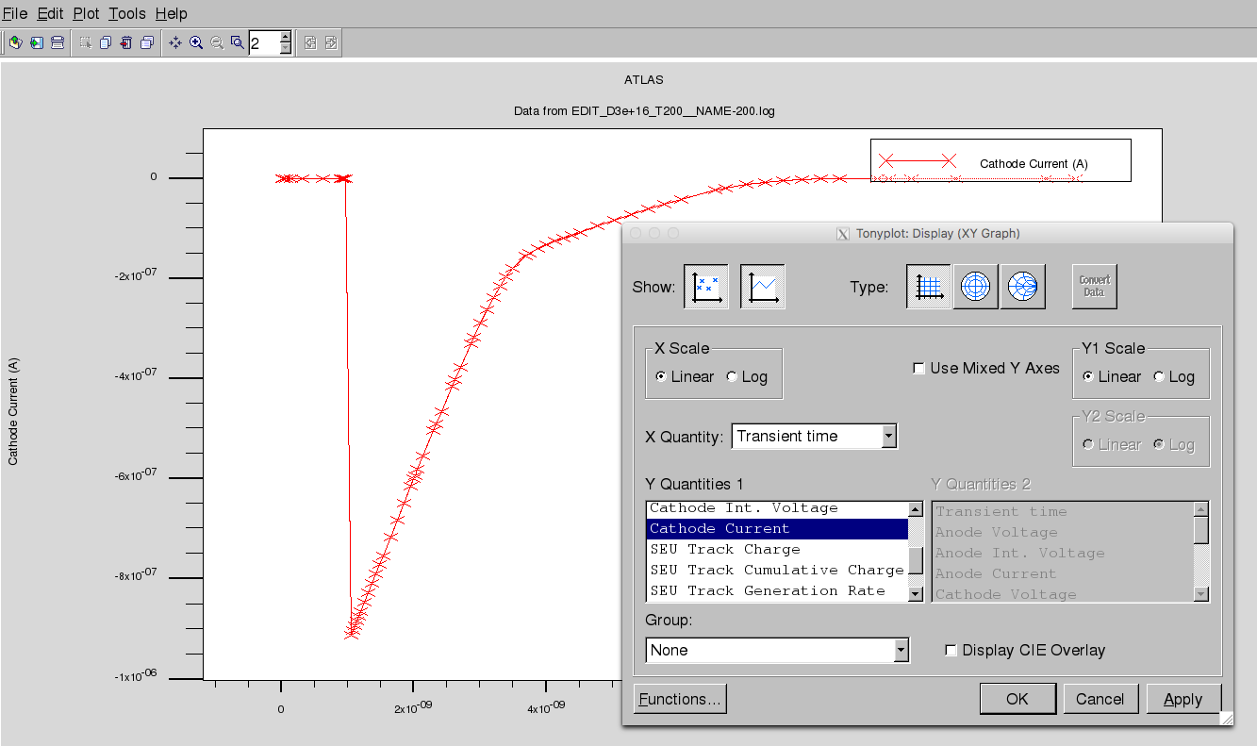
Tonyplot of log file
- Plot
- X Quantity – Transient time
- Y quantity/cathode (or anode) charge

