Gas Discharge Studies

Background
You’re near the Blanche test stand developed to study dielectric breakdowns in liquid argon. High voltage behavior is not well understood in liquid argon. This R&D is largely in support of the new liquid argon projects the lab is sponsoring. Nearby, you can see some power supplies and high voltage feedthroughs.

This exercise will be done in gas, and is meant to loosely probe the Paschen curve.

Paschen’s Law – Stolen shamelessly from Wikipedia
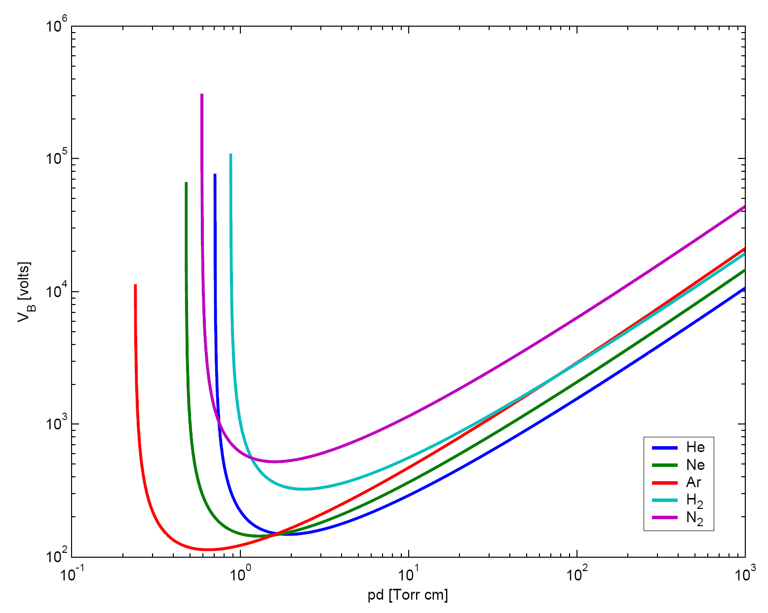
The mean free path of a molecule in a gas is the average distance between its collision with other molecules. This is inversely proportional to the pressure of the gas. In air, the mean free path of molecules is about 96 nm. Since electrons are much smaller, their average distance between colliding with molecules is about 5.6 times longer, or about 0.5 µm. This is a substantial fraction of the 7.5 µm spacing between the electrodes for minimal arc voltage. If the electron is in an electric field of 43 MV/m, it will be accelerated and acquire 21.5 eV of energy in 0.5 µm of travel in the direction of the field. The first ionization energy needed to dislodge an electron from nitrogen molecule is about 15.6 eV. The accelerated electron will acquire more than enough energy to ionize a nitrogen molecule. This liberated electron will in turn be accelerated, which will lead to another collision. A chain reaction then leads to avalanche breakdown, and an arc takes place from the cascade of released electrons.
More collisions will take place in the electron path between the electrodes in a higher-pressure gas. When the pressure–gap product is high, an electron will collide with many different gas molecules as it travels from the cathode to the anode. Each of the collisions randomizes the electron direction, so the electron is not always being accelerated by the electric field—sometimes it travels back towards the cathode and is decelerated by the field.
Collisions reduce the electron's energy and make it more difficult for it to ionize a molecule. Energy losses from a greater number of collisions require larger voltages for the electrons to accumulate sufficient energy to ionize many gas molecules, which is required to produce an avalanche breakdown.
On the left side of the Paschen minimum, the product is small. The electron mean free path can become long compared to the gap between the electrodes. In this case, the electrons might gain lots of energy, but have fewer ionizing collisions. A greater voltage is therefore required to assure ionization of enough gas molecules to start an avalanche.
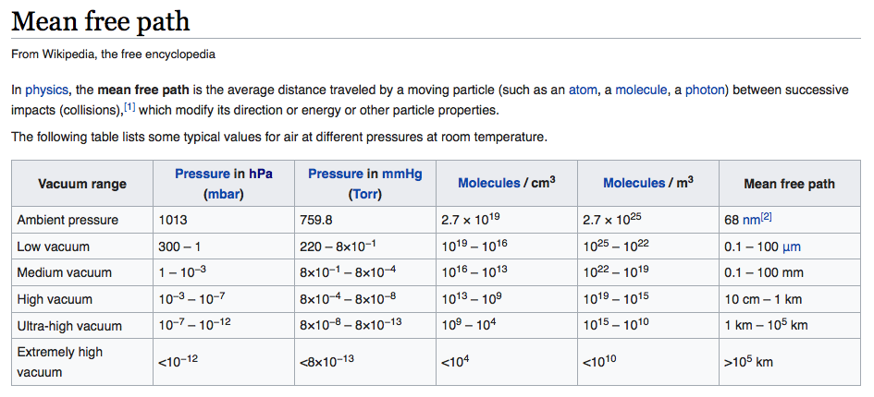

Surroundings & Setup
Sarah, Cat, Jon, Carlos, or Ernesto will be helping you. We will also tell you what to do if we have a tornado, and where the bathrooms and coffee are.

Billy is a technician at the lab; he can tell you about pumps. Other folks around this setup that can help or point you in the right direction are Jon, Carlos, Ernesto, Ron, Alan, Hans.

Test vessel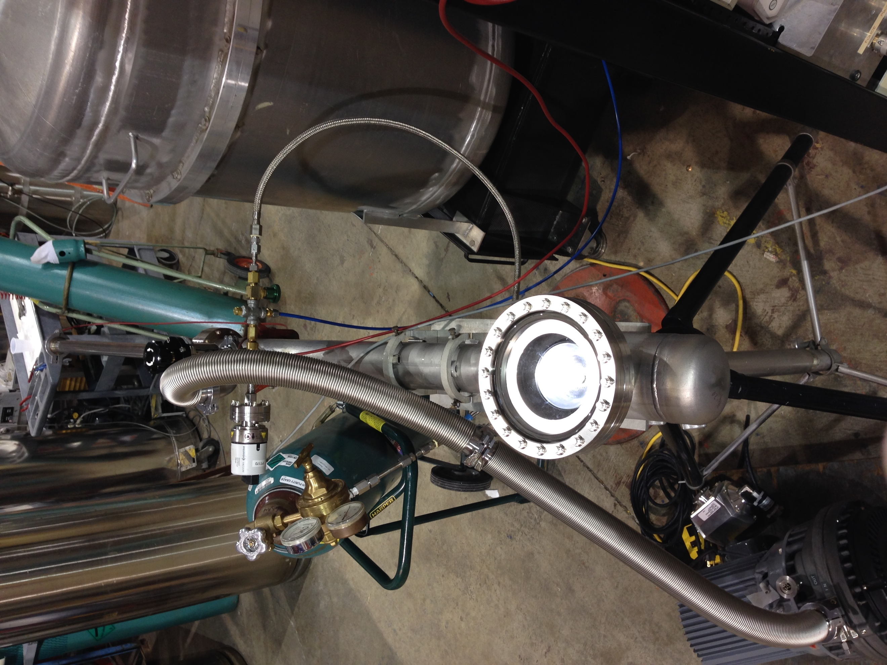 | Argon gas regulator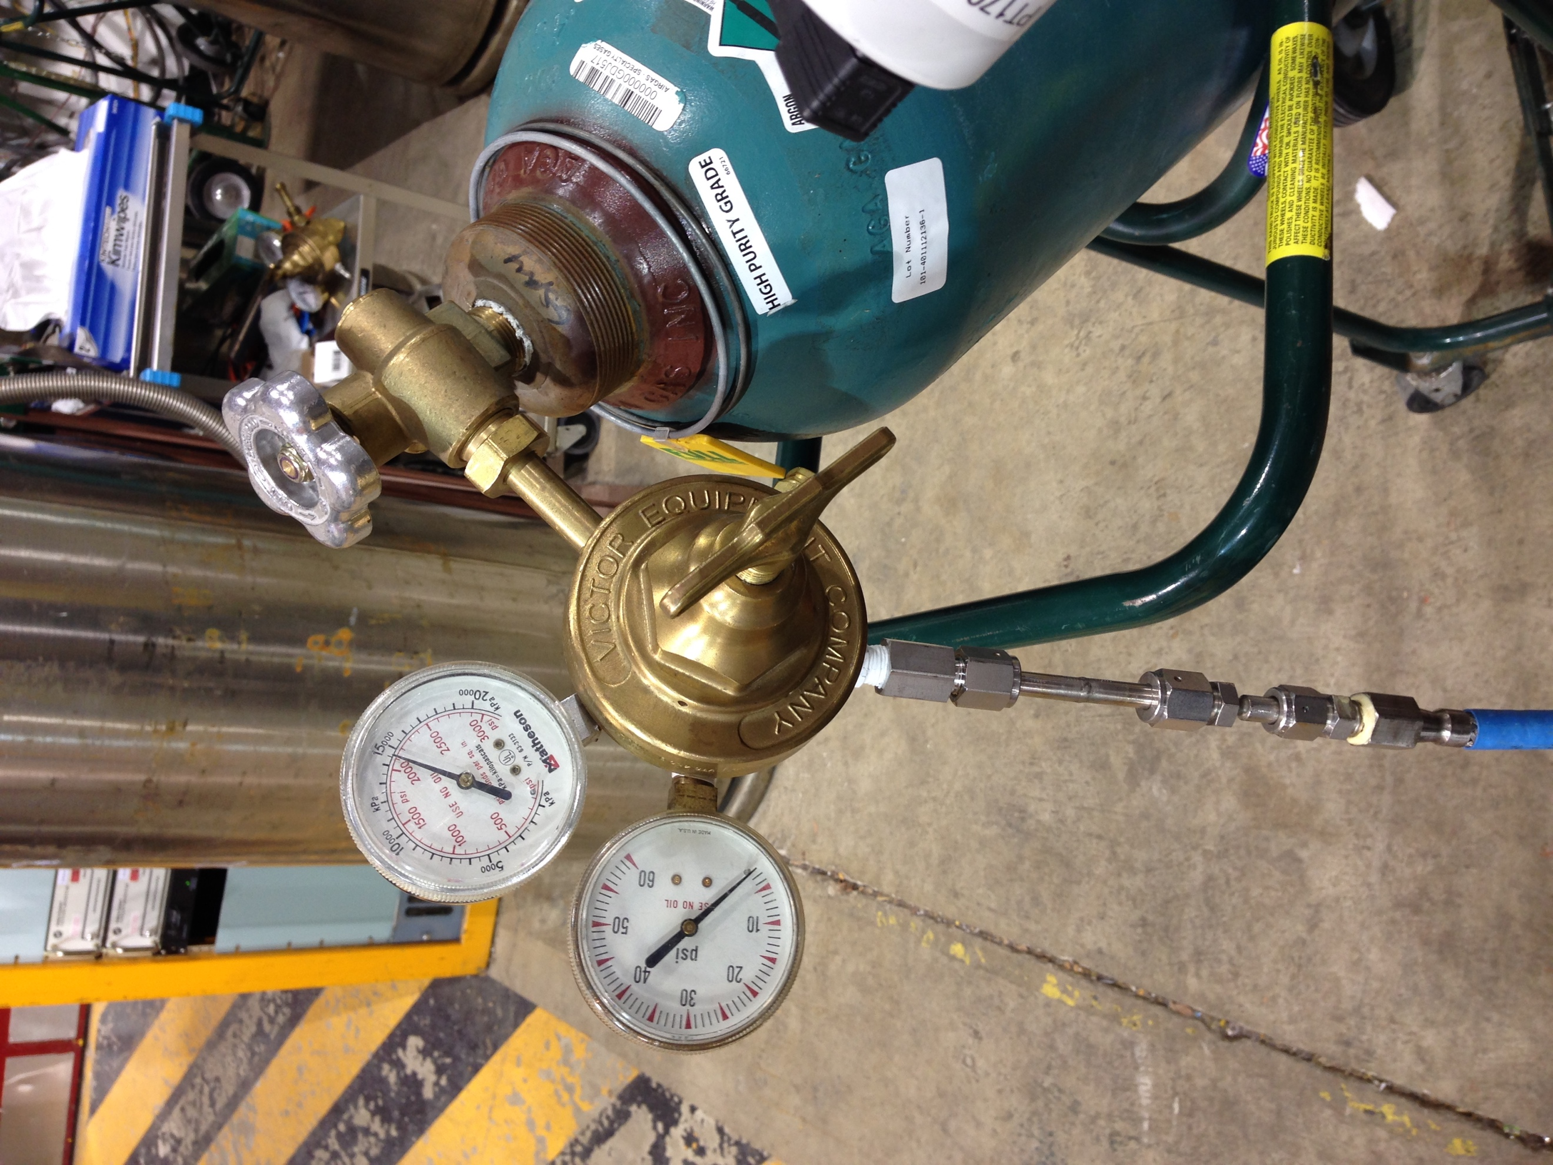 | Vacuum valve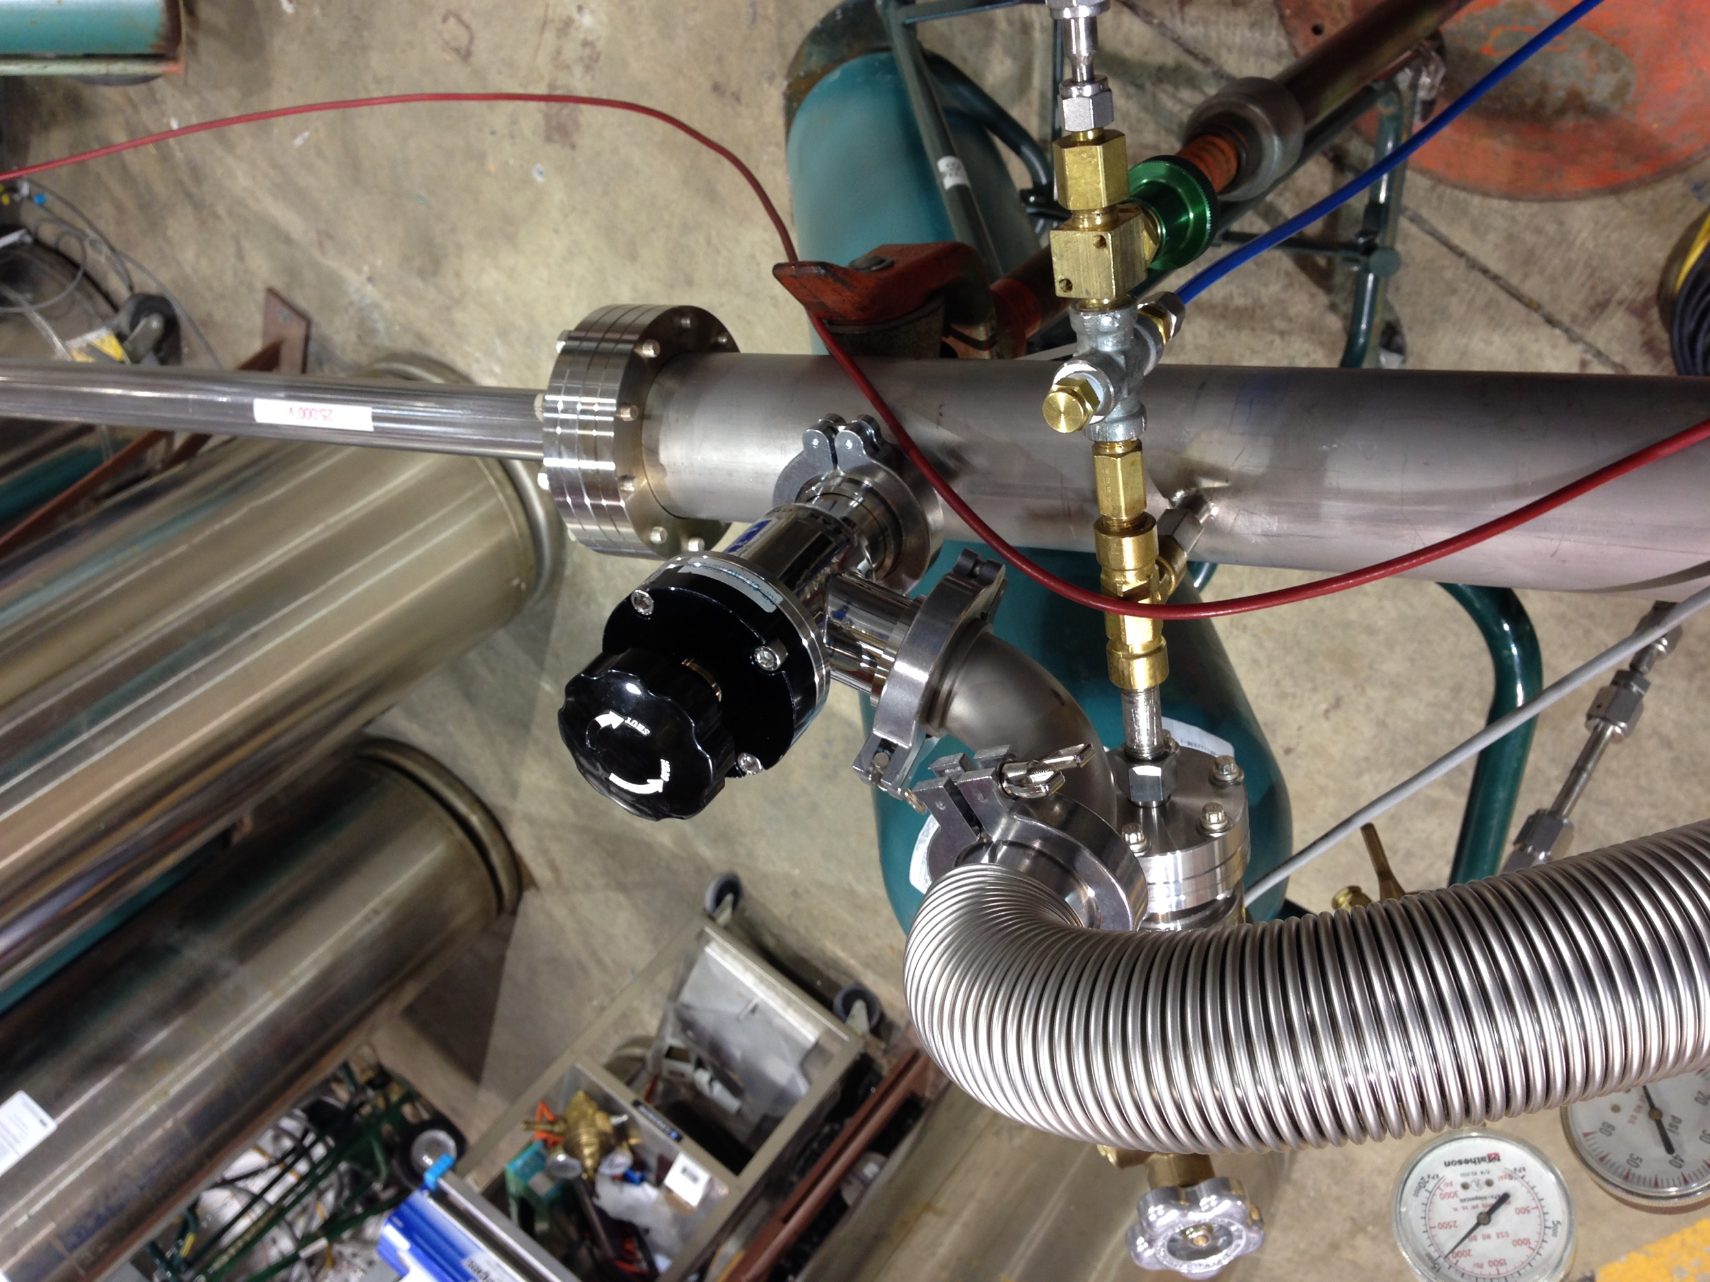 | Vacuum pump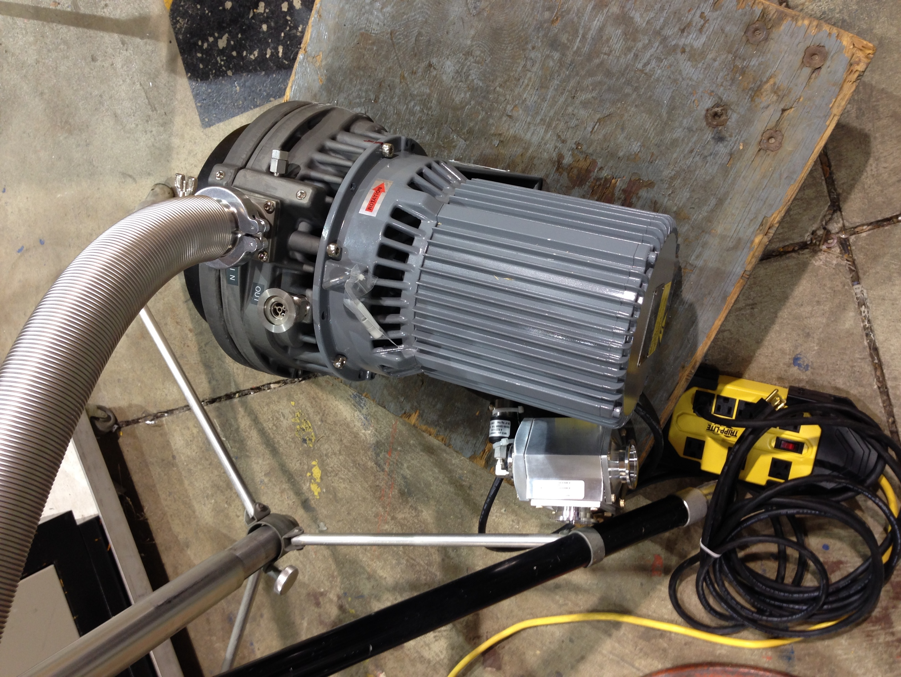
Absolute pressure gauge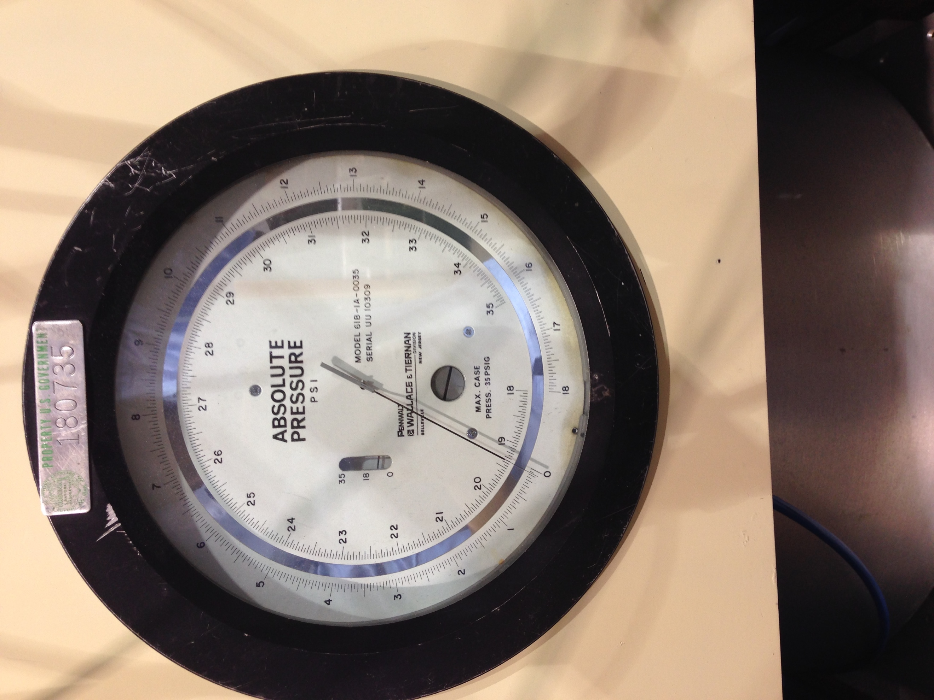 | Vacuum gauge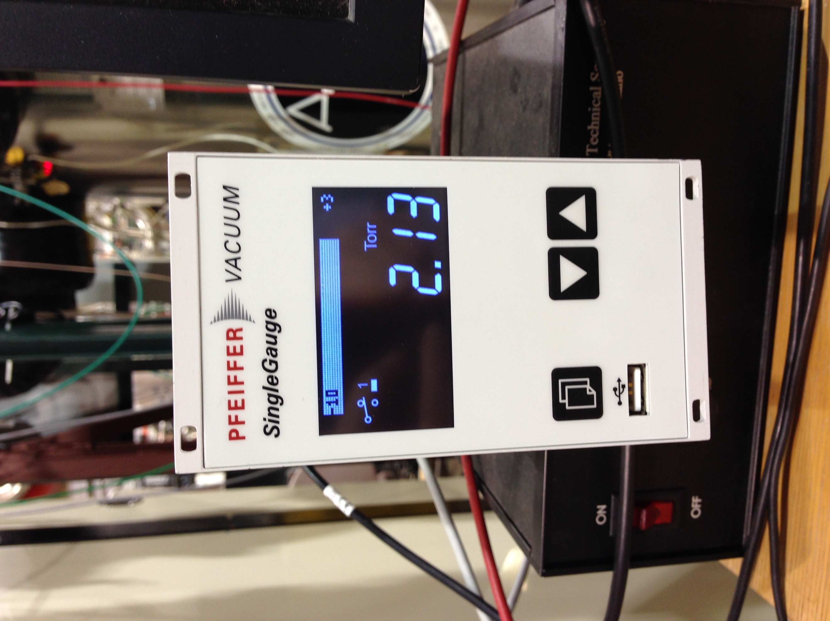 | High voltage power supply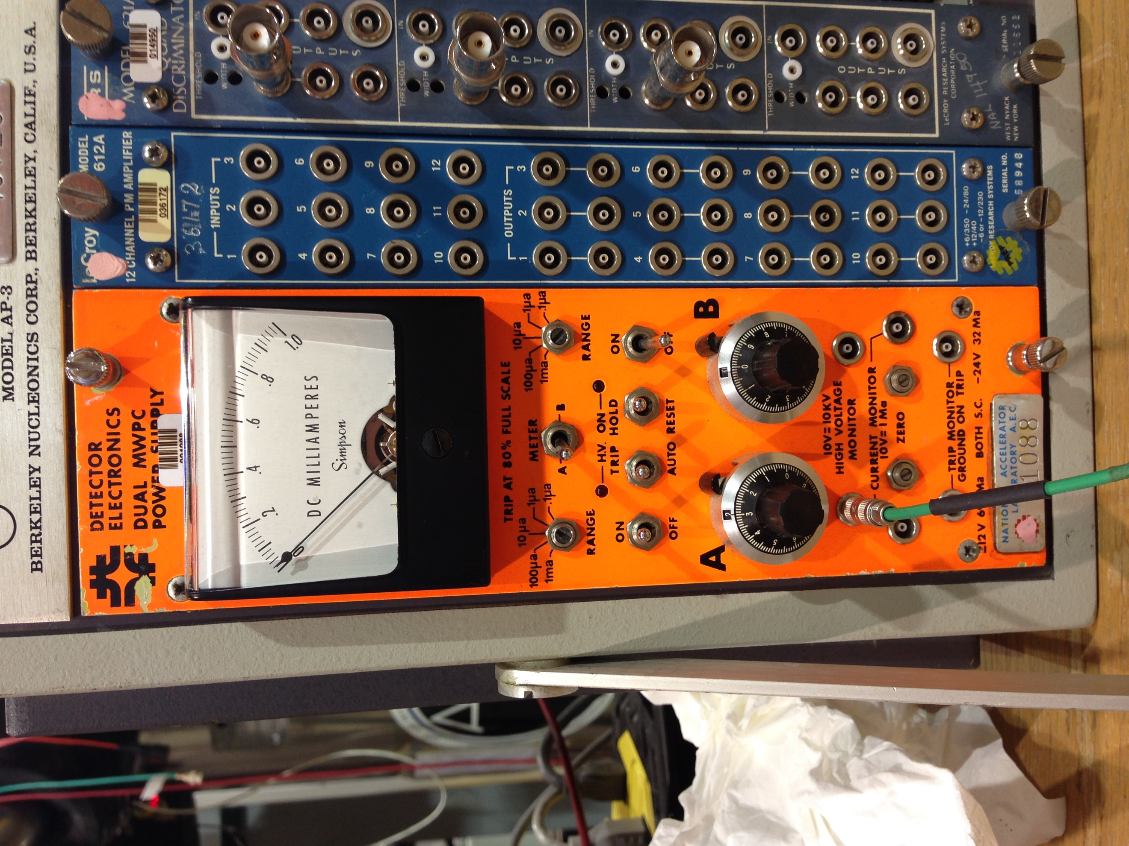 | Spark!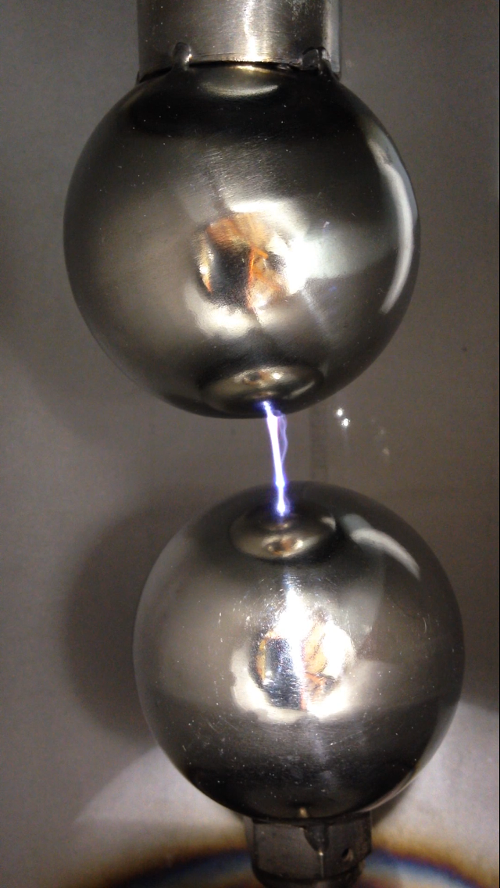

- The test vessel is pictured in the upper left. On the top, there is a high voltage feedthrough entering the vessel. A view port is mounted on the face of the vessel so you can see possible electrical breakdown between the balls.
- Argon gas is connected to the test vessel. The regulator is in the next picture. The gauge on the right is the pressure at the bottle. The gauge on the left is the pressure available to the test vessel. For this test, we’ll keep the pressure to the test vessel at about a pound. If you follow the gas line to the vessel, you’ll see a green “Nu-pro” valve. Use this isolate the argon gas from the test vessel. Clockwise is closed; counter clockwise is open.
- The next picture is the valve that isolates the vacuum from the system. If you want to expose the vessel to the vacuum pump, open the valve. If you want to isolate it (like when you are adding gas), close it.
- The upper right picture is the vacuum pump. It’s a rough pump and can start working from an atmosphere environment. This is different from turbo pumps (watch out for those in life). The switch for this pump is just the red button on the outlet switch.
- In the lower right, an absolute pressure gauge is shown. Use this for higher pressures (on this scale, down to a fraction of a psi). To use this gauge, line the needle up with its reflection in the mirror by eye and take a reading.
- To the right is the vacuum gauge. These are more common on vessels here. Use this for lower pressure values. It should start getting sensible measurements in the few Torr range.
- The next photo is the power supply we’ll be using for the test. At the lab, these are called “Droege” supplies after Thomas Droege who developed them for wire chambers. We’ll be running in a trip mode. These units trip at 80% of the current setting. The current setting is set by a little turn switch. It is currently set to 1 uA – let’s leave it there. There’s a print out on the desk if you want to know more.
- The last shot is of a spark between the spheres in the vessel. We’ll only get nice sparks at higher pressures.

Steps
- Turn off and disconnect the vacuum if not already done.
- Make sure the argon gas line is closed.
- Tilt the vessel back using the stand.
- Take off the window.
- Adjust the lower ball position to a desired value (measure it also).
- Put the window back on.
- Tilt the vessel back up and lock it in position. (Lunch)
- Plug in the Pfeiffer vacuum gauge and start the program on the computer.
  - Goal here is just to show you that you can use simple LabView programs with hardware to monitor and log their readings. You can see the program if you enter “Ctrl+e” on the display.
- Note the absolute pressure gauge.
- Hook up the roughing pump. The argon cylinder should already be connected.
- Hook up the SHV cable to the power supply (Droege) and the high voltage feedthrough.

Let’s get some decent argon in the chamber
- Close the argon gas line to the chamber (close the green Nu-Pro valve).
- Turn on the vacuum pump. Open the valve to the vacuum. Pump down the chamber to 10⁻² Torr. Isolate the vacuum pump by closing the valve.
- Back fill the vessel with a ~psi of argon gas by opening the gas valve. Close the gas valve.
- Pump down the vessel again to ~8x10⁻³ Torr range. Don’t forget to isolate the vacuum when you are done.
- Record your pressure.

Now record the trip voltage vs. pressure
- On the power supply, make sure the “A” dial is set to 0 (all the way counter clockwise). Now enable the HV output on the PS and have the PS set to “Trip Hold” (these are the two right switches). The red light should come on. Slowly raise the voltage by turning the dial until it trips. Note the voltage. Do this a few times if you wish. Each member of your team can should a try. At higher pressures, one can also try to see the discharge in the vessel.
- Now take readings at around, 0.02, 0.05, 0.08, 0.1, 0.5, 0.8 Torr – it doesn’t have to be exact -- just get a range of readings. Perhaps note how the breakdowns look different in the vessel.
- The vacuum gauge is not accurate at ~>0.5 Torr. You’ll have to change over to the absolute gauge. Take readings every psi or so up to about 10 psi on the absolute gauge. If you try to get level with the needle, you will see there’s a mirror reflection. Line the needle and the reflection up to get the correct reading. Record your pressure.
- Try plotting the trip voltage versus the pressure. Can you fit it? How does it compare to the earlier Paschen curve?
The Paschen curve measured breakdown between two plates in a uniform field. In our setup, we have two balls. Any ideas why our minimum might drag a bit on the low side? Any observations during those readings (for the lower pressures, it’s hard to see glowing)?
Since we have two balls rather than plates, the breakdown path can easily take a longer route and extend its minimum breakdown voltage through a lower range of pressures. At some point, even longer paths become challenging and we get breakdown at a higher value. Also, we do not have a uniform field; the field is higher at the surface of the balls so the model doesn’t exactly hold here.
- Higher pressures: Requires higher voltages to overcome collisions with particles. Breakdown takes the shortest path.
- Minimum: Electrons gain enough energy between collisions that they can ionize molecules making an avalanche. Breakdown path is also the shortest here.
- Lower pressures: There are not enough particles to ionize on the direct path between the spheres – in our setup, the BD could take a longer path to stay at a low voltage.
There are likely other deviations from Paschen’s law due to our not having a uniform electric field.

Triggering on a Trip
If you have enough time (at least an hour; maybe two), one can use the trip condition on the Droege to trigger a camera. We have a fancy camera from Edgertronic (feel free to Google them; their manual is the Wiki under “support” on top of their page). This is a high-speed camera that can take movies up to a little over 17,000 frames per second.
- If you look at the Droege PS printout, at the end, it reads that there is a trip monitor on the unit. It reads, “The trip monitor is a TTL compatible open collector output that is grounded when either supply is tripped.”
- Go ahead and look up in your favorite source what “open collector” means. One needs to supply a voltage to the trip monitor, and when the supply trips, the “open collector” inside acts like a sink dropping the voltage to 0. The power supplies likely operated this way so that if one’s experiment had many power supplies, one of them tripping (and sinking the voltage!) would disable all of the power supplies.
- There is a little power supply on the desk. The TTL signal mentioned earlier refers to a +3.3 V signal. Try to adjust the output of the power supply to +3.3 volts using the multimeter.
- Now we can take the output of the little power supply and think of how to connect it to the Droege. We want to limit the current into the Droege’s “open collector” transistor when it trips. We have to provide a load (a resistor). One is included for you in the Pomona box. Check that the resistance value is about 2kOhm (if it’s not, we’ll have to repair it). Plug it into the power supply and have a “tee” going to the Droege trip monitor and the scope or multimeter.
- Check what the voltages are before and after the trip. It should be 3.3 V and 0 V.
- Now reset the Droege power supply. Flip both of the switches circled below up and down. Does the voltage reading at the scope or multimeter go back to 3.3 V?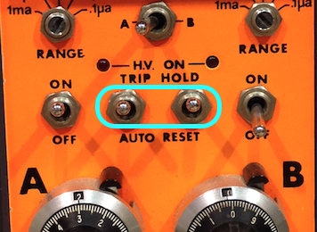
- Ok, now let’s look into triggering the camera. If you go to their wiki page, click “Using the camera,” “Trigger,” and then go to the bottom of the page and click the link under signaling, you’ll see a section on triggering the camera.
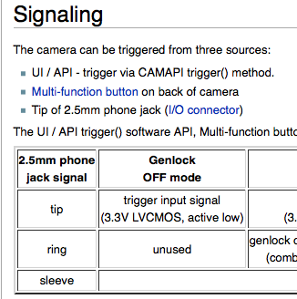
- We have to use a 2.5 mm jack.
- The table on the wiki says that the tip of the jack uses a 3.3 V signal, and when it is low, it is active. So with the tip at 3.3 V, nothing happens; when it drops to 0 V, the camera is triggered. The sleeve value is cut out of the screen shot. The sleeve should be grounded.
- We have a 2.5 mm jack connected to a Limo cable. Check that the tip of the jack is connected to the signal of the limo. Check the grounds. If this isn’t right, we’ll have to repair it.
- Plug the limo cable into the “tee.”

Get the camera online
- Identify a stand for the camera.
- Place the camera on the stand. Plug in the Ethernet cable. Plug in the power cable.
- On the computer, open a Chrome browser and go to 10.11.12.13. A camera interface window should pop up and you’ll see a number of settings.
- Take off the lens cover and see if you can see anything on the computer. Try to get the test vessel’s spheres in focus.
- Plug in the 2.5 mm jack. The camera will probably trigger when you do this. It’s ok, just ignore this one video.
- Do not set the power supply on “Auto Reset” – This will mess up the camera.
- Now do a breakdown measurement. You’ll get a nice spark at slightly higher pressures. You may be able to get some corona (glow) discharges at some of the lower/mid-pressures.
- The camera should trigger. In the Chrome viewer, push the “play” triangle button to watch the last video. If you want to download the video, there is a button on the same menu.
- Try different frames per second settings. For higher values, you may benefit from an additional light.
- Can you set an upper bound on the amount of time a spark in gas is? See any interesting features?

Extra ideas
Different gases? One can try nitrogen or air as well.
Different spacings? One can take off the front view port and change the spacing.

Sample Data
This data was recorded very quickly. Your group can likely do better.
