**Laser Test**

**EDIT 2018**

Goals:

* Characterize pulse shape from a silicon diode as a function of bias voltage
* Measure depletion voltage

Devices

* 300 micron diodes (Hamamatsu Dzero) n-type
* 500 micron diodes (Novati) p-type
* 200 micron SOI diodes (Novati) p-type
* 100 micron NIU wafer bonded sensors n-type

Test Equipment:

* 1060 nm laser pulse generator
* Diode and fast pulse amplifier
* Oscilloscope

Device Geometry:



Silicon on Insulator Full Wafer (D0) Deep diffused (HGC)

You will use the same diodes used in the CV and IV characterization. In this case, the signal line is connected to the preamp input and a 2410 source measure unit will provide the detector bias. Some diodes have their top surfaces aluminized, with a small hole to admit laser list – these are hard to align. Diodes should be placed on the stage located under the laser focus lens and can be secured with a single screw. You can check the devices using the inspection microscope in the burn in room. Confirm that the wirebonds have not been damaged. They are very delicate.

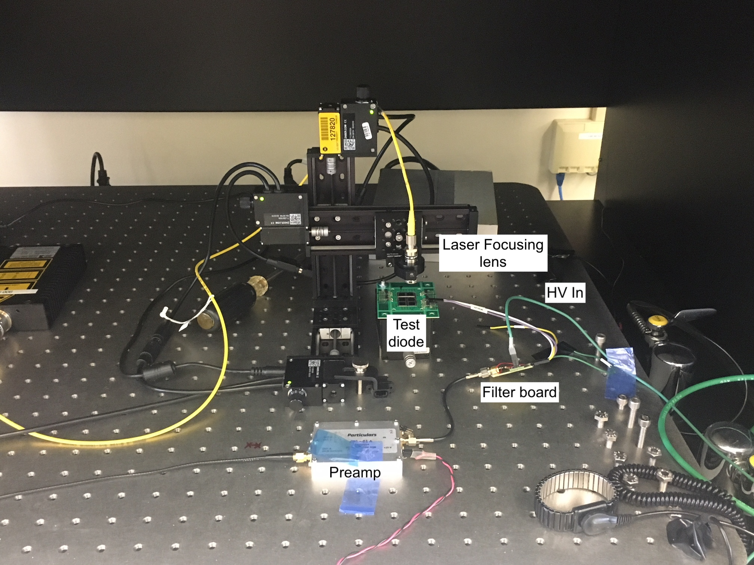

Setup

* The stake connections on the diode to be studied should be connected to the small adapter board which also contains the high voltage input. Signal is black, bias voltage is red.
* Ask an instructor to check the setup before you turn on voltage
* The labview VIS are in:   
  C:\Users\lipton.PPD-119418\Documents\EDIT2018
* Launch
  + Waveform_Subtract_noise_EDIT.vi
  + TDS_Waverform_compare_EDIT.vi
  + 2410_control_EDIT.vi
* Start the 2410 control VI. to “operate” to bias on at 0 volts
* Turn on the laser – red button on the laser pulser.
* Use the Labview 2410 program to set the 2410 to ~(+ p-on-n/- n-on-p) 30 volts, confirm that you see a pulse

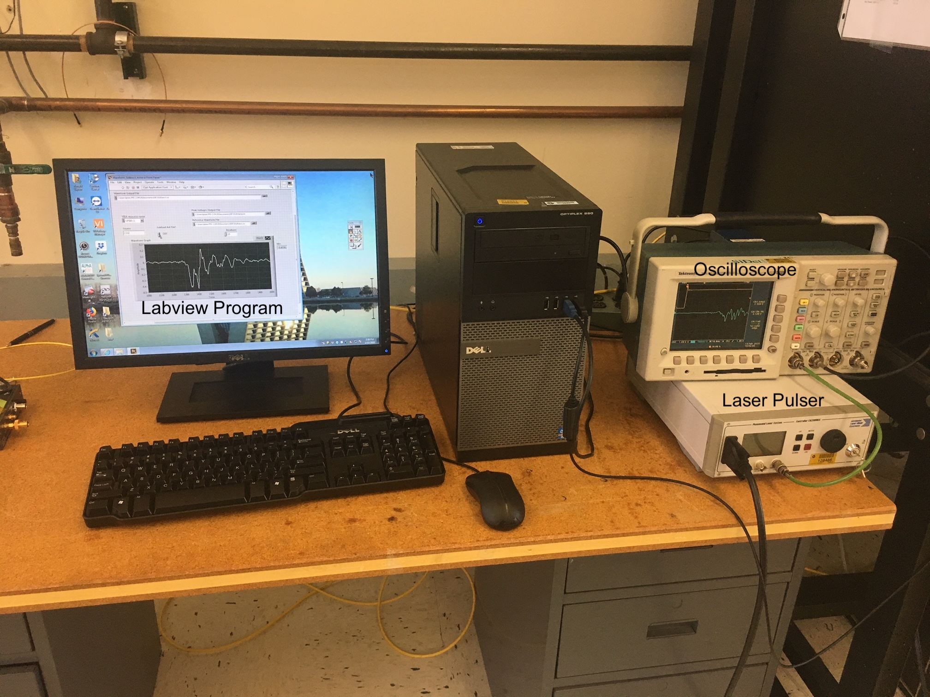

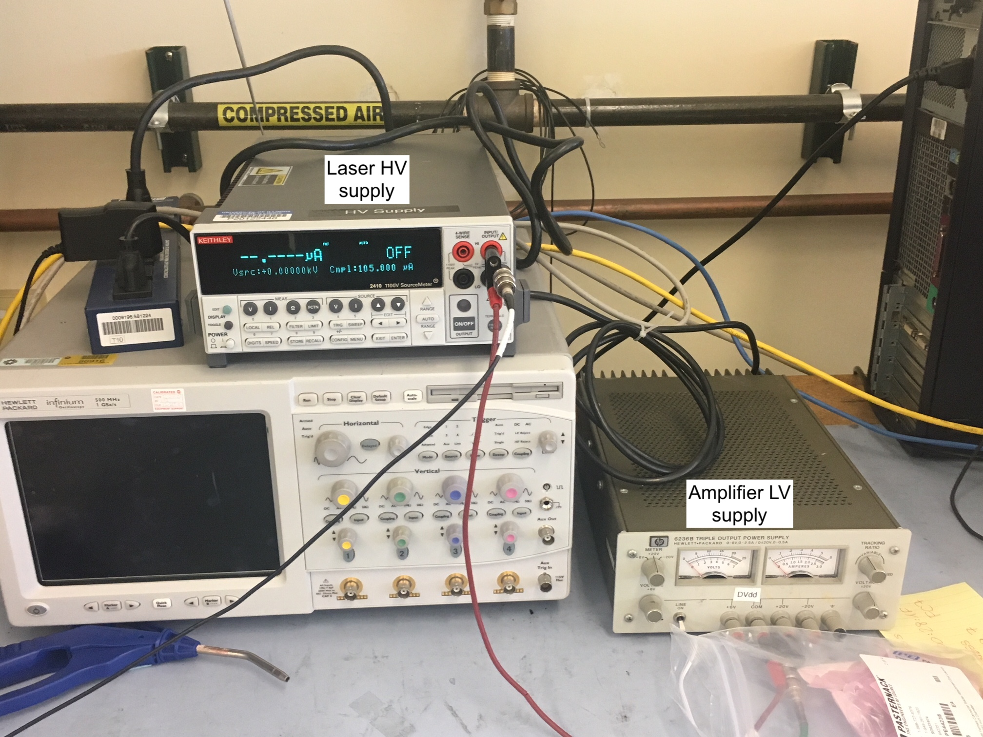

The preamp signal is sent to an oscilloscope. The scope is in turn read out by an oscilloscope through a Labview interface. The program will read the current waveform *averaged* by the scope.

The scope can be set to average many measurements. This reduces the random noise. However coherent noise (caused by the laser pulser) remains. To subtract this you can take a reference waveform with the signal removed, either by turning off the laser or by turning off the detector bias.

Measurements:

* Record the pulse shape on the oscilloscope every 20 volts until the output value appears to saturate (depletion voltage)
* Use the TDS_waveform_compare program to plot and compare the waveforms you have measured
* Plot peak charge collected as a function of bias. What is the depletion voltage? Compare it to the value measured in the CVsection.
* Do you see a difference between p and n type sensors?
* Is the pulse shape different than the Silvaco simulation? Why?
* How does the 10-90% rise time change as a function of bias voltage?