CURRENT DEVELOPMENTS OF LASER TRACKER TESTING STANDARD*
M. Saure, Hexagon Manufacturing Intelligence, Unterentfelden, Switzerland

Abstract
Three major standards have been published defining an acceptance and verification test procedure for Laser Trackers.
- ASME B89.4.19
- VDI/VDE 2617-10
- ISO 10360-10
However, these standards have not reached a wide acceptance by Laser Tracker users when testing the performance of a system due to the large effort performing the test. Currently the test procedures of ASME B89.4.19 and ISO 10360-10 are being reviewed to improve usability and user acceptance. This paper will give an overview about the current state of the revisions of ASME B89.4.19 and ISO 10360-10 and an outlook about the goals and timeline for both standards.

THE ASME B89.4.19 STANDARD
The American Society of Mechanical Engineers (ASME) is a professional association which publishes codes and standards in many technical areas. The B89 “Dimensional Metrology” is the subcommittee responsible for the ASME B89.4.19 “Performance Evaluation of Laser-Based Spherical Coordinate Measurement Machines” [2] standard. The current document of the B89.4.19 standard was published in 2006.

ASME B89.4.19 REVISION
Prior to the revision of ASME B89.4.19 the National Institute of Standards and Technology (NIST) has raised the question to interested Laser Tracker users whether the interim test method published as NIST IR8016 [1] should become should become a published standard, due to the increased demand from users for a defined test method.
Three possibilities were considered:
- Publish the NIST IR8016 test method as an ASTM E57 standard.
- Initiate a revision of ASME B89.4.19. Since the standard is already 10 years old a revision is due anyway.
- Wait for the next revision of ISO 10360-10 to add the test method as an annex.
ASME was open to do a revision of the B89.4.19 standard, so it was decided that this standard should be revised and the NIST IR8016 should be included into the document. NIST was asked to lead the project for this revision. Bala Muralikrishnan was appointed as project leader for this revision. The project meetings are held as bi-weekly telephone conference.

Scope
Within the revision of B89.4.19 the following topics should be addressed:
- Update the current Appendix F (Interim testing). Replace the current method by the NIST IR8016 test with some small modifications
- Add a dedicated clarification that ADM measurements can be used to establish metrological traceable reference lengths in accordance with ASME B89.7.5 -2006 Clause 2
- Correct errors in main body
The target time line for publishing the new revision of B89.4.19 is in the second quarter of 2019.

Non-goals
ASME preferred a small revision to be able to publish a new revision fast. Despite of some known weaknesses of the performance evaluation defined in chapter 6 of B89.4.19 [4] it has been decided that the performance evaluation in chapter 6 of the main body should remain unchanged.

CURRENT STATUS
A draft for the new interim test method is available and has been sent out to the project team members for review.
The interim test comprises of the following parts:
- Two-face measurements
- Length measurements (symmetric and asymmetric positions)
- Orient-to-gravity test

Two-face and Length measurements
The test setup for two-face measurements and length measurements is combined in a common setup. The test is performed at different orientations and positions of the reference length as shown in Fig. 1.
In total 15 two-face measurements and 15 lengths measurements are taken. All of the two-face errors and length measurement errors should be smaller than the corresponding manufacturer specified MPE (Maximum Permissible Error) or a suitable tolerance value defined by the user depending on the ambient conditions where the Laser Tracker is operated.
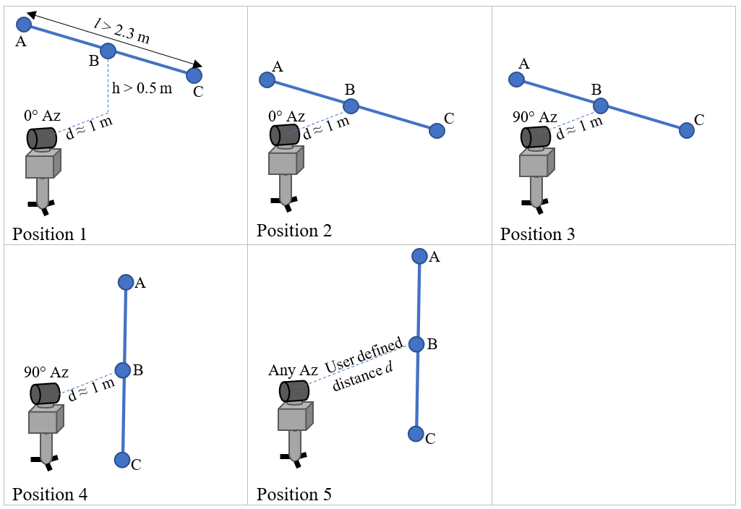

Figure 1: Test setup for combined two-face and length measurements

Orient-to-Gravity Test
Most of the current Laser Tracker models offer the ability to reference the sensor coordinate system to gravity using an inclination sensor. To test the performance of the Laser Tracker’s level system an additional test has been added. The test setup is shown in Fig. 2.
Position 1 Position 2
A

B

C

d

d

d

2
d

X

Y

Z

Figure 2: Orient-to-gravity test setup
The orient-to-gravity test is a relative comparison only. Level frames established in different positions are compared to each other to detect calibration errors of the inclination sensor. The test procedure is described below:
- Two reflector nests A and B are placed on floor, the distance between the nest should be between 2 to 5 meters. A third nest C is placed, so that AC is perpendicular to AC.
- Place the Laser Tracker at Position 1, in line with AB and establish a level frame, so that the Z-axis of the system is aligned to gravity.
- Measure the reflectors placed in nests A, B and C.
- Move the origin of the coordinate system to point a and clock the Y-axis towards point B.
- Record the Z-coordinates of points B (Z_{B1}) and C
(Z_{B1}).
- Now tilt the Laser Tracker slightly and establish a new level frame.
- Measure A, B and C again.
- Translate the coordinate system to point A and rotate the Y-axis towards point B.
- Record the Z-coordinates of points B (Z_{B2}) and C
(Z_{B2}).
- Calculate the height differences ΔZ_{B} = Z_{B2} - Z_{B1} and ΔZC = ZC2 - ZC1.
- Convert the height differences into to angular units, e_{B} = ΔZ_{B}/(2d) and e_{C} = ΔZ_{C}/(2d).
- Compare these values against the MPE values of the manufacturer specifications.
Optionally the Laser Tracker may be moved into a second position (Position 2) in between nests A and B. A third set of height differences ΔZ_{B,} ΔZ_{C} is taken from this station and compared to Position 1. This enables the users to not only look at the pure inclinations sensor reading but get an indication about the combined angular and inclination reading, more like an overall system check of the heights determined by the Laser Tracker, similar to the test methods for geodetic level instruments.

ISO 10360-10 STANDARD
The ISO 10360-10 “Geometrical Product Specifications (GPS) — Acceptance and reverification tests for coordinate measuring systems (CMS) — Part 10: Laser trackers for measuring point-to-point distances” has been published in 2016. This standard has been elaborated under the responsibility of the ISO Technical Committee 213 Working Group 10 (ISO/TC213 WG10), who is responsible for the whole series of ISO 10360 standards, “Geometrical Product Specifications (GPS)” for coordinate measuring machines (CMM) and systems.
The acceptance and reverification test defined in chapter 6 comprises of the following test items:
- Probing size and form error tests for SMR
(spherically mounted reflectors), probes (stylus and retro-reflector combination (SRC)) and scanners (optical distance sensor and retro-reflector combination (ODR))
- Location errors (two-face tests)
- Length measurement errors
The length measurements defined within ISO 1036010:2106 divide into a core set of 41 measurement and an additional set of 64 measurements to obtain 105 length measurements in total, to be consistent with other standards from the 10360 series. The document proposes two alternatives for the additional set of measurements, alternative 1 is similar to the procedure of B89.4.19, alternative 2 is similar to the procedure defined in VDI/VDE 2617 Part 10.

ISO 10360-10 REVISION
Test campaigns with the acceptance test have shown, that the effort to perform all length measurements is very high, a full working day is needed to complete all length measurements. Therefore, any of the published Laser Tracker testing standards have not reached a wide user acceptance.
A mathematical analysis of the sensitivities of the known geometrical errors of a Laser Tracker towards the different length measurement positions by NIST [4] has shown, that the core set of 41 measurements is sufficient to determine all the known geometrical errors reliably. Considering the large effort to perform all 105 length measurements the gain of information achieved by the additional sets of measurements is questionable. Based on this experience the ISO/TC213 WG10 has been approached to discuss the justification of large effort involved in the acceptance test. During the regular working group meetings in September 2017 it has been decided to open the document for revision again.

Scope
- Significant reduction of effort required to perform the acceptance testing with the goal to increase usability and user acceptance of the standard
- Reduce number of length measurements to the core set of 41 (or even less)
- Add user defined two-face measurements to give users the opportunity to adapt the testing volume to their needs
- Add a more specific interim test to the document. The current Annex F does not give much guidance to users about useful interim testing.
- Adapt new approach to express length measurement errors (E_{Avg} instead of E_{Uni} / E_{Bi})
- Add a dedicated repeatability test to support the introduction of E_{Avg} and as a justification to reduce the number of length measurements.

CURRENT STATUS
During the last meeting ISO/TC213 WG10 has decided to issue a committee draft (CD) with the following editions:
- Length measurement tests reduced to core set of 41 measurements
- Two user defined two-face positions added
- Annex F unchanged at this stage
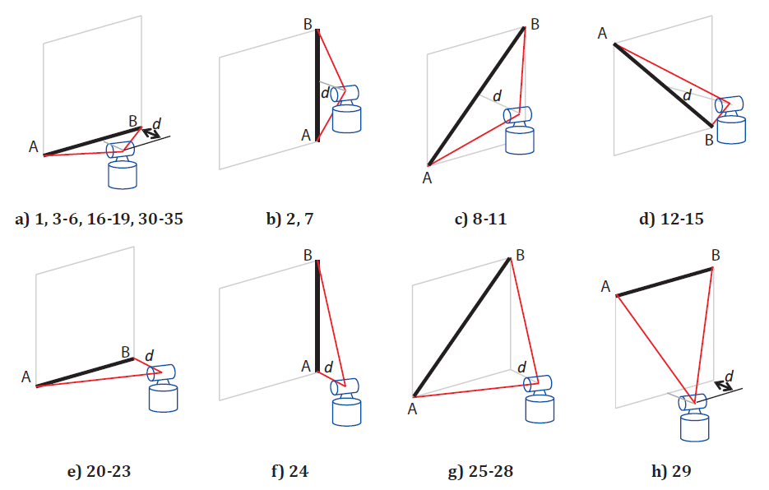
Figure 3: Reference length positions of core set
ISO member states can submit comments to the draft, which will be discussed during the next meeting in January 2019.
The interim test method agreed for the new ASME B89.4.19 document should be added to Annex F of ISO 10360-10 as soon as it is finalized.
The publication of the new revision of ISO 10360-10 will take approximately three years.

CONCLUSION
The interim test method based on NIST IR8016 [1] offers a comprehensive and fast test for regular checks of the performance of a Laser Tracker. This test method could become widely accepted in the industry if both standards, ASME B89.4.19 and ISO 10360-10, adapt the same method. This gives the manufacturers of metrology software packages the opportunity to develop wizards for performing the measurements and analyzing the results.
The planned changes to the acceptance method of ISO 10360-10 have the potential to significantly reduce the effort to perform this test. In return this should increase the acceptance of the test method by users.

REFERENCES
- Vincent D. Lee, Christopher Blackburn, Bala Muralikrishnan, Daniel Sawyer, Mark Meuret, Aaron Holeyer: “A Proposed Interim Check for Field Testing a Laser Tracker’s 3-D Length Measurement Capability Using a Calibrated Scale Bar as a Reference Artifact”, U.S. Department of Commerce, National Institute of Standards and Technology, September 2014,
http://dx.doi.org/10.6028/NIST.IR.8016
- ASME B89.4.19-2006, “Performance Evaluation of Laser Based Spherical Coordinate Measurement Machines”
- ISO 10360-10:2016(E), “Geometrical Product
Specifications (GPS) — Acceptance and reverification tests for coordinate measuring systems (CMS) — Part 10: Laser trackers for measuring point-to-point distances”
- B. Muralikrishnan, D. Sawyer, C. Blackburn, S. Phillips, B. Borchardt, W.T. Ester, ASME B89.4.19 Performance Evaluation Tests and Geometric Misalignments in Laser
Trackers, Journal of Research of the National Institute of Standards and Technology, Volume 114, Number 1, January-February 2009 [J. Res. Natl. Inst. Stand. Technol. 114, 21-35 (2009)]
- B. Muralikrishnan, D. Sawyer, C. Blackburn, S. Phillips, C. Shakarji, E. Morse, R. Bridges, Choosing Test Positions for Laser Tracker Evaluation and Future Standards Development, The Journal of the CMSC, Vol. 6, No. 1 Spring 2011

