CONFIGURATION AND OPERATION STATUS OF HLS AND WPS SYSTEM INSTALLED IN PAL-XFEL*
Hyojin Choi†, Sangbong Lee, Hong-Gi Lee, Jang Hui Han, Seung Hwan Kim, Heung-Sik Kang
Department of Accelerator, PAL-XFEL, Pohang, Korea

Abstract
Several parts that comprise the large scientific equipment should be installed and operated at precise three-dimensional location coordinates X, Y, and Z through survey and alignment to ensure their optimal performance. As time goes by, however, the ground goes through uplift and subsidence, which consequently changes the coordinates of installed components and leads to alignment errors ΔX, ΔY, and ΔZ. As a result, the system parameters change, and the performance of the large scientific equipment deteriorates accordingly.
Measuring the change in locations of systems comprising the large scientific equipment in real time would make it possible to predict alignment errors, locate any region with greater changes, realign components in the region fast, and shorten the time of survey and alignment. For this purpose, HLS and WPS system are installed in PAL-XFEL.

introduction
All components of pohang accelerator laboratory’s X-ray free-electron laser (PAL-XFEL) were completely installed in December 2015, and Hard X-ray 0.1nm lasing achieved through its beam commissioning test and machine study on March 16, 2017. The beam line users are use the hard x-ray since March 22, 2017 [1, 2].
The hydrostatic leveling sensor (HLS) and wire position sensor (WPS) system has been installed since September 2016 to measure and record changes of the building floor and devices in real time (see Fig. 1) [3, 4].

hls system

Internal observation of Water pipe
In order to observe and monitor the internal conditions of the water pipe, a transparent plastic pipe was installed in a total of 10, including the LINAC section 8 and Undulator section 2 as shown in Table 1. As a result, the phenomenon of water droplets forming on the inner walls of the pipe was observed (see Fig. 2). For an accurate measurement of the sensor, it is necessary to understand the physical and chemical phenomenon related to water generated within the water pipe that provide a reference as well as exert an external influence (see Fig. 3). Ultrasonic-type HLS was chosen because it has the self-calibration function that can always overcome changes in physical properties of water and provide accurate measurements.
Table 1: Location of transparent plastic pipe installed
- LINAC section: 8 EA
location (meter) - 25, 60, 109, 202, 217, 260, 328, 447
- Undulator section: 2 EA
location (meter) - 777, 940

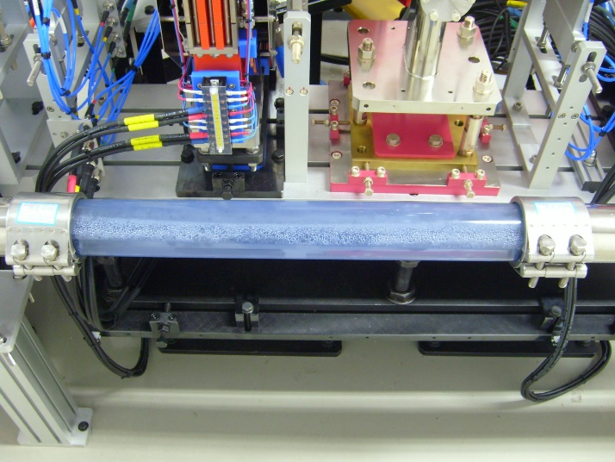
Figure 2: Water droplets generated within the water pipe

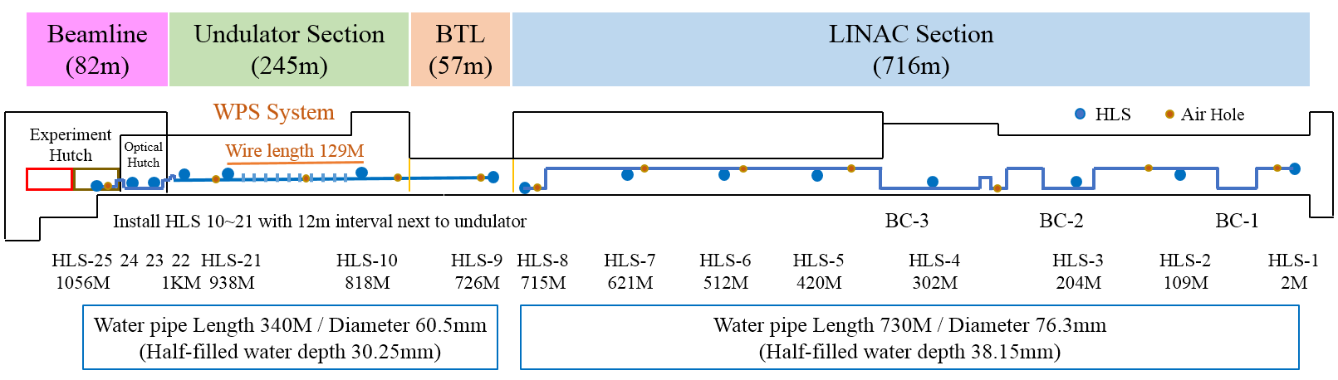
Figure 1: The position of HLS and WPS and specification of HLS water pipe in PAL-XFEL (Top view).

*Work supported by Ministry of the Science, ICT and Future Planning
†choihyo@postech.ac.kr

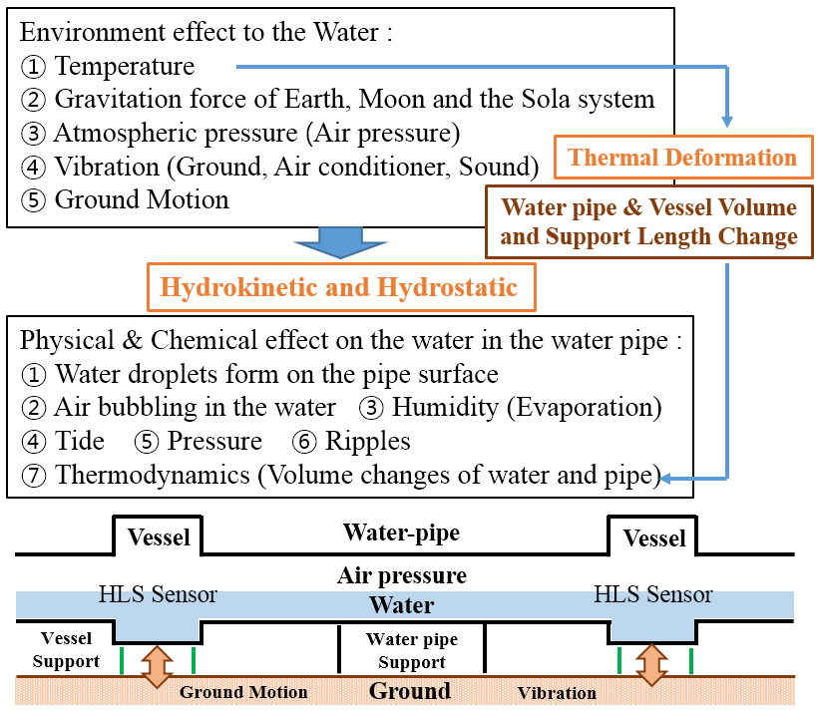
Figure 3: Factors affecting HLS measurement.

HLS system inspection
After having installed the HLS system in 2016, atmospheric pressure was observed in the HLS-1 measurement because the water pipe of the BC-1 area was installed too low (see Fig. 4). In the process of solving this problem, the importance of the water pipe providing a reference was recognized once again. Ever since, HLS system inspection was regularly implemented once a year to see if the HLS system is operating properly. Also, the conditions of the HLS sensor and water pipe as shown in Table 2 may be verified through inspection work [5, 6].

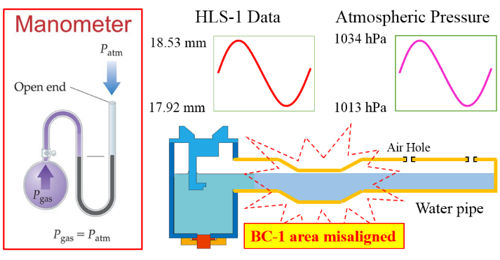
Figure 4: Manometer for measuring atmospheric pressure.
Table 2: HLS system inspection item
- Is the height of the sensor aligned to be 17.5 mm high?
- Is the sensor linearly measuring the measuring range 17.5±2.5 mm without any distortion?
- Does the height alignment conditions of the pipe meet the water flow variation range 17.5±2.5 mm?
- Is the water flow within the pipe smooth?
HLS system inspection was implemented on July 2018. Through the inspection, a total of three unusual behaviors were observed in the HLS measurements, such as HLS-4 and HLS-7 in the LINAC section (see Fig.5) and HLS-9 in the Undulator section (see Fig. 6 and Fig. 7). Such problems were observed because the setting of the output signal amplitude for HLS electronics was set low to maintain the lifespan of the HB10KB3T ultrasonic transducer longer. The problem was solved by slightly increasing the output signal amplitude.

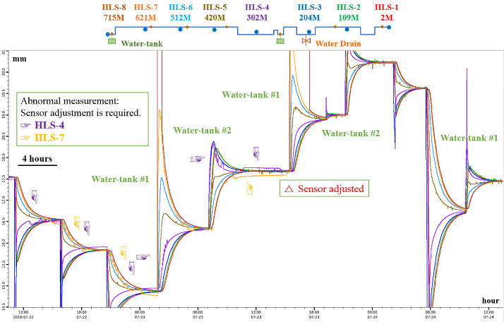
Figure 5: LINAC section.

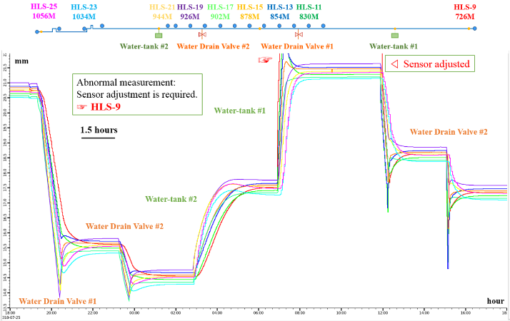
Figure 6: Undulator section A.

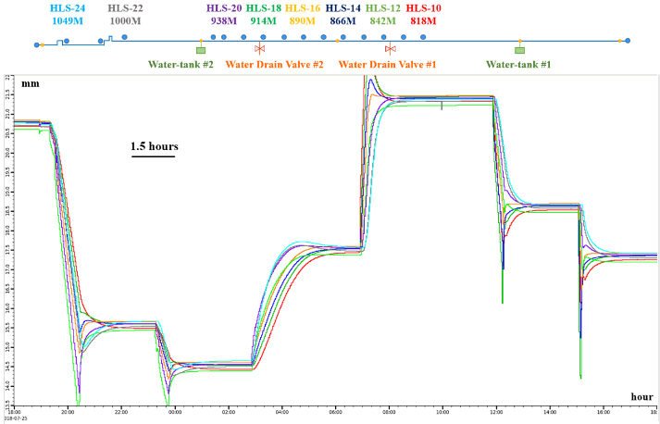
Figure 7: Undulator section B.
As a result of the observation, the height alignment conditions of the water pipe satisfied the HLS measuring range (17.5±2.5 mm) and it was confirmed that the time required for maintaining the water-equilibrated state within the water pipe was about 4 hours of the LINAC section and about 1.5 hours for the Undulator section.

HLS adjustment
Oscilloscope is necessary for adjusting HLS electronics (see Fig.8). After confirming the three return signal voltage (< 3 volts, 1 Mohm) reflected from the reflector block on the oscilloscope, turn the reflector block to the left and right so that the difference between T1 and T2 in the HLS measurement program becomes about 10,000 (see Fig. 9). If the return signal voltage on the Oscilloscope screen is too low, increase the output signal amplitude or the return signal gain (see Fig. 10).

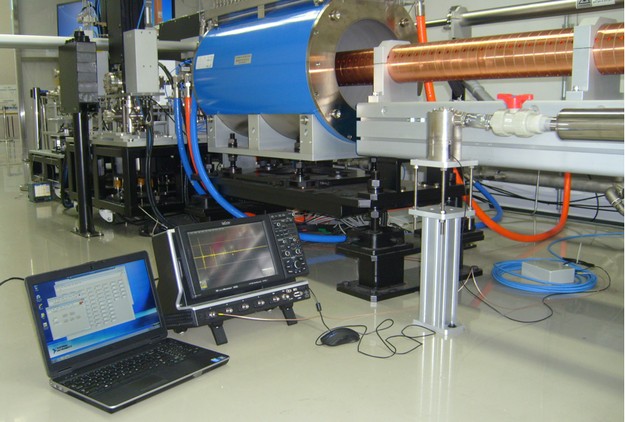
Figure 8: Preparation for HLS electronics adjustment.

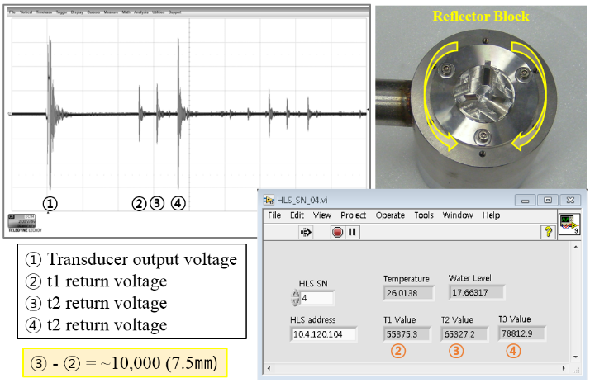
Figure 9: Reflector block inspection method.

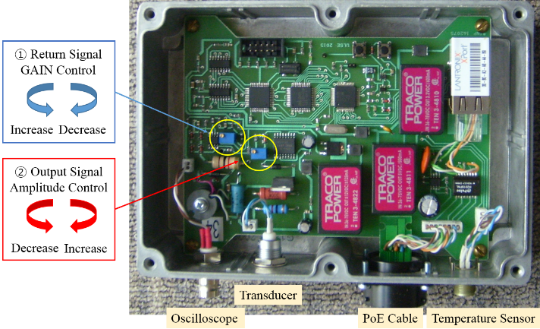
Figure 10: HLS electronics adjustment method.

LINAC section water flow
Water pipe caliber was selected due to the plan of installing water pipes of the LINAC section in a straight line manner on the building floor. However, the situation of waveguide and cable operators having to pass under the accelerator girder in order to work occurred. Inevitably, after having to move the installation location of the water pipe to the side of the accelerator girder, many elbow pipes were used as shown in Table 3 (see Fig.11). Due to such situation, the water flow of the LINAC section has slowed down and about 4 hours is required in order to maintain the equilibrium of the water within the water pipe. For smooth water flow, it is best to install the water pipe in a straight line. Also, the air flow within the pipe must be smooth as well in order for water to flow smoothly. For smooth air flow, air holes should be installed at intervals of 100 meters in the water pipe (see Fig. 1).

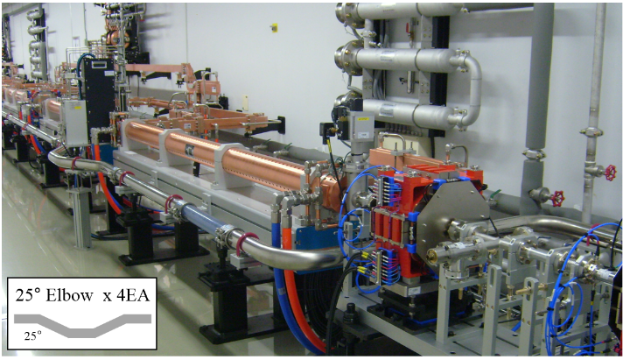
Figure 11: 25° and 90° elbow pipe installed in LINAC section.

Table 3: Elbow types and installed locations
Device | Location (meter) |  | Elbow type
Screen monitor | 10 | 25° x 4EA
Screen monitor | 20 | 25° x 4EA
Screen monitor | 30 | 25° x 4EA
BC ¹⁾ -1 | 48 | 90° x 4EA + 45° x 4EA
Screen monitor | 85 | 25° x 4EA
Screen monitor | 135 | 25° x 4EA
Screen monitor | 195 | 25° x 4EA
BC ¹⁾ -2 | 211 | 90° x 4EA + 45° x 4EA
Screen monitor | 240 | 25° x 4EA
BAS ²⁾ -2 | 260 | 90° x 4EA
BC ¹⁾ -3 | 314 | 90° x 4EA + 45° x 4EA
Screen monitor | 327 | 25° x 4EA
Screen monitor | 364 | 25° x 4EA
Screen monitor | 418 | 25° x 4EA
Screen monitor | 540 | 25° x 4EA
Beam collimator | 602 | 25° x 4EA
Screen monitor | 608 | 25° x 4EA
Beam collimator | 658 | 25° x 4EA
Beam collimator | 683 | 25° x 4EA
LINAC End | 698 | 90° x 2EA
- BC: bunch compressor
- BAS: beam energy analytical station
Table 4 shows the elbow type and position in the undulator section. In terms of radiation safety regulations, four 90° elbow were placed in front of the optical hutch (OH) wall, and lead shielding was made in the OH (see Fig. 12).
Table 4: Elbow types and installed locations
Device | Location (meter) |  | Elbow type
Undulator Hall | 1015 | 90° x 4EA
Optical Hutch | 1031 | 90° x 2EA
Optical Hutch | 1049 | 90° x 2EA
Beamline Hutch | 1051 | 90° x 2EA

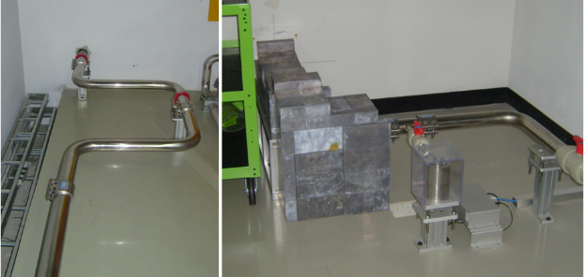
Figure 12: .Front of OH wall (left), OH inside (right)

protection of hls electronics from strong radiation
Korea multi-purpose accelerator complex (KOMAC - 100 MeV, 20 mA), which has been operating in the Gyeongju city ever since the completion of construction in 2012, installed the HLS system in 2017 to observe changes in the building floor [7]. Failure has occurred to a portion of the HLS electronics that was installed within the tunnel due to strong radiation from the proton accelerator. To solve this problem, 30 meter extension cable was purchased from GE sensing & inspection technologies Gmbh, which produce and sell ultrasonic transducers and operate the HLS system by installing all HLS electronics on the outside of the tunnel where there are no radiation influences (see Fig.13). Extension cables are produced in accordance with the desired length of the user. So, the proton and heavy-ion accelerators where strong radiation is generated, it is worth taking into considering the method of installing and operate HLS electronics outside of the tunnel.

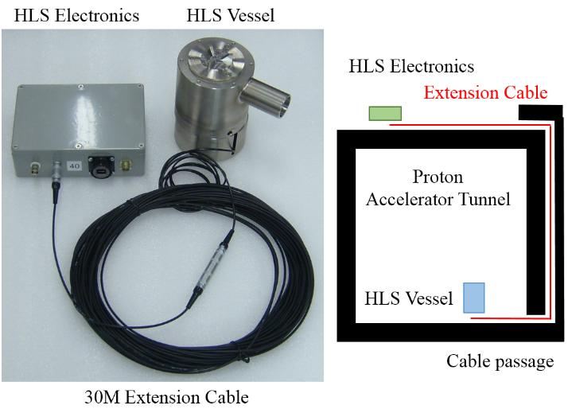
Figure 13: HLS extension cable installation.
Since PAL-XFEL (10 GeV, 200 pC, 60 Hz) is an electron accelerator and because its radiation is not severe then proton accelerator, all HLS electronics are installed and operated within the tunnel floor (see. Fig.14).

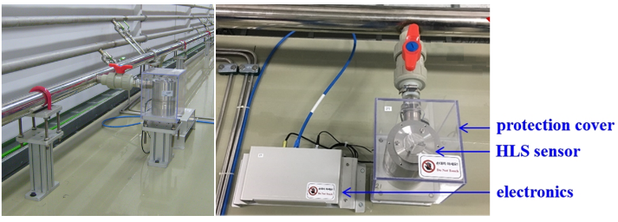
Figure 14: HLS installed in Undulator section.

WPS system
WPS system installed in the PAL-XFEL is explained in detail on reference 3.

hls & WPS measurement program
HLS and WPS measurement program used in PAL-XFEL is prepared through the LabVIEW program through the help of the budker institute of nuclear physics (BINP) research institute and FOGALE Nanotech. EPICS communication uses CaLab produced and distributed by helmholtz-zentrum berlin (BESSY) research center [8]. HLS and WPS measurement can be checked in real-time through the PAL-XFEL operation screen (see Fig.15).

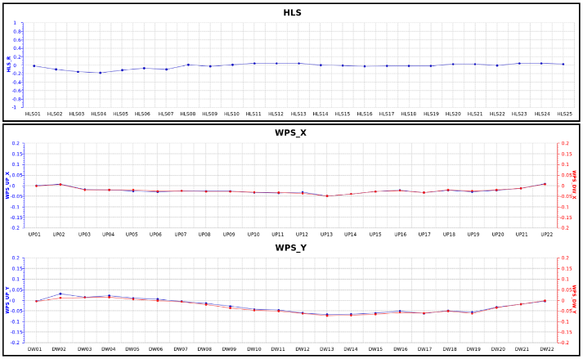
Figure 15: HLS and WPS operation screen.

CONCLUSION
PAL-XFEL, after having installed HLS and WPS system in 2016, has been operating without any failures to this day. The Pohang area experienced an earthquake that recorded a magnitude of 5.4 on the Richter scale on November 15, 2017 and 4.7 on February 11, 2018. However, due to the HLS and WPS measurement, they were able to inspect the changes in the location of building and equipments in real-time and this allowed them to execute restoration (realignment) work in a prompt manner. In addition, they were able to acknowledge the vulnerable areas of the ground and building floors based on persistent measurements and are capable of calculating transitional aspects of the ground and building flow after heavy rain. Also, based on the results of HLS and WPS observations, it is now possible to determine the operation point for the beam base alignment (BBA) of the Undulator and equipment realignment point of the survey and alignment (S/A) team. The HLS and WPS systems are suitable for real-time surveys of changes in location of building floors and equipments of large science equipment.

acknowledgEmentS
We would like to thank Dr. A.G. Chupyra and Dr. M.N. Kondaurov of BINP, and Mr. Jean-Christophe Clenet and Mme. Elodie Bollet of FOGALE Nanotech for their technical advice and for helping us with the process of installing the HLS and WPS system in PAL-XFEL.

References
[1] I.S. Ko et al., “Construction and Commissioning of PAL-XFEL Facility”, Applied Science, vol. 7, no. 5, p. 479, 2017, doi:10.3390/app7050479
[2] H.-S. Kang et al., “Hard X-ray free-electron laser with femtosecond-scale timing jitter”, Nature Photonics, vol. 11, p. 708, 2017, doi:10.1038/s41566-017-0029-8
[3] HJ Choi et al., “Wire position system to consistently measure and record the location change of girders following ground changes”, Journal of Physics: Conf. Series, vol. 874, p. 012088, 2017, doi:10.1088/1742-6596/874/1/012088
[4] Hyojin Choi et al., “HLS System to Measure the Location Changes in Real Time of PAL-XFEL Devices”, in Proc. of IPAC’18, Vancouver, Canada, May 2018, paper WEPAL070, doi:10.18429/JACoW-IPAC2018-WEPAL070
[5] H.J. Choi et al., “Real-Time Measurement of Flutuations of Building Floor and Installed Devices of Large Scientific Equipment”, in Proc. of HB2018, Daejeon, Korea, June 2018, paper THA2WD03.
[6] H.J. Choi et al., “Operation status of HLS System Installed to Measure Ground Change of Large Scientific Equipment in Real Time”, in Proc. of MEDSI2018, Paris, France, June 2018, paper WEPH18.
[7] Dae-Il Kim et al., “Preliminary Operation of the HLS for Measuring Vertical Movement of the Accelerator Building at KOMAC”, in Proc. of Transactions of the Korean Nuclear Society Spring Meeting, Jeju, Korea, May 2018.
[8] Choi H et al., “LabVIEW EPICS program for measuring BINP HLS of PAL-XFEL”, in Proc. of ICALEPCS2015, Melbourne, Australia, October 2015, paper WEPGF115, doi:10.18429/JACoW-ICALEPCS 2015-WEPGF115

