

**U.S. HL-LHC Accelerator Upgrade Project**

**Magnetic Measurement Systems**

**Requirements and Design Specifications**

**For Q1/Q3 Cryostat Assemblies Horizontal Test**

|  |  |  |
| --- | --- | --- |
| **Prepared by:** **Joe DiMarco** Date: 1/10/2018 | **Organization**  FNAL | **Contact**  [dimarco@fnal.gov](mailto:dimarco@fnal.gov)  (630) 840-2672 |
| **Reviewed by: Guram Chlachidze** Date: 1/10/2018 | **Organization**  FNAL | **Contact**  [guram@fnal.gov](mailto:guram@fnal.gov)  (630) 840-4622 |
| **Reviewed by: George Velev**  Date: | **Organization**  FNAL | **Contact**  [velev@fnal.gov](mailto:velev@fnal.gov)  (630_-840-2203 |
| **Approved by: Giorgio Apollinari**  US HL-LHC AUP Project Manager  Date: | **Organization**  FNAL | **Contact**  [apollina@fnal.gov](mailto:apollina@fnal.gov)  (630) 840-4641 |

**Revision History**

|  |  |  |  |
| --- | --- | --- | --- |
| **Revision** | **Date** | **Section No.** | **Revision Description** |
| Draft | 10/10/2018 | All | Initial Draft |
|  |  |  |  |
|  |  |  |  |
|  |  |  |  |
|  |  |  |  |
|  |  |  |  |
|  |  |  |  |
|  |  |  |  |
|  |  |  |  |
|  |  |  |  |
|  |  |  |  |
|  |  |  |  |

**Table of Contents**

1. Scope 4
2. Rotating Coil Measurement System 4
3. Stretched Wire Measurement System 6
4. Magnetic measurements at Horizontal Test Stand 7
5. Appendix 8

References 10

1. Scope

This document describes magnetic measurement systems for testing Q1/Q3 cryostat assemblies at Fermilab’s Horizontal Test Stand.

Total of ten of LQXFA cryostat assemblies are expected to be fabricated and delivered to CERN by the U.S. HL-LHC Accelerator Upgrade Project (US HL-LHC AUP). One cold mass LMQXFA [1] is installed in each cryostat assembly. Each cold mass consists of two MQXFA quadrupole magnets [2].

All prototype and production MQXFA magnets will be fully trained and tested in the vertical test facility at Brookhaven National Laboratory (BNL). Comprehensive magnetic measurements also will be done at BNL.

The list of magnetic measurments expected at Fermilab’s horizontal test stand is also presented.

1. Rotating Coil Measurement System
   1. Requirements

The rotating coil measurements are expected to measure the following

* Integrated quadrupole field with accuracy better than 0.1% and resolution better than 0.01%
* Harmonic coefficients accuracy of 5ppm of main field in the body region for orders 3 to 14
* Integral harmonics
* Local twist variation of the quadrupole roll angle as a function of axial position at the 0.5mrad level
* Local magnetic axis with respect to external fiducials at the 0.2mm level
* End field harmonics determined every 0.25m axially

In addition, the system should be easily replicable for performing low field measurements during quadrupole assembly.

* 1. Design Specifications

To achieve the above, the following system is proposed:

* A relatively short, encapsulated probe system which is transported through the magnet
* Printed Circuit Board based radial harmonics coil probe, having 2 PCBs of length 0.22m each (length is ~2 twist pitch lengths of the Rutherford cable)
* PCB’s feature radius independent measurement of quad strength, and harmonics measurements which have bucked the dipole and quadrupole fields
* On-board encoder which is rigidly coupled to the rotating PCB
* On-board gravity reference with resolution < 1mrad
* Probe drive and signal cables exiting one end of the probe with laser tracker targets mounted on opposite end
* Push-pull belt drive for positioning probe
* Automatic probe spooling system to manage cables during positioning
* Externally driven non-magnetic flex drive for probe rotation
* Radius of rotation of PCB outer edge to be placed at as large a radius as practical, aiming for a minimum of about 0.05m (the reference radius used in reporting multipoles), with sensitivity adjusted so that harmonic accuracy can be achieved.
* Voltage induced during measurements at high field < 10V
* Amplifiers as part of DAQ for use in low-field measurements
* Precision axial positioning via laser tracker feedback
* Precise knowledge of effective probe length, so that positioning systems can achieve integral accuracy with no gaps at the level of 0.05% and effective magnetic length and magnet axial center location to better than 1mm.
* Rotation rate of probe should be at least 1Hz
* At least 8 channels of high resolution (> 18 bit) voltage/flux measurement with continuous streaming of data signals.
* Real-time monitoring of raw signals and partially processed results with quality checks.
* Automatic tracking of probe and data acquisition calibrations used for each measurement
* Straightforward logging, archival, and retrieval of measurement raw data and analyzed results
* Automated control of current and scan positioning from harmonic data acquisition system and read-back of these and other ancillary data into the measurement file.

If integral measurements of field during simulated accelerator cycles is required, a longer probe (up to length ~5m, but in any case long enough to cover the entire end region could be developed.

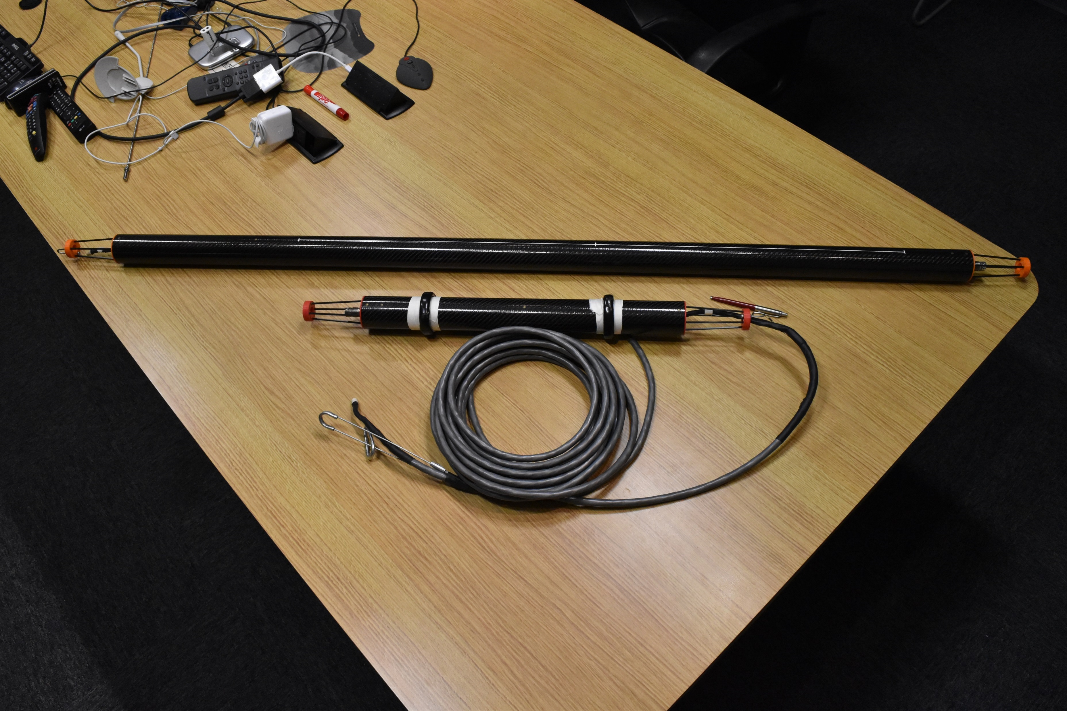

Fig. 1 Self-contained rotating probe assembly (Ferret)

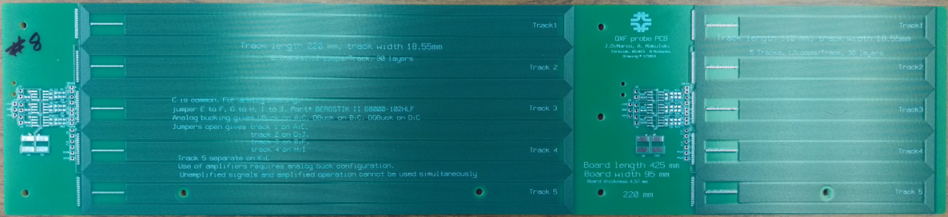

Fig. 2 110-mm and 220-mm long multi-layer PCB probes

1. Single Stretched Wire (SSW) Measurement System
   1. Requirements

The SSW measurements are expected to measure the following

* Integrated quadrupole field with accuracy better than 0.05% and resolution better than 0.01% of the two-magnet assembly at currents corresponding to injection and collision energies.
* Integral roll angle of the individual magnets relative to gravity at level better than 0.1 mrad at low and high fields.
* Quadrupole magnetic axis with average center displacement error as related to external fiducials on the magnet < 0.25 mm, and with yaw and pitch angular errors corresponding to a level below 0.05 mm at the ends of each magnet.
  1. Design Specifications

The SSW system description:

* 1µm accuracy positioning in X and Y directions
* Tensioning motor and gauge for removal of sag effects from measurements
* Wire vibration determination method also for removal of sag effects
* Ability to use AC current on magnet for low-field measurements (either with magnet at room or cryogenic temperature).
* FDI 2056 integrator, bi-polar op-amp power supply (Kepco), frequency generator, and high accuracy volt meter.
* EMMA-based control and data acquisition software that automatically performs the standard measurements needed and records and displays data. This includes DC and AC modes of operation and sag correction for the various measurements: average offset, yaw/pitch measurements, sag calibration, and roll angle.
* Calibrated surface plates that can be zeroed with a micro-level and provide a gravity reference.
* Fiducial nests with calibrated distances to wire, for transferring of axis position to magnet fiducials via laser tracker
* Three-point supports atop a base structure for parallel alignment of the stages to the test stand.

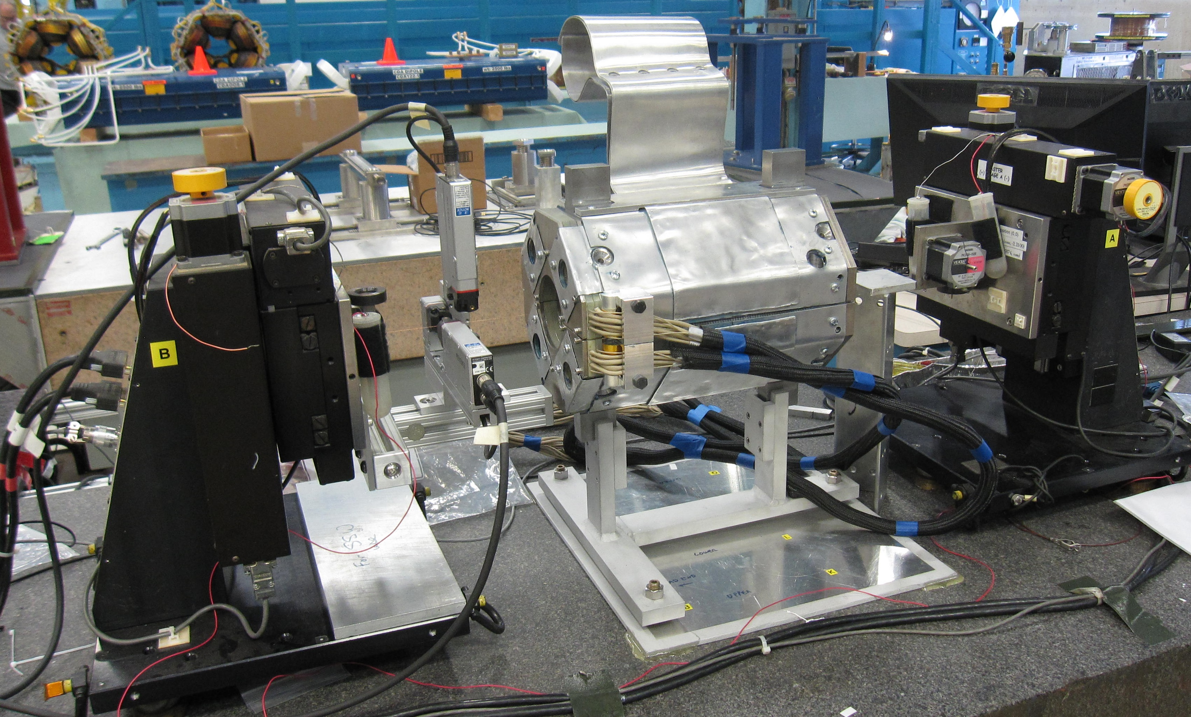

Fig. 3 Stages of SSW system used for measurement of LCLS-II magnets

1. Magnetic measurements at Horizontal Test Stand

Room temperature Measurements

* 1. Alignment measurements at room temperature
     1. Verify the deviation of each MQXFA magnet axis along the common magnetic axis
     2. Verify the deviation of each MQXFA field angle from the common average magnetic field angle

Cold measurements at 1.9 K

* 1. Integral field strength measurements at injection (8.5 T/m) and collision (132.6 T/m)
     1. SSW measurements at 960 A and 16480 A
  2. Integral harmonics (longitudinal scan) at injection (8.5 T/m) and collision (132.6 T/m) currents
     1. Rotating probe measurements at 960 A and 16480 A
  3. Cold alignment measurements at 1.9 K
     1. Repeat SSW measurements in 4.1
  4. Harmonic measurements for the simulated machine cycle (accelerator profile)
     1. Measurements at different locations

Measurements at room temperature after the warmup

* 1. Alignment measurements
     1. Repeat SSW measurements in 4.1

1. Appendix

Definitions below are copied from LMQXFA Cold Mass FRS [1].

Reference system is: *y* along the magnet axis, *z* is vertical direction and *x* is horizontal towards the centre of the accelerator.

The *y*-center of the magnetic length for the combined two MQXFA system is the mid-point between the two individual MQXFA magnetic *y*-centers.

Measurement accuracy of the magnetic length needs to be better than ± 1 mm (at 1.9 K).



Fig. 4 Lines representing the two MQXFA and the common magnetic axis

The pole line is a line (see Fig. 5) perpendicular to the magnet longitudinal axis connecting the two similar poles (N-N or S-S, 180 degree apart) (at the center of the pole).

Field angle is defined as the angle of the pole line connecting the South poles. The angle is measured counter clockwise, looking from the interaction point toward the IR magnets and the zero angle is defined as the gravity line pointing upward. Field angle is equivalently defined as the angle with respect to gravity that gives a zero average skew quadrupole component (with an additional 45 degree offset compared to pole line definition).

The average field angle is the field angle averaged over the length of a single magnet.

The common average field angle is the angle that bisects the average field angle of the two magnets.

Magnetic transverse center (or simply magnetic center) is the point at the intersection of the two crossing pole lines.

The average magnetic axis is one of the idealized lines through the bore of the magnet which has zero integrated field value when performing the field integration along this line. The point at the *y*-center of the magnet which is common to any of the family of average magnetic axes is referred to as the nodal point.

The magnetic axis (or true magnetic axis – see Fig. 4) is the idealized line which is both an average magnetic axis and which minimizes the second moment of field integration along the line.

The common axis of the two magnets is the average magnetic axis for the two magnets. This is the line that intersects the individual magnetic axes of both MQXA magnets at their *y*-centers (i.e. contains the nodal points of both magnets).

In determining deviation from the common axis, the distance between the common magnetic axis and the point on the magnetic axes of MQXFA is measured on the line perpendicular to the common magnetic axes (though for the small angles required here, the cosine error using a line perpendicular to the individual axes would be negligible anyway).

Angles between any pole lines are compared relative to the projected (perpendicular projection) lines onto the plane that is perpendicular to the common magnetic axes (again the small angles and cosine effects generally make the “would-be errors” from these effects negligible).



Fig. 5 Definition of the pole lines and magnetic center point. The pole line is an idealized line connecting the two similar poles (N-N or S-S, 180 degree apart) at their centers. The magnetic center point is the point where the idealized pole lines cross each other

1. REFERENCES

[1] LMQXFA Cold Mass Functional Requirements Specification, US-HiLumi-doc-64

[2] MQXFA Magnet Fubnctional Requirements Specification, US-HiLumi-doc-36