A Proposal for an Irradiation Test Area “ITA”
at the End of the Linac

A. Apresyan, D. Christian, J. Freeman, R. Lipton, P. Merkel, A. Prosser, E.Ramberg, M. Rominsky, V. Rusu, R. Tesarek, R. Tschirhart, L. Uplegger

13 September, 2017

Introduction

As particle beams become ever more intense, creating detectors that can withstand these high radiation environments becomes extremely challenging. As an example, over the lifetime of the next set of CMS upgrade detectors, the flux going through them will reach 10¹⁶ per cm², or about 5 MGy. Proton flux near neutrino targets is far greater. It is widely agreed that there is a dearth of locations in the U.S. where samples of detectors can be irradiated with a high energy proton beam up to these levels. There are no facilities that can provide irradiation followed by testing in a low flux test beam. Fermilab has this unique capability in the MTA enclosure at the end of the Linac, combined with the Fermilab Test Beam Facility (FTBF). We propose that Fermilab create an area called the “Irradiation Test Area”, or “ITA”, in this enclosure. It would be managed by the Test Beam Facilities department in PPD that oversees the FTBF. As discussed below, there is a great need for irradiation tests for the next generation of detectors at LHC and we foresee the majority of runs in the ITA during the first year would be for the LHC program. We would coordinate with other U.S. institutions that are already making plans for irradiation tests at lower energies. If this model works, we could expand its usage to support other research, beyond the LHC. We have been contacted by the sPHENIX group at Brookhaven to assess our irradiation options.

Need for ITA by CMS:

The HL-LHC upgrades will require an extensive program of irradiation and detector validation. The inner trackers for CMS and ATLAS expect integrated fluences of >10¹⁶ neuron-equivalent/cm². This is more than an order of magnitude larger than for the current trackers. The CMS High Granularity Calorimeter (HGC) will be exposed to fluences in the 10¹⁴-10¹⁶ range, requiring various levels of radiation hardness. One goal of an irradiation program is to match the detector design to the projected dose to minimize the overall cost of these detectors by only using the more expensive thin, n-on-p detectors where they are needed.

The CMS HGC will use 8” silicon wafers. These large area wafers, which have not yet been used for a HEP experiment, can significantly reduce costs for large area devices such as the CMS HGC (600 m²). However, foundries are designed to handle full thickness wafers (725 microns), whereas radiation hardness requires thin active silicon layers (100-300 microns). This thinning will require new fabrication techniques and materials. There are similar issues for the tracker as well as the Low Gain Avalanche Diodes (LGADs) proposed for the CMS and ATLAS timing layers.

All of the sensors and associated electronics will need to be validated for the full range of fluences. For example, n-on-p sensors are expected to be more radiation hard, but are more expensive to fabricate. Similarly, devices with thinner active areas are expected to be more radiation hard than thicker devices, but these devices require special processing to produce either physically thin wafers or devices with thin high resistivity active area stacked on lower resistivity material. Examples of this are deep diffused silicon, Silicon-on- Insulator (SOI), and Silicon-Silicon bonded wafers. Many of these technologies have not yet been validated for the full range of radiation doses. Therefore we will need to test and qualify candidate sensors from several different vendors with several process variants, thicknesses, design rules, and substrates. In addition, we want to match dose and fluence to region of the detector.

FTBF Test Beams

Coupled to this powerful irradiation capabilities is the unique Fermilab Test Beam Facility (FTBF), which can then handle irradiated samples and measure their efficiencies. The CMS test beam group T992 has pioneered the procedures for handling irradiated sensors at FTBF. They work very closely with the radiation technicians to bring the samples back on site. There is a refrigerator next to the radioactive source box, providing separation from the rest of the facility. In addition, the ATLAS test beam experiments carried out at FTBF have followed the same procedures of communicating with the radiation technicians here.

Other facilities in the U.S.

The requirements for radiation hardness in LHC detectors adds up to a very substantial radiation verification program, with over 100 individual exposures needed. At the moment there are no facilities in the US that can support the range of this work. The 800 MeV pion beam at Los Alamos supports limited irradiations and provides a valuable service. However, there are limitations to availability and access:
“Typically the UNM group submits a proposal on behalf of ourselves and 5-10 collaborating institutions for two proton exposures of about 2 ×1016 p/cm2 each, scheduled for July and December. This translates to about 72 hours of beam twice per year. Because of the small beam diameter, these runs are typically oriented toward silicon and diamond sensors, tracking modules, electronics chips, and small mechanical samples.”
This availability is not adequate for the rigorous radiation testing required for HL-LHC. The CMS HGC group is commissioning the 17 MeV proton linac at Florida State University for use as an irradiation facility, but this does not have the optimal energy and has limited access and availability. We have established that the facilities at TRIUMF are not adequate for these high doses.

Just recently, there has been a call to set up irradiation facilities at Argonne National Laboratory. This would be in the ‘LEAF’, or Low Energy Accelerator Facility. A 55 MeV electron beam would be available, as well as a 1-3 MeV gamma source yielding up to 100 MRad dose. From this gamma facility a photonuclear induced neutron beam capability would exist, with beam averaging about 0.5 MeV and fluence of about 8E11 per second per cm². Having these lower energy, high flux beams available for detector irradiation, in conjunction with the FTBF testing area and a new 400 MeV irradiation area at Fermilab, will make the Chicago region a powerful hub for this kind of activity.

A Description of the MTA

The beam enclosure designated “Muon Test Accelerator” or “MTA” – is located at the end of the linear accelerator (LINAC), where a beam of 400 MeV energy H- ions can be switched away from the trajectory that would normally take them into the Booster after stripping away the electrons. The MTA enclosure is shown in Figure 1.

Beam Capabilities at MTA

The operational characteristics of the MTA beamline is given in reference 1. A summary of beam parameters is shown in Table 1.

Table 1: Beam parameters to be expected at the DUT (Device Under Test)
Beam Specifications | Min | Max
Beam Size (±3σ) at DUT | 1 cm | 5-7 cm
Beam Divergence (±3σ) at DUT | 0.1 mr | 1 mr
Number of Proton/pulse | 0.3×10¹² | 7.5×10¹²
Pulse Duration | 2 µs | 50 µs

The length of the LINAC pulse is typically 50 μsec, with 4.5E12 protons per pulse (PPP) being delivered. Total beam flux delivered is then proportional to the number of these pulses.

Pulses are provided to the Booster at 15 Hz rep rate. The smallest effect on the physics program would be to extract one of these pulses over a long supercycle – say one per minute, as is done currently. At that rate, then one can irradiate a

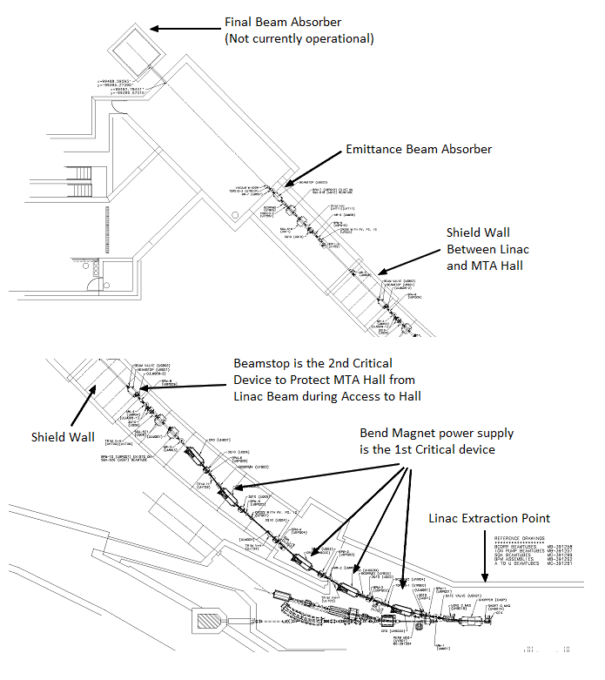
Figure 1: A map of the MTA beamline (lower figure) leading into the MTA test enclosure (upper figure). The two areas for absorbers are shown. The large blank area in the MTA enclosure is filled with a 5T solenoid magnet and a large RF cavity. This would be the ‘experimental’ area where the movable absorber can be placed.

sample with 1E15 protons in about 220 minutes, or 4 hours. This would have an impact on the Fermilab neutrino physics program of 1.7%. If the Booster beam is down for any reason, and one can dedicate full time to irradiation, then this rate could conceivably be increased to the level of 1E15 in 20 minutes. No other U.S. facility can provide this kind of intensity and energy for irradiation studies.

The 2 modes of running beam to MTA are ‘emittance’ mode and ‘experimental’ mode. The shielding assessment establishes these modes and what is needed for each. In experimental mode there is a clause that says each experiment must be considered individually. For experimental mode you can either run the beam all the way to the permanent absorber that is buried in the downstream wall (which has not yet been done) or absorb all of the beam in a movable absorber that can be installed in different locations. This absorber has been used in 2 locations in the enclosure. If a different location is desired, then one has to amend the shielding assessment to verify that it is OK to put the absorber there. About 1 to 2 weeks of beamline physicist work is required for creating that assessment.

The intensity limits for the two modes of operation are: 600 pulses/hour or 4.5 x 10^15 protons/hour for beam measurements ‘emittance mode’) and 60 pulses/hour or 4.5 x 10^14 protons/hour to MTA experiments (‘experimental mode’)

Status of the MTA area

Here is a summary of the status of MTA from Tom Kobilarcik, the MTA beamline physicist. Currently, the approved configuration is shown in Figure 2, with the movable absorber in a furthest downstream location such that irradiation of components in the beamline will be minimized. The MTA beamline is not operational, due to beryllium contamination caused by a ruptured window in the beamline.

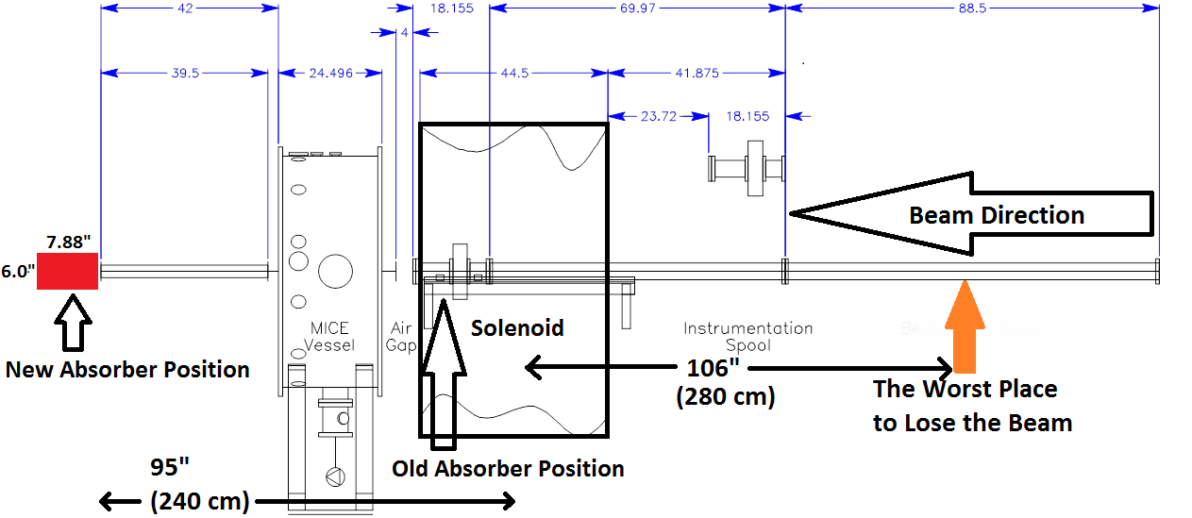

Figure 2: This side view of the current configuration shows beam pipe spool pieces. The beam absorber will rest against the final downstream vacuum window flange.

We need 4 MWPC wire chambers repaired and installed. This will require re-wrapping the wires., aligning it to the beamline, hooking it up to a readout system and then perform measurements. It is estimated that three technicians working full time for 1 week could likely get the beamline cleaned and rebuilt, including new windows. It is estimated that the cost for the beamline work will be about $10K.

There is a large RF cavity in the enclosure, belonging to the MTA researchers. Although it is not required that this cavity be removed before running any intense beam, it is recommended so as to make removal in the future safer. Removing this cavity requires significant planning and resources. We estimate an engineer would need to spend a week making plans with the Industrial Hygiene group. We estimate at least 2 weeks full time for 3 technicians to get the cavity out. This will require 1 day with a crane from outside. (Note: this is assuming all of the hardware for de-installation is still available. We are not sure where this equipment ended up being stored at. The engineer who installed the cavity, Ryan Schultz, has since left the lab.)

We do not know if the current ion pump works. For the future it is recommended that we install an additional ion pump. This would allow work in the experimental area with UBV03 (vacuum valve) closed. In the event of a problem in the experiment the beamline would still be protected. A new ion pump would likely cost $10K. If the upstream ion pump is bad then we need 2 ion pumps. There is also a beam valve that may or may not function properly. (cost estimate?).

The emittance absorber still has beryllium in it. The samples around it came back above the beryllium action level. We should plan on 3 techs for 2 days and 1 engineer to perform the hazard analysis and plan of action. If you only ran in emittance mode to the first absorber then removing the MICE cavity would not technically be required.

For any experiment we will need to buy a vacuum window, cost estimate $5K. Then we will need an engineer to write the window note. I would plan on 1 engineer for at least 1 week to get this done. Any experiment will require an ORC.

Summary of costs and manpower:
Beamline repair: $10k, 3 technician weeks
Beam Window: $5K, 1 Engineer week
Ion pumps and valve: $15K,
Emittance absorber cleaning: 3 technician days, 1 Engineer day
Removing the RF cavity: 1 engineer week, 6 technician weeks
Assuming a day of manpower is on the order of $1000, then this totals to approximately $50K in labor and $30K in materials. The cost of operations is unknown at the moment.

Summary

It is imperative that the next phase of detectors and readout for the HL-LHC experiments be tested for radiation hardness, up to and beyond a fluence of 1E16 particles per cm². There is support from both the CMS and ATLAS collaborations for this activity. In addition, the sPHENIX group has expressed interest in having an irradiation facility near the FTBF. Our ability to provide both a test beam and an irradiation facility at one location makes Fermilab unique and will draw in many users. We propose that a minimal set of repairs at MTA be performed so that we can deliver 4 hours of irradiation beam into the enclosure to determine viability of this plan.

References
1) “MuCool Test Area (MTA) Experimental Capabilities”; March 2014
2) “MTA Facility Proposal for Beam Studies with the MICE Cavity”; March 7, 2016

