

**U.S. HL-LHC Accelerator Upgrade Project**

**REQUIREMENTS SPECIFICATION FOR THE ASSEMBLY OF LQXFA/LQXFB**

|  |  |  |
| --- | --- | --- |
| **Prepared by:** Date: 05/06/2016  Ruben Carcagno, US HL-LHC AUP Deputy Project Manager and Sandor Feher, US HL-LHC L3 manager | **Organization**  FNAL | **Contact**  [ruben@fnal.gov](mailto:ruben@fnal.gov)  (630) 840-3915 |
| **Reviewed by:** Date:  Giorgio Ambrosio, US HL-LHC AUP MQXFA L2 Manager | **Organization**  FNAL | **Contact**  [giorgioa@fnal.gov](mailto:giorgioa@fnal.gov)  (630) 840-2297 |
| **Reviewed by:**  Date:  Paolo Ferracin, HL-LHC MQXFA CERN coordinator  Juan Carlos Perez HL-LHC WP3 WP Engineer  Andrea Musso HL-LHC WP3 WP Engineer  GianLuigi Arduini HL-LHC WP2 WP Leader  Amalia Ballarino HL-LHC WP6A WP Leader  Jean-Paul Burnet HL-LHC WP6B WP Leader  Daniel Wolmann HL-LHC WP7 WP Leader  Serge Claudet HL-LHC WP9 WP Leader  Paolo Fessia HL-LHC WP15 WP Leader  Isabel Bejar Alonso HL-LHC Quality, Resources, Risk Officer | **Organization**  CERN | **Contact**  [Paolo.Ferracin@cern.ch](mailto:Paolo.Ferracin@cern.ch) |
| **Approved by:**  Date:  Giorgio Apollinari, US HL-LHC AUP Project Manager | **Organization**  FNAL | **Contact**  [apollina@fnal.gov](mailto:apollina@fnal.gov)  (630) 840-4641 |
| **Approved by:**  Date:  Ezio Todesco, HL-LHC WP3 Work Package Leader  Lucio Rossi, CERN HL-LHC Project Coordinator | **Organization**  CERN | **Contact**  [Ezio.Todesco@cern.ch](mailto:Ezio.Todesco@cern.ch) |

**Revision History**

|  |  |  |  |
| --- | --- | --- | --- |
| **Revision** | **Date** | **Section No.** | **Revision Description** |
| Draft | 4/01/17 | All | Initial Draft |
|  |  |  |  |
|  |  |  |  |
|  |  |  |  |
|  |  |  |  |
|  |  |  |  |
|  |  |  |  |
|  |  |  |  |
|  |  |  |  |
|  |  |  |  |
|  |  |  |  |
|  |  |  |  |

**TABLE OF CONTENTS**

1. Purpose 4

2. Introduction 4

3. Functional Requirements Overview 6

4. Physical Requirements 6

4.1. Physical Envelope Requirements 6

4.2. Weight Requirements 8

5. Cold Mass Requirements 8

6. Alignment Requirements 8

7. Vacuum Vessel Requirements 8

8. Forces Requirements 9

9. Leak Rate 9

10. Heat Loads 9

11. Electrical/Instrumentation Requirements 9

11.1. Instrumentation Wiring and Electrical Busses 9

11.2. Voltage Limits 10

12. Quench Requirements 10

13. Radiation Hardness Requirements 10

14. Reliability Requirements 10

15. Interface Requirements 10

16. Safety Requirements 11

17. CERN Provided Parts 11

18. Functional Requirements Summary Tables 12

19. References 14

1. Purpose

This document specifies the functional requirements for the High Luminosity LHC (HL-LHC, or HiLumi LHC) LQXFA and LQXFB cryostat assemblies work that is performed at the US. Ten (5 LQXFA and 5 LQXFB) of these cryostat assemblies are expected to be fabricated and delivered to CERN by the U.S. HL-LHC Accelerator Upgrade Project (US HL-LHC AUP) as part to the U.S. contributions to the LHC High Luminosity Upgrade. These cryostat assemblies are the quadrupole magnetic components of the HL-LHC Q1 and Q3 inner triplet optical elements in front of the interactions points 1(ATLAS) and 5 (CMS). One LMQXFA cold mass is installed in each LQXFA/B cryostat assembly. LMQXFA requirements are specified in [1]. LMQXFA cold masses will be fabricated by US HL-LHC AUP, cryostats and cryostat-assembly tooling will be fabricated by CERN. US HL-LHC AUP will perform assembly of the cold masses in the cryostats and cold test.

If all the threshold functional requirements specified in this document are verified, then US HL-LHC AUP LQXFA and LQXFB deliverables should be fit for the intended use and satisfy CERN’s needs for the HL-LHC upgrade. The quality of the US HL-LHC AUP LQXFA and LQXFB deliverables will be measured by the degree to which its characteristics fulfill the requirements specified in this document [2]

1. Introduction

The Inner Triplet (IT) quadrupoles are the magnetic system used that allow reaching low beta functions around the Interaction Point (IP). The triplet is made of three optical elements: Q1, Q2, and Q3. The upgrade of the Inner Triplets in the high luminosity insertions is the cornerstone of the LHC upgrade. The decision for HL-LHC heavily relies on the success of the advanced Nb3Sn technology that provides access to magnetic fields well beyond 9 T, allowing the maximization of the aperture of the IT quadrupoles. A 15-year-long study led by the DOE in the US under the auspices of the U.S. LARP program, and lately by other EU programs, has shown the feasibility of Nb3Sn accelerator magnets. The HL-LHC is expected to be the first application of accelerator-quality Nb3Sn magnet technology in an operating particle accelerator.

For HL-LHC, 20 IT Nb3Sn quadrupoles (16 plus spares) are needed: they all feature 150 mm aperture and operating gradient of 132.6 T/m, which entails 11.5 T peak field on the coils. In addition, HL-LHC will use the same Nb3Sn technology to provide collimation in the Dispersion Suppression (DS) region, which will be achieved by replacing a number of selected main dipoles with two shorter 11 T Nb3Sn dipoles (MBH). For more details see [3].

Figure 1 shows a conceptual layout of the HL-LHC interaction region, and Figure 2 shows the CERN nomenclature of the IT system.

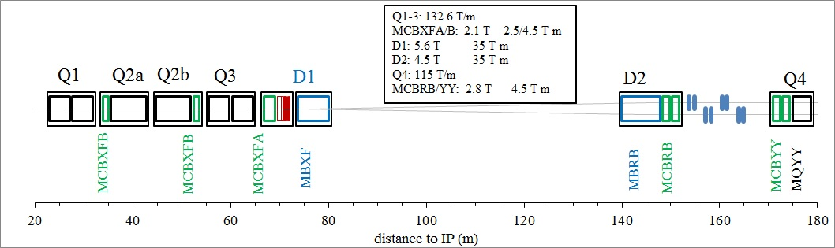

Figure 1: Conceptual layout of the IR region of HL-LHC– thick boxes are magnets, thin boxes are cryostats

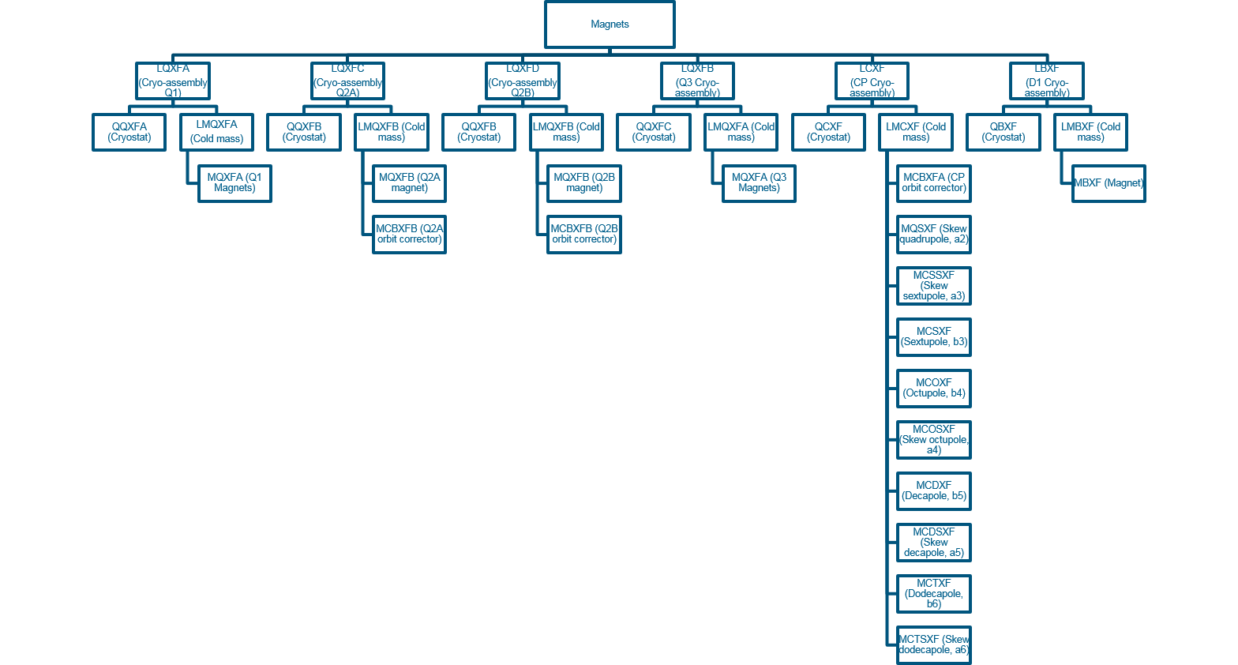

Figure 2: CERN Naming Conventions for HL-LHC Inner Triplets

The MQXFA magnet is the quadrupole magnetic element of Q1 and Q3, including the coils and mechanical support pieces to a perimeter defined by the outer shell of the magnets and the end plates of each magnet. A pair of ~ 5m MQXFA magnet structures is installed in a stainless steel helium vessel, including the end domes, to make the Q1 and Q3 Cold Mass (LMQXFA). The LMQXFA, when surrounded by the QQXFA or QQXFC cryostat shields, piping, and vacuum vessel, is then the LQXFA cryo-assembly for Q1 and the LQXFB cryo-assembly for Q3 (see Figure 3), as installed in the tunnel of LHC.

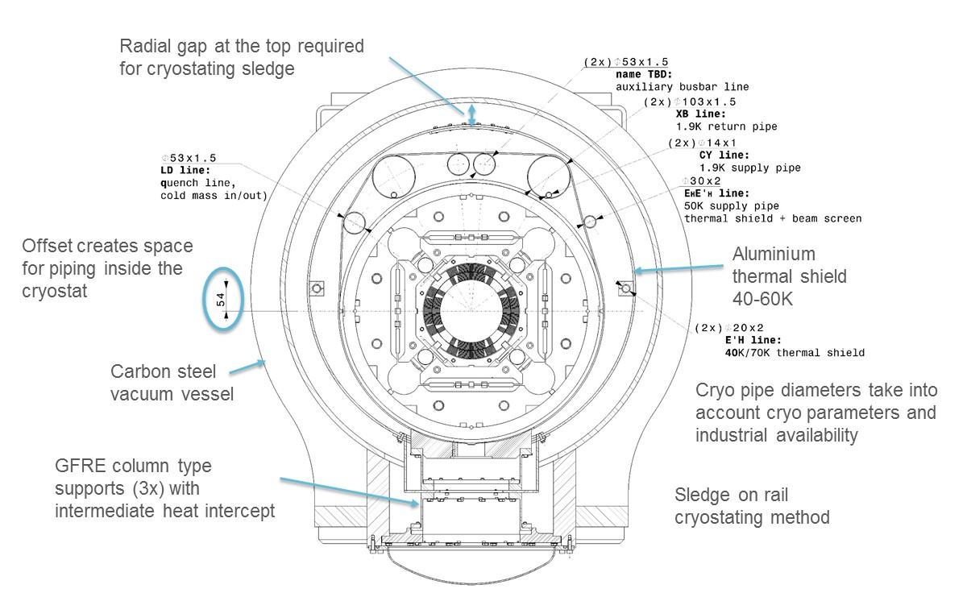

Figure 3: LQXFA-LQXFB Cross Section (measurements are in mm).

1. Functional Requirements Overview

The LQXFA/LQXFB functional requirements are the high-level technical requirements for the LQXFA/LQXFB cryostat assembly. These requirements are driven by the optics functions that the Q1 and Q3 elements need to satisfy plus physical, operational, environmental, and risk tolerance constraints. In addition to functional requirements, this document also includes some non-functional requirements such as reliability, interface, and safety requirements for completeness.

To clarify the intent, in this document requirements are classified into two groups: “Threshold” requirements and “Objective” requirements. Threshold requirements are requirements that contain at least one parameter that the project must achieve, and objective requirements are requirements that the project should achieve and will strive to achieve.

Each requirement should be verifiable by a Quality Control (QC) process. If all the requirements (specified in this document) are verified at a threshold level, then the U.S. HiLumi LQXFA/LQXFB Cryostat Assembly deliverables will be fit for the intended use and satisfy CERN’s needs for the HL-LHC upgrade.

**Detailed verification procedures and acceptance criteria are defined in a separate document [2]. At CERN’s discretion, deliverables that fall short of the threshold requirements may still be acceptable.**

This document provides some background information for each requirement, and throughout this document requirements are identified by a requirement ID of the format “**R-T-XX**”, and “**R-O-XX**” where “T” is for “Threshold”, “O” is for “Objective” and XX is the corresponding requirement number.

At the end of the document Tables 3 and 3 summarize all LQXFA/LQXFB threshold and objective requirements.

1. Physical Requirements
   1. Physical Envelope Requirements

In Figure 4 the layout drawing (LHCLSXH_0010 version AF)of the LHC IR magntes (Q1, Q2 and Q3) are shown. The dimensions that are listed in the layout drawing are subject to change however any changes needs to be confirmed by equipment owners.

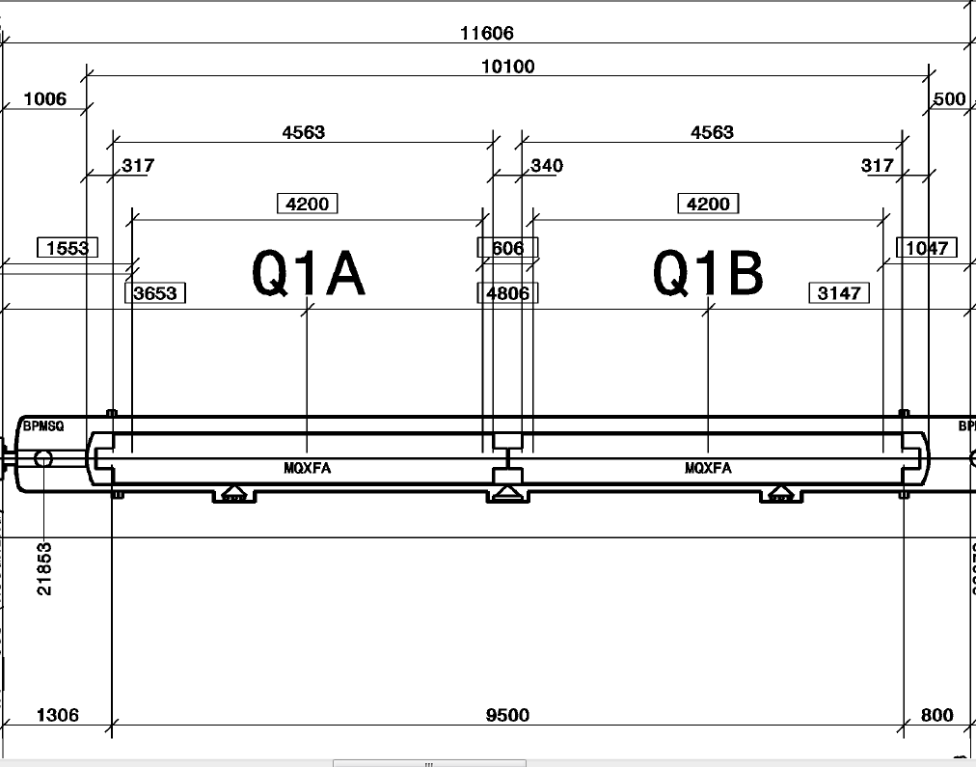

Figure 4 A portion from the LHCLSXH_0010 version AF drwaing is shown for illustration puposes (dimensions are in mm).

**R-T-01 Those dimensional values (listed in drawing LHCLSXH_0010) that have direct impact on two different equipment owners must be respected as envelope dimensions that could not be violated even if the fabrication tolerances or other constraints are taken into consideration. Any changes of LHCLSXH_0010 drawing must be approved by the Q1/Q3 equipment owners as well.**

From the layout constraints R-T-02 mechanical dimensional requirments are derived:

**R-T-02: The LQXFA/LQXFB vacuum vessel physical length (end flange to end end flange) must be ≤ 9,500 mm (the actual length shell be specified to make sure that the length plus the tolerance value is less than 9,500 mm). This dimension is at room temperature (296 K).**

**R-T-03 Any support structure attached to the vacuum vessel must be within 1,055 mm outer diameter**. **This dimension is at room temperature (296 K).**

Note:

* Components attached to the vacuum vessel required for cryostat installation may exceed the 1,055 mm diameter envelope if it does not interfere with transportation in the LHC tunnel
* Figure 4 is a section from the layout drawing: LHCLSXH_0010 version AF. If at any time the drawing is revised this docment may also be re-vised to indicate changes affected by the Q1/Q3 Cold Mass design.
  1. Weight Requirements

**R-T-04 The total weight of the whole cryostat assembly must be ≤ 25 000 kg.**

Note:

* The total weight should include any accessories to the cryostat assembly that are permanently attached to it and could not be removed during lifting operation.

1. Cold Mass Requirements

**R-T-05: The LQXFA/LQXFB cryostat assembly contains one LMQXFA cold mass. The LMQXFA cold mass must satisfy the LMQXFA requirements specifications [1] and the LQXFA/LQXFB interface specifications [4].**

The LQXFA/LQXFB Interface Specification provides details for the attachment of the LMQXFA cold mass to the cryostat feet and the alignment interface of LMQXFA to the Cryostat asembly.

1. Alignment Requirements

Figure 4 shows dimensions and distances for Q1A and Q1B (Q3A and Q3B are the same) assumed in the present lattice layout. The requirement for positioning LMQXFA within LQXFA/LQXFB is:

**R-T-06: LMQXFA cold mass is centered in Z within ± 5 mm with respect to the Z-center of the QQXFA/QQXFC vacuum vessel using the Z-center of the magnetic lengths.**

Note:

* The vacuum vessel dimensions are referenced to the vacuum vessel coordinate system. The Z direction is the centerline of the vacuum vessel. The gravity line pointing upward is the Y direction. The origin of the coordinate system is at the center of the vacuum vessel.
* The vacuum vessel centerline is estublished by finding the center of the vacuum vessel end flanges at both ends of the vessel and placing a line through the center points of the two ends. Half way relative to the two centerpoints (on the centerline) is the center of the vacuum vessel.
* The Cold Mass fix point is at the center of the cold mass and cryostat.

**R-O-01: The common magnetic axis of cold mass must be positioned within ±1 mm accuracy with respect to the vacuum vessel end flange center points. The deviation of the common magnetic field angle of the cold mass (in the vacuum vessel coordinate system) must be within ±5 mrad.**

1. Vacuum Vessel Requirements

**R-T-07: The QQXFA and QQXFC are a pressure vessels that must be designed and documented in accordance with CERN and U.S. HL-LHC Accelerator Upgrade Project safety agreements [5].**

**R-T-08: The QQXFA and QQXFC vacuum vessel must be designed for a Maximum Allowable Working Pressure (MAWP) of 1 bar differential either direction.**

1. Forces Requirements

Once installed as part of the LHC Inner Triplet System, the LQXFA/LQXFB cryostat assemblies can experience asymmetric axial forces due to quench on other magnets and other events.

**R-T-09: The LQXFA/LQXFB cryostat assembly must be capable of sustaining loads resulting from up to 25 bar (125% of MAWP) of pressure differential in the LHe containment vessel (cold mass and associated pipes) and 1 bar pressure differential in the vacuum vessel without physical damage or performance degradation.**

Note:

* CERN is responsible to provide design, fabrication procedures and components that meet the R-T-09 requirements. Fermilab is reponsible that the execution of the assembly meets the assembly specifications.

1. Leak Rate

**R-T-10: The LHe containment vessel (Cold Mass and associated pipes) and all other pressurized pipes need to be leak tight under their operating pressure. The leak check must measure that the leak reate is lower than 10-9 torr-liter/sec.**

1. Heat Loads

**R-T-11: The LQXFA/LQXFB cryostat assembly must be designed and manufactured to be able to intercept most of the heat flow from room temperature to 1.9 K. The maximum static heat flow to 1.9 K must be less than equal to 0.85 W/m for LQXFA and 0.84 W/m for LQXFB.**

1. Electrical/Instrumentation Requirements
   1. Instrumentation Wiring and Electrical Busses

**R-T-12: Instrumentation wiring and electrical busses during the assembly process must be handled carefully not to introduce any performance degradation.**

Note:

* Wiring introduced performance degradation is any wiring issues that cause magnet operational deficiency like QPS is not fully functional due to a lost V-tap etc.
* CERN will provide all wires and busses routing and installation procedures used in LQXFA/LQXFB cryostat assemblies.
  1. Voltage Limits

**R-T-13: The LQXFA/LQXFB cryostat assembly voltage limits must meet or exceed the LMQXFA voltage limit requirements specified in [1].**

1. Quench Requirements

**R-T-14: The LQXFA/LQXFB quench performance must meet the LMQXFA cold mass quench performance requirements specified in [1].**

This requirement means that the cryostat assembly quench performance is limited by the LMQXFA cold mass, ultimately the MQXFA magnet, and not by cryostat assembly superconducting components such as heat loads.

1. Radiation Hardness Requirements

The LQXFA/LQXFB cryostat assembly will be located near the IP where radiation is expected. With a nominal luminosity 5 times larger than the nominal design goal of the LHC, CERN is planning to fabricate and install a newly designed absorber, using thick tungsten (W) shielding attached to the beam screen to reduce the effect of collision debris. The W shielding will limit the radiation damage over the HL-LHC accumulated luminosity of 3000 fb-1 to a maximum of 30 MGy. This value is similar to the expected radiation doses for the nominal LHC [3].

**R-O-02: All LQXFA/LQXFB components can withstand a maximum radiation dose of 30 MGy.**

1. Reliability Requirements

**R-O-03: LQXFA/LQXFB reliability requirements are the same as the LMQXFA reliability requirements specified in [1].**

1. Interface Requirements

The MQXFA/LQXFB cryostat assembly interfaces with the following systems:

1. The LMQXFA cold mass
2. The CERN supplied Cryogenic System, consisting of:
   1. The CERN supplied cooling system
   2. The CERN supplied pressure relief system
3. The CERN supplied power system
4. The CERN supplied quench protection system, consisting of:
   1. Quench Detection System
   2. Strip Heaters Power Supplies
   3. CLIQ system
5. The CERN supplied instrumentation system

Detailed interface documentation must be provided for each of these interfaces.

**R-T-15: The LQXFA/LQXFB cryostat assembly must meet the detailed interface specifications with the following systems: (1) LMQXFA cold masses; (2) the CERN supplied Cryogenic System; (3) the CERN supplied power system; (4) the CERN supplied quench protection system, and (5) the CERN supplied instrumentation system. These interfaces are specified in Interface Control Document [4].**

1. Safety Requirements

Each HL-LHC work package will be subject to safety requirements specified in a CERN “Launch Safety Agreement (LSA)” document [5]. This LSA will specify the CERN safety rules and host state regulations applicable to the systems/processes and the minimal contents of the Work Package safety file needed to meet the Safety Requirements.

**R-T-16: The LQXFA/LQXFB cryostat assembly must comply with CERN’s Launch Safety Agreement (LSA) for IR Magnets (WP3) [5]**

1. CERN Provided Parts

**R-T-17: CERN provides all the parts for LQXFA/LQXFB cryostat assemblies except the LMQXFA cold mass itself. The cryostat kit for the prototype and 10 production units will be supplied and shipped to Fermilab by CERN at no cost to US HL-LHC AUP. The list of the componenets of the kit can be found in [6].**

Note:

* Shipping document will provide the inspection forms for all the different parts.

1. Tooling

R-T-18: Cryostat assembly tooling will be designed, procured and shipped to Fermilab by CERN or a vendor selected by CERN at no cost to US HL-LHC AUP. The tooling that will be used for cryostat assemblies at CERN and Fermilab will be identical with minor differences that are site and cryostat specific (if any).

Note:

* Fermilab personnel will be responsible to work with CERN or with the vendor selected by CERN durig the installation of the tooling at Fermilab site.

1. Cryostat Assembly Procedures

R-T-19: Cryostat assembly procedures including every QC and QA steps will be developed by CERN. The first prototype crostat assembly work will be directed by CERN personnel to assure proper transfer of the procedures to Fermilab. At Fermilab an engineer will be assigned to be in charge for the cryostat assembly work.

1. Shipping of the Cryo-assemblies to CERN

R-T-20: Fermilab is responsible for shipping the Cryo-asemblies to CERN. Fermilab will procure special shipping frames (two) that will assure 80% shock reduction.

Note:

* The cryostat and cold mass design need to whithstand 2g acceleration in every directions, based on accidental shipping malefunction that creates up 10 g acceleration.

1. Functional Requirements Summary Tables

Table 2. LQXFA/LQXFB Threshold Functional Requirements Specification Summary Table

|  |  |
| --- | --- |
| **ID** | **Description** |
| R-T-01 | **Those dimensional values (listed in drawing LHCLSXH_0010) that have direct impact on two different equipment owners must be respected as envelope dimensions that could not be violated even if the fabrication tolerances or other constraints are taking into consideration. Any changes of LHCLSXH_0010 drawing must be approved by the Q1/Q3 equipment owners as well.** |
| R-T-02 | **The LQXFA/LQXFB vacuum vessel physical length (end flange to end end flange) must be ≤ 9,500 mm (the actual length shell be specified to make sure that the length plus the tolerance value is less than 9,500 mm). This dimension is at room temperature (296 K).** |
| R-T-03 | **Any support structure attached to the vacuum vessel must be within 1,055 mm outer diameter**. **This dimension is at room temperature (296 K).** |
| R-T-04 | **The total weight of the whole cryostat assembly must be ≤ 25 000 kg.** |
| R-T-05 | **The LQXFA/LQXFB cryostat assembly contains one LMQXFA cold mass. The LMQXFA cold mass must satisfy the LMQXFA requirements specifications [1] and the LQXFA/LQXFB interface specifications [4].** |
| R-T-06 | **LMQXFA cold mass is centered in Z within ± 5 mm with respect to the Z-center of the QQXFA/QQXFC vacuum vessel using the Z-center of the magnetic lengths.** |
| R-T-07 | **The QQXFA and QQXFC are a pressure vessels that must be designed and documented in accordance with CERN and U.S. HL-LHC Accelerator Upgrade Project safety agreements [5].** |
| R-T-08 | **The QQXFA and QQXFC vacuum vessel that must be designed for a Maximum Allowable Working Pressure (MAWP) of 1 bar differential either direction.** |
| R-T-09 | **The LQXFA/LQXFB cryostat assembly must be capable of sustaining loads resulting from up to 20 bar of pressure differential in the LHe containment vessel (cold mass and associated pipes) and 1 bar pressure differential in the vacuum vessel without physical damage or performance degradation.** |
| T-T-10 | **R-T-10: The LHe containment vessel (Cold Mass and associated pipes) and all other pressurized pipes need to be leak tight under their operating pressure. The leak check must measure that the leak reate is lower than 10-9 torr-liter/sec.** |
| R-T-11 | **The LQXFA/LQXFB cryostat assembly must be designed and manufactured to be able to intercept most of the heat flow from room temperature to 1.9K. The maximum static heat flow to 1.9 K must be less than equal to 0.85 W/m for LQXFA and 0.84 W/m for LQXFB.** |
| R-T-12 | **Instrumentation wiring and electrical busses during the assembly process must be handled carefully not to introduce any performance degradation.** |
| R-T-13 | **The LQXFA/LQXFB cryostat assembly voltage limits must meet or exceed the LMQXFA voltage limit requirements specified in [1].** |
| R-T-14 | **The LQXFA/LQXFB quench performance requirements must meet or exceed the LMQXFA cold mass quench performance requirements specified in [1].** |
| R-T-15 | **The LQXFA/LQXFB cryostat assembly must meet the detailed interface specifications with the following systems: (1) LMQXFA cold masses; (2) the CERN supplied Cryogenic System; (3) the CERN supplied power system; (4) the CERN supplied quench protection system, and (5) the CERN supplied instrumentation system. These interfaces are specified in Interface Control Document [4].** |
| R-T-16 | **The LQXFA/LQXFB cryostat assembly must comply with CERN’s Launch Safety Agreement (LSA) for IR Magnets (WP3) [5]** |
| R-T-17 | **CERN provides all the parts for LQXFA/LQXFB cryostat assemblies except the LMQXFA cold mass itself. The cryostat kit for the prototype and 10 production units will be supplied by CERN at no cost to US HL-LHC AUP. The list of the componenets of the kit can be found in [6].** |
| R-T-18 | **Cryostat assembly tooling will be designed, procured and shipped to Fermilab by CERN or a vendor selected by CERN at no cost to US HL-LHC AUP. The tooling that will be used for cryostat assemblies at CERN and Fermilab will be identical with minor differences that are site and cryostat specific (if any).** |
| R-T-19 | **Cryostat assembly procedures including every QC and QA steps will be developed by CERN. The first prototype crostat assembly work will be directed by CERN personnel to assure proper transfer of the procedures to Fermilab. At Fermilab an engineer will be assigned to be in charge for the cryostat assembly work.** |
| R-TR-20 | Fermilab is responsible for shipping the Cryo-asemblies to CERN. Fermilab will procure special shipping frames (two) that will assure 80% shock reduction. |

Table 3: LQXFA/LQXFB Objective Functional Requirements Specification Summary Table

|  |  |
| --- | --- |
| **ID** | **Description** |
| R-O-01 | **The common magnetic axis of cold mass must be positioned within ±1 mm with respect to the vacuum vessel end flange center points . The deviation of the common magnetic field angle of the cold mass (in the vacuum vessel coordinate system) must be within ±5 mrad.** |
| R-O-02 | **All LQXFA/LQXFB components can withstand a maximum radiation dose of 30 MGy.** |
| R-O-03 | **LQXFA/LQXFB reliability requirements are the same as the LMQXFA reliability requirements specified in [1].** |

1. References

[1] LMQXFA Functional Requirements Specification, US-HiLumi-doc-64; CERN EDMS 1686197

[2] Acceptance Criteria, US-HiLumi-doc-xx (no-draft yet)

[3]High-Luminosity Large Hadron Collider (HL-LHC). Preliminary Design Report, edited by G. Apollinari, I. Béjar Alonso, O. Brüning, M. Lamont, L. Rossi, CERN-2015-005 (CERN, Geneva, 2015), DOI: <http://dx.doi.org/10.5170/CERN-2015-005>

[4] LQXFA/LQXFB Interface Control Document (to be defined)

[5] CERN Launch Safety Agreement for IR Magnets (WP3), CERN EDMS 1550065

[6] Parts exchange between US HL-LHC AUP and CERN HL-LHC WP3, US-HiLumi-doc-844; CERN EDMS 1825173