|  |  |  |  |
| --- | --- | --- | --- |
| FUNCTIONAL SPECIFICATION | | | |
| LMQXFA cold mass | | | |
| **Abstract**  This document specifies the functional requirements for the LMQXFA cold mass readapted for the American contribution. If all the requirements specified in this document are met, then the U.S. HL-LHC AUP LMQXFA deliverables will be accepted by CERN for the HL-LHC project.  Please note that the definition of threshold as it is being used by the American contribution is not the same as objective, according to the HL-LHC quality policy.  **\*Note**  The document needs to be re-discussed in order to address some of the remarks arisen from the verification and approval phase (see note page 2).  A new version will be issued after discussion. | | | |
| Traceability | | | |
| ***Prepared by:*** R. Carcagno (US LARP), S. Feher (US LARP) | | | Date: 11/07/2017 |
| ***Verified by:*** C. Adorisio, G. Arduini, V. Baglin, M. Bajko, A. Ballarino, I. Bejar Alonso, J. P. Burnet, F. Cerutti, P. Chiggiato, S. Claudet, D. Delikaris, P. Ferracin, P. Fessia, S. Gilardoni, V. Mertens, T. Otto, M. Pojer, G. de Rijk, A. Siemko, L. Tavian, R. Van Weelderen, D. Wollmann | | | Date: 12/07/2017 |
| ***Approved by***: L. Bottura, O. Bruning , J.M. Jimenez, L. Rossi, E. Todesco | | | Date: 28/07/2017 |
| ***Distribution***: US LARP | | | |
| ***Ref. Doc:*** | | | |
| Rev. No. | Date | Description of Changes (major changes only, minor changes in EDMS) | |
| 0.5 | 12/07/2017 | Version for verification | |
| 0.9 | 28/07/2017 | Version for approval (see note) | |
| 1.0 | 02/08/2017 | Valid version of the document with comments to be addressed before issuing the next version | |
|  |  |  | |

**\*Note: Remarks to be addressed in the next version of the document based on** [**LHC-LMQXFA-ES-0001 v0.5**](https://edms.cern.ch/document/1686197/0.5) **and** [**LHC-LMQXFA-ES-0001 v0.9**](https://edms.cern.ch/document/1686197/0.9)

-There is no specification on the maximum acceptable roll error between the two MQXFA magnets inside the LMQXFA?

-There is no specification of the maximum acceptable roll error of the LMQXFA end covers with respect to the MQXFA magnets?

___________________________________________________________________________________________

Table 1:

We should specify whether these are the inner diameter at 1.9 K or room temp

In the same table: row "Cold Bore Tube": Is this the inner diameter of the interface piping containing the cold bore? The cold bore has a smaller diameter (inner and outer)

Page 8

- R-T-04 and text immediately preceding it:

The specification should include the requirement that there should be no obstruction for the insertion of the cold bore and later for the shielded beam screen.

- R-T-05: (proposed change)

The LMQXFA magnetic elements are two identical MQXFA magnets connected in series ....and with the same polarity...... The MQXFA magnets must satisfy the MQXFA requirements specification [1] and the LMQXFA interface specification [4].

- R-T-06 (proposed change)

The distance between the two nodal points of the MQXFA magnets is 4806 mm ± 5 mm at nominal operating temperature (1.9 K).

This is the critical parameter of the optics and the specs is given on quantities later defined.

Page 10

- R-O-02: (proposed change)

The common magnetic axis of the two-magnet system should be determined with respect to cold mass fiducials with accuracy of ±0.2 mm to both nodal points. The common average MQXFA field angle with respect to cold mass fiducials should be measured with accuracy better than 0.5 mrad. The magnetic length and the nodal points of each of the two MQXFA magnets in the cold mass need to be known within ±1 mm accuracy relative to external fiducials on the cold mass.

General for Section 6:

There is no specification for mechanical tolerances for the alignment of the mechanical centres and axes. This should be specified to guarantee no loss in aperture and to avoid issues with the insertion of cold bore and shielded beam screens

- R-T-08: Low cobalt content Austenitic Stainless Steel Grade 316L: is this a special known grade of 316L with defined max. content levels of Co or should this max. content be specified ? This question is valid also for Section 9 in the following page.

Page 16

Table 3: If retained the comments on R-T-04/05/06 should be included

Page 17

If retained the comment on T-O-02 should be included

Page 18

Note 1: bullet 1:

y along the mechanical? axis

We should add in general that it should be possible to reconstruct the reference system with respect to a series of fiducials on the cold mass. These represent our references. Survey could comment in that respect.

Bullet 2: proposed change

The y-center of the magnetic length for the combined two MQXFA system is the mid-point between the two individual MQXFA magnetic nodal points.

The notion of y centre is not defined that is why we should use the notion of nodal centre, provided my interpretation is correct

Note 2:

Bullet 2: "....from the interaction point....."

it is probably better to use a reference within the cold mass. The proposed use of the IP as reference might be misleading at the moment of construction. WE could use the connection side as reference.

"......with respect to gravity....."

For the the survey team to comment but again angles should be defined with respect to fiducials on the cold mass

Bullet 1: y center is not defined.

In general the way the nodal point is measured should be further clarified as this is a critical definition.

Bullet 3: (proposed change):

The common axis of the two magnets is the average magnetic axis for the two magnets. This is the line that intersects the individual magnetic axes of both MQXA magnets at their nodal points.

Fig. 7: according to the definition given in Note 1: y coordinate ==> z coordinate.

As already commented for the MQXF functional specification we intend the tolerances as peak values (not r.m.s.). i.e. the +/- 2 mrad is the maximum deviation

It would be really important to get feedback from the survey team on the methods of defining references and alignment tolerances they will have when aligning the cold mass in the cryostat and in the machine.

___________________________________________________________________________________________

Figure 4 - identify mandatory interface dimensions (e.g. length, magnetic centers, distances) and add tolerance as from the requirements.

Not found specific reference to the polarity of the magnets in the series connection.

No reference to the difference of integral transfer function among the magnets.

It is not clear what the "load conditions" for 25 bar overpressure are, and what loads will be applied. There should be a reference to a (future ?) document specifying all possible load conditions, including the 25 bar test pressure, to insure that all cases are covered.

The expansion loop should specify a maximum force allowed for a 30 mm displacement (joint).

Splice resistance is an objective, but we still need a maximum acceptance threshold.

The appendix is confusing. Is this consistent at all with the standard for the LHC defined in EDMS 90250 ? It seems to me that the use of poles and pole lines is not a good reference, as it results in a field angle of 45 degrees for a normal quadrupole (did I understand well ?). Note that definition for triplets were already settled in EDMS 367802, and this document still applies. I propose to reference those documents, and use the latter (EDMS 367802) or revise it as appropriate.

Comments from Ezio:

-There is no specification on the maximum acceptable roll error between the two MQXFA magnets inside the LMQXFA?

Yes the specification is ±2 mrad with respect to common reference system

-There is no specification of the maximum acceptable roll error of the LMQXFA end covers with respect to the MQXFA magnets?

This will be specified in the document [5]

Figure 4 - identify mandatory interface dimensions (e.g. length, magnetic centers, distances) and add tolerance as from the requirements.

The interface requirement with tolerances are given in RT-01 and RT-02.

No reference to the difference of integral transfer function among the magnets.

This is given in the magnet FRS.



**U.S. HL-LHC Accelerator Upgrade Project**

**LMQXFA COLD MASS**

**FUNCTIONAL REQUIREMENTS SPECIFICATION**

|  |  |  |
| --- | --- | --- |
| **Prepared by:** Date: 05/06/2016  Ruben Carcagno, US HL-LHC AUP Deputy Project Manager and Sandor Feher, US HL-LHC L3 manager  Ezio Todesco, HL-LHC WP3 Work Package Leader | **Organization**  FNAL | **Contact**  [ruben@fnal.gov](mailto:ruben@fnal.gov)  (630) 840-3915 |
| **Reviewed by:** Date:  Giorgio Ambrosio, US HL-LHC AUP MQXFA L2 Manager | **Organization**  FNAL | **Contact**  [giorgioa@fnal.gov](mailto:giorgioa@fnal.gov)  (630) 840-2297 |
| **Reviewed by:**  Date:  CERN | **Organization**  CERN | **Contact** |
| **Approved by:**  Date:  Giorgio Apollinari, US HL-LHC AUP Project Manager | **Organization**  FNAL | **Contact**  [apollina@fnal.gov](mailto:apollina@fnal.gov)  (630) 840-4641 |
| **Approved by:**  Date:  CERN | **Organization**  CERN | **Contact** |

**Revision History**

|  |  |  |  |
| --- | --- | --- | --- |
| **Revision** | **Date** | **Section No.** | **Revision Description** |
| Draft | 10/13/15 | All | Initial Draft |
| Draft | 5/6/2016 |  | 1. Incorporated comments from Feb 2016 QXF Workshop and March 2016 HL-LHC Circuits Review 2. Changed project name to the official DOE name of “US HL-LHC Accelerator Upgrade Project” (US HL-LHC AUP) throughout the document 3. Updated titles on signature page 4. Removed section 2.1 “Institutional Responsibilities”, this should be specified in a higher level document 5. Updated Reference to CERN’s HL-LHC PDR and LSA |
| 0.1 | 5/11/16 |  | First version uploaded in EDMS for review inside the task. EDMS ref document added and list of reviewers and approvers updated |
| 0.2 | 6/24/16 |  | Updated requirements on alignment. Removed requirement on beam loss monitor. |
| 0.3 | 3/20/17 | All | All the section were worked on |
| 0.4 | 30/6/17 |  | Ezio version including new information on the cold mass from Herve Prin and Delio Duarte Ramos |
| 0.5 | 4/7/17 |  | Approved by Herve and Delio |
| 0.6 | 10/7/17 |  | Comments from Ferracin, Rossi, Feher, Ambrosio, Claudet.  Revision of alignment section |
| 0.7 | 11/7/17 |  | Additional comments |
| 0.8 | 30/01/18 |  | Feher version includes the material change for the shell material from 316L to 316LN and modifying the appendix to get clear definition of the field angle that is not defined in refence [5]. |
|  |  |  |  |
|  |  |  |  |

**TABLE OF CONTENTS**

1. Purpose 8

2. Introduction 8

3. Functional Requirements Overview 10

4. Physical Requirements 11

4.1. Physical Envelope Requirements 11

4.2. End Cover and Piping Requirements 11

5. Magnetic Elements Requirements 12

6. Alignment Requirements 12

7. Pressure Vessel Requirements 13

8. Forces Requirements 14

9. Cold Bore Tube Requirements 14

10. Busbars Scheme and Requirements 14

11. Electrical/Instrumentation Requirements 15

11.1. Instrumentation 15

11.2. Instrumentation Wiring 15

11.3. Voltage Limits 16

11.4. Survey 16

12. Quench Requirements 16

12.1. Free Cross Section 16

13. Radiation Hardness Requirements 17

14. Reliability Requirements 17

15. Interface Requirements 17

16. Safety Requirements 17

17. CERN Provided Parts 18

18. Functional Requirements Summary Tables 19

19. References 20

20. Appendix 21

1. Purpose

This document specifies the functional requirement for the High Luminosity LHC (HL-LHC, or HiLumi LHC) LMQXFA Cold Masses. Ten (10) of these cold masses are expected to be fabricated and delivered to CERN by the U.S. HL-LHC Accelerator Upgrade Project (US HL-LHC AUP) as part to the U.S. contributions to the LHC High Luminosity Upgrade. These cold masses are the quadrupole magnetic components of the HL-LHC Q1 and Q3 inner triplet optical elements in front of the interactions points 1(ATLAS) and 5 (CMS). Two MQXFA magnets are installed in each LMQXFA Cold Mass. MQXFA requirements are specified in [1].

If all the threshold functional requirements specified in this document are met, then US HL-LHC AUP LMQXFA cold mass deliverables should be fit for the intended use and satisfy CERN’s needs for the HL-LHC upgrade [2]. The quality of the US HL-LHC AUP LMQXFA deliverables will be measured by the degree to which its characteristics fulfill the requirements specified in this document. Detailed verification procedures and acceptance criteria are defined in a separate document [3]. At CERN’s discretion, deliverables that fall short of the threshold requirements may still be acceptable.

1. Introduction

The Inner Triplet (IT) quadrupoles are the magnetic system that allow reaching low beta functions around the Interaction Point (IP). The triplet is made of three optical elements: Q1, Q2, and Q3. The upgrade of the Inner Triplets in the high luminosity insertions is the cornerstone of the LHC upgrade. The decision for HL-LHC heavily relies on the success of the advanced Nb3Sn technology that provides access to magnetic fields well beyond 9 T, allowing the maximization of the aperture of the IT quadrupoles. A 15-year-long study led by the DOE in the US under the auspices of the U.S. LARP program, and lately by other EU programs, has shown the feasibility of Nb3Sn accelerator magnets. The HL-LHC is expected to be the first application of accelerator-quality Nb3Sn magnet technology in an operating particle accelerator.

For HL-LHC, 20 IT Nb3Sn quadrupoles (16 plus spares) are needed: they all feature 150 mm aperture and operating gradient of 132.6 T/m, which entails 11.4 T peak field on the coils. In addition, HL-LHC will use the same Nb3Sn technology to provide collimation in the Dispersion Suppression (DS) region, which will be achieved by replacing a number of selected main dipoles with two shorter 11 T Nb3Sn dipoles (MBH). For more details see [2].

Figure 1 shows the layout of the HL-LHC interaction region, and Figure 2 shows the CERN nomenclature of the IT system.

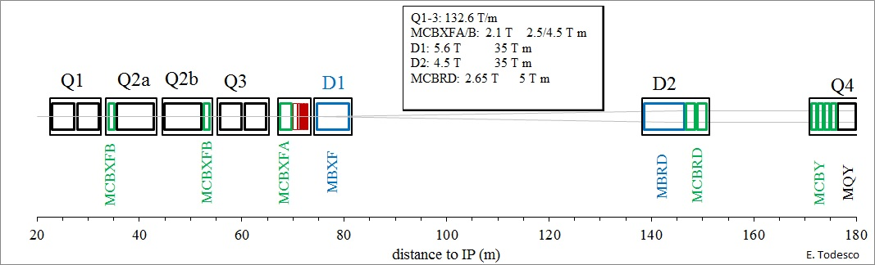

Figure 1: Conceptual layout of the IR region of HL-LHC (thick boxes are magnets, thin boxes are cryostats).

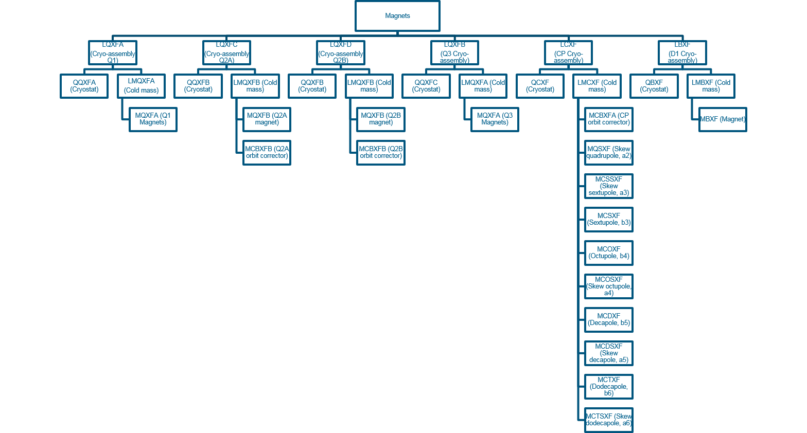

Figure 2: CERN Naming Conventions for HL-LHC Inner Triplets.

The MQXFA magnet is the quadrupole magnetic element of Q1 and Q3, including the coils and mechanical support pieces to a perimeter defined by the outer Al shell of the magnets and the end plates of each magnet. Figure 3 shows the LMQXFA cold mass cross section. A pair of 4.2-m-long (magnetic) MQXFA magnet structures is installed in a stainless steel helium vessel, including the end covers, to make the Q1 and Q3 Cold Mass (LMQXFA), see Figure 4. Q2a and Q2b each consist of a 7.15-m-long (magnetic) single unit MQXFB. The LMQXFA, when surrounded by the QQXFA or QQXFC cryostat shields, piping, and vacuum vessel, is then the LQXFA cryo-assembly for Q1 and the LQXFB cryo-assembly for Q3, as installed in the tunnel of LHC.

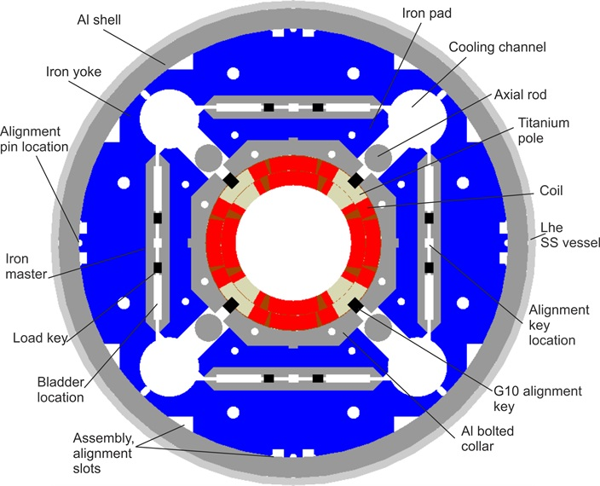

Figure 3: LMQXFA Cross Section. The magnet MQXFA does not include the LHe SS vessel.

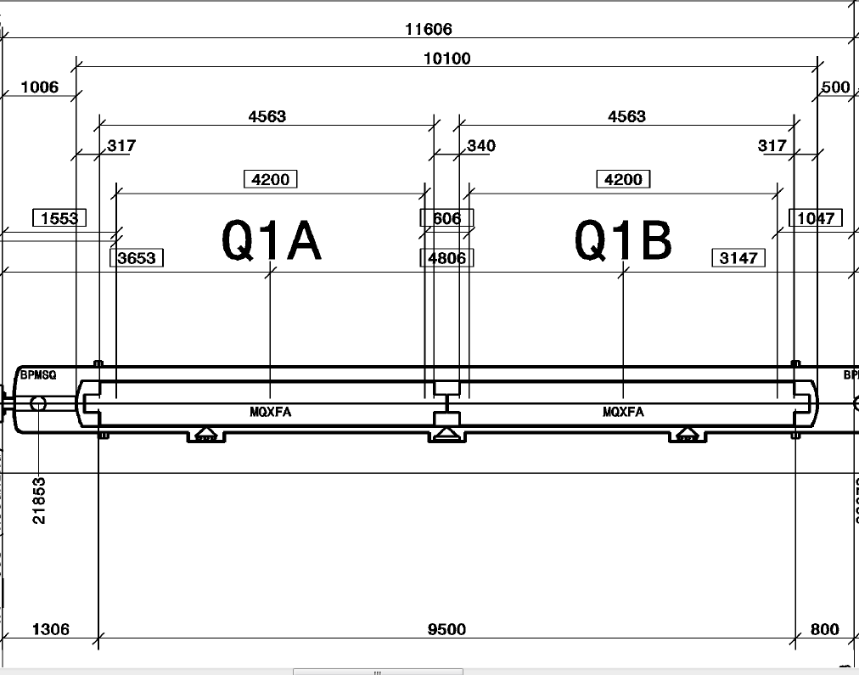

Figure 4: LMQXFA Cold Mass Assembly comprising of two MQXFA magnet elements. Quotes in square boxes are at 1.9 K, otherwise at room temperature.

1. Functional Requirements Overview

The LMQXFA functional requirements are the high-level technical requirements for the LMQXFA magnet structure. These requirements are driven by the optics functions that the Q1 and Q3 elements need to satisfy plus physical, operational, environmental, and risk tolerance constraints. In addition to functional requirements, this document also includes some non-functional requirements such as reliability, interface, and safety requirements for completeness.

To clarify the intent, in this document requirements are classified into two groups: “Threshold” requirements and “Objective” requirements. Threshold requirements are requirements that contain at least one parameter that the project must achieve, and objective requirements are requirements that the project should achieve and will strive to achieve.

Each requirement should be verifiable by a Quality Control (QC) process. If all the requirements (specified in this document) are verified at a threshold level, then the U.S. HiLumi LMQXFA cold mass deliverables will be fit for the intended use and satisfy CERN’s needs for the HL-LHC upgrade.

Detailed verification procedures and acceptance criteria are defined in a separate document [3]. At CERN’s discretion, deliverables that fall short of the threshold requirements may still be acceptable.

This document provides some background information for each requirement, and throughout this document requirements are identified by a requirement ID of the format “**R-T-XX**”, and “**R-O-XX**” where “T” is for “Threshold”, “O” is for “Objective” and XX is the corresponding requirement number.

At the end of the document Tables 3 and 4 summarize all LMQXFA threshold and objective requirements.

1. Physical Requirements
   1. Physical Envelope Requirements

In Figure 4 the layout drawing (LHCLSXH_0010 version AF)of the LHC IR magnets are shown.

**R-T-01: The LMQXFA assembly physical length (end cover to end cover, including tolerances) must be ≤ 10,100 mm. This dimension is at room temperature (296 K).**

**R-T-02: The LHe stainless steel vessel outer diameter, including tolerances, must not exceed 630 mm**. **This dimension is at room temperature (296 K).**

Note:

* Components attached to the vessel required for cryostat installation may exceed the 630 mm diameter envelope. This dimensional envelope is intended for the vessel shell only.
* Figure 4 is a section from the layout drawing: LHCLSXH_0010 version AF. If at any time the drawing is revised this document may also be re-vised to indicate changes affected by the Q1/Q3 Cold Mass design.
  1. End Cover and Piping­ Requirements

**R-T-03: The LMQXFA end cover must include piping listed in Table 1 for cryogenic and electrical connectivity purposes.**

**F3**

**L1**

Table 1: LMQXFA interface piping, penetrations and other functions (dimensions are at room temperature)

|  |  |  |
| --- | --- | --- |
| **Function** | **Number** | **Inner diameter (mm)** |
| Cold Bore Connection | 1 | 150 |
| Helium Vessel Connection | 2 | 100 |
| Busbar Connection | 1 | 50 |
| Heat Exchanger Connection | 2 | 100 |

Heat exchanger and helium vessel connection openings must be aligned with the MQXFA magnet yoke cooling channel(s), see Figures 3 and 5.

Note: The end cover is symmetrical with respect to the vertical plane. This allows use of the end covers on either end of the cold mass. The end covers will be provided by CERN.



Figure 5: LMQXFA Cold Mass Assembly seen from the end covers.



Figure 6: Detail of the interconnection between two LMQXFA Cold Mass Assembly: heat exchangers (green), helium vessel connection (brown), beam tube (yellow), and busbar parallel line (blue).

The cold mass assembly must leave a clear and free space to insert the heat exchanger tubes and the busbar cartridge.

**R-T-04: The LMQXFA cold mass assembly must not have any obstructions or interferences that will prevent insertion along the entire LMQXFA length of (i) the CERN-supplied 74 mm OD (plus 2 mm for tolerance value) heat exchanger tubes and their supports through the MQXFA cooling channels, of (ii) the busbar cartridge used to connect in series the two magnets making the cold mass, and of (iii) the cold bore.**

1. Magnetic Elements Requirements

**R-T-05: The LMQXFA magnetic elements are two identical MQXFA magnets connected in series and with the same polarity. The MQXFA magnets must satisfy the MQXFA requirements specification [1] and the LMQXFA interface specification [4].**

The LMQXFA Interface Specification provides details for the MQXFA welding and alignment interface to the LMQXFA stainless steel pressure vessel.

1. Alignment Requirements

The magnetic length of each MQXFA is 4200 mm at 1.9 K [1,2]. Figure 4 shows dimensions and distances for the two magnets inside the cold mass in the present lattice layout. We first give the tolerances on the relative longitudinal position of the active part of the magnets (magnetic length). The reference system is described in [5], with the additional definition of the local field direction as provided in the Appendix. The magnetic axis of each magnet is localized with a stretched wire measurements with respect to the cold mass fiducials. The nodal point of a magnet is the midpoint of the magnetic axis. The magnetic axis of the cold mass goes through the two nodal points of each magnet (see Fig. 7).

**R-T-06: The distance between the two nodal points of the MQXFA magnetic lengths is 4806 mm ± 5 mm at nominal operating temperature (1.9 K).**

Figure 7. MQXFA magnetic axis, nodal points, and the cold mass magnetic axis.

**R-O-01: The maximum deviation of each MQXFA magnet axis along the common magnetic axis must be within ±0.5 mm both in horizontal and in vertical direction. The deviation of each MQXFA field angle from the common magnetic field angle must be within ±2 mrad.**

A threshold requirement for the above quantities will be set in the acceptance plan.

The procedure of alignment of the magnets in the cold mass, the fiducial systems in the magnets and in the cold mass, and the tolerances of the alignment with respect to the cold mass fiducials will be given in a separate document [6].

Finally, we give a requirement on the precision of the measurements.

* The measurements in the transverse plane are required to allow reaching the final tolerances on the alignment through a motor system acting on the cryostat.
* The measurements on the longitudinal direction are necessary for the setting of the quadrupole power trims to reach the nominal optics.

**R-O-02: The common magnetic axis of the two-magnet system should be determined with respect to cold mass fiducials with accuracy of ±0.2 mm to both nodal points. The common average MQXFA field angle with respect to cold mass fiducials should be measured with accuracy better than 0.5 mrad. The magnetic length and the nodal points of each of the two MQXFA magnetsin the cold mass need to be known within ±1 mm accuracy relative to external fiducials.**

A threshold requirement for these quantities will be set in the acceptance plan

Note:

* The integrated field angle is measured along the common magnetic axis.
* The orientation of the pole lines must be the same for the two MQXFA magnets.

The relative alignment values are verified by a single stretched wire (SSW) measurement system. This measurement requires each magnet to be powered independently at a minimum of 10 A AC current during 1.9 K testing. This is guaranteed by the 35 A trim (see R-T-13). The common axis and angle measured at low current alignment measurements will be verified at high current values at least once so to verify that the low current alignment measurements are representative of alignment at higher currents.

1. Pressure Vessel Requirements

**R-T-07: The LMQXFA is a pressure vessel that must be designed and documented in accordance with CERN and U.S. HL-LHC Accelerator Upgrade Project safety agreements [7].**

**R-T-08: The LMQXFA pressure vessel material for the cylindrical shell and end covers must be Austenitic Stainless Steel Grade 316LN with Co content lower than 0.1%.**

**R-T-09: The LMQXFA provides a 1.9 K helium vessel that must be designed for a Maximum Allowable Working Pressure (MAWP) of 20 bar differential with an applied test pressure of 25 bar.**

1. Forces Requirements

Once installed as part of the LHC Inner Triplet System, the LMQXFA cold mass assemblies can experience asymmetric axial forces due to quench on other magnets and other events.

**R-T-10: The LMQXFA cold mass assembly must be capable of sustaining loads resulting from up to 25 bar of pressure differential without physical damage or performance degradation. The load conditions will be specified in [8].**

1. Cold Bore Tube Requirements

The cold bore tube is inserted in the completed LMQXFA assembly, centered in the MQXFA magnets by contact between the insulation on the outside of the cold bore tube and the insulating slides set on the coil poles in the magnet assembly. The cold bore tube is terminated with a flange at either end of the end domes of the LMQXFA and includes supports and insulation as specified in [4]. Cold bore tube will be provided by CERN. Its material shall be seamless austenitic stainless steel grade 316LN with Co content lower than 0.1%.

1. Busbars Scheme and Requirements

The purpose of the main bus for LMQXFA is to connect in series the two magnets, and to bring the connection side of one the two magnets to the connection of the other magnet; these two busbars will be coupled together and will travel inside the cold mass, in one of the holes not used by the heat exchangers. A resistive lead trim is also needed in each magnet (see Fig. 8). There will be no busbars relative to other circuits travelling through the cold mass. The cable for the busbars will be provided by CERN.

**R-T-11: The LMQXFA cold mass will have two main superconducting leads on each side going through the busbar line connection. An additional resistive lead (trim) is required to have current unbalance up to 35 A between the two magnets during operation. The additional lead exits the cold mass through the helium vessel connection. Four additional resistive leads (CLIQ, two per magnet) are required for protection system. These four additional leads exits the cold mass through the helium vessel connection.**

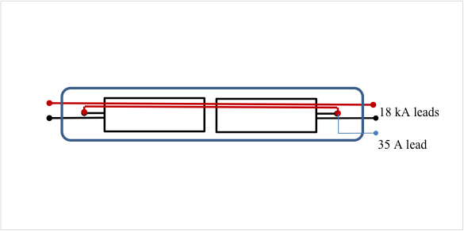

Figure 8: Electrical scheme of the cold mass, with the two magnets (rectangles), busbars cartridge (red lines), trim leads (light blue), and cold mass envelope (rounded rectangle). CLIQ leads are not shown.

**R-T-12: The 18 kA busbars will be made with the same Nb-Ti cable used for the connections of the magnet.**

The two busbars are coupled in a busbar cartridge fitting the yoke hole. The cartridge is inserted in the cold mass after the SS shell welding and before the electrical connections to the magnets and the end dome welding.

Expansion loops are needed in the end domes of the assembly to accommodate thermal contraction/expansion of the magnets and bus work both internal to the cold mass assembly and external, resulting in the following requirement:

**R-T-13: The busbars must include expansion loops, to be contained within the end cover section and able to accommodate up to 30 mm of axial movement due to differential thermal expansion/contraction. The maximum force allowed for a 30 mm displacement is 500 N, to be confirmed after manufacturing of the first cold mass.**

**R-O-03: The busbars will include maximum four internal splices. Splice resistance target value must be less than 1.0 nΩ at 1.9 K. A target value at room temperature will also be specified after the completion of the prototype program. An acceptance threshold will be defined after the completion of the short model program.**

There are CERN requirements for the splice resistance as well as the solder and flux used for these splices:

**R-T-14: Splices are to be soldered with CERN approved materials [9]**

Note:

* The joint resistance is measured with voltage taps.

**R-T-15: The 35 A lead and the CLIQ leads are copper resistive leads. The cross-section of the 35 A lead is to be specified. The CLIQ lead has a 10 mm2 cross-section.**

1. Electrical/Instrumentation Requirements
   1. Instrumentation

**R-T-16: In each cold mass, two temperature sensors will be installed. These sensors are the short type thermometer assembly (36 mm x 12 mm x 10 mm) typically used by CERN and specified in [10]**

The location is chosen to minimize the radiation dose and to give the most reliable information for both magnets. Two sensors in the same positions are used for redundancy. The thermometer assemblies will be calibrated and supplied by CERN.

**R-T-17: The LMQXFA cold mass assembly includes a minimum of 16 voltage taps.** **The Quench Detection voltage taps should follow MQXFA redundancy requirement (see [1] R-T-15).**

The instrumentation requirement for each MQXFA magnet inside the cold mass assembly is specified in [1]. The LMQXFA assembly includes the wiring for MQXFA instrumentation:

* 1. Instrumentation Wiring

**R-T-18: Instrumentation wires type, preliminary quantity and function are given in Table 2.**

**R-T-19: The LMQXFA instrumentation wiring must exit the cold mass assembly through the helium vessel connection. Instrumentation of each magnet will exit the cold mass on opposite sides.**

Note:

* The routing and termination of the wiring will be specified in the interface document [4].

A preliminary list of the LMQXFA instrumentation wires is shown in Table 2.

Table 2: LMQXFA Instrumentation wiring

|  |  |  |
| --- | --- | --- |
| **LMQXFA Wiring** | **Qty** | **Type** |
| Voltage Taps | 16 | 22 AWG polyamide coated wire |
| Temperature Sensor Leads | 2 | 30 AWG polyamide coated wire |
| Warm Up Heater Leads | 2 | 18 AWG polyamide coated wire |
| Quench Heater Leads | 24 | 18 AWG polyamide coated wire |

* 1. Voltage Limits

**R-T-20: The LMQXFA cold mass assembly voltage limits must meet or exceed the MQXFA voltage limit requirements specified in [1].**

* 1. Survey

**R-T-21: The LMQXFA cold mass assembly will have 12 mirrors positioned in groups of 4, in the mid-point and towards the cold mass ends, at 45°, 135°, 225° and 315°, to be used for the monitoring of the position of the cold mass inside the cryostat.**

These mirrors have to be fixed to the SS shell in the positions and with tolerances that will be specified by CERN. The mirrors will be provided by CERN. The mirrors will reflect the laser beam sent through a hole in the cryostat vessel and thermal shields.

1. Quench Requirements

**R-T-22: The LMQXFA quench performance requirements must meet or exceed the MQXFA magnet quench performance requirements specified in [1].**

This requirement means that the cold mass assembly quench performance is limited by the MQXFA magnets, and not by cold mass assembly superconducting components such as busbars and splices. Therefore, superconducting busbars must be designed and fabricated with adequate margin, support, expansion loops, and cooling provisions.

* 1. Free Cross Section

**R-T-23: After installation and routing of heat exchanger tubes, instrumentation wiring, and superconducting busbars there must be a free LMQXFA cross section area of 150 cm2 in the helium volume.**

This requirement is to allow adequate 1.9 K helium communication for heat transport and quench venting path. Note that this requirement also sets a minimum diameter for end cover pipes.

1. Radiation Hardness Requirements

The LMQXFA cold mass assembly will be located near the IP where radiation is expected. With a nominal luminosity 5 times larger than the nominal design goal of the LHC, CERN is planning to fabricate and install a newly designed absorber, using thick tungsten (W) shielding attached to the beam screen to reduce the effect of collision debris. The W shielding will limit the expected radiation damage over the HL-LHC lifetime to a maximum of 35 MGy. This value is similar to the expected radiation doses for the nominal LHC [2], and is reached only in some locations of the cold mass, namely around the magnet aperture. Therefore lower radiation hardness requirements can be accepted depending on the location in the cold mass.

**R-T-24: All LMQXFA components should withstand a maximum radiation dose of 35 MGy or shall be approved by CERN for use in a specific location**

1. Reliability Requirements

**R-O-04: LMQXFA reliability requirements are the same as the MQXFA reliability requirements specified in [1].**

1. Interface Requirements

The LMQXFA cold mass assembly interfaces with the following systems:

1. The MQXFA magnets
2. The CERN supplied QXFA/B Cryostats
3. The CERN supplied piping
4. The CERN supplied Cryogenic System, consisting of:
   1. The CERN supplied cooling system
   2. The CERN supplied pressure relief system
5. The CERN supplied power system
6. The CERN supplied quench protection system, consisting of:
   1. Quench Detection System
   2. Strip Heaters Power Supplies
   3. Possibly a CLIQ system
7. The CERN supplied instrumentation system

Detailed interface documentation must be provided for each of these interfaces.

**R-T-25: The LMQXFA cold mass assembly must meet the detailed interface specifications with the following systems: (1) MQXFA magnets; (2) The CERN supplied QQXFA/B Cryostats; (3) the CERN supplied piping; (4) CERN supplied Cryogenic System; (5) the CERN supplied power system; (6) the CERN supplied quench protection system, and (7) the CERN supplied instrumentation system. These interfaces are specified in Interface Control Document [4].**

1. Safety Requirements

Each HL-LHC work package will be subject to safety requirements specified in a CERN “Launch Safety Agreement (LSA)” document [6]. This LSA will specify the CERN safety rules and host state regulations applicable to the systems/processes and the minimal contents of the Work Package safety file needed to meet the Safety Requirements.

**R-T-26: The LMQXFA cold mass assembly must comply with CERN’s Launch Safety Agreement (LSA) for IR Magnets (WP3) [7]**

1. CERN Provided Parts

**R-T-27: CERN provided parts for LMQXFA assemblies are specified in [11]. These parts for the prototype and series (including spares) will be supplied by CERN.**

1. Functional Requirements Summary Tables

Table 3: LMQXFA Threshold Functional Requirements Specification Summary Table

|  |  |
| --- | --- |
| **ID** | **Description** |
| R-T-01 | **The LMQXFA assembly physical length (end cover to end cover, including tolerances) must be ≤ 10,100 mm. This dimension is at room temperature (296 K).** |
| R-T-02 | **The LHe stainless steel vessel outer diameter, including tolerances, must not exceed 630 mm**. **This dimension is at room temperature (296 K).** |
| R-T-03 | **The LMQXFA end cover must include piping listed in Table 1 for cryogenic and electrical connectivity purposes.** |
| R-T-04 | **The LMQXFA cold mass assembly must not have any obstructions or interferences that will prevent insertion along the entire LMQXFA length of (i) the CERN-supplied 74 mm OD (plus 2 mm for tolerance value) heat exchanger tubes and their supports through the MQXFA cooling channels, of (ii) the busbar cartridge used to connect in series the two magnets making the cold mass, and of (iii) the cold bore** |
| R-T-05 | **The LMQXFA magnetic elements are two identical MQXFA magnets connected in series and with the same polarity. The MQXFA magnets must satisfy the MQXFA requirements specification [1] and the LMQXFA interface specification [4].** |
| R-T-06 | **R-T-07: The distance between the two nodal points of the MQXFA magnetic lengths is 4806 mm ± 5 mm at nominal operating temperature (1.9 K).** |
| R-T-07 | **The LMQXFA is a pressure vessel that must be designed and documented in accordance with CERN and U.S. HL-LHC Accelerator Upgrade Project safety agreements [5].** |
| R-T-08 | **The LMQXFA pressure vessel material for the cylindrical shell and end covers must be Low cobalt content Austenitic Stainless Steel Grade 316LN.** |
| R-T-09 | **The LMQXFA provides a 1.9 K helium vessel that must be designed for a Maximum Allowable Working Pressure (MAWP) of 20 bar differential with an applied test pressure of 25 bar.** |
| R-T-10 | **The LMQXFA cold mass assembly must be capable of sustaining loads resulting from up to 25 bar of pressure differential without physical damage or performance degradation. The load conditions will be specified in [8].** |
| R-T-11 | **The LMQXFA cold mass will have two main superconducting leads on each side going through the busbar line connection. An additional resistive lead (trim) is required to have current unbalance up to 35 A between the two magnets during operation. The additional lead exits the cold mass through the helium vessel connection. Four additional resistive leads (CLIQ, two per magnet) are required for protection system. These four additional leads exits the cold mass through the helium vessel connection.** |
| R-T-12 | **The 18 kA busbars will be made with the same Nb-Ti cable used for the connections of the magnet.** |
| R-T-13 | **The busbars must include expansion loops, to be contained within the end cover section and able to accommodate up to 30 mm of axial movement due to differential thermal expansion/contraction. The maximum force allowed for a 30 mm displacement is 500 N, to be confirmed after manufacturing of the first cold mass.** |
| R-T-14 | **Splices are to be soldered with CERN approved materials [9].** |
| R-T-15 | **The 35 A lead and the CLIQ leads are copper resistive leads. The cross-section of the 35 A lead is to be specified. The CLIQ lead has a 10 mm2 cross-section.** |
| R-T-16 | **In each cold mass, two temperature sensors will be installed. These sensors are the short type thermometer assembly (36 mm x 12 mm x 10 mm) typically used by CERN and specified in [10]** |
| R-T-17 | **The LMQXFA cold mass assembly includes a minimum of 16 voltage taps.** |
| R-T-18 | **Instrumentation wires type, preliminary quantity and function are given in Table 2.** |
| R-T-19 | **The LMQXFA instrumentation wiring must exit the cold mass assembly through the helium vessel connection. Instrumentation of each magnet will exit the cold mass on opposite sides.** |
| R-T-20 | **The LMQXFA cold mass assembly voltage limits must meet or exceed the MQXFA voltage limit requirements specified in [1]** |
| R-T-21 | **The LMQXFA cold mass assembly will have 12 mirrors positioned in groups of 4, in the mid-point and towards the cold mass ends, at 45°, 135°, 225° and 315°, to be used for the monitoring of the position of the cold mass inside the cryostat.** |
| R-T-22 | **The LMQXFA quench performance requirements must meet or exceed the MQXFA magnet quench performance requirements specified in [1].** |
| R-T-23 | **After installation and routing of heat exchanger tubes, instrumentation wiring, and superconducting busbars there must be a free LMQXFA cross section area of 150 cm2 in the helium volume.** |
| R-T-24 | **All LMQXFA components should withstand a maximum radiation dose of 35 MGy, or shall be approved by CERN for use in a specific location** |
| R-T-25 | **The LMQXFA cold mass assembly must meet the detailed interface specifications with the following systems: (1) MQXFA magnets; (2) The CERN supplied QQXFA/B Cryostats; (3) the CERN supplied piping; (4) CERN supplied Cryogenic System; (5) the CERN supplied power system; (6) the CERN supplied quench protection system, and (7) the CERN supplied instrumentation system. These interfaces are specified in Interface Control Document [4].** |
| R-T-26 | **The LMQXFA cold mass assembly must comply with CERN’s Launch Safety Agreement (LSA) for IR Magnets (WP3) [5].** |
| R-T-27 | **CERN provided parts for LMQXFA assemblies are specified in [11]. These parts for the prototype and series (including spares) will be supplied by CERN.** |

Table 4: LMQXFA Objective Functional Requirements Specification Summary Table

|  |  |
| --- | --- |
| **ID** | **Description** |
| R-O-01 | **The maximum deviation of the MQXFA axis (of each magnet) along the common magnetic axis must be less than ±0.5 mm. The deviation of both MQXFA average field angles from the common magnetic field angle must be less than ±2 mrad.** |
| R-O-02 | **The common magnetic axis of the two-magnet system should be determined with respect to cold mass fiducials with accuracy of ±0.2 mm to both nodal points. The common average MQXFA field angle with respect to cold mass fiducials should be measured with accuracy better than 0.5 mrad. The magnetic length and the nodal points of each of the two MQXFA magnetsin the cold mass need to be known within ±1 mm accuracy relative to external fiducials.** |
| R-O-03 | **The busbars will include three internal splices. Splice resistance target value must be less than 1.0 nΩ at 1.9 K. A target value at room temperature will also be specified after the completion of the prototype program. An acceptance threshold will be defined after the completion of the short model program.** |
| R-O-04 | **LMQXFA reliability requirements are the same as the MQXFA reliability requirements specified in [1].** |

1. References

[1] MQXFA Functional Requirements, US-HiLumi-doc-36

[2] High-Luminosity Large Hadron Collider (HL-LHC). Technical Design Report, edited by G. Apollinari, I. Béjar Alonso, O. Brüning, M. Lamont, L. Rossi, <https://edms.cern.ch/ui/file/1723851/0.71/HL_TDR_V07.0.2016.10.05.Version15.2h.pdf>

[3] Acceptance Criteria Document, in preparation.

[4] LMQXFA Interface Control Document, in preparation.

[5] L. Bottura, D. Missiaen, “Definitions of Survey and Magnetic Data for the Inner Triplet Systems at IR1, 2, 5 and 8”, CERN EDMS 367802. <https://edms.cern.ch/document/367802> .

[6] Alignment procedure for the triplet magnets in the cold mass, in preparation.

[7] CERN Launch Safety Agreement for IR Magnets (WP3), CERN EDMS 1550065.

Conformity approach for Pressure Equipment for the High Luminosity LHC Project, CERN EDMS 1698982.

Exceptional Approach to Conformity Assessment of Pressure Vessels in WP3, CERN EDMS 1753780

[8] Load conditions for the triplet cold masses in different operational scenario, in preparation.

[9] Soldering material and procedure defined by CERN.

[10] LHC-QIT-ES-0001 rev 1.1, “LHC Cryogenic Thermometers”

[11] “Exchange of components between HL LHC AUP and CERN for the triplet”, CERN EDMS 1825173. [https://edms.cern.ch/document/1825173](https://edms.cern.ch/document/1825173/0.1)

1. Appendix

The pole line is a line (see Figure 7) perpendicular to the magnet beam axis connecting the two similar poles (N-N or S-S, 180 degree apart) (at the center of the pole).

Field angle is defined as the angle of the pole lines which connect the South poles. The angle is measured counter-clockwise, looking from the interaction point toward the IR magnets and the zero angle is defined as the gravity line pointing upward. Field angle is equivalently defined as the angle with respect to gravity that gives a zero average skew quadrupole component (with an additional 45 degree offset compared to pole line definition).

For completeness, the angles between any pole lines are compared relative to the projected (perpendicular projection) lines onto the plane that is perpendicular to the common magnetic axes (note that the small angles and cosine effects generally make the “would-be errors” from these effects negligible).

Note:

* The gravity line as the zero angle reference line will be used during the assembly phase of the magnets at the surface of the earth to establish the coordinate system for alignment.

Figure 9. Definition of the pole line and magnetic center point are shown. The pole lines are idealized lines connecting the two similar poles (N-N or S-S, 180 degrees apart) at their centers. The pole lines are perpendicular to each other, and their intersection coincides with the local magnetic center .