

**US HL-LHC Accelerator Upgrade Project**

**MQXFA Electrical Design Criteria**

|  |
| --- |
| **Prepared by:**  Giorgio Ambrosio, US HL-LHC AUP Magnets L2 Manager, FNAL  Emmanuele Ravaioli, US HL-LHC AUP Magnets Quench Protection expert, LBNL |
| **Reviewed by:** |
| **Approved by:** |

**Revision History**

|  |  |  |  |
| --- | --- | --- | --- |
| **Revision** | **Date** | **Section No.** | **Revision Description** |
| v0 | 1/11/18 | All | Initial Release |
|  |  |  |  |
|  |  |  |  |
|  |  |  |  |
|  |  |  |  |

Contents

1 Introduction 3

2 Peak Voltage Estimate 3

3 Electrical Requirements 5

4 Insulation Design Criteria 6

5 Electrical QC Plan 9

6 Feedback from Short Models and Prototypes Testing 10

7 References 11

# Introduction

This document presents the Electrical Design Criteria for the design, manufacturing and test of MQXFA magnets and components.

Twenty (20) of these magnets will be fabricated and delivered to CERN by the U.S. HiLumi project as part to the U.S. contributions to the LHC High Luminosity Upgrade [1]. These magnets are the quadrupole magnetic components of the HL-LHC Q1 and Q3 inner triplet optical elements in front of the interactions points 1 (ATLAS) and 5 (CMS). A pair of ~4.5-m-long MQXFA magnets is installed in a stainless-steel helium vessel, including the end domes, to make the Q1 Cold Mass or the Q3 Cold Mass.

CERN is responsible for the Inner Triplet design, assembly and all cryostats. The US HL-LHC Accelerator Upgrade Project is responsible for the design, manufacturing and test of the MQXFA magnets and Q1/Q3 Cold-Masses.

This document contains: (i) the Electrical Requirements, (ii) the Insulation Design Criteria, (iii) the Electrical QC Plan, and (iv) the plan of Feedback from Short-Model and Prototype testing.

# Peak Voltage Estimate

During operation the MQXFA magnets may experience high voltages in case of magnet quench. An extensive study of peak voltages during operation of the HL-LHC Inner Triplet magnets has been performed taking into account the possible impact of different conductor/coil parameters, different quench-start locations, and in case of heater failure scenarios. The results are summarized in [2] for three possible quench protection systems: (i) only Outer Layer Quench Heaters (O-QH), (ii) Outer and Inner Layer Quench Heaters (O-QH + I-QH), and (iii) Outer Layer Quench Heaters and Coupling Loss Induced Quench system (O-QH + CLIQ). The third option is the baseline quench protection system for the Inner Triplet of HL-LHC.

Table 1 shows the range of hot-spot temperatures, Coil-to-Ground voltages (Ug), and Turn-to-Turn voltages (Ut) for strand parameters (copper content, RRR, strand diameter) varying within tolerances, and different quench-start locations. Figure 1 shows the impact on peak Coil-to-Ground voltage of variations of strand parameters and quench-start location.

The failure case analysis is presented in Table 2, that shows simulated hot-spot temperature, peak voltage to ground and peak turn to turn voltage obtained for one failure or two simultaneous failures of QH circuits, at nominal and at ultimate current. Uncertainty ranges are due to the different locations of the initial quench and of the failing QH circuits.

The MQXFA magnets, set in Q1 and Q3 cryo-assemblies, are shorter that the MQXFB magnets, which are set in the Q2a and Q2b cryo-assemblies. Therefore, the MQXFA peak voltages are lower than the MQXFB peak voltages reported in [2] and summarized in Table 1 and 2. In absence of failures, the peak voltages to ground and turn-to-turn voltages developed in MQXFA are roughly scaled with the ratio between MQXFA and MQXFB magnetic length (i.e. 4.2/7.15 ≈ 0.59).

Due to the Inner Triplet circuit configuration [2], which includes two CLIQ units per Q1/Q3 cryo-assembly connected across magnets, additional failure cases need to be included in the worst-case analysis: one CLIQ unit failing in open circuit; and one CLIQ unit not charged (50 mΩ resistance). Since the effects of a failure in the two units are different, a total of four cases are considered. These cases were simulated at nominal current with the STEAM framework coupling LEDET and SPICE models. At nominal current, the peak characteristic voltages reached in MQXFA worst case are slightly lower than MQXFB peak voltages without failures, and about 25% lower than MQXFB worst-case voltages.

Table : Effect of strand parameters on quench protection performance. Simulated hot spot temperature, peak voltage to ground and peak turn to turn voltage obtained after a quench at nominal and at ultimate current, for varying fraction of copper in the conductor, RRR and strand diameter. Uncertainty ranges also include the effect of different quench locations (from [2]).

|  |  |  |  |  |
| --- | --- | --- | --- | --- |
| **Configuration** | Thot [K] | Ug,peak [V] | Ut,peak [V] | |
| **Nominal current** | | | |
| O-QH | 293-364 | 304-619 | 62-123 | |
| O-QH + I-QH | 230-263 | 438-592 | 46-90 | |
| O-QH + CLIQ | 215-248 | 521-658 | 49-90 | |
| **Ultimate current** | | | |
| O-QH | 312-389 | 362-860 | 72-145 | |
| O-QH + I-QH | 253-290 | 552-766 | 57-109 | |
| O-QH + CLIQ | 237-273 | 664-924 | 61-109 | |

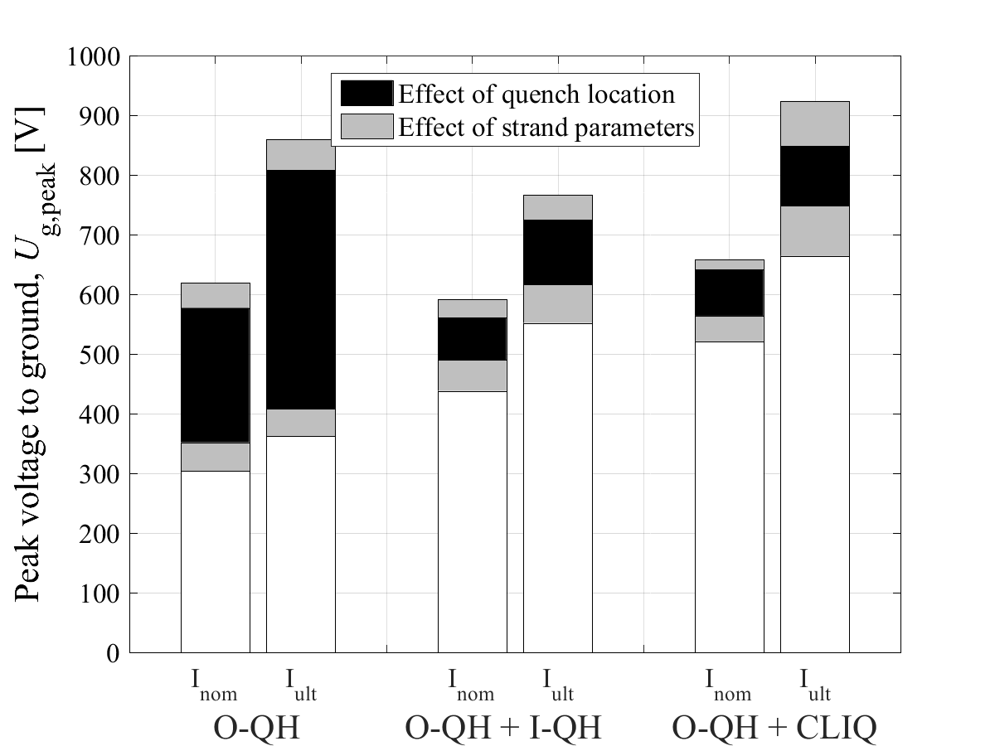

Figure : Effect of strand parameters on quench protection performance. Simulated peak voltage to ground obtained after a quench at nominal and at ultimate current, for varying fraction of copper in the conductor, RRR and strand diameter. Uncertainty ranges also include the effect of different quench locations. These peak voltages are computed for all Inner Triplet magnets. MQXFA peak voltages are lower than these values by ~0.6 in absence of CLIQ failures, and slightly lower than these values in case of one CLIQ unit failure.

Table : Failure case analysis. Simulated hot-spot temperature, peak voltage to ground and peak turn to turn voltage obtained for one failure or two simultaneous failures of QH circuits, at nominal and at ultimate current. Uncertainty ranges are due to the different locations of the initial quench and of the failing QH circuits [2].

|  |  |  |  |  |  |  |  |  |  |
| --- | --- | --- | --- | --- | --- | --- | --- | --- | --- |
| **Configuration** | Thot [K] | | | Ug,peak [V] | | | Ut,peak [V] | | |
| No f | 1 | 2 | No f | 1 | 2 | No f | 1 | 2 |
| **Nominal current** | | | | | | | | |
| O-QH | 330-345 | 345-362 | 363-384 | 577 | 702 | 868 | 113 | 122 | 132 |
| O-QH + I-QH | 251-253 | 255-266 | 277-283 | 561 | 716 | 928 | 83 | 90 | 100 |
| O-QH + CLIQ | 236-237 | 238-240 | 239-242 | 641 | 668 | 666 | 83 | 84 | 86 |
| **Ultimate current** | | | | | | | | |
| O-QH | 352-369 | 364-385 | 379-406 | 808 | 916 | 1068 | 133 | 141 | 152 |
| O-QH + I-QH | 276-279 | 279-292 | 301-310 | 725 | 898 | 1128 | 101 | 109 | 120 |
| O-QH + CLIQ | 260-262 | 261-264 | 262-267 | 874 | 910 | 909 | 101 | 103 | 105 |

Some extreme cases presented in [2] (for instance: one coil with RRR 150, and 3 coils with RRR=350) shall be avoided by strand QC implementing Statistical Process Control, and by coil selection during magnet assembly readiness reviews.

# Electrical Requirements

The results of the analysis presented in the previous section, and criteria based on the LHC design/fabrication/operational experience [4] have been used by CERN to set the Electrical Functional Requirements. The hipot requirements, extracted from the MQXFA Functional Requirements Specification [3], are presented in Table 2 for reference. The Coil to Ground Hi-pot values are based on the expected maximum voltage at nominal current. This is consistent with the HL-LHC definition of ultimate performance, which should be reached with no margin.

Table 2: Required hi-pot test voltages and leakage current

|  |  |  |  |  |
| --- | --- | --- | --- | --- |
| **Circuit Element** | **Expected Vmax [V]** | **V hi-pot [kV]** | **I hi-pot [µA]** | **Minimum time duration [s]** |
| Coil to Ground at RT * | n.a. | 3.7 | 10 | 30 |
| Coil to Quench Heater at RT * | n.a. | 3 | 10 | 30 |
| Coil to Ground at cold ** | 670 | 1.8 | 10 | 30 |
| Coil to Quench Heater at cold ** | 900 | 2.3 | 10 | 30 |

* Room Temperature conditions refer to air at 20±3 °C and relative humidity lower than 60% (values t.b.c.)

** Cold conditions refer to nominal cryogenic conditions (superfluid helium)

# Insulation Design Criteria

The Insulation Design Criteria are based on standard practices for accelerator magnets and on LARP experience [5]. The MQXFA Functional Requirements Specification [3] requires that “all MQXFA components must withstand a radiation dose of 35 MGy, or shall be approved by CERN for use in a specific location as shown in the MQXFA Material list (US HiLumi DocDB # 96)”. Therefore, G10 cannot be used in any location of MQXFA magnets, whereas polyimide can be used in any location. G11 can be used in the locations listed in the MQXFA Material list, based on analysis of local dose and required material properties. For epoxy impregnation LARP has extensively used CTD-101K [5,6]. A dedicated test campaign performed under the EuCARD program [7] has demonstrated that CTD-101K is suitable for use in the Inner Triplet magnets of High Luminosity LHC.

Coil-Ground Insulation

The Coil-Ground insulation between coils and collars shall be made of polyimide layers. Each layer shall have a minimum thickness of 110 um. The minimum number of layers is 3, and seams shall not overlap in order to have everywhere at least 2 continuous layers between coil and ground. These polyimide layers are in addition to the G11 layers set on collars inner surface, and to the polyimide layers that may be used for coil shimming.

Minimum creep path is 7 mm. This criterion is based on the helium voltage breakdown that is 3 kV with 5 mm distance at 75 K and 1 bar [8].

At magnet ends these polyimide layers shall extend beyond coil ends by at least 20 mm.

The pole keys shall be made of G11 (or equivalent insulating material). The collar edges around the pole keys shall be covered by polyimide (7 mm minimum).

End pushers apply a significant load on coil ends. The ground insulation between coil saddles (or saddle extensions) and the end pushers shall be sufficiently strong to withstand the coil axial loads and sufficiently thick to separate coil to ground: mm thickness is 10 mm.

In order to have sufficient cooling, the coil inner surface has to be at least 40% polyimide free (MQXFA requirement R-T-7 [3]). Since epoxy impregnated S2-fiberglass may not be crack-free, adequate polyimide insulation shall be installed on the cold bore. This insulation, which is part of the MQXFA magnet coil-ground insulation system, shall be described in the MQXFA Magnet – LMQXFA Cold Mass Interface document.

Coil-Coil Insulation

Coil to coil insulation is set on coil midplanes and around their edges. The minimum coil-coil insulation shall be made of a G11 layer (minimum thickness is 125 um) potted on each coil midplane, and of a polyimide layer (minimum thickness is 125 um) extending at least 7 mm beyond the midplane edge, on each coil.

Heater-Ground

The protection heaters are installed on coil outer surface before epoxy impregnation, and they become permanent part of each coil during the potting process. Therefore, they share the same insulation to ground of the coils.

Special care must be paid to the wiring of the leads around the end pushers in order to avoid the possibility of pinching the leads during magnet end pre-loading.

Heater-Coil

The optimization of the heater-coil insulation is often the result of a difficult trade-off: on one side a too thick insulation may lead to excessive heater delays (the time between heater firing and the heater induced quench); on the other hand, a too thin insulation may lead to failing heater-coil hipot requirements. LARP has shown that the minimum acceptable heater-coil insulation is made of a 50-um polyimide layer where heaters are glued (trace), in addition to the cable insulation. These traces shall be hipot-tested upon reception (for acceptance) and shall be carefully stored to assure that no damage to the insulation may occur during storage, shipment, or other operations.

Special care must be paid for the heaters-lead connections. These connections shall be embedded in pockets within the coil saddles (or saddle extensions) where additional polyimide insulation shall be added to the standard trace insulation. Epoxy or similar material shall be used to permanently secure the leads and provide stress-relief after soldering the connections.

Inner Layer Quench Heaters have shown a weakness during LARP R&D: delamination (“bubbles”) between trace and winding, or between trace and the fiberglass cloth on coil inner surface. Attempts to avoid this issue (for instance applying perforations on the polyimide at minimum distance of 5 mm from the quench heaters) have caused improvements but did not manage to solve the issue completely. Therefore, Inner Layer Quench Heaters shall not be used unless a reliable solution to this issue is found.

Layer-Layer

The layer-layer insulation is applied on the wound-and-cured inner layer before winding the outer layer. Therefore, the layer-layer insulation shall be designed to withstand the coil heat treatment. LARP has demonstrated that S2-fiberglass cloth pre-shaped and cured with ceramic binder provides a smooth surface for outer layer winding, and sufficiently good electrical insulation if a limited amount of ceramic binder is used. The AUP project shall assess the correct amount of ceramic binder and set procedures for controlled and uniform application. The minimum thickness of the layer-layer insulation is 500 um. LARP has shown that saddle edges may compromise the layer-layer insulation if there is excessive compression caused by conductor expansion during heat treatment. Therefore, the cavity of the reaction fixture shall be computed using the conductor dimensions after heat treatment. Additional requirements for coil parts are presented in next section.

Coil parts

All coil parts (pole parts, wedges, end parts, saddles and saddle extensions) will be installed before coil heat treatment. Therefore, all coil parts shall be able to withstand the heat treatment without damage nor excessive deformation. End parts, saddle and saddle extension shall be coated with insulation materials capable of withstanding the heat treatment, and subsequent cold shocks. Wedges and pole parts shall be insulated with S2-fiberglass. The wedges shall use an S2-sleeve with minimum thickness of 125 um. The coil pole shall be insulated with several turns of S2-glass tape for a minimum thickness of 400 um. The tape width shall be equal to the insulated cable width, and the tape shall be wound around the pole in order to provide thickness as uniform as possible.

Turn-turn

The turn-turn insulation shall be continuous and as uniform as possible. LARP has demonstrated that S2-glass braided on the cable provides a continuous and uniform insulation, whose thickness can be fine-tuned during R&D and kept constant during production. The minimum recommended insulation thickness is 140 um, based on LARP experience. The S2-glass provides separation between the turns, which is filled by epoxy during the impregnation process. A thorough analysis of turn-turn voltages has demonstrated that they will be lower than 105 V in any quench condition including failure scenarios [2]. Therefore, this insulation scheme is adequate also in case of epoxy cracks since turn-turn voltages are lower than the Paschen minimum for helium (150-160 V [8, 9]). It should also be noted that MQXFA magnets are operating at higher pressure·distance values (>28 Pa·m) than the Paschen minimum for helium (6 Pa·m), and that non-flat electrode geometry is expected to increase the minimum breakdown voltage [10, 11]. These factors provide a safety margin larger than 10.

Special care must be paid to prevent metallic inclusions, which may compromise the turn-turn electrical insulation. The methods to prevent metallic inclusions shall include: continuous electrical QC of insulated cable with low-voltage rollers, and high-voltage impulse tests of coils after epoxy impregnation.

# Electrical QC Plan

The electrical QC plan shall include, but not be limited to, the following parts:

Coil parts electrical QC:

The insulated cable shall be fully inspected for conductive inclusions and insulation damages.

All coil end parts, saddles and saddle extensions shall be visually inspected for checking coating integrity. Coating thickness shall be spot checked.

All outer layer traces (with quench heaters) shall be fully inspected and hipot-tested upon reception from vendor.

Fiberglass tapes and clothes, which will be installed before heat treatment, shall be spot checked to assure that all batches are free from organic binders and inclusions.

Coil fabrication electrical QC:

Coil electrical QC shall include measurement during coil fabrication of: coil RLQ (resistance, inductance and quality factor), Voltage Taps and Heaters resistance, Continuity monitoring, Hipot tests (QH to Coil, Coil to Pole, Coil to saddles, QH to saddles, IL saddles to OL saddles), and Impulse tests (direct and reverse).

Magnet assembly electrical QC:

Magnet electrical QC shall include the following measurement during magnet assembly and before coils are spliced together: RLQ for each coil, Voltage Taps and Heaters resistance, Hipot tests (Coil to Ground, QH to Coil, QH to ground), and Impulse tests (direct and reverse).

These measurements shall be performed after coils are spliced together: magnet RLQ, Voltage Taps and Heaters resistance, Hipot tests (Coil to Ground, QH to Coil, QH to ground), and Impulse tests (direct and reverse).

Magnet cold test electrical QC:

Magnet electrical QC shall include the following measurement before cold test: magnet RLQ, Voltage Taps and Heaters resistance, Hipot tests (Coil to Ground, QH to Coil, QH to ground), and Impulse tests (direct and reverse).

Hipot tests shall be repeated, at lower voltage, after cooldown to 1.9 K.

# Feedback from Short Models and Prototypes Testing

During the demonstration phase Short Models and Prototypes shall be cold tested in conditions as close as possible to the MQXFA operating conditions in HiLumi LHC (for instance parameters of Heater Firing Units and CLIQ Units should be adjusted to reproduce MQXFA operating conditions on short models and prototypes). If any weakness is identified, it shall be addressed and successfully resolved before starting MQXFA production. Inner Layer Quench Heaters shall not be installed on MQXFA production coils unless a solution to the “bubble” issue is tested and demonstrated through short models and/or prototypes.

# References

1. “High-Luminosity Large Hadron Collider (HL-LHC) TDR” CERN-2017-007-M
2. E. Ravaioli, “Quench Protection Studies for the High-Luminosity LHC Inner Triplet Circuit” US-HiLumi-doc-363
3. “MQXFA Functional Requirements Specification”, US-HiLumi-doc-36
4. F. Rodriguez Mateos, “Criteria for HL-LHC Inner Triplet Electrical Requirements” ???
5. G. Sabbi et alt. “LARP ….”
6. Composite Technology Development, Inc., “CTD-101K Epoxy Resin System Datasheet”, available online at http://www.ctd-materials.com/papers
7. J. Polinski, M. Chorowski, and P. Bogdan, “Certification of the Radiation Resistance of Coil Insulation Material” EuCARD-Del-D7-2-1-final-1
8. P. Fessia, G. Kirby, J.C. Perez, and F.O. Pincot, “Guidelines for the insulation design and electrical test of superconducting accelerator magnets during design assembly and test phase” CERN EDMS# 1264529.
9. J. Knaster and R. Penco, “Paschen Tests in Superconducting Coils: Why and How” IEEE Trans. App. Supercond., vol. 22, no. 3, 9002904, June 2012
10. an S. Uhm, Han S. Uhm, “Investigation of electrical breakdown properties in curved electrodes”, Physics of Plasmas, Vol. 7, No. 11, pp. 4748-4754, Nov. 2000.
11. Shou-Zhe Li, and Han S. Uhm, “Investigation of electrical breakdown characteristics in the electrodes of cylindrical geometry”, Physics of Plasmas, Vol. 11, No. 6, pp. 3088-3095, June 2004.