|  |  |  |  |
| --- | --- | --- | --- |
| FUNCTIONAL SPECIFICATION | | | |
| MQXFA MAGNETS | | | |
| **Abstract**  This document specifies the functional requirements for the MQXFA magnet readapted for the American contribution. If all the requirements specified in this document are met, then the U.S. HL-LHC AUP MQXFA deliverables will be accepted by CERN for the HL-LHC project.  Another separate document will be issued by the American contribution for the MQXFA cold mass functional requirements.  Please note that the definition of threshold as it is being used by the American contribution is not the same as objective, according to the HL-LHC quality policy. | | | |
| Traceability | | | |
| ***Prepared by:*** R. Carcagno (US LARP) | | | Date: 05/06/2016 |
| ***Verified by:*** C. Adorisio, G. Arduini, V. Baglin, M. Bajko, A. Ballarino, I. Bejar Alonso, J. P. Burnet, F. Cerutti, P. Chiggiato, S. Claudet, D. Delikaris, P. Ferracin, P. Fessia, V. Mertens, T. Otto, M. Pojer, S. Gilardoni, A. Siemko, L. Tavian, R. Van Weelderen, D. Wollmann | | | Date: 02/06/2017 |
| ***Approved by***: L. Bottura, O. Bruning , J.M. Jimenez, L. Rossi, E. Todesco | | | Date: 27/06/2017 |
| ***Distribution***: US LARP | | | |
| ***Ref. Doc:*** MQXFA Conceptual Specification ([EDMS 1366547](https://edms.cern.ch/document/1366547)) | | | |
| Rev. No. | Date | Description of Changes (major changes only, minor changes in EDMS) | |
| 0.5 | 02/06/2017 | Version for verification | |
| 0.9 | 27/06/2017 | Version for approval | |
| 1.0 | 11/07/2017 | Valid version of the document | |
|  |  |  | |
|  |  |  | |



**U.S. HL-LHC Accelerator Upgrade Project**

**MQXFA MAGNETS**

**FUNCTIONAL REQUIREMENTS SPECIFICATION**

|  |  |  |
| --- | --- | --- |
| **Prepared by:** Date: 05/06/2016  Ruben Carcagno, US HL-LHC AUP Deputy Project Manager | **Organization**  FNAL | **Contact**  [ruben@fnal.gov](mailto:ruben@fnal.gov)  (630) 840-3915 |
| **Accepted by:**  Giorgio Ambrosio, US HL-LHC AUP MQXFA L2 Manager | **Organization**  FNAL | **Contact**  [giorgioa@fnal.gov](mailto:giorgioa@fnal.gov)  (630) 840-2297 |
| **Accepted by:**  Ruben Carcagno, US HL-LHC AUP Deputy Project | **Organization**  FNAL | **Contact**  [ruben@fnal.gov](mailto:ruben@fnal.gov)  (630) 840-3915 |
| **Accepted by:**  Giorgio Apollinari, US HL-LHC AUP Project Manager | **Organization**  FNAL | **Contact**  [apollina@fnal.gov](mailto:apollina@fnal.gov)  (630) 840-4641 |

**Revision History**

|  |  |  |  |
| --- | --- | --- | --- |
| **Revision** | **Date** | **Section No.** | **Revision Description** |
| v.0.5 | 7/8/2016 | All | Release for Work Package Review |
|  | 5/2/2017 | All | Accepted all changes requested by WP2, and Coil-Ground HVW values requested by F. Rodriguez-Mateos at CM28 |
| V.0.9 | 27/06/2017 | All | Document sent for final approval |
|  |  |  |  |
|  |  |  |  |
|  |  |  |  |
|  |  |  |  |
|  |  |  |  |
|  |  |  |  |
|  |  |  |  |
|  |  |  |  |

**TABLE OF CONTENTS**

1. Purpose 6

2. Introduction 6

3. Functional Requirements Overview 8

4. Physical Requirements 9

4.1. Coil Aperture Requirement 9

4.2. Physical Envelope Requirements 9

4.3. Alignment Requirements 10

5. Magnetic Field Requirements 10

5.1. Operating Gradient 10

5.2. Magnetic Length 10

5.3. Field Quality 10

5.4. Fringe Field 11

6. Cryogenic Requirements 11

6.1. Operating Temperature 11

6.2. Heat Loads 11

6.2.1. Coil Peak Power 12

6.2.2. Total Heat Load 12

6.3. Cooling Requirements 12

6.3.1. Provisions for installation of Heat Exchangers Tubes 12

6.3.2. Provisions for heat extraction 12

6.4. Peak Pressure 12

6.5. Cooldown and Warmup 13

7. Electrical Requirements 13

7.1. Operating Current 13

7.2. Maximum Operating Current Ramp Rate 13

7.3. Maximum Operating Voltage 13

7.4. Electrical Busses 13

7.5. Instrumentation 14

7.6. Voltage Withstand Levels 14

8. Quench Requirements 15

8.1. Quench Training Requirements 15

8.2. Quench while ramping down 15

8.3. Quench Protection 15

9. Radiation Hardness Requirements 15

10. Reliability Requirements 16

10.1. Number of Powering Cycles 16

10.2. Number of Quenches 16

11. Interface Requirements 16

12. Safety Requirements 17

13. CERN Provided Parts 17

14. Requirements Summary Tables 18

15. References 20

1. Purpose

This document specifies the functional requirements for the High Luminosity LHC (HL-LHC, or HiLumi LHC) MQXFA Magnets. Twenty (20) of these magnets shall be fabricated and delivered to CERN by the U.S. HiLumi project as part to the U.S. contributions to the LHC High Luminosity Upgrade. These magnets are the quadrupole magnetic components of the HL-LHC Q1 and Q3 inner triplet optical elements in front of the interactions points 1 (ATLAS) and 5 (CMS). Two MQXFA magnets are installed in each Q1 or Q3. Since these magnets are identical whether installed in Q1 or Q3, the functional requirements are identical for all MQXFA magnets.

If all the threshold requirements specified in this document are verified, then the U.S. HL-LHC Accelerator Upgrade Project (US HL-LHC AUP) MQXFA magnet deliverables shall fit for the intended use and satisfy CERN’s needs for HL-LHC. The quality of the US HL-LHC AUP MQXFA deliverables will be measured by the degree to which its characteristics fulfill the requirements specified in this document.

1. Introduction

The triplet quadrupoles are the magnetic system that allows reaching low beta functions around the Interaction Point (IP). The triplet is made of three optical elements: Q1, Q2, and Q3. The upgrade of the Inner Triplets in the high luminosity insertions is the cornerstone of the LHC upgrade. The decision for HL-LHC heavily relies on the success of the advanced Nb3Sn technology that provides access to magnetic fields well beyond 9 T, allowing the maximization of the aperture of the triplet quadrupoles. A 15-year-long study led by the DOE in the US under the auspices of the U.S. LARP program, and lately by other EU programs, has shown the feasibility of Nb3Sn accelerator magnets. The HL-LHC is expected to be the first application of accelerator-quality Nb3Sn magnet technology in an operating particle accelerator.

For HL-LHC, 20 triplet Nb3Sn quadrupoles (16 plus spares) are needed: they all feature 150 mm aperture and operating gradient of 132.6 T/m, which entails 11.4 T peak field on the coils. In addition, HL-LHC will use the same Nb3Sn technology to provide collimation in the Dispersion Suppression (DS) region, which will be achieved by replacing a number of selected main dipoles with two shorter 11 T Nb3Sn dipoles (MBH). For more details see [1].

Figure 1 shows a conceptual layout of the HL-LHC interaction region, and Figure 2 shows the CERN nomenclature of the triplet system.

The MQXFA magnet is the quadrupole magnetic element of Q1 and Q3, including the coils and mechanical support pieces to a perimeter defined by the aluminum outer shell, the connection box on the lead end, and the end plate (including its tie-rods) on the return end of each magnet. A pair of ~4.5-m-long MQXFA magnets is installed in a stainless steel helium vessel, including the end domes, to make the Q1 Cold Mass or the Q3 Cold Mass (both called LMQXFA). Q2a and Q2b each consist of a single unit MQXFB ~7.5-m-long magnet.

The LMQXFA, when surrounded by the QQXFA or QQXFC cryostat shields, piping, and vacuum vessel, is then the LQXFA cryo-assembly for Q1 and the LQXFB cryo-assembly for Q3, as installed in the tunnel of LHC.

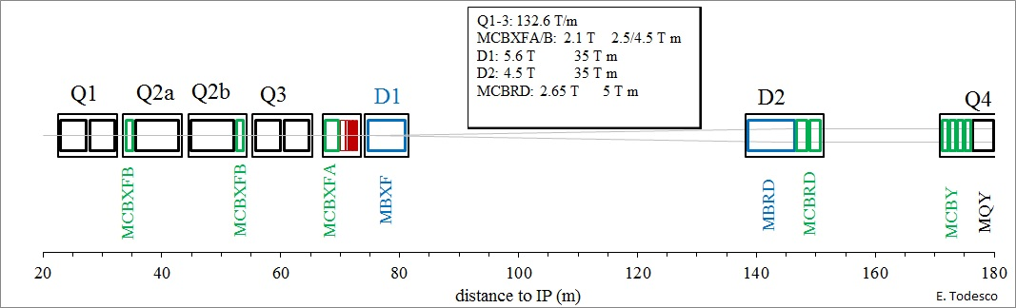

Figure 1: Conceptual layout of the IR region of HL-LHC– thick boxes are magnets, thin boxes are cryostats

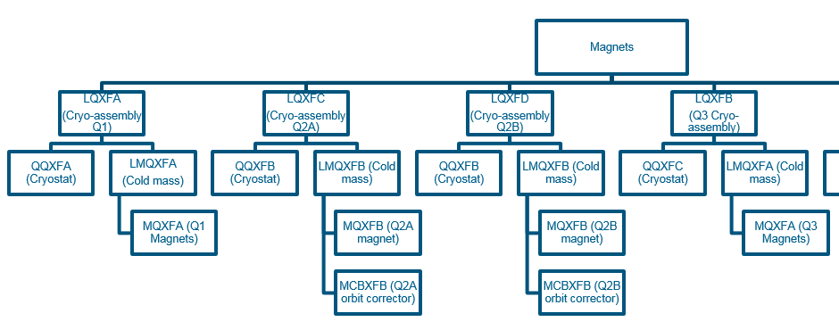

Figure 2: CERN Naming Conventions for HL-LHC Inner Triplets

This functional requirements specification is for MQXFA only, however most of the requirements are the same for MQXFB (the length is the main exception). There will be mutual benefit, for CERN and US HL-LHC AUP, in keeping the MQXFA and MQXFB designs as close to each other as possible. A separate functional requirements specification will be written for cold mass assembly, LMQXFA and LMQXFB.

The MQXF design (Figures 3 and 4) consists of four 2-layer Nb3Sn coils. The quadrupole makes use of an aluminum-shell based structure developed within the LARP collaboration. Coils are mainly pre-stressed by the Al shell during the cool-down, acting as the structure to contain the Lorentz forces during powering. The level of stress is fine-tuned during the loading of the coil, which is done at room temperature using water-pressurized bladders and interference keys [1].

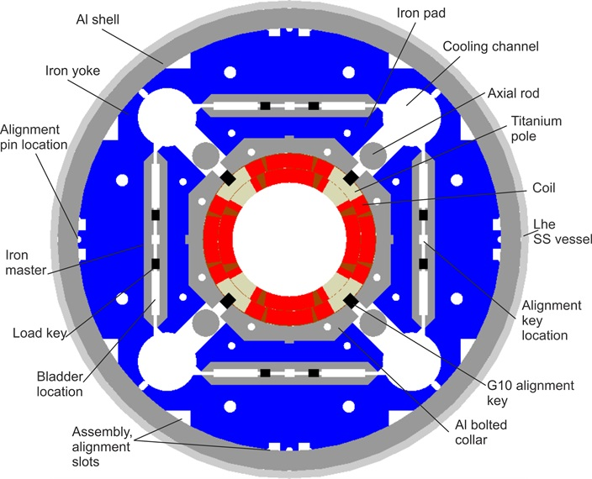

Figure 3: MQXFA cross-section

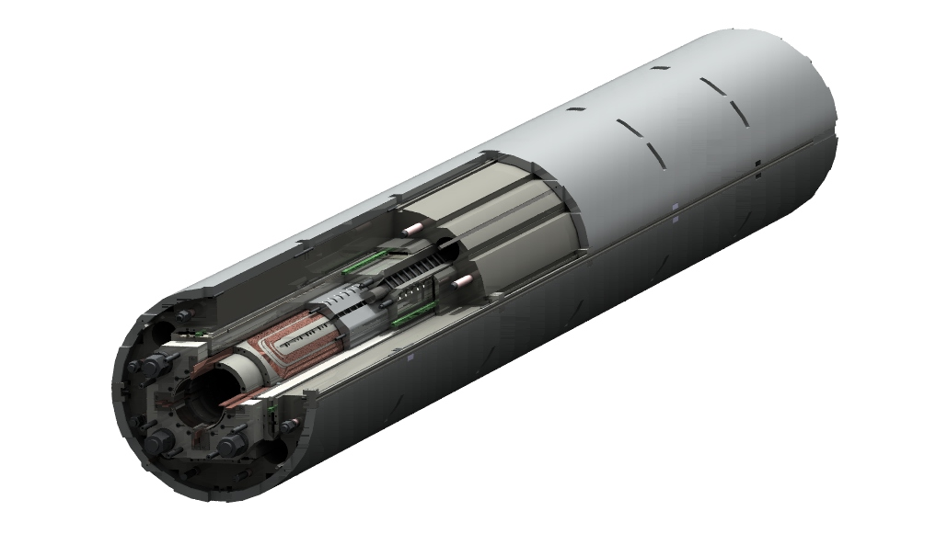

Figure 4: MQXFA 3-D conceptual cutaway view

1. Functional Requirements Overview

The MQXFA functional requirements are the high-level technical requirements for the MQXFA magnet structure. These requirements are driven by the optics functions that the Q1 and Q3 elements need to satisfy plus physical, operational, environmental, and risk tolerance constraints. In addition to functional requirements, this document also includes some non-functional requirements such as reliability, interface, and safety requirements for completeness.

Some requirements in this document may be expressed using CERN terms such as “nominal”, “target”, and “ultimate”. To clarify the intent, in this document requirements are classified into two groups: “Threshold” requirements and “Objective” requirements. Threshold requirements are requirements that contain at least one parameter that the project must achieve, and objective requirements are requirements that the project should achieve and will strive to achieve. The CERN/AUP Acceptance Document will describe the acceptance criteria for the magnets, including the case of magnets not fulfilling the objective requirements.

Each requirement should be verifiable by a Quality Control (QC) process. If all the requirements specified in this document are verified at threshold level, then the US HL-LHC AUP MQXFA magnet deliverables will be fit for the intended use and satisfy CERN’s needs for the HL-LHC upgrade.

**Detailed verification procedures and acceptance criteria will be defined in a separate document. At CERN’s discretion, deliverables that fall short of the threshold requirements may still be acceptable.**

This document provides some background information for each requirement, and throughout this document requirements are identified by a requirement ID of the format “**R-T-XX**”, and “**R-O-XX**” where “T” is for “Threshold”, “O” is for “Objective” and XX is the corresponding requirement number.

At the end of the document Tables 4 and 5 summarize all MQXFA threshold and objective requirements.

1. Physical Requirements
   1. Coil Aperture Requirement

**R-T-01: The MQXFA coil aperture requirement is 150 mm. This aperture is the nominal coil inner diameter at room temperature, excluding ground insulation, inner layer quench heaters, cold bore, and beam screens. The electrical insulation and heater thicknesses have to be compatible with an outer diameter of the cold bore of 145.75 mm at room temperature, ensuring a gap of 1.5 mm for the cooling between the coils and the cold bore. The cold bore has to be supported inside the magnet aperture by slides attached to the coil poles.**

This aperture represents an increase of 80 mm over the present LHC inner triplet coil aperture of 70 mm. The larger aperture is a key MQXFA requirement for HL-LHC, because it allows a smaller * and higher luminosity. Advances in Nb3Sn technology for superconducting magnets allow this increase in aperture while keeping the magnet length at acceptable values.

* 1. Physical Envelope Requirements

**R-T-02: The MQXFA physical outer diameter must not exceed 614 mm**.

The MQXFA physical outer diameter is defined by the outer diameter of the MQXFA structure aluminum shell (see Figures 3 and 4). The stainless steel shell installed around the aluminum shell is part of the cold mass assembly scope (LMQXFA/B) and not part of the MQXFA scope.

The diameter limitation is driven by the available physical space envelope in the cryostat provided by CERN, which is 630 mm for the maximum outer diameter of the LMQXFA/B stainless steel vessel shell. A maximum outer diameter of 614 mm for the MQXFA aluminum shell leaves sufficient space for an 8 mm thick wall stainless steel shell capable of sustaining the peak pressure requirement of 20 bar.

* 2. Alignment Requirements

**R-O-01: Variation of local position of magnetic center must be within ±0.5 mm; variation of local position of magnetic axis within ±2 mrad. Local positions are measured with a 500 mm long probe every 500 mm.**

1. Magnetic Field Requirements
   1. Operating Gradient

**R-T-03: The MQXFA magnet must be capable of operate at steady state providing a gradient of 143.2 T/m in superfluid helium at 1.9 K and for the magnetic length specified in R-T-04, when powered with current of 17.9 kA.**

This gradient corresponds to the HL-LHC ultimate gradient, which is 108% of the nominal operating gradient of 132.6 T/m.

Verification of this requirement is expected to involve testing the magnet in a vertical test stand to a maximum magnet current corresponding to the ultimate gradient of 143.2 T/m (17.89 kA).

* 1. Magnetic Length

**R-T-04: The MQXFA magnetic length requirement is 4.2 m with a tolerance of ± 5 mm at 1.9 K.**

* 2. Field Quality

**R-O-02: The MQXFA field harmonics must be optimized particularly at high field. Table 2 provides expected values for field harmonics at a reference radius of 50 mm [5].**

Table 2: Expected systematic harmonics in the triplet, with separation of head contributions



In the table, we use the following definitions: (i) The standard deviation of the integrated values of the 10 magnets should be smaller or equal to the random; (ii) the average of the integrated values of the 10 magnets will be within the range integral±uncertainty. As shown in Table 2, contributions of the coil ends have to be taken into account and optimized and/or compensated through the straight part [1].

Random components are estimated for a 25 µm random error in the block positioning for non-allowed, and 100 µm for the allowed (see Table 2); most critical components are low order harmonics (b3, a3, b4, a4). Magnetic shimming is allowed for correcting these harmonics [1].Threshold values for harmonics will be given in the Acceptance Document.

* 1. Fringe Field

**R-O-03: The fringe field target for the magnet installed in the cryostat is less than 50 mT at 10 mm from the outer surface of the cryostat.**

1. Cryogenic Requirements
   1. Operating Temperature

**R-T-05: MQXFA magnets must be capable of operation in pressurized static superfluid helium (HeII) bath at 1.3 bar and at a temperature of 1.9 K.**

* 1. Heat Loads

The primary heat load in MQXFA magnets is collision debris from the interaction point. Although the HL-LHC has a nominal luminosity 5 times larger than the nominal design goal of the LHC, CERN is planning to install an absorber, using thick tungsten (W) shielding attached to the outer surface of the beam screen to reduce the effect of collision debris on both MQXFA radiation damage and heat load (Figure 7). This absorber shall be installed in the LQXFA and LQXFB cryoassembly at CERN.

* + 1. Coil Peak Power

MQXFA magnets are expected to operate under a maximum coil peak power of 3 mW/cm3 (at nominal peak luminosity), as in the present Nb-Ti LHC inner triplet. They shall operate at 4.5 mW/cm3 at ultimate peak luminosity, without margin.

* + 1. Total Heat Load

The total heat load on the MQXFA magnets is mainly due to collision debris. In Q1 the collision debris is expected to generate a heat load of 114 W, and in Q3 of 134 W; both loads are at nominal luminosity of 5×1034 cm2 s-1 [1]. They shall operate with a total (static + dynamic) heat load of 290 W and 305 W heat load at ultimate luminosity, without margin.

* 1. Cooling Requirements

Cooling to remove the heat loads mentioned in the previous section is ensured via two 68-mm-inner-diameter heat exchangers in which saturated HeII circulates. In these heat exchangers the heat is extracted by vaporization of the superfluid helium which travels as a low pressure two-phase flow through them. The bayonet heat exchangers are installed in-line through all the Inner Triplet magnets (Q1, Q2a, Q2b, Q3) and interconnects, with a phase separator at the Q2a-Q2b interconnect.

* + 1. Provisions for installation of Heat Exchangers Tubes

The heat exchanger tubes are required to carry a total heat load on Q1 and Q3 of 360 W at a luminosity of 5×1034 cm2 s-1. This requirement resulted in the following CERN choices and parameters relevant to MQXFA [2]:

**R-T-06: The MQXFA cooling channels must be capable of accommodating two (2) heat exchanger tubes running along the length of the magnet in the yoke cooling channels. The minimum diameter of the MQXFA yoke cooling channels that will provide an adequate gap around the heat exchanger tubes is 77 mm.**

* + 1. Provisions for heat extraction

**R-T-07: At least 40% of the coil inner surface must be free of polyimide.**

This is a measureable requirement to keep the peak operating coil within its temperature margin.

The heat loads from the coils and the beam-pipe area can only evacuate to the two heat exchangers mentioned above by means of the static pressurized HeII. To this end the MQXFA cold mass design shall incorporate the necessary helium passages specified in [1] and [2], resulting in:

**R-T-08: The MQXFA must have provisions for the following cooling passages: (1) Free passage through the coil pole and subsequent G-10 alignment key equivalent of 8 mm diameter holes repeated every 50 mm; (2) free helium paths interconnecting the four yoke cooling channels holes; and (3) a free cross sectional area of at least 150 cm2.**

* 1. Peak Pressure

The maximum internal pressure in the MQXFA magnet structure is 20 bar, set by the cold mass helium vessel Maximum Allowable Working Pressure (MAWP). Peak pressures might be experienced by the MQXFA magnet after a full energy magnet system quench, and will be kept below the MAWP by the CERN supplied relief system. Therefore:

**R-T-09: The MQXFA magnet structure must be capable of sustaining a sudden rise of pressure from atmospheric up to 26 bar without damage and without degradation of subsequent performance.**

* 1. Cooldown and Warmup

**R-T-10: The MQXFA magnet structure must be capable of surviving a maximum temperature gradient of 100 K, during a controlled warm-up or cool-down, and to experience the thermal dynamics following a quench without degradation in its performance.**

The maximum temperature gradient imposed on the MQXFA magnet during cooldown and warmup is expected to be 100 K during testing. The temperature gradient during cooldown and warmup in the tunnel is expected to be less than this upper limit.

1. Electrical Requirements
   1. Operating Current

The planned capacity of HL-LHC electrical circuits, including electrical connections inside the magnets, is 18 kA. The nominal MQXFA operating current is expected to be 16.47 kA, and the ultimate operating current is expected to be 17.89 kA [1].

* 1. Maximum Operating Current Ramp Rate

**R-T-11: The MQXFA magnets must be capable of operating at a ramp rate smaller than ±30 A/s.**

* 1. Maximum Operating Voltage

The differential inductance of the MQXFA cold mass (two 4.2 m long magnets in series) is expected to be 68±1 mH at nominal current. During operation, the 14 A/s ramp rate creates a voltage of ~1 V at the end of the cold mass. The maximum operating voltage is during a quench, for which the requirement is:

**R-T-12: The MQXFA magnet must withstand a maximum operating voltage of 670 V to ground during quench.**

* 1. Electrical Buses

**R-T-13: MQXFA magnets must be delivered with a (+) Nb-Ti superconducting lead and a (-) Nb-Ti superconducting lead, both rated for 18 kA and adequately stabilized for connection to the Cold Mass LMQXFA electrical bus.**

These leads must be adequately spliced to the Nb3Sn coil cable. Both leads must come out at the same end of MQXFA magnet. The requirement for splices are:

**R-T-14: Splices are to be soldered with CERN approved materials.**

**R-O-04: Splice resistance target is less than 1.0 nΩ at 1.9 K.**

The joint resistance is measured with voltage taps.

* 1. Instrumentation

**R-T-15: Voltage Taps: the MQXFA magnet shall be delivered with three redundant (3x2) quench detection voltage taps located on each magnet lead and at the electrical midpoint of the magnet circuit; two (2) voltage taps for each quench strip heater; and two (2) voltage taps for each internal MQXFA Nb3Sn-NbTi splice. Each voltage tap used for critical quench detection must have a redundant voltage tap.**

The exact location of each voltage tap will be specified in the interface document [3]

* 1. Voltage Withstand Levels

**R-T-16: The MQXFA magnet coils and quench protection heaters must pass a hi-pot test specified in Table 3.**

Table 3: Required hi-pot test voltages and leakage current

|  |  |  |  |  |
| --- | --- | --- | --- | --- |
| **Circuit Element** | **Expected Vmax [V]** | **V hi-pot** | **I hi-pot**  **[µA]** | **Minimum time duration [s]** |
| Coil to Ground at RT * | n.a. | 3.7 kV | 10 | 30 |
| Coil to Quench Heater at RT * | n.a. | 3 kV | 10 | 30 |
| Coil to Ground at cold ** | 670 | 1.8 kV | 10 | 30 |
| Coil to Quench Heater at cold ** | 900 | 2.3 kV | 10 | 30 |

* Room Temperature conditions refer to air at 20±3 °C and relative humidity lower than 60% (values t.b.c.)

** Cold conditions refer to nominal cryogenic conditions (superfluid helium)

For coil-to-ground voltages, a safety factor of 2 plus 500 V is applied for tests at cold. A factor of 2 is used to scale voltages up to room temperature.

For quench heaters, values are obtained the same way for tests at cold, while limiting the voltage to 3 kV at room temperature.

As far as the inter-turn test voltage is concerned, the maximum impulse voltage that can be applied to coils at any intermediate step is 2.5 kV. The expected maximum inter-turn voltage applied is around 70 V (tbc). No safety factor is applied to this value. Consequently at least one test at room temperature must be performed after impregnation that proves that the withstand level is correct. The impulse test must follow a standard capacitive discharge and proper calibration of the system.

Continuity tests must be applied to guarantee that galvanic separation at low voltage is present between coils and pole pieces and end shoes.

1. Quench Requirements
   1. Quench Training Requirements

**R-O-05: After a thermal cycle to room temperature, MQXFA magnets should attain the nominal operating current with a target of no more than 1 quench.**

**R-T-17: After a thermal cycle to room temperature, MQXFA magnets should attain the nominal operating current with no more than 3 quenches.**

* 1. Quench while ramping down

**R-T-18: MQXFA magnets must not quench while ramping down at 300 A/s from the nominal operating current**

* 1. Quench Protection

MQXFA quench protection will be accomplished with CERN supplied power supplies, CERN supplied quench detection system, and CERN supplied strip heater power supplies, through the use of MQXFA voltage taps and quench protection strip heaters. A CERN supplied CLIQ (Coupling Loss Induced Quench) system is also part of the protection scheme.

The MQXFA magnet must have voltage taps located on each magnet lead and at the electrical midpoint of the magnet circuit. This configuration allows quenches to be detected via a voltage imbalance between half magnet coil circuits. Once a quench is detected in any element in the inner triplet, the power supply system will be turned off and all or some quench protection strip circuits in all magnets in the triplet will be energized.

**R-T-19: The MQXFA quench protection components must be compatible with the CERN-supplied quench protection system and comply with the corresponding interface document specified by CERN [3].**

This is an important interface between MQXFA and CERN supplied equipment. The quench protection system is a highly integrated system with a complex interface between CERN supplied equipment and MQXFA components.

1. Radiation Hardness Requirements

The MQXFA magnet structure will be located near the IP where radiation is expected. With a nominal luminosity 5 times larger than the nominal design goal of the LHC, CERN is planning to fabricate and install a newly designed absorber, using thick tungsten (W) shielding attached to the beam screen (Figure 7) to reduce the effect of collision debris. The W shielding will limit the radiation dose over the HL-LHC accumulated luminosity of 3000 fb-1 to a maximum of 25 MGy. This value is similar to the expected radiation doses for the nominal LHC [1]. Note that this value is for the coil components, other MQXFA structure components will be subject to a lower expected dose.

**R-T-20: All MQXFA components must withstand a radiation dose of 35 MGy** **, or shall be approved by CERN for use in a specific location as shown in [6]”**

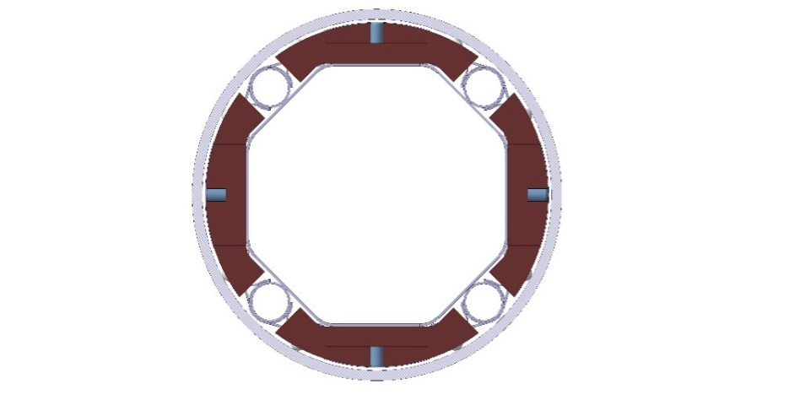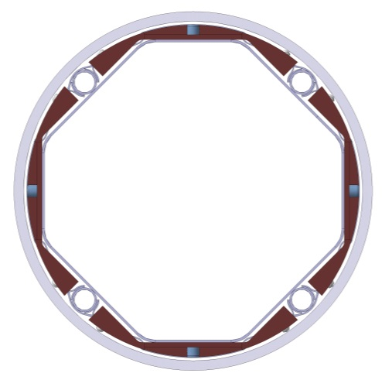

Figure 7: Beam screen (grey) with tungsten shielding (dark brown) and cooling tubes in Q1 (left) and in Q2-D1 (right)

1. Reliability Requirements

The MQXFA magnets are expected to sustain 10 years of HL-LHC operation under nominal luminosity conditions, limited primarily by the integrated dose to the materials in the coils. In the course of these 10 operational years, the magnets are expected to survive the following conditions:

* 1. Number of Powering Cycles

**R-T-21: MQXFA magnets will operate in the HL LHC era for an order of magnitude of 5000 cycles. The long term reliability of the design will be proven with a magnet submitted to 2,000 powering cycles in individual test.**

* 1. Number of Quenches

**R- O-06: MQXFA magnets shall survive at least 50 quenches after the acceptance test.**

1. Interface Requirements

The MQXFA magnet structure interfaces with the following systems:

1. The LMQXFA System, including:
   1. The 1.9 K stainless steel helium vessel, including the cold bore tube and end domes
   2. Two heat exchanger pipes installed in the MQXFA yoke cooling channels
   3. The LMQXFA electrical busbars and instrumentation wiring system
2. The CERN supplied Cryogenic System, consisting of:
   1. The CERN supplied cooling system
   2. The CERN supplied pressure relief system
3. The CERN supplied power system
4. The CERN supplied quench protection system, consisting of:
   1. Quench Detection System
   2. Strip Heaters Power Supplies
   3. CLIQ system
5. The CERN supplied instrumentation system

Detailed interface documentation must be provided for each of these interfaces.

**R-T-22: The MQXFA magnets must meet the detailed interface specifications with the following systems: (1) other LMQXFA Cold Mass components; (2) the CERN supplied Cryogenic System; (3) the CERN supplied power system; (4) the CERN supplied quench protection system, and (5) the CERN supplied instrumentation system. These interfaces are specified in Interface Control Document [3].**

1. Safety Requirements

Each HL-LHC work package will be subject to safety requirements specified in a CERN “Launch Safety Agreement (LSA)” document [1]. This LSA specifies the CERN safety rules and host state regulations applicable to the systems/processes and the minimal contents of the Work Package safety file needed to meet the Safety Requirements.

**R-T-23: The MQXFA magnets must comply with CERN’s Launch Safety Agreement (LSA) for IR Magnets (WP3) [4]**.

No pressure vessel or welding components are expected to be present in MQXFA. Safety requirements are expected to include a list of MQXFA materials and their mass for activation studies, and to have Co traces under 0.1% in weight for massive iron and steel components.

1. CERN Provided Parts

MQXFA CERN provided parts are under discussion, and are not expected to be part of these requirements.

1. Requirements Summary Tables

Table 4: MQXFA Threshold Requirements Specification Summary Table

|  |  |
| --- | --- |
| **ID** | **Description** |
| R-T-01 | The MQXFA coil aperture requirement is **150 mm**. This aperture is the nominal coil inner diameter at room temperature, excluding ground insulation, inner layer quench heaters, cold bore, and beam screens. The electrical insulation and heater thicknesses have to be compatible with an outer diameter of the cold bore of 145.75 mm at room temperature, ensuring a gap of 1.5 mm for the cooling between the coils and the cold bore. The cold bore has to be supported inside the magnet aperture by slides attached to the coil poles |
| R-T-02 | The MQXFA physical outer diameter must not exceed **614 mm**. |
| R-T-03 | The MQXFA magnet must be capable of operate at steady state providing a gradient of **143.2 T/m** in superfluid helium at 1.9 K and for the magnetic length specified in R-T-04, when powered with current of 17.9 kA. |
| R-T-04 | The MQXFA magnetic length requirement **is 4200 ± 5 mm** at **1.9 K**. |
| R-T-05 | MQXFA magnets must be capable of operation in pressurized static superfluid helium (HeII) bath at **1.3 bar** and at a temperature of **1.9 K.** |
| R-T-06 | The MQXFA cooling channels must be capable of accommodating **two (2)** heat exchanger tubes running along the length of the magnet in the yoke cooling channels. The minimum diameter of the MQXFA yoke cooling channels that will provide an adequate gap around the heat exchanger tubes is **77 mm.** |
| R-T-07 | At least **40%** of the coil inner surface must be free of polyamide. |
| R-T-08 | The MQXFA structure must have provisions for the following cooling passages: (1) Free passage through the coil pole and subsequent G-10 alignment key equivalent of **8 mm** diameter holes repeated every **50 mm**; (2) free helium paths interconnecting the yoke cooling channels holes; and (3) a free cross sectional area of at least **150 cm2** |
| R-T-09 | The MQXFA magnet structure must be capable of sustaining a sudden rise of pressure from atmospheric up to **26 bar** without damage and without degradation of subsequent performance. |
| R-T-10 | The MQXFA magnet structure must be capable of surviving a maximum temperature gradient of 100 K, during a controlled warm-up or cool-down, and to experience the thermal dynamics following a quench without degradation in its performance. |
| R-T-11 | The MQXFA magnets must be capable of operating at ±**30 A/s.** |
| R-T-12 | The MQXFA magnet must withstand a maximum operating voltage of **670** V to ground during quench. |
| R-T-13 | MQXFA magnets must be delivered with a (+) Nb-Ti superconducting lead and a (-) Nb-Ti superconducting lead, both rated for **18 kA** and adequately stabilized for connection to the Cold Mass LMQXFA or LMQXFAB electrical bus. |
| R-T-14 | Splices are to be soldered with CERN approved materials. |
| R-T-15 | Voltage Taps: the MQXFA magnet shall be delivered with **three redundant (3x2)** quench detection voltage taps located on each magnet lead and at the electrical midpoint of the magnet circuit; **two (2)** voltage taps for each quench strip heater; and **two (2)** voltage taps for each internal MQXFA Nb3Sn-NbTi splice.Each voltage tap used for critical quench detection must have a redundant voltage tap. |
| R-T-16 | The MQXFA magnet coils and quench protection heaters must pass a hi-pot test specified in **Table 3.** |
| R-T-17 | After a thermal cycle to room temperature, MQXFA magnets should attain the nominal operating current with no more than 3 quenches. |
| R-T-18 | MQXFA magnets must not quench while ramping down at **300 A/s** from the nominal operating current |
| R-T-19 | The MQXFA quench protection components must be compatible with the CERN-supplied quench protection system and comply with the corresponding interface document specified by CERN [3]. |
| R-T-20 | All MQXFA components must withstand a radiation dose of 35 MGy, or shall be approved by CERN for use in a specific location as shown in [6]” |
| R-T-21 | MQXFA magnets will operate in the HL LHC era for an order of magnitude of 5000 cycles. The long term reliability of the design will be proven with a magnet submitted to 2,000 powering cycles in individual test |
| R-T-22 | The MQXFA magnets must meet the detailed interface specifications with the following systems: (1) other LMQXFA (B) Cold Mass components; (2) the CERN supplied Cryogenic System; (3) the CERN supplied power system; (4) the CERN supplied quench protection system, and (5) the CERN supplied instrumentation system. These interfaces are specified in Interface Control Document [3]. |
| R-T-23 | The MQXFA magnets must comply with CERN’s Launch Safety Agreement (LSA) for IR Magnets (WP3) [4]. |

Table 5: MQXFA/B Objective Requirements Specification Summary Table

|  |  |
| --- | --- |
| **ID** | **Description** |
| R-O-01 | Variation of local position of magnetic center must be within **±0.5 mm**; variation of local position of magnetic axis within **±2 mrad**. Local positions are measured with a 500 mm long probe every 500 mm. |
| R-O-02 | The MQXFA field harmonics must be optimized at high field. Table 2 provides specific target values for field harmonics at a reference radius of **50 mm.** |
| R-O-03 | The fringe field target for the magnet installed in the cryostat is less than **50 mT** at 10 mm from the outer surface of the cryostat. |
| R-O-04 | Splice resistance target is less than **1.0 nΩ** at 1.9K. |
| R-O-05 | After a thermal cycle to room temperature, MQXFA magnets should attain the nominal operating current with a target of no more than **1** quench. |
| R-O-06 | MQXFA magnets shall survive at least 50 quenches after the acceptance test. |

1. References

[1] High-Luminosity Large Hadron Collider (HL-LHC). Technical Design Report, edited by G. Apollinari, I. Béjar Alonso, O. Brüning, M. Lamont, L. Rossi, <https://edms.cern.ch/ui/file/1723851/0.71/HL_TDR_V07.0.2016.10.05.Version15.2h.pdf>

[2] D. Bozza and R. van Weelderen, HiLumi LHC, FP7 High Luminosity Large Hadron Collider Design Study, Deliverable Report, Design Study of the Cooling, 12 October 2015, CERN-ACC-2015-012, R. van Weelderen, <https://indico.cern.ch/event/633630/contributions/2573050/attachments/1464927/2264386/Recap_v1.3.pdf> and D. Berkowitz, “Preliminary summary of the heat loads on the LSS.R5 of HL-LHC”, CERN [EDMS 1610730](https://edms.cern.ch/ui/doc/1610730)

[3] Interface Control Document WBS 302.2.01 – CERN WP3, US HiLumi DocDB # 384; and Internal Interface Control Document WBS 302.2.07 - 302.2.09, US HiLumi DocDB # 216

[4] CERN Launch Safety Agreement for IR Magnets (WP3), CERN EDMS 1550065 (to be finalized)

[5] R. Wolf, “FIELD ERROR NAMING CONVENTIONS FOR LHC MAGNETS”, EDMS Document No.

90250.

[6] “MQXFA Material list” US HiLumi DocDB # 96