ArgonCube Cryostat Technical Proposal

Kathrine Cipriano, Ang Lee, Shishir Shetty, Andy Stefanik, and Mike Zuckerbrot

February 21st, 2018

Introduction

This document is a design proposal for the ArgonCube cryostat. The design of ArgonCube is modeled off the 35 Ton cryostat, which is currently operational at Fermilab. The 35T cryostat (US short tons) is a membrane cryostat that consists of a thin layer of corrugated stainless steel followed by insulation and concrete. The goal of the ArgonCube design is to minimize the radiation length of one cryostat wall. This can be accomplished by creating a “window” in one wall and replacing the concrete with a thinner material, such as G10. G10 was the primary material analyzed for this report. However, the group is currently researching other materials, including Carbon Fiber, and other window concepts to achieve the low-radiation length cryostat wall.

Contents

1. Membrane Cryostat Background Information 3
2. 35 Ton Experiment- Summary of Successfully Built Membrane Cryostat 3
3. Design Proposal for ArgonCube Cryostat 4
4. FEA Results of G10 Window in ArgonCube Cryostat 8
5. Carbon Fiber Window Analysis 10
6. Conclusion 12
7. References 12
8. Appendix A- Radiation Length Calculations 14
9. Appendix B- Window Strength Calculations 15
10. Appendix C- Technical Paper on 35 Ton Cryostat 16
11. Appendix D- FEA Results of G10 Window and Carbon Fiber Window 17

Membrane Cryostat Background Information

Membrane cryostats consist of a very thin layer of corrugated stainless steel (the membrane) surrounded by a structural support system and insulation. The membrane design, shown in Figure 1, allows for expansion and contraction of the stainless steel wall, which is typically a few millimeters thick. Membrane cryostats have been successfully used for transportation and storage in the liquid natural gas (LNG) industry since 1959 [1]. With advancing technology, tanker ships now have the capacity to carry up to 266,000m3 of LNG in membrane vessels [2].

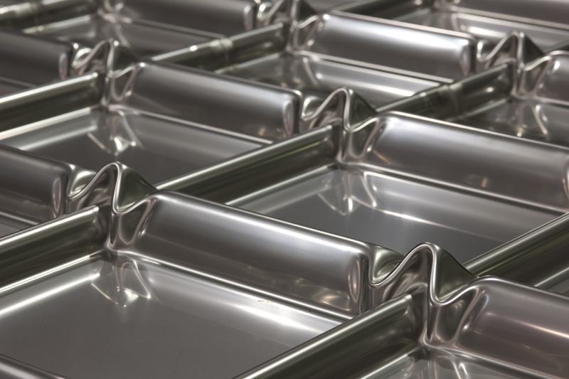

Figure 1: Section of membrane wall at Fermilab [3]

35T Experiment- Summary of Successfully Built Membrane Cryostat

Fermilab built a membrane cryostat for the 35 Ton experiment in 2013. IHI Corporation designed the membrane cryostat and oversaw the installation process at Fermilab. The 35T cryostat, with a volume of 29m3, was built as a prototype to determine if membrane tank technology would meet the scientific and engineering requirements of the LBNF/DUNE project. Factors taken into consideration during the design and construction processes were thermal performance, feasibility for liquid argon, argon purity, and leak tightness [4]. These goals were successfully met. The heat leak through the cryostat walls, calculated by Terry Tope, was found to equal 11.5 W/m2 [5]. The 35T cryostat has proven to be feasible for liquid argon use and has been operational since 2014. Physicists have achieved high purity levels of liquid argon, more than 1.4 millisecond electron lifetimes, by circulating the liquid argon through an external filtration system [4]. The two filters, the first containing a molecular sieve and the second containing copper pellets, remove water and oxygen impurities from the liquid argon. During the initial cryostat pressure test, a leak check was performed on the membrane and no leaks were found [4].

There are eight layers that make up the 35T vessel walls. The layers are summarized in Table 1, below. The GRE/GRU layers are estimated to be 0.5mm thick, so the radiation length for these two layers was considered negligible.

Table 1: 35 Ton Cryostat Layers

|  |  |  |
| --- | --- | --- |
| **Layer** | **Material** | **Thickness (mm)** |
| Membrane | 304 Stainless Steel | 2 |
| Fireproof board | Calcium Silicate board | 10 |
| GRE/GRU | Glass reinforced epoxy/glass reinforced urethane | 0.5 |
| Insulation | High temperature polyurethane foam | 190 |
| GRE/GRU | Glass reinforced epoxy/glass reinforced urethane | 0.5 |
| Insulation | High temperature polyurethane foam | 200 |
| Moisture Barrier | Carbon Steel | 1.2 |
| Reinforced Concrete | Reinforced concrete | 300 |

Terry Tope’s pressure vessel engineering note on the 35T cryostat contains the structural calculations and testing of the concrete. Cured concrete cylinders were tested 5, 7, and 28 days after being poured. The resulting 28-day compressive strength was 35.9MPa (5,213psi), which met the 34.5MPa (5,000psi) requirements for 35T [5]. The design pressure of 35T is 20.6kPa (3psig) at -189°C (-309°F).

Design Proposal for ArgonCube Cryostat

The basis of the ArgonCube cryostat design stems from the design of the 35 Ton vessel. The proposal is to build a membrane vessel for ArgonCube with the same (or similar) cryostat walls as 35T. A critical design component of the ArgonCube cryostat is reducing the radiation length through one of the cryostat walls. The goal is to achieve a radiation length of 0.5. This minimized radiation length is only important for the cryostat wall between the liquid and gas vessels (Figure 2). Calculations determined that the radiation length through the 35T vessel is 2.9. The largest contributing factor to this high radiation length is the concrete layer. Table 2 shows the layers and corresponding radiation lengths.



Table 2: Radiation Lengths of 35 Ton Cryostat Layers

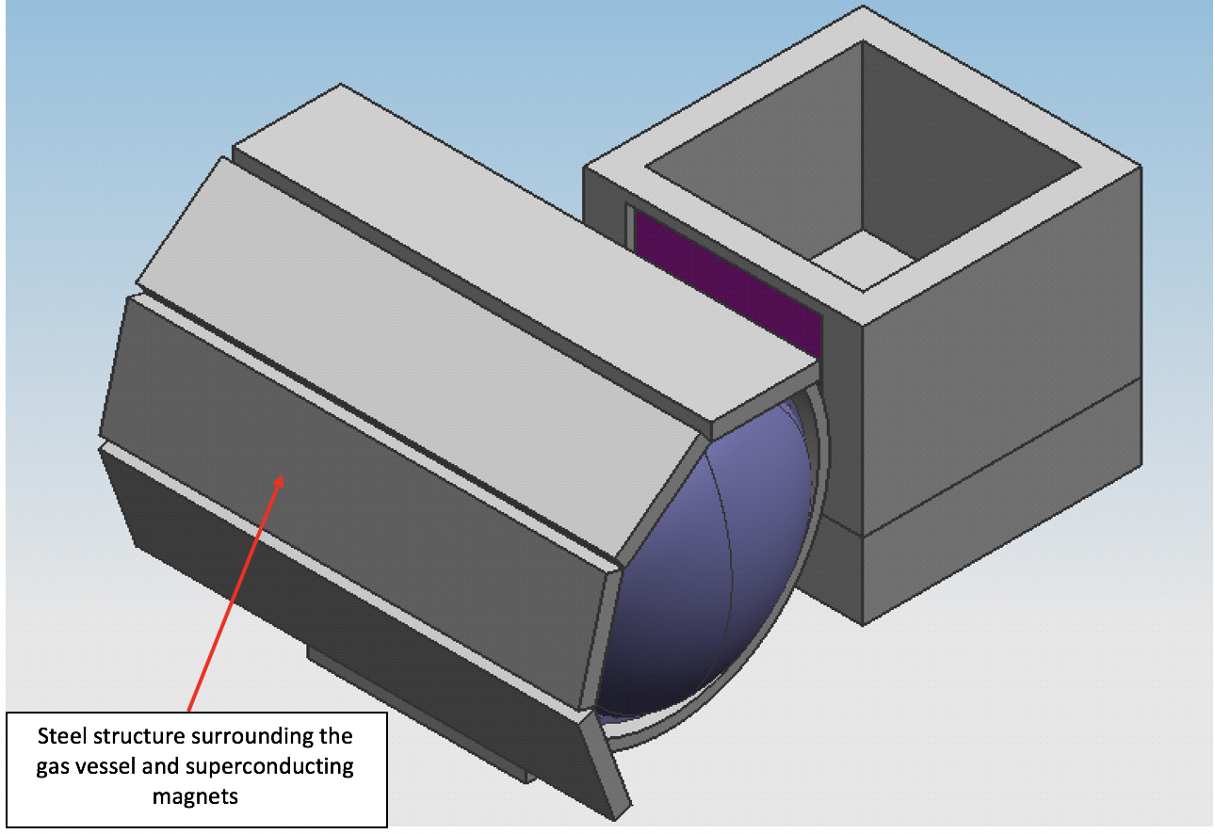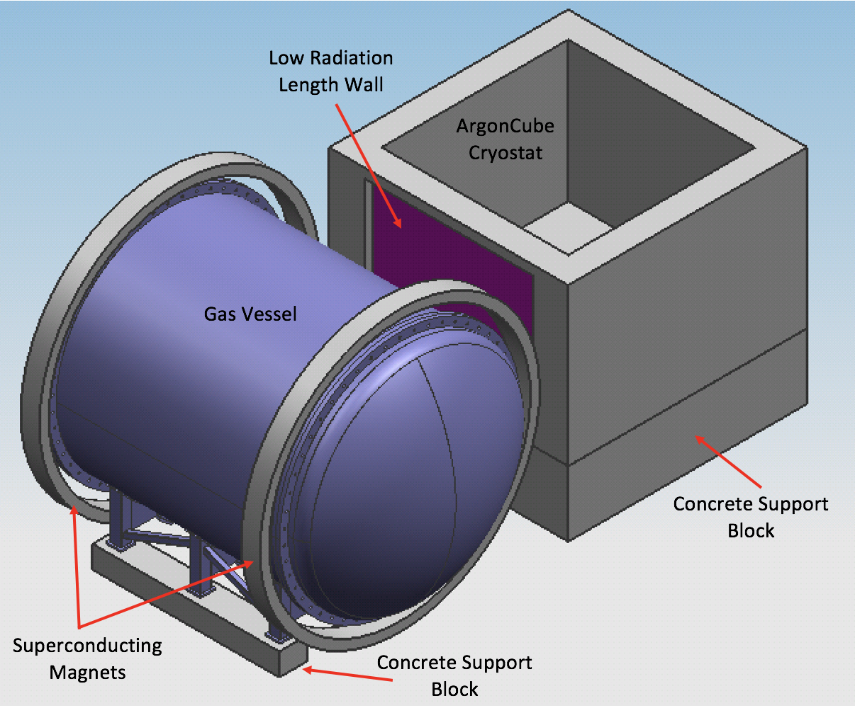

Figure 2: ArgonCube cryostat and gas vessel (top) and depiction of steel shielding around magnets (bottom)

A layer of G10 instead of concrete could be used for the ArgonCube cryostat to maintain structural requirements and minimize radiation length. The layers of the ArgonCube cryostat, including the G10 window, are shown in Figure 3. A 3.25m x 4.5m x 0.1m (10.7ft x 14.8ft x 4in) window of G10 would be fixed within the surrounding concrete wall (Figure 4). The specific method of fixing the sheet of G10 in the surrounding concrete has yet to be finalized. However, the edge conditions for the calculations remain the same regardless of what material or method is used. The area of the G10 window covers most of the dimensions of the cylindrical TPC (5m diameter, 5m-long) in the gas vessel. This ensures that a large portion of the gas TPC area would see the low radiation length. The radiation length through the eight layers of the ArgonCube cryostat wall, using G10 instead of concrete, is 0.8. Calculations for this result are shown in Appendix A. Table 3 summarizes each layer and the corresponding radiation lengths.

Table 3: Radiation Lengths of ArgonCube Cryostat Layers with G10 Sheet



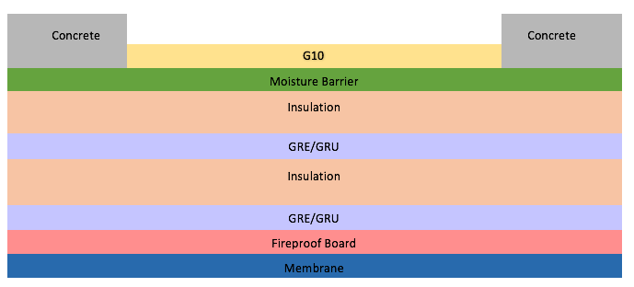

Figure 3: Layers of ArgonCube cryostat’s low radiation length wall (layers not to scale)

Using 35T as a baseline again, it was assumed that the maximum design pressure in the ArgonCube cryostat would be approximately 20.6kPa (3psig). That pressure, combined with the hydrostatic pressure of 50.9kPa (7.4psig), equals a total pressure of 71.6kPa (10.4psig) applied uniformly across the G10 window. Roark and Young flat plate formulas were used to determine the maximum stress and deflection values of the G10 plate [1]. It was assumed that a uniform pressure of 71.6kPa (10.4psig) was distributed evenly across the entire plate because it was more conservative than using a hydrostatic pressure distribution. It was also assumed that all four edges of the G10 plate were fixed. A solid 0.1m x 3.25m x 4.5m sheet of G10 was used for the calculations. As a result, the G10 plate could withstand a maximum bending stress of 31.9MPa (4,629psi). The resulting maximum deflection with these conditions is equal to 11.35mm (0.4in). This deflection is less than half the thickness of the G10 plate, so the Roark and Young formulas used are valid [1]. These calculations are located in Appendix B.

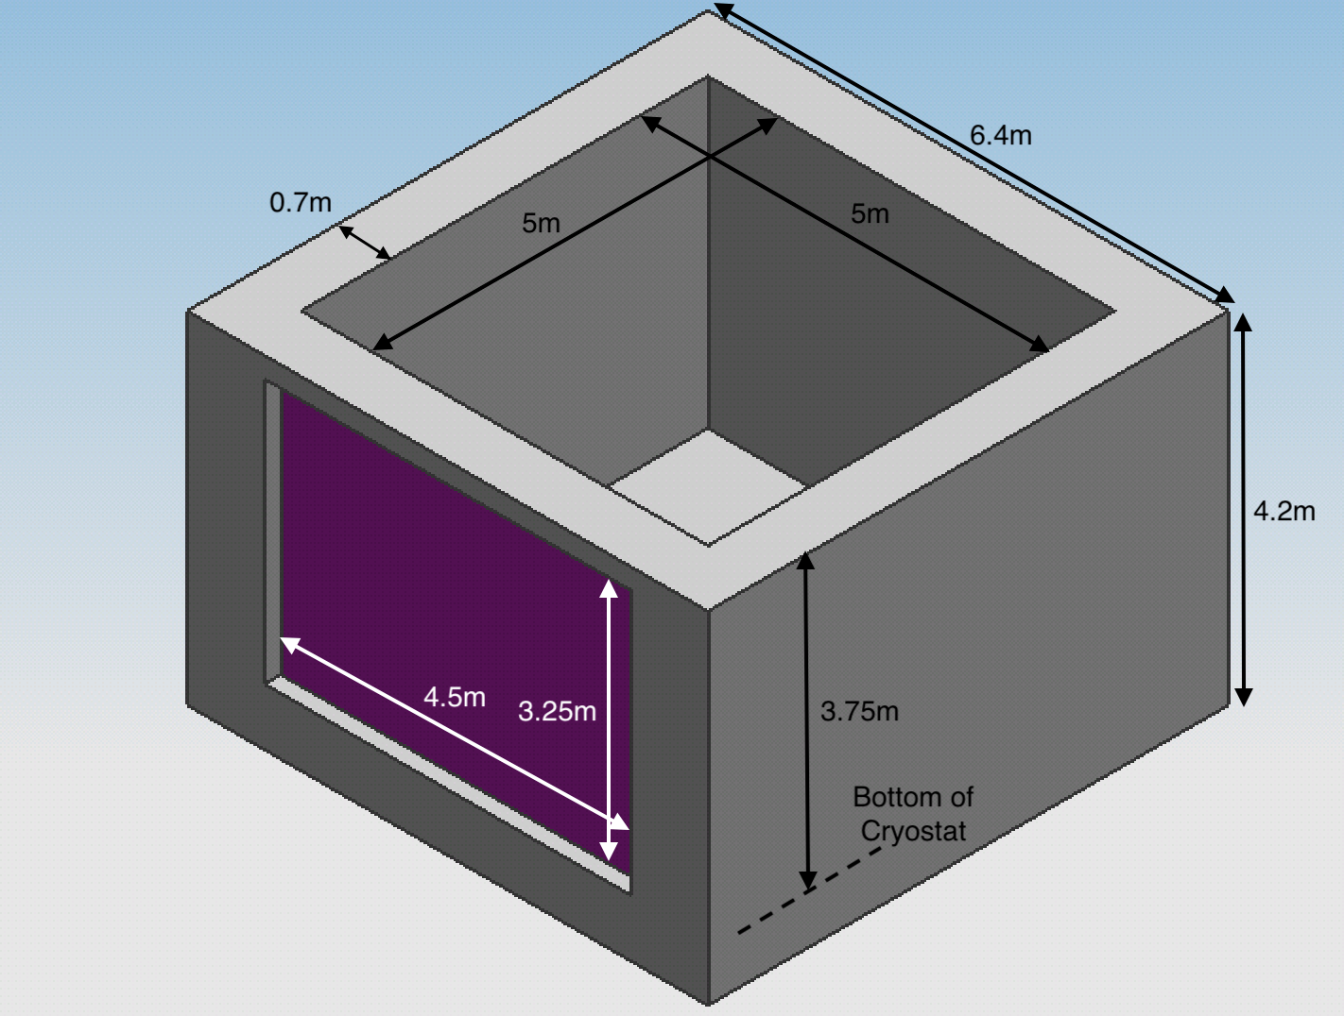

Figure 4: Dimensions of ArgonCube cryostat

G10 was chosen as one option for the material of the low radiation length wall due to its high strength and low radiation length. In addition, sheets of Aluminum and Titanium were tested in place of the G10 window. With these materials, the resulting radiation lengths were 1.16 for all layers including Aluminum and 1.96 for all layers including Titanium. Future analyses will include calculations for a Carbon Fiber window, and curved Aluminum and Titanium windows. Curved sheets can withstand higher pressures than flat plates. With resistance to higher pressure, the thickness of the material could be reduced, thus reducing the radiation length.

FEA Results of G10 Window in ArgonCube Cryostat

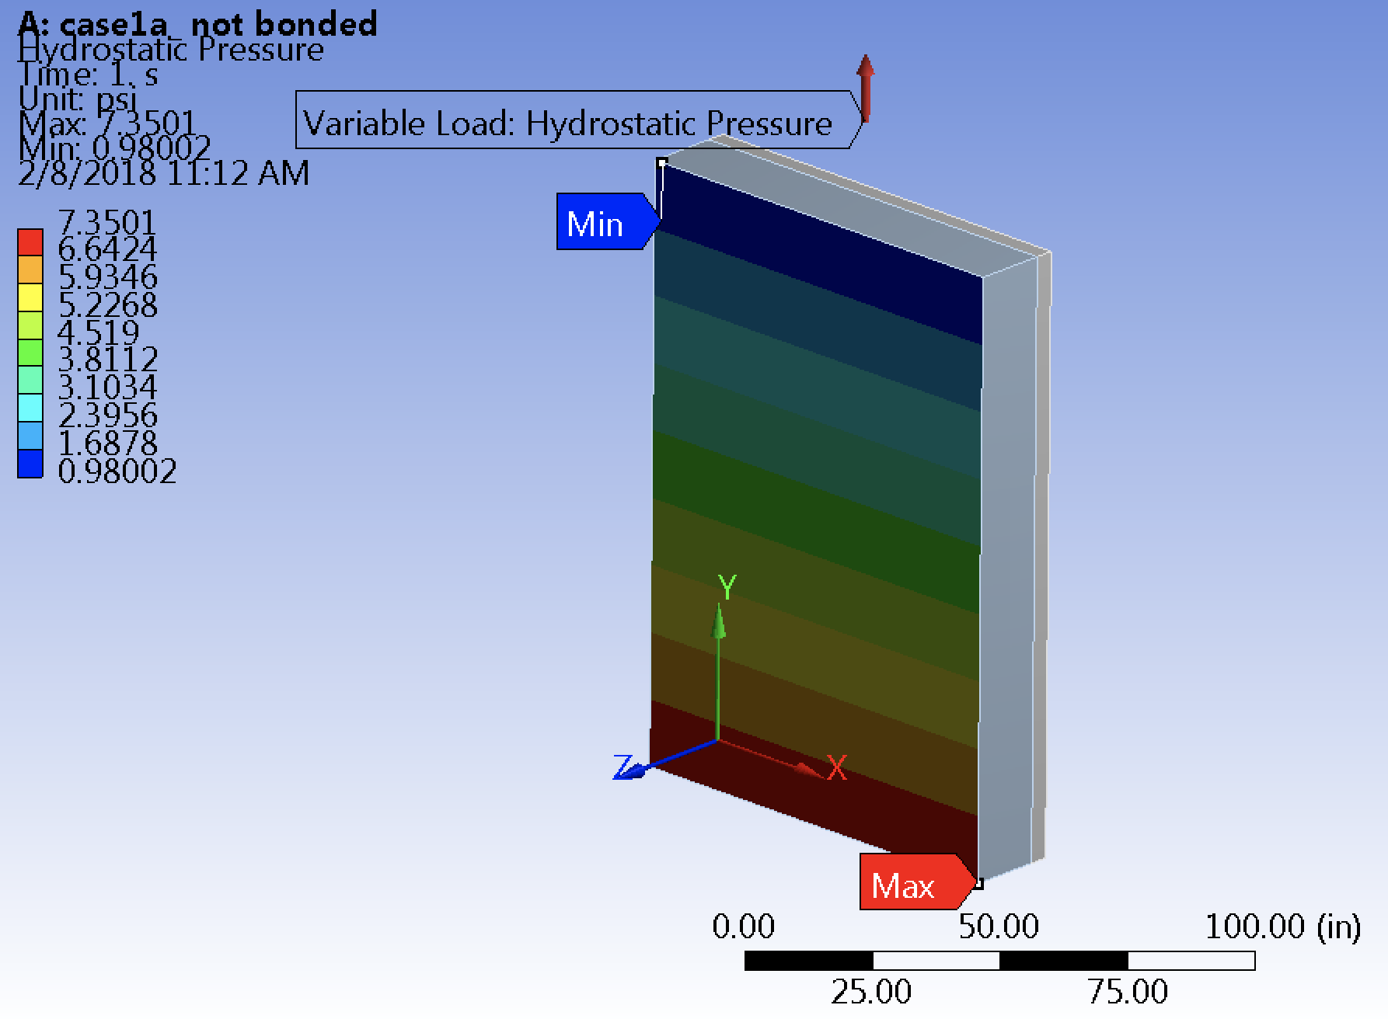Ang Lee (Fermilab) completed a finite element analysis (FEA) to analyze the G10 window and insulation. A total pressure of 71.4kPa (10.35psig) was applied to the window and insulation: 50.7kPa (7.35psig) of hydrostatic pressure and 20.6kPa (3psig) of uniform pressure (Figure 5). A vertical plane of symmetry was applied to the window for ease of analysis. This is clarified in Figure 6.

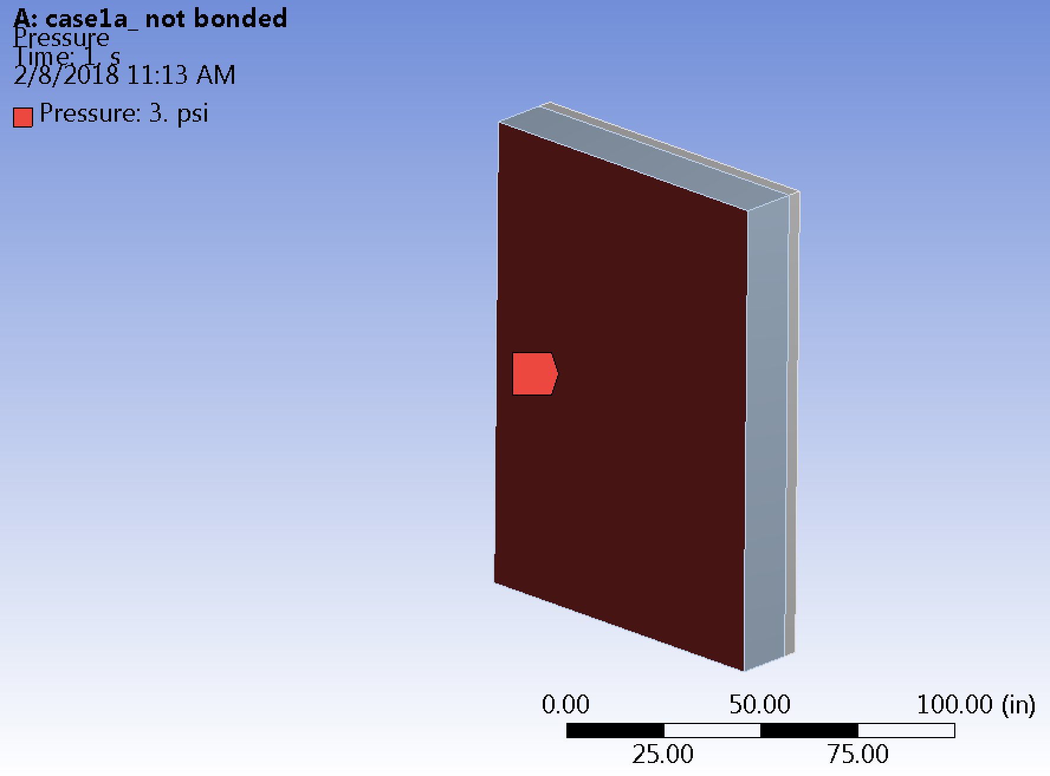

Figure 5: Pressure boundary conditions for G10 window and insulation

Figure 6: Dimensions of window and plane of symmetry

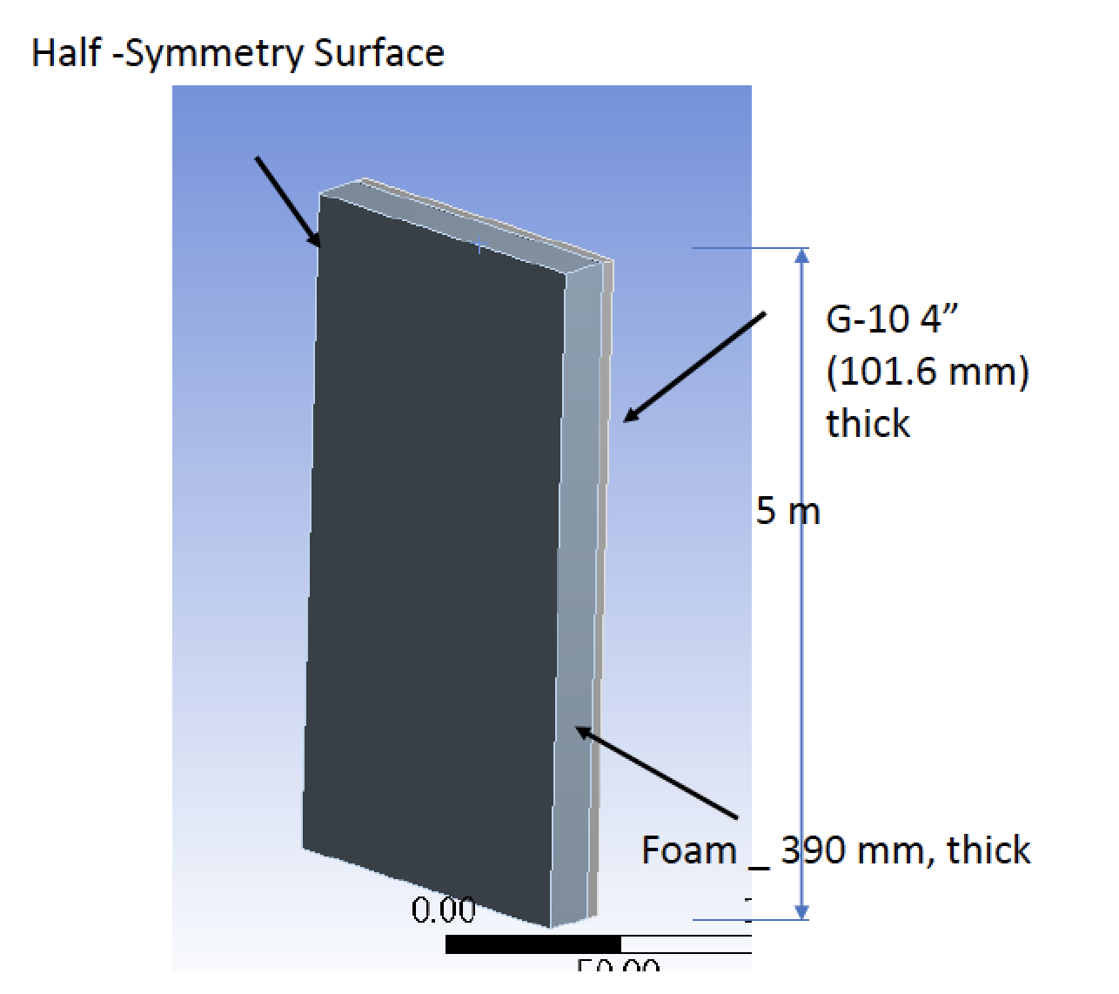

3.25m

Four cases were analyzed with different boundary conditions:

* Case 1a:
  + Outer 4 walls of G10 are fixed
  + G10 and insulation are not bonded
* Case 1b:
  + Outer 4 walls of G10 are fixed
  + G10 and insulation are bonded
* Case 2a:
  + Outer 4 walls of G10 and insulation are fixed
  + G10 and insulation are not bonded
* Case 2b:
  + Outer 4 walls of G10 and insulation are fixed
  + G10 and insulation are bonded

The worst-case scenario is 1a. Even with these boundary conditions (outer four walls of the G10 are fixed and the G10 and insulation are not bonded), the deflection is 9mm (0.36in). This is minimal compared to the overall size of the window. Additionally, the applied stress is 20.4MPa (2,954psi). This is well below the tensile and compressive strengths of the G10: 257MPa (32,278psi) and 448MPa (65,000psi), respectively [6]. The majority of the 71.4kPa (10.35psig) pressure applied to the window is absorbed by the G10 window, but the insulation does experience some of the stress. The tensile and compressive strengths of the Rohacell insulation are 100kPa (145psi) and 400kPa (58psi), respectively [7]. These are larger than the maximum (tensile) and minimum (compressive) principal stresses on the insulation. The maximum deflection at the center of the G10 window is (0.36in) according to the FEA. Figure 8 shows the deflection and stress results.

Figure 8: Equivalent stress and deflection results from FEA

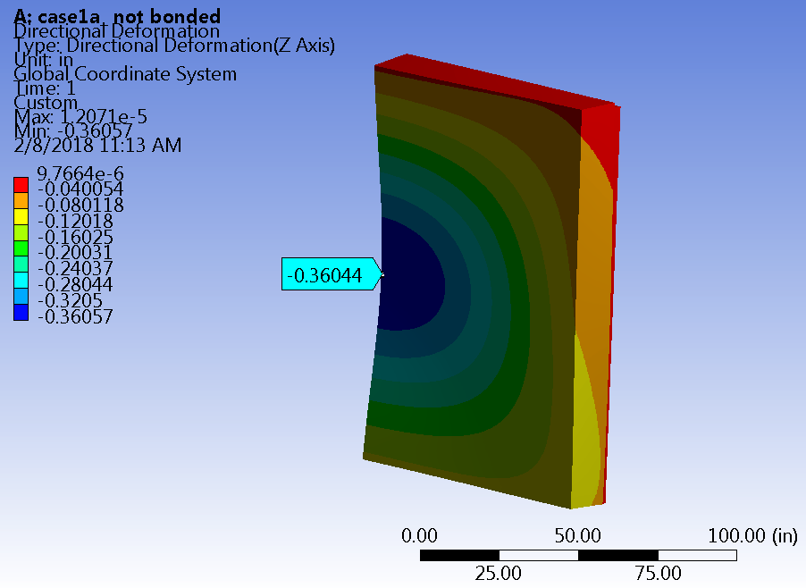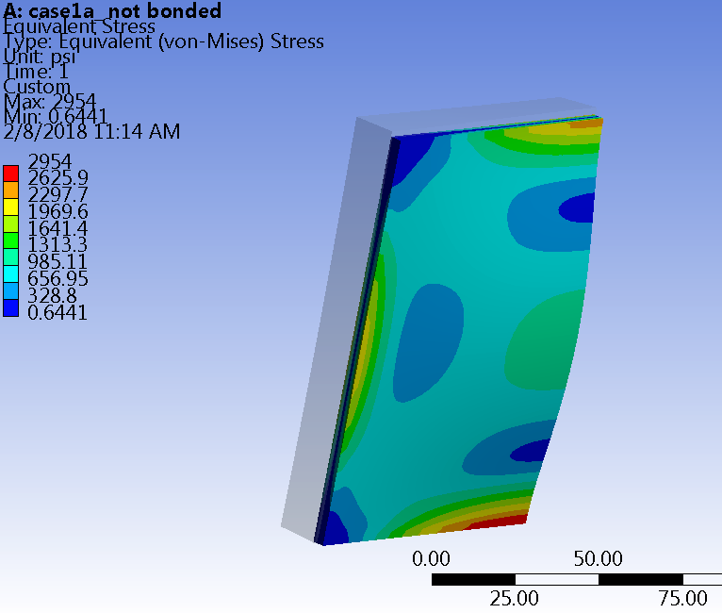

Carbon Fiber Window Analysis

Another material that could be used for the thin window is carbon fiber. The carbon fiber window would consist of a 203mm-thick (8in) layer of high-density polyurethane foam insulation sandwiched between two 5mm-thick (0.19in) layers of carbon fiber. The layers of a carbon fiber window are listed below in Table 4. Figure 9 shows the layers of the cryostat wall with the carbon fiber window instead of G10. The window of carbon fiber would produce a total radiation length of 0.29.

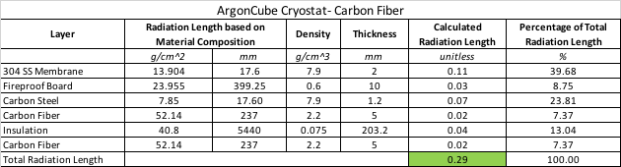

Table 4: Radiation Lengths of ArgonCube Cryostat with Carbon Fiber

An FEA was completed by Ang Lee for the carbon fiber window using the same input parameters as the G10 analysis. The results are listed in Figures 10-12. With 203mm (8in) of insulation between two 5mm-thick (0.19in) sheets of carbon fiber, the resulting deflection is equal to 10.16mm (0.40in). The resulting maximum principle (tensile) stress on the carbon fiber sandwich is 215.8kPa (31.3psi) and the resulting minimum principle (compressive) stress is 458.3kPa (66.48psi). These stress results are less than the tensile and compressive strengths of the insulation, which are 2.8MPa (406psi) and 1.5MPa (217psi), respectively. 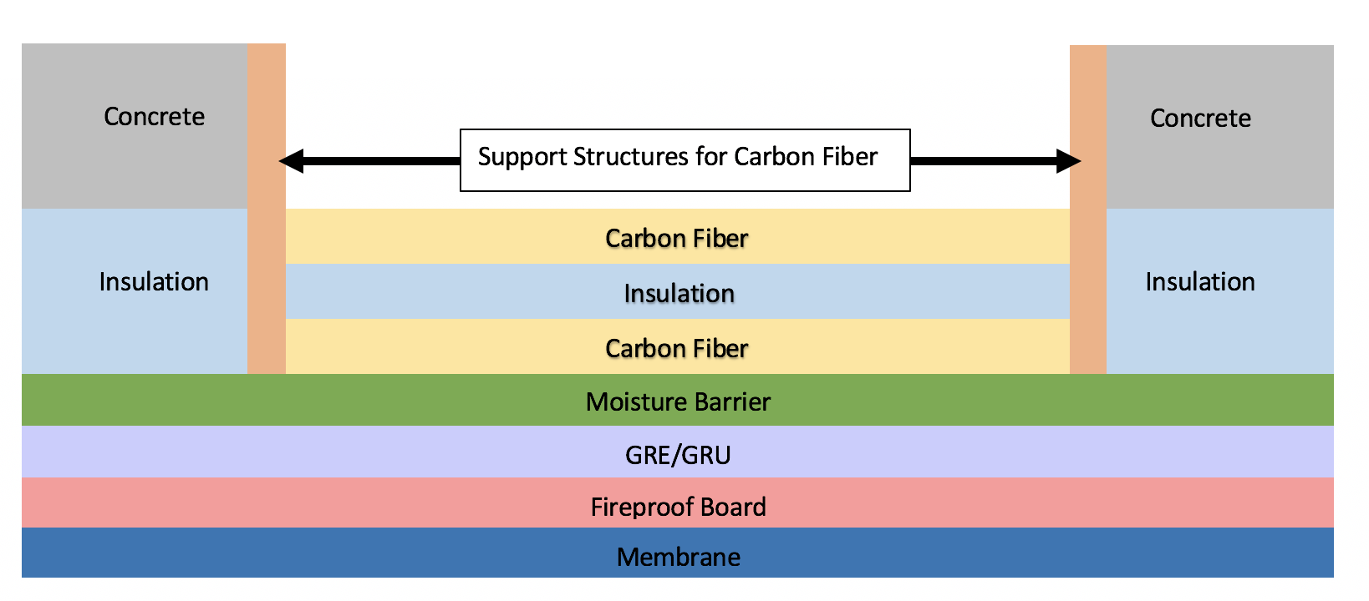

Figure 9: Layers of cryostat wall with carbon fiber window (layers not to scale)

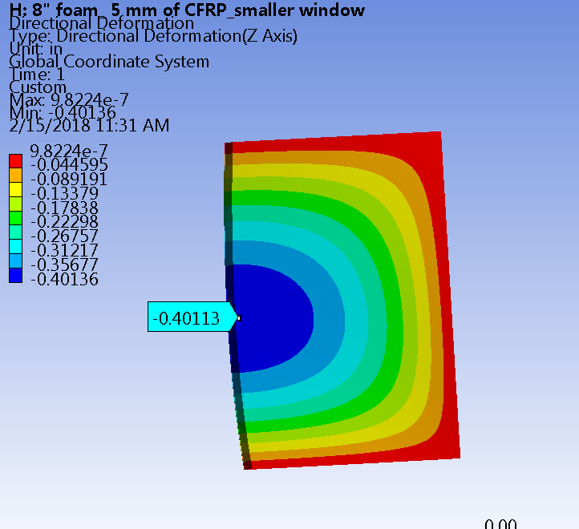

Figure 10: FEA results of carbon fiber sandwich window

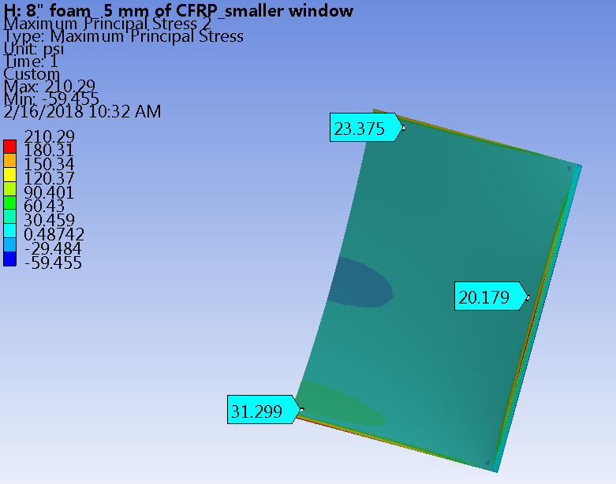

Figure 11: FEA of carbon fiber window showing maximum princle (tensile) sress

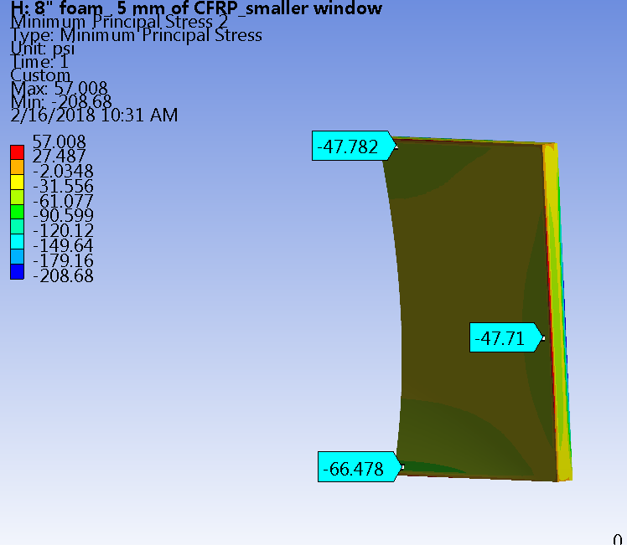

Figure 12: FEA of carbon fiber window showing minimum principle (compressive) stress

Conclusion

The proposed design for the ArgonCube cryostat provides a minimized radiation length through the cryostat wall while maintaining structural requirements for a cryostat of this size. With a 0.1m-thick G10 window in one of the cryostat walls, the total radiation length of the wall is 0.8. The wall of insulation sandwiched between carbon fiber sheets would result in a total radiation length of 0.29. The G10 and carbon fiber sandwich windows are both viable options for the ArgonCube cryostat. The basis for the ArgonCube cryostat stems from the 35T cryostat, which was successfully built at Fermilab in 2014 and has been operational since then.

References

[1] Peter G. Noble, “A short history of LNG shipping 1959-2009,” Texas Section, SNAME, 2009.

[2] "LNG carrier", *En.wikipedia.org*, 2017. [Online]. Available:

https://en.wikipedia.org/wiki/LNG_carrier. [Accessed: 15- Dec- 2017].

[3] Fermilab, *LBNE Membrane wall section @ Lab F*. 2011.

[4] D. Montanari, M. Adamowski, B. Baller, R. Barger, E. Chi, R. Davis, B. Johnson, B. Kubinski,

R. Mahoney, E. McCluskey, J. Najdzion, B. Norris, R. Rucinski, R. Schmitt, J. Stewart, T. Tope and D. Watkins, "First scientific application of the membrane cryostat technology", 2014.

[5] Tope, T. Fermilab. (2013). LBNE 35 Ton Prototype, Revision 9.

[6] Carl L. GoodZeit (Retired BNL and SSCL) “Superconducting Accelerator Magnets, An

Introduction for Mechanical Design and Construction”, Jan, 2001

[7] "Technical Information- Rohacell A", *Rohacell.com*. [Online]. Available:

http://www.rohacell.com/sites/lists/RE/DocumentsHP/ROHACELL%20A%20product%20inf\ ormation.pdf. [Accessed: 08- Jan- 2018].

Appendix A- Radiation Length Calculations

Appendix B- Window Strength Calculations

Appendix C- Technical Paper on 35T Cryostat

Appendix D- FEA Results of G10 Window and Carbon Fiber Window