Building WebPages to Display the Temperature Monitoring Project using Dreamweaver

Amanda Bland

Mississippi Valley State University
14000 Hwy 82 West
Itta Bena, MS 38941



Supervisors:
Tim Kasza
Dr. David Ritchie
Adam Walters
Computing Division
Fermi National Accelerator Laboratory
Batavia, IL 60510



SIST. 2008

Abstract

This document describes a project to expand and improve the web pages used to monitor the temperatures in areas of the Fermilab Computing Division’s Grid Computing Center and Lattice Computing Center.

The History of Fermilab

On November 21, 1967, the United States Atomic Energy Commission, under a bill signed by President Lyndon B. Johnson, commissioned the construction of what was then known as the National Accelerator Laboratory. The lab’s inaugural director, Dr. Robert R. Wilson, dedicated the laboratory to an unyielding philosophy of scientific excellence and through the following years molded the lab into an essential research institution engaged in the study of high-energy particle physics.

On May 11, 1974, the facility was renamed in honor of the 1938 Italian Nobel Prize winning physicist Enrico Fermi.

Fermilab is home to the largest high-energy physics laboratory in the United States, as well as the world’s highest energy accelerator known as the Tevatron (Energy Doubler).

Fermilab’s main focus is research on the fundamental particles of physics. At the laboratory, scientists probe the smallest particles of matter in order to study the smallest distances known to science. The main goal through all of the work is to understand the fundamental particles and the forces that hold them together or force them apart.

The information is obtained through high energy particle collision experiments where subatomic particles are forced to collide at high speeds. The particle fragments are scattered into detectors. As a result of these studies, discoveries of particles such as the bottom quark (1977), and the top quark (1995) have continually put Fermilab on the forefront of scientific discovery. Findings such as these continue to make Fermilab one of the chief research facilities in the world.

The Purpose of Fermilab

Fermi National Accelerator Laboratory advances the understanding of the fundamental nature of matter and energy by providing leadership and resources for qualified researchers to conduct basic research at the frontiers of high energy physics and related disciplines.

The Importance of Computers to Fermilab

The experiments performed at Fermilab every day would be less useful if the scientists were not able to study completely the information gathered. Computers help to gather the information quickly and completely. For this reason computers are essential to Fermilab’s work. With the large amount of information coming from research detectors such as CDF and D0, the computing centers such as the Lattice Computing Center (LCC), the Feynman Computing Center (FCC), and the Grid Computing Center (GCC) are necessary to the research.

Computers are used for taking the data and analyzing the data. Analyzing the data is done in two steps. The first step examines the raw data and produces summary data. The following steps investigate the summary data in great detail—often taking two or three years to complete the analysis.

This long amount of time can be shortened by providing more computers. For this reason the Computing Division constructed GCC by converting old buildings that were home to now complete experiments which had previously installed large amounts of electrical power and cooling.

The GCC construction resulted in a 2000 square foot computer room containing almost 3,000 computers. The numerous computers produce a large amount of heat. Computer room air conditioners (CRAC’s) are required to regulate the room’s temperature.

Because GCC is far away from the Computing Division’s offices, the Facilities Department staff realized that a remote temperature monitoring program was needed in order to alert the staff to technical mishaps or CRAC unit malfunctions. Such a program was created and extended over several years by students Sirius Ben-Judah, Eric Rivera, Kati Skelton, Constantine Mukasa, Phil Scherer, and DeMarcus Thomas under the direction of past Computing Division member David Ritchie.

My task, for the summer of 2008, under the direction of Tim Kasza, David Ritchie, and Adam Walters, was to figure out a way to improve the way the data was currently displayed, but with the same look and feel as the current Computing Division’s main webpage.

Figure 1. Screenshot of the old Temperature Monitoring Webpage

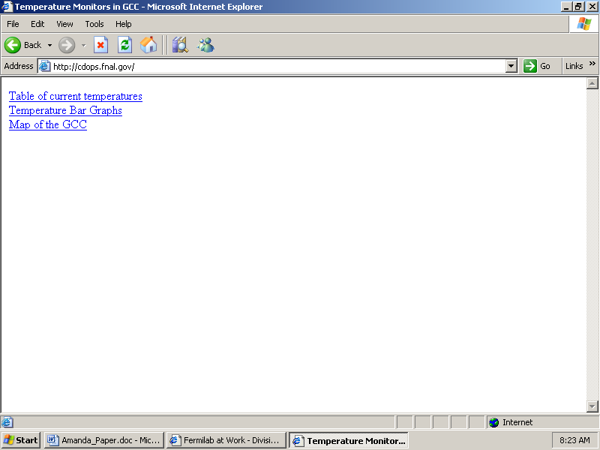

Figure1.1 As you can see, the original webpage was just a blank html page with three active links.

The Project

For the purpose of my project, I was required to modify the existing webpage currently being used to display data for the generated pages by python, for the temperature monitoring. Also, I recreated some pages on the Computing Division’s homepage facilities operation department using

Learned Technology needed for the project

Before arriving at Fermilab I had some programming and web design experience. For example, I had previously worked with Macromedia Dreamweaver and Fireworks at a previous internship, and some aspects of “object-oriented” programming – all of which provided useful background to my Fermilab project.

However, in order to do this project, I had to know some additional specific usages, skills, and techniques of Dreamweaver. For example, I had to go to the local library and read several books explaining how to utilize certain features commonly used on Dreamweaver. In addition, I had to research online “About”articles on topics that weren’t specifically covered in the textbooks.

Finally, beyond the specific needs of the project, I became familiar with additional programming languages such as, Python and Perl.

Learning Perl

The first language that I became familiar with here at Fermilab was Perl. PERL (Practical Extraction and Report Language) was created by Larry Wall in 1987. The language is available for Unix, Windows NT, Mac, and DOS computer systems. I learned the language in about a week using Pearls of Perl by David Ritchie and several other resources, such as about.com. These documents taught me Perl through examination of several small programs. This finally concluded with me writing a simple shopping adventure game using the Perl language, in which, through many stages, the player can chose to shop at several stores and from there, put together the perfect outfit.

I downloaded the Perl software from http://www.perl.org/ and the Pearls of Perl document from http://www.DavidJRitchie.com//pop/pop.html.

Learning Python

Python was created by Guido Van Rossum in February of 1991. His work with previous languages such as ABC, Modula-3, and Amoeba could be called the driving force behind Python’s production. Since its creation, it has been modified and adapted by other programmers to make certain the language will remain up-to-date and to keep the software current for programming needs. Python was designed to emphasize the work of the programmer versus the computers effort. The used several documents to learn what I now know about Python. Two in particular being about.com and a document titled Non-Programmers Tutorial for Python, which was written by Josh Cogliati and is available online at http://ccism.pc.athabascau.ca/html/courses/comp200n/python/easytut.html. Upon completion of this document, Dr. Ritchie told me to create a game that could be both beneficial in my learning process here and when I went back home. Eventually I decided on creating a math game for a sixth grade class I sometimes tutor at my old elementary school.

Learning Dreamweaver
Adobe Dreamweaver is a web development application originally created by Macromedia and now owned by Adobe Systems, which acquired Macromedia in 2005. Dreamweaver is available for both Mac and Windows operating systems. Recent versions have incorporated support for web technologies such as CSS, JavaScript, and various server-side scripting languages and frameworks including ASP.NET, ColdFusion, JavaServer Pages, and PHP.
The first version Dreamweaver 1.0 was released in December of 1997. The version that the department purchased however, is Adobe Creative Suite 3. Upon arriving here, at a previous internship, I briefly worked with Macromedia Dreamweaver and Fireworks. So, I basically knew a little about working with Dreamweaver, but had never actually created an entire website on my own.
Some of the more specific aspects of Dreamweaver I had to research in order to utilize, included creating image maps, creating cascading style sheets, and rollover effects.
Figure 2. Screenshot of the the Dreamweaver software
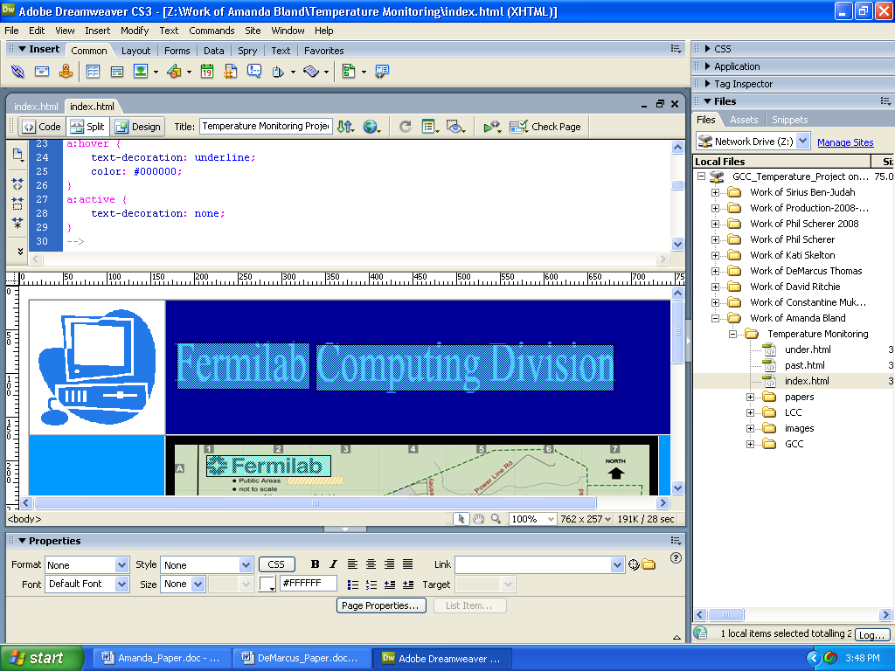
Figure 2.1 One of the many features is that Dreamweaver allows the user to either work in design view, split view, or code only view. This is an example of the split view.
Figure 3. Screenshots of a few pages I created
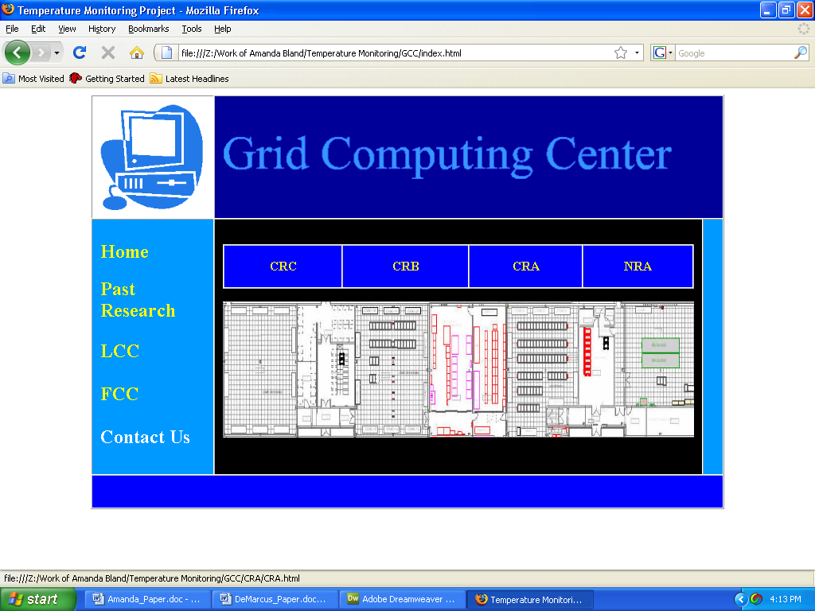

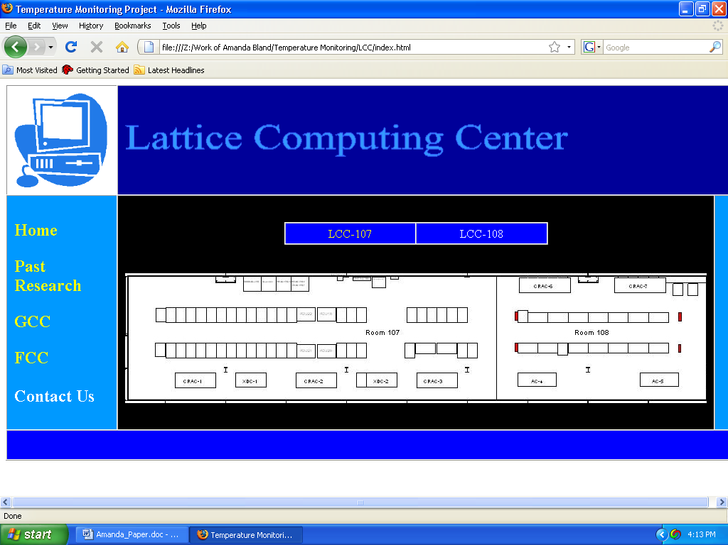
Figure 3.1 Two screenshots of the Grid Computing Center and Lattice Computing Center’s webpage.

Improving Temperature Monitoring at GCC

Phil Scherer’s Enhancements
This summer, I worked with Phil Scherer, an incoming freshman at Rose Hulman Institute of Technology in Terre Haute, IN. He has worked on the project for approximately two years. Because of this, our supervisor decided to let him deal with making enhancements to the actual Python script currently being used to monitor the temperatures. The enhancements he made, were the following:
- Combined the currently used XML files into one unified storage system.
- Added data to include recorded temperatures as far back as 366 days.
- Removed hard-coded thresholds.
- Made temperature thresholds similar throughout the entire program.
- Added thresholds to the hot aisles.
- Added incident reporting with generated attachment pages that can be opened using excel, notepad, etc.

Conclusions

Success of Project
The project in my opinion was a huge success. I was able to accommodate the look and feel that my supervisors were looking for as well as add my own flavor to the overall website.

Actual Departmental use of the program
One enjoyable aspect of my project is that I can see how the webpage is beneficial to the staff of the Computing Division. Now, there is an actual way to display all the rooms currently being monitored without memorizing several url’s that you have to type in. As far as the manageability of the webpage, the excellent thing about Dreamweaver is that someone who has basically no knowledge about programming can utilize the design display only feature and work from there. The only downside would be if the page wasn’t displaying exactly how you wanted it, then it would take some programming knowledge to read the code and find where the problem might be.

Future Enhancements
Some future enhancements that were discussed during the end of the summer included, monitoring in the Feynman Computing Center, the Lattice Computing Center’s room 108, and the Grid Computing Center’s computer room C. Also, the next summer student would need to update the pages for each room and add any necessary data.

Acknowledgements
First and foremost, I would like to thank God for blessing me with this wonderful opportunity,
Ms. Diane Engram and Linda Diepholz for accepting me into the program, Mrs. Sandra Charles and Dr. Davenport for their many words of encouragement, Mr. Rick Hill for responding to my request to download Dreamweaver on my desktop in a timely fashion, to my supervisors Tim Kasza, David Ritchie, and Adam Walters for being open to answer any questions I may have had, the entire Computing Division, my partner Phil Scherer for his many days of criticism , my SIST Committee mentor David Peterson, Dr. Joe Anderson for writing me a letter of recommendation and last but not least, my parents Edgar and Constance Bland Jr. and grandparents for their much needed support throughout this entire endeavor.

References

Cogliati, Josh. Non-Programmers Tutorial for Python. Josh Cogliati., Idaho Falls, Idaho, 1999
History (http://www.fnal.gov/pub/about/whatis/history.html)

Thomas, DeMarcus. Temperature Monitoring in GCC. 2007

Python Tutorial http://ccism.pc.athabascau.ca/html/courses/comp200n/python/easytut.html

Perl Tutorial http://www.svs.com/djr01//pop/pop.html

About Dreamweaver http://en.wikipedia.org/wiki/Dreamweaver

