4th CONCEPT DETECTOR WITH A SINGLE SOLENOID:
A PRELIMINARY ANALYSIS

Matthew Cosenza
Illinois Institute of Technology
Submitted August 7, 2006

Supervised by Ryuji Yamada P.H.D, Technical Division, Magnet Systems Department

Summer Internship in Science and Technology (SIST)
Fermi National Accelerator Laboratory
P.O. Box 500 M/S 117
Batavia, IL 60510-0500


Table of Contents
Table of Figures……………………………………………………………….. ………………….3
Abstract…………………………………………………………………………………………… 4
Introduction……………………………………………………………………………………….. 5
Materials and Methods……………………………………………………………………………. 6
Results and Future Work….……………………………………………………………………… 7
Literature Cited…………………………………………………………………………………… 7
Acknowledgments………………………………………………………………………………… 8
Appendix A: Concept Designs in COMSOL……………………………………………………... 9
Appendix B: Analysis Plots……………………………………………………………………... 12
Appendix C: Magnetic Field Stress Analysis in Two Dimensions……………………………... 14
Table of Figures
Figure 1: ILC Overview...………………………………………………………………………… 5
Figure 2: Fully Assembled 4th Concept Detector.....……………………………………………… 9
Figure 3: 4th Concept Detector without end cap…..…………………………………………….. 10
Figure 4: 4th Concept Detector without end cap or vacuum vessel casing……………………… 10
Figure 5: 4th Concept Detector XZ cross-section…..…………………………………………… 11
Figure 6: 4th Concept Detector YZ cross-section..……………………………………………… 11
Figure 7: Magnetic Flux Density Analysis Plot………………………………………………… 12
Figure 8: Deflection Analysis Plot……………………………………………………………… 12
Figure 9: Stress Analysis Plot…………………………………………………………………… 13
Figure 10: 2D COMSOL Sketch of 4th Detector..……………………………………………… 15
Figure 11: Subdomain Plot……………………....……………………………………………… 16
Figure 12: Magnetic Flux Density Analysis Plot..……………………………………………… 18
Figure 13: Deflection Analysis Plot…..………………………………………………………… 19
Figure 14: Stress Analysis Plot.………………………………………………………………… 20
Abstract
4th Concept Detector with a Single Solenoid: A Preliminary Analysis. MATTHEW B. COSENZA (Illinois Institute of Technology, Chicago, IL 60616) RYUIJI YAMADA (Fermi National Accelerator Laboratory, Batavia, IL 60510).

The 4th Concept Detector will have two proposal designs, a two-solenoid design and a one-solenoid design. Using a finite element analysis (FEM) program called COMSOL, preliminary magnetic field, stress, and deflection analyses were developed for the newer one-solenoid design. Much of the summer was dedicated to understanding COMSOL and learning how to use the computer assisted drawing (CAD) tools associated with the program. The overall weight of the structure was assessed and it was determined that due to the size and weight of the detector, a new support system needs to be developed.
Introduction
The purpose of this project is to complete a preliminary Computer Assisted Drawing (CAD) with Finite Element Analysis (FEA) of the magnetic field and stresses caused by the magnetic field of a single solenoid design for the 4th Concept Detector for the International Linear Collider (ILC).
Particle Accelerators and the need for Detectors
When the ILC is built, detectors will be needed to study the particles that will be generated when the particle beams are collided. Ernst Lawrence built the first Cyclotron in 1929. Since then, many leaps have been made in the field of particle acceleration culminating in the construction of the Tevatron at Fermilab and the LHC at CERN. The Tevatron accelerates both protons and antiprotons to 1 TeV (Terra-electron Volt) and smashes them together. These collisions occur in two places along the Tevatron’s accelerator ring, one at D0 and the other at CDF. The two collaborations sift through data to find out more information about particles such as the top quark and the Higgs boson.
ILC
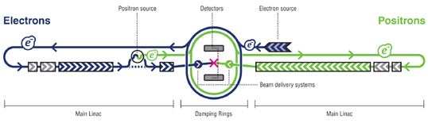
Figure 1 – An overview of the International Linear Collider (linearcollider.org).
There are a few countries looking to acquire the bid for the International Linear Collider. The United States is a strong candidate for acquiring the ILC. If the US wins the bid, the ILC will be built at Fermilab. Current plans for the ILC include two detectors that can alternate time in and out of the beam line. The ILC will collide electrons and positrons. Two 10-mile long beam lines will meet at a central location for the collisions to occur. The initial design for the ILC allowed for four detectors to be used at two separate collision points. This proved to be too expensive so there is only one collision point and either of two detectors will take readings from this point. Initially there were three teams working on designs for the detectors, a European team, an Asian team, and an American team. Enough people liked certain aspects of a new concept calorimeter that was not going to be used by any of the teams that they decided to create a team to work on the 4th Concept Detector design. Since the initial design process, the Asian and European teams have combined to work on one design. The 4th Concept Detector team is much smaller than the American and Asian and European teams and is an international team.
4th Concept Detector
The initial proposal for the 4th Concept Detector uses a two-solenoid design. There is, however, some doubt to the practicality of two solenoids. A new proposal is being drawn up and will utilize a conventional one-solenoid design. The one-solenoid design will be lighter and cheaper to manufacture. The new design will have a solenoid with an inner diameter of 6 meters with steel used as its yoke and structure for carrying the muon chambers. The steel will reach 13 meters in diameter. The force generated by the magnetic field on the end caps will be approximately 1300 tons. The entire structure will weigh approximately 11,000 tons.
Methods and Materials
The main design tool used for this project was COMSOL. Utilizing COMSOL’s powerful Finite Element Analysis, a two-dimensional magnetic field analysis, stress analysis and deflection analysis were calculated. Following a similar method to the instructions outlined in Appendix C, the analysis plots shown in Appendix B were created.
COMSOL, a commercial Finite Element Analysis program, is gaining in popularity. Its computational power is unmatched by any other FEA program, though it still has some issues that could be worked out. One problem with COMSOL is that the CAD component of the program is not very intuitive. The most time-consuming part of an analysis is adding the geometry. Once the geometry is added (via the CAD component or Import Module), calculations can easily be made. A detailed calculation process is discussed in Appendix C.
There were some issues with importing of the calorimeter geometry into COMSOL. A script needs to be written in order to import the geometry from the files that are currently available or the COMSOL Import Module needs to be purchased. Both a script and the module would work quite well. The script would be considerably cheaper but require more man-hours. The problem is that the program only imports the first surface triangle or piece and doesn't continue to the rest of the file.
Results and Future Work
A new support structure needs to be designed so that the detector doesn’t distort itself while it’s moved in or out of the beam line. The current structure shown in Appendix A is flimsy and heavy. Once the muon chamber design is more detailed and the calorimeter is included in the schematic a structural engineer should redesign the support system to be sturdier and lighter.
Literature Cited
http://www.linearcollider.org/cms/

Acknowledgements
I would like to acknowledge Dianne Engram, Jameison Olsen, and the rest of the SIST committee for the opportunity to work at Fermilab this summer. I would also like to thank my supervisor, Ryuji Yamada, for his patience and guidance in my studies for the summer, my mentor, Cosmore Sylvester, for helping me focus on the important parts of my research, and Dr. Davenport for his assistance in the final touches to my paper and presentation.
Appendix A: Concept Designs in COMSOL

The following figures depict basic designs of the 4th Concept Detector to be used at the yet to be built ILC. Orange depicts the base that will move the structure in and out of the beam line. Light blue depicts the steel structure that outlines the end caps and muon chambers. Dark green depicts the structural aluminum that will be used to support the conducting coil. Red depicts the conducting coil. Gray depicts the vacuum chambers surrounding the coil.

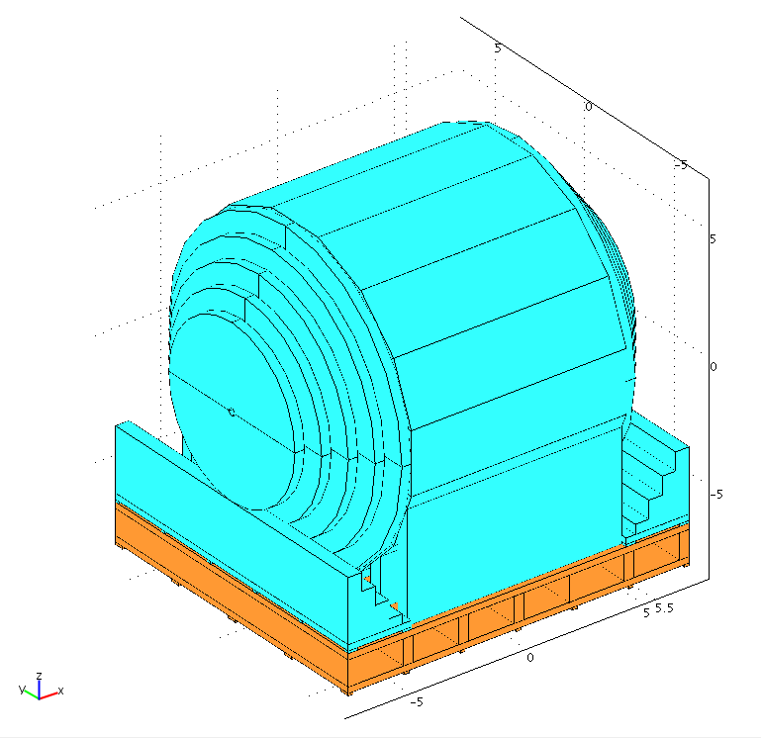
Figure 2 – Aerial 3D view of the fully assembled 4th Concept Detector in COMSOL.

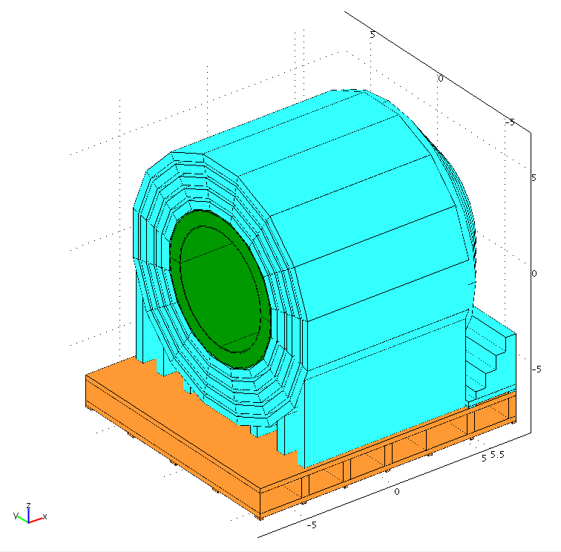
Figure 3 – Aerial 3D view of the 4th Concept Detector with an end cap removed.

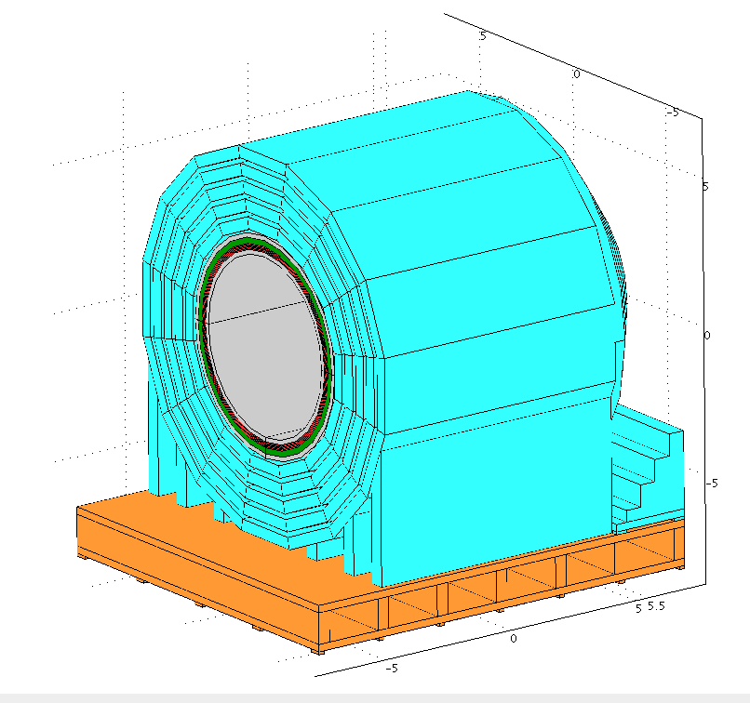
Figure 4 – Aerial 3D view of the 4th Concept Detector with an end cap and the vacuum vessel casing removed.

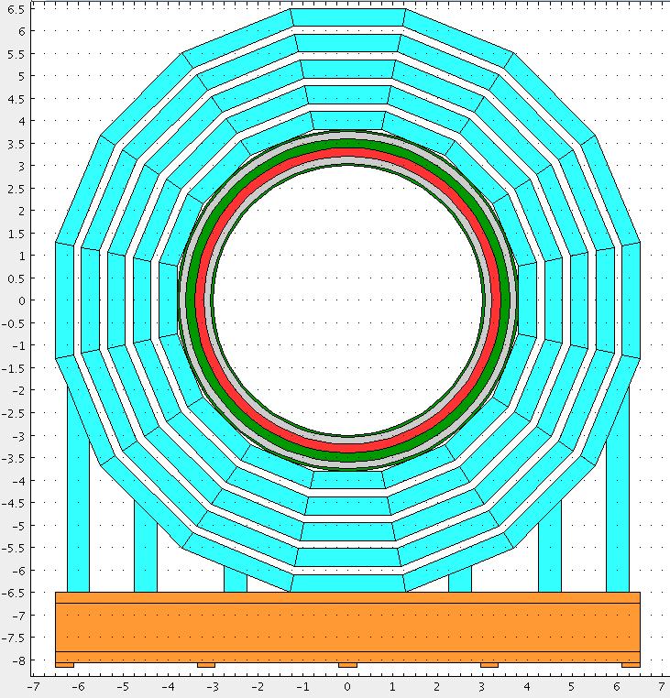
Figure 5 – XZ-plane cross-sectional plot of the 4th Concept Detector.

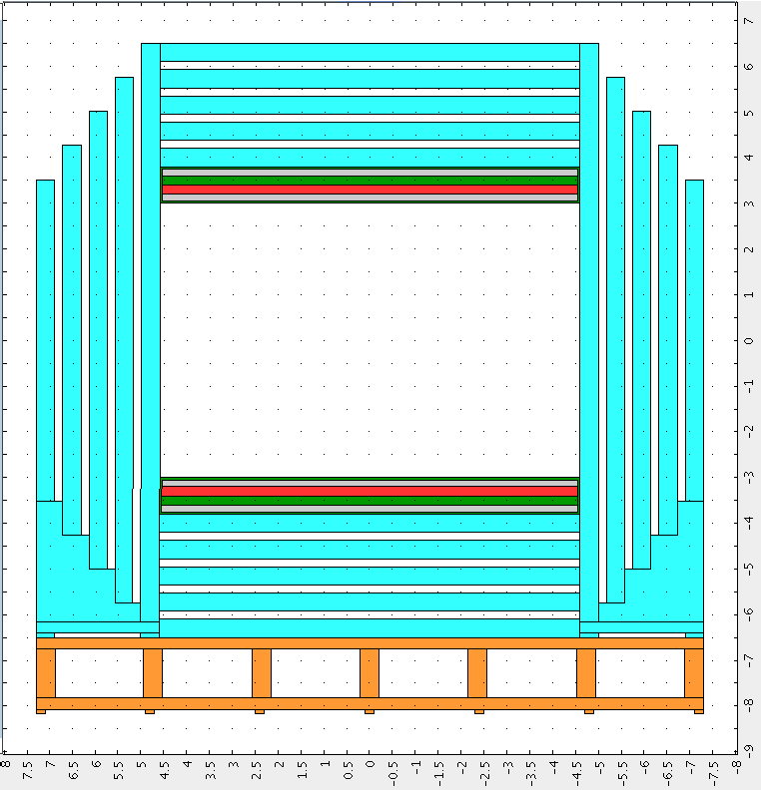
Figure 6 – YZ-plane cross-sectional plot of the 4th Concept Detector.
Appendix B: Analysis Plots

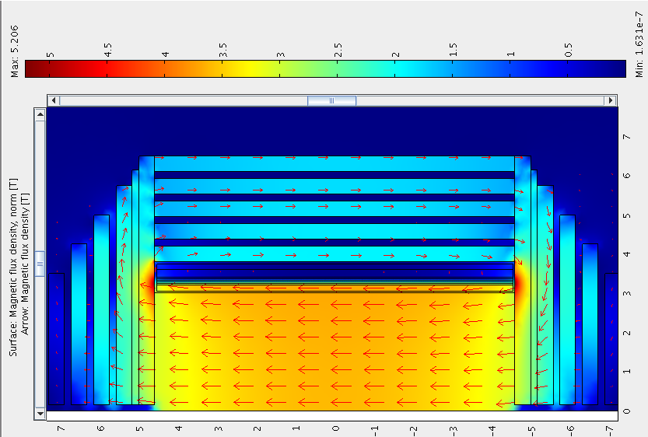
Figure 7 – The Magnetic Flux Density plot shows that the field generated by the solenoid is approximately 3.5 Tesla.

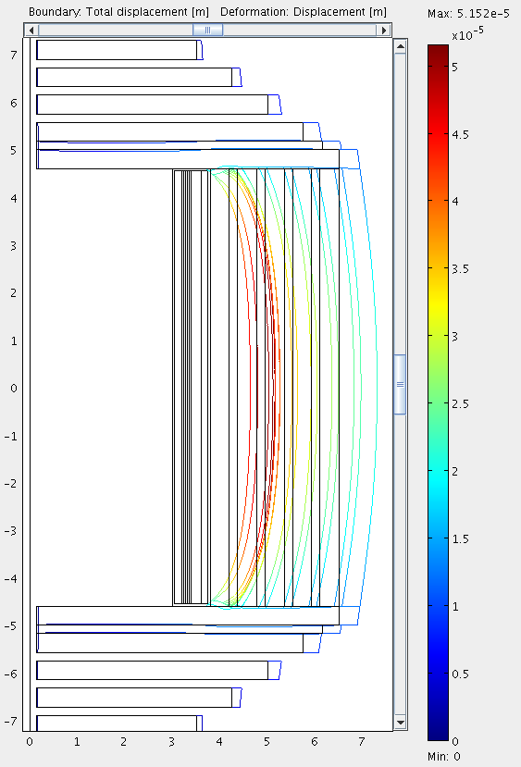
Figure 8 – The Deflection Plot shows that the maximum deflection caused by the solenoid is approximately 51.5 microns.

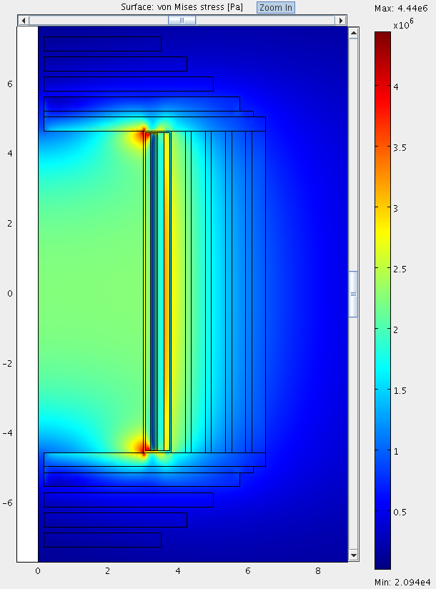
Figure 9 - The Stress Plot shows that the maximum stress caused by the solenoid is approximately 4.4 MPa.
Appendix C: Magnetic Field Stress Analysis in Two Dimensions

First access COMSOL. From the Model Navigator select Axial Symmetry (2D) from the drop down menu. Click the Multiphysics button. From the Application Modes list select COMSOL Multiphysics, Electromagnetics, then Magnetostatics. Click the Add button. Next select Structural Mechanics Module, then Axial Symmetry, Stress-Strain from the Application Modes list. Click the Add button then click OK.

Geometry Assembly

Now the geometry of the detector must be added. Figure 10 shows the geometry with dimensions that was put into COMSOL.

To obtain this geometry put the following rectangles into COMSOL.

4th Detector Dimensions for 2D Analysis
(All Dimensions in meters)
Piece | r | z | width | height
aluminum support | 3.000 | -4.600 | 0.800 | 9.200
aluminum bobbin | 3.400 | -4.550 | 0.200 | 9.100
inner vacuum | 3.050 | -4.550 | 0.150 | 9.100
outer vacuum | 3.600 | -4.550 | 0.150 | 9.100
solenoid 1 | 3.200 | -4.550 | 0.040 | 9.100
solenoid 2 | 3.240 | -4.550 | 0.040 | 9.100
solenoid 3 | 3.280 | -4.550 | 0.040 | 9.100
solenoid 4 | 3.320 | -4.550 | 0.040 | 9.100
solenoid 5 | 3.360 | -4.550 | 0.040 | 9.100
vertical steel 1 | 3.800 | -4.600 | 0.400 | 9.200
vertical steel 2 | 4.375 | -4.600 | 0.400 | 9.200
vertical steel 3 | 4.950 | -4.600 | 0.400 | 9.200
vertical steel 4 | 5.525 | -4.600 | 0.400 | 9.200
vertical steel 5 | 6.100 | -4.600 | 0.400 | 9.200
horizontal steel 1 | 0.150 | 4.600 | 6.350 | 0.400
horizontal steel 2 | 0.150 | 5.175 | 5.600 | 0.400
horizontal steel 3 | 0.150 | 5.750 | 4.850 | 0.400
horizontal steel 4 | 0.150 | 6.325 | 4.100 | 0.400
horizontal steel 5 | 0.150 | 6.900 | 3.350 | 0.400
horizontal steel 6 | 0.150 | 5.000 | 6.000 | 0.175
Table 1 - Drawing Dimensions in meters.

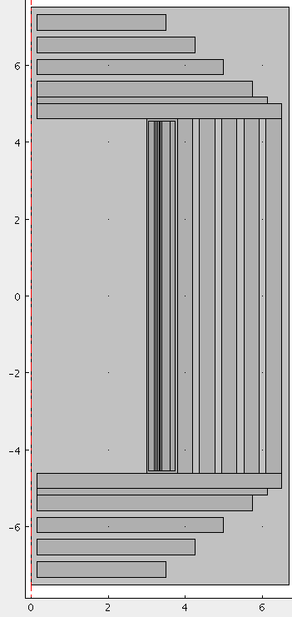
Figure 10 - 2D COMSOL Sketch of 4th Detector.

Use the Mirror tool (normal vector R=0 and Z=1) to obtain the lower 6 horizontal steel plates.

Subdomain Settings and Boundary Conditions

Once the geometry is in place, the proper subdomain and boundary settings must be established. From the Multiphysics drop-down menu select Magnetostatics. Next from the Physics drop-down menu select Subdomain Settings. According to Figure 11 select all light blue rectangles. Click Load and select Soft Iron from the materials library. Change the μ_{r} (isotropic) equation to a constant 100. Now select the dark green piece. Load the Aluminum 6063-T83 material data for this piece. For the red rectangles load the Aluminum material data and set J_{phi} to 15e6 A/m². For the gray pieces and the box surrounding the outside of the detector, load the material data for Air.
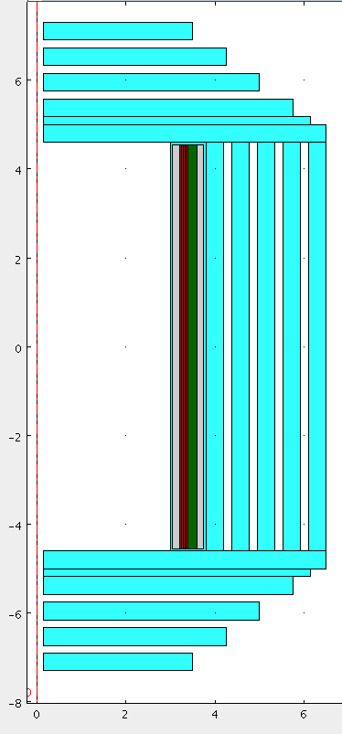
Figure 11 - Subdomain Plot.

Now from the Multiphysics drop-down menu select Axial Symmetry, Stress-Strain. Open up the subdomain settings box from the Physics drop-down menu. For the light blue rectangles shown in Figure 11 select Structural Steel from the materials library, for the dark green section select Aluminum 6063-T83, and for the red sections select Aluminum. For the remaining sections (gray and white) select Air. Select the large white section. Click on the Constraint tab and change the Constraint condition to Prescribed displacement. Check the box labeled R_{z}. Next select only the red sections. Click on the Load tab and change the equation for F_{r} to normB_qa*normB_qa/2/mu0_qa. The formula for F_{r} is taken from Equation (1).

, (1)

Select Magnetostatics from the Multiphysics drop-down menu again. Now select Boundary Settings from the Physics drop-down menu. Select the line that is on the z-axis. Change the Boundary condition to Axial symmetry. Select the other three borders to the largest rectangle and change the Boundary condition to Magnetic insulation. No alterations must be made to the boundary settings for the Axial Symmetry: Stress-Strain model.

Solving

Select Solver Manager from the Solve drop-down menu. Under the Solve For and Output tabs ensure that Magnetostatics (qa) is the only level highlighted. Click Apply, then click Solve. Once the solver is complete go to the Initial Value tab and click the Store Solution button. Next click the Stored Solution radio button under Initial value. On the Solve For and Output tabs highlight all of Geom1 (2D). Click Apply, then click OK.

From the Multiphysics drop-down menu select Magnetostatics (qa) then open up the Subdomain Settings box again. According to Figure 11, select the light blue rectangles. Load the material properties for Soft Iron. In the μ_{r} (isotropic) equation, alter the equation to show MUR(normB_qa) instead of MUR(normB_emqa). Click Apply, then click OK. Click the solve button.

Plotting

Once the solver is done, the Magnetic Flux Density plot should look similar to Figure 12 with a maximum of approximately 5.73 Tesla. To show the arrows select Plot Parameters from the Postprocessing drop-down menu. Select the Arrow tab. Check the box that says Arrow Plot. From the Subdomain Data subtab select Magnetic flux density from the drop-down menu. Set Number of points to 20 in both the r- and z-axis’. Click Apply, then click OK.

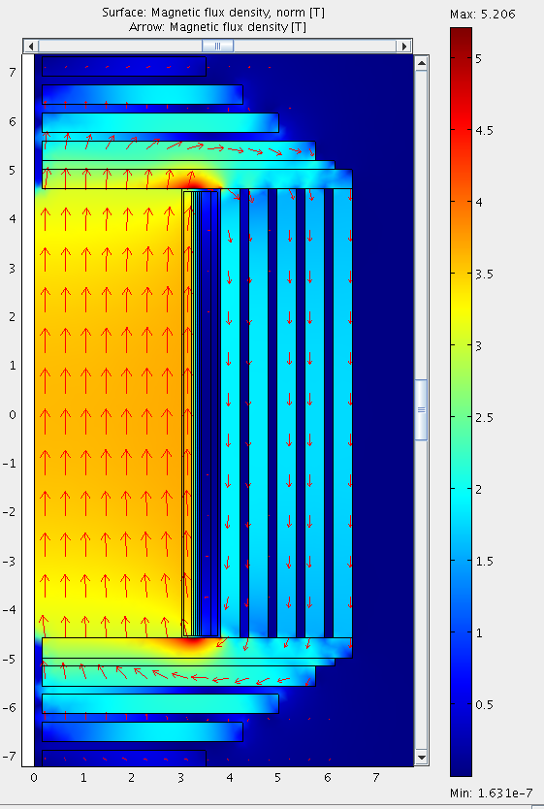
Figure 12 - Magnetic Flux Density Plot.

To show the stress analysis as shown in Figure 13, select Plot Parameters from the Postprocessing drop-down menu. Select the Subdomain tab. Select von Mises stress from the drop-down menu. Next select the Arrow Tab and deselect the box that says Arrow Plot. Click Apply, then click OK.

Figure 13 - von Mises stress plot.

To show the displacement analysis as shown in Figure 14, select Plot Parameters from the Postprocessing drop-down menu. Select the Boundary tab. Select Total displacement from the drop-down menu. Next select the Deformation tab. Check the Boundary box. For the Boundary data tab, select displacement from the drop-down menu. Select the General tab and deselect the Surface check box. Click Apply, then click OK.

Figure 14 - Boundary Displacement Plot.

