Monitoring the consequences of ground motion on accelerators:
The “ATL” Law

Prepared by: Andre Prescod
College of Science, Mathematics & Engineering Technology
South Carolina State University, Orangeburg

Fermi National Laboratory
Batavia Illinois
60510-0500
August 7th, 2008

A Report submitted in partial fulfillment of the requirements of the SIST program.

Supervised by: James T Volk
Applications Physicist II
Accelerator Division
Abstract
Central to high energy particle acceleration and collisions, is the ability to control beams of particles with a high degree of accuracy. The interaction point (IP) is determined by a complex system of control in which electrically charged particles are steered via the electric fields of electromagnets. Paramount to this process then, is the alignment of these magnets. Beyond this initial alignment though, is the need to re-align these magnets due to ground motion amongst other factors. The extent of the natural gradual ground motion can be measured and interpreted via the existing ATL law. The ATL law suggests that for two points separated by a distance L for time T, the rms (root mean square) relative displacement of these two points is directly proportional to the product of T and L. To study this for the magnets, HLS (Hydro static water Level System) systems were setup within the region at two sites; the LaFrage mines and at MINOS. By measuring the changes in water levels, the ATL law can be applied to obtain the ‘A’ value for the Fermilab region. Using the water level variations a series of calculations are made using VBA for Excel, and subsequently the A value of the Fermilab region was found to be = 2 to 6 x10⁻⁶ μm²/s-m. Using this ‘A’ value, the relative displacement of the magnets can be corrected using further programming and algorithms. This study of the ground motion also aids in providing statistical analysis of the feasibility of the ILC being constructed in the Galena Platteville shale of Illinois(incidentally the sensors at both sites are at least 100m below grade just as the proposed depth of the ILC).

Table of Contents

Introduction: Presenting Fermilab 5
Accelerators: The Effect of Ground motion 7
The ATL Law 9
Experimental Details 10
Visual Basic for Applications: VBA for Microsoft Excel 16
Results and Setbacks 21
Conclusion and Evaluation 23
Future Works 26
References 27
Acknowledgements 28
Appendix A-D 29-32

Table of Figures

Diagram 1: Simple HLS 11
Figure 1: HLS setup MINOS (Budker sensor) 12
Figure 2: LaFrage mine HLS setup with cement pillar 13
Figure 3: Budker Sensor 14
Figure 4: Balluff Sensor 15
Figure 5: Step by step sequence of calculating ‘A’ 18-20

Introduction
Presenting: Fermilab
Initially known as the National Accelerator Laboratory, Fermilab was renamed in 1974 in honor of 1938 Nobel Prize winner Enrico Fermi. The “defined” mission of the lab is to advance the understanding of the fundamental nature of matter and energy. More practically, the lab attempts to explain/explore certain loopholes in the standard model by observing matter in high energy collisions, and developing new theories for a new dawn of physics. Founded in 1967, Robert Rathburn Wilson was named as its first director. Fermilab has seen its share of acclaimed and in some cases decorated physicists as its director, from then until now. Among them 1988 Nobel Prize in Physics laureate, Leon Lederman, who served as director until that prize-winning year. The current director is 2005 Panofsky Prize winner Piermaria Oddone.
Particle acceleration is at the helm of Fermilab’s very existence. A particle accelerator basically uses electric fields to control electric particles. Using the electric fields created by electromagnets, “beams” of electrically-charged particles are steered and controlled, and over time, accelerated within the particle accelerators at Fermilab. There are a series of accelerators at Fermilab used in a step by step process, of which the Tevatron is the largest and final accelerator. At four miles in circumference it is substantially more powerful than any other in the world; second only to the newly constructed Large Hadron Collider (LHC) in Switzerland, and uses superconducting electromagnets as its source of electric field. These accelerators are being used to create collisions of proton and antiproton particles, and to record the results of these high energy collisions. These experiments are in an attempt, to discover the missing link, in the conditions of matter in the early universe.
However central to all of this, is the ability of physicists to control the beams, such that the collisions are best. Even further, being able to control the beam suggests ideal electric fields, which in turn suggests proper magnet alignment. Of course there would also be the appropriate computer programs, and alignment algorithms to control these alignments from a remote location. This paper however, focuses on the impact of the earth’s motion on this magnetic alignment. More directly, this paper analyzes ground motion of water pools that were set up for modeling the slow degeneration in the alignment of magnets. It explores theories that have been found to express a relation between distance and time and the existence of a constant, in the determination of an alignment ‘factor’ at some point, based on these ground motion variations. This paper also presents and evaluates data on this theory to better determine a model for magnet alignment and how often it needs to be done.

Theory

Accelerators:
The Effect of Ground Motion

The resultant motion of the proton/antiproton beam, due to the movement of the quadrupole (magnet) itself, is quite substantial. For this reason ground motion is of particular interest to accelerator builders. For collider designs, the requirement to achieve a high luminosity at the interaction point places the most stringent restrictions on ground motion.
Ground motion and vibration can be a limiting factor in the performance of colliders, in particular linear colliders and large hadron colliders. Studies of ground motion have been carried out around the world for many years and it has been found that ground motion and vibration have two significant effects on a collider. They can cause the beams to miss each other at the interaction point (IP), and they can cause beam emittance growth, which reduces the luminosity.
Emittance refers to the extent occupied by the particles of the beam in space and momentum phase space as it travels. A low emittance particle beam is a beam where the particles are confined to a small distance and have practically the same momentum. A beam transport system will only allow particles that are close to its design momentum, and of course they have to fit through the beam pipe and magnets that make up the system. In a colliding beam accelerator, keeping the emittance small increases the likelihood of particle interactions, resulting in higher luminosity.
Luminosity is the number of particles per unit area, per unit time multiplied by the opacity of the target, usually expressed in either the cgs units, or cm⁻² s⁻¹ or b⁻¹ s⁻¹. Opacity describes the absorption and scattering of radiation in a medium. A colliding beam should have high luminosity and low emittance, to yield maximum interactions. In an ideal accelerator with well-aligned magnetic elements, the closed orbit passes through the centers of bending magnets and quadrupoles to provide optimal conditions for the operation of the machine.
It is not difficult to see then, why determining ground motion trends, and curbing them somewhat, is important for current and future work in particle acceleration. However in the collection of this data there are a number of interpretations and/or data analysis techniques of ground motion and they are: (Please refer to Appendix for these techniques with the exception of the ATL law)
- Power Spectral Density
- Wave Propagation
  - P-waves
  - S-waves
  - Surface waves
  - Love waves
  - Rayleigh waves
- Apodisation
- Velocity or Displacement Power Spectral Density
- Coherence and Correlation
- Ground Motion Spectra
  - Tidal Motion
  - Micro-seismic Peak
  - Crustal Resonance
  - Technical Noise and Cultural Noise
  - Ground Motion due to Airplanes
- The “ATL” Law

As mentioned before though, the scope of this paper is the ATL law and its application to Fermilab.

The ATL Law

An alternative method for analyzing some components of low frequency ground motion over long time intervals makes use of the so called "ATL law". It is used to describe the diffusive or Brownian motion that unconnected points on the ground (or structures attached to the ground) undergo. It also acts as a low intensity baseline to the regular (in time and space) motion due to propagating waves in the upper Earth's crust. According to the ATL law, the relative motion of two point scales is proportional to the product of the spatial and temporal interval between measurements. This empirical rule gives the rms relative displacement of two points separated by a distance and time as:-
Where the constant is of the order of, depending on conditions at the site, this corresponds to a power spectral density of:-
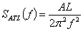, for (where ƒ refers to frequency in Hz)
This law is particularly useful for modeling the slow degeneration in the alignment of magnets in the accelerator which leads to the periodic need for realignment. At Fermilab, the ATL law is applied via the use of a water level system known as the Hydro Static water Level System for collecting the data, which is then analyzed in Microsoft Excels VBA to better determine the “A” value for this region.
Experimental Details
To facilitate the ground motion analysis ‘HLS’ are used to measure the change in floor level, and the water level variations. Fermilab and Budker institute have been collaborating on Hydro Static water Level Systems to measure ground motion for many years. Tests are conducted underground at a preferred depth of 100 or more meters below the surface in the Galena Platteville dolomite. Two of the current systems are in the near MINOS hall on the Fermilab site and the Lafarge (formerly Conco Western) mine in North Aurora Illinois. Both systems are in the Galena Platteville dolomite. Both systems use Budker institute designed and produced HLS systems to measure the change in floor level (refer to Figure 3 for the basic setup of the HLS with the Budker sensor).
Hydro static water levels are based on the principle that water seeks its own level. Distilled water is used since it is safe and the physical properties are well known so that measured data can be corrected for errors. There are two types of sensors being used in these HLS systems at Fermilab: the Budker sensor and the considerably less expensive Balluff proximity sensor (refer to Figure 4). For this study though the focus was on the Budker sensor since the data collected was from the Lafarge mine as well as on site at MINOS. In all cases a two pipe system is used at Fermilab. One pipe is full of water and connects each vessel or pool. This pipe is always below the desired level of water in each pool. The second pipe is elevated above the pools and is full of air (see Diagram 1).

Diagram 1: Simple diagram of the setup of the HLS system

The advantage of a two pipe system over a single half filled pipe is the ability to manoeuvre over or around obstacles between each pool. A half filled pipe system must be level throughout the installation. The sensors are spaced 30 meters apart, and consist of a stainless steel pool connected with 12.7 mm ID polyethylene tubing to adjoining pools (water filled tubes). Figure 1 shows the actual setup of the HLS system at MINOS.

Figure 1: HLS setup at MINOS (BUDKER sensor)
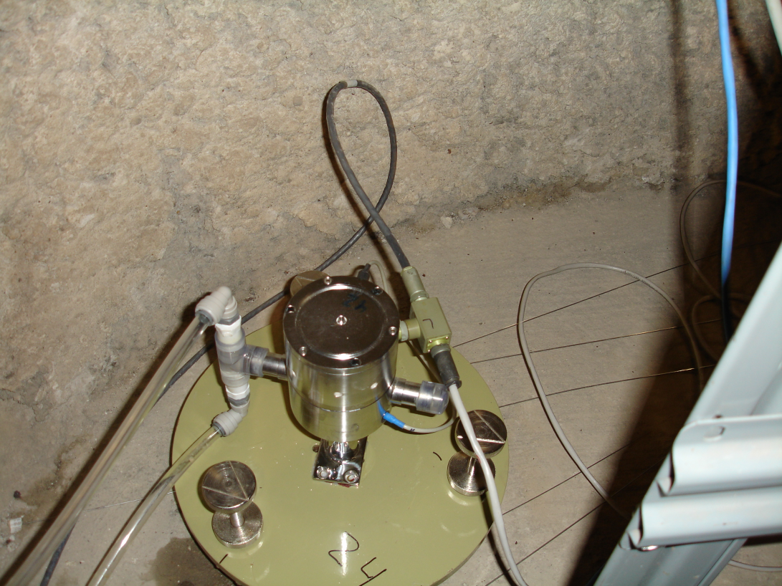
In the body of the pool there is a temperature sensor that records the water temperature and allows for corrections to be made for expansion due to temperature changes. Each pool sits on a plate with adjustable legs to allow for leveling of each sensor relative to the others. Since the pools are connected by tubes, to ensure a level starting point the legs are adjusted relative to one another. In some instances in LaFrage mines precisely measured cement “foundations” had to be setup as to allow for better leveling between adjacent pools (see Figure 2).

Figure 2: LaFrage mine HLS setup with cement pillar.
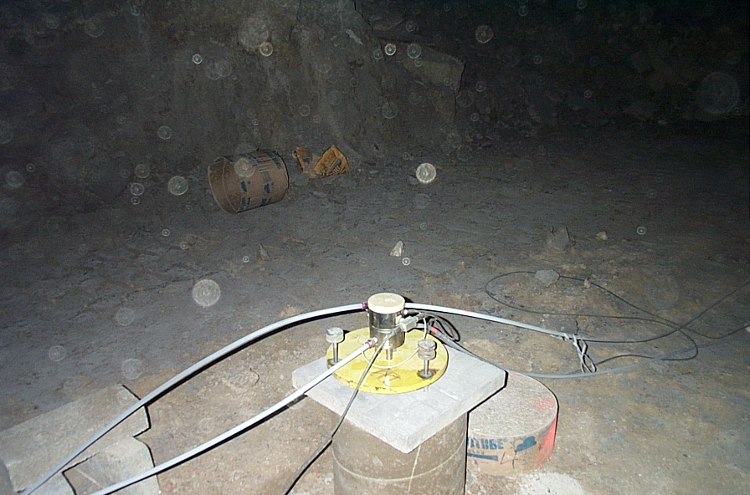
On top of the pool is the sensor and electronics. The sensor measures the capacitance of the gap between the sensor face and the top of the water. These capacitive sensors are used to determine the distance between the top of the water and the “cap” (or sensor face). The sensor is heated to prevent condensation; this would interfere with the precision of the measurements. Each sensor has been calibrated before installation. The gap measurement is accurate to 1 micro meter over a range of 10 mm. A power and data cable daisy chains between each sensor. The data is read out through a National Instruments card into a PC. Software reads out the data at 1 minute intervals and stores the data for later analysis. Systems are checked every business day to ensure the sensors and computers are functioning. At the end of every month data taking is automatically stopped and restarted. A reset pulse is sent out to each sensor in case a software hang occurred.
Figure 3: Budker sensor

Figure 4: Balluff sensor not used in this analysis but is used on site at the MP8 tunnel for similar ground motion analysis

The data that is read out through the National Instruments card into a PC is then archived as comma separated files online at http://dbweb1.fnal.gov:8100/ilc/ILCGroundApp.py/index . The data is timed stamped in one minute intervals using Central time. All levels are in micro meters, temperatures are in degrees C and pressure is in kilo Pascal. In order to make this data ‘useful’ Visual Basic for Applications was used.

Visual Basic for Applications:
VBA for Microsoft Excel
- What was the intended outcome of using VBA in Excel?
In order to make the comma separated data files of over 40,000 data points per month more useful, a suitable data analysis program was necessary. Microsoft Office Excel easily compiles the data into rows and columns. By copying the data from the online database into a notepad (.txt) file, then by renaming this file into a compatible file extension (.csv Comma Separated Value), the data becomes manageable. Once this is done, by writing a suitable macro data from any month can be used to determine the ‘A’ value. Depending on the computer being used this file may actually be downloadable as a ‘.csv’ file.
- What is a Macro?
A macro is a rule or pattern that specifies how a certain input sequence should be mapped to an output sequence according to a defined procedure. It basically is the group of instructions that the user wants executed within a given application (in this case Excel).
- What does this macro do?
The process is to first calculate the second differences for the system. In the case of the MINOS data for example, there are four sensors L0 through L3 two second differences can be calculated these are (in general a double difference is (D0-D1) – (D1-D2)) ;
SD012 = L0-2L1-L2
SD123 = L1-2L2-L3
Where L0, L1, L2 and L3 are the levels recorded for each sensor in micrometers.
This double difference is then squared for time slices from one minute to the range selected by the user. The average of the selected time slice is then found and divided by 30 to give the average dispersion per meter (since the sensors are separated by 30 meters). This average dispersion is plotted against time is second and the slope of this plot represents the A value in the ‘ATL’ analysis.
However before any of these calculations could have been done, their first needed to be some editing to the raw data. The macro needed to be user friendly so that any user regardless of familiarity, would be able to enter data of their choice and an A value would be returned. Simply put, the macro is the most logical way of processing this data since it would be rather time consuming to manually input these formulas on every occasion, again calling to mind the amount of data points there are (at least40,000 points per month for three years). Following are a series of example images showing the comma separated data, the raw .csv data, the final data, a plot of the dispersion and ‘A’ value, and of course a sample of the macro.

Figure 5: Step by step sequence of calculating ‘A’
Samples of the online comma separated data, and ‘.csv’ file extension data in Microsoft Office Excel. 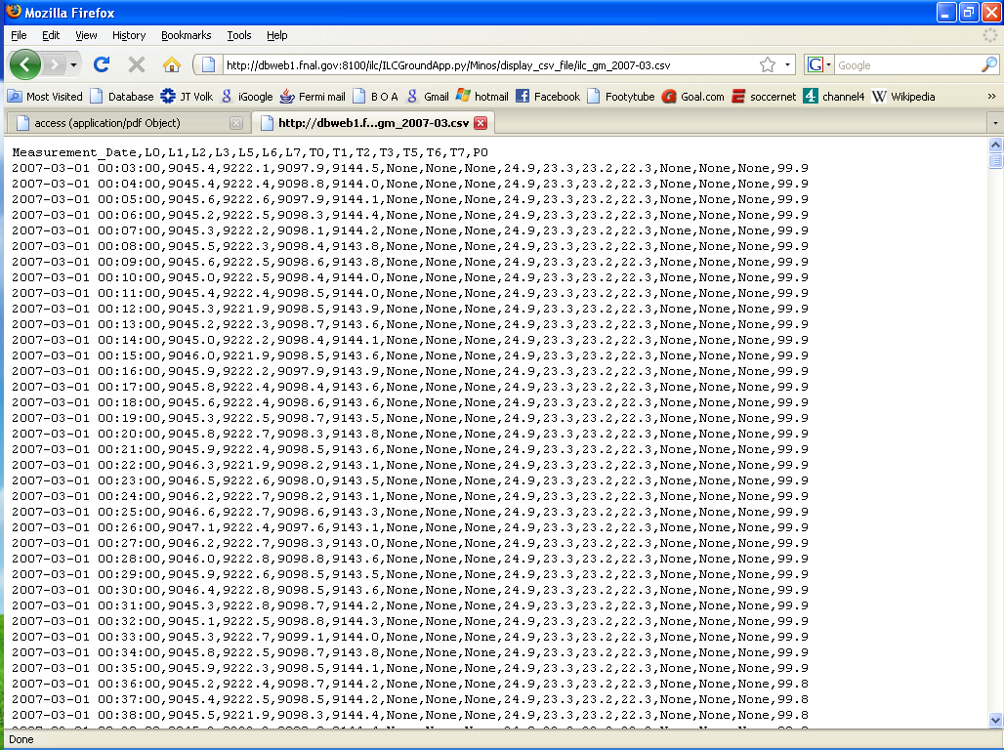
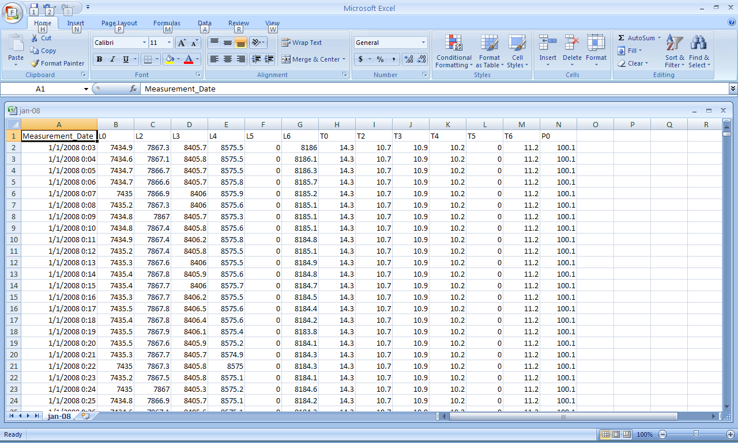
Data that has been processed and formulas entered
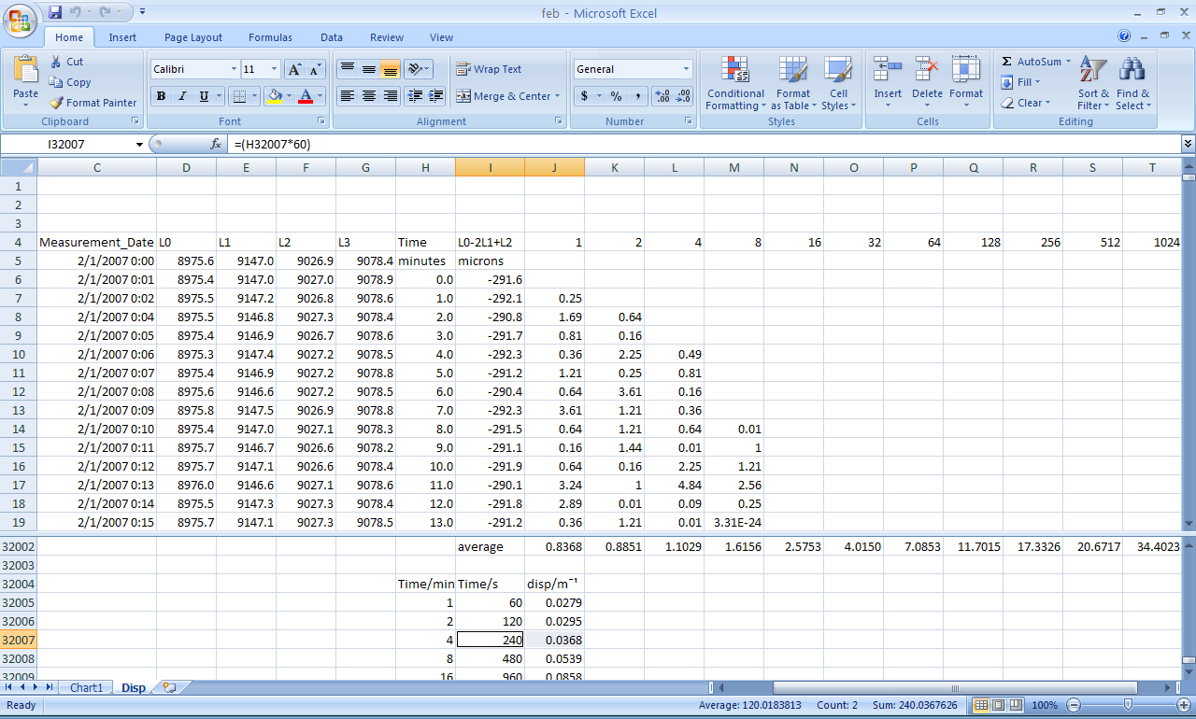
Plot of the Dispersion per meter versus time in seconds, the slope of which is ‘A’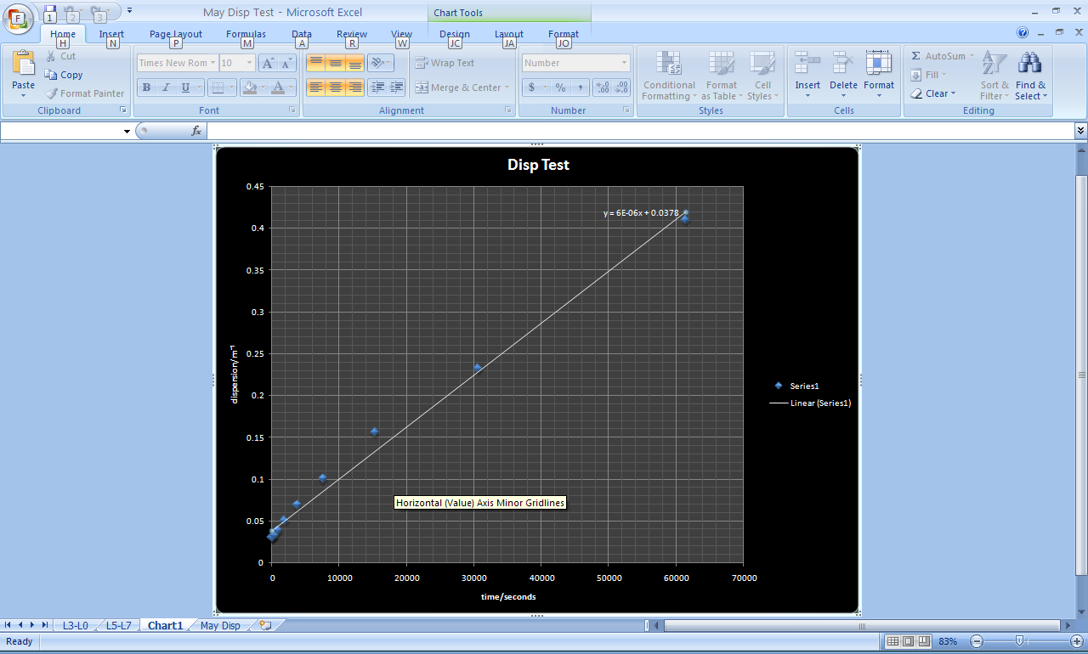
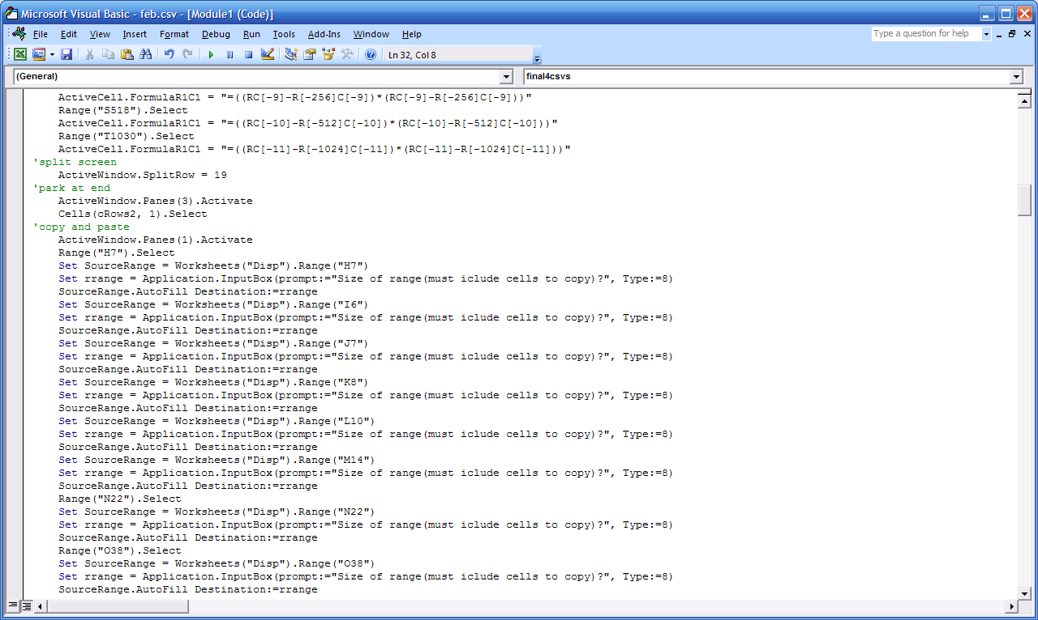
Sample of the VBA macro

Results and Setbacks
Data has been collected every minute for over 24 months in HLS systems installed in the Lafarge mines and at MINOS. The value of the constant A in the ATL law has been determined to be in the range of 2 to 6 x10⁻⁶ μm²/s-m (i.e. from 2x10⁻⁶ to 6x10⁻⁶ μm²/s-m) for the Fermilab area. This would suggest then, that the root mean square relative displacement of two magnets in this region, is equal to the product of the distance between them, the time, and this constant. Beyond the scope of this research though, this data will be used in some alignment algorithm to make the physical adjustment of the magnets. In the determining of this constant however, there were a number of modifications that had to be made.
The macro:
- At first the method of applying the data to all selected cells, was a command called a ‘for loop’. In a ‘for loop’ basically, the user directs the program to execute a command for the selected number of rows. Below is an example:
Range("C6:C6").Select
Selection.Copy
For r=6 To cRows
Cells(r,3).Select
ActiveSheet.Paste
Next
This code selects a certain cell and then instructs the program to copy its contents from row six to the selected row number. The problem with this format was the amount of time it took Excel 2007 to execute. A faster and easier format needed to be used.
- The first macro also didn’t allow for customizable month or day selection, in that only data input of a certain amount could be worked. The upgraded version took several weeks to tweak to its finished product. Any programmer can give testimony to the difficulties in just getting the program to do what is wanted without it disagreeing. It used the more basic copy and paste command. Following is an example of the improved macro:
Set SourceRange = Worksheets("May Disp").Range("H7")
Set rrange = Application.InputBox(prompt:="Size of range(must iclude cells to copy)?", Type:=8)
SourceRange.AutoFill Destination:=rrange
Although the actual code is longer, the execution time is considerably shorter, and uses less memory. This method also allows for and input dialogue box where the user can then choose the range to execute.
Microsoft Office Excel 2007
- Unfortunately, as much as Excel was most suitable for the job, it also proved to be troublesome. Excel does not allow for plotting of any data as long as there are more than thirty two thousand data points. In fact, even though the data to be plotted was only ever going to be eleven, the mere fact that the data was derived from more than thirty two thousand data entries, caused excel to deny the macro. Because of this in designing the dialogue box that prompts the user to enter how many rows, there is also the warning that a value of fewer than thirty two thousand must be entered. If not, the macro would not work and instead a notification of an ‘overload’ would come up and subsequently end the macro.

Conclusion and Evaluation
In the process of this research a lot can be taken into deeper consideration. There were no recognizable trends in the data from month to month; therefore this surveying is something that will continue indefinitely. Unless the earth stops spinning for some reason ground motion will always be an issue facing accelerator builders, regardless of how gradual this motion is. This leads to thinking of a possible solution. For instance, the age-old anecdote that prevention is better than cure. How realistic is it to suggest that this ongoing analysis and subsequent re-alignment may not even be necessary? What preventative measures exist and have they being utilized?
Below is a list of preventative measures that should be considered for future accelerator construction:-
- Design machines with parameters and lattices that are less sensitive to position errors
- Choose a site where natural and man-made disturbances are minimised (Try to choose a site on scientific and technical grounds and not political ones)
- Undertake careful design of building structure and foundations
- Undertake careful design and modelling of all magnet support structures. Use FEA to predict resonant frequencies of all magnet structures and modify as appropriate
- Do not spoil a good site by carelessly introducing sources of vibration from reciprocating pumps, cooling water etc., as well as maintaining constant temperatures with small gradients around sensitive components

Subsequently if the “vaccines” failed or were not administered, the following cures may be used:
1. Periodic surveying and alignment of lattice magnets: It is possible to calculate the amount of diffusive motion of the lattice magnets that can be expected (after their initial settlement). Given a judgement of an acceptable period between realignment campaigns it is then possible to calculate the likely steering corrector strengths required. Note that this will tell you the levels of correction necessary to get the beam back through the centre of the quadrupoles; it does not mean that the beam is following the initial trajectory.
2. Vibration isolation: This is possible for driving frequencies some way above the resonant frequency of the structure, but requires structures with very soft spring constants in the region of the resonance.
3. Vibration damping: This technique relies on coupling the resonating structure to an object (say, for example, the floor) that is not resonating at that frequency via a material with very specific anisotropy in its properties. Unfortunately the properties of these damping materials are usually highly dependent on temperature and stress.
4. Dynamic alignment: This is requires a source of misalignment information (possibly from 5. below) plus a motorised realignment mechanism to position the most crucial magnets back to a better aligned position. The frequency range over which this would be expected to work would need careful consideration.
5. Beam-based feedback: If all else fails, then some form of beam-based feedback can be used to overcome a certain amount of positional instability of the magnets, over frequency ranges that need to be defined.

Surely though this research did not unearth some new need for ideal treatment. It begs the question then, what measures were and/or are already being undertaken at Fermilab.
As it turns out, a substantial amount of research has been done in this aspect. In terms of existing particle colliders such as the Tevatron, only counter measures can be undertaken. There are several complex vibration damping, and vibration isolation systems in place. The suggested dynamic alignment also exists, where automatic re-alignments are done based on the data being read at all times. Extensive research has been done on the subject of treatments to counteract beam ‘motion’ by Cheng-Yang Tan, who has subsequently written a number of papers all of which may be accessed at http://beamdocs.fnal.gov/AD-public/DocDB/ListBy?authorid=99

Future Works

This study is part of a larger scale proposal for the International Linear Collider (ILC) to be built in the Galena Platteville shale of Illinois. Based on the data collected for over 24 months by J T Volk, P LeBrun, V Shiltsev, and S Singatulin from the HLS(s) installed at the depth that the ILC would be built in Illinois, a clearer picture can be seen. The deep mine studies for the ILC show that even bedrock moves to some extent. Cultural noise such as blasting (as much as 1-2 kilometers away) and operation of large machines can cause significant motion of the floor. In addition ground water pumping can cause shifts in the floor that are significant for ILC alignment. In locating the ILC it will be necessary to determine all possible sources of cultural noise in the general area of the tunnel and to understand the underground hydrology of the area. It should be noted though that cultural seismic noise is attenuated with depth.
Both the MINOS and Aurora mine systems continue to operate. The data collected over years will provide useful input to ILC simulations studying the effects of motion on the various ILC components. Future plans include an automatic data collection and posting so that other interested groups may use the data collected. Hopefully, with this proposal (ILC) more vaccines than cures are used.

References
Ground Motion,
< http://www.desy.de/~sahoo/WebPage/>

James Volk
Verbal communiqué, Applications Physicist II, Accelerator Division
< http://home.fnal.gov/~volk/>

Measurements of ground vibrations and calculation of their effect on the diamond light source
< http://accelconf.web.cern.ch/accelconf/e00/PAPERS/WEP7B04.pdf>

Vladimir Shiltsev
“Space-Time Ground Diffusion: the ATL law for Accelerators”
< http://www.slac.stanford.edu/econf/C951114/papers/036.PDF>

Wikipedia Encyclopedia
<http://Wikipedia.org>

Acknowledgements
In the completion of this summer experience, I can only look back with feelings of appreciation and respect for those who have helped and guided me along the way. I would like to firstly thank God for enabling me the opportunity to work in such a meaningful, pro-active and eye-opening environment.
To the EOO administration; Ms. Dianne Engram, Ms. Linda Diepholz, and Ms. Sandra Charles, a hearty thank you for all of your guidance and patience with not just me but all of us interns. Your wisdom and kindness in the handling of all of our needs; from living arrangements to car rentals, even to our paychecks, served as an example of your faith that we too would carry out our duties as interns. For this I can only be grateful that I was allowed to work under your nurturing care.
I am thankful to God that I was able to work under my supervisor James Volk. I feel fortunate, in that I worked under a man that saw this not as an opportunity to just get some work done, but to genuinely expose a student to the “life and times” of a particle physicists. I don’t think any other student could say they went into the mines in Aurora and mixed cement in the name of science. I don’t think any other could say they learnt about epoxy adhesives, vacuum chambers, water levels, visual basic programming, vibration isolation tables, x-ray producing tubes, soldering and constructing a power source, again, all in the name of science. To say it differently; a very special thanks to James Volk for allowing me the chance to learn so much and see so much in twelve weeks.
Lastly I would like to thank Dr. Davenport as well as my mentor Cosmore Sylvester, for their guidance, in ensuring that a knowledgeable report could be written from this experience; not just a figurative memory. For your help and continued direction thank you very much.

Appendix A

Power Spectral Density
In general, the power spectral density (PSD) of a noise signal is defined as:-
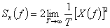
where the Fourier transform of the noise signal is defined as:-
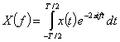
In order to calculate the Fourier transform in a reasonable amount of time on the limited computing resources available until recently, a number of algorithms were developed to speed up the process. These are all known under the generic name of Fast Fourier Transform (FFT) and rely on using 2^{n} data points in order to reduce the number of duplicated calculations.

Apodisation (windowing)
Only data from a finite period of time can be Fourier transformed. The effect of this abrupt truncation in the time domain is to introduce distortion in the frequency domain. The result from the FFT consists of the convolution of the Fourier transform of an infinite set of data with the Fourier transform of the sampling window. In order to reduce this effect an artificial window function (sometimes called an apodisation function) is superimposed onto the data prior to transformation. This function is equal to one in the centre of the data, and gradually approaches zero at the extreme edges of the data array, via an arbitrary function.

Appendix B

Velocity or Displacement Power Spectral Density
The result of the PSD calculation is then velocity power spectral density with units of (m/s)²/Hz. In the case of the small ground motions we are concerned with (assuming we are not considering earthquakes in the near vicinity!), a more useful combination of units is (µm/s)²/Hz in most cases. Beware that these units are sometimes rationalised to µm²/s
However, it would be more interesting to know the magnitude of the displacement experienced in a given frequency band. For this we first need to calculate the displacement power spectral density, which is defined as:-
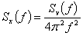
This is because although displacement and velocity are related by , their Fourier harmonics are related by:-
Thus it is straight forward to modify the velocity power spectral density calculated earlier and convert it into a displacement power spectral density with units of (m or µm)²/Hz

Appendix C
Coherence and Correlation
If all the quadrupoles in storage ring move together then there will be no impact on the beam. This would be the case if the wavelength of the ground motion was significantly bigger than diameter of the ring, or if the vibration was coherent over the ring dimensions. The property of coherence between the motions detected at two different measurement points is defined by first calculating the normalized. Cross-correlation function:-
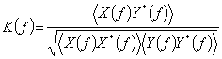
Where and are the Fourier transforms of two signals as previously defined, and 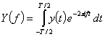, the brackets are intended to indicate an average over several sets of measurement, and the * indicates the complex conjugate. The real part of the normalized cross-correlation function is called the correlation and the modulus the coherence. The value of the coherence can have a maximum value of one, implying that the two signals have a constant phase relationship. Conversely, a coherence of close to zero implies very little correlation (in the non-mathematical sense) between the signals.

Appendix D

Wave Propagation
Before interpreting a typical ground motion power spectral density spectrum, it is useful to understand some of the properties of seismic waves. These can be split into two groups; body waves which travel in any direction through the Earth in two forms:-
• P-waves are simple compression (longitudinal) waves,
• S-waves are transverse waves in which the rock undergoes shear displacements perpendicular to the direction of propagation of the wave.
Surface waves can only propagate on the surface of the Earth's crust; two important types are:-
• Love waves are like horizontal S-waves except the amplitude decreases with increasing depth,
• Rayleigh waves are similar to ocean waves in that any point on the medium through which the wave is travelling describes an ellipse as the wave passes.
The velocity of the waves is determined by the bulk modulus K (the change in volume against pressure) or the rigidity modulus µ (the angular deformation against shear force) and the density ρ of the rock. The velocity of a P-wave is:-
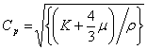while the velocity of a S-wave is:-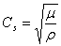
Because K is always positive, C_{p} is always greater than C_{s}. Note that the bulk and rigidity moduli can be converted into the more familiar Poissons’ Ratio σ:-
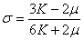
and Young's Modulus:-
