**Active Shielded ND Solenoids**

V. Kashikhin, 08/30/18

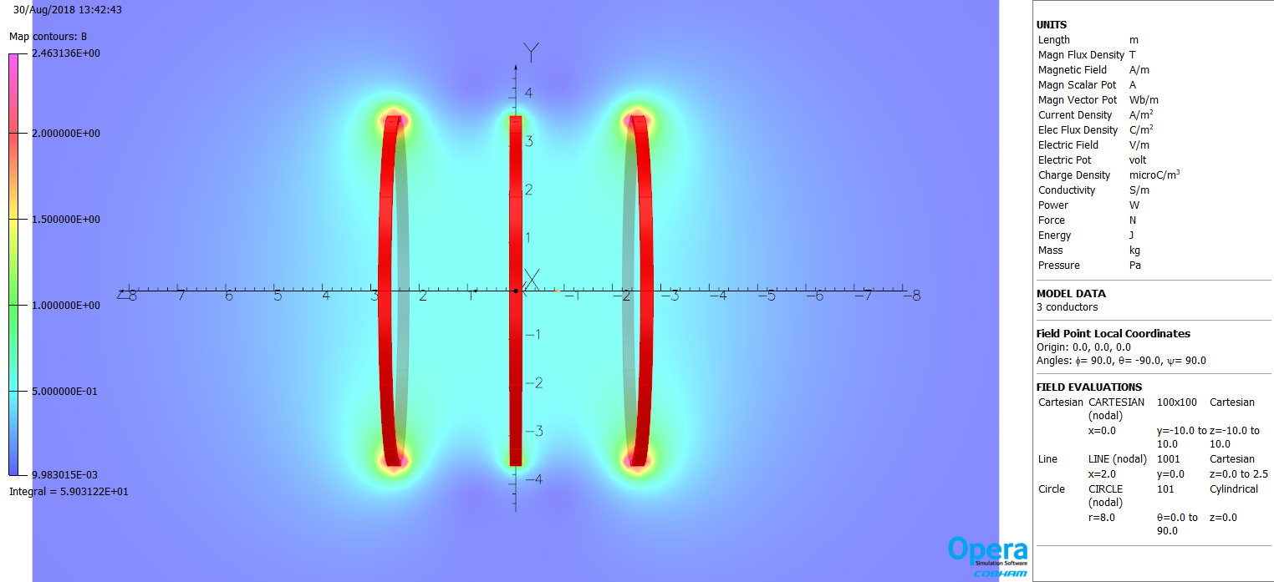

Fig. 1. Three coils with total currents: side coils 2MA, and center coil 0.8MA.

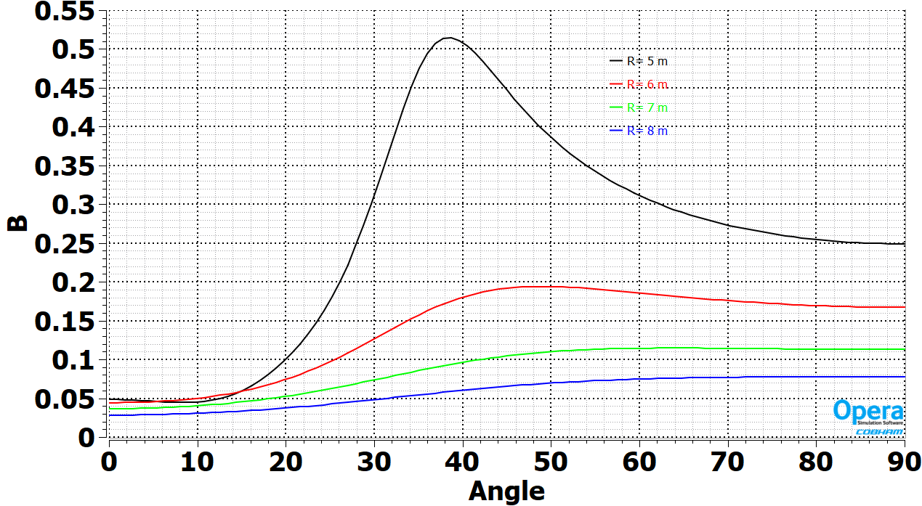

Fig. 2. Fringe field around coils.

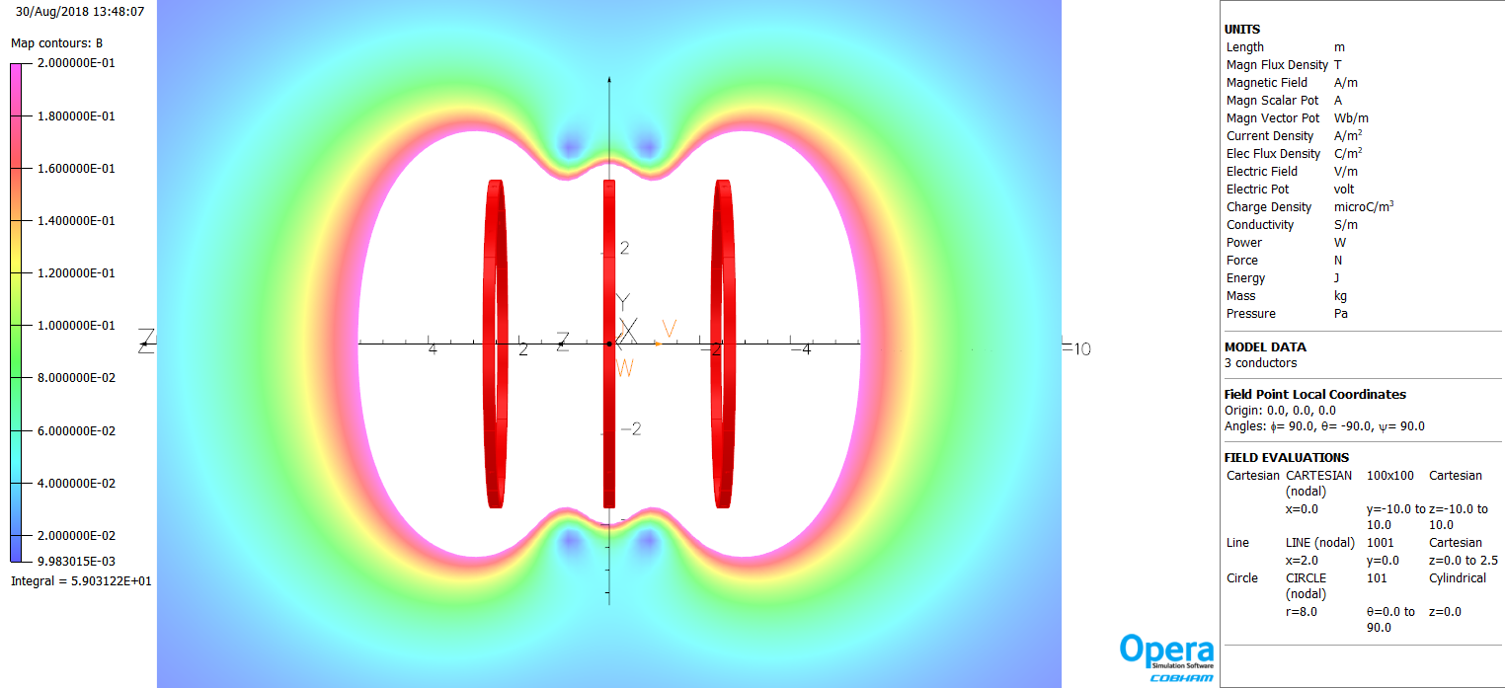

Fig. 3. Area with the field below 0.2 T.

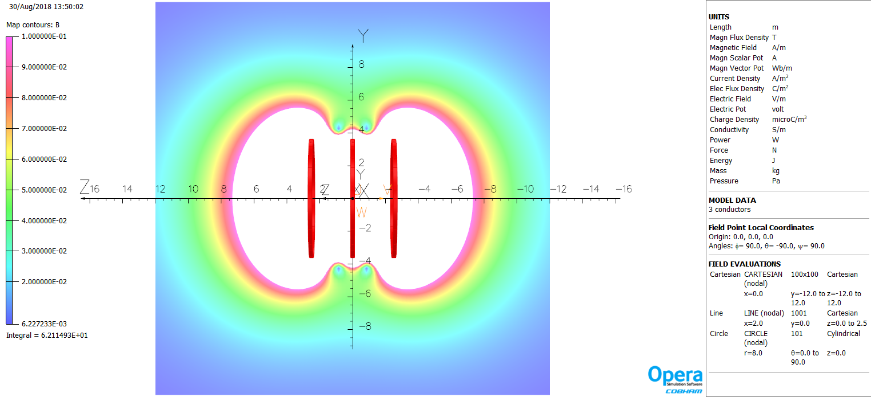

Fig. 4. Area with the field below 0.1 T, center field is 0.5 T.

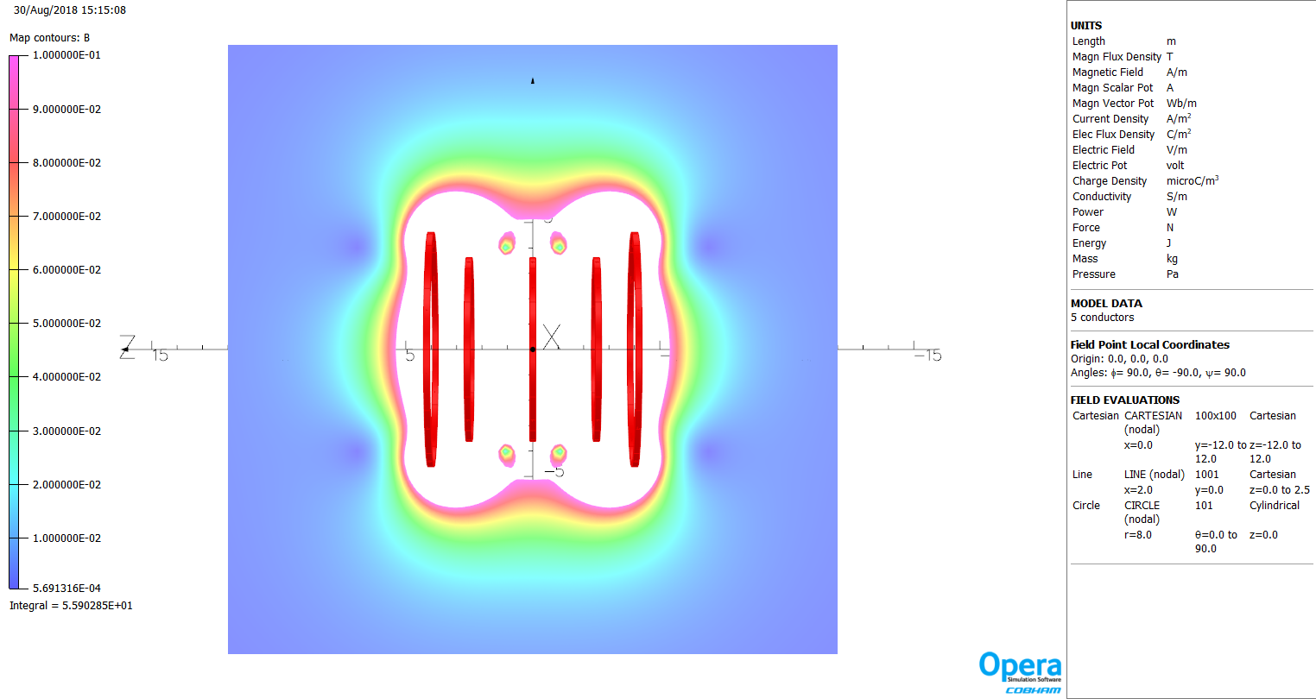

Fig. 5. Field area below 0.1 T with the active shielding: three main coils with total currents: side coils 2.44MA, and center coil 0.98MA, two shielding coils -1.22MA, center field 0.5 T.

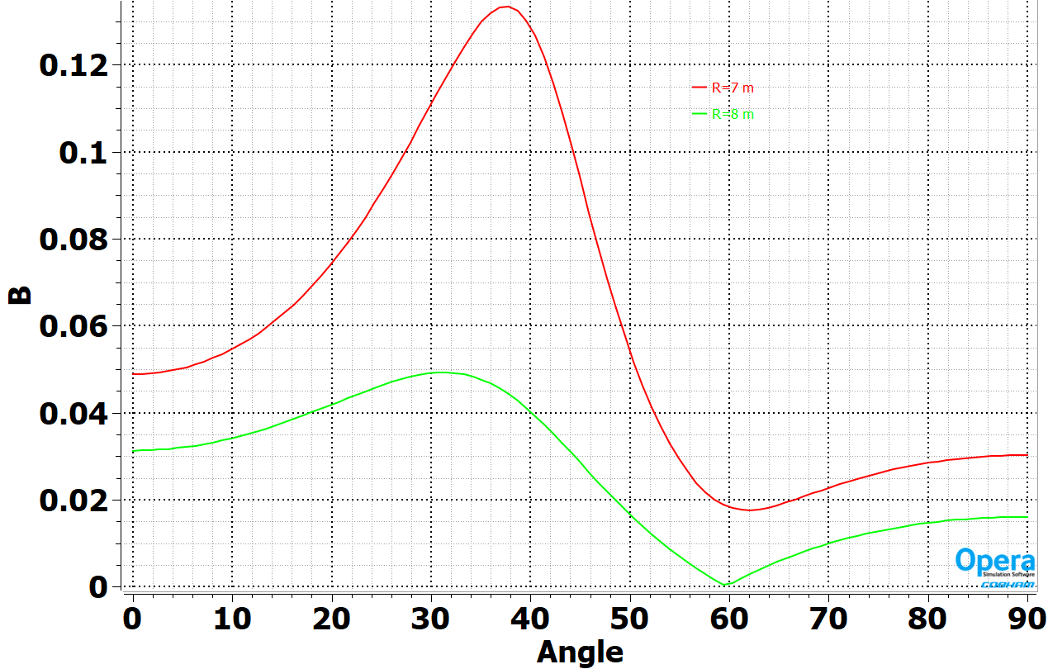

Fig. 6. Active shielding: Three main coils with total currents: side coils 2.44MA, and center coil 0.98MA, two shielding coils -1.22MA, center field 0.5 T.

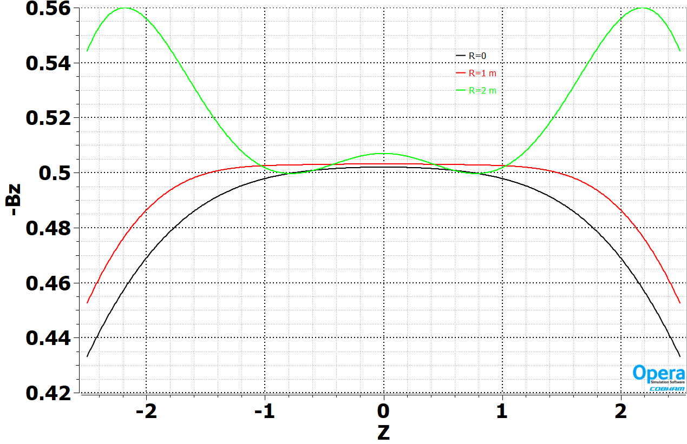

Fig. 7. Bz field in the magnet bore.

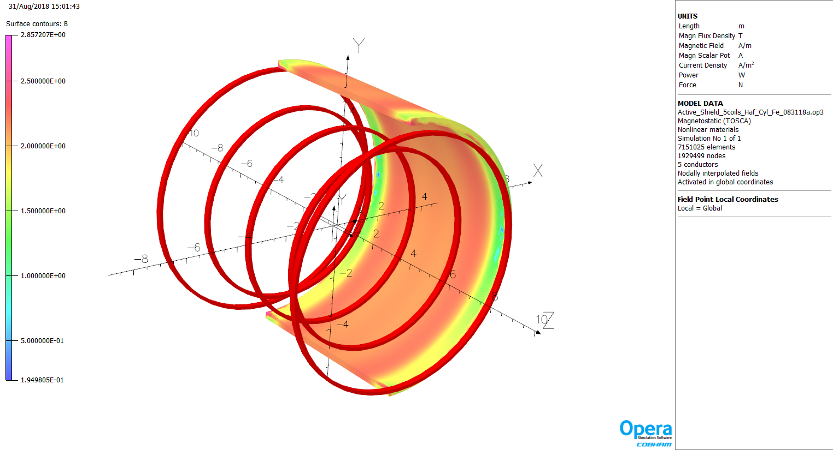

Fig. 8. Active shielding: Three main coils with total currents: side coils 2.44MA, and center coil 0.98MA, two shielding coils -1.22MA, center field 0.53 T.

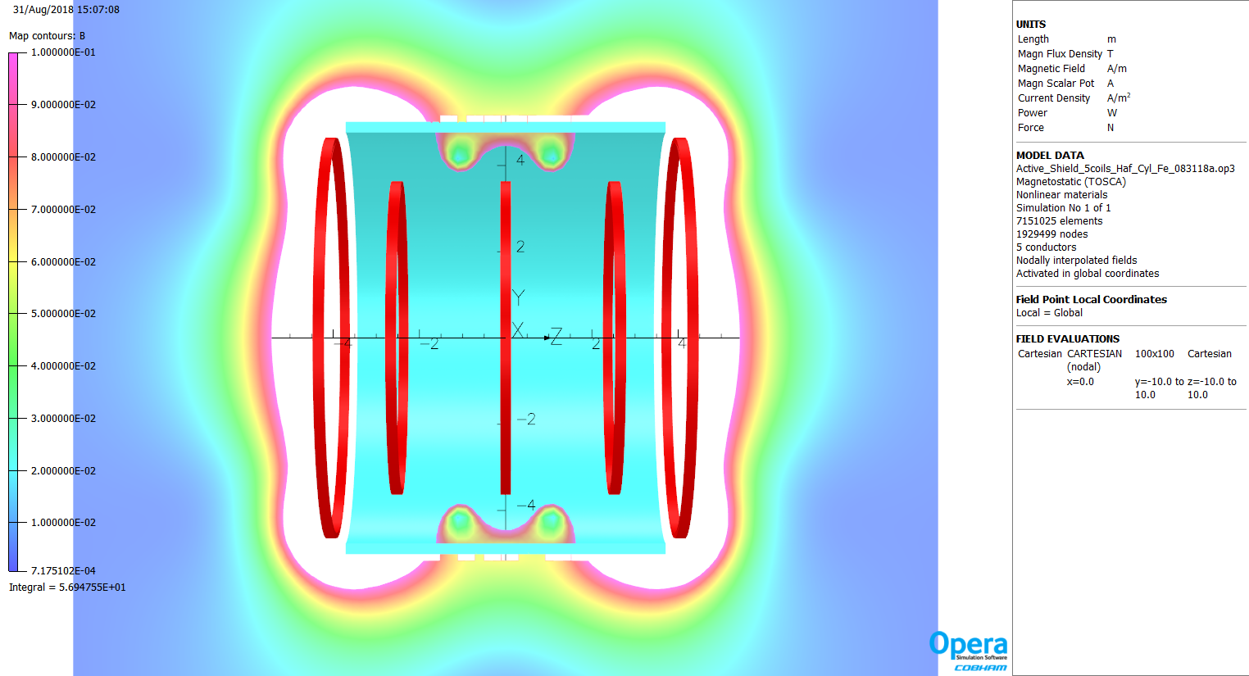

Fig. 9. Field area below 0.1 T with the active shielding: three main coils with total currents: side coils 2.44MA, and center coil 0.98MA, two shielding coils -1.22MA, center field 0.53 T. Stored energy is 115 MJ.

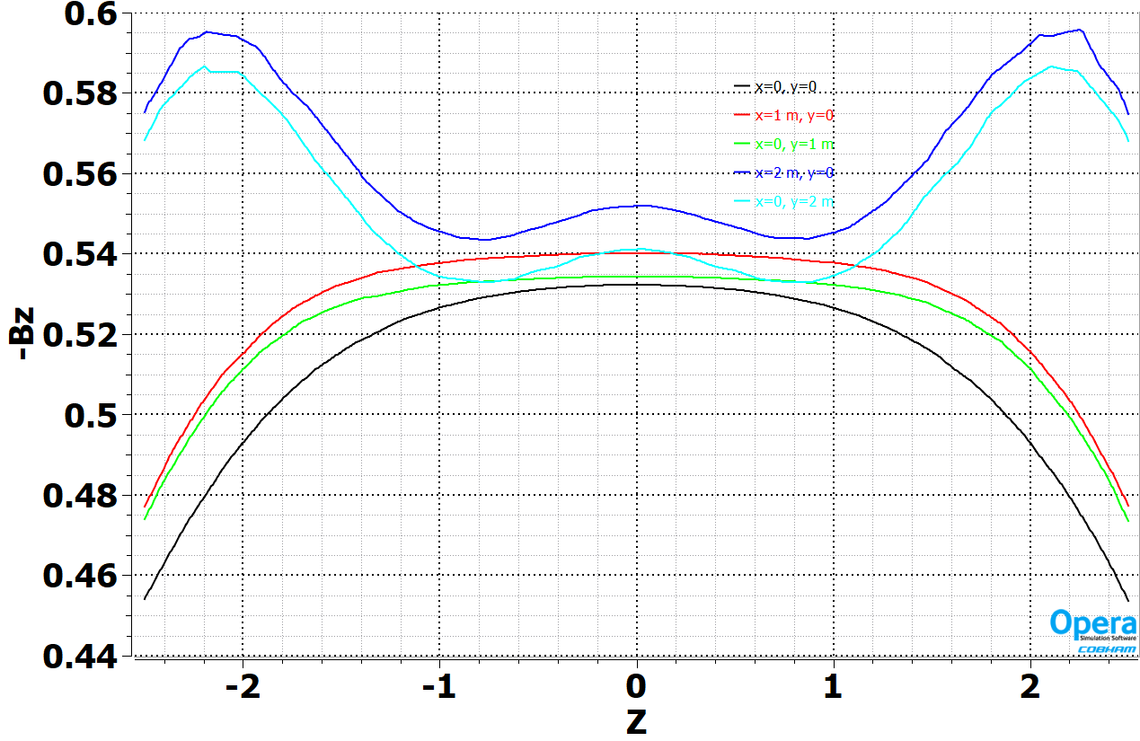

Fig. 10. Bz fields in the magnet bore: three main coils with total currents: side coils 2.44MA, and center coil 0.98MA, two shielding coils -1.22MA, center field 0.53 T.

|  |  |  |  |  |  |
| --- | --- | --- | --- | --- | --- |
| Name | Rinner, m | Router, m | Width, m | Z, m | Iw, MA |
| Center coil | 3.5 | 3.625 | 0.24 | 0 | 0.98 |
| Main side coils | 3.5 | 3.625 | 0.24 | ±2.5 | 2.44 |
| Shielding coils | 4.5 | 4.625 | 0.24 | ±4.0 | -1.22 |
| Iron Shield 180 deg. | 4.75 | 5.0 | ±3.7 | 0 | - |