PIP-II BTLBA Beam Absorbers
Preliminary Design Review Charge

Document number: ED000

Document Approval

Name: Ioanis Kourbanis
Org: AD
Contact: ioanis@fnal.gov
Role: L2 Manager for PIP-II Accelerator Upgrades

Revision History

Revision | Date Release | Originator:  Role: | Description of Change
- |  |  | Initial Release
Revision control is managed via Fermilab Teamcenter Workflows.

Table of Contents

1. Introduction 3
2. Review Agenda 4
3. Review Charge Statement 6
4. Acronyms 6
5. Reference Documents (to be available on Indico and, where noted, on Teamcenter 7

Introduction
A Preliminary Design Review (PDR) is needed for the Beam Transfer Line Absorbers. A permanent 50 KW Beam Absorber is located at the end of Beam Absorber line and one 5 KW portable absorber is to be used for Linac beam commissioning. The Beam Absorber core box consists of a graphite cylinder surrounded by an Aluminum jacket with cooling channels. The core box is surrounded by Aluminum and Steel plates. Concrete shielding will be stacked around the absorber core to minimize the radiation exposure.

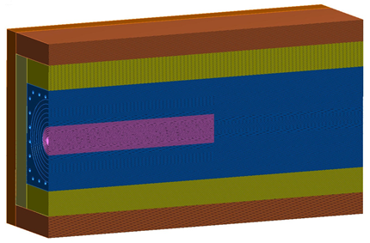

Figure 1: Permanent Beam Absorber.

Review Agenda
Location: | “The Cooler” East Booster Tower
Date: | March 19, 2019
Time:  Indico Site:  Participants: | 08:30 – 4:00 PM  https://indico.fnal.gov/event/20170/ (material to be posted by 03/15)  C. Baffes(Chair) AD Role: Reviewer for PIP-II  F. Pellemoine FRIB Role: Reviewer for PIP-II  W. Schmitt AD Role: Reviewer for PIP-II  I. Kourbanis AD Role: Coordinator  M. Xiao AD Role: Presenter  V. Pronskikh AD Role: Presenter  Y. He AD Role: Presenter

Agenda details:

Introduction: I. Kourbanis

Team Introduction and Organization

PIP-II Context

Review Charge

PIP-II Transferline and Absorber Line: M. Xiao

Requirements

Configuration

MARS Calculations: V. Pronskikh

Beam Absorbers Design: Y. He

Absorber design

FEA model

Temperature Profiles

Closeout – Review Chair

Summary Statement

Preliminary Findings

Preliminary Comments

Preliminary Recommendations

Review Charge Statement
The reviewers are asked to perform a Preliminary Design Review of BTLBA Beam Absorbers.

Specifically, the panel is asked to answer the following charge questions:

- Are the requirements documented, clear, complete and appropriate?

- Is the proposed design for the beam absorbers likely to meet requirements? Explain any deficiencies or concerns.

- Are there any features present (or absent) that threaten the intended function and performance of this design?

- Is the proposed shielding of the main absorber adequate?

- Have safety and environmental aspects been appropriately considered?

- Have quality aspects been appropriately considered?

The intended outcome of the review:
- Collect and document findings, comments and recommendations necessary to proceed to the Final Design stage

The following documents will be available on the Indico site approximately 1 week before the review:
- This charge document
- Functional requirements specifications for MI/RR Upgrades
- Technical requirements specification for MI RF Upgrade
- Risk assessment table
- Safety by Design table
- Design Review Report Template, to be completed by the reviewers

Acronyms

MI | Main Injector
BTLBA | Beam Transfer Line Beam Absorber
PDR | Preliminary Design Review
FEA | Finite Element Analysis

Reference Documents (to be available on Indico and, where noted, on Teamcenter)

1 | PIP-II Project Review Plan (ED0008163)
2 | Functional requirements for Beam Absorbers
3 | Technical requirements specification for Beam Absorbers
4 | Preliminary interface document (ED0007705)
5 | Risk assessment table
6 | Safety by Design table
7 | Design Review Report Template, to be completed by the reviewers

