Fermi National Accelerator Laboratory
Applied Physics and Superconducting Technology Division SRF Department
P.O. Box 500
Batavia, IL 60510
Fermilab

LCLS-II Cryomodule pCM Shipping Restraint Engineering Note

Fermilab Design Note: ED000nnnn

Rev | Date | Description | Originated by | Approved by
None | January 31, 2019 | Original issue | T. Nicol

LCLS-II Cryomodule pCM Shipping Restraint Engineering Note

Fermilab Design Note: ED000nnnn

Contents
Introduction 3
Modified M-mount 4
Installation and removal 12
Summary and conclusions 12
References 13

Introduction
The long-term plan to protect the cold end coupler bellows in production LCLS-II cryomodules during shipment is to install a neoprene support between the cold end coupler tube and the existing G-10 support bracket. The support, called an M-mount, developed by engineers at Jefferson Lab, is shown in red in figure 1 [1][2]. It is installed after final assembly through the tuner access ports or from the end of the cryomodule in the case of the end-most cavity. It is necessary to install it after assembly because it cannot be in place during cold testing of the cryomodule. After shipment to SLAC, the mount is removed by the same means. Not shown is a nylon tie-wrap installed at the same time to hold the support in position.
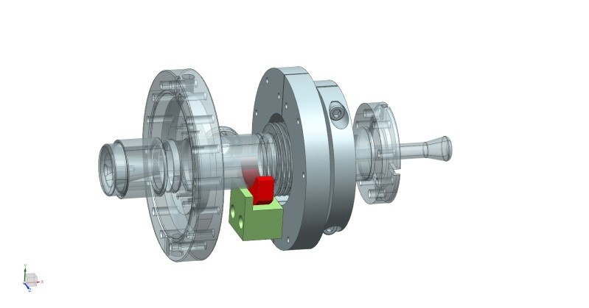
Figure 1. M-mount installed in an LCLS-II coupler

The pCM or prototype cryomodules at both Fermilab and Jefferson Lab are slightly different than their production counterparts. They employ a split collar around the bellows and a different type of G-10 block, both of which preclude using the M-mount as designed. The reasons for the differences are several, but center around the position of the RF pickup port on the cold end coupler tube. On the pCMs, the port is at the 6-o’clock position and so occupies the same space as the production G-10 support block. On subsequent cryomodules, the probe was rotated 90 degrees. Figure 2 shows the cold end coupler bellows on the pCM at Fermilab.

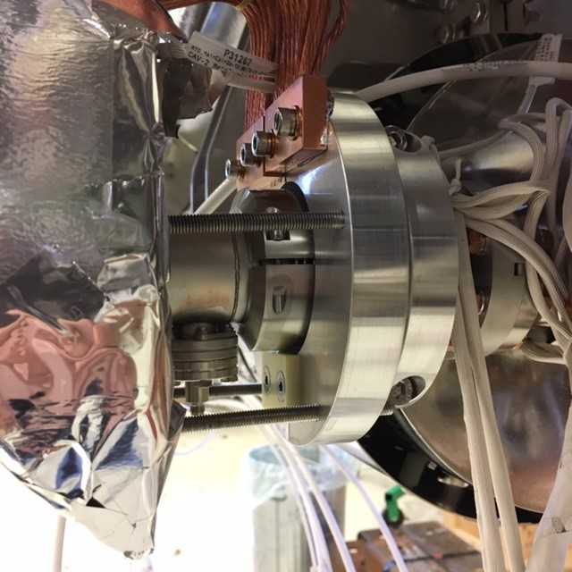
Figure 2. Cold end coupler bellows on the pCM at Fermilab

Modified M-mount
It’s likely that the presence of the split collar around the bellows would be sufficient restraint of the cold end bellows during shipment. There is evidence from several pCM shipments around Jefferson Lab and from Jefferson Lab to Fermilab, that the integrity of the bellows remained intact. Our preference, however, is to err on the safe side and provide an extra degree of protection. The nominal clearance between the OD of the bellows split collar and the ID of the 5 K intercept is 3 mm, about the limit of what bellows testing indicated as potentially problematic. The goal of the pCM shipping restraint design was to replicate the form and function of the production cryomodule M-mount as closely as possible. Toward that end, the existing G-10 plate shown below the coupler in figure 2 was replaced by a G-10 part that has the same flat shown in the existing part plus a holder for a neoprene support similar to that used in the M-mount. Figures 3 through 7 show the new assembly. Note that the parts shown in these figures are 3-D printed versions of the actual final parts. The neoprene used in the support is 60-durometer, also the same as that used in the production M-mounts. The mounting holes and fasteners used for the new G-10 bracket are the same as those in the existing pCM G-10 support plate.

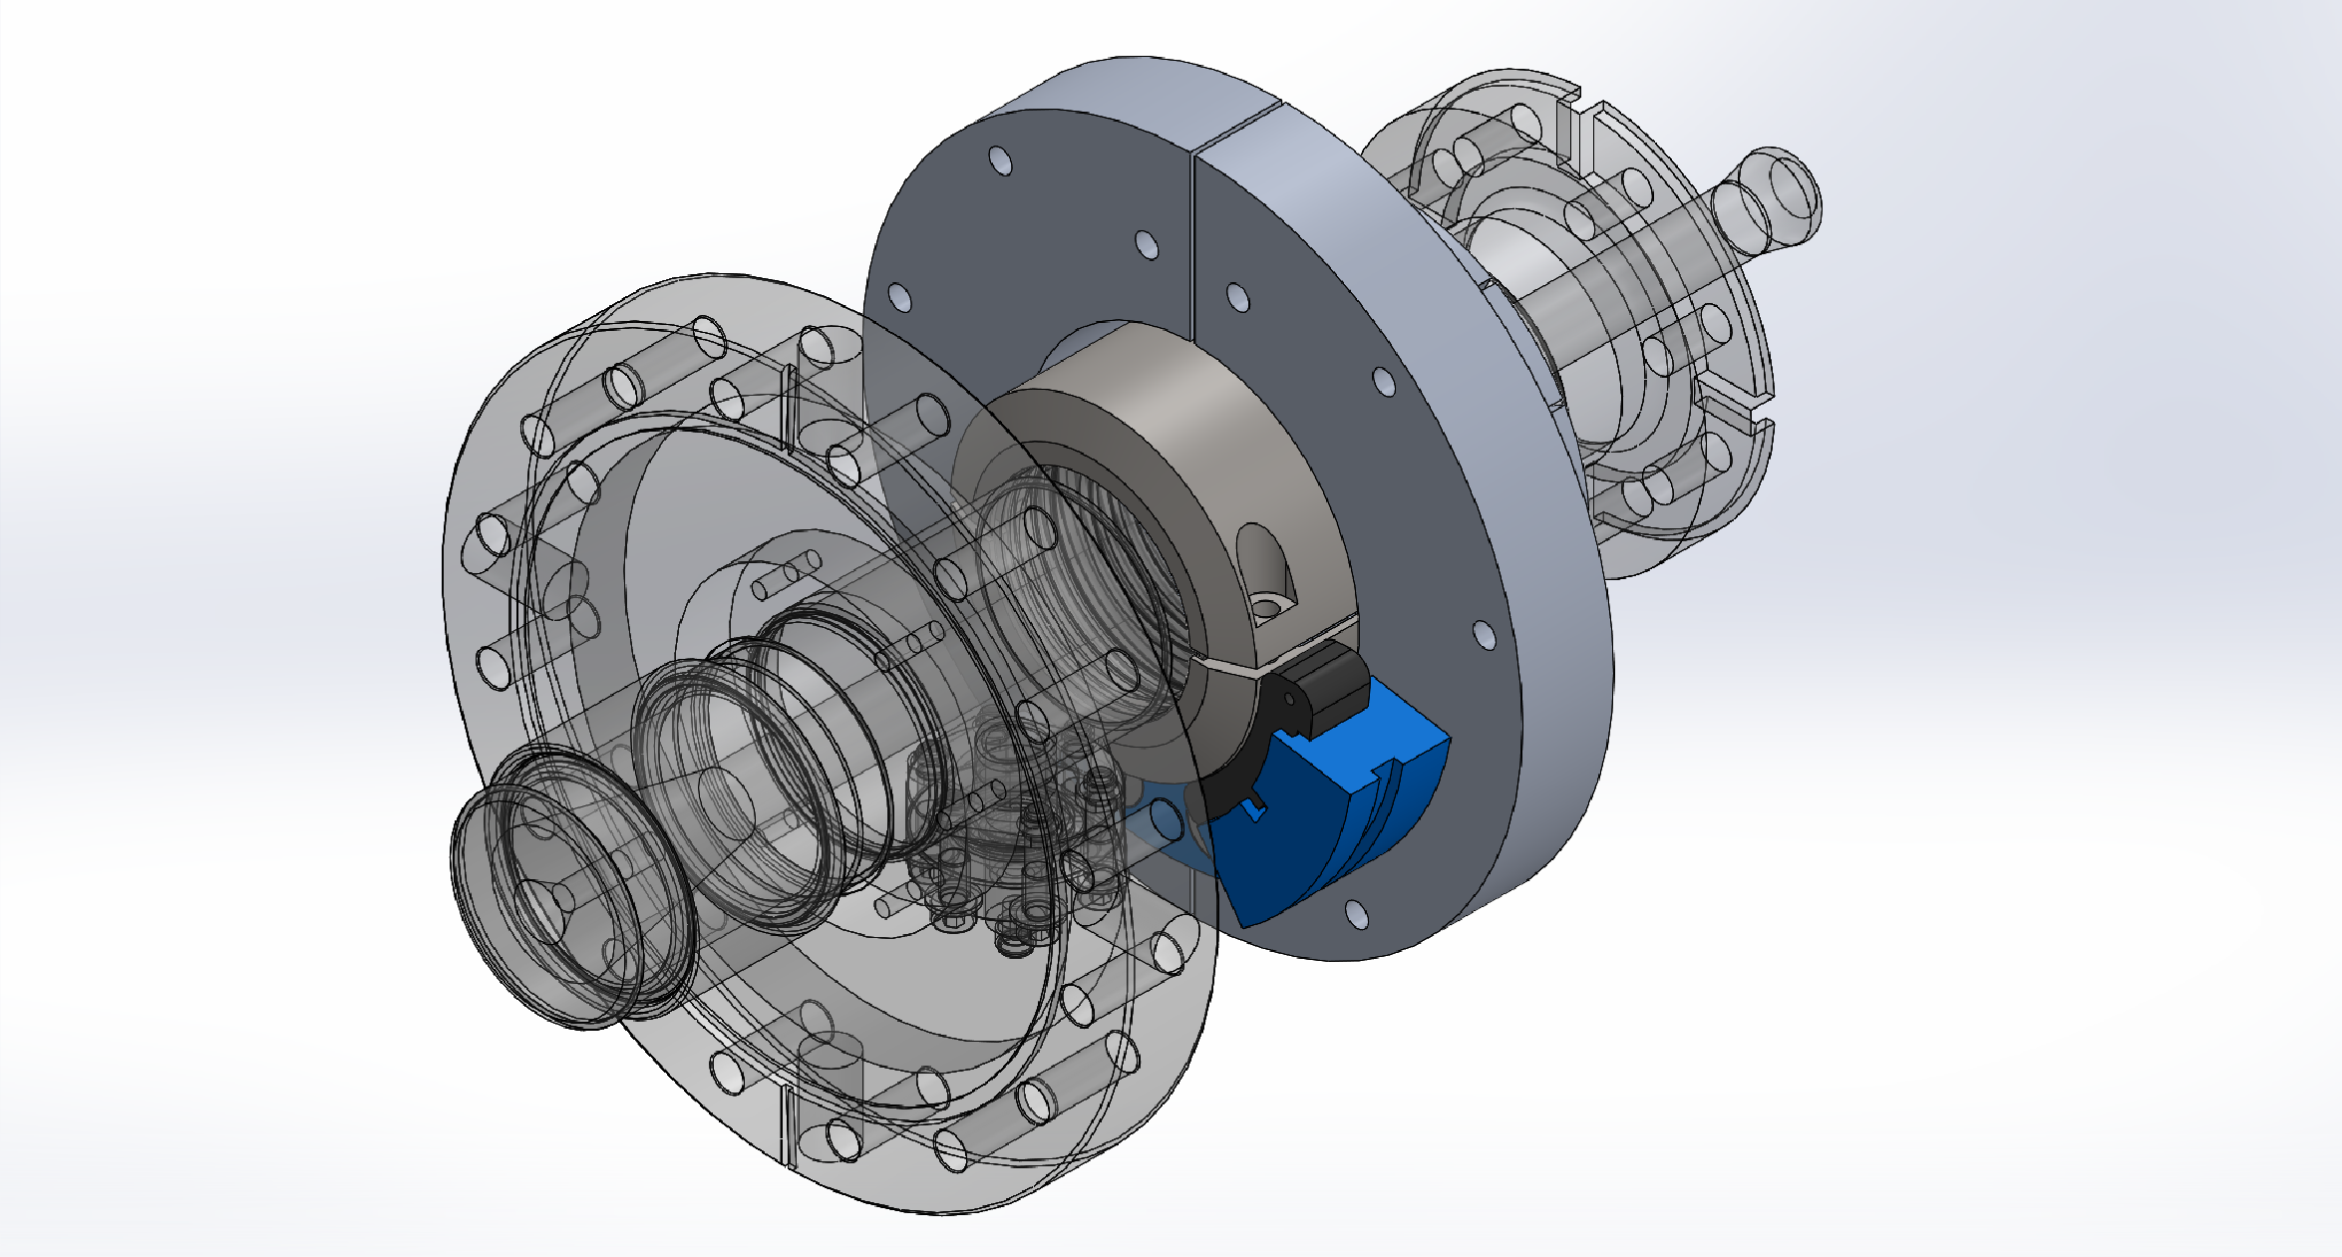
Figure 3. Solid model of the assembled modified M-mount

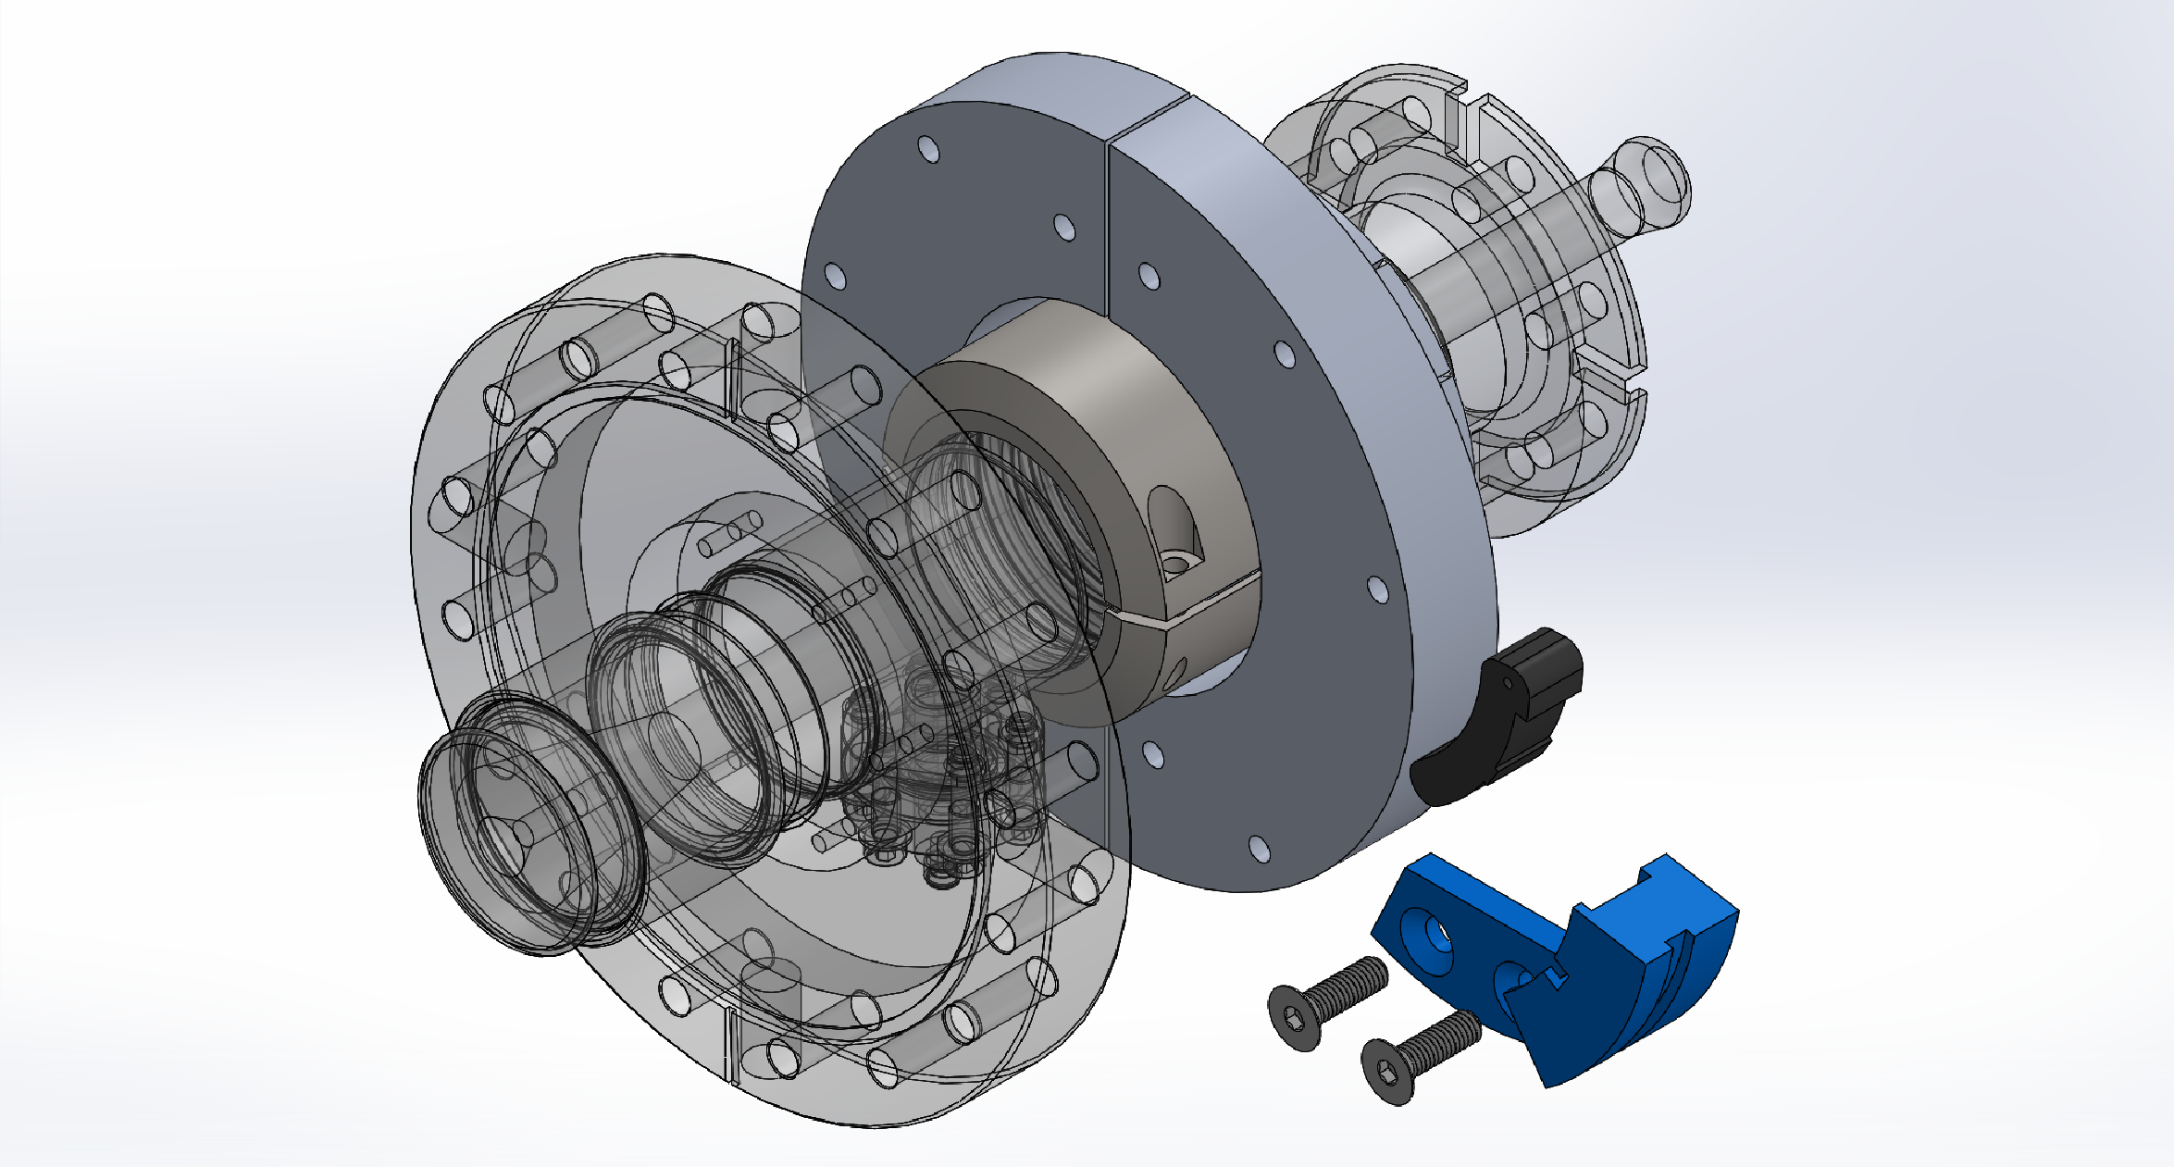
Figure 4. Solid model of the assembled modified M-mount – exploded view

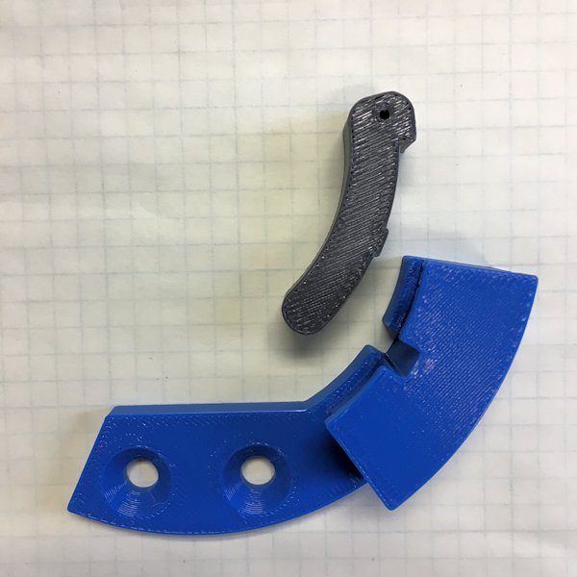
Figure 5. 3-D printed prototype parts

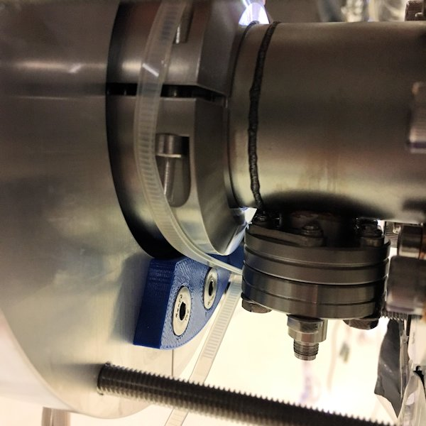
Figure 6. 3-D printed parts installed – view 1

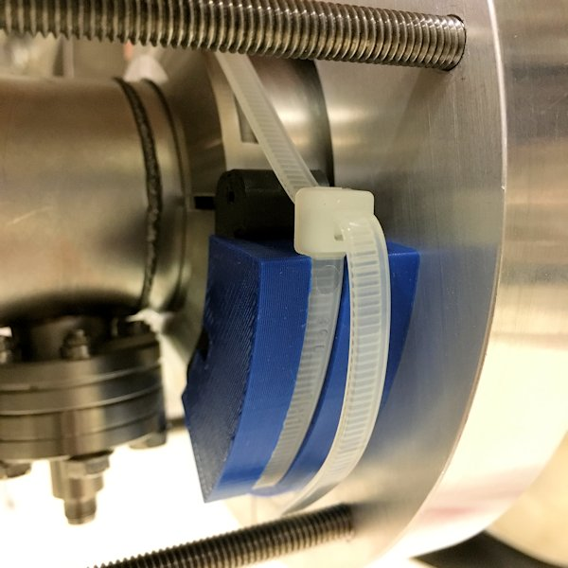
Figure 7. 3-D printed parts installed – view 2

The engineering drawings for the support, support bracket, and bellows collar are shown in figures 8 through 10. The bellows collar was only needed for the shaker table test to replicate the as-installed pCM coupler.

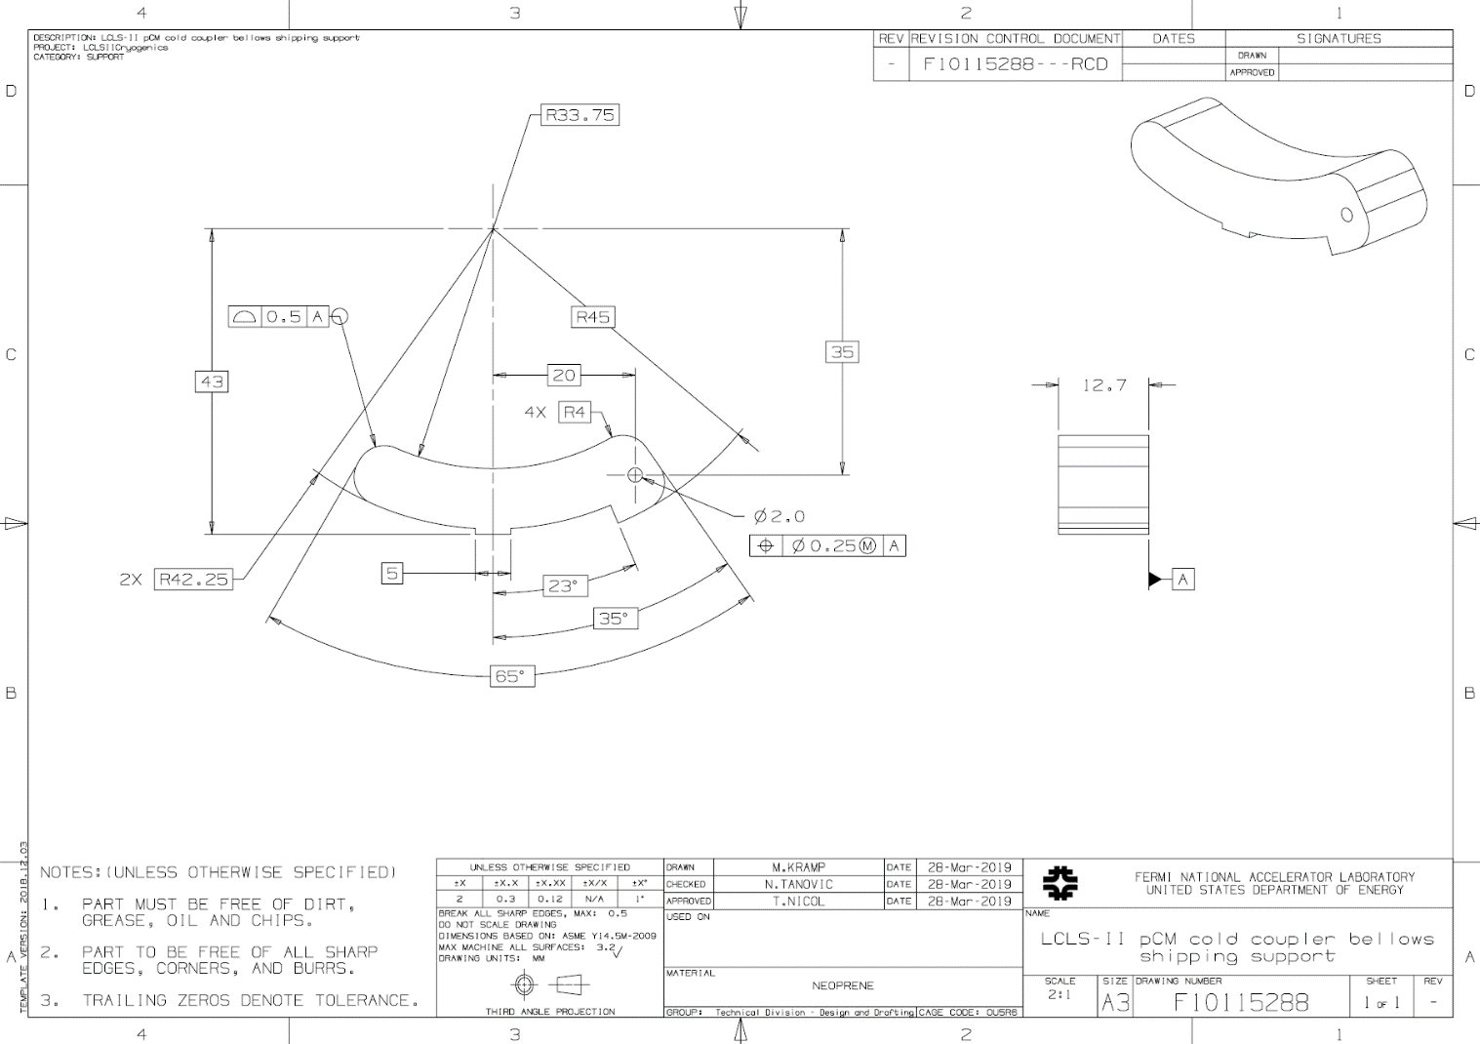
Figure 8. pCM neoprene shipping support

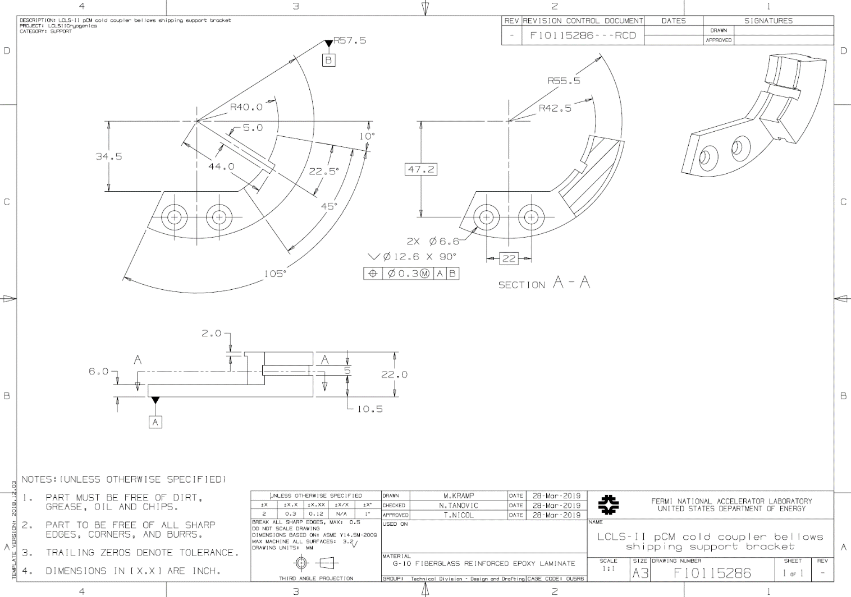
Figure 9. pCM G-10 shipping support bracket

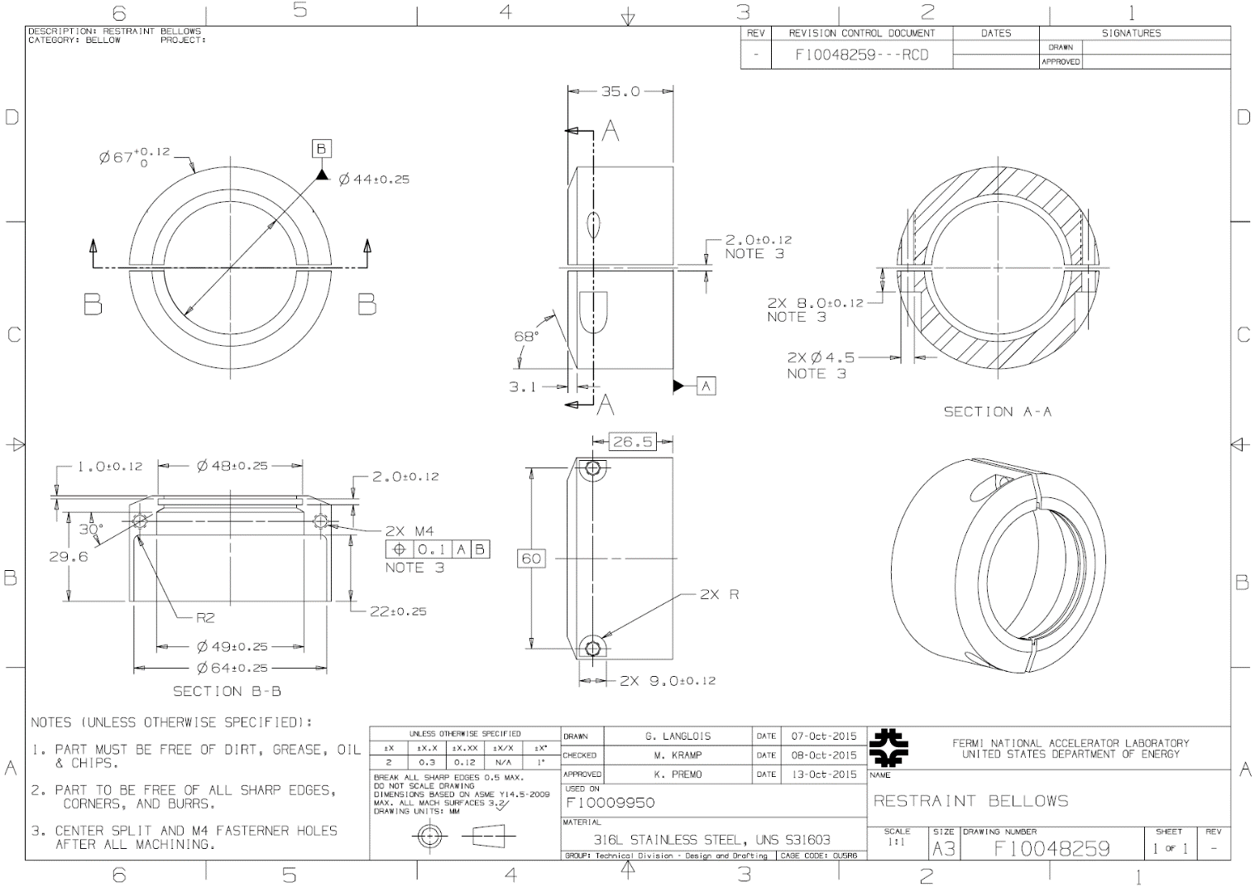
Figure 10. pCM stainless steel coupler cold bellows collar

Installation and removal
Unlike the installation of the production M-mounts, the modified mounts at Fermilab were installed prior to cryomodule final assembly so installation through the tuner access ports was not required. The neoprene support has an attached string like the production mounts to facilitate removal. After shipping when pCM is at SLAC, the neoprene support is removed like the production support, i.e. working through the tuner access port, the tie-wrap is cut and the neoprene support is removed using the attached string. The G-10 bracket remains inside the cryomodule.

Summary and conclusions
A total of nine supports were fabricated plus one cold end bellows collar. The ninth set of parts and the bellows collar were installed on a test coupler and tested on the shaker table at Solution Engineering Group, Montgomery, IL. The results of that test were successful and are published in separate report by Nikolay Solyak. Eight support are installed in the pCM at Fermilab which awaits completion and shipment to SLAC.

References
- M-Mount Engineering Note, J. Matalevich, Jefferson Lab, December 2018.
- LCLS-II FPCW Bellows Restraint Installation, R. Legg, Jefferson Lab, January 2019.
- Report on the pCM shipping support shaker table test, Nikolay Solyak, March 2019.

