PD in ICEBERG – PLANS FOR 2nd RUN 04/29/2019

* ICEBERG SCHEDULE/PLANS (from Shekhar’s last DUNE collaboration call)

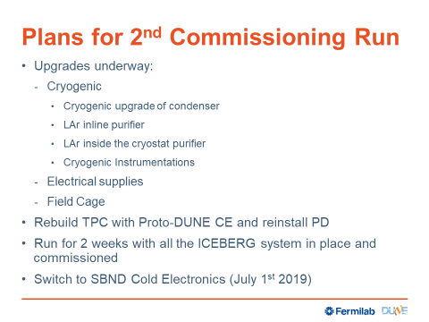

* PD:

Warm tests with Mu2e FEB and SSP: earliest is the week of May 13th because we cannot insert the Arapuca arrays into the APA before that.

In the meantime:

* Dave Warner will do an improvement on the X-Arapucas (week of May 6th)
* Aleena will put the SSP into the DAQ – more in her talk
* Rory will work on the second channel – more in her talk
* 2nd run will last two weeks. Main goal is to match light flashes with TPC tracks.
* Laura and Franciole will start simulation work for the Arapucas in ICEBERG: need to give them the geometry (CE)
* Investigate noise in the Arapucas (see Rory’s presentation).

ORGANIZATIONAL MATTER:

We need to find a new time slot for this meeting as it conflicts with the physics + simulation meeting.

I will send a doodle poll for finding a new meeting time.