Underground

- How many detectors are required? The DUNE ND hall will require space for three detectors. A Liquid Argon Detector and a Multi-Purpose Detector (MPD) will be located in the main cavern permitting travel transverse to the neutrino beamline. A third, stationary detector will be located in a cavern alcove. See Figure 1 (needs update) for a spatial arrangement. The cavern must also provide sufficient space for cryoplants and cryogenic service lines to the surface building. The latter space requirements will be included in the ND hall design document by end summer 2019.
- How many detectors are being planned for in the design? The Near Detector reference design includes all three detectors. Installation of the three detectors and their time phasing to be determined.
- What are their dimensions? See Figure 1 and the following table (initial estimates)

LAr Detector | 11m X 8m X 6m (WDH) | ~ 500t
MPD | 11m X 8m X 8m | ~ 150t
3DST-S | 6.1m X 6.6m X 8.5m | ~ 500t

- What is the necessary proximity of the detector(s) to each other? The two detectors (LAr, MPD) in the main cavern should be positioned as close as possible to each other. The detector in the alcove has no proximity requirement.
- How are the detectors serviced? Stair structures, which are an integral part of the detector scope and design, will provide access to the top as well as the side of the detectors for ongoing servicing. For major servicing of internal detector components, the detectors will be moved to the service position adjacent to the cavern shaft.
To minimize the overall detector size (and hence the cavern size) we may require mezzanine structures supported from the cavern walls to facilitate access to detector components. Such structures may have to be provided as facility scope. First layouts will be available by conclusion of the ND conceptual design end of calendar year 2019.
- What are the clearance dimensions required to service the detector(s)? For major servicing of internal detector components, the detectors will be moved to the service position adjacent to the cavern shaft. Only one detector will be serviced at a single point in time. Therefore, due to the cavern layout, sufficient laydown space will be available for lifting fixtures and for assembly/repair of detector components.
- What are the minimum and maximum dimensions of the primary access shaft to move the detector components from the surface to the hall? The inner, fully accessible diameter of the access shaft shall be 38 feet. See Figure 1 for a typical layout including a personnel elevator. Areas of the access shaft can be utilized for facility utility routing. Space will also be required to route larger detector cryogenics lines to the surface. The next ND detector design drawing will include initial routing layouts.
- Can these detectors be assembled underground as a means of reducing the shaft size? The ND detector design will be optimized to permit assembly underground. However, core detector sub-components for all three detectors are of substantial size and cannot be assembled/fabricated underground. Therefore, the ND hall requires the access shaft as shown in Figure 1.
- Does the detector have to move within the detector hall? Two detectors (the LAr detector and the MPD detector) have to move transversely to the neutrino beamline.
- How is it moving? The current plan is to utilize several sets of Hillman rollers on flat steel plates embedded in the cavern floor. A rack-and-pinion system including a motor drive for each of the two detectors will provide the motion. The movement system will also include design features to minimize trip hazards. An important element of the movement system for each detector will be very large energy chains (flexible, articulated housings), which contain flexible power and signal cables and flexible cryogenic lines. The energy chains consist of commercially acquired energy chains, the chain containment channels, and the chain support systems. The next ND detector hall layout drawing will include such initial designs.
- Who is providing the movement system? The movement system is part of the US detector scope. Steel or anchor plates embedded in the floor may have to be provided/installed by facilities. The large energy chains will be supported by I-beam structures mounted off the rock wall. These may have to be provided/installed by facilities.
- What is required from conventional facilities to support the movement system? The detailed scope division is not yet determined. Although the movement systems are part of the US detector scope, practical as well as building safety considerations may necessitate facilities involvement. At a minimum, trenches and attachment points in the floors have to be designed and implemented by facilities. Attachment points on the cavern rock walls and structures for the energy chains have to be included in facilities final design and engineering packages. In addition, the detector load will be transferred to the building structure through the movement system. Facilities structural calculations have to consider these exact locations.
- What is the travel length of the detector(s) within the hall? The detectors will move 30.5 meter.
- How often and how fast will the detector(s) be moved? TBD. Movement will be very slow to minimize vibrations.
- What size (dimensions and weights) of all detector components and detector support systems? See item 3 for detectors. Additional weights for the detector support infrastructure will be made available by the time of the near detector CDR.
- What is the minimum required crane envelope (hook height, maximum pick, including lifting fixtures and rigging)? See Figure 1.
- What utilities (type, load, etc.) are needed for the detector(s)? TDB
- Are there any special lighting requirements? There are no special lighting requirements.
- Are there any specific grounding or shielding requirements for the detector(s)? The detectors will each require independent grounding systems. The detailed design is not yet developed.
- How much space is required for racks and other equipment located in the controls room? TBD What are the power or cooling requirements for any electronics racks in the detector hall? TBD Is there a requirement for standby or UPS power for these racks? Yes.
- Where is the control room located and what are the requirements to move data from the detector to some central data processing center? TBD
- Are there cyber (WiFi) or cellular requirements for the underground detector hall? If so, please list. WiFi
- Are there environmental requirements for the assembly/installation or operation of the detector(s) (max/min temp, max/min humidity, etc.)? There will be separate environmental requirements for operation as well as assembly/maintenance of the detectors, but they are not yet established. For instance, operation will require temperature control. Assembly/maintenance will require cleanliness. Humidity control will be required to control water and ice buildup. Cavern water intrusion has to be controlled to avoid water dripping on detector equipment. Adequate water routing and sealing should be implemented in the cavern design. Separate roof structures inside the cavern are not desirable.
- What ODH provisions are required and are these integrated into the facility Fire and Life Safety systems? If so, who provides these systems? ODH systems will be required. These are currently not part of the ND detector design scope.
- Are there any stability or vibration requirements? Yes, the detectors have vibration requirements which are not yet formalized. This will affect large machinery equipment for facility operation.
- Are there cavern finish requirements (floor level, floor flatness, dust control, wall reflectance, floor/wall finish, sealers/hardeners/coatings, etc.)? There are floor flatness requirements for the moving systems. Dust control during detector assembly/maintenance may be more cost efficiently achieved with temporary enclosures. Wall finish is not critical as long as the minimum detector hall space needs are not violated (including rock anchors protruding into the cave volume). Locations where support structures will be mounted to the rock wall may require concrete pad designs. Water intrusion control will be required. We are currently generating a cavern interface drawing which will include an initial set of such specifications.
- What embedments and supports are required for the detector(s) and support systems (cabling, piping, etc.)? The ND detector design is not yet mature enough to specify anchor embedments and support pad designs. However, the next ND detector hall layout drawing will include initial designs for auxiliary detector support systems. These should be sufficient for facility preliminary design.
- Are there limitations to the fire and life safety requirements for the detector(s)? For example, no wet pipes above the detector. No wet pipes.
- Are there any secondary containments required, such as an argon sump? TBD
- Are there minimum soil/rock cover requirements around the cavern? Not beyond cavern structural requirements
- What flexibility exists to position the detector hall with respect to the target? There exists very little flexibility. For example, can the detector(s) be located immediately downstream of the absorber hall? NO, this is not a feasible location.
- Are there any radiation or radioactive considerations underground? No.
- Are there any radioactive background considerations for the underground space or materials used in the construction? No.
- What is the maximum daily personnel occupancy of the underground spaces during construction? 16 hr.
- Are there plans to use any diesel, propane, or other non-electric-powered material handling equipment underground during construction? Propane
- Egress Implications: The current ND hall layout assumes the need for only one independently vented fire escape route along one side of the cavern. Due to the increased size of the current cavern design this should be reconfirmed as soon as possible since the current layout would not easily permit adding another escape route.

Surface
- Are there any gas or liquid fill or purge systems provided by conventional facilities? Yes.
- How are the liquid cryogens transported to the detector(s)? There will be LN2 fill and vent lines and LAr fill and vent lines. LN2 and LAr storage dewars will be located on the surface. LHe liquification and storage will occur in the underground cavern.
- What are the maximum trailer and load dimensions and weights? It looks like standard trailers will be ok. Max transport size will be TBD
- Are there any hardstand/laydown area requirements? Yes.
- Is equipment/material staging required within the surface conventional facility? If so, what are the dimensions, weights, etc.? Is crane coverage required? TBD

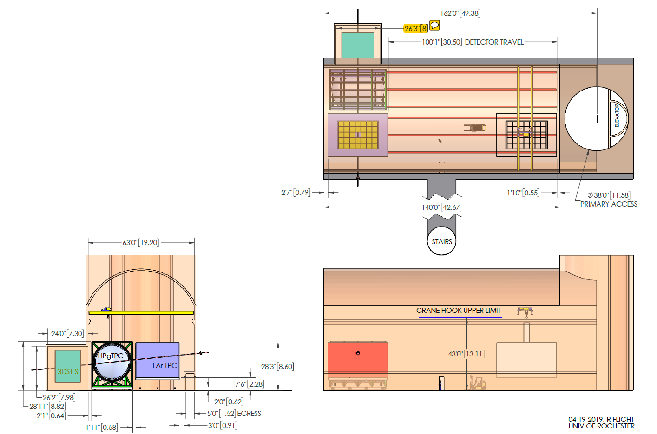

Figure 1: Schematic of ND hall reference design

