Plans for noise mitigation

* Shorten RJ45 signal cables
* PL506 cannot be shared with CE
* New power supply for biasing the SiPMs, replacing the Keithley (and the PL506)
* Candidate power supply may have been found available at Fermilab:

Kepco JQE 100-10M power supply 0-100 V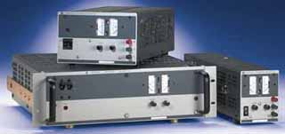

* Low noise: 3 mV level (power supplies used in LIGO phase 2)

Requested a quote for model 25-20DM (half rack, digital)