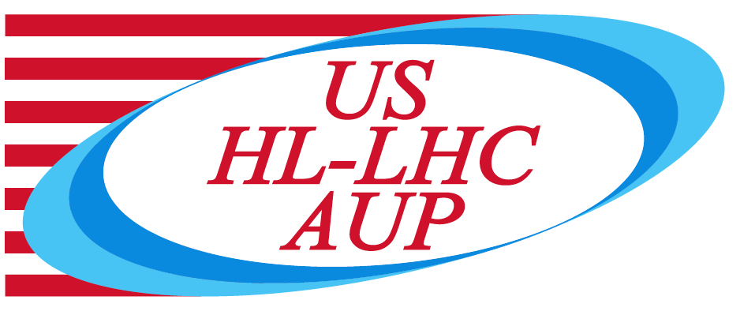

US HL-LHC Accelerator Upgrade Project

Report of the
Production Readiness Review of the HL-LHC AUP

MQXF Strand Procurement Task 302.2.02
August 22nd 2019

– Steve Gourlay, chair person (LBNL)
- Najib Cheggour (NHMFL)
- Paolo Ferracin (CERN)
- Diego Perini (CERN)

TABLE OF CONTENTS

1. Goal and scope 3
2. Technical details 4
3. Comments 4
4. Recommendation 6

- Goal and scope

The HL-LHC AUP 302.2.02 scope covers strand procurement, vendor QC supervision, QC validation, and preparation and test of extracted strands and witness samples. The HL-LHC AUP project received CD-3a approval for conductor procurement in October 2017, and the remaining scope of 302.2.02 was approved under CD-3b in February 2019. This PRR covers the remaining scope approved under CD-3b: QC validation, and preparation and test of extracted strands and witness samples.
The 302.2.02 L3 Manager (Lance Cooley) is presently with FSU and the NHMFL, where strand QC validation is being performed. The 302.2.02 L3 Manager Deputy (Vito Lombardo) is at FNAL where extracted strands and witness samples are prepared and tested.
Production Readiness Review (PRR) is a major review step in the HL-LHC Accelerator Upgrade Project (AUP). It is held prior to the start of series production, and is intended to be a largely technical review, but include assessment of the planned cost, schedule, and personnel needs to complete the production.

Scope of this PRR:
- Parts and materials for testing virgin strands, extracted strands and witness samples.
- Procurements, sample preparation and test procedures.
- Interfaces.

Goal of this PRR:
- Approval of plans and procedures for remaining scope of 302.2.02.

- Technical details
Committee
Steve Gourlay, chair (LBNL)
Najib Cheggour (NHMFL)
Paolo Ferracin (CERN)
Diego Perini (CERN)

Date and Time
Aug 22, 2019; start time: 7/9/10/16 (LBNL/FNAL/NHMFL/CERN)

Location/Connection
NHMFL, room TBD
Video-link by Zoom, info by email.

Link to agenda with talks and other documents
https://indico.fnal.gov/event/21525/

- Review Charges response

- Scope and interfaces: is the L3 task scope clearly defined and are interfaces with other tasks sufficiently well-defined for execution during QC validation, and preparation and test of extracted strands and witness samples?
The Committee agrees that the scope of the L3 task is well defined. Interfaces between AUP and the strand supplier and between AUP strand procurement/testing and cable fabrication teams are crafted extremely well. Good communication between the teams provides for important feedback and the existence of several control points insures that the strands delivered to AUP satisfy strand specs agreed on between AUP and the vendor. We also feel that the change of scope that was implemented after the cable PRR is very useful.

- Procurement and Manufacturing: are the procurement and manufacturing work flow documents and travelers —including scheduling, personnel needs, floor space, and facilities requirement—appropriate to execute these activities during series production?
Yes

- QA/QC: is the QA/QC plan adequate? Is there appropriate documentation for quality control procedures, manufacturing and inspection plan, and data reporting?
The QA/QC plan is adequate, except for the lack of validation by the coil testing program, as discussed in the comments below.

- Cost and Schedule: are the cost and schedule estimates sufficiently well-defined and of adequate maturity to support these activated during series production?
Yes
- ES&H: Have all hazards been identified and addressed? Are ES&H policy and documentation sufficient for the series production?
Yes, based on what was presented.
- Risk: are risks understood and appropriately managed for the series production?
Yes. The lack of feedback from coil testing to strand testing should be considered (see below).
- N/A

- Is this L3 task ready for series production?

Yes

- Comments

A possible weak link in the current process is possible lack of obtaining timely feedback from the coil testing to the strand procurement/testing to either validate the current work-flow or implement changes in case unknowns are discovered during coil testing. For example, if changes in the heat-treatment schedule were to be required by the coil team, a mechanism should be in place to generate a timely response by the strand procurement/testing team before the QC validation testing is all completed. Otherwise, a new campaign of strand testing will have to be started and a new budget allocated for it.

Concerning QC validation tests, we noticed systematic discrepancies in RRR data of the vendor and NHMFL. Whereas this was explained by the fact that the vendor uses a different definition of RRR that yields more conservative values, it was noted that discrepancies as high as 15 % do exist even when the same definition was used. Furthermore, RRR values of NHMFL for samples reacted at 665 ⁰C/75h are higher than those of the supplier for samples reacted at 665 ⁰C/50h. This means that NHMFL data for the latter heat-treatment schedule would be even higher and discrepancies would be more than 15 %.

Though not a recommendation, the Committee urges closer examination of experimental set-ups used in benchmarking the RRR measurements and implement corrective measures to reduce discrepancies. For example, the use of a well-characterized Nb-Ti conductor (SRM?) for RRR benchmarking may be useful to eliminate factors arising from the heat-treatment of Nb₃Sn wires, and ultimately help pin down the origins of data discrepancies.

Finally, benchmarking experiments (for both I_{c} and RRR measurements) should be done in the test facilities normally used in the labs involved as well, to provide back up in the future if the need arises.

- Recommendations

None

