PIP-II Booster Injection Absorber PDR Review Charge

Document number: ED000xxxx

Document Approval

Name:  Org:  Contact:  Role: | Date:
Name:
Org:
Contact:
Role:
Name:
Org:
Contact:
Role:
Name:
Org:
Contact:
Role:
Name:
Org:
Contact:
Role:

Revision History

Revision | Date Release | Originator:  Role: | Description of Change

Table of Contents

1. Introduction 4
2. Review Agenda 4
3. Review Charge Statement 6
4. Acronyms 7
5. Reference Documents 7

Introduction
For PIP-II the Injection to the Booster will be at 800 MeV over a .550 msec period. The injected beam power is 17 KW a factor of 4 larger of what it is today. A waste beam absorber is required to intercept the unstripped neutrals and any H- that miss the foil. The Injection Absorber will be installed after the last ORBUMP magnet due to the lack of space required to transport the beam to an outside area (Figure 1). A Preliminary Design Review (PDR) is needed for the Booster Injection Absorber.

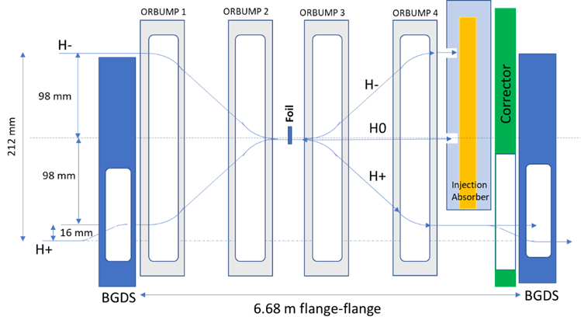

Figure 1: Booster Injection Insert with the Injection Absorber.

Review Agenda

“Booster Injection Beam Absorber PDR” Agenda
Location: | Loft
Date: | November 20th 2019
Time:  Indico Site: | 08:30-16:00  https://indico.fnal.gov/event/22416/

Participants:

Ioanis Kourbanis  ioanis@fnal.gov | Fermilab AD-MI Department | Role: Coordinator
Dean Still  still@fnal.gov | Fermilab AD-Muon Department | Role: Review Chair
Nicholas Evans  evansnj@ornl.gov | Organization | Role: Reviewer
Nikolai Mokhov  mokhov@fnal.gov | Fermilab AD-Target Systems Department | Role: Reviewer
Kamran Vaziri  vaziri@fnal.gov | Fermilab ES&H | Role: Reviewer
David Johnson  dej@fnal.gov | Fermilab AD-Proton Source Department | Role: Presenter
Vitaly Pronskikh  vspron@fnal.gov | Fermilab AD-Target Systems Department | Role: Presenter
Jesse Batko  jbatko@fnal.gov | Fermilab AD-Mechanical Support Department | Role: Presenter

Agenda details:

Introduction: Review Coordinator

PIP-II Booster Injection/Beam Absorber: David Johnson

MARS Simulations: Vitaly Pronskikh

Thermal Analysis: Jesse Batko

Closeout – Review Chair

[Summary Statement]

[Preliminary Findings]

[Preliminary Comments]

[Preliminary Recommendations]

Review Charge Statement
The reviewers are asked to perform a Preliminary Design Review of Booster Injection Beam Absorber for PIP II.

Specifically, the panel is asked to answer the following charge questions:

- Are the requirements documented, clear, complete and appropriate?

- Is the proposed design for the Booster Injection Beam Absorber likely to meet requirements? Explain any deficiencies or concerns.

- Are there any features present (or absent) that threaten the intended function and performance of this design?

- Have safety and environmental aspects been appropriately considered?

- Have quality aspects been appropriately considered?

The intended outcome of the review:
- Collect and document findings, comments and recommendations necessary to proceed to the Final Design stage.

The following documents will be available on the Indico site approximately 1 week before the review:
- This charge document.
- Functional requirements specifications for Booster Upgrades.
- Technical requirements specification for Booster Injection Absorber.
- Risk assessment table
- Safety by Design table.
- Design Review Report Template, to be completed by the reviewers

Acronyms
List and define any relevant acronyms as necessary.

ORBUMP | Orbit Bump
BGDS | Booster Gradient Defocusing Short Magnet

Reference Documents
List any relevant documents referred to in the Review Charge Statement. Include reference links or locations where the references are found. This list should include all documents with which the review committee should be familiar prior to the review.

1 | PIP-II Technical Review Plan – TC ED0008163
2 | PIP-II Quality Assurance Plan DocDB # 142
3 | PIP-II Systems Engineering Management Plan – TC ED0008164
4 | PIP-II IESH Management Plan DocDB # 141
5 | 121.02 SRF and Cryo Systems Design Plan DocDB # 2605
6 | 121.03 Accelerator Systems Design Plan DocDB # 2599
7 | 121.04 Linac Installation and Commissioning Design Plan DocDB # 2581
8 | 121.05 Accelerator Complex Upgrades Design Plan DocDB # 2593
9 | 121.06 Conventional Facilities Design Plan DocDB # 2587
10 | PIP-II Value Engineering Plan DocDB # 2830
11
12
13

The review coordinator should populate this following table with the document list for this review from their SDP.

Table 1 - Document Deliverables for this review from the System Design Plan
 | Document Title | Status  (preliminary, final, released) | Comments
1
2
3
4
5
6

