PIP-II AccU Booster Injection Absorber
Technical Requirements Specification

Document number: ED000, Rev. -

Document Approval
Signatures Required | Date Approved
Originator: David Johnson, PIP-II Booster L3 Manager
Approver: Ioanis Kourbanis, PIP-II Accelerator Complex Upgrades L2 Manager
Approver: Engineer
Approver: Alex Martinez, Integration Coordinator
Approver: Allan Rowe, Project Engineer

Revision History

Revision | Date of Release | Description of Change
- | 31-August- 2019 | Initial Release

Table of Contents
1. Purpose 4
2. Scope 4
3. Acronyms 4
4. Reference 4
5. Key Assumptions 5
6. Technical Requirements 5
7. Standard Safety Requirements 6

Purpose
A TRS describes the technical characteristics, performance requirements, and requested behavior of a system or component. TRS requirements may be derived from higher-level requirements in an FRS or ICD, or recommended from the design process. TRS requirements may be specific to a particular design concept.

Scope
Design and fabrication of a waste beam injection absorber for 800 MeV H- into the Booster from the new PIP-II Linac.

Acronyms
CAD | Computer Aided Design
FESHM | Fermilab ES&H Manual
FRCM | Fermilab Radiological Control Manual
FRS | Functional Requirements Specification
TC | Teamcenter
WBS | Work Breakdown Structure
RF | Radio Frequency
MI | Main Injector
AccU | Accelerator Upgrade

Reference

# | Reference | Document #
1 | The PIP-II Preliminary Design Report | docdb - 2261
2 | FRS, | ED0008140
3 | ICD, | ED0007705
13 | Fermilab Engineering Manual
14 | Fermilab Environmental Safety and Health Manual
15 | Fermilab Radiological Control Manual

Key Assumptions
The following key assumptions are relevant to these requirements:

- Booster injection from the 800 MeV PIP-II Linac will take place in the Booster Long 11 straight section. The Long 11 straight section will be lengthened to accommodate four ORBUMP magnets plus foil system, injection absorber, corrector package, vacuum bypass, and diagnostics.
- The assumed nominal beam energy, intensity, and injected beam power will be 800 MeV, 6.7x10¹² H-/Bcy, and 17.1 kW at 20 Hz.
- The stripping foil is symmetrically located between the middle ORBUMP magnets and the nominal stripping foil efficiency will be 99.9%.
- The closed orbit produced by the ORBUMP magnets will be a symmetric 4 bump such that the neutral hydrogen from the foil will exit parallel to the Booster elevation and any H- missing foil will impact the absorber at H- injection level.
- The injection absorber will be located downstream of the last ORBUMP magnet and upstream of the Booster correction package.

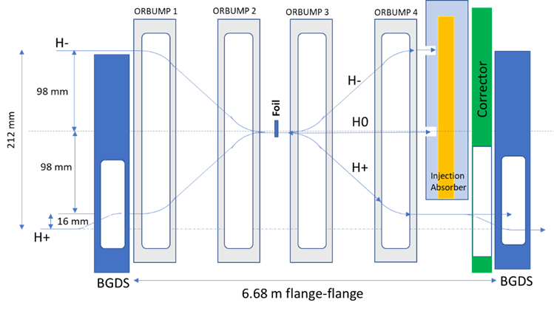

Technical Requirements

A discussion of these technical requirements for the Injection Absorber are discussed in PIP-II document # PIP-II-doc-4176.

Requirement # | Requirement Statement
Configuration
T-121.05.04.02-001 | The absorber must fit within the available space inside the injection straight section.
T-121.05.04.02-002 | The absorber must be able to accept up to 200 Watts of beam power without requiring water cooling.
T-121.05.04.02-003 | Components either side of the absorber bust be able to be serviced or removed considering ALARA.
T-121.05.04.02-004 | The residual activation of the outside Absorber shielding, and upstream / downstream components should be less than 100 mRem/hr.
T-121.05.04.02-005 | The prompt dose at the exterior of the berm (where personnel could be exposed) should be classified for “unlimited occupancy” or <0.05 mRem/hr.
T-121.05.04.02-006 | Ground (Drinking) water activation for tritium < 20 piC/ml-yr.
T-121.05.04.02-007 | Ground (Drinking) water activation for sodium-22 < 0.2 piC/ml-yr.
T-121.05.04.02-008 | Surface water (collected by sumps) for tritium < 2000piC/ml-yr with normal sump pump cycle time)
T-121.05.04.02-009 | Surface water (collected by sumps) for sodium-22 < 10 piC/ml-yr.
T-121.05.04.02-010 | Capable of handling a single pulse of x2 over design level
T-121.05.04.02-011
T-121.05.04.02-012

Capabilities and Performance
T-121.05.04.03-008
User Interface and Safety
T-121.03.08.03-008 | Interface with Radiation Safety Interlock Systems

Standard Safety Requirements
The system shall abide by all Fermilab ES&H (FESHM) and all Fermilab Radiological Control Manual (FRCM) requirements including but not limited to:

Electrical Safety
- FESHM Chapter 9190 Grounding Requirements for Electrical Distribution and Utilization Equipment
Radiation Safety

- FRCM Chapter 8 ALARA Management of Accelerator Radiation Shielding
- FRCM Chapter 10 Radiation Safety Interlock Systems
- FRCM Chapter 11 Environmental Radiation Monitoring and Control
General Safety
- FESHM Chapter 2000 Planning for Safe Operations

Any changes in the applicability or adherence to these standards and requirements require the approval and authorization of the PIP-II Technical Director or designee.

In addition, the following codes and standards in their latest edition shall be applied to the engineering, design, fabrication, assembly and tests of the given system:

NEPA 70 – National Electrical Code
IEC Standards for Electrical Components

In cases where International Codes and Standards are used the system shall follow FESHM Chapter 2110 Ensuring Equivalent Safety Performance when Using International Codes and Standards and requires the approval and authorization of the PIP-II Technical Director or designee.

