Requirements and preliminary layout for 800 MeV Booster Injection Absorber

David Johnson

August 31, 2019

**Introduction**

The new 800 MeV PIP-II injection will be installed Long 11. The current flange to flange length of the Booster straight section is 5.69 m. The “D” combined function magnets on either side of the new injection straight section will be reduced in length to allow for a 6.68 m flange-flange insert. Figure 1 shows the layout of the injection insert. The four ORBUMPS are used to distort the Booster closed orbit during injection and guide the injected H- onto the foil. The foil will strip the H- ions to H+ and H0 ions, Some of the neutral H0 ions. These neutral ions will not be affected by the downstream ORBUMP magnets and will impact the injection waste beam absorber at approximately 116 mm above the closed orbit. Due to the gaussian nature of the injected H- ions and the desire to have the injected beam close to the foil edge to minimize the number of “parasitic” hits on the foil by the circulating beam, thus reducing the loss by Rutherford scattering and nuclear collisions. We have selected a position on the foil which approximately 1% of the incoming H- Gaussian tail misses the foil. These ions will be deflected by the downstream ORBUMPS and impact the waste beam absorber about 211 mm above the Booster closed orbit.

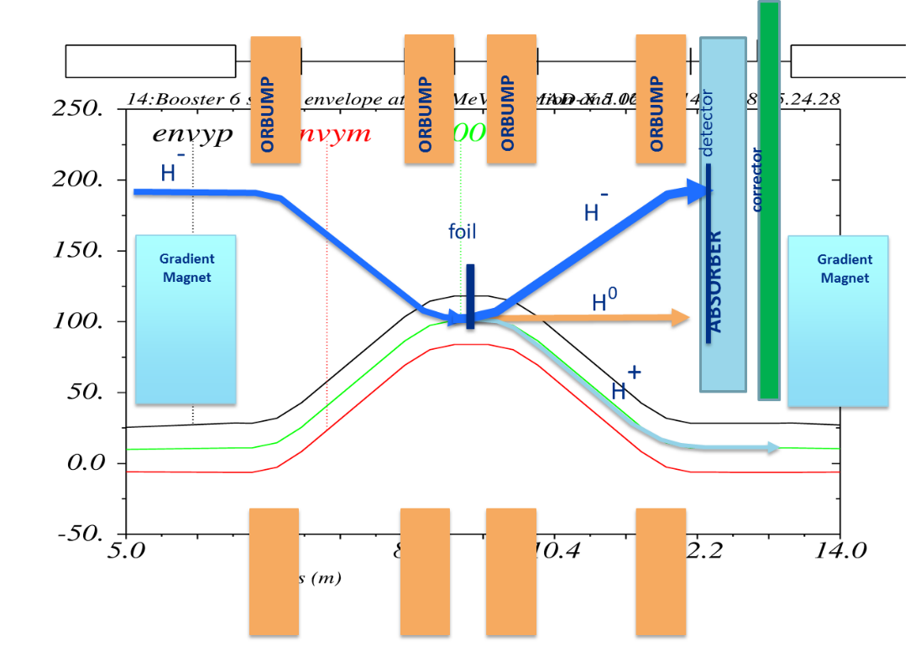

Figure 1: Layout of the PIP-II 800 MeV injection straight section shoeing the various beam trajectories and the location of the ORBUMPS, Injection waste beam absorber, and the Booster correction package between the reduced length “D” gradient magnets.

**Beam parameters**

At the expected foil thickness of 535 ug/cm2 the stripping efficiency should be about 99.89% such that we have about 0.17% of the neutral ions hitting the absorber. For 17.1 kW injection intensity, this is about 30 Watts into the absorber from the neutrals. For 1% of the H- missing the foil, this corresponds to about 170 Watts hitting the foil. Clearly the H- missing the foil is the dominate contribution. This contribution can be minimized by collimation in the beamline to reduce the extent of the Gaussian tails. For the design of the injection absorber handling capacity we will use the 170 Watts and 30 Watts beam power estimates. As a point of reference SNS counts on 2% H- tails missing the foil.

Table 1: Beam parameters

|  |  |  |  |  |
| --- | --- | --- | --- | --- |
| Parameter | Value | Intensity | Joules | Watts |
| Injected H- | NA | 6.7E12 | 85.76 | 17.15E3 |
| H- missing foil | 1% | 6.7E10 | 8.76 | 170 |
| H0 waste beam | 0.17% | 1.15E10 | 1.48 | 30 |
| TOTAL beam Power to absorber | |  | | 200 |
| Rep rate | 20 Hz |  | | |
| Revolution Period | 1.87E-6 sec |
| Nbr Injected turns | ~290 |
| Injection time | 0.542 ms |

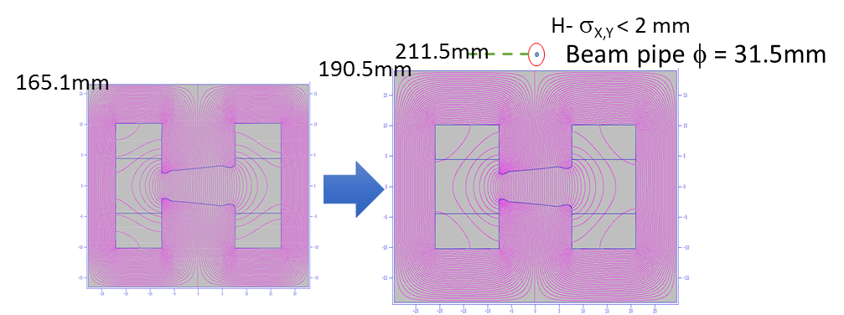The geometry of the absorber is highly constrained by the strength/length of the ORBUMP and painting magnets to be able to bring the injection line into the Booster over the reduced length gradient magnet at the upstream end of the injection straight section. In order to reduce the length of the gradient magnet, the back leg of the magnet needs to be increased by ~ 1 inch to eliminate saturation, according preliminary Poisson simulations. [1] This requires the beamline elevation of ~ 212 mm above the Booster centerline. Illustrated in Figure 2.

Figure 2: Elevation of injection beamline based upon the need to increase the back leg of the shortened “D” gradient magnet.

**Straight Section Geometry**

As seen in Figure 1, the absorber is sandwiched between the last ORBUMP magnet and the Booster correction package. The steel length of the Booster correction package is 0.4318 m (17”). A H&V BPM is to be installed inside this corrector with the downstream flange of the BPM mating to the “D” gradient magnet and the upstream end of the BPM terminating in a QD flange and welded bellows. The total f-f length of this system is to be 0 .4418m (~21”). The layout of components is shown in Figure 3.

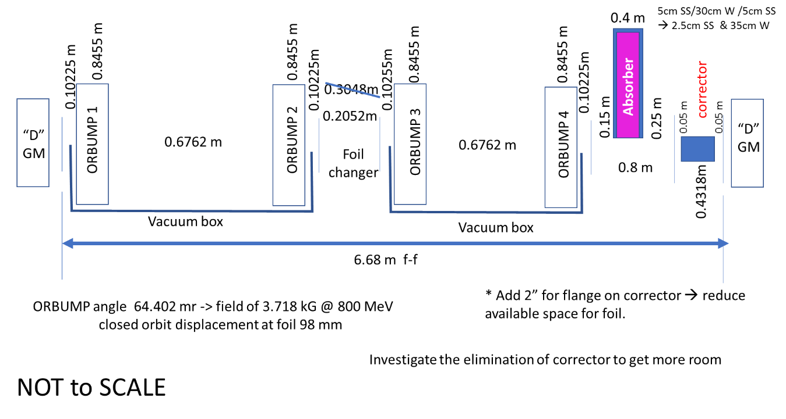

Figure 3: Preliminary component placement in the PIP-II 800 MeV injection straight section.

**Radiological Limits**

There are two areas of concern when discussing accelerator produced radiation and radio-nuclides. On involves minimizing ionization radiation to workers outside the enclosure from prompt radiation and workers inside the radiation enclosure from residual activation of equipment. The other concerns the production of radionuclides that could enter the environmental watershed, either through “drinking water” or “surface water” contamination. These limits are determined by applicable EPA/DOE/FNAL orders. The main radionuclides of concern at Fermilab are 3H and 22Na.

Table 2: Radiological Requirements [2]



The PIP-II injection waste beam absorber and its shielding must meet or exceed the Radiological Requirements for ground water protection, surface water (collected by the Booster sump pumps), and human protection through limiting residual activation ad the external surface of the collimators and the prompt dose at the exterior surface of the berm where personnel may be present. These are summarized in Table 2.

**Concentration Model**

TM-1850 and TM-1851 present a detailed methodology for estimating radionuclide production in the soil and migration in ground water. EP Note 8 (1994) discusses the adoption of the concentration model for use determining activation of soil and migration in groundwater.

The absorber and shielding must meet or exceed the Radiation safety criteria for ground water protection, surface water (collected by the MI sumps) protection, and human radiation protection (residual dosage at the exterior surface). These are determined by the applicable EPA/DOE/FNAL orders. Table 1 gives the limits

for H3 concentrations, residual activation of device, and limits on prompt dose.

The methodology described in EP Note 17 “The Concentration Model Revisited” will be utilized to determine maximum beam intensity in the absorber.

The initial concentration at of the radio nuclides is given in EP Note 17 as

 eq.1

The parameters are described in the EP Note 17 as:

* Np is the number of protons per year
* <S> is the star density in stars/cm3 in unprotected soil averaged over a volume surrounding the source out to an appropriate boundary (described below)
* Ki is the production yield of the ith isotope in atoms/star
* Li is the fraction of the ith isotope produced in the soil that is leachable by water
* s  is the density of the soil in gm/cm3
* wi is the ratio of the weight of water to the weight of soil that corresponds to the leaching fraction for the ith nuclide
* tir is the irradiation time
* i is the half-life of the ith radio nuclide. (12.3yr for 3H and 2.6 yr for 22Na)
* The expression in brackets [] describes the radio isotope build up to saturation. For irradiation times long compared to I, the term in brackets approaches unity.
* The numerical; factor converts disintegrations/sec to pCi and years to seconds.

The prescription for calculation the average stars given in EP Note 17 is obtained from the star density contour plots in r and z by going out in r and z from their values for the star density Smax at the boundary to those values at which S has dropped to 1% of its maximum value.

According to EP Note 15, the average star density, <S>, has been approximated by A*Smax, where A has taken on a value of 0.019 for “large absorbers typical of the Fixed target experimental areas”. As noted, this value is not always valid. A value of 0.19 is more appropriate where the “star density is nearly independent of the longitudinal distance from the target. “For most situations a = 0.1 appears to be a conservative estimate for most situations.

Groundwater

The final concentration at a point down-gradient in the aquifer, to be compared to the drinking water limit, is given by

 eq. 2

R is the reduction factor due to the transport from the source (Booster tunnel elevation) to the aquifer.

The magnitude of these reduction factors for the nominal geology around the Booster tunnel elevation make reaching the “ground water” limit the less likely than reaching the “surface water” limit.

Surface water

The surface water refers to that water collected by the sump at MI-10 and discharged to the surface. EP Note 17 discusses a method for estimating the concentration in sump discharge as discussed by the AP0 Review Committee Report. Here the annual flushing procedure was thought to be the most appropriate since the sumps run many times during the year and the radio nuclides don’t have time to build up. Hence, the concentration can be calculated taking the irradiation time at 1 year (at most). The average star densities, <S>, are calculated averaged from the location of Smax to those values at the elevation of the underdrain, not to those coordinates where S has dropped to 1% Smax.

If there is more than one radionuclide produced, the following relation should be utilized is determining allowable beam intensity [EP Note 21].

 eq. 3

In practice, the sum is kept less than or equal to 0.8.

Figure 4 shows the initial layout geometry of the ORBUMP, Absorber, Corrector, and Gradient magnet used in the MARS model for evaluation of absorbed dose and residual dose.

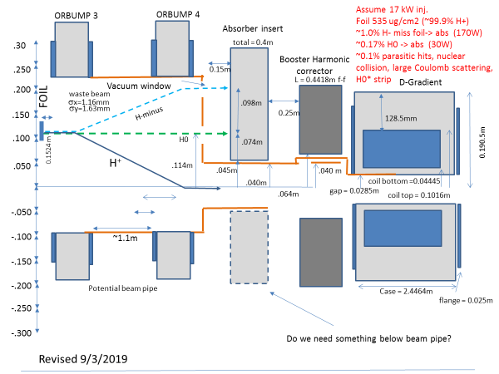

Figure 4: Preliminary real estate for injection absorber + shielding (not shown)

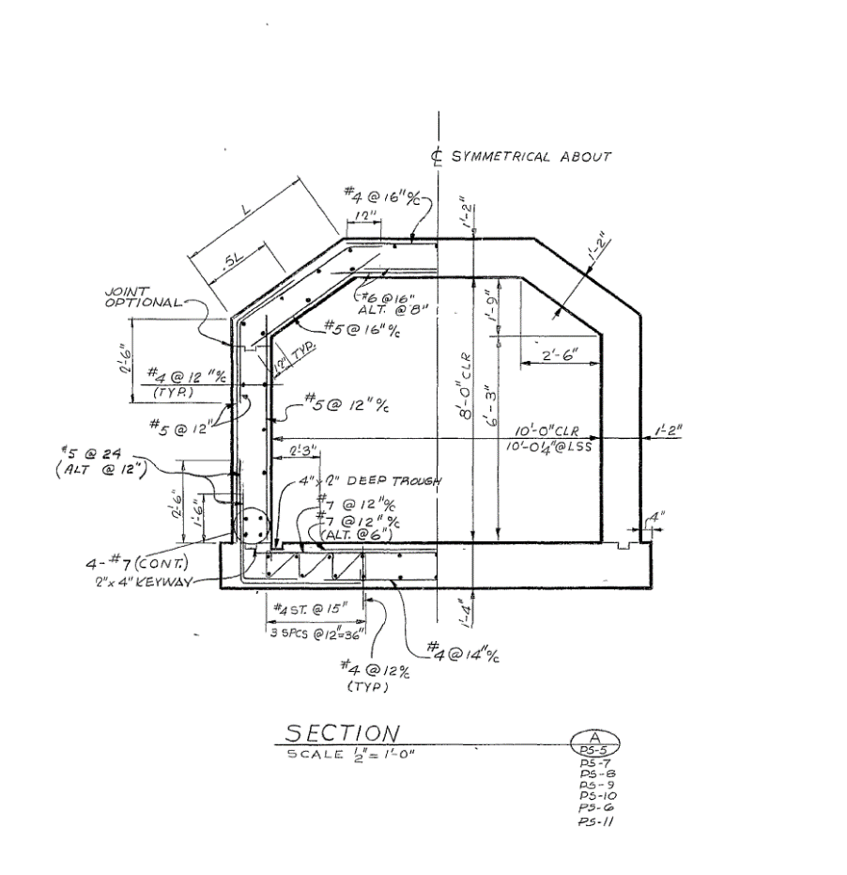The Booster straight section is located 30 inches off the inside of the tunnel wall and 48 inches from the floor. This geometry is shown in figure 5 for estimations of prompt dose and sump/ground water concentrations.

Figure 5: Cross section of the Booster tunnel. Beam centerline is 30” from left hand wall and 48” from floor.

**Initial MARS Simulations [3]**

The first MARS model of the injection region contained: 1) the last ORBUMP, 2) a 0.3m injection absorber (IA), 3) the BMA corrector, 4) and the downstream “D” gradient magnet, with a 0.2m drift apace between ORBUMP and absorber (DOA) and 0.1 m drift between absorber and corrector (DAC). This model looked at two absorber configurations, the first 0.3m of stainless steel (SS), and the second a 0.2 piece of tungsten with 0.05m of stainless steel on either side. Both of these models took up only 60 cm in the longitudinal dimension. The absorber was 7.5 cm wide and 24.5 cm tall with the bottom of the absorber at 40 mm above the centerline. The results of the Residual Activation simulation for both configurations after 30 irradiation and 1 day cool down are shown in Figure 6.

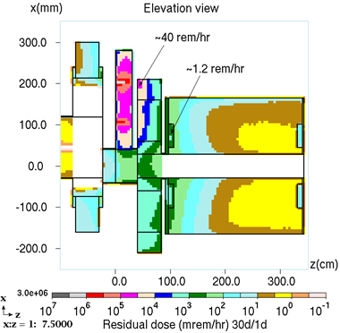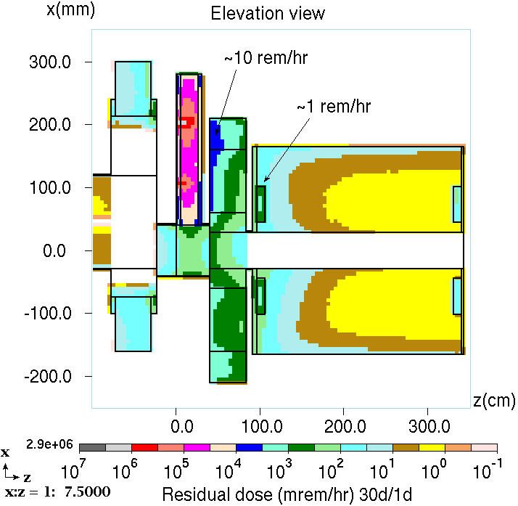

Figure 6: Residual dose rate for first model after 30 day irradiation and 1 day cooldown for stainless steel (left) and stainless steel-tungsten sandwich (right).

Looking at the 30 mm stainless steel absorber its clear from the residual 40 rem/hr that this thickness is not enough to contain the primary or shower. Looking at the 5cm SS/20cm W/5 cm SS sandwich that higher density material in the absorber helps reduce the residual in the corrector. Looking at the plan view from this data (not shown) the peak residual in the SS absorber was 100 rem/hr, while the W sandwich was 150 reml/hr on contact. Clearly this model did not leave enough room for any shielding external to absorber

A second MARS model expanded the thickness of the tungsten from 20 to 30 cm keeping the 5 cm of SS around all sides of the tungsten and expanded the width of the absorber from 7.5 cm to 22.5 cm. In addition, the drift on either side of the absorber was modified to that shown in Figure 2. Now the beamline length that includes the absorber and future shielding (not shown) increases the space allowed to 80 cm.

The results of the calculation for the residual activation for the second model is shown in Figure 7. From the reduction of the residual dose on the edge of the corrector from ~10 rem/hr (previous model with tungsten absorber sandwich) to ~ 2 rem/hr with the thicker and wider tungsten absorber. However, the “on contact” residual dose on the tungsten absorber remains at 150 rem/hr !

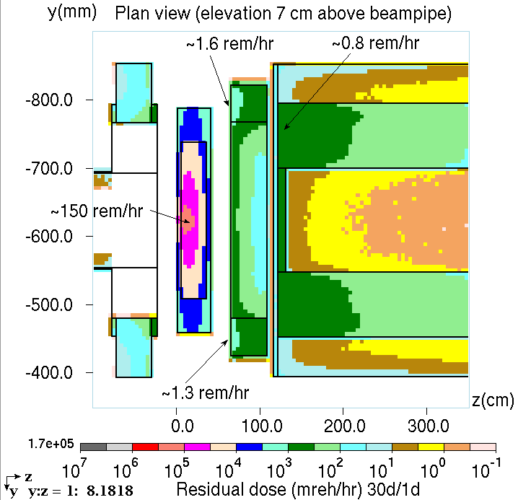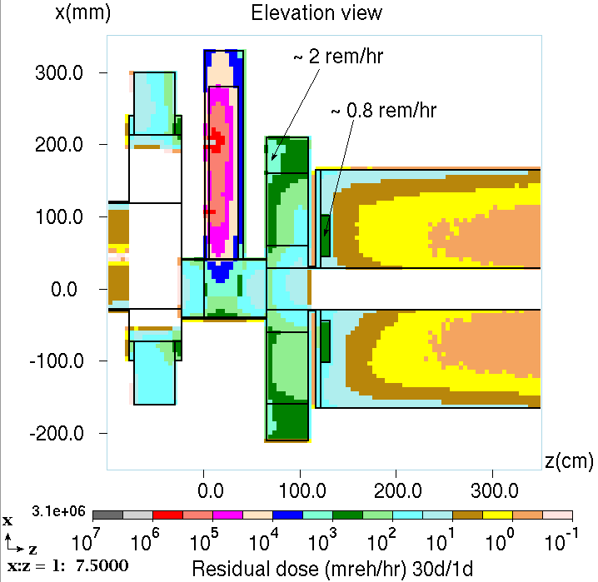

Figure 7: Residual dose of second model for elevation (left) and plan view (right).

**Other constraint**

In addition to the radiological constraints, we do not want to have to cool the absorber with water cooling. A RAW system would complicate the absorber system and the goal of the absorber design is too not require active water cooling.

A preliminary ANSYS thermal analysis was performed [4] of the heat load for three preliminary absorber configurations: 1) Tungsten block with SS cover, 2) Tungsten block with SS cover, an air gap, and an outer shield of steel with marble shielding, and 3) Same as #2 but with air gap replaced with more steel. The analysis included both a steady state and transit indicate that with 200 W average input beam power in air without shielding indicated that the maximum temperature of 114oC

**References (to be completed)**

[1] Omar

[2] Concentration model

[3] Igor Rakhno

[4] Jesse Batko