PIP-II Specialty Magnet
Technical Requirements Specification

Document number: ED0011xxxx, Rev. -

Document Approval
Signatures Required | Date Approved
Originator:
Approver: Alex Martinez, Integration Coordinator
Approver: Elvin Harms, L2 Manager (for given system)

Revision History

Revision | Date of Release | Description of Change

Table of Contents
1. Purpose 4
2. Scope 4
3. Acronyms 4
4. Reference 4
5. Key Assumptions 5
6. Functional Requirements 5
7. Safety Requirements 7

Purpose
There will be a total of three kinds of specialty magnets in the Linac to Booster transfer line for PIP-II, a fast switch magnet, a three way lambertson magnet and two beam dump sweep magnets. A Booster Injection C-magnet, which is in the FRS, is no longer required and is not included in this TRS. These magnets are used in the BTL abort line. This TRS will specify the magnet requirements.

Scope
WBS Dictionary Definition for the BTL MagPS: Design, procurement, fabrication, and testing of all types (dipoles, quads, correctors, special) of magnets and power supplies in the beam transfer line. This specific TRS addresses the technical requirements of the quadrupole magnets

Acronyms
FESHM | Fermilab ES&H Manual
FRCM | Fermilab Radiological Control Manual
FRS | Functional Requirements Specification
TRS | Technical Requirements Specification
L2 | WBS Level 2
L3 | WBS Level 3
PIP-II | Proton Improvement Plan II Project
SCD | System Configuration Document
TC | Teamcenter
WBS | Work Breakdown Structure
BTL | Beam Transfer Line
EPDM | Engineering Process Document Management
NPT | National Pipe Thread

Reference

# | Reference | Document #
1 | EPDM | ED0005433
2 | Fermilab Engineering Manual | NA
3 | BTL Dipole FRS | NA
4 | BTL Dipole Magnet Preliminary Design | NA
7 | Physics Driven Requirement | ED001026

Key Assumptions
It is assumed that the fast switch magnet will be a modified Tevatron A0 Abort magnet and that the beam sweep magnets will be existing EDTA magnets. It is assumed that the 3 way Lambertson magnets will be delivered complete with water manifolds and beam tube. It is also assumed that these magnets will be capable of DC operation at 1000 MeV .

Technical Requirements
The requirements for the for these specialty magnets are shown below. Also included, where appropriate are the parameters of the existing magnets.

5-1. Fast Switch Magnet
The fast switch magnet is used to move beam between the straight-ahead line to Booster and the beam abort line:
Table 5-1. Fast Switch Magnet

Requirement # | Requirement Statement
T-S-121.03.05-A001 | Effective length of the fast switch magnet shall be less than 2 m
T-S-121.03.05-A002 | The fast switch magnet shall be capable of providing a minimum bend angle of .0035 radians for 1000 MeV beam
T-S-121.03.05-A003 | The fast switch magnet shall have a gap of at least 52 mm.
T-S-121.03.05-A004 | The fast switch magnet shall have a beam aperture of greater than 46 mm.
T-S-121.03.05-A005 | The good field region shall not be less than 24 mm in diameter about the center
T-S-121.03.05-A006 | The fast switch magnet field uniformity shall be better than dB/B=1.0%
T-S-121.03.05-A007 | The fast switch magnet integrated field shall be equal to or greater than 20mT-m at 500 amps
T-S-121.03.05-A008 | The fast switch magnet shall be capable of a 20 micro sec rise and fall time
Table 5-1A. Tevatron A0 Abort Magnet
Requirement # | Requirement Statement
T-S-121.03.05-B001 | Effective length is 1.92 m
T-S-121.03.05-B002 | The magnet physical length is 2.18 m
T-S-121.03.05-B003 | Beam tube ID is 47.6 mm and is ceramic
T-S-121.03.05-B004 | The magnet gap of is 58 mm.
T-S-121.03.05-B005 | The magnet is a single turn magnet with an inductance of 3.15.E-6 H
T-S-121.03.05-B006 | The magnet had a 20 micro sec rise time for aborting beam in the Tevatron

5-2. 3 Way Septum
The fast switch magnet horizontally deflects beam into the field region of the 3-way septum to move beam into the abort channel. Beam that is not deflected by the fast switch magnet goes into the central channel which is field free. This magnet can be constructed of several shorter magnets to give the correct displacement over the total effective length. The total displacement of the beam over the 2.6 m length is 87 mm. Since the “third leg” of this septum will not be required for the current project, this magnet can be modular so as to have individual magnets of either side of the field free region. The concept is shown in these sketches:

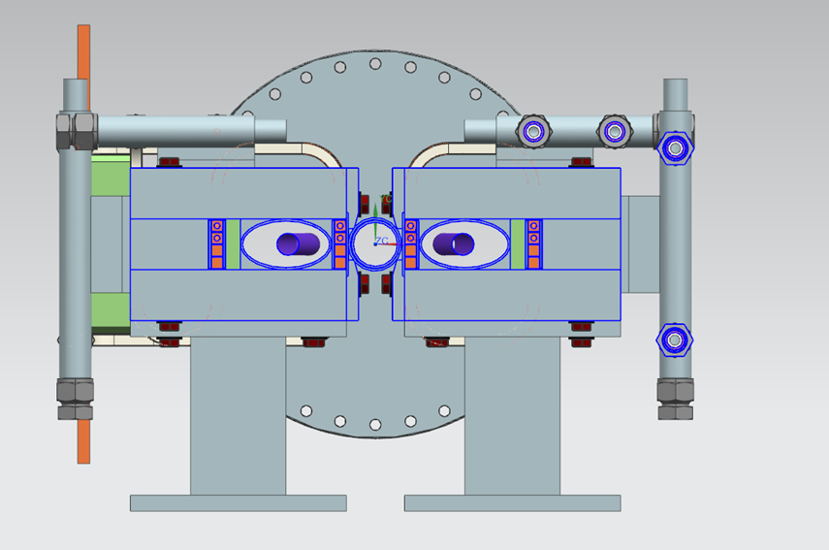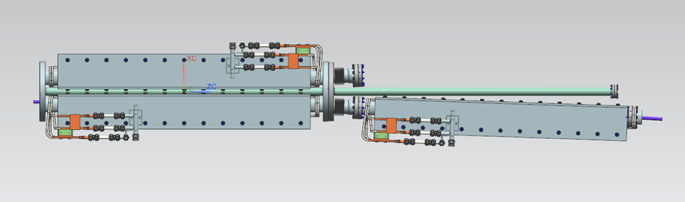
The requirements are shown below:
Table 5-2. 3-Way Septum Magnet

Requirement # | Requirement Statement
T-S-121.03.05-C001 | The 3-way septum shall have a minimum aperture of 40 mm in the field free region
T-S-121.03.05-C002 | The 3-way septum shall have a minimum gap of 40 mm in the field region
T-S-121.03.05-C003 | The 3-way septum shall have a total effective length of 2.6 m
T-S-121.03.05-C004 | The 3-way septum shall have a good field region of 30 mm diameter along the beam trajectory
T-S-121.03.05-C005 | The 3-way septum maximum integrated field shall be .43T-m
T-S-121.03.05-C006 | Physical length of the 3-way septum (length including coils) shall not exceed 3.0 m
T-S-121.03.05-C007 | The 3-way septum field uniformity shall be better than dB/B=.2%
T-S-121.03.05-C008 | The 3-way septum shall be capable of DC operation at 1350 amps
T-S-121.03.05-C009 | The 3-way septum shall have a septum thickness of 17 mm or less
T-S-121.03.05-C010 | The 3-way septum shall have a field free region in which the magnetic field is less than .05 gauss
T-S-121.03.05-C011 | The 3-way septum shall be capable of ramping at a maximum rate of .01 T-m/sec Integrated field (31 Amps/sec)
T-S-121.03.05-C012 | The 3-way septum shall not exceed transverse dimensions of 600 mm width and 600 mm height
T-S-121.03.05-C013 | The 3-way septum coils shall be continuous (no splices)
T-S-121.03.05-C014 | The 3-way septum coils shall provide for water cooling; the bus used shall have a hole for water of at least 5 mm diameter
T-S-121.03.05-C015 | The 3-way septum shall be assembled with a beam tube. The beam tube shall be made of either 316 or 304L stainless steel
T-S-121.03.05-C016 | The ends of the beam tube shall extend a minimum of 3” from the ends of the external coils
T-S-121.03.05-C017 | The ends of the beam tube shall be clean cut and perpendicular to between .005” to .010”
T-S-121.03.05-C018 | The 3-way septum beam tube shall be of such a shape as to allow for beam transport throughout the magnet
T-S-121.03.05-C019 | The 3-way septum shall have eight alignment fiducials welded to the steel; 2 on top of each end and 1 at each end on the sides of the magnet on the midline of the magnet
T-S-121.03.05-C020 | The 3-way septum shall be able to be hipotted up to 1000 volts DC with less than 1 microamp of current

5-3. -Beam Sweep Magnets
In order to reduce heating on the abort dump, the aborted beam will be deflected by two beam sweep magnets which will move the beam in a circular pattern on the face of the beam dump. One magnet would deflect horizontally while the other would deflect vertically. Both magnets would operate at 11 hz with one system being 90 degrees out of phase with the other. One possible solution is to use an existing FNAL magnet known as an EDTA magnet. The requirements are shown here and the characteristics of the EDTA magnet are shown after this.
Table 5-3. Beam Sweep Magnets

Requirement # | Requirement Statement
T-S-121.03.05-D001 | Effective length of each beam sweep magnets is 0.5 m
T-S-121.03.05-D002 | Physical length of the beam sweep magnet (length including coils) shall not exceed 0.85 m
T-S-121.03.05-D003 | The beam sweep magnet shall provide for a maximum bend angle of .0155 radians at 1000 MeV
T-S-121.03.05-D004 | The beam sweep magnet gap shall be 52 mm
T-S-121.03.05-D005 | The good field region shall not be less than 24 mm in diameter about the center
T-S-121.03.05-D006 | The beam sweep magnet field uniformity shall be better than dB/B=1.0%
T-S-121.03.05-D007 | The beam sweep magnet integrated field shall be .1T-m at less than 50 amps
T-S-121.03.05-D009 | The beam sweep magnet shall be capable of ramping at 11 Hz
T-S-121.03.05-D010 | The beam sweep magnet shall not exceed transverse dimensions of 600 mm width and 600 mm height
T-S-121.03.05-D011 | The beam sweep magnet coils shall be continuous (no splices)
T-S-121.03.05-D012 | The beam sweep magnet shall have eight alignment fiducials welded to the steel; 2 on top of each end and 1 at each end on the sides of the magnet on the midline of the magnet
T-S-121.03.05-D013 | The beam sweep magnet shall be able to be hipotted up to 500 volts DC with less than 1 microamp of current

Table 5-3A. EDTA Magnet

Requirement # | Requirement Statement
T-S-121.03.05-E001 | The EDTA magnet has a calculated effective length of .569 m
T-S-121.03.05-E002 | The EDTA magnet has a calculated transfer function of .00495 T/amp
T-S-121.03.05-E003 | The EDTA magnet has estimated resistance of .1273 ohms at 20 degrees C
T-S-121.03.05-E004 | The EDTA magnet has a gap of 50.8 mm
T-S-121.03.05-E005 | The EDTA magnet has a flange to flange length of .81 m
T-S-121.03.05-E006 | The EDTA magnet is not water cooled

Table 5-3. Magnet Water Requirements
Requirement # | Requirement Statement
T-S-121.03.05-D001 | All external water connections shall be appropriately sized female NPT fittings
T-S-121.03.05-D002 | The maximum water pressure drop is 80 psid at the operating flow
T-S-121.03.05-D003 | Water flow velocity in the magnet coils shall be between 5 and 8 feet per second
T-S-121.03.05-D004 | Water temperature rise shall not exceed 10 degrees C above the nominal 35 degrees C water temperature ( 5.5 degrees F)
T-S-121.03.05-D005 | Nominal inlet water temperature is 95 degrees F (35 degrees C)

Table 5-4. Magnet Support Structure Requirements
Requirement # | Requirement Statement
T-S-121.03.05-F001 | All magnets shall have three feet for mounting that are welded to the body of the magnet; these feet will be located 22% of the length from each end
T-S-121.03.05-F002 | All magnets shall have provisions to allow for rigging the magnet; this could be tapped holes of an appropriate size to allow for swivel hoist rings that are appropriate for the magnet load with a safety margin

Safety Requirements
The system shall abide by all Fermilab ES&H (FESHM) and all Fermilab Radiological Control Manual (FRCM) requirements including but not limited to:

Electrical Safety
- FESHM Chapter 9110 Electrical Utilization Equipment Safety
- FESHM Chapter 9160 Low Voltage, High Current Power Distribution Systems
- FESHM Chapter 9190 Grounding Requirements for Electrical Distribution and Utilization Equipment
Pressure Piping safety
- FESHM Chapter 5031.1 Piping Systems
General Safety
- FESHM Chapter 2000 Planning for Safe Operations

Any changes in the applicability or adherence to these standards and requirements require the approval and authorization of the PIP-II Technical Director or designee.

In addition, the following codes and standards in their latest edition shall be applied to the engineering, design, fabrication, assembly and tests of the given system:

NFPA 70 – National Electrical Code
IEC Standards for Electrical Components
ASME BPVC Section IX Qualification Standard for Welding, Brazing and Fusing Procedures

In cases where International Codes and Standards are used the system shall follow FESHM Chapter 2110 Ensuring Equivalent Safety Performance when Using International Codes and Standards and requires the approval and authorization of the PIP-II Technical Director or designee.

Additional Safety Requirements that are not listed in the general list above shall be included in the Requirements table in the Functional Requirements section.

